Q7. Retrieve all orders with status = 'Delivered'.
select * from orders where status = 'Delivered' ;
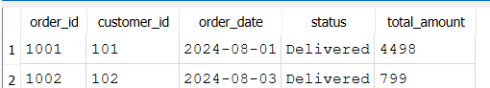

Q8. Find all products in the 'Electronics' category with a unit_price greater than ₹2000.
select * from products where category = 'Electronics' AND unit_price > 2000 ;
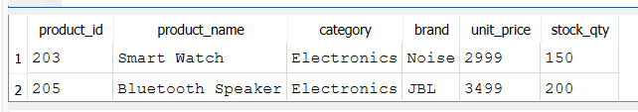

Q9. List all customers who joined in the year 2024 and belong to the state 'Maharashtra'.
select * from customers ;
select * from customers where state='Maharashtra' AND join_date BETWEEN '2024-01-01' AND '2024-12-31';
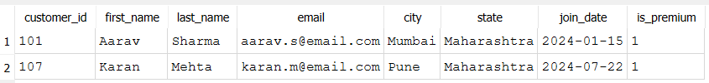

Q10. Find all orders placed between '2024-08-10' and '2024-08-25' (inclusive) that are NOT cancelled.
select * from orders where order_date BETWEEN '2024-08-10' and '2024-08-25' AND status <>'Cancelled' ;
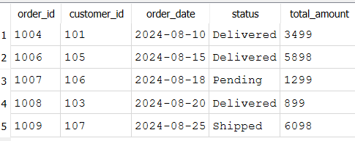
Q11. Explain what the index idx_orders_date does. How would it improve the performance of a query that filters orders by order_date? Write a sample query that would benefit from this index.
--query that filters orders by order_date
------index idx_orders_date is created on the order_date column where index store the values of order_date in a stored structure
------it improves the performance of queries that filter , sort or search within the order date
SELECT * FROM orders WHERE order_date BETWEEN '2024-08-10' AND '2024-08-25';
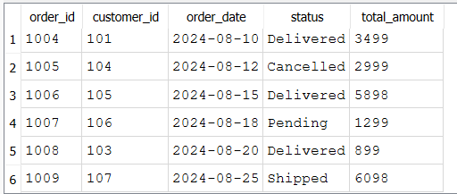

Q12. If you run: SELECT * FROM customers WHERE YEAR(join_date) = 2024; — would the index on join_date be used? Explain why or why not, and rewrite the query to be index-friendly (SARGable).
--Im using the sql lite and there is no YEAR function in the same way MySQL and applying the function to an indexed column generally prevents the DB from using the index efficiently
select * from customers WHERE YEAR(join_date) = 2024 ;
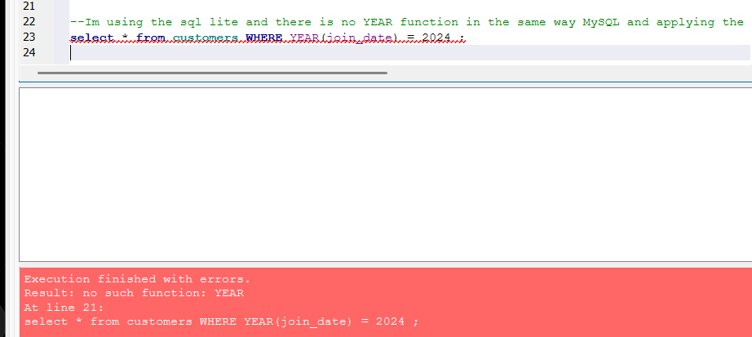
--- so the Index - friendly (SARgable) Query
select * from customers where join_date BETWEEN '2024-01-01' AND '2024-12-31' ;
