Q13. Count the total number of orders in the orders table.
--Counting the total oders in the order table
select count(*) as total_orders from orders ;


Q14. Find the total revenue (SUM of total_amount) from all 'Delivered' orders.
-- Display the total Revenue by calculating Sum of total Amount from all Delivered orders
select SUM(total_amount) as Total_revenue from orders where status = 'Delivered' ;


Q15. Calculate the average unit_price of products in each category.
--Display the average of unit_price of the products columns with recepect to each category
select category , AVG(unit_price) as Average from products group by category ;
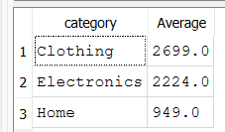

Q16. For each order status, find the count of orders and the total revenue. Sort the result by total revenue in descending order.
--Query to display the for each odder - order status withcount of orders AND total revenue + sorting in decending ORDER
select status , count(order_id) as count_of_orders , sum(total_amount) as total_revenue from orders group by status ORDER by total_revenue DESC ;
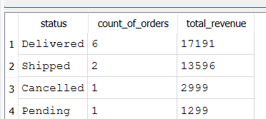

Q17. Find the most expensive (MAX) and cheapest (MIN) product in each category.
--Query for display the Maximum and Minimum product in each category in products table
select category , MAX(unit_price) as Maximum_price , MIN(unit_price) as Minimum_price from products group by category ;
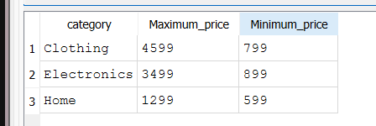

Q18. List all product categories where the average unit_price is greater than ₹2000. (Hint: Use HAVING clause)
--Query to display the product categories whoes avg price greater than 2000
--select category from products GROUP by category having avg(unit_price) > 2000;
SELECT category,AVG(unit_price) AS average_price FROM products
GROUP BY category
HAVING AVG(unit_price) > 2000;
