

Sabre Java Printing Module (SJPM)

Logging Guide

provides detailed instructions on the SJPM Server and Client logging functions.

**10 December 2014**

|  |
| --- |
| © 2014, Sabre Inc. All rights reserved.  This documentation is the confidential and proprietary intellectual property of Sabre Inc. Any unauthorized use, reproduction, preparation of derivative works, performance, or display of this document, or software represented by this document, without the express written permission of Sabre Inc. is strictly prohibited.  Sabre and the Sabre logo design are trademarks and/or service marks of an affiliate of Sabre Inc. All other trademarks, service marks, and trade names are owned by their respective companies. |

Contents

General Information 3

1.1 SJPM Logging Overview 3

SJPM Logging 4

2.1 Enabling/Disabling SJPM Server and Client Logging (Auto) 4

2.1.1 Enabling SJPM Server Logging 4

2.1.2 Disabling SJPM Server Logging 6

2.1.3 Enabling SJPM Client Logging 8

2.1.4 Disabling SJPM Client Logging 8

2.2 Enabling/Disabling SJPM Server and Client Logging (Manual) 9

2.2.1 Enabling SJPM Server Logging (Manual) 9

2.2.2 Disabling SJPM Server Logging (Manual) 14

2.2.3 Enabling SJPM Client Logging (Manual) 19

2.2.4 Disabling SJPM Client Logging (Manual) 21

# 1

# General Information

## 1.1 SJPM Logging Overview

**Server Logging:**

SJPM provides logging for the SJPM Server for the purposes of troubleshooting issues. Server log files are written to the default location of “**C:\Program Files\SJPM\server\logs**”. In Windows 7 and 8 they are written to the default location of “**C:\Program Files (x86)\SJPM\server\logs**”.

A total of ten (10) 20meg log files are created. Logging will continue to log rotating between the ten file names with the intent to be able to capture the issue within one of the 10 files. All ten files should be sent for investigation.

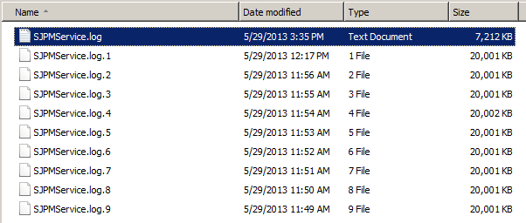

**Client Logging:**

SJPM provides logging for the SJPM Client for the purposes of troubleshooting issues. The Client log file is written to the user’s home directory.

One log files is created.



# 2

# SJPM Logging

## 2.1 Enabling/Disabling SJPM Server and Client Logging (Auto)

This section describes the procedures for enabling/disabling the SJPM Server and Client logging features through the SJPM taskbar icon menu for troubleshooting and issue resolution. By default SJPM logging is disabled. Once logging is complete be sure to turn off SJPM Logging. (See the Disabling Logging sections)

## 2.1.1 Enabling SJPM Server Logging

**Follow these steps to enable Server Logging in SJPM:**

1. Right click on the SJPM taskbar icon and then click on “**Server Logging**”.

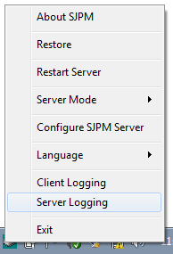

1. The following popup window will appear. Click on the “**Yes**” button to restart the SJPM server.

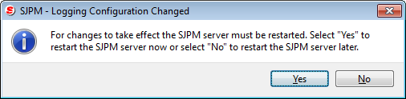

1. On the SJPM Client GUI screen “**LOGGING IS ACTIVE**” will be displayed in the status bar in red with the log level, filename and location.

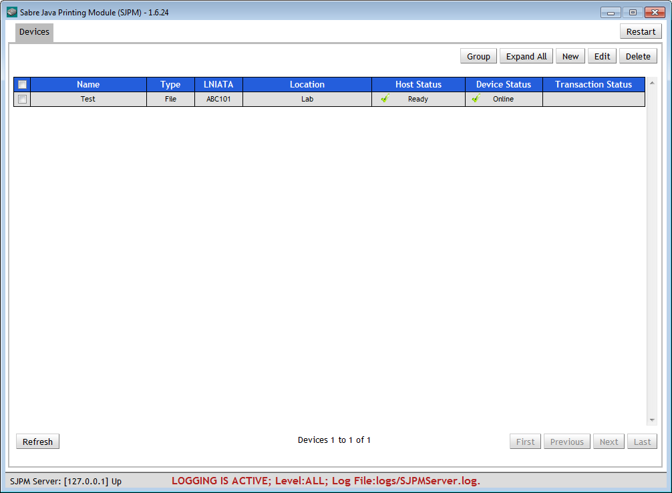

1. Server log files are written to the default location of “**C:\Program Files\SJPM\server\logs**”. In Windows 7 and 8 they are written to the default location of “**C:\Program Files (x86)\SJPM\server\logs**”.

## 2.1.2 Disabling SJPM Server Logging

**Follow these steps to disable Server Logging in SJPM:**

1. Right click on the SJPM taskbar icon and then click on “**Server Logging**”.

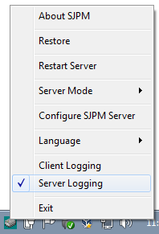

1. The following popup window will appear. Click on the “**Yes**” button to restart the SJPM server.

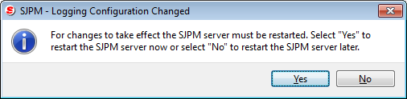

1. On the SJPM Client GUI screen the red “**LOGGING IS ACTIVE**” will no longer be displayed in the status bar.

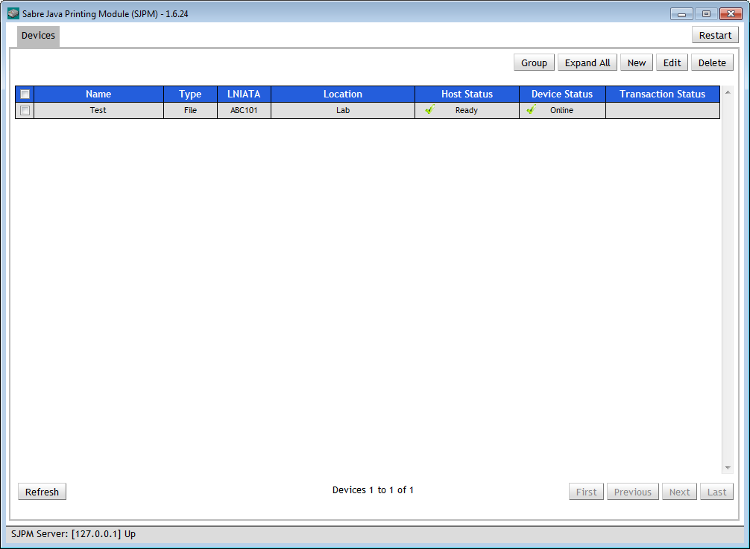

## 2.1.3 Enabling SJPM Client Logging

**Follow these steps to enable Client Logging in SJPM:**

1. Right click on the SJPM taskbar icon and then click on “**Client Logging**”.

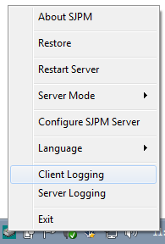

1. The Client log file is written to the user’s home directory.

## 2.1.4 Disabling SJPM Client Logging

**Follow these steps to disable Client Logging in SJPM:**

1. Right click on the SJPM taskbar icon and then click on “**Client Logging**”.

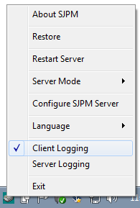

## 2.2 Enabling/Disabling SJPM Server and Client Logging (Manual)

This section describes the procedure for enabling/disabling the SJPM Server and Client logging features manually through the properties files for troubleshooting and issue resolution. By default SJPM logging is disabled. Once logging is complete be sure to turn off SJPM Logging. (See the Disabling Logging sections)

## 2.2.1 Enabling SJPM Server Logging (Manual)

**Follow these steps to manually enable Server Logging in SJPM:**

1. In Windows Explorer navigate to the following directory:

“**C:\Program Files\SJPM\server**”

Windows 7 and 8 “**C:\Program Files (x86)\SJPM\server**”.

1. Use a text editor such as Notepad and open the “**server.properties**” file.
2. Search for the text string “**loglevel=NONE**”.

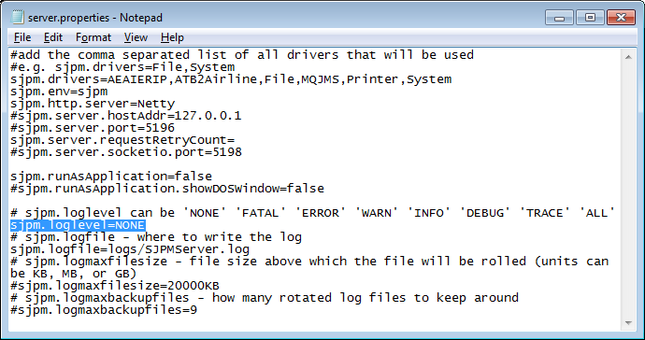

1. Change the “**loglevel**” to “ALL”.

Example: “**loglevel=ALL”**

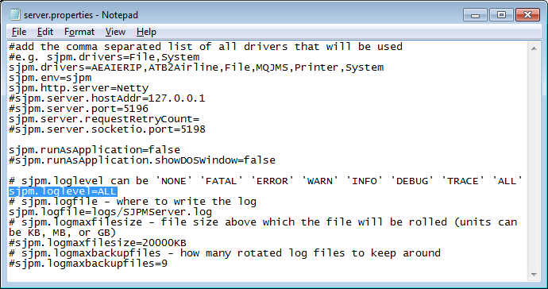

1. Save the changes to the “**server.properties**” and restart the SJPM Server. In the SJPM Client GUI click on the “**Restart**” button.



1. Click on the “**OK**” button to restart the SJPM Server.

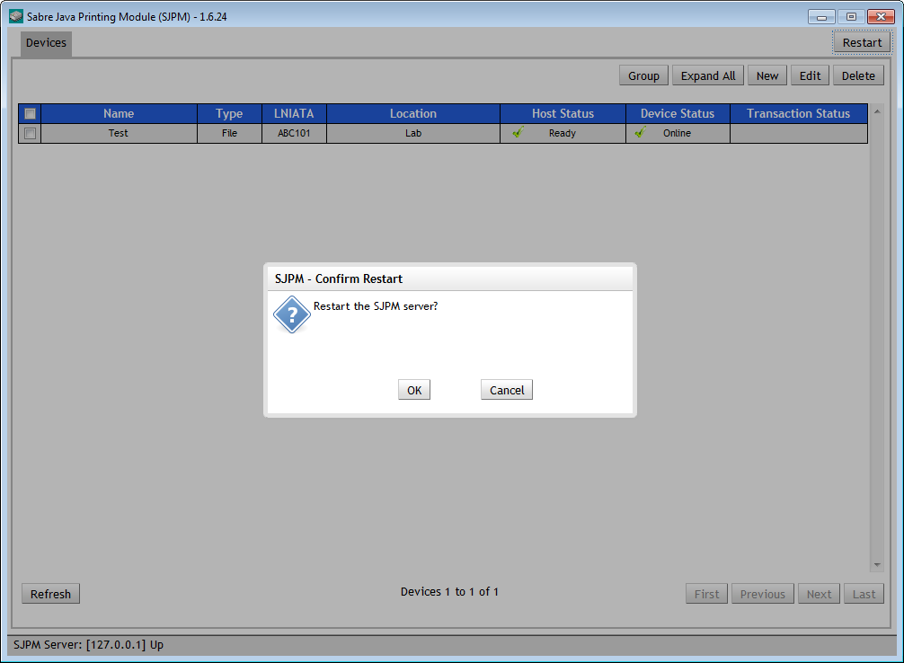

Server log files are written to the default location of “**C:\Program Files\SJPM\server\logs**”. In Windows 7 and 8 they are written to the default location of “**C:\Program Files (x86)\SJPM\server\logs**”.

SJPM will display the current logging status, logging level, and location of the log file.



**Note: Once logging has been completed turn off logging.**

## 2.2.2 Disabling SJPM Server Logging (Manual)

**Follow these steps to manually disable Server Logging in SJPM:**

1. In Windows Explorer navigate to the following directory:

“**C:\Program Files\SJPM\Server**”

Windows 7 and 8 “**C:\Program Files (x86)\SJPM\server**”.

1. Use a text editor such as Notepad and open the “**server.properties**” file.
2. Search for the text string “**loglevel=ALL**”.



1. Change the “**loglevel**” to “**NONE**”.

Example: “**loglevel=NONE”**



1. Save the changes to the “**server.properties**” and restart the SJPM Server. In the SJPM Client GUI click on the “**Restart**” button.



1. Click on the “**OK**” button to restart the SJPM Server.



On the SJPM Client GUI screen the red “**LOGGING IS ACTIVE**” will no longer be displayed in the status bar.



## 2.2.3 Enabling SJPM Client Logging (Manual)

**Follow these steps to manually enable Client Logging in SJPM:**

1. In Windows Explorer navigate to the following directory:

“**C:\Program Files\SJPM\client\QtClient**”

Windows 7 and 8 “**C:\Program Files (x86)\ SJPM\client\QtClient**”.

1. Use a text editor such as Notepad and open the “**client.ini**” file.
2. Search for the text string “**loglevel=OFF**”.

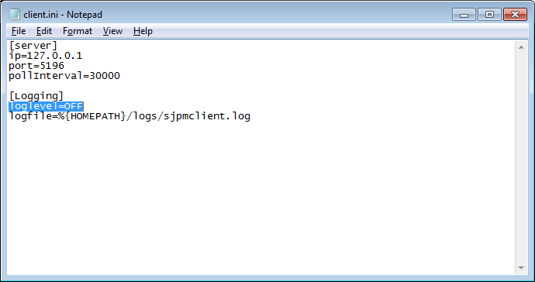

1. Change the “**loglevel**” to “ALL”.

Example: “**loglevel=ALL”**

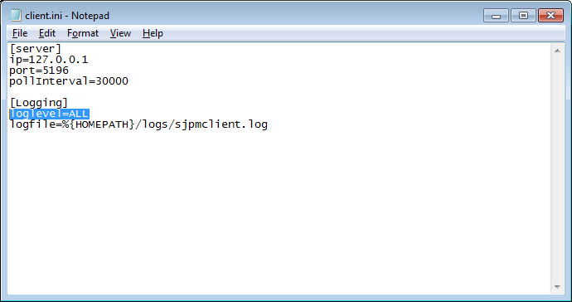

1. Save the changes to the “**client.ini**” file.
2. Right click on the SJPM Windows taskbar icon and then click on the “**Exit**” menu item to close the SJPM Client.
3. From the SJPM Start menu click on the “**Start**” button, then click on “**Programs**” or “**All Programs**”, then click on the “**SJPM**” menu item, and then click on the “**SJPM Client**” menu item to start the SJPM Client.
4. The Client log file is written to the user’s home directory.

## 2.2.4 Disabling SJPM Client Logging (Manual)

**Follow these steps to manually disable Client Logging in SJPM:**

1. In Windows Explorer navigate to the following directory:

“**C:\Program Files\SJPM\client\QtClient**”

Windows 7 and 8 “**C:\Program Files (x86)\ SJPM\client\QtClient**”.

1. Use a text editor such as Notepad and open the “**client.ini**” file.
2. Search for the text string “**loglevel=ALL**”.



1. Change the “**loglevel**” to “**OFF**”.

Example: “**loglevel=OFF”**



1. Save the changes to the “**client.ini**” file.
2. Right click on the SJPM Windows taskbar icon and then click on the “**Exit**” menu item to close the SJPM Client.
3. From the SJPM Start menu click on the “**Start**” button, then click on “**Programs**” or “**All Programs**”, then click on the “**SJPM**” menu item, and then click on the “**SJPM Client**” menu item to start the SJPM Client.