AWS Config Setup Guide (IAM User + Dedicated S3 Bucket)

Step 1: Create an S3 Bucket
1. Log in as the IAM user you will use for AWS Config (Cloud-security-project).
2. Go to S3 → Create bucket.
3. Enter a unique bucket name (e.g., cloud-security-***********).
4. Select the same AWS region as your Config deployment.
5. Leave ACLs disabled (default, recommended).
6. Click Create bucket.
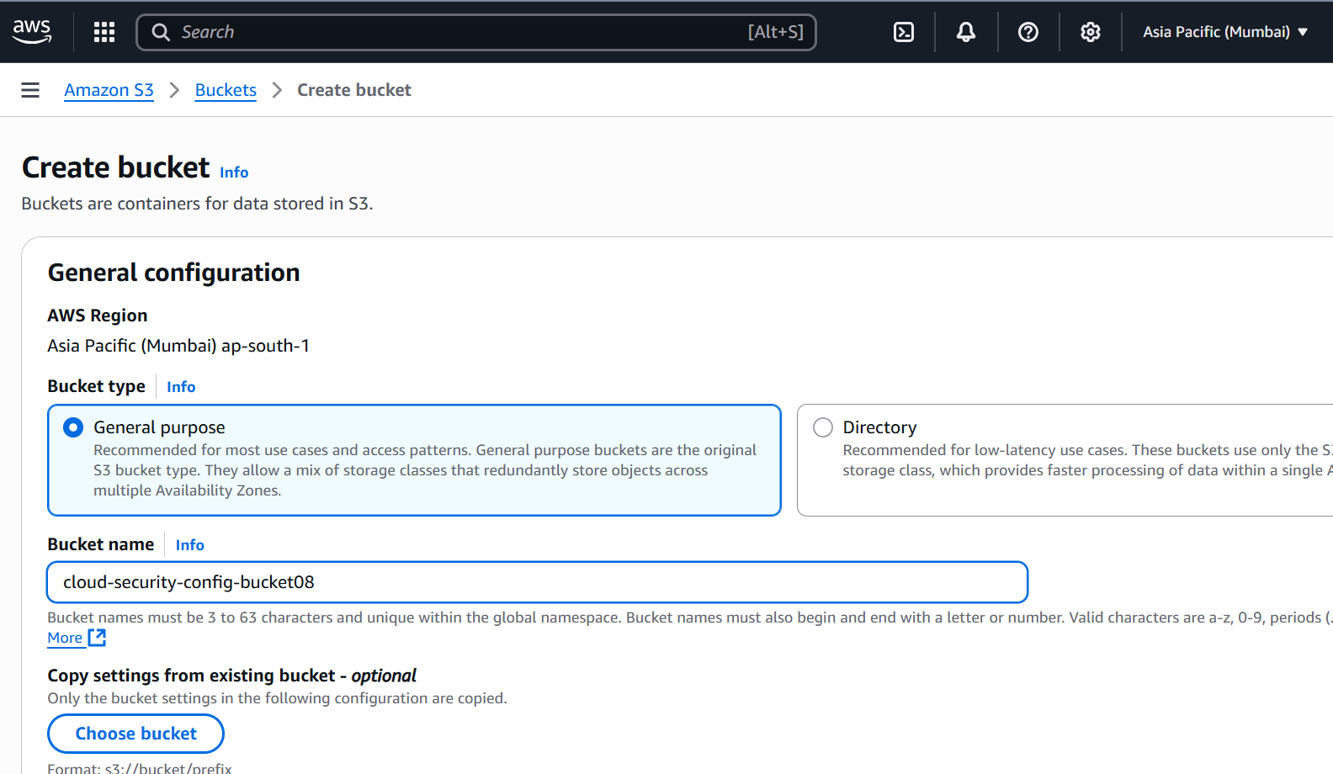

Step 2: Assign Bucket-Specific Permissions to IAM User
Attach an inline policy to your IAM user with the following JSON:
{
"Version": "2012-10-17",
"Statement": [
{
"Effect": "Allow",
"Action": "s3:ListAllMyBuckets",
"Resource": "*"
},
{
"Effect": "Allow",
"Action": [
"s3:ListBucket",
"s3:GetBucketLocation"
],
"Resource": "arn:aws:s3:::cloud-security-config-bucket"
},
{
"Effect": "Allow",
"Action": [
"s3:PutObject"
],
"Resource": "arn:aws:s3::: cloud-security-config-bucket/*"
}
]
}

Explanation:
• ListBucket → lets AWS Config check bucket contents
• GetBucketLocation → allows Config to verify bucket region
• PutObject → allows AWS Config to store snapshots

Step 3: Configure AWS Config
1. Log in as the IAM user.
2. Open AWS Config → Get Started.
3. Select resources to record → Recommended: All resources.
4. Select S3 bucket → Choose the bucket you just created (myproject-config-bucket).
5. SNS notifications → Optional, for alerting.
6. Enable multi-region recording if required.
7. Click Start Recording.

Step 4: Verify Configuration
1. Go to AWS Config → Settings → Configuration recorder status should show Recording: True.
2. Verify that snapshot JSON files appear in the S3 bucket.
3. Test notifications via SNS if enabled.

Step 5: Security Considerations
• IAM user has access only to this bucket, following the least privilege principle.
• ACLs are disabled, so all access is controlled via policies.
• No full S3 access is needed, reducing risk.

