BUSINESS PROCESS MODELING
PROJECT: BharatGen – Indic Language AI Support Assistant for Indian SMEs
Week 2 Task | Senior Business Analyst (Technical)
Prepared as a continuation of the Week 1 Market Research and Analysis Report

1. Executive Summary
This report models the key business processes for BharatGen, the Indic-language AI support assistant for Indian small and medium enterprises (SMEs) introduced in the Week 1 market research report. BharatGen allows an SME to upload its product catalogue, price list or FAQ, converts the content into searchable knowledge, and responds to customer questions through WhatsApp in supported Indian languages. The process models cover onboarding and knowledge-base setup, customer-query handling, human handover when the AI cannot answer reliably, and ongoing monitoring and improvement.
The diagrams use a simplified BPMN-inspired notation: circles indicate process start/end events, rounded rectangles indicate activities, and diamonds indicate decision points. These are conceptual business process models for the hypothetical company and prototype described in Week 1; technical implementation details and operational controls should be validated before a production launch.

2. Scope, assumptions and modeling notation

2.1 Scope
- SME onboarding, plan selection and upload of business knowledge documents.
- Document processing and indexing using the RAG pipeline and ChromaDB described in Week 1.
- Customer messages received through WhatsApp and answers generated from the SME’s own content.
- Human review for uncertain or unsupported answers.
- Monitoring service performance and updating the knowledge base.

2.2 Assumptions
- The SME has permission to use the uploaded documents and customer data.
- The knowledge source is readable and contains current product, price, policy or FAQ information.
- A WhatsApp messaging integration and a dashboard are available in the proposed service.
- A confidence threshold is configured for routing uncertain answers to a human; the exact threshold is a business rule to be agreed with stakeholders.
- The process diagrams describe intended workflows, not a claim that every integration is already deployed.

2.3 BPM notation key
Start/end event (circle): marks where a process begins or finishes. Activity (rounded rectangle): work performed by a person or system. Gateway (diamond): a decision that determines the next route. Arrows show the expected sequence of work. For readability, the diagrams are linear summaries; decision branches and exception paths are explained in the process descriptions below.

3. Process 1 — SME onboarding and knowledge-base setup
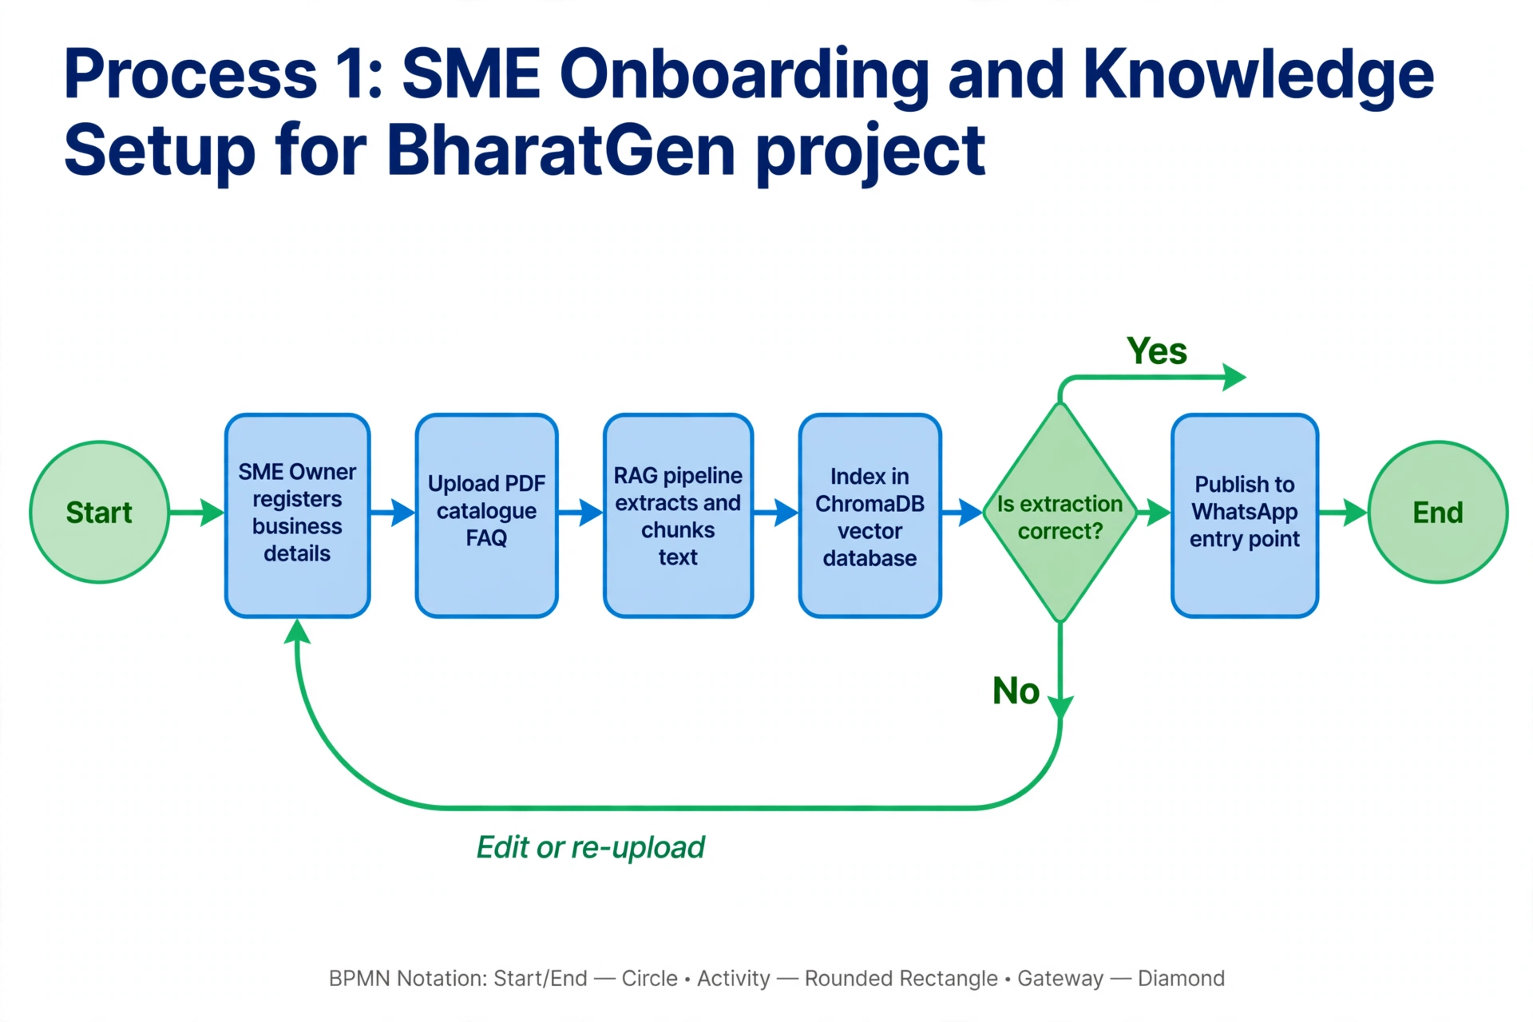

3.1 Purpose and participants
Purpose: enable an SME to configure BharatGen with trusted business information before customer conversations are automated. Main participants are the SME owner, BharatGen application, document-processing/RAG pipeline and the support administrator when an upload fails.

3.2 Detailed process
1. Start and registration: the SME owner registers, provides basic business details and selects a plan. The application validates required fields and records the account.
2. Knowledge upload: the owner uploads a product catalogue, price list or FAQ as a PDF. The interface confirms the file and explains that the uploaded information will be used to answer customer questions.
3. Document processing: the RAG pipeline extracts text, divides it into manageable chunks and prepares the content for retrieval. If the file is unreadable, empty or unsupported, the workflow returns an error and asks the owner to upload a corrected file.
4. Indexing: processed chunks are stored in a searchable vector index such as ChromaDB. The system records the source document and processing status so that the SME can identify which version is active.
5. Validation gateway: the owner or system checks whether important details—such as product names, prices and FAQs—were extracted correctly. If validation fails, the owner edits or replaces the source and processing is repeated. If validation passes, the knowledge base is approved.
6. Publish: the approved assistant is connected to the SME’s WhatsApp entry point and made available for customer questions. The owner receives a status confirmation.

3.3 Inputs, outputs and controls
Inputs: SME account details, selected plan, PDF documents and approval to process the information. Outputs: an active SME profile, searchable knowledge base, processing status and a published assistant. Key controls include file-type and size checks, duplicate/version handling, owner validation of extracted information, access control, and a clear error message when processing fails.

3.4 Success measures
- Onboarding completion rate and time to first successful answer.
- Document-processing success rate and number of failed uploads.
- Percentage of active knowledge bases reviewed and approved by the SME owner.

4. Process 2 — Customer question and AI response
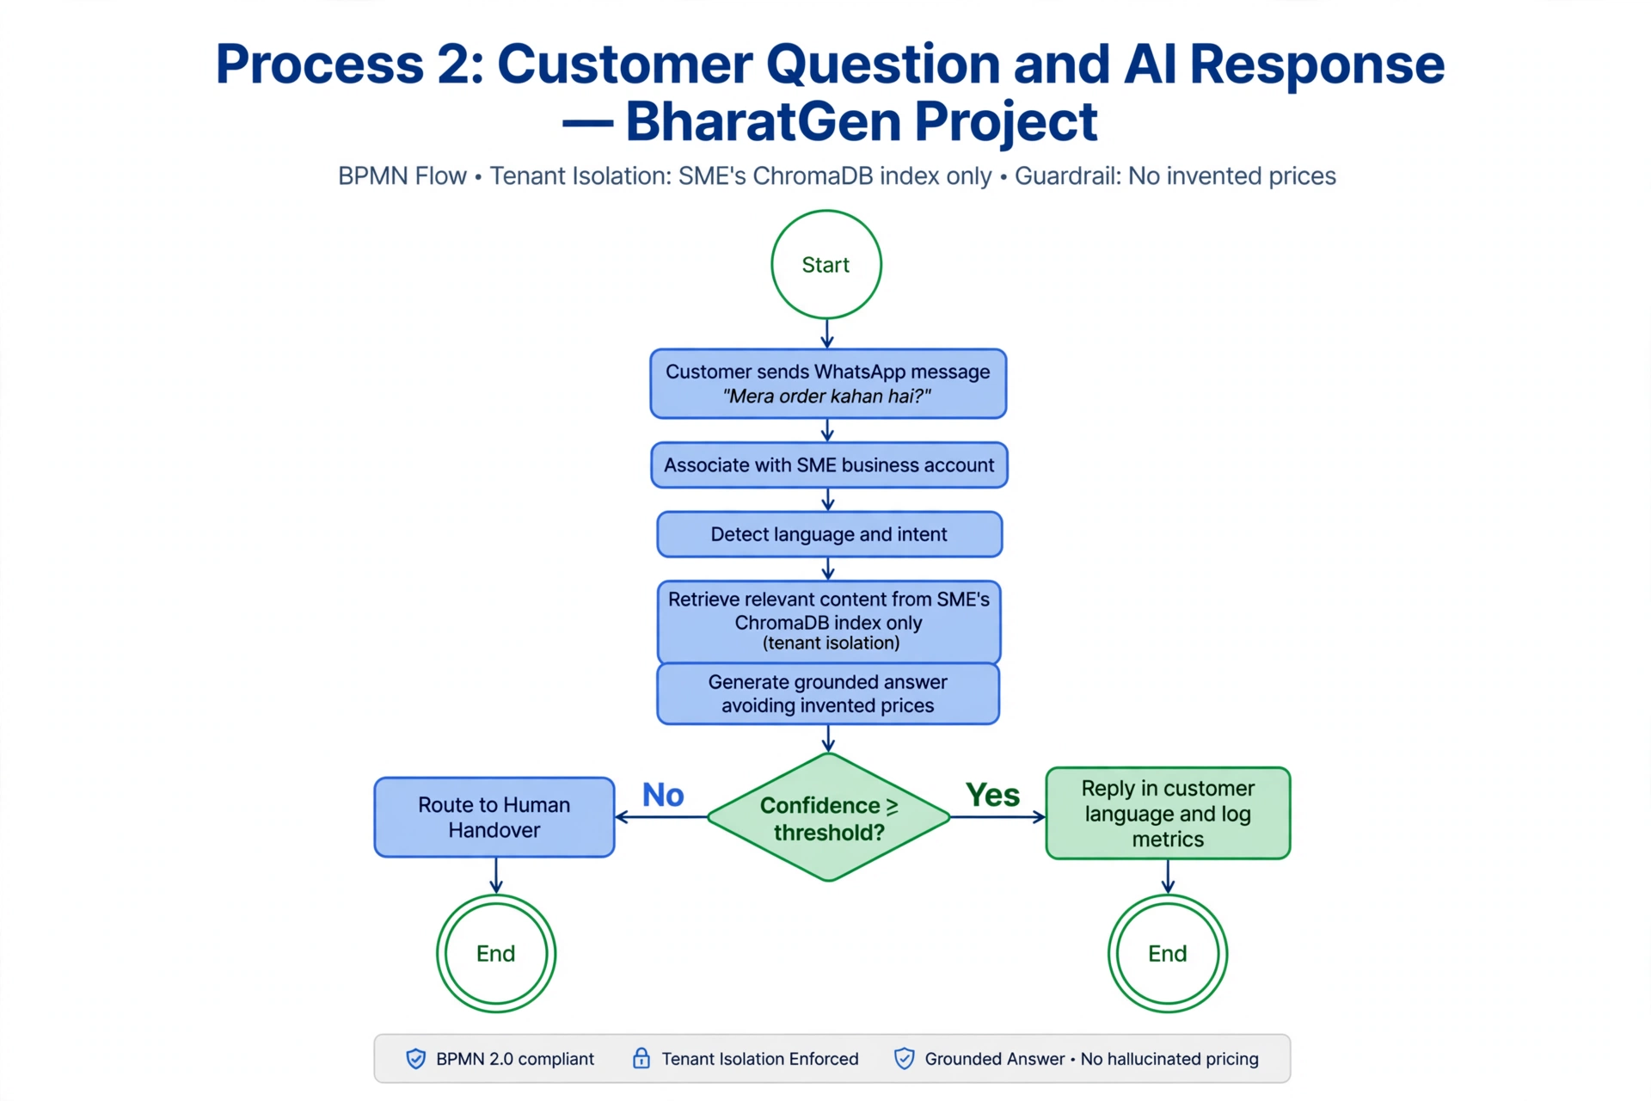

4.1 Purpose and participants
Purpose: respond quickly to customer questions in the customer’s language while grounding answers in the SME’s own information. Participants are the customer, WhatsApp channel, BharatGen application, retrieval system and language model.

4.2 Detailed process
1. Message received: a customer sends a message such as “Mera order kahan hai?” through the SME’s WhatsApp channel. The system associates the message with the correct business account and conversation.
2. Language and intent: the application identifies the likely language and the type of request, for example product information, price, availability, delivery or a policy question.
3. Retrieve relevant content: the RAG pipeline searches the SME’s indexed documents for passages related to the question. Retrieval should use only the relevant business knowledge available to that SME.
4. Generate grounded answer: the model creates a concise answer using the retrieved content. The design should avoid inventing prices, policies or order details that are not present in the source.
5. Confidence gateway: the system checks whether the retrieved evidence and generated answer meet the configured confidence/quality rule. If acceptable, the answer proceeds to the customer. If not, the query is routed to the human-handover process described in Section 5.
6. Reply and log: BharatGen sends the answer in the customer’s language and records appropriate conversation and performance events for operational monitoring, subject to the privacy and retention rules set by the business.

4.3 Inputs, outputs and controls
Inputs: customer message, business identity, indexed SME documents and language/model services. Output: a response grounded in available business information, or a handover when the evidence is insufficient. Controls include tenant separation so one SME’s data is not used for another SME, source-grounding, confidence checks, message-failure handling, rate limits and privacy-aware logging.

4.4 Success measures
- Automation rate: percentage of eligible conversations answered without human intervention.
- First-response time and answer latency.
- Customer satisfaction (CSAT), repeat-contact rate and answer correction rate.
- Grounded-answer rate and rate of unanswered or escalated questions.

5. Process 3 — Low-confidence response and human handover
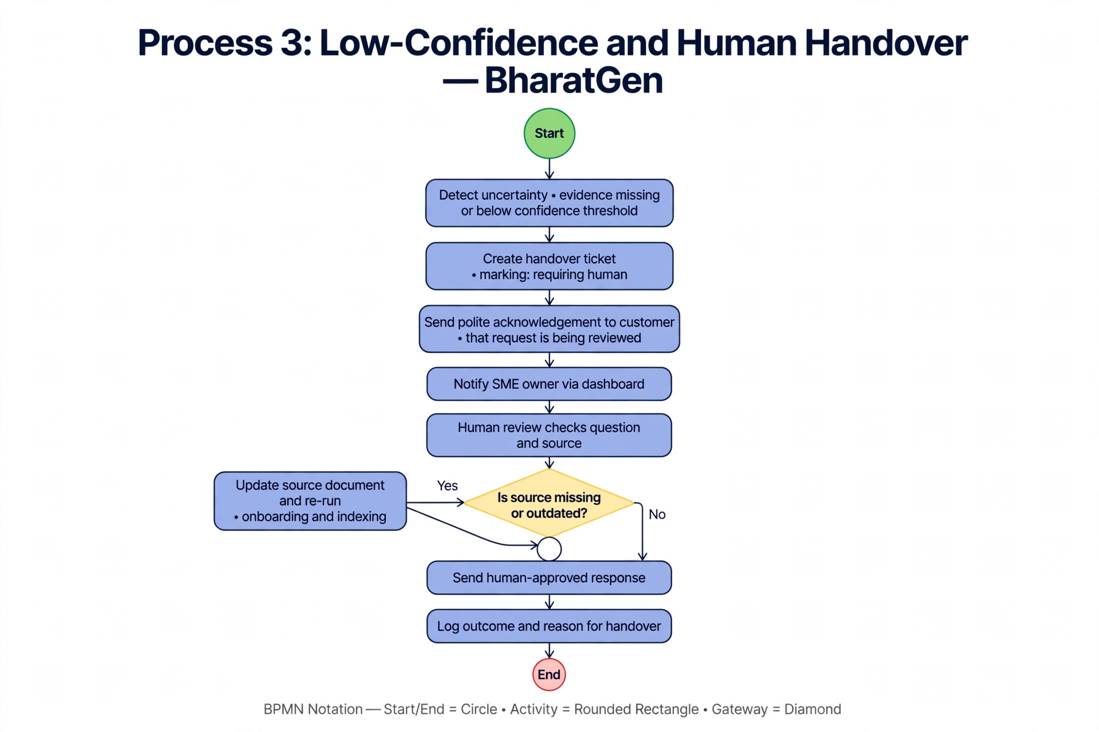

5.1 Purpose
This process prevents BharatGen from presenting uncertain information as fact. It begins when the retrieval step finds no suitable evidence, the answer fails the configured confidence rule, or the question needs human judgment.

5.2 Detailed process
1. Detect uncertainty: the application flags the conversation when evidence is missing, conflicting or below the agreed confidence threshold. The threshold should be tested and tuned rather than assumed to be universally accurate.
2. Create a handover item: the conversation is marked as requiring human support. The customer should receive a polite acknowledgement that the request is being reviewed, instead of a speculative answer.
3. Notify the SME: the owner or support agent receives the question and relevant conversation context through the dashboard or configured notification channel.
4. Human review: the agent checks the original question and the available business source. The agent may answer directly, ask the customer for clarification, or update the source document if the information is missing or outdated.
5. Send and record: the human-approved response is sent to the customer. The case outcome and reason for handover are logged to support auditability and process improvement.
6. Improve the knowledge base: if the issue reveals a missing FAQ or incorrect source, the owner updates the document and re-runs the onboarding/indexing process. The revised knowledge should be tested before it becomes active.

5.3 Exceptions and controls
If no agent is available, the customer should receive a realistic expected response time or an alternative contact route. High-risk requests, complaints, sensitive personal information or requests requiring account-specific verification should be routed according to a documented business policy. Access to conversation history should be restricted to authorized staff.

5.4 Success measures
- Time to human acknowledgement and time to resolution.
- Percentage of escalations resolved within the service target.
- Reasons for escalation, corrected-answer rate and recurring knowledge gaps.

6. Process 4 — Monitoring, feedback and service improvement
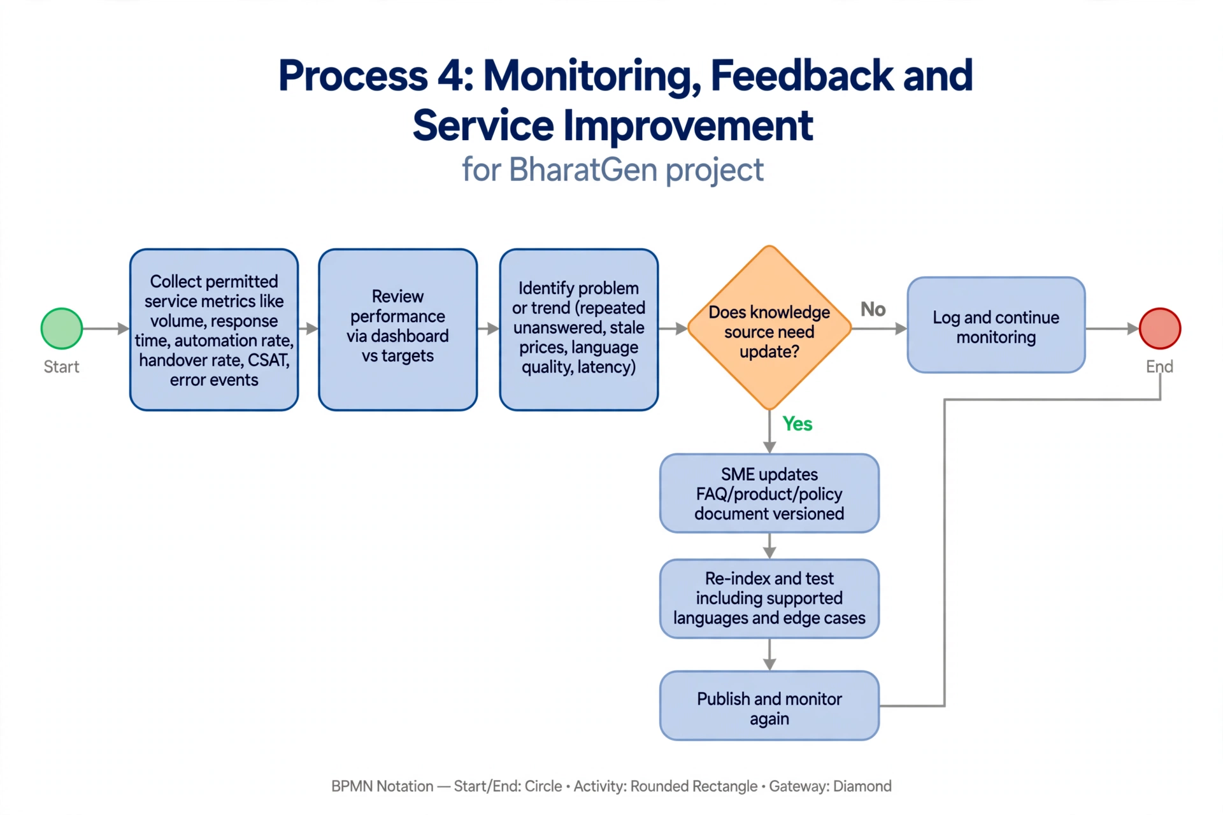

6.1 Purpose and detailed process
BharatGen should use operational data and SME feedback to improve reliability without treating raw metrics as proof that every answer is correct. The process starts with collection of permitted service metrics, including message volume, response time, automation rate, handover rate, customer feedback and error events.
1. Review performance: the business analyst or service owner reviews dashboards at an agreed cadence and compares results with targets.
2. Identify a problem or trend: examples include repeated unanswered questions, poor satisfaction for a language, increased response latency, stale prices or a spike in human handovers.
3. Update the knowledge source: the SME owner corrects or adds the relevant FAQ, product detail or policy. Changes should be versioned and approved.
4. Re-index and test: the system refreshes the searchable index and runs representative test questions, including supported languages and common edge cases.
5. Publish and monitor: once checks pass, the update is made active. Metrics are reviewed again to confirm that the change helped and did not create regressions.

6.2 Key performance indicators
KPI | What it measures | How to use it
Automation rate | Eligible conversations resolved without a human | Track efficiency; investigate unexpected rises or falls.
First-response time | Time from customer message to first reply | Monitor responsiveness and channel reliability.
CSAT | Customer rating or feedback after support | Segment by language and issue type.
Escalation rate | Share of conversations handed to a person | Review causes; a lower rate is not always better if safety worsens.
Answer correction rate | Share of answers later corrected by a person | Use as a quality signal and update test cases.
Knowledge freshness | Age/status of critical source information | Prompt SME owners to review prices and policies.

6.3 Governance
Metrics should be collected only for a clear operational purpose, with access and retention rules defined by the business. Personal data should be minimized in dashboards and test datasets. Any use of customer conversations to improve prompts or knowledge must follow applicable consent, privacy and company policies.

7. Cross-process dependencies and exception handling
- The customer-response process depends on a successfully processed and current knowledge base created during onboarding.
- If the WhatsApp channel or model service is unavailable, the system should return a safe failure message, retry where appropriate, and preserve a case for follow-up rather than silently dropping the query.
- If a customer asks for order-specific status, BharatGen can answer only if a trusted order system or relevant source is integrated and authorized; a general FAQ alone is insufficient.
- Document changes should be versioned, validated and reversible so incorrect information can be rolled back.
- Human handover is a planned part of the service, not a process failure by itself. The objective is safe and useful resolution, not maximum automation at any cost.

8. Risks and recommended mitigations
Risk | Recommended mitigation
Incorrect or unsupported answer | Retrieve from approved SME content, apply confidence checks, test common questions and provide human handover.
Outdated product or price information | Show source version/date, assign ownership and schedule periodic review.
Cross-business data leakage | Separate tenant indexes and permissions; test access boundaries.
Poor extraction from PDFs | Validate extraction, display processing status and let owners replace or correct files.
Language quality varies | Test representative questions in each supported language and review customer feedback by language.
Privacy or retention issues | Minimize personal data, restrict access, define retention and obtain required permissions/consents.
Integration outage | Monitor dependencies, retry safely, log failures and provide a fallback contact route.

9. Implementation priorities
Priority 1 — Establish a reliable happy path: SME upload, document validation, indexing, WhatsApp query, grounded answer and dashboard status.
Priority 2 — Add quality and exception handling: confidence-based human handover, message delivery failure handling and clear customer acknowledgements.
Priority 3 — Add operational visibility: automation rate, response time, CSAT, escalation reasons, and document freshness.
Priority 4 — Validate privacy and security: access controls, tenant isolation, consent/notice, retention policy and review of applicable legal requirements.
Priority 5 — Test before release: create test cases for Hindi, Marathi and other supported languages, ambiguous questions, missing information, outdated documents and service outages.

10. Conclusion
The four process models describe the main operating lifecycle for BharatGen: prepare trusted SME knowledge, answer customer questions using retrieval-augmented generation, hand uncertain cases to a person, and continuously improve the service through measured feedback. The models extend the Week 1 market analysis into an operational view and identify the participants, activities, decisions, outputs, controls and performance indicators needed for a practical service. Before production deployment, the proposed workflows should be reviewed with SME owners and technical stakeholders, then validated against real integrations, privacy requirements and agreed service targets.

Appendix A — Process model overview
Process | Primary output | Owner / main participant
1. Onboarding and knowledge setup | Approved searchable knowledge base | SME owner and BharatGen system
2. Customer question and AI response | Grounded answer or escalation | Customer, WhatsApp channel and AI service
3. Human handover | Human-reviewed answer and case outcome | SME owner / support agent
4. Monitoring and improvement | Updated knowledge and measured service quality | Business analyst, service owner and SME

Reference basis
Primary project context: Week 1 document, “Market Research and Analysis Report — BharatGen: Indic Language AI Support Assistant for Indian SMEs.” This Week 2 report carries forward the project description and technical elements named there, including WhatsApp, RAG, ChromaDB, the document-upload workflow, dashboard monitoring and KPIs such as automation rate, CSAT and cost saved. Process details not specified in Week 1 are presented as proposed assumptions and recommendations for the hypothetical operating model.

