 | Laboratory Assignment Number 2 for ME 218a  Pre-Lab Due by 5:00pm on October 12, 2017  Due by 5:00pm on October 17, 2017
Your Name: Navjot Singh
Part 0: Pre-Lab
Assignment:
❑ | 0.1) | Complete the design requested in Part 1.1.
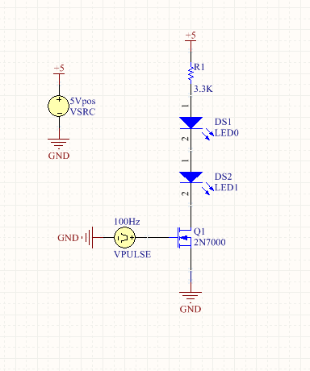
❑ | 0.2) | Explain how you will verify that you have achieved a functional circuit in Part 1.2.
I will verify I have a functional circuit by using the oscilloscope and probing the node between R1 and DS1. Through the voltage at that node (with respect to ground) I can derive the current running through the resistor (Ohms law), which is the same as the current running through the LED’s. (5V – V_measured)/3.3k = i. The V_measured should be the average of the lowest point of the square wave, which would indicate the average high current running through the LED’s. If this is around 0.5mA, then the circuit is working.
❑ | 0.3) | Explain how you will make the measurement requested in Part 1.3
The measurement can be made by zooming into the square wave on the oscilloscope at the point where the state changes from low to high or high to low, as this will be the location where a voltage spice will likely occur, and thus correlate to a peak current. The probing point will be the same as explained in 0.2.
❑ | 0.4) | Complete the design requested in Part 2.1. Focus on circuit topology, not component values.
 |  | 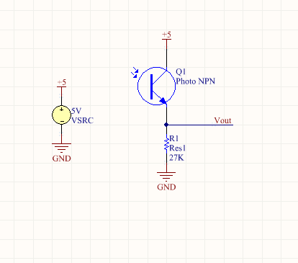
❑ | 0.5) | Complete the design requested in Part 2.4. Focus on circuit topology, not component values.
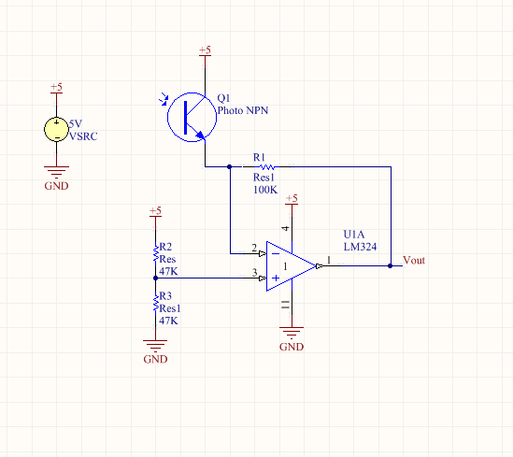
❑ | 0.6) | Complete the design requested in Part 3.1. Focus on circuit topology, not component values.
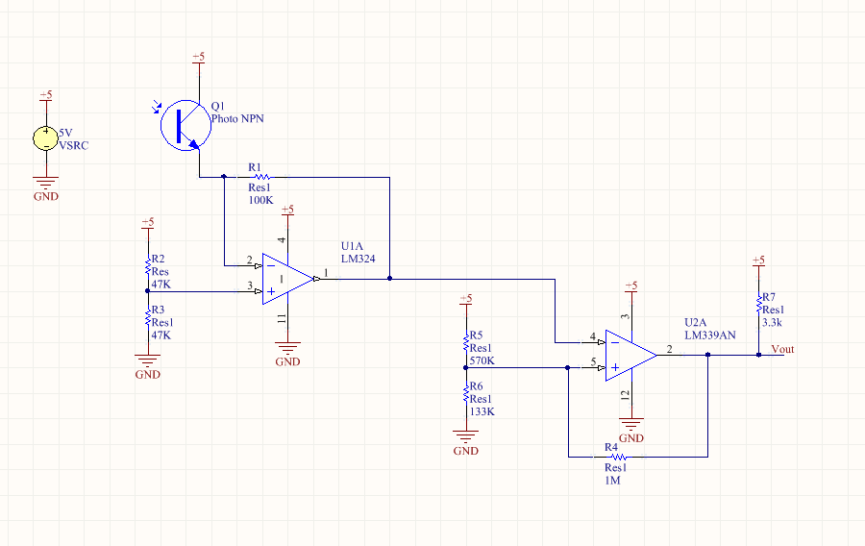
❑ | 0.7) | Log in to your Bitbucket account that you created in Homework 0 and create a new Repository called Lab2.
In the report:
Include your answers to the pre-lab section (corrected, if necessary) as part of your final lab report document.

Part 1: An IR Signal Source
Assignment:
❑ | 1.1) | Design a circuit to use the signal from the Cruve Tracer Board to drive the series combination of an IR LED and a visible red LED with a current of approximately 0.5mA when emitting. Enter your design into Altium. The drive signal will be at a frequency of approximately 1kHz. The output from the Pls output on the Curve Tracer Board swings between 0V and 5V. You should assume that it is capable of sourcing or sinking 0.2mA of current.
❑ | 1.3) | What is the peak current through the IR LED in your actual circuit? (Don't worry, the red LED will be quite dim.)
Peak current = 0.71 mA
❑ | 1.4) | What are the measured rise and fall times (10-90%) of the current through the LEDs?
Current: Fall time = 840 ns Rise time = 800ns
In the report:
Include your design for parts 1.1, the peak current measured from 1.3 and measured rise and fall times from Part 1.4.

Part 2: Capturing a Usable Signal
Assignment:
❑ | 2.1) | Design a circuit to detect IR radiation using the LTR3208E and only passive components. You may leave final value selection until the next step. You should use only a single 5V supply. Enter your design into Altium.
❑ | 2.3) | What are the measured rise and fall times (10-90%) of the output signal from your receiver circuit? Make sure that the ON period of the drive is on the order of 4-5τ or longer and the time scale of the oscilloscope is such that the on time approximately fills the screen.
Voltage: Rise time = 360us Fall time = 340us

❑ | 2.4) | Design a trans-resistive circuit to detect IR radiation using the LTR3208E, an LM324 and passive components. You may leave final value selection until the next step. You should use only a single 5V supply. Enter your design into Altium.
❑ | 2.6) | What are the measured rise and fall times (10-90%) of the output signal from your circuit?
Voltage: Rise = 240us Fall time = 205us
❑ | 2.8) | What are the measured rise and fall times (10-90%) of the output signal from your circuit?
Voltage: Rise = 320us Fall time = 330us
❑ | 2.9) | Design a trans-resistive circuit to detect IR radiation using the QSD2030F photodiode, an MCP6294 and passive components. You may leave final value selection until the next step. You should use only a single 5V supply. Enter your design into Altium.
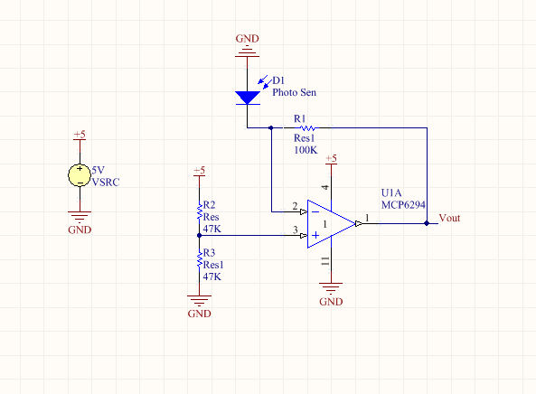
❑ | 2.11) | What are the measured rise and fall times (10-90%) of the output signal from your circuit?
Voltage: Rise time = 6.8us Fall time = 6.5us
In the report:
Include your designs for Parts 2.1, 2.4 & 2.9, the rise and fall times measured in Parts 2.3, 2.6, 2.8 & .2.11

Part 3: Creating a Digital Representation
Assignment:
❑ | 3.1) | Design a circuit to take the output created by your circuit from Part 2.7 and produce a digital output that swings between approximately 0V and 5V. Your design should include hysteresis to insure a clean, noise free transition. You may leave final value selection until the next step. You should use only a single 5V supply. Enter your design into Altium.
❑ | 3.3) | What are the measured rise and fall times (10-90%) of the output signal from your circuit?
Voltage: Rise time = 140ns Fall time = 500ns
❑ | 3.4) | When you are done with your report, create a commit to your Lab 2 repository, push it up to the remote and take a screen shot of the SourceTree window with the Log/History tab selected (Alt-PrtScr) and paste it into your report so that we can see the history of your commits as you worked through the lab.
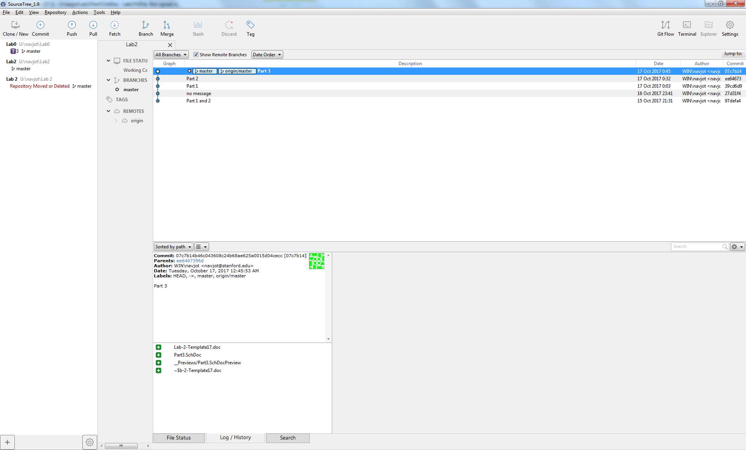
In the report:
Include your design from Part 3.1, the measured rise and fall time from part 3.3 and the screenshot from 3.4.

