**Testing Report:** the manual testing of coding and validations shows that correct data should be entered to create an account.

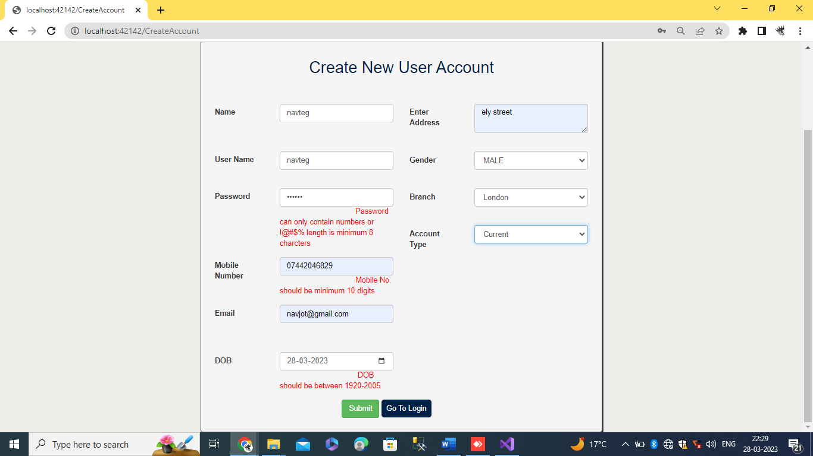

Once sort all incorrectness then user will able to create an account.

