Image showing what final UI should look like –

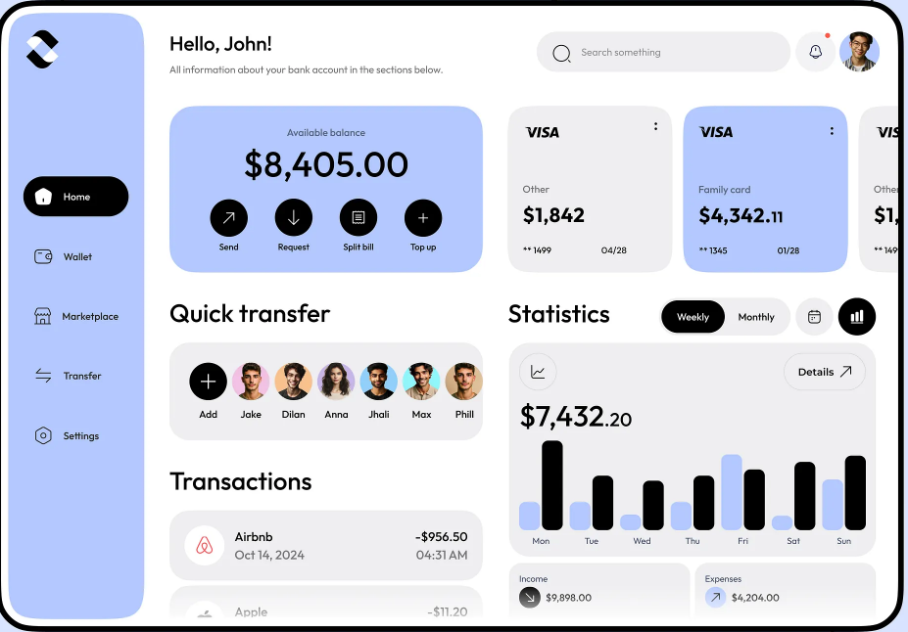

Rest of the context -   
Here’s a **chronological log** of finance saas project so far, combining product strategy (Prompt 1) and the advanced UI/UX prompt (Prompt 2).

**📝 Project Log: Personal Finance SaaS (India) — CSV Upload + Budget Tracker**

**1️⃣ Product Strategy & Workflow**

**You decided to combine:**

* **CSV Upload:** Users import their bank statements (no live bank sync needed).
* **Budget-Based Tracker:** The app analyzes spending and tracks budgets/goals automatically.

**Workflow Steps:**

1. **User uploads a CSV** of their bank statement (via drag-and-drop or file picker).
2. **Mapping UI** lets users align CSV columns (e.g., ‘Txn Date’ → date, ‘Description’ → note).
3. **Backend processes transactions** (normalize amounts, identify accounts, store in Supabase).
4. **Auto-categorization** of transactions (via keyword matching, regex, and possibly ML).
5. **Budget engine** lets users set and monitor budgets (e.g., ₹2000/month for Food).
6. **Visualization dashboard** displays:
   * Donut charts (Spending by Category)
   * Line graphs (Daily balance)
   * Bar charts (Month-to-month comparison)
   * Insights tab (alerts, tips)
7. **Optional premium features** (via Stripe paywall):
   * Multiple bank uploads
   * Export to PDF/Excel
   * Auto-categorization
   * Personalized alerts

Tech Stack :

• **Frontend**: React + TailwindCSS + Framer Motion + Zustand

• **Backend**: Node.js + Express

• **Auth**: NextAuth.js (JWT-based, fully free)

• **Database**: Supabase (PostgreSQL with RLS)

• **CSV Parsing**: Papaparse (client-side)

• **Charts**: Recharts or Chart.js

• **Payments**: Stripe (test/paywall logic included)

**Benefits:**

* Real user data, no Plaid/Setu dependency
* Actionable insights and budgeting
* Monetizable with premium features
* Low onboarding friction

**Extra UX Ideas:**

* Budget suggestions based on patterns
* Smart notifications (“You’ve never spent this much on Zomato before”)
* Weekly email summaries
* “Financial Personality” score

**2️⃣ UI/UX Vision & Implementation**

**You wanted a visually stunning, modern, and animated UI.**  
You provided a reference dashboard image and asked for a prompt to ensure all pages match its style, structure, and color palette.

**Key UI/UX Directives:**

* **Navigation sidebar** with minimalist icons and rounded rectangles
* **Glassy, rounded cards and panels** with soft pastel palette (blues/whites/corals)
* **Large, bold sans-serif headings and numbers**
* **Charts and widgets** (donut, bar, line) styled as in the reference
* **Consistent spacing, ample whitespace, and gentle corner radii**
* **Subtle but “insane” animations and micro-interactions**:
  + Cinematic card/panel entrances (bounce, flip, fade)
  + Animated counters, charts, and tab/page transitions
  + Expressive emoji/Lottie badges, confetti/fireworks on success
  + Hover/focus effects, animated alerts, and celebration banners
* **Responsive design:** Sidebar collapses to mobile nav, cards stack vertically
* **Accessibility:** High color contrast, keyboard navigation, reduced motion option

**Pages Covered:**

* Landing/Dashboard (balance, charts, insights, alerts)
* CSV Upload (drag-and-drop, mapping, progress, confetti)
* Budgets (category cards, sliders, feedback)
* Transactions (table, bulk actions, edit flow)
* Insights (trends, tips, animated charts)
* Settings/Account (profile, theme toggle, Stripe integration)
* Error/404 (cute illustration, animated button)

**3️⃣ Progress Update**

* **Result:** The UI is now ready for the landing page and the home page.

**4️⃣ Next Steps**

* You can now proceed to make other pages and connect backend logic (CSV parsing, budget engine, Supabase integration).
* Implement premium gating (Stripe).
* Polish micro-interactions and test accessibility/responsiveness.

**Summary:**  
You’ve defined a clear, user-focused workflow for a finance SaaS using CSV uploads and budget tracking, and have successfully generated a visually unified, animated UI using v0.dev. You’re now set up for backend integration and feature expansion!

Let me know if you want a more technical implementation plan, code structure, or help with any backend/frontend integration!

for the csv upload based finance saas project, i have completed the landing and home page. What should be my next steps? should I first make other pages or add backend functionality and csv file upload etc. Cuz currently only the ui is there, no functionality