A Data-Grounded Verification Framework for Reducing LLM Hallucination in Accessible Chart-Based Question Answering

Navaneeth
School of Computer Science and Engineering
Vellore Institute of Technology
Chennai, India
navaneeth.2024@vitstudent.ac.in
l
Srihari V
School of Computer Science and Engineering
Vellore Institute of Technology
Chennai, India
srihari.v2024@vitstudent.ac.in

Abstract — Nowadays, Large Language Models (LLMs) are increasingly used by visually impaired users to answer chart-based questions. However, LLMs are susceptible to hallucinations and can portray inconsistencies in the answers provided. In this paper, a solution to this problem is provided. We propose a data-driven anti-hallucination layer that checks every LLM answer before sending it to the user. A deterministic and systematic module derives the true answer from the chart and its data table itself for each question and then using two LLMs (Llama 3.2 3B, run locally, and Gemini Flash-Lite, accessed through an API), the LLM answer is extracted for the same question. Both the answers are then compared using numeric tolerance and fuzzy string matching, with cosine similarity computed only for analysis. If any answer is flagged as hallucinated or inconsistent with the true data, the answer is rechecked with the original value and resent to correct itself. This ensures that no answer goes unchecked or unverified.
This evaluation has been carried out on 200 questions (800 answers). The hallucination rate for Llama 3.2 3B was 59.0% (short answers) and for Gemini Flash-Lite was 3.0% (short answers). The verifier achieved a precision of 0.983 and recall of 1.000 in a human audit, reducing Llama’s hallucinated answers reaching the user from 59.0% to at most 2.0%. Apart from this, a classifier was also used under models such as Logistic Regression and Random Forest, and were explained using SHAP. What was observed was that the classifier without any access to the true values of the chart classified hallucinated answers as correct as well as producing false alarms by classifying right answers as hallucinated. This goes to show that a classifier is not the best approach to this problem as without the true data for reference, the classification cannot replace verification against the data.
Keywords — Large Language Models, Hallucinations, Chart-Based Question Answering, Data-Grounded Verification, SHAP, Accessibility

Introduction
Large Language Models and Artificial Intelligence have grown exponentially in recent years. A lot of our standard tasks now incorporate AI. They are used to answer questions on a daily basis. They're also being used by people who are visually impaired to help them understand and derive information from chart data. Systems such as VizAbility [9] and GeoVisA11y [10] use LLMs to answer chart-based questions for the visually impaired, but they do so without any verification of the answer. One of the drawbacks is that AI tends to hallucinate, making it provide wrong or inconsistent answers. AI used to answer questions via LLMs is prone to hallucination and so this is a major barrier to any inferences or observations that are to be made. The solution to this ongoing problem is to verify the answer against the data itself. By combining a rule-based engine which computes the correct answer directly from the data in the chart with the new intelligence of the LLM, we can ensure that no answer derived from the chart data is left unchecked. We can be sure that the true data is extracted and that the LLM answer is properly scrutinized. This dramatically reduces the chance of hallucinated answers reaching the user.
The whole premise is to create a consistent and reliable experience for the visually impaired, one that will help them achieve their end goal with as little variation as possible. We're in a position where we can leverage the intelligence of the next generation of AIs and LLMs in conjunction with existing technology to create a system that can detect and correct hallucinations in its answers.
The main objectives of this work are as follows:
1. To design a system which will compute the true answer from the chart’s data table.
2. To get answers from the LLMs for the same chart-based questions.
3. To check that the actual answer and the LLM answer are in fact the same. If they are found to be inconsistent then re-verify and re-send the correct answer.
4. To evaluate how effectively this approach detects and corrects hallucinations.
5. To analyze why LLMs behave this way and which factors make hallucination more likely.
We can now build a system that detects and fixes hallucinations in chart-based answers prior to them being presented to the user. The system is evaluated on the ChartQA dataset [12].

Literature Review
The rapid uptake of large language models (LLMs) has made conversational question answering a viable method for accessing information, including information in charts. However, LLMs have been extensively shown to produce fluent but factually incorrect content (commonly referred to as hallucination). Research in this area can be broken down into four broad categories: the nature and classification of LLM hallucination, hallucination in the context of chart understanding, LLM-based chart accessibility systems and verification of LLM-generated chart content. This section reviews 11 papers across these areas and identifies the research gaps that led to the development of the proposed verification layer. Minaee et al. [1] carried out a survey of the major LLM families (GPT, LLaMA and PaLM) looking at the techniques used to build, augment and evaluate them and observed that LLMs are increasingly being used as general purpose task solvers. Huang et al. [2] present a comprehensive survey of hallucination in LLMs, defining it as the generation of content that is plausible but not factually correct. The authors propose a taxonomy of hallucination, examine the causes of hallucination and review the state of the art in terms of detection, benchmarks and mitigation techniques, noting that the issue is a serious one when it comes to the reliability of LLMs in real world information systems. Maleki et al. [3] carried out a systematic review of the definitions of “AI hallucination” across 14 databases and found a significant lack of consistency in the use of the term, calling for a more unified understanding of the phenomenon. A number of studies have looked at the categorization and quantification of hallucination. Rawte et al. [4] profiled hallucination by degree, orientation and category and identified six types, one of which was numeric nuisance (i.e. the model generating incorrect numerical values). They released a dataset of 75,000 samples from 15 LLMs and proposed the Hallucination Vulnerability Index (HVI) to rank the models in terms of their vulnerability to hallucination. Sun et al. [5] looked at 243 instances of distorted information produced by ChatGPT and identified eight first level error types, including mathematical errors, reasoning errors, logic errors and unfounded fabrication. The real-world impact of hallucination was demonstrated by Athaluri et al. [6] who found that of the 178 references generated by ChatGPT for research proposals, 69 had no DOI and 28 could not be found at all. While these studies all confirm that hallucination is both common and multifaceted, they are all focused on the description and measurement of the problem rather than on correcting it at the point of use. Hallucination is particularly problematic in the context of chart understanding where the answers must be strictly consistent with the data in the chart. Wang et al. [7] introduced ChartHal, a fine-grained benchmark that categorizes chart–question pairs into 12 different hallucination inducing scenarios with a human validated dataset of 1,062 samples. Their evaluation of 15 state of the art vision language models revealed a high level of hallucination with even the proprietary models GPT-5 and o4-mini achieving only 34.46% and 22.79% accuracy respectively and the models frequently fabricating content when the question involved information that was not present in the chart or was contradictory. Lim et al. [8] attributed part of the problem to the training data and observed that the existing chart datasets contain captions that cannot be inferred from the chart itself. They introduced ChartCap, a dataset of 565K real world chart images with type specific captions that are derived solely from the chart data itself and showed that models trained on this data produced more accurate captions with fewer hallucinations. These studies improve the way hallucination is measured or reduce it via training but they do not verify individual answers prior to them being delivered to a user. LLMs have also been applied directly to the creation of accessible chart systems. Gorniak et al. [9] presented VizAbility, a system that combines keyboard-based chart navigation with LLM based conversational interaction. The system uses the chart data, the encoding of the chart and the user context along with external web knowledge to answer questions. The system achieved 87.39% query classification accuracy and approximately 76.01% and 81.82% of its line and bar chart responses respectively were rated as “Good” or “Very Good”. Although their prompts were designed to reduce the likelihood of hallucination, the answers were not checked against values derived from the data. Li et al. [10] developed GeoVisA11y, an LLM based question answering system for geovisualizations aimed at screen reader users. In their evaluation 289 of the 345 questions (83.8%) were answered correctly with the remaining incorrect answers being a mixture of LLM hallucinations (e.g. the model falsely claiming a geographic connection). Both of these systems demonstrate the value of conversational chart access but both deliver the LLM’s answer to the user without any independent verification, so a hallucinated answer can reach a user who has no visual means of detecting it. The work most closely related to this study is that of Ashok [11] who proposed a verification framework for LLM generated chart captions. The framework extracts numerical claims from the captions using regular expressions, cross checks them against the data in the chart with a ±2% tolerance and corrects any inconsistencies through a direct substitution or regeneration loop. Experiments on 102 charts from the VisText and PlotQA datasets showed a 22.2% improvement in factual accuracy with high inter-rater agreement (Cohen’s κ = 0.81). However, the framework is only applicable to captions rather than question answering, the evaluation was on a relatively small number of charts and the error rate of the verifier itself is not reported. Several limitations can be identified from the body of work reviewed. First, the existing chart accessibility systems [9], [10] deliver the LLM’s answer to the user without any verification of the answer against the underlying data despite the fact that they have demonstrated that they can produce incorrect and hallucinated responses. Second, the research into hallucination in the context of charts [7], [8] has focused on benchmarking the models or improving the training data rather than on the correction of answers at the point of generation. Third, the hallucination taxonomies [4], [5] describe the types of numeric and reasoning errors but do not provide a mechanism for the detection and correction of those errors in a deployed system. Fourth, the closest verification approach [11] is designed for captions rather than for conversational question answering and the error rate of the verifier is rarely reported. Finally, there is very little in the way of research comparing the degree to which open source and commercial models hallucinate on chart data or in terms of which factors make an answer more likely to be hallucinated. The proposed system tackles these issues via a data-driven verification layer for chart question answering. A rule-based oracle derives the correct answer to each question directly from the data in the chart's table. Each LLM answer is then compared against this oracle answer using numeric tolerance, fuzzy string matching and cosine similarity prior to being returned to the user. Any answer that is determined to be hallucinated is re-prompted with the verified value and re-checked. A template-based fallback is used to ensure that no answer which has not been verified is ever presented to the user. The system is tested with both an open-source model (Llama 3.2 3B) and a commercial model (Gemini Flash-Lite), and the verifier’s own accuracy is assessed via a human audit. Further to this, Logistic Regression and Random Forest models (explained via SHAP) are used to determine which features make an LLM answer more likely to be a hallucination. This work builds upon previous work which has simply described and measured hallucination, to one which verifies and corrects it, thus providing a more robust basis for chart question answering.

Proposed System/Methodology

System Overview
The solution is a verification pipeline placed in between the user and the LLM. The idea here is to make sure the user gets the actual answer rather than hallucinated answers. The true answer is extracted from the charts and its data table. The question is then asked to the LLM and the LLM gives its answer. The verification pipeline then checks if both the true answer and LLM answer match. If they match, the answer is sent to user, and if it doesn’t match, the LLM is re-prompted once with the verified value and the new answer is re-checked; if it still fails, a template answer built from the true value is sent.
In addition, Logistic Regression and Random Forest classifiers, explained with SHAP, are used to analyze which factors make an answer likely to be hallucinated. The system is implemented in Python using pandas, RapidFuzz, Sentence-Transformers, scikit-learn and SHAP, and is organized as a series of Jupyter notebooks backed by shared code modules. The overall architecture of the system is shown in Fig. 1.
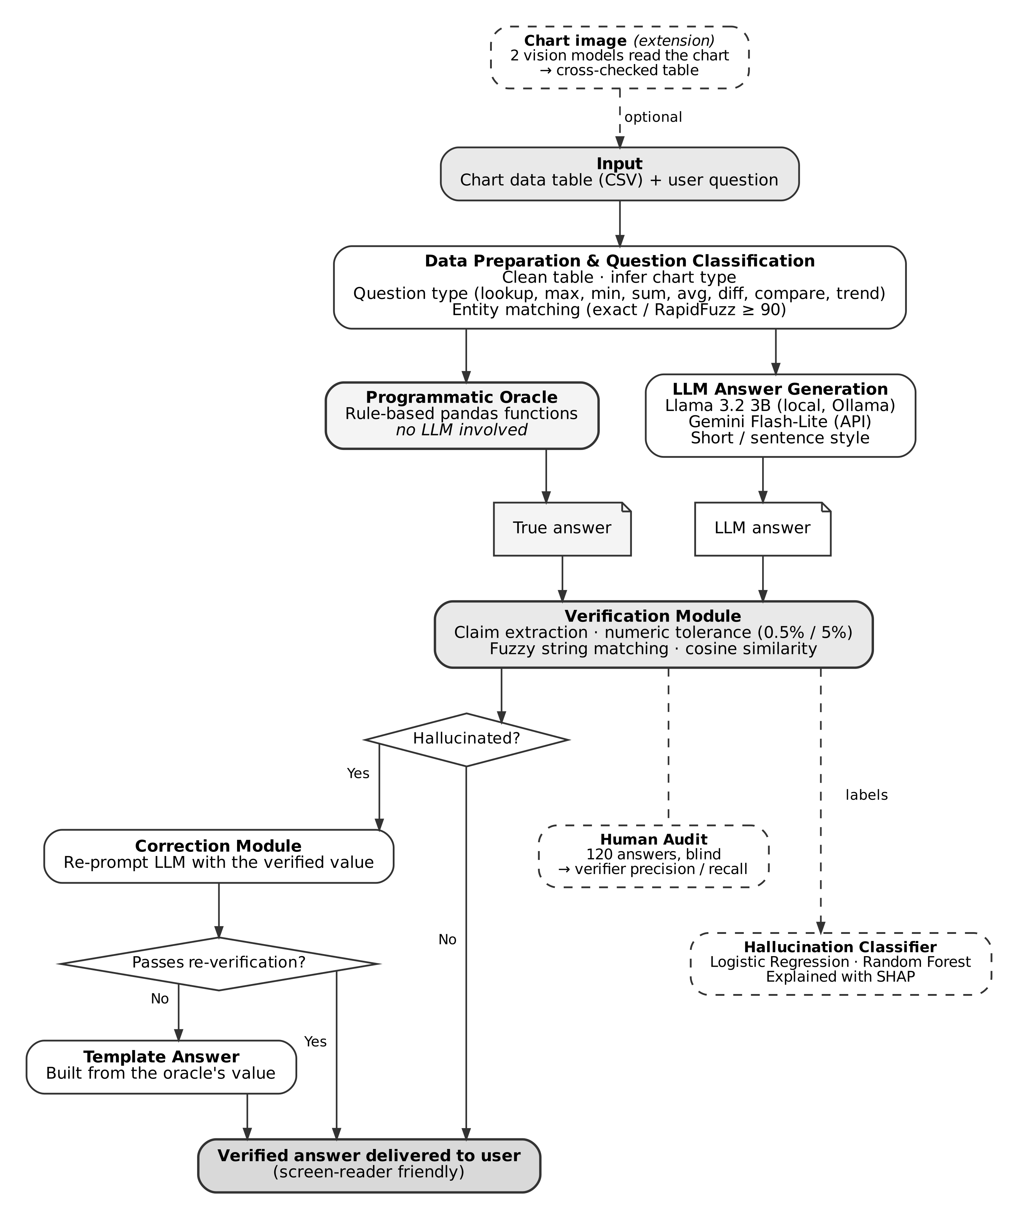
- Architecture of the proposed verification layer. Dashed components denote the evaluation and analysis modules and the optional chart-image extension.

System Architecture

Data Preparation Module:
The system uses the test split of the ChartQA dataset [12] which contains 2,500 question–answer pairs (1,250 human-written and 1,250 machine-generated) and 1,509 chart data tables in CSV format.
- Table cleaning. Each table is cleaned so that formatted values such as “36%”, “$1,200” or “457*” are converted to numbers, with the first column treated as category labels and the remaining columns as data series. Tables that cannot be parsed are logged and skipped, leaving 1,508 usable tables.
- Chart type. ChartQA does not record chart type, so each chart is classified as bar, line or pie from the shape of its table:
  - line: time-based labels with at least five points;
  - pie: a single series of at most eight values summing to approximately 100;
  - bar: all other charts.

Question Classification Module:
Each question is assigned one of eight types using keyword rules: lookup, maximum, minimum, sum, average, difference, comparison and trend.
Questions are excluded when they cannot be answered reliably from the data table alone:
- questions referring to colors (e.g., “the blue bar”),
- questions that count visual elements,
- questions requiring several chained operations.
To locate the rows and columns a question refers to, numeric labels such as years must match exactly, while text labels are matched using RapidFuzz fuzzy string matching with a similarity threshold of 90.

Programmatic Oracle:
The oracle is a set of deterministic, rule-based Python functions that compute the true answer from the data table using standard pandas operations. For example, a maximum question is answered by locating the highest value in the relevant series, and a difference question by subtracting two values. When a question is ambiguous, the oracle refuses to answer rather than guessing.
The oracle was validated against ChartQA’s human-annotated answers using relaxed accuracy, in which numerical answers within 5% of the gold answer count as correct. It answered 1,034 of 1,094 attempted questions correctly (94.5%). Only these validated questions were retained, and a stratified sample of 200 questions was drawn, with at most 45 per question type and a fixed random seed.

LLM Answer Generation Module:
Two LLMs were evaluated:
- Llama 3.2 3B, an open-source model run locally through Ollama;
- Gemini 3.5 Flash-Lite, a commercial model accessed through Google’s API, with the API key read from an environment variable rather than stored in code.
Each model receives the chart type, the raw CSV data and the question, along with a system prompt instructing it to answer using only the given data. Each question was asked in two styles:
- a short answer containing only the value;
- a full sentence suitable for a screen reader.
This produced 800 answers in total. A temperature of 0 was used for repeatability, and every response was cached to disk so that repeated runs make no new requests.

Verification Module:
The verification module extracts the claim made in each LLM answer and compares it with the oracle’s answer.
- Numerical answers.
  - In short answers, the final number is taken as the claim.
  - In sentence answers, the number closest to the true value is selected. Numbers belonging to category labels, age ranges or the question itself are excluded first.
  - The module also handles ratios written as “1:4” or “1 to 4”, unit words such as “million” and “billion”, and numbers written as words.
  - A tolerance of 0.5% is applied to lookup questions, where the value only needs to be copied. A tolerance of 5% is applied to calculated answers.
- Categorical answers. The module identifies which category label the answer names, using whole-word and fuzzy matching.
- Yes/No answers. These are compared directly.
Each answer is assigned one of seven statuses: correct, wrong value, wrong entity, wrong answer type, refusal, unparseable or no answer. Any status other than correct is treated as a hallucination. Cosine similarity between each answer and a reference sentence was also computed using the all-MiniLM-L6-v2 Sentence-Transformers model. It was used as an analytical measure rather than a decision criterion, because it measures wording similarity rather than factual correctness.

Correction Module:
For each answer flagged as hallucinated, the LLM is re-prompted with the original data and question, its previous answer, and the verified correct value, and asked to restate its answer. The new answer is checked again by the verification module. If it still fails, a template answer such as “The answer is 25.” is generated from the oracle’s value. As a result, every answer delivered to the user is either a verified LLM answer, a verified corrected answer, or a template answer derived directly from the data.

Hallucination Classifier and SHAP Analysis:
To analyze which factors make an answer prone to hallucination, Logistic Regression and Random Forest classifiers were trained to predict the verifier’s hallucination label. The classifiers use only information available before an answer is checked:
- the model and answer style,
- the question type and length,
- the chart type and table size,
- properties of the answer, such as its length, whether it contains a refusal or hedging words, and whether it names a category from the chart.
Features derived from the true answer were deliberately excluded, because they would make the classifier simply relearn the verifier’s own rules. Since each question appears in four answers (two models × two styles), the data was split by question into training (70%) and test (30%) sets to prevent leakage, and results were confirmed with 5-fold grouped cross-validation.
Both classifiers use balanced class weights to account for the smaller number of hallucinated answers. A baseline classifier using only the model and answer style was trained for comparison. Predictions were explained using SHAP [13], with TreeExplainer for the Random Forest and LinearExplainer for Logistic Regression.

Chart Image Extension:
To examine cases where only a chart image is available, a preliminary extension was evaluated on 40 chart images:
- Two different vision models (Qwen2.5-VL 3B and Gemma 3 4B) each read the chart into a data table.
- Values on which both readings agree within 5% are marked confirmed; the rest are marked uncertain.
- The oracle and verifier then run on the extracted table.
- Each final answer is labeled verified (all required values confirmed), estimated (at least one uncertain value) or unverified (the oracle could not compute an answer).

Data Flow Description
The data flow of the proposed solution can be described as:
- The charts and their data tables are loaded, cleaned and sorted by question and chart type.
- The actual answers are extracted.
- The same question is sent to the LLM for it to answer.
- The verification pipeline checks if both LLM and true answer match
- If it matches, the answer is sent to the user. But if it doesn’t, then the LLM is re-prompted once with the verified value and its new answer is re-checked.
- If the corrected answer still fails verification, a template answer derived from the oracle is delivered instead.

Evaluation Metrics
The system was evaluated at three levels:
- Hallucination rate: The number of answers that came out as hallucinated or wrong. These answers were sorted by question type and chart type and also by which LLM they hallucinated under.
- Verifier accuracy: There is always a scope for error, even in the verifier. Hence, a human audit was done to make sure the verifier did its job well. The verifier’s precision, recall, false-positive rate and false-negative rate were then estimated from this audit.
- Classifier performance: Evaluation metrics for the classifier include F1-score, ROC-AUC, precision and recall. The classifiers outperformed the baseline but remained much weaker than the verifier. Hence, a classifier alone was not the right approach.

Design Choices and Reproducibility
- It is not possible to use LLMs to extract the true answers as they are susceptible to hallucinations. Therefore, the true answer is always computed by deterministic code.
- The LLM answers are generated with a temperature of 0 and a fixed seed (42) and are cached, making it possible to re-run it multiple times without making multiple calls.
- Llama 3.2 3B is open-source and runs locally on this machine, and Gemini is used within its free tier, reducing the costs.

Implementation and Results

Implementation Environment
The proposed solution was implemented using Python 3.12 in Visual Studio Code. Separate Python notebooks were created at each step, making sure each result was well-defined and documented properly. This was done with the help of packages like pandas, NumPy, RapidFuzz, Sentence-Transformers, scikit-learn, SHAP and Matplotlib. Llama 3.2 3B and Gemini 3.5 Flash-Lite were used to generate answers, and Qwen2.5-VL 3B and Gemma 3 4B for chart-image extraction. All experiments were carried out on a Windows laptop with 16 GB RAM and integrated Intel Arc graphics, and all local models ran on the CPU. To ensure that there was no need to make multiple calls for re-running the system, all the LLM’s responses are cached.

Oracle Validation
Before being used for the verification pipeline, the extracted true answers were cross-verified with ChartQA’s human-annotated answers to make sure answers were extracted correctly. The table shows how many answers were extracted correctly. They are sorted by question type.

- Oracle Precision by Question Type
Question type | Answered | Correct | Precision
Lookup | 824 | 800 | 97.1%
Maximum | 146 | 121 | 82.9%
Difference | 50 | 48 | 96.0%
Minimum | 25 | 22 | 88.0%
Comparison | 17 | 14 | 82.4%
Average | 13 | 12 | 92.3%
Sum | 13 | 12 | 92.3%
Trend | 6 | 5 | 83.3%

Hallucination Rate Before Verification
The table below shows the hallucination rate of each LLM sorted by answer type. It is evident that Llama 3.2 3B hallucinates about 59% of its short answer questions and about 31% of its sentence answer questions. We can see that Gemini, being a widely used commercial LLM, also hallucinates about 3% for short answer questions and 1.5% for sentence answer questions. This goes to show that LLMs are susceptible to hallucinating when answering chart-based questions. As shown in Fig. 3, Llama’s short answers were wrong on 86.7% of difference and 83.3% of average questions, compared with 20.0% of lookups.
- Hallucination Rate Before Verification
Model | Short answer | Sentence answer
Llama 3.2 3B | 59.0% | 30.5%
Gemini Flash-Lite | 3.0% | 1.5%
In most of the cases, the hallucinations were either the number being wrong or the category itself being wrong – a wrong value (73), a number given when a category was asked (22), or a wrong category (18).

Correction Results
Out of the 188 answers that hallucinated, 165 were turned into correct answers upon re-verification with the true answers. All 9 of Gemini’s flagged answers were corrected; the 23 that still failed were all Llama’s. This is where the direct use of true answer table comes in. Since the answers still come up wrong, the pipeline directly sends the true answer to the user.

Verifier Accuracy (Human Audit)
To assess the reliability of the verifier itself we manually labeled 120 answers (60 flagged, 60 passed) without access to the verifier’s decisions. As per Table III the verifier achieved a precision of 0.983, a recall of 1.000 and an F1-score of 0.992 with a false positive rate of 0.005 and a false negative rate of zero.
- Verifier Performance from Human Audit
Metric | Value
Precision | 0.983
Recall | 1.000
F1-score | 0.992
False-positive rate | 0.005
False-negative rate | 0.000
No hallucinations were missed in the 60 audited passed answers. Again as this is a sample the result establishes a 95% upper bound of 4.9% on the miss rate for passed answers rather than proving it to be zero. Applying that bound to each group the estimated residual hallucination rate after verification is at most 2.0% for Llama short answers and 3.4% for Llama sentence answers (see Fig. 2). For Gemini Flash-Lite whose initial hallucination rates were already very low the upper bound of 4.7–4.8% is higher than the actual rate so the audit is too small to demonstrate a measurable reduction for that model.

Cosine Similarity Analysis

For the answers in the form of sentences, the average cosine similarity between the answer and the reference sentence was almost equal in correct and hallucinated cases. For Llama answers, the scores for correct and hallucinated answers were 0.809 and 0.763 respectively, while for Gemini, the correct and hallucinated predictions received the scores 0.813 and 0.842 respectively, having hallucinated answers score even higher than the correct ones. A hallucinated sentence “Database has the lowest market share” is formulated almost the same as the correct answer, which means semantic similarity cannot reliably detect the inaccuracy.

Hallucination Classifier
The table illustrates how the classifiers performed through 5-fold grouped cross-validation, which avoids leakage by keeping all responses to the same question in the same fold. Both the Logistic Regression and Random Forest methods outperformed the baseline model that only used the model and answer style, which means that they managed to learn more than the difference between the two large language models (LLMs). Nonetheless, their precision remained moderate. When tested on the data set reserved for testing, Random Forest produced 22 false alarms and missed 9 of the 51 hallucinations as noted in Fig. 4.
- Classifier Performance (5-Fold Cross-Validation, Mean)
Model | Precision | Recall | F1-score | ROC-AUC
Baseline (model + style only) | 0.448 | 0.955 | 0.609 | 0.850
Logistic Regression | 0.584 | 0.854 | 0.692 | 0.908
Random Forest | 0.682 | 0.727 | 0.701 | 0.913
SHAP analysis provided in Fig. 5 indicates that the model used was the most important factor causing hallucinations, with answers from Llama 3.2 3B being most amenable to hallucination. This was followed by answering a “which” question with a number instead of a name of the category; failure to name any category from the chart; giving short answers, and asking a difference question with lookup questions being associated with the lowest degree of risk. For comparison, a classifier given features computed from the true answer reached an F1-score of 0.98 and an ROC-AUC of 1.00, but it was excluded because it simply reproduces the verifier’s decisions.

Chart Image Extension (Preliminary)
In terms of interpreting the 40 charts, Qwen2.5-VL 3B registered an accuracy rate of 96.6%, whereas with Gemma 3 4B it was at 65.3%. It is worth noting that the values confirmed by both models turned out to be true in 99.3% of the cases examined (285 values), with only 2 values misread identically by both models. The comparison shown in Table V helps evaluate how the vision model performs in comparison to the entire verification layer.

- Chart Image Results (40 Questions)
 | Wrong answers | Confidently wrong
Vision model alone | 12.5% | 12.5%
With verification layer | 5.0% | 2.5%
22 out of the 23 answers labeled verified were confirmed correct, only one of them differing from the actual value by 0.8%. It should be mentioned that the results are to be treated as preliminary as the rules governing table-reading were improved when working on these charts.

Overall Evaluation
According to the results, smaller models of LLMs often tend to give rise to hallucinations when it comes to providing answers for questions for charts and graphs and most of the errors caused by the hallucinations has been observed in the calculation-based questions. The validation layer that has been proposed in this case has been able to detect the hallucinated answers with precision and recall measures of 0.983 and 1.000, respectively. In the case of the model of the Llama version 3.2 with 3B, the number of hallucinated answers have been reduced from 59.0% of the total answers given out for the user to at most an estimated 2.0% of the total answers given out.
Despite the efficiency achieved through the proposed measures, there are still some limitations within the approaches involved:
- One of the weaknesses of the approach is that it requires data table of the chart.
- The approach is only useful in case questions fall into the type computed by the oracle.
- The evaluation was conducted on a sample of 200 questions from one dataset with two different LLMs.
Given all those limitations, it should be noted that grounding the answers is a reliable and clear solution to answer the chart-related questions.
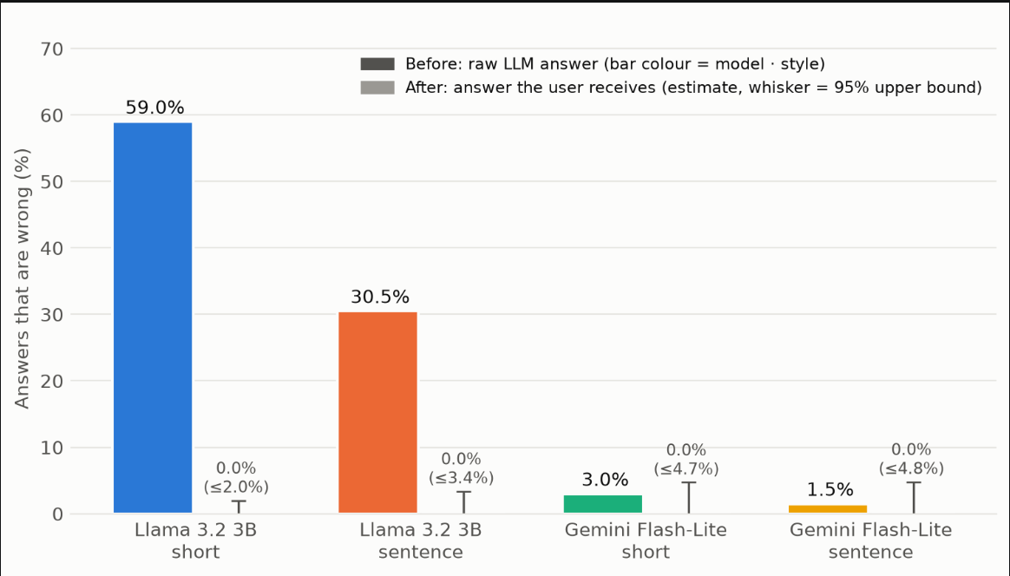
- Hallucination rate before and after verification (bar color = model and answer style; whiskers show the 95% upper bound after verification).
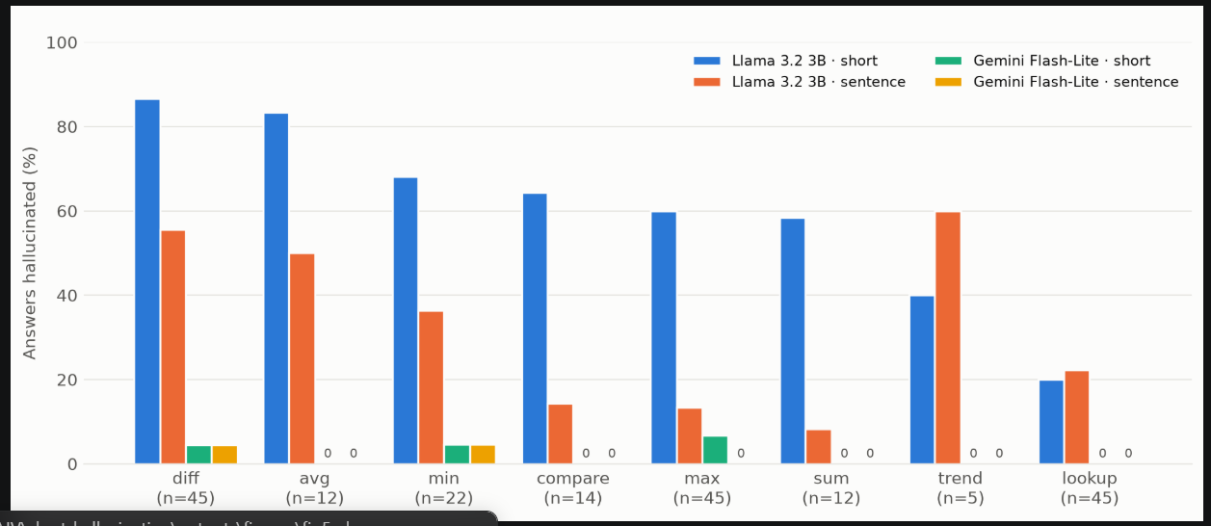
- Hallucination rate by question type before verification.
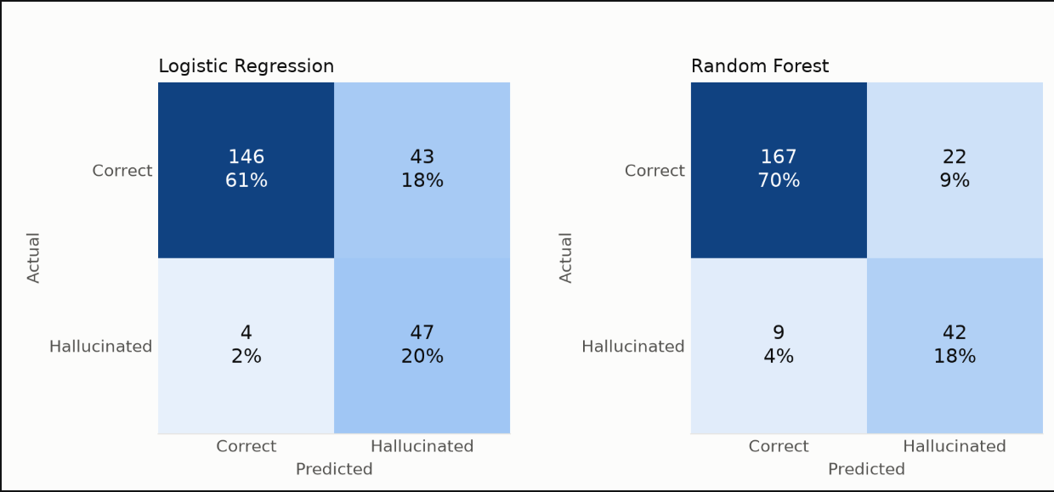
- Confusion matrices of the hallucination classifiers on the test set (240 answers).
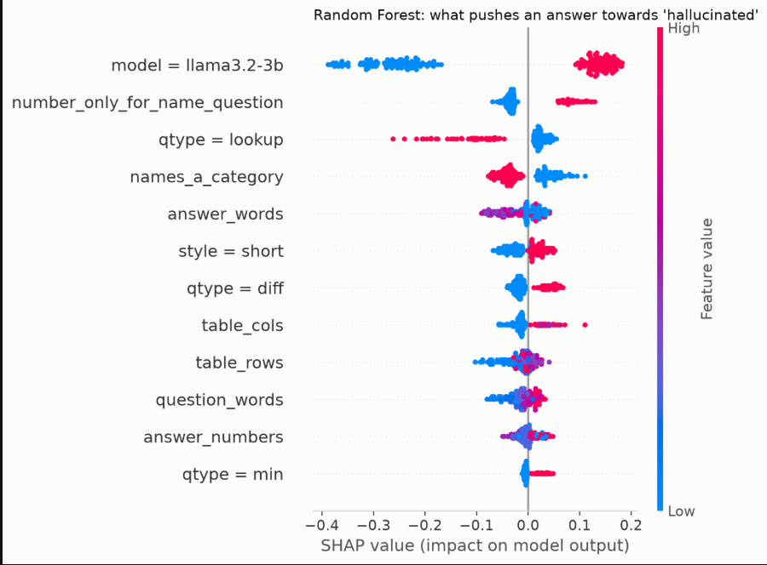
- SHAP summary for the Random Forest classifier.
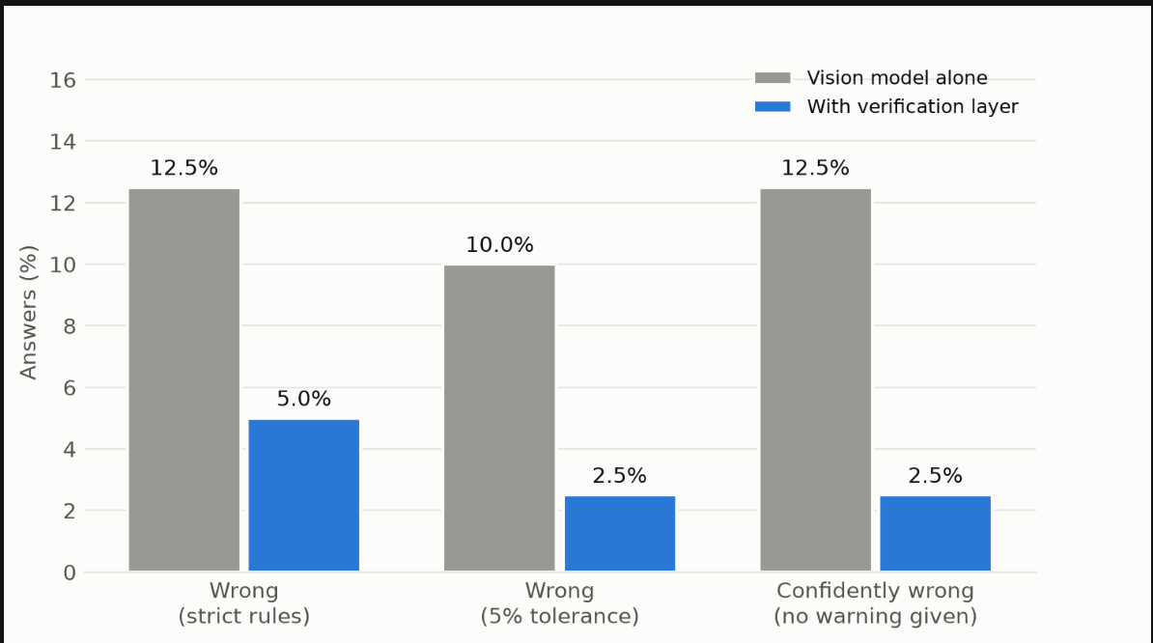
- Chart images: vision model alone vs. with the verification layer (40 charts).
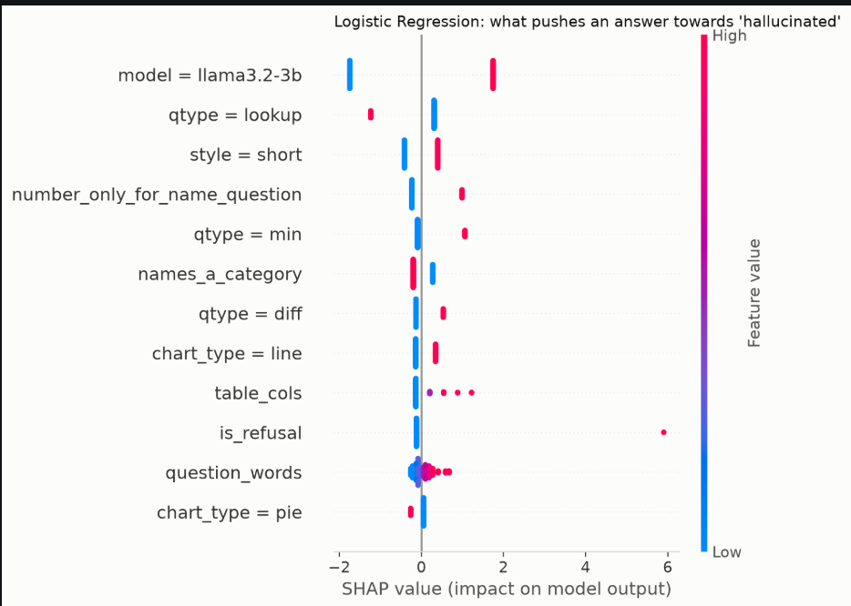
- SHAP summary for the Logistic Regression classifier.
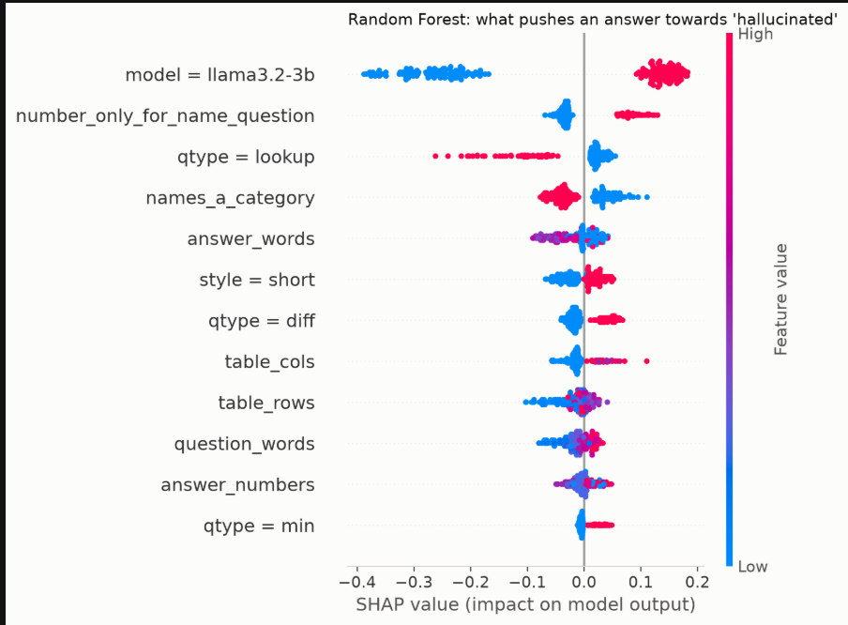

Discussion and Analysis

Comparative Analysis
Previous efforts in the field of hallucinations in chart comprehension have concentrated largely on identifying the issue or attempting to minimize it through training. Existing benchmarks like ChartHal [7] reveal how frequently vision-and-language models provide false responses to chart-related queries, and databases like ChartCap [8] mitigate hallucinations through training on better and more accurate chart-aware descriptions. While the aforementioned methods are effective and applicable to real life, they do not provide any feedback on the reliability of the generated response. Some methodologies use another LLM to assess the generated answer, while others rely on checking for semantic similarity between the outputs; unfortunately, both of these methodologies share a common flaw: the checking mechanism is also open to making a mistake. Our findings confirmed it: cosine similarities of correct and hallucinated phrases turned out to be almost indistinguishable. In contrast, the proposed system verifies each answer after generation against values computed by deterministic code, so it needs no retraining and every decision can be traced to a value in the data table.

Evaluation of Results
The assessment shows that the checking layer works reasonably well for catching hallucinations and cleaning them before they reach the user. When the oracle was compared to human annotations, its precision rate amounted to 94.5%. The verifier showed the precision rate of 0.983 and recall of 1.000 in the human audit. In terms of the Llama version 3.2 3B the layer drove down the instances of hallucinated replies reaching the users from 59.0% down to 2.0% maximum in the case of short replies and from 30.5% to 3.4% for full sentences. The findings help explain their source. The majority of mistakes occurred in the calculation-type questions (for instance, in the case of differences and averages), while lookup questions were answered much better. This indicates that small LLMs are able to extract data from the table correctly, but they are poor at making conclusions based on this data, which is exactly where the check helps the most. Gemini Flash-Lite was able to hallucinate fewer times, but the audit was too small to demonstrate a measurable reduction, which implies that the most pronounced effect of the layer is observed with smaller models operating locally. The classifier results point to the same tendency but from a different angle: although the Random Forest achieved an ROC-AUC of 0.913, it still produced 22 false alarms and missed 9 hallucinations, showing that predicting hallucinations without the data cannot replace verifying answers against it.

Advantages and Innovations
The main strength of the proposed system is that its verification is deterministic. Since the oracle is based on rules and not on some other LLM, it yields the same results consistently and does not produce hallucinatory content; moreover, if a question is ambiguous, the oracle will not answer at all instead of risking this ambiguity by providing an approximate answer. The proposed system is also highly transparent, as every time an answer is flagged, it can be easily traced to a specific value to which the answer has been checked and thus it can be clarified why exactly the answer was refused. Our solution is also entirely model-agnostic, as it can use both a local model as well as a cloud API, thus avoiding the need for re-training the model for its use. Finally, we enhance the reliability of our method at the correction stage by re-providing the value to the model once again, and if the model fails again to provide a correct answer, we can simply employ a template answer based on what the oracle suggested. The SHAP-explained classification model adds to the solution by providing information about the types of questions and answers that are most often subject to hallucinations. Moreover, the chart-image module shows that the technique is transferable to charts that are provided only as images, whereby the two vision networks check each other’s perception of inputs and label the answer in the three categories of verified, estimated, and unverified. Thus, collectively, these properties establish a strong potential of the system for applications of accessibility since visually impaired users rely completely on the information they receive in regard to the chart.

Challenges and Limitations
Despite being promising, there are some drawbacks to note. The main verification system depends on the access to the chart’s underlying data table, which is often not available. The oracle also has only eight types of available queries and does not accept more complex requests such as questions regarding color or complicated reasoning chain. In this paper, we have worked with two LLMs and have examined 200 questions from one data set only, so the findings may not apply to different data sources or models. The audit of the model consisted of 120 answers which is enough to define an upper bound on the verifier’s miss rate, but too small to show a reduction for models that rarely hallucinate. Additionally, the types of charts were determined based on the shape of each data table rather than the dataset’s labels. The outcomes from the chart-image need to be taken with caution because the rules for table parsing were made more precise when working with 40 charts that were also used for testing. Moreover, vision models proved to be very slow when processed on the CPU, taking between 42 and 78 seconds per chart. This slow down makes the use of the technology in real-time not effective. Future work will test the image extension on new charts, extend the oracle by adding more types of questions, and check the system against larger samples and different datasets.

Summary of Findings
To summarize, the new system provides a solution for detecting and correcting hallucinations in chart question answering tasks. Every response produced by the LLM is verified against a value directly derived from the data contained in the chart. The system has high performance in terms of the identification of hallucinations (both precision and recall) and has decreased the amount of hallucinated responses received by the user in the case of the small model, with most of the flagged responses corrected while providing data-driven fallback for the rest. The results show that utilizing semantic similarity and classifiers cannot be sufficient to conduct data-based verification. Hallucinations also happen mostly when the answers require calculations. Thanks to combination of methods like deterministic verification accompanied by transparent correction and extension for images of charts, the system is able to contribute towards a practical solution that provides an explainable foundation for accessible chart question answering.

Conclusion and Future Work
This work describes a verification layer that reduces hallucination in LLM-based chart question answering by having a verifier check every answer against a value computed directly from the chart data. Rather than have the LLM or some other model judge the output, the system uses a deterministic rule-based oracle to compute the correct answer. The verifier then compares the LLM’s answer against the oracle value using a numeric tolerance and fuzzy label matching. If a hallucination is detected it is corrected via a re-prompt to the model or a fallback to a template answer. On 200 questions from the ChartQA dataset the oracle achieved 94.5% precision against human annotations and the verifier achieved 0.983 precision and 1.000 recall in a blind human audit. For Llama 3.2 3B the layer reduced the rate of hallucinated answers getting to the user from 59.0% to a maximum of around 2.0% and the vast majority of answers that were flagged as hallucinated were successfully corrected. The results also show that hallucinations are concentrated in the questions that require calculation, that semantic similarity is not able to tell the difference between a correct and a hallucinated answer and that a classifier which is trained to detect hallucinations without access to the data cannot in fact replace verification against the data. A preliminary extension to the chart images shows that cross checking two vision models can make the approach work even when the underlying data table is not available. The approach is model agnostic, runs on a standard laptop without a GPU and explains every decision it makes so it provides a very practical basis for trustworthy chart question answering, particularly for the visually impaired who are completely reliant on the answer they get.
There are still a number of avenues for future work. The chart image extension will be assessed on a held out set of charts (the results we've seen so far were obtained on the same charts that we used to refine the table parser). The oracle will be expanded to handle more question types (e.g. counting, multi-step reasoning, questions involving multiple data series). The system will be evaluated on larger samples, other LLMs and other chart datasets to test whether the results generalize. The human audit can be scaled up by combining a larger fixed sample with automated checking and disagreement triage to give us tighter bounds on the verifier’s miss rate. For accessibility we could extend the system to include speech input and speech output so that users could ask questions about a chart and have the verified answers spoken back to them and we could also look at faster vision models to get image based verification much closer to real time.
Overall this work demonstrates that grounding the LLM's answers in verifiable data rather than just going with the model’s output is an effective and explainable way of making conversational chart question answering more reliable and more accessible.

References
- S. Minaee, T. Mikolov, N. Nikzad, M. Chenaghlu, R. Socher, X. Amatriain, and J. Gao, “Large language models: A survey,” arXiv:2402.06196, 2024.
- L. Huang, W. Yu, W. Ma, W. Zhong, Z. Feng, H. Wang, Q. Chen, W. Peng, X. Feng, B. Qin, and T. Liu, “A survey on hallucination in large language models: Principles, taxonomy, challenges, and open questions,” ACM Trans. Inf. Syst., vol. 43, no. 2, Art. no. 42, Jan. 2025, doi: 10.1145/3703155.
- N. Maleki, B. Padmanabhan, and K. Dutta, “AI hallucinations: A misnomer worth clarifying,” arXiv:2401.06796, 2024.
- V. Rawte, S. Chakraborty, A. Pathak, A. Sarkar, S. M. T. I. Tonmoy, A. Chadha, A. Sheth, and A. Das, “The troubling emergence of hallucination in large language models – An extensive definition, quantification, and prescriptive remediations,” in Proc. Conf. Empirical Methods Natural Lang. Process. (EMNLP), 2023, pp. 2541–2573.
- Y. Sun, D. Sheng, Z. Zhou, and Y. Wu, “AI hallucination: Towards a comprehensive classification of distorted information in artificial intelligence-generated content,” Humanit. Soc. Sci. Commun., vol. 11, Art. no. 1278, 2024, doi: 10.1057/s41599-024-03811-x.
- S. A. Athaluri, S. V. Manthena, V. S. R. K. M. Kesapragada, V. Yarlagadda, T. Dave, and R. T. S. Duddumpudi, “Exploring the boundaries of reality: Investigating the phenomenon of artificial intelligence hallucination in scientific writing through ChatGPT references,” Cureus, vol. 15, no. 4, Art. no. e37432, Apr. 2023, doi: 10.7759/cureus.37432.
- X. Wang, Y. Cui, X. Yao, S. Wang, G. Hu, and X. Qin, “ChartHal: A fine-grained framework evaluating hallucination of large vision language models in chart understanding,” arXiv:2509.17481, 2025.
- J. Lim, J. Ahn, and G. Kim, “ChartCap: Mitigating hallucination of dense chart captioning,” arXiv:2508.03164, 2025.
- J. Gorniak, Y. Kim, D. Wei, and N. W. Kim, “VizAbility: Enhancing chart accessibility with LLM-based conversational interaction,” in Proc. 37th Annu. ACM Symp. User Interface Softw. Technol. (UIST), 2024, doi: 10.1145/3654777.3676414.
- C. Li, R. Y. Pang, A. Chheda-Kothary, A. Sharif, H. Assalif, J. Heer, and J. E. Froehlich, “GeoVisA11y: An AI-based geovisualization question-answering system for screen-reader users,” in Proc. CHI Conf. Human Factors Comput. Syst. (CHI), Barcelona, Spain, 2026, doi: 10.1145/3772318.3790334.
- T. T. Ashok, “LLM-powered chart captioning and insight generation: Towards trustworthy visualization narratives,” TechRxiv preprint, Oct. 2025, doi: 10.36227/techrxiv.176070670.04768024/v1.
- A. Masry, D. X. Long, J. Q. Tan, S. Joty, and E. Hoque, “ChartQA: A benchmark for question answering about charts with visual and logical reasoning,” in Findings Assoc. Comput. Linguist. (ACL), 2022, pp. 2263–2279.
- S. M. Lundberg and S.-I. Lee, “A unified approach to interpreting model predictions,” in Adv. Neural Inf. Process. Syst. (NeurIPS), 2017, pp. 4765–4774.

