Contents

General 2

Setup 3

Watch 5

Bootstrap 6

# General

<https://github.com/jmcooper/angular-fundamentals-files/>

<https://jcoop.io/angular-2-practice-exercises/>

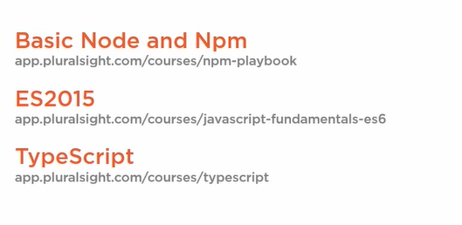

# Setup

Before installing Angular 2 you will require to install

* **Node and NPM**

Angular uses NPM ([Node Package Manager](https://www.tutorialsteacher.com/nodejs/what-is-node-package-manager)) to install libraries, packages and also to execute scripts. Install Node.js and NPM on your local machine.

1. Download the node js and run the setup ( <https://nodejs.org/> )

**Or**

1. Download the NVM ( Node version Manager) and run the setup   
   ( <https://github.com/coreybutler/nvm-windows/releases> )
2. use nvm install 14.16.0
3. then nvm use 14.16.0

Angular requires NPM v6.11 or later (update the version using

npm install -g npm )

* **Angular CLI**

After installing Node.js and NPM, install the Angular CLI.

Angular provides many libraries and packages for application development. You can install libraries required for your application using Angular CLI (Command Line Interface). Angular CLI is also used to generate, build, run, and deploy Angular application.

Use npm install -g @angular/cli

Angular CLI use Package.json in your application to install all the necessary libraries and packages for your application, including the required Angular framework libraries.

npm uninstall -g angular-cli ----or---  
npm uninstall -g @angular/cli  
npm cache clean –force

* **Visual Studio Code**

Visual Studio Code for Angular application development.

To open Use code .

* **Starting Up**

1. npm install -g npm
2. npm install -g @angular/cli or npm install -g @angular/cli@11.2.3
3. ng new myAppName
4. Some times will require to del existing node_modules and run npm install

* **Build/Run Application**

1. ng server –o / ng serve -open
2. npm start

# Watch

1. npm install npm-watch
2. now open package.json and inside script object insert below:

"watch": "npm-watch",

1. Now insert a new object anywhere in your package.json file.

"watch": {

"build": {

"patterns": [

"src"

],

"extensions": "js,jsx"

}

},

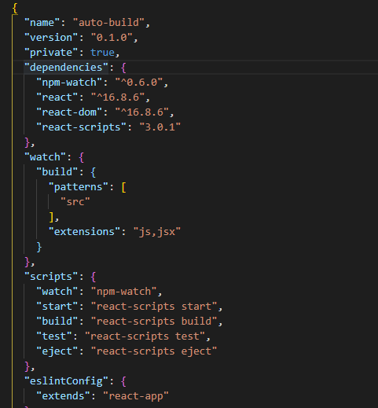

# Bootstrap

npm install ngf-bootstrap –save

# App Bootstrapping

Bootstrapping begin from main.ts (is loaded by webpack) which is configure in angular.json under build/options and this is used by webpack config for our site

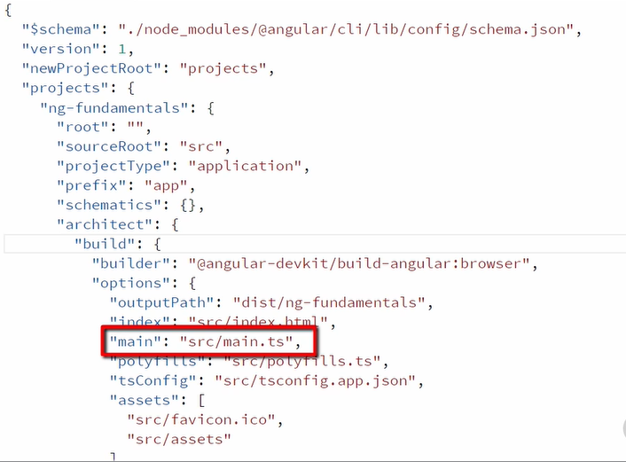

And in main.ts we are bootstrapping AppModule

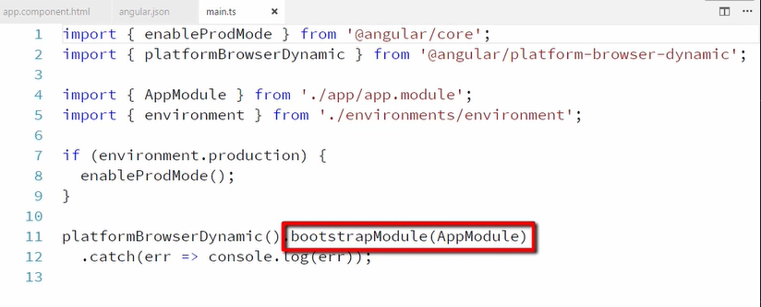

And out AppModule has app Component which is configured in app.component.ts

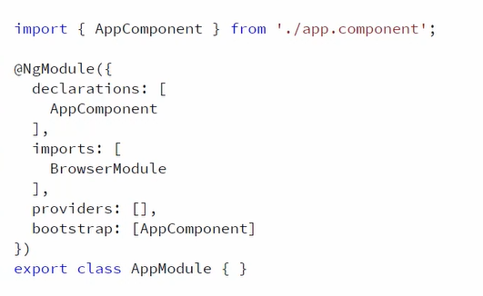

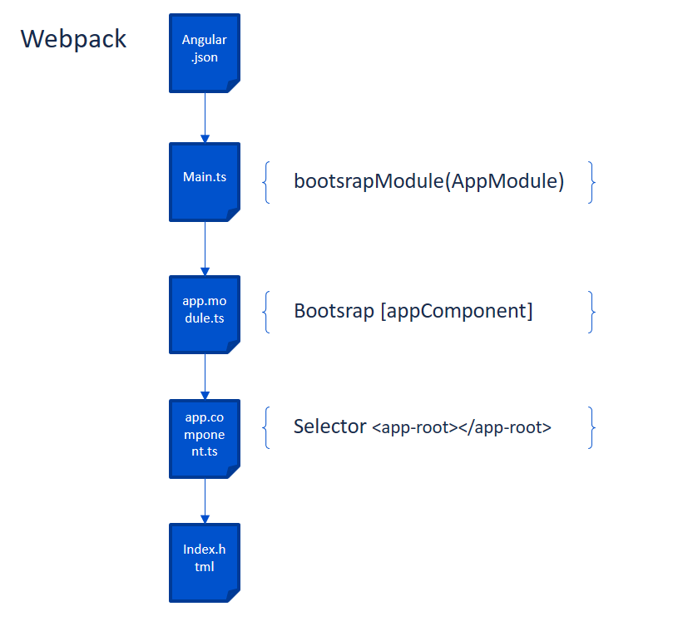

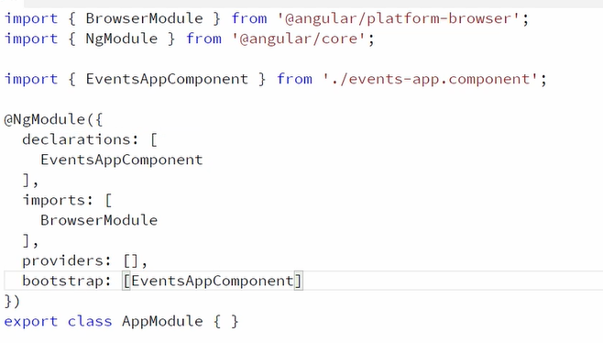

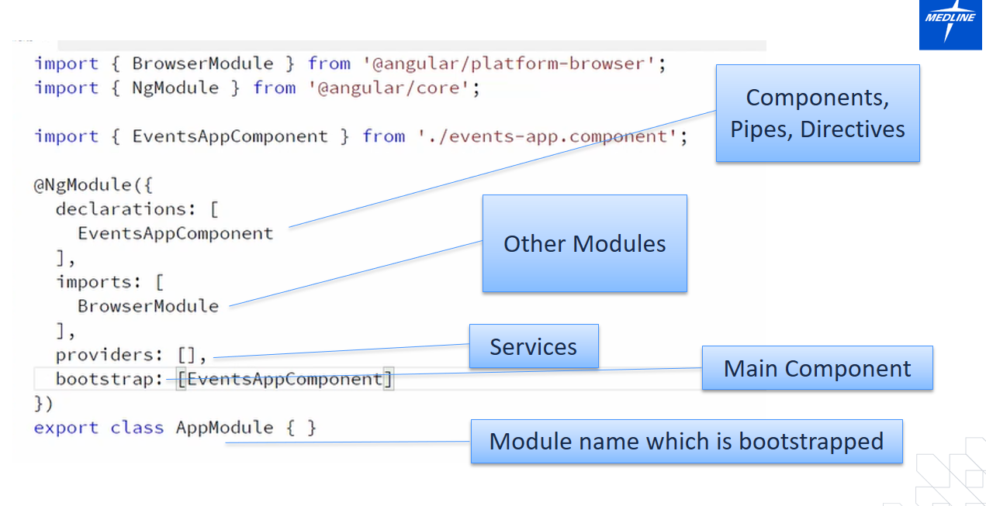

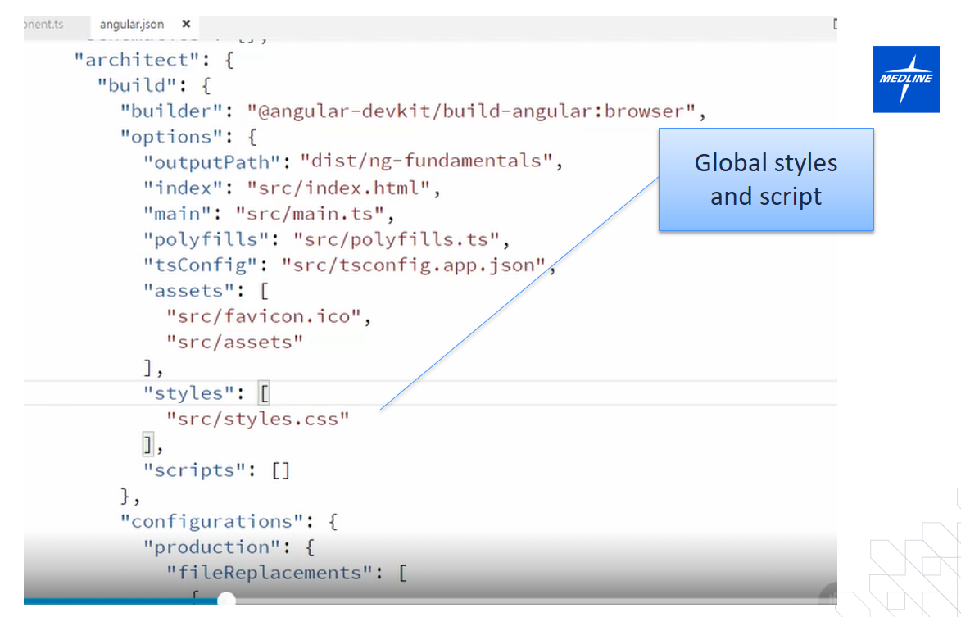

Other third party or common files can be added here

