**Components:**

Creating new

ng generate component <name>

Syntax

|  |
| --- |
| import { Component } from '@angular/core';  @Component({  selector: 'app-component-overview',  templateUrl: './component-overview.component.html',  })  export class ComponentOverviewComponent {  } |

Basic Component

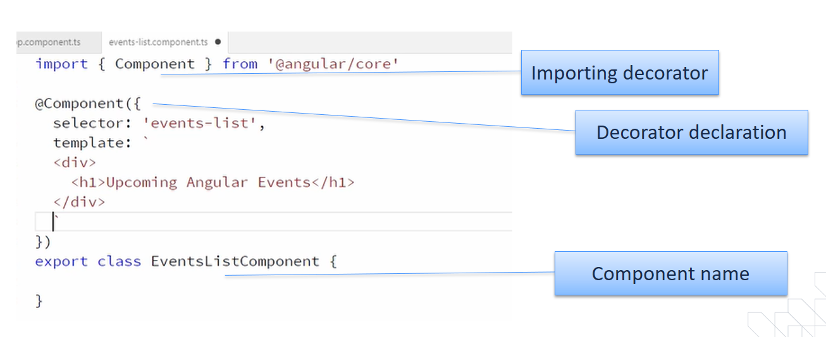

Now register the newly created component in module under declaration and import

