***Introduction :***

Now a days what you are doing in online , everything is on cloud.

What is cloud?

Someone will day it is widely distributed , someone will say it is purely network based because one system is connecting with through network so that we are gathering the information , storing the information through the network , Someone will say cloud computing is itself is a storage this is also correct why because we are storing lots of data , retrieving lots of data , whatever you want to store we can store it n the cloud , Now we will see the exact definition of cloud ?

Cloud is nothing but using someone else’s server to host, to process, or to store data is called cloud.

With the help of the cloud you are storing the data , not in your system , if you are storing the data in your system , your system capacity is very less when compared to the cloud , if you want to store the large amount of data .

Let’s see you are using tablet, mobile, laptop. With the help of these you are accessing cloud through internet as shown below.

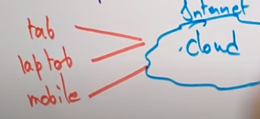

We are having some cloud providers.

The internet will be accessing the cloud providers like amazon , google,Microsoft who will provide there server to store the data.

Hence cloud providers will have the servers where the customers can store their data on their servers.

With the help of cloud providers we want to access different services , what are those services SaaS (Software as Service), PaaS (Platform as a Service),IaaS(Infrastructure as a service).

These are the services provided by the cloud providers for the customers.

Suppose the users want to use SaaS (Software as a service ) , means they want to download some softwares with the help of the cloud.

With the help of Cloud providers they are asking platform as a service (PaaS).

Now we will see how the cloud computing evolved around the Years .

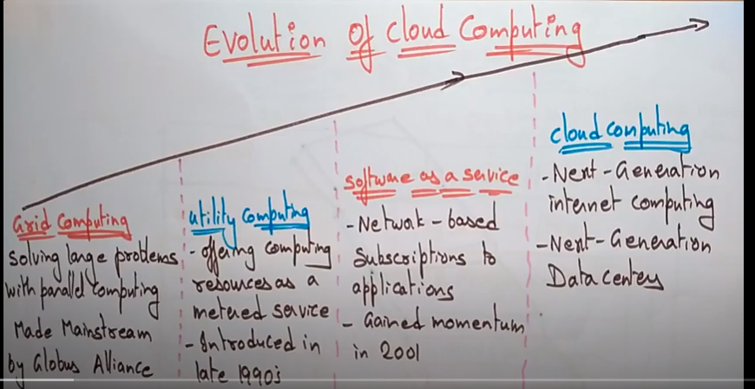

Before and all if we want to do ant transcations we need to do on single system only , Now cloud computing came into picture which is very flexible and will be available to everyone to access wherever you are.

***Grid Computing :***

Starting we used to have grid computers , what we used to do on this , We used to solve large probles using parallel computing concepts .

This was made as the main stream by Globus Alliance .

***Utility Computing:***

It offers computing resources as a metered service and it was introduced in 1990’s.

Then came Software as a Service.

***Software As A Service:***

The computer service is upgraded as software as service,here it is purely network based subscription and it gained momentum in 2001.

***Cloud Computing:***

Here came cloud into the market which is nothing but Next Generation Internet computing and Next Generations Data centers.

The main use of the cloud computing is internet computing and maintaining data centers for storing the data .

Internet computing is accessing the data where ever you want and whatever time you want , and data centers is used to store the data in the cloud .

Now we will see the evolution of cloud services .

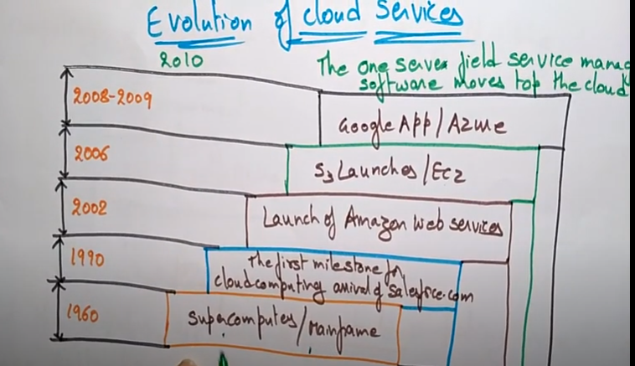

Initially at 1960 , we don’t have cloud , that time when computers are introduced , we have super computer and Mainframe as a computer technologies .

1990 🡪 The first milestone is done for cloud computing by salesforce.com,salesforce.com has forst started cloud service.

2002 🡪 Amazo web services has been launched on 2002 and they started providing services to the customers.

2006 🡪 in this year S3 is launched and EC2

2008 -2009 🡪 Google App and Azzure came into picture

***Customer Oriented Definition of Cloud :***

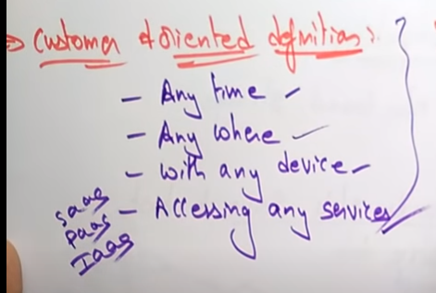

Customer oriented definition is like Anytime, anywhere in the world, with any device (either mobile,tab,laptop) , they can started access any services PaaS,SaaS,IaaS.

This is customer Oriented Definition.

***Business Oriented Definition of Cloud:***

First thing they will tell it is universal Access.

The data which they are storing the cloud with the help of servers , because the organization branches will be in different countries , so that whatever the data provided on the cloud , can be provided by another branch people.

And they think about scalable services, if I use cloud server what is benefit I will get, means expenses are incurred only when they are needed.

New Applications services will be available on the cloud (XaaS).

Pay As You Go 🡪 How much you store , pay for that only .

Storing of data is more then you need to pay more.

This is the business oriented defintaion.

In GMAIL they will give only 15GB of free space, whenever your 15GB is done then you need to upgrade the cloud .

Now see what is meant by Cloud Computing .

***Cloud Computing:***

It is the delivery of On-Demand computer services over the internet on a pay-as-you-go service.

The main thing is it giving service to the people based on On-Demand over the internet on Pay as you go basis.

If you exceed your free limit then you need to pay and use the cloud services.

Rather than managing the files on a local storage device , this cloud computing makes it possible to save them over internet.

Now everyone is storing all their data in the cloud , not in the personal compter, hence maintainence makes very easy .

Examples : Gmail, Hotmail,YahooMail.

***Why Cloud Computing:***

Before there is no cloud computing , everything we used to use the personal devices for storage of data.Now we will see the difference between the Onpremises Single system or Single organization and Cloud computing services.

For On premises , it will be higher pay and less scalability , even you are not using the entire storage you need to pay for the hard disk and scalability is very less .

But for cloud computing , pay for what you use , scalability is very high .

In Onpremesis , we need to a lot huge space for servers , whereas for cloud no space for servers is required.

No Automatic updates will be there for On Premises , where as for Cloud computing Automatic software updates will be there.

On Premises, we need to appoint separate team for hardware and software maintenance where as for cloud no experts are required .

Lack of flexibility in On premises where as in Cloud high flexibility.

On Premises , data cannot be accessed remotely , Data can be accessed remotely and even shared anywhere over the internet .

Takes longer implementation time where as in cloud computing rapid implementation.

In On premisis , poor data security and in cloud we have better data security .

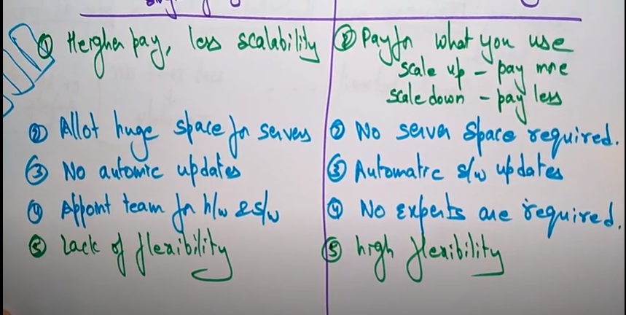

All Clouds are data centers , We will have different clouds available .

Public cloud, private cloud and hybrid cloud .

We will the use cases of each cloud.

Before public code there was a problem like this ,

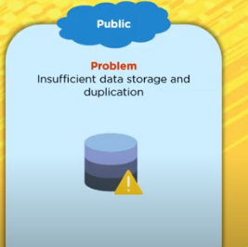

There was a problem for insufficient data storage and duplication of data .

Public cloud has resolved this ,

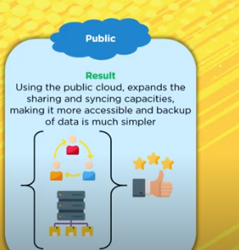

Public cloud has the property of sharing , syncing capabilities and it makes the data much simpler.

Another case is for private cloud ,

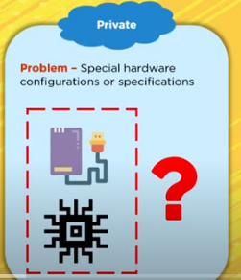

How we can use the specified software as well as with specifications.

This is resolved with the introduction of private cloud in which the private cloud fetches the hardware as per the requirements of an application .

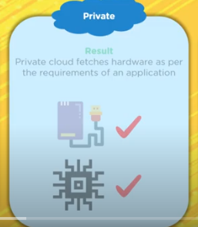

Another use case is how to handle the high peak traffic ? ( This was done after the introduction of Hybrid cloud)

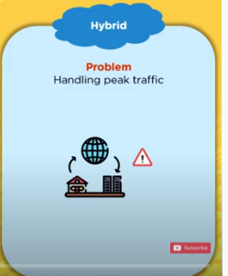

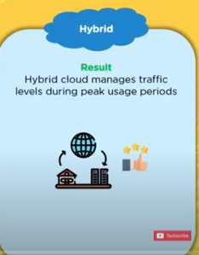

With the hybrid cloud , we can manage the traffic levels .

Lets see the definition of the 3 cloud models .

**Public Cloud :**

It is the cloud computing infrastructure that is located in the on premises of the company that offers the services. Means the data center would be located at their premises.

Example : GlobalDots is the company that offers cloud services worldwide services for public cloud.

**Private Cloud :**

It is nothing but cloud infrastructure for a dedicated customer or for the organization and this will ot be shared with the other users .

Ex: Dell

**Hybrid Cloud :**

It is nothing but the combination of public and the private cloud.

Its based on the purpose and the requirements .

Ex: IBM

Tenancy in Public cloud : Here different organizations in different companies will share their data in this environment , since it is a multi tenant , there data is completely isolated to another data organization as well .

Tenancy in Private Cloud : It is a single tenant , since private cloud infrastructure is dedicated to the single customer or the single organization.

**Tenancy in Hybrid Cloud :**

The data stored in a public cloud is multi tenant and is kept secure with the help of private cloud.

**Exposure to Public :**

How the public access this cloud models , public cloud is accessed by everyone.There are least restrictions , any place , any device, any geography can access this device.

**Exposure to Private :**

Only admins in this organization can use these servies.

**Exposure to Hybrid:**

Since it is a combination of public and private , any user can access in public as well as in organization.

**Data Center Locations:**

**Public Cloud:**

Data center services for the public cloud are in the same location where t he cloud provider is located.

Over the internet , this data center can be accessed.

**Private Cloud:**

The data center location of the private cloud be inside the organization network only , so it will not be on the public network or internet . It is within the organization.

**Hybrid Cloud :**

The data center location within the organization for private cloud services and anywhere on the internet for the public cloud services.

It depends on the organization to decide whether they can deploy their services in public or private.

Public : The cloud service provider will manages the services where as the organization uses them.

Private : Admins in the organization will manages the services.

Hybrid : The organization operates the private cloud where the cloud service providers manage the public cloud.

**Hardware Components :**

Everything will be taken care by the cloud service provider, like software’s and hardware’s .

Those people who don’t want to use their infrastructure will go to public cloud , since it is available on the internet .

Private Cloud : Here organization offers the soft wares with specific specifications and this is more expensive.