There will be 2 steps in the cloudera installation .

1. VM Installation
2. Cloudera Installation

Download the cloudera from the below link.

<https://drive.google.com/file/d/1pp1ugBM0vIMJaPKlSjq2g1yITFbEtgti/view?usp=sharing>

Step-1 : Download Cloudera from the above link .

Step-2 : Download VMplayer 64Bit

Step-3 : Extract cloudera in a specific folder which will be accessible

Step-4 : Install VM player

Step-5 : Access extracted Cloudera from the VM player

Step-6 : Check whether the cloudera is switched in VMplayer

Step-6 : IF cloudera is not switched on , Enable VTX technology

Means you need to enable VTXtechnology in BIOS settings .

Download VM player :

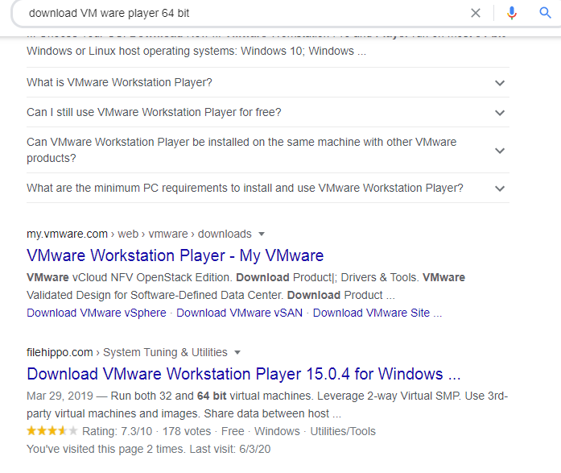

Go to filehippo link and download the VMplayer from it .--> You can see Download Free version ..

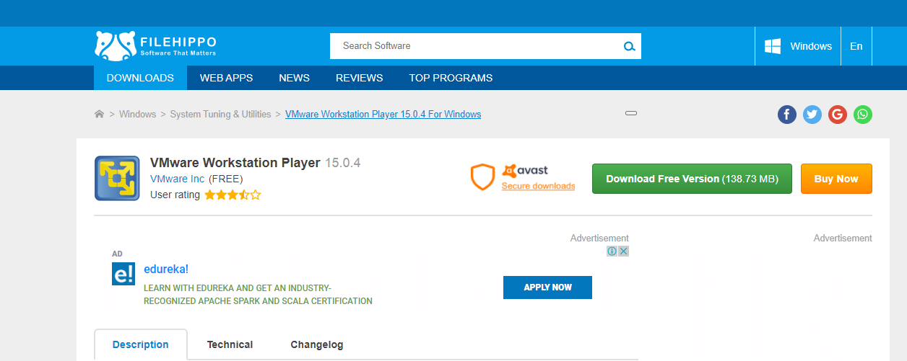

Your VMplayer will get downloaded .

You will get .exe file , click on next you will get your VMplayer install in your machine .

Once you complete the set up you can see VM ware work station in desktop.

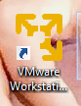

Click on it …

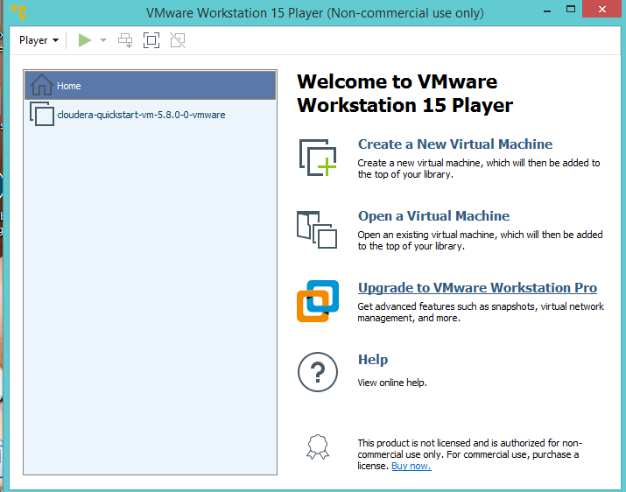

Since I have Cloudera installed , I can see cloudera under Home , else you need to click Open a virtual Machine .

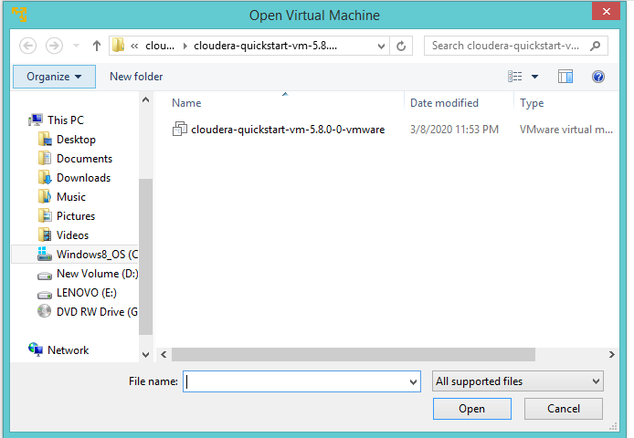

Click on Open .

Then you can see the cloudera option here .

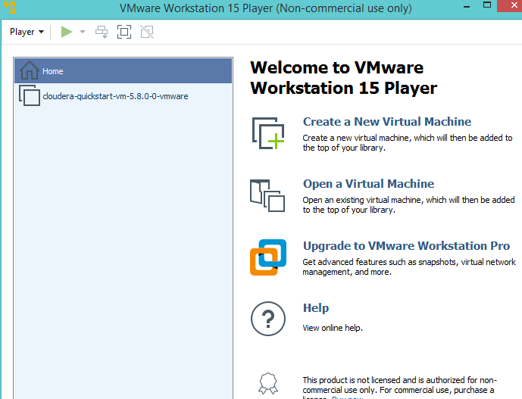

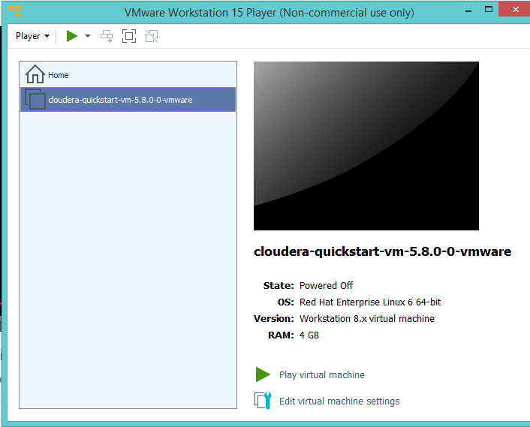

Click on Play virtual machine .

So that your cloudera gets started .

It may take a bit of time to get started .