**A dynamics 365 connected CRM App**

Statement of Work (SoW)

Table of Contents

1. Project Brief 2

2. Project Discussion 2

3. Methodology 2

4. Report Example 2

# Project Brief

We want to sell an app solution similar to this on MS Market Place <https://appsource.microsoft.com/en-us/product/dynamics-365-for-operations/visionetsystems.fashioncloud365?tab=Overview> No identical but if you have worked on a system similar to this in the past which can be quickly modified, please contact us. Or if you can build a similar one quickly to be sold on MS App source

# Project Discussion

Skype

# Methodology

1. Get Access of Quickbooks
2. Get Access of Airtable
3. Get Access of Google Analytics
4. Create a dashboard on Power BI using Quickbooks Data
5. Create a dashboard on Power BI using data on Airtable data
6. Create a dashboard on Power BI using Google Analytics Data
7. Iterate, test and Deliver Dashboards

# Report Example

Reference Data: Brand & Category Analysis - March 2022.xlsx

Marketing Brand & Category Spend Analysis - March 2022

FYI, this is one the report that we manually extract from different sources including adwords and airtable data.

We follow following steps to compile it.

1. Get spend details from Google and Bing ads

2. Get sales data from airtable

3. Combine both data using keywords (product part numbers) as a reference point.

4. Calculate numbers such as total spend, total sales, order volume, return on add spend.

Step 3 is done manually.

This is one of the report that we want to automate, other reports I will share later.

Hello Everyone,

Please find the below Marketing Spend Analysis for the M/O March 2022.(Reference File are attached)

* The Spend for 2022, is around **$37,000/-**
* The direct ROAS is **1.97** with sales of **$72,508/-** and AOV of **$477/-**
* The overall Marketing ROAS (Excluding Repeat Buying & Outbound) is **10.50** with the sales of **$387,209/-** and the AOV is **$1,450/-**

**Performance By Brand :**

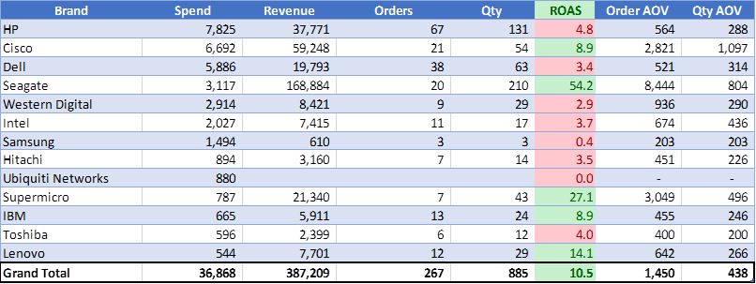

**Performance by Category :**

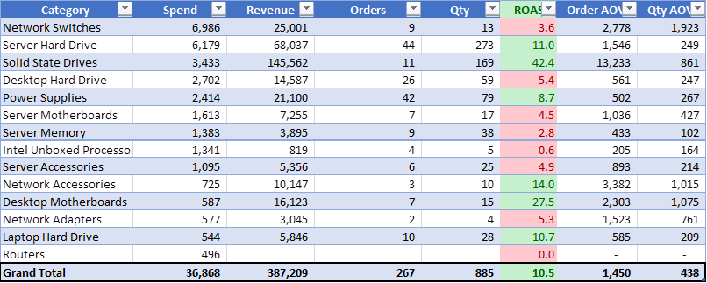

Let me know incase of any ambiguity.