## **Creating the entities**

### **BaseModel**

### **Roles**

### **User**

### **Session Status:**

### **Session**

## **Creating the controllers:**

### **AuthController**

### **RoleController**

### **UserController**

## **Creating the dtos:**

### **UserDto**

### **Create Login Dto**

### **Create Logout Dto**

### **Create the CreateRoleRequestDto**

### **Create the SetUserRolesRequestDto**

### **Create the SignUpRequestDto**

### **Create the SignUpRequestDto**

## **Creating the services:**

### **User Service:**

### **Role Service:**

### **Auth Service:**

#### **Sign-Up:**

#### **Login:**

#### **Validate:**

#### **Logout:**

## **Creating the repositories:**

### **User Repo:**

### **Role Repo:**

### **Session Repo:**

## **Updating the controllers:**

### **AuthController**

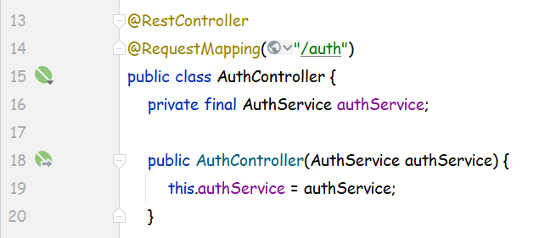

### **RoleController**

### **UserController**

Disable Spring Security:  
