1. **What is storage gateway**

<https://docs.aws.amazon.com/storagegateway/latest/userguide/initiator-connection-common.html>

AWS Storage Gateway connects an on-premises software appliance with cloud-based storage.

* seamless integration
* data security
* scalable
* cost-effective

Offerings:

* File based: File interface to S3, using NFS, S3 app/service.
* Volume based: Cloud-backed storage volume mounted as iSCSI. Supports cached and stored volumes.
* Tape based: Archive backup to Amazon glacier. Provides virtual tape infra and scales endlessly.

1. **Port requirement for File Gateway**

<https://docs.aws.amazon.com/storagegateway/latest/userguide/Resource_Ports.html>

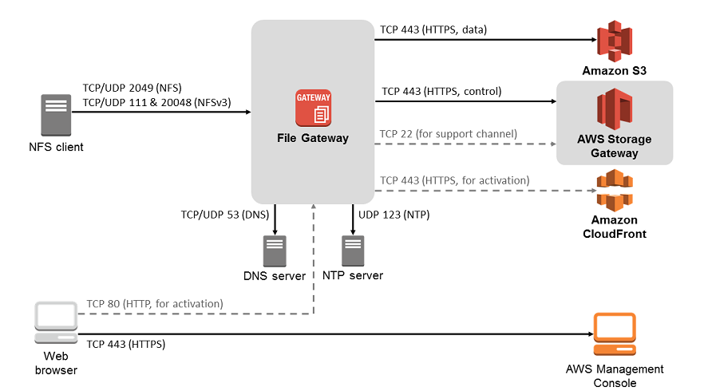

**Ports required by all gateway types**

|  |  |  |  |  |
| --- | --- | --- | --- | --- |
| **From** | **To** | **Protocol** | **Port** | **How Used** |
| Storage Gateway VM | AWS | TCP | 443 (HTTPS) | For communication from AWS Storage Gateway VM to the AWS service endpoint. For information about service endpoints, see [Allowing AWS Storage Gateway Access Through Firewalls and Routers](https://docs.aws.amazon.com/storagegateway/latest/userguide/Requirements.html#allow-firewall-gateway-access). |
| Your Web browser | Storage Gateway VM | TCP | 80 (HTTP) | By local systems to obtain the storage gateway activation key. Port 80 is only used during activation of the Storage Gateway appliance.  AWS Storage Gateway VM does not require port 80 to be publicly accessible. The required level of access to port 80 depends on your network configuration. If you activate your gateway from the AWS Storage Gateway Management Console, the host from which you connect to the console must have access to your gateway’s port 80. |
| Storage Gateway VM | Domain Name Service (DNS) server | UDP/UDP | 53 (DNS) | For communication between AWS Storage Gateway VM and the DNS server. |
| Storage Gateway VM | AWS | TCP | 22 (Support channel) | Allows AWS Support to access your gateway to help you with troubleshooting gateway issues. You don't need this port open for the normal operation of your gateway, but it is required for troubleshooting. |
| Storage Gateway VM | NTP server | UDP | 123 (NTP) | Used by local systems to synchronize VM time to the host time. The Storage Gateway VM is configured to use the following ntp servers:   * 0.amazon.pool.ntp.org * 1.amazon.pool.ntp.org * 2.amazon.pool.ntp.org * 3.amazon.pool.ntp.org |

In addition to the common ports, file gateway requires the following ports.

**Ports required by file gateway only**

|  |  |  |  |  |
| --- | --- | --- | --- | --- |
| **From** | **To** | **Protocol** | **Port** | **How Used** |
| NFS client | Storage Gateway VM | TCP/UDP | 2049 (NFS) | For local systems to connect to NFS shares your gateway exposes. |
| NFS client | Storage Gateway VM | TCP/UDP | 111 (NFS) | For local systems to connect to the portmapper your gateway exposes.  **Note**  Only needed for NFSv3 clients. |
| NFS client | Storage Gateway VM | TCP/UDP | 20048 (NFS) | For local systems to connect to mountd your gateway exposes.  **Note**  Only needed for NFSv3 clients. |

1. Issue we can face with File storage Gateway

<https://docs.aws.amazon.com/storagegateway/latest/userguide/file-share-issues.html>

**File Storage Gateway.**

<https://docs.aws.amazon.com/storagegateway/latest/userguide/storagegateway-ug.pdf#create-file-gateway>

