**CS1106: ASSIGNMENT**

**SURVEY MANAGEMENT SYSTEM**

**PREPARED BY**

Sahil Singhavi (2019BTECHCSE083)

Navneet Gupta (2019BTECHCSE075)

**SUBMITTING TO**

Dr. S.Taruna

Department of Computer Science Engineering

Institute of Engineering and Technology (IET)

JK Lakshmipat University, Jaipur

10/may/2021

TABLE OF CONTENTS

|  |  |  |
| --- | --- | --- |
| S.NO. | CONTENT | PAGE NO. |
| 1. | INTRODUCTION AND OBJECTIVE   1. OVERVIEW OF TOOLS AND LANGUAGE USED  * HTML &CSS * PHP & MySQLi * JAVASCRIPT * BOOTSTRAP  1. FUNCTIONALITY 2. DATABASE DESIGN PROCESS   1. ER Diagram  2. Relational Schema | **1**  **1**  **2**  **3**  **3**  **4** |
| 2. | DETAILS OF TABLE USED IN THIS PROJECT   1. Code for Table answers 2. Code for Table questions 3. Code for Table survey_set 4. Code for Table users | 5  6  7 |
| 3. | LOGIN FRAME AND ITS CODE | 8-9 |
| 4. | FRAME BASED ON USERS TABLE   1. User home dashboard 2. User Survey widget 3. Admin new user add 4. Admin user list | 10-13 |
| 5. | FRAME BASED ON ANSWERS TABLE   1. User answer survey | 14-15 |
| 6. | FRAME BASED ON SURVEY_SET AND QUESTIONS   1. Admin home dashboard 2. Admin new survey add 3. Admin survey list 4. Admin survey report | 16-20 |
| 7. | APPENDEX: A | 21-30 |

INTRODUCTION AND OBJECTIVE

The Project titled Online Survey System is a database connectivity application that uses front end as HTML, CSS, and backend as PHP/MySQLi, JavaScript (jQuery/Ajax), and Bootstrap for the design.

The Online Survey System is a simple project that can help a certain school, company or any organization that conducting surveys within its circle. The system has 2 types of users which is the admin and subscribers/users. The admin is the one who manages all the data of this system also the user role who is permitted to create a new user. The subscribers/users are those system users that answer the survey. The system has a simple form builder feature to create a survey questionnaire. The survey form builder has only 3 options to choose from for the type of inputs on how the users/subscribers answer the questions. The 3 options are the radio options, checkbox, and text area. The radio button will be used if the survey question requires only (1) one answer and the checkbox is for the survey question that allows multiple options that can user/subscriber choose. The text area will serve the dynamic survey question such as the comment. The system generates a printable report for the result of each survey set.

1. **OVERVIEW OF TOOLS AND LANGUAGE USED**

The application is created using Microsoft Visual Studio IDE and for the database connectivity and running XAMPP is used.

The Visual Studio IDE (integrated development environment) is a software program for developers to write and edit their code. Its user interface is used for software development to edit, debug, and build code. It contains completion tools, compilers, and other features to facilitate the software development process. It also includes a code editor supporting IntelliSense (the code completion component) as well as code refactoring. The integrated debugger works both as a source-level debugger and a machine-level debugger. Other built-in tools include a code profiler, designer for building GUI applications, web designer, class designer, and database schema designer.

XAMPP is a free and open-source cross-platform web server solution stack package developed by Apache Friends, consisting mainly of the Apache HTTP Server, MariaDB database, and interpreters for scripts written in the PHP and Perl programming languages. XAMPP is one of the best Apache distributions that helps developers create a local web server for testing and deployment purposes. Since its cross-platform, you can use on Windows, macOS, or Linux.

* **HTML &CSS**
  + - HTML (Hypertext Mark-up Language) is used to create the actual content of the page, such as written text, and CSS (Cascade Styling Sheets) is responsible for the design or style of the website, including the layout, visual effects and background colour.
* **PHP & MySQLi**
  + - The PHP Hypertext Pre-processor (PHP) is a programming language that allows web developers to create dynamic content that interacts with databases. PHP is basically used for developing web-based software applications. It is Fast, flexible, and pragmatic.
    - The MySQLi Extension (MySQL Improved) is a relational database driver used in the PHP scripting language to provide an interface with MySQL databases. It can do both procedural and object-oriented. The main useful features are an Object-oriented interface support for prepared statements support for multiple statements support for transactions enhanced debugging capabilities embedded server support. MySQLi is database drive which is used for php languages and provides an interface for MySQL.
* **JAVASCRIPT**
  + - JavaScript is a text-based programming language used both on the client-side and server-side that allows you to make web pages interactive.
    - jQuery is a JavaScript library designed to simplify HTML DOM tree traversal and manipulation, as well as event handling, CSS animation, and Ajax.
* **BOOTSTRAP** 
  + - Bootstrap is a free and open-source CSS framework directed at responsive, mobile-first front-end web development. It contains CSS- and JavaScript-based design templates for typography, forms, buttons, navigation, and other interface components.

1. **FUNCTIONALITY**

The database and web application allow technicians to complete the following functions:

* Enter a new survey service request form
* Check survey answer and question
* View the report of survey

The database is password-protected and requires a login.

The application and database also allow the manager of the service centre to generate counts in reports by username, survey id and date of survey as well as manage the table data.

1. **DATABSE DESIGN PROCESS**
2. **ER Diagram**

ER Diagram stands for Entity Relationship Diagram, also known as ERD is a diagram that displays the relationship of entity sets stored in a database. ER diagrams help to explain the logical structure of databases.

ER diagrams are created based on three basic concepts: entities, attributes, and relationships.

ER Diagrams contain different symbols that use rectangles to represent entities, ovals to define attributes and diamond shapes to represent relationships.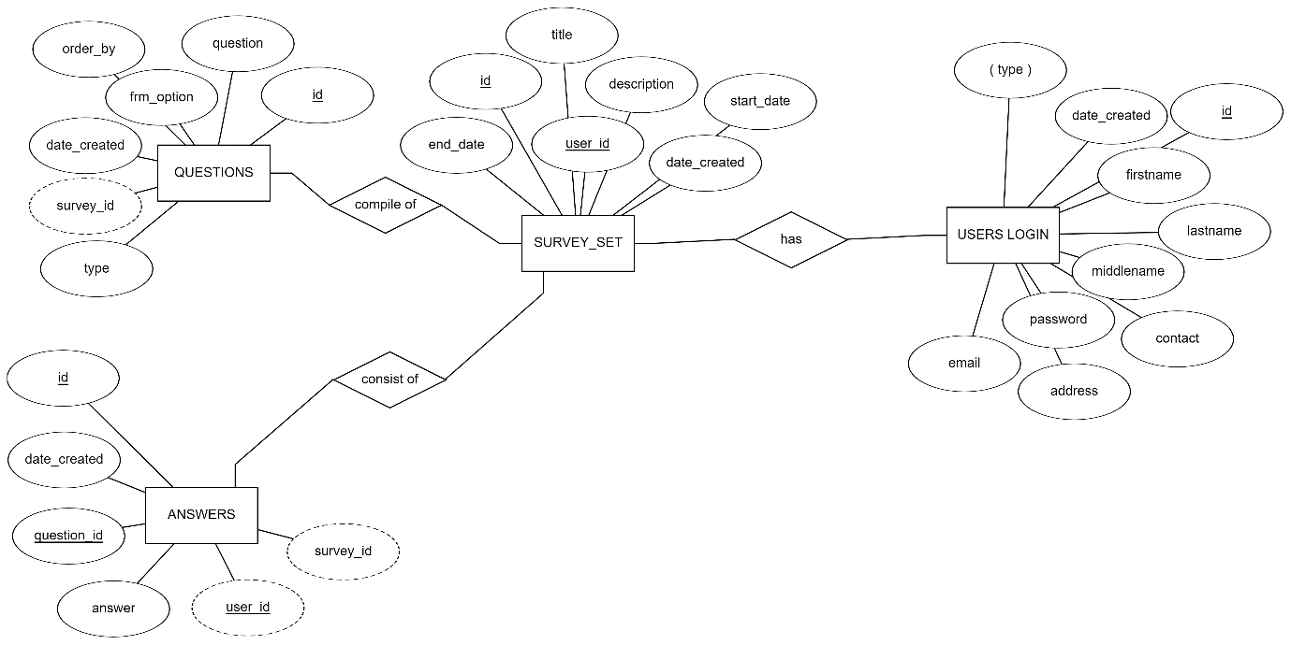

1. **Relational schema**

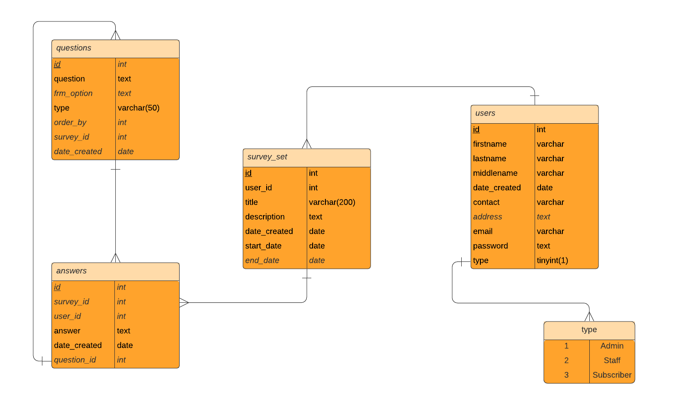Relation schema defines the design and structure of the relation like it consists of the relation name, set of attributes/field names/column names. every attribute would have an associated domain**.**

1. **Basic design for the application**

In Appendex : A code of the basic frame work is presented.

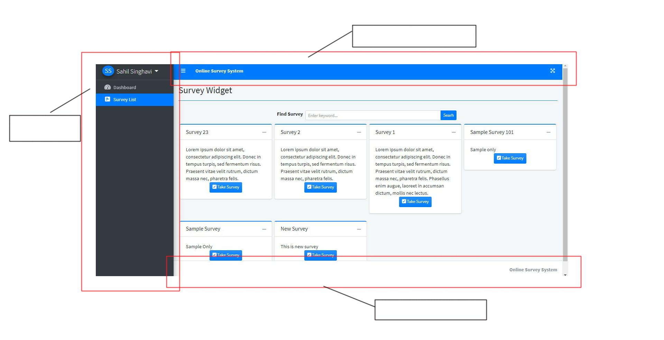

DETAILS OF TABLE USED IN THIS PROJECT

The database consists of four tables. The main tables are the answers, questions, survey_set and users.

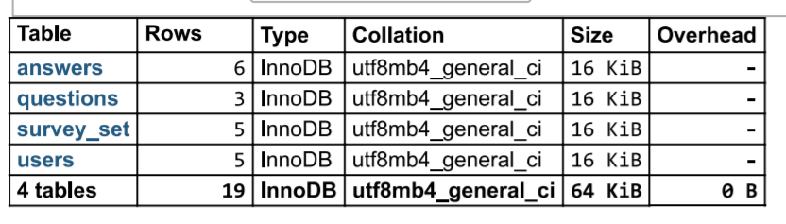

|  |  |
| --- | --- |
| Database Table | Description |
| users | Contains the user personal detail for login |
| questions | Contains the survey details for questioning |
| answers | Contains the survey result |
| survey_set | Contains the survey id and description of the survey for user. |

-- Database: `survey_db`

1. **Table structure for table `answers`**

CREATE TABLE `answers` (

`id` int(30) NOT NULL, Primary Key,

`survey_id` int(30) NOT NULL,

`user_id` int(30) NOT NULL,

`answer` text NOT NULL,

`question_id` int(30) NOT NULL,

`date_created` datetime NOT NULL DEFAULT current_timestamp()

) ENGINE=InnoDB DEFAULT CHARSET=utf8mb4;

1. **Table structure for table `questions`**

CREATE TABLE `questions` (

`id` int(30) NOT NULL, Primary Key,

`question` text NOT NULL,

`frm_option` text NOT NULL,

`type` varchar(50) NOT NULL,

`order_by` int(11) NOT NULL,

`survey_id` int(30) NOT NULL,

`date_created` datetime NOT NULL DEFAULT current_timestamp()

) ENGINE=InnoDB DEFAULT CHARSET=utf8mb4;

1. **Table structure for table `survey_set`**

CREATE TABLE `survey_set` (

`id` int(30) NOT NULL, Primary Key,

`title` varchar(200) NOT NULL,

`description` text NOT NULL,

`user_id` int(30) NOT NULL,

`start_date` date NOT NULL,

`end_date` date NOT NULL,

`date_created` datetime NOT NULL DEFAULT current_timestamp()

) ENGINE=InnoDB DEFAULT CHARSET=utf8mb4;

1. **Table structure for table `users`**

CREATE TABLE `users` (

`id` int(30) NOT NULL, Primary Key,

`firstname` varchar(200) NOT NULL,

`lastname` varchar(200) NOT NULL,

`middlename` varchar(200) NOT NULL,

`contact` varchar(100) NOT NULL,

`address` text NOT NULL,

`email` varchar(200) NOT NULL,

`password` text NOT NULL,

`type` tinyint(1) NOT NULL DEFAULT 3 COMMENT '1=Admin,2 = Staff, 3= Subscriber',

`date_created` datetime NOT NULL DEFAULT current_timestamp()

) ENGINE=InnoDB DEFAULT CHARSET=utf8mb4;

**DATABASE CONNECTION (db_connect)**

<?php

$conn= new mysqli('localhost','root','','survey_db')or die("Could not connect to mysql".mysqli_error($con));

**LOGIN FRAME AND ITS CODE (login.php)**

This page gives the access for both user and Admin where system users will submit their credentials to access the data and functionalities of the system.

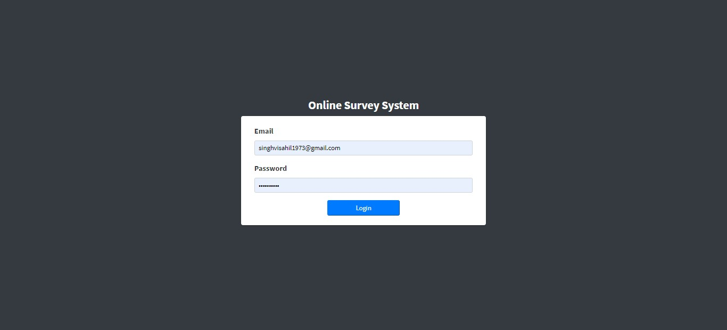

<!DOCTYPE html>

<html lang=”en”>

<?php

session_start();

include(‘./db_connect.php’);

?>

**Code on Login button**

$(‘#login-form’).submit(function(e){

e.preventDefault()

$(‘#login-form button[type=”button”]’).attr(‘disabled’,true).html(‘Logging in…’);

if($(this).find(‘.alert-danger’).length > 0 )

$(this).find(‘.alert-danger’).remove();

$.ajax({

<url:'ajax.php?action=login>’,

method:’POST’,

data:$(this).serialize(),

error:err=>{

console.log(err)

$(‘#login-form button[type=”button”]’).removeAttr(‘disabled’).html(‘Login’);

},

success:function(resp){

if(resp == 1){

location.href =’index.php?page=home’;

}else{

$(‘#login-form’).prepend(‘<div class=”alert alert-danger”>Username or password is incorrect.</div>’)

$(‘#login-form button[type=”button”]’).removeAttr(‘disabled’).html(‘Login’);

}

}

})

})

$(‘.number’).on(‘input’,function(){

var val = $(this).val()

val = val.replace(/[^0-9 \,]/, ‘’);

$(this).val(val)

})

**FRAME BASED ON USERS TABLE**

1. **USER HOME DASHBOARD**

This page give access to the user to view the active survey in the survey list and can take survey. this page also gives the user to see the answer of the previous survey which he has taken.

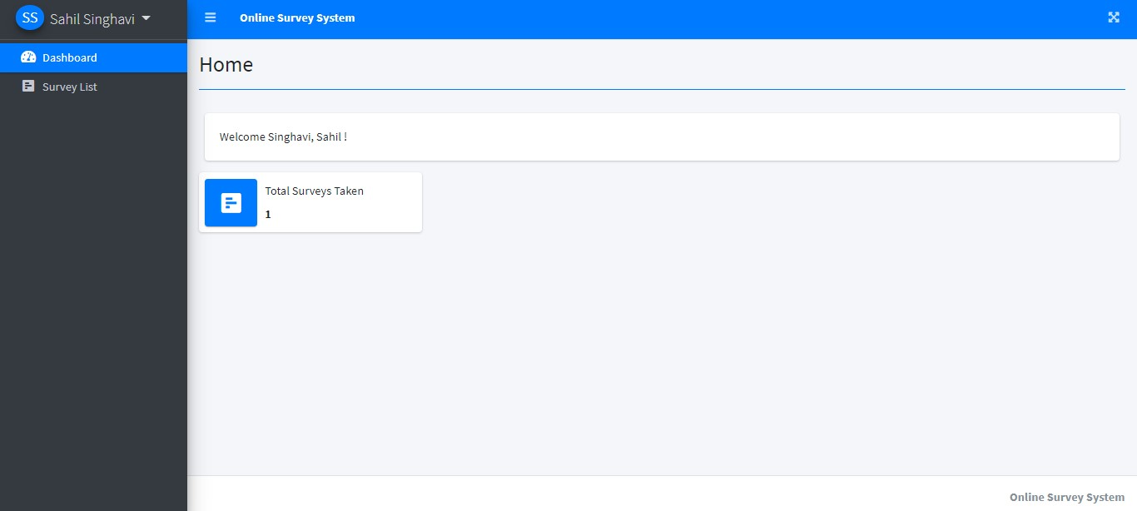

1. **USER SURVEY WIDGET**

This page is in the user portal where he can apply for the active survey and check the answer which are provided by the admin.

The php file used in this page are

* **survey_widget.php** :- This php file make the table for the representation of the data .
* **ticket_list.php**
* **view_survey.php**

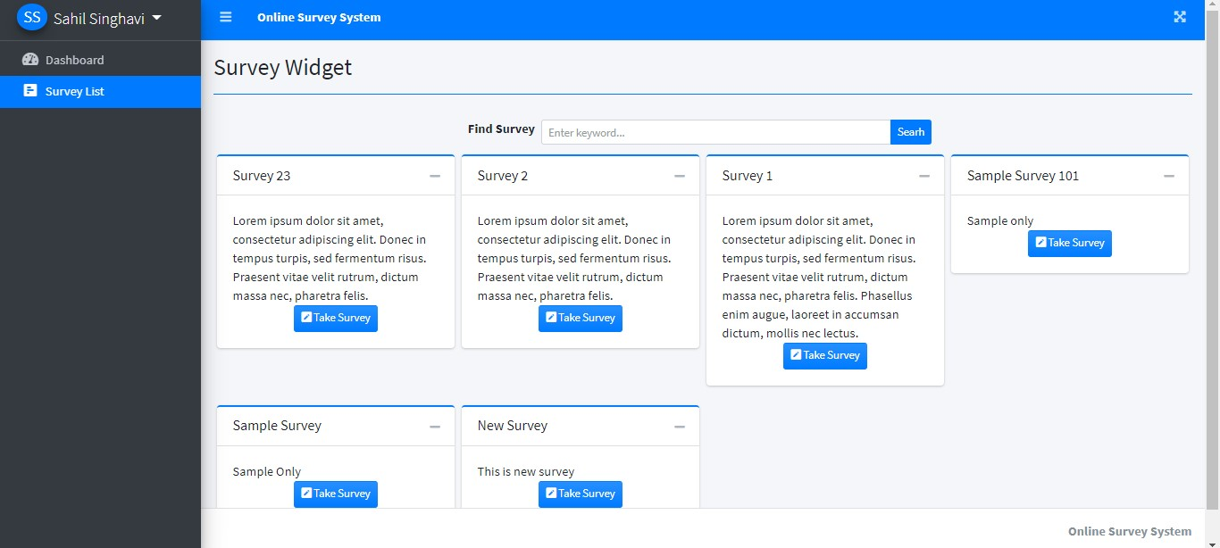

**Query for the survey enabled for the user by admin**

<?php

$qry = $conn->query("SELECT * FROM survey_set where id = ".$_GET['id'])->fetch_array();

foreach($qry as $k => $v){

if($k == 'title')

$k = 'stitle';

$$k = $v;

}

$answers = $conn->query("SELECT distinct(user_id) from answers where survey_id ={$id}")->num_rows;

?>

1. **ADMIN NEW USER ADD (new_user.php)**

In this page admin create new user by entering their credential like Name, Contact No., address, E-mail, and password.

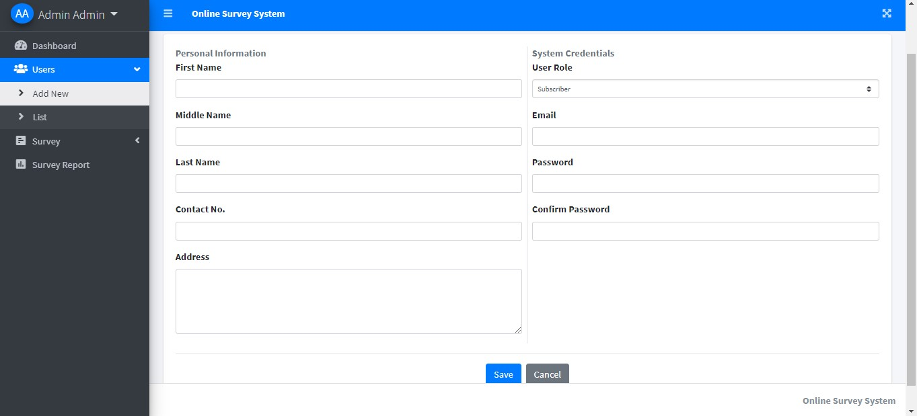

1. **ADMIN USERS LIST**

This page gives admin access to view the user detail and manage them.

The php file used in this page are

* **managing_user.php**
* **edit_user.php**
* **user_list.php**
* **view_user.php**

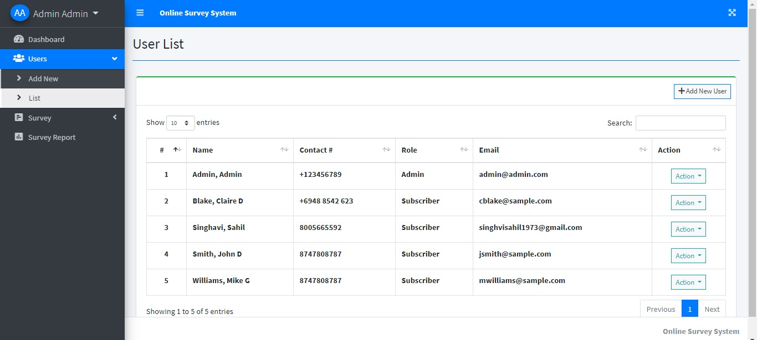

**Query for editing user detail in action bar**

<?php

include 'db_connect.php';

$qry = $conn->query("SELECT * FROM users where id = ".$_GET['id'])->fetch_array();

foreach($qry as $k => $v){

$$k = $v;

}

include 'new_user.php';

?>

**Query for connecting to database and selecting table**

<?php

include('db_connect.php');

session_start();

$utype = array('','users','staff','customers');

if(isset($_GET['id'])){

$user = $conn->query("SELECT * FROM {$utype[$_SESSION['login_type']]} where id =".$_GET['id']);

foreach($user->fetch_array() as $k =>$v){

$meta[$k] = $v;

}

}

?>

**Query for the above form for editing detail**

<form action="" id="manage-user">

<input type="hidden" name="id" value="<?php echo isset($meta['id']) ? $meta['id']: '' ?>">

<div class="form-group">

<label for="name">First Name</label>

<input type="text" name="firstname" id="firstname" class="form-control" value="<?php echo isset($meta['firstname']) ? $meta['firstname']: '' ?>" required>

</div>

<div class="form-group">

<label for="name">Middle Name</label>

<input type="text" name="middlename" id="middlename" class="form-control" value="<?php echo isset($meta['middlename']) ? $meta['middlename']: '' ?>">

</div>

<div class="form-group">

<label for="name">Last Name</label>

<input type="text" name="lastname" id="lastname" class="form-control" value="<?php echo isset($meta['lastname']) ? $meta['lastname']: '' ?>" required>

</div>

<div class="form-group">

<label for="username">Email</label>

<input type="text" name="email" id="email" class="form-control" value="<?php echo isset($meta['email']) ? $meta['email']: '' ?>" required autocomplete="off">

</div>

<div class="form-group">

<label for="password">Password</label>

<input type="password" name="password" id="password" class="form-control" value="" autocomplete="off">

<small><i>Leave this blank if you dont want to change the password.</i></small>

</div>

**FRAME BASED ON ANSWERS TABLE**

1. **USER ANSWER SURVEY**

This page shows the detail of survey and the questionaries of the survey which the admin provided to the user.

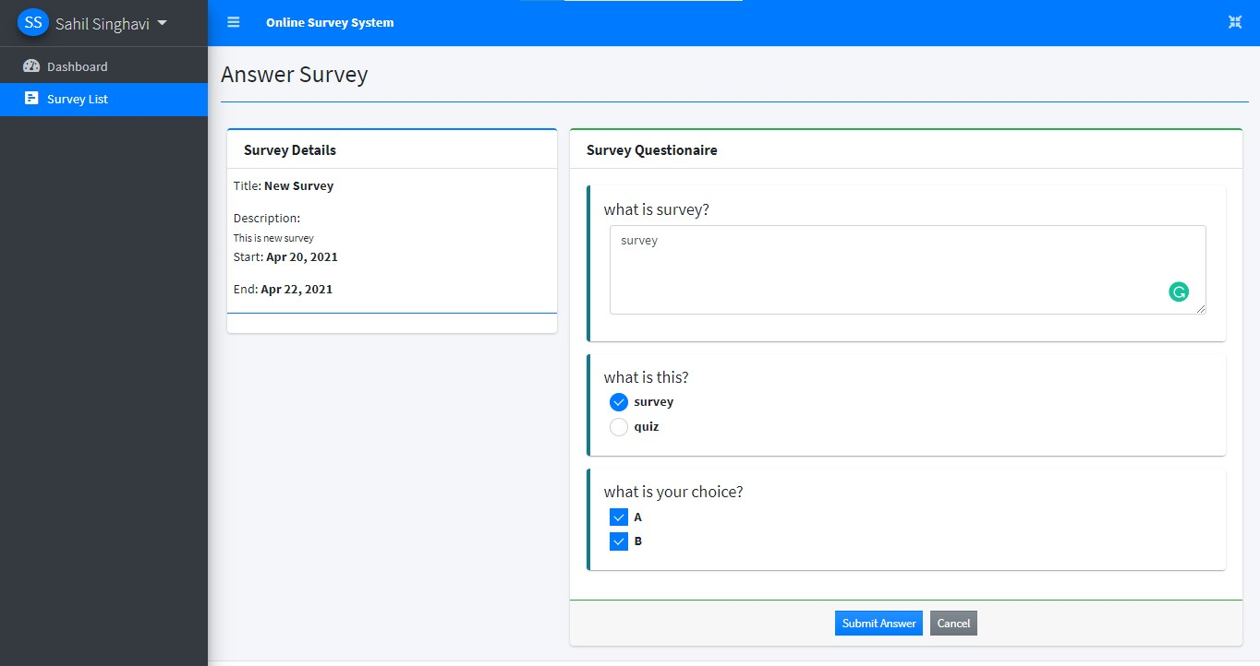

**Connecting it with the database**

<?php

$qry = $conn->query("SELECT * FROM survey_set where id =".$_GET['id'])->fetch_array();

foreach($qry as $k => $v)

{

if($k == 'title')

$k = 'stitle';

$$k = $v;

}

?>

**Fetching details from database For survey details**

<h3 class="card-title"><b>Survey Details</b></h3>

</div>

<div class="card-body p-0 py-2">

<div class="container-fluid">

<p>Title: <b><?php echo $stitle ?></b></p>

<p class="mb-0">Description:</p>

<small><?php echo $description; ?></small>

<p>Start: <b><?php echo date("M d, Y",strtotime($start_date)) ?></b></p>

<p>End: <b><?php echo date("M d, Y",strtotime($end_date)) ?></b></p>

</div>

**Storing answer in survey questionnaire to the database**

<?php

$question = $conn->query("SELECT * FROM questions where survey_id = $id order by abs(order_by) asc,abs(id) asc");

while($row=$question->fetch_assoc()):

?>

**FRAME BASED ON SURVEY_SET AND QUESTIONS**

1. **ADMIN HOME DASHBOARD**

This is the home page of admin after logging. Admin have many rights like creating new user, survey creation, managing account and viewing credential.

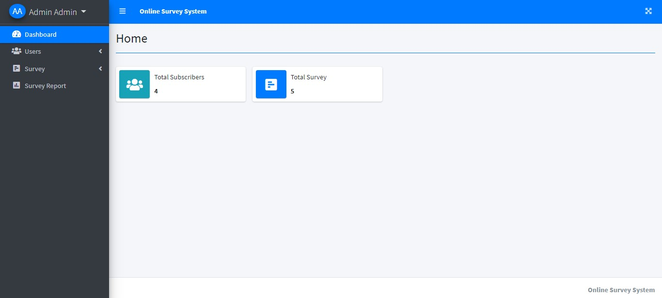

Code for above page in APPENDEX:B1

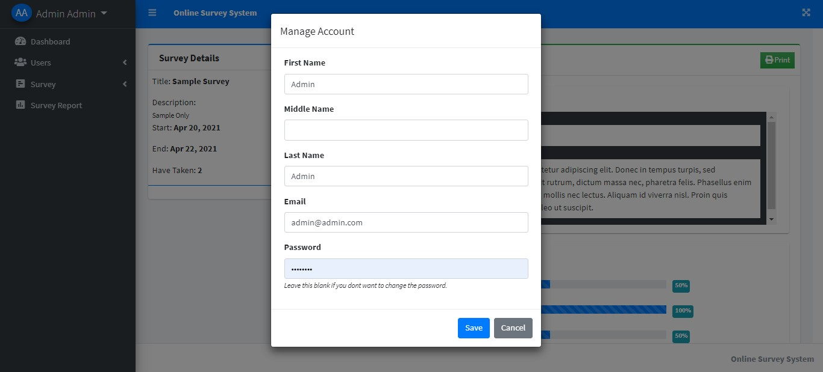

1. **ADMIN NEW SURVEY ADD**

This page allow admin to create new survey in which admin must fill title of the survey, start and end date with the description of the survey.

The php file used in this page are :-

* **New_user.php**
* **Managing_user.php**

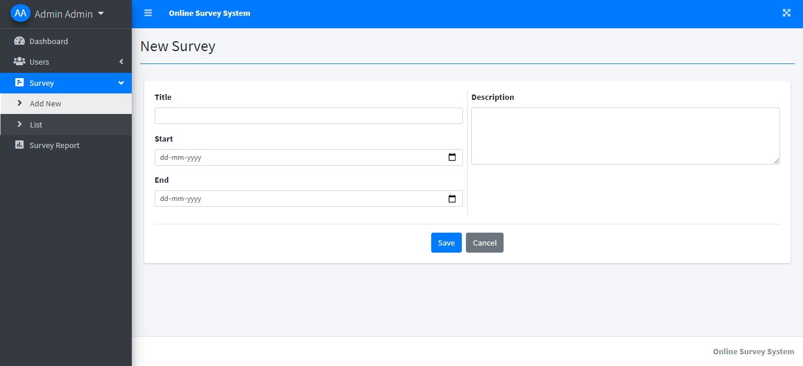

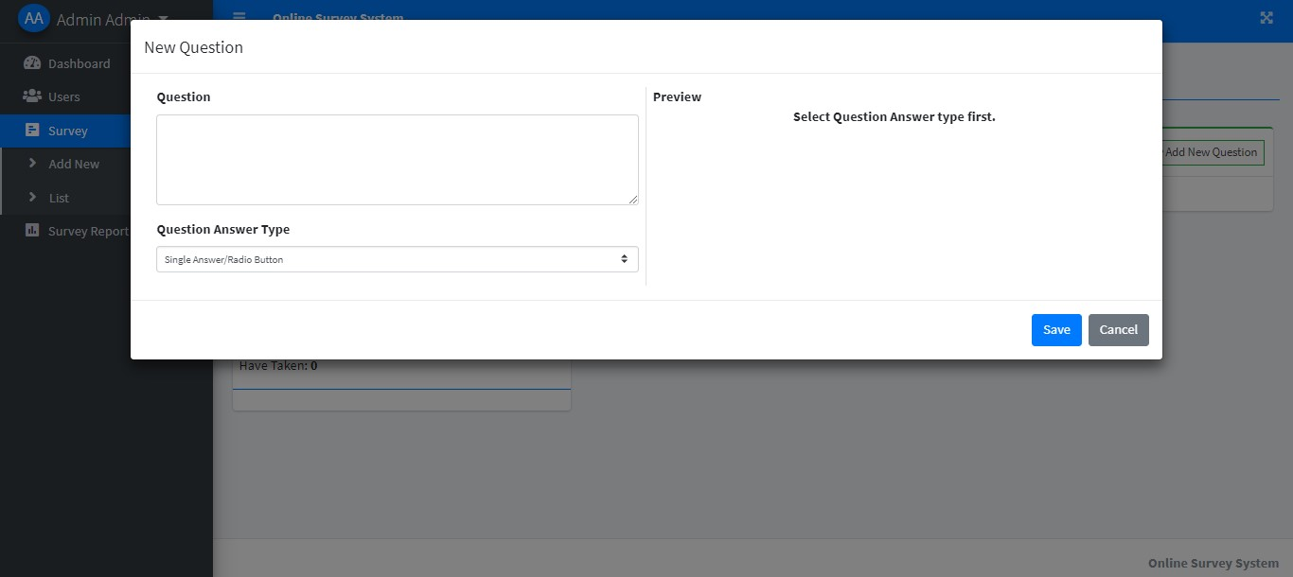

**Query for entring this page**

<?php include 'db_connect.php' ?>

<?php

if(isset($_GET['id'])){

$qry = $conn->query("SELECT * FROM questions where id = ".$_GET['id'])->fetch_array();

foreach($qry as $k => $v){

$$k = $v;

}

}

?>

1. **ADMIN SURVEY LIST**

This page shows the detail of the active and the past survey and have the

Function like view, edit and delete.

The php file used in this page are

* **Survey_list.php**
* **Edit_survey.php** :- Used for editing survey details

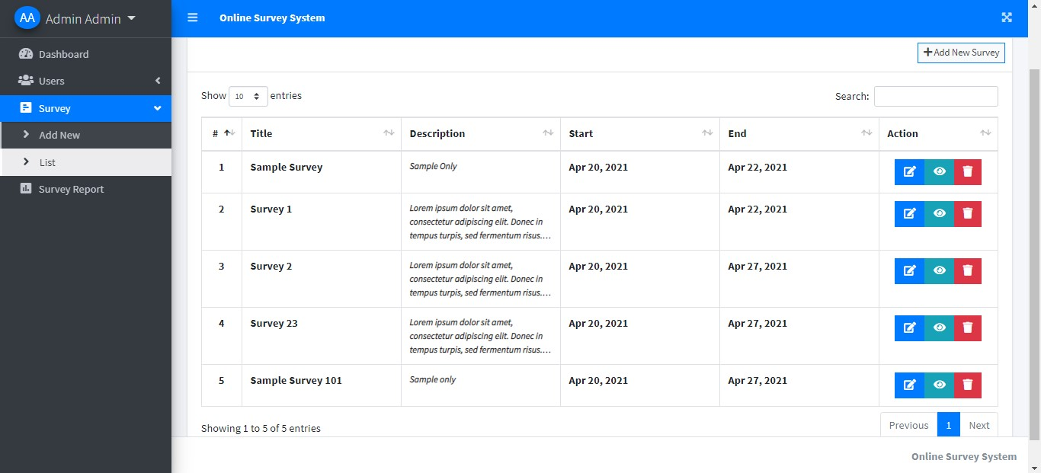

**Query for checking details of survey in database**

<?php

$i = 1;

$qry = $conn->query("SELECT * FROM survey_set order by date(start_date) asc,date(end_date) asc ");

while($row= $qry->fetch_assoc()):

?>

**Query for editing survey detail in action bar**

<?php

include 'db_connect.php';

$qry = $conn->query("SELECT * FROM survey_set where id = ".$_GET['id'])->fetch_array();

foreach($qry as $k => $v){

if($k == 'title')

$k = 'stitle';

$$k = $v;

}

include 'new_survey.php';

?

1. **ADMIN SURVEY REPORT**

This page shows the report of every survey which are taken, and the admin can also print the report and analyse the data with percentage. Admin also have search option to find survey.

This php file used in this page are

* **print_report.php**
* **survey_report.php**
* **view_survey_report.php**

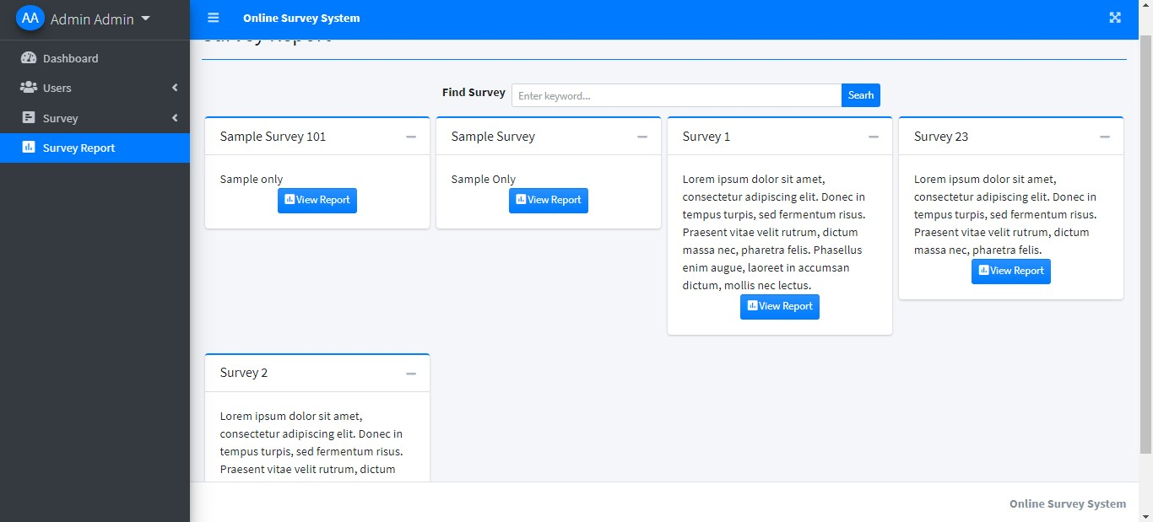

**Query for selection of database**

<?php

$answers = $conn->query("SELECT distinct(survey_id) from answers where user_id ={$_SESSION['login_id']}");

?>

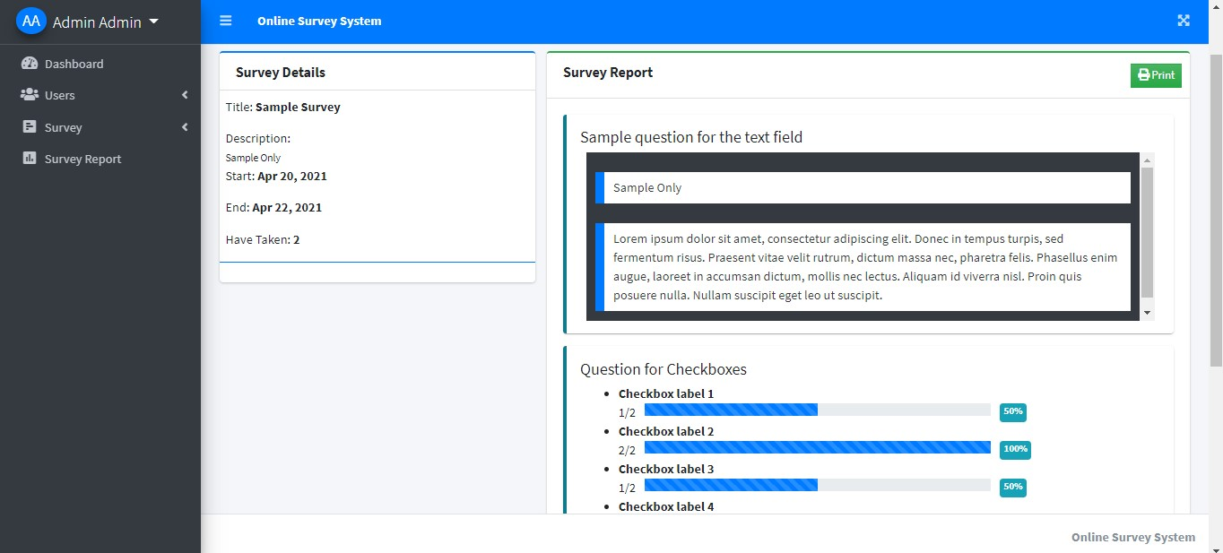

**Query for checking answer**

<?php

$qry = $conn->query("SELECT * FROM survey_set where id = ".$_GET['id'])->fetch_array();

foreach($qry as $k => $v){

if($k == 'title')

$k = 'stitle';

$$k = $v;

}

$taken = $conn->query("SELECT distinct(user_id) from answers where survey_id ={$id}")->num_rows;

$answers = $conn->query("SELECT a.*,q.type from answers a inner join questions q on q.id = a.question_id where a.survey_id ={$id}");

$ans = array();

while($row=$answers->fetch_assoc()){

if($row['type'] == 'radio_opt'){

$ans[$row['question_id']][$row['answer']][] = 1;

}

if($row['type'] == 'check_opt'){

foreach(explode(",", str_replace(array("[","]"), '', $row['answer'])) as $v){

$ans[$row['question_id']][$v][] = 1;

}

}

if($row['type'] == 'textfield_s'){

$ans[$row['question_id']][] = $row['answer'];

}

}

?>

**Query**

<?php

$question = $conn->query("SELECT * FROM questions where survey_id = $id and type !='textfield_s' order by abs(order_by) asc,abs(id) asc");

while($row=$question->fetch_assoc()):

?>

**BIBLIOGRAPHY**

**APPENDEX :A**

* **HEADER FOR THE APPLICATION (header.php)**
* <head>
* <meta charset="utf-8">
* <meta name="viewport" content="width=device-width, initial-scale=1">
* <?php
* ob_start();
* $title = isset($_GET['page']) ? ucwords(str_replace("_", ' ', $_GET['page'])) : "Home";
* ?>
* <title><?php echo $title ?> | Online Survey System</title>
* <?php ob_end_flush() ?>
* <!-- Google Font: Source Sans Pro -->
* <link rel="stylesheet" href="https://fonts.googleapis.com/css?family=Source+Sans+Pro:300,400,400i,700&display=fallback">
* <!-- Font Awesome Icons -->
* <link rel="stylesheet" href="assets/plugins/fontawesome-free/css/all.min.css">
* <!-- overlayScrollbars -->
* <link rel="stylesheet" href="assets/plugins/overlayScrollbars/css/OverlayScrollbars.min.css">
* <!-- DataTables -->
* <link rel="stylesheet" href="assets/plugins/datatables-bs4/css/dataTables.bootstrap4.min.css">
* <link rel="stylesheet" href="assets/plugins/datatables-responsive/css/responsive.bootstrap4.min.css">
* <link rel="stylesheet" href="assets/plugins/datatables-buttons/css/buttons.bootstrap4.min.css">
* <!-- Select2 -->
* <link rel="stylesheet" href="assets/plugins/select2/css/select2.min.css">
* <link rel="stylesheet" href="assets/plugins/select2-bootstrap4-theme/select2-bootstrap4.min.css">
* <!-- SweetAlert2 -->
* <link rel="stylesheet" href="assets/plugins/sweetalert2-theme-bootstrap-4/bootstrap-4.min.css">
* <!-- Toastr -->
* <link rel="stylesheet" href="assets/plugins/toastr/toastr.min.css">
* <!-- iCheck for checkboxes and radio inputs -->
* <link rel="stylesheet" href="assets/plugins/icheck-bootstrap/icheck-bootstrap.min.css">
* <!-- Theme style -->
* <link rel="stylesheet" href="assets/dist/css/adminlte.min.css">
* <link rel="stylesheet" href="assets/dist/css/styles.css">
* <script src="assets/plugins/jquery/jquery.min.js"></script>
* <!-- jQuery UI 1.11.4 -->
* <script src="assets/plugins/jquery-ui/jquery-ui.min.js"></script>
* <!-- summernote -->
* <link rel="stylesheet" href="assets/plugins/summernote/summernote-bs4.min.css">
* </head>
* **FOOTER FOR THE APPLICATION (footer.php)**
* <!-- SweetAlert2 -->
* <script src="assets/plugins/sweetalert2/sweetalert2.min.js"></script>
* <!-- Toastr -->
* <script src="assets/plugins/toastr/toastr.min.js"></script>
* <!-- Select2 -->
* <script src="assets/plugins/select2/js/select2.full.min.js"></script>
* <!-- Summernote -->
* <script src="assets/plugins/summernote/summernote-bs4.min.js"></script>
* <script>
* $(document).ready(function(){
* // $('.datetimepicker').datetimepicker({
* // format:'Y/m/d H:i',
* // startDate: '+3d'
* // })
* $('.select2').select2({
* placeholder:"Please select here",
* width: "100%"
* });
* })
* window.start_load = function(){
* $('body').prepend('<div id="preloader2"></div>')
* }
* window.end_load = function(){
* $('#preloader2').fadeOut('fast', function() {
* $(this).remove();
* })
* }
* window.viewer_modal = function($src = ''){
* start_load()
* var t = $src.split('.')
* t = t[1]
* if(t =='mp4'){
* var view = $("<video src='"+$src+"' controls autoplay></video>")
* }else{
* var view = $("<img src='"+$src+"' />")
* }
* $('#viewer_modal .modal-content video,#viewer_modal .modal-content img').remove()
* $('#viewer_modal .modal-content').append(view)
* $('#viewer_modal').modal({
* show:true,
* backdrop:'static',
* keyboard:false,
* focus:true
* })
* end_load()
* }
* window.uni_modal = function($title = '' , $url='',$size=""){
* start_load()
* $.ajax({
* url:$url,
* error:err=>{
* console.log()
* alert("An error occured")
* },
* success:function(resp){
* if(resp){
* $('#uni_modal .modal-title').html($title)
* $('#uni_modal .modal-body').html(resp)
* if($size != ''){
* $('#uni_modal .modal-dialog').addClass($size)
* }else{
* $('#uni_modal .modal-dialog').removeAttr("class").addClass("modal-dialog modal-md")
* }
* $('#uni_modal').modal({
* show:true,
* backdrop:'static',
* keyboard:false,
* focus:true
* })
* end_load()
* }
* }
* })
* }
* window._conf = function($msg='',$func='',$params = []){
* $('#confirm_modal #confirm').attr('onclick',$func+"("+$params.join(',')+")")
* $('#confirm_modal .modal-body').html($msg)
* $('#confirm_modal').modal('show')
* }
* var Toast = Swal.mixin({
* toast: true,
* position: 'top-end',
* showConfirmButton: false,
* timer: 5000
* });
* window.alert_toast= function($msg = 'TEST',$bg = 'success'){
* console.log('TEST')
* Toast.fire({
* icon: $bg,
* title: $msg
* })
* }
* $(function () {
* $('.summernote').summernote({
* height: 300,
* toolbar: [
* [ 'style', [ 'style' ] ],
* [ 'font', [ 'bold', 'italic', 'underline', 'strikethrough', 'superscript', 'subscript', 'clear'] ],
* [ 'fontname', [ 'fontname' ] ],
* [ 'fontsize', [ 'fontsize' ] ],
* [ 'color', [ 'color' ] ],
* [ 'para', [ 'ol', 'ul', 'paragraph', 'height' ] ],
* [ 'table', [ 'table' ] ],
* [ 'view', [ 'undo', 'redo', 'fullscreen', 'codeview', 'help' ] ]
* ]
* })
* })
* </script>
* <script src="assets/plugins/bootstrap/js/bootstrap.bundle.min.js"></script>
* <!-- overlayScrollbars -->
* <script src="assets/plugins/overlayScrollbars/js/jquery.overlayScrollbars.min.js"></script>
* <!-- AdminLTE App -->
* <script src="assets/dist/js/adminlte.js"></script>
* <!-- PAGE assets/plugins -->
* <!-- jQuery Mapael -->
* <script src="assets/plugins/jquery-mousewheel/jquery.mousewheel.js"></script>
* <script src="assets/plugins/raphael/raphael.min.js"></script>
* <script src="assets/plugins/jquery-mapael/jquery.mapael.min.js"></script>
* <script src="assets/plugins/jquery-mapael/maps/usa_states.min.js"></script>
* <!-- ChartJS -->
* <script src="assets/plugins/chart.js/Chart.min.js"></script>
* <!-- AdminLTE for demo purposes -->
* <script src="assets/dist/js/demo.js"></script>
* <!-- AdminLTE dashboard demo (This is only for demo purposes) -->
* <script src="assets/dist/js/pages/dashboard2.js"></script>
* <!-- DataTables & Plugins -->
* <script src="assets/plugins/datatables/jquery.dataTables.min.js"></script>
* <script src="assets/plugins/datatables-bs4/js/dataTables.bootstrap4.min.js"></script>
* <script src="assets/plugins/datatables-responsive/js/dataTables.responsive.min.js"></script>
* <script src="assets/plugins/datatables-responsive/js/responsive.bootstrap4.min.js"></script>
* <script src="assets/plugins/datatables-buttons/js/dataTables.buttons.min.js"></script>
* <script src="assets/plugins/datatables-buttons/js/buttons.bootstrap4.min.js"></script>
* <script src="assets/plugins/jszip/jszip.min.js"></script>
* <script src="assets/plugins/pdfmake/pdfmake.min.js"></script>
* <script src="assets/plugins/pdfmake/vfs_fonts.js"></script>
* <script src="assets/plugins/datatables-buttons/js/buttons.html5.min.js"></script>
* <script src="assets/plugins/datatables-buttons/js/buttons.print.min.js"></script>
* <script src="assets/plugins/datatables-buttons/js/buttons.colVis.min.js"></script>
* **INDEX FOR THE APPLICATION (index.php)**
* <!DOCTYPE html>
* <html lang="en">
* <?php session_start() ?>
* <?php
* if(!isset($_SESSION['login_id']))
* header('location:login.php');
* include 'header.php'
* ?>
* <body class="hold-transition sidebar-mini layout-fixed layout-navbar-fixed layout-footer-fixed">
* <div class="wrapper">
* <?php include 'topbar.php' ?>
* <?php include 'sidebar.php' ?>
* <!-- Content Wrapper. Contains page content -->
* <div class="content-wrapper">
* <div class="toast" id="alert_toast" role="alert" aria-live="assertive" aria-atomic="true">
* <div class="toast-body text-white">
* </div>
* </div>
* <div id="toastsContainerTopRight" class="toasts-top-right fixed"></div>
* <!-- Content Header (Page header) -->
* <div class="content-header">
* <div class="container-fluid">
* <div class="row mb-2">
* <div class="col-sm-6">
* <h1 class="m-0"><?php echo $title ?></h1>
* </div><!-- /.col -->
* </div><!-- /.row -->
* <hr class="border-primary">
* </div><!-- /.container-fluid -->
* </div>
* <!-- /.content-header -->
* <!-- Main content -->
* <section class="content">
* <div class="container-fluid">
* <?php
* $page = isset($_GET['page']) ? $_GET['page'] : 'home';
* include $page.'.php';
* ?>
* </div><!--/. container-fluid -->
* </section>
* <!-- /.content -->
* <div class="modal fade" id="confirm_modal" role='dialog'>
* <div class="modal-dialog modal-md" role="document">
* <div class="modal-content">
* <div class="modal-header">
* <h5 class="modal-title">Confirmation</h5>
* </div>
* <div class="modal-body">
* <div id="delete_content"></div>
* </div>
* <div class="modal-footer">
* <button type="button" class="btn btn-primary" id='confirm' onclick="">Continue</button>
* <button type="button" class="btn btn-secondary" data-dismiss="modal">Close</button>
* </div>
* </div>
* </div>
* </div>
* <div class="modal fade" id="uni_modal" role='dialog'>
* <div class="modal-dialog modal-md" role="document">
* <div class="modal-content">
* <div class="modal-header">
* <h5 class="modal-title"></h5>
* </div>
* <div class="modal-body">
* </div>
* <div class="modal-footer">
* <button type="button" class="btn btn-primary" id='submit' onclick="$('#uni_modal form').submit()">Save</button>
* <button type="button" class="btn btn-secondary" data-dismiss="modal">Cancel</button>
* </div>
* </div>
* </div>
* </div>
* <div class="modal fade" id="uni_modal_right" role='dialog'>
* <div class="modal-dialog modal-full-height modal-md" role="document">
* <div class="modal-content">
* <div class="modal-header">
* <h5 class="modal-title"></h5>
* <button type="button" class="close" data-dismiss="modal" aria-label="Close">
* <span class="fa fa-arrow-right"></span>
* </button>
* </div>
* <div class="modal-body">
* </div>
* </div>
* </div>
* </div>
* <div class="modal fade" id="viewer_modal" role='dialog'>
* <div class="modal-dialog modal-md" role="document">
* <div class="modal-content">
* <button type="button" class="btn-close" data-dismiss="modal"><span class="fa fa-times"></span></button>
* <img src="" alt="">
* </div>
* </div>
* </div>
* </div>
* <!-- /.content-wrapper -->
* <!-- Control Sidebar -->
* <aside class="control-sidebar control-sidebar-dark">
* <!-- Control sidebar content goes here -->
* </aside>
* <!-- /.control-sidebar -->
* <!-- Main Footer -->
* <footer class="main-footer">
* <div class="float-right d-none d-sm-inline-block">
* <b>Online Survey System</b>
* </div>
* </footer>
* </div>
* <!-- ./wrapper -->
* <!-- REQUIRED SCRIPTS -->
* <!-- jQuery -->
* <!-- Bootstrap -->
* <?php include 'footer.php' ?>
* </body>
* </html>
* **SIDE BAR FOR THE APPLICATION (sidebar.php)**
* <aside class="main-sidebar sidebar-dark-primary elevation-4">
* <div class="dropdown">
* <a href="javascript:void(0)" class="brand-link dropdown-toggle" data-toggle="dropdown" aria-expanded="true">
* <span class="brand-image img-circle elevation-3 d-flex justify-content-center align-items-center bg-primary text-white font-weight-500" style="width: 38px;height:50px"><?php echo strtoupper(substr($_SESSION['login_firstname'], 0,1).substr($_SESSION['login_lastname'], 0,1)) ?></span>
* <span class="brand-text font-weight-light"><?php echo ucwords($_SESSION['login_firstname'].' '.$_SESSION['login_lastname']) ?></span>
* </a>
* <div class="dropdown-menu" style="">
* <a class="dropdown-item manage_account" href="javascript:void(0)" data-id="<?php echo $_SESSION['login_id'] ?>">Manage Account</a>
* <div class="dropdown-divider"></div>
* <a class="dropdown-item" href="ajax.php?action=logout">Logout</a>
* </div>
* </div>
* <div class="sidebar">
* <nav class="mt-2">
* <ul class="nav nav-pills nav-sidebar flex-column nav-flat" data-widget="treeview" role="menu" data-accordion="false">
* <li class="nav-item dropdown">
* <a href="./" class="nav-link nav-home">
* <i class="nav-icon fas fa-tachometer-alt"></i>
* <p>
* Dashboard
* </p>
* </a>
* </li>
* <?php if($_SESSION['login_type'] == 1): ?>
* <li class="nav-item">
* <a href="#" class="nav-link nav-edit_user">
* <i class="nav-icon fas fa-users"></i>
* <p>
* Users
* <i class="right fas fa-angle-left"></i>
* </p>
* </a>
* <ul class="nav nav-treeview">
* <li class="nav-item">
* <a href="./index.php?page=new_user" class="nav-link nav-new_user tree-item">
* <i class="fas fa-angle-right nav-icon"></i>
* <p>Add New</p>
* </a>
* </li>
* <li class="nav-item">
* <a href="./index.php?page=user_list" class="nav-link nav-user_list tree-item">
* <i class="fas fa-angle-right nav-icon"></i>
* <p>List</p>
* </a>
* </li>
* </ul>
* </li>
* <li class="nav-item">
* <a href="#" class="nav-link nav-is-tree nav-edit_survey nav-view_survey">
* <i class="nav-icon fa fa-poll-h"></i>
* <p>
* Survey
* <i class="right fas fa-angle-left"></i>
* </p>
* </a>
* <ul class="nav nav-treeview">
* <li class="nav-item">
* <a href="./index.php?page=new_survey" class="nav-link nav-new_survey tree-item">
* <i class="fas fa-angle-right nav-icon"></i>
* <p>Add New</p>
* </a>
* </li>
* <li class="nav-item">
* <a href="./index.php?page=survey_list" class="nav-link nav-survey_list tree-item">
* <i class="fas fa-angle-right nav-icon"></i>
* <p>List</p>
* </a>
* </li>
* </ul>
* </li>
* <li class="nav-item">
* <a href="./index.php?page=survey_report" class="nav-link nav-survey_report">
* <i class="nav-icon fas fa-poll"></i>
* <p>
* Survey Report
* </p>
* </a>
* </li>
* <?php else: ?>
* <li class="nav-item">
* <a href="./index.php?page=survey_widget" class="nav-link nav-survey_widget nav-answer_survey">
* <i class="nav-icon fas fa-poll-h"></i>
* <p>
* Survey List
* </p>
* </a>
* </li>
* <?php endif; ?>
* </ul>
* </nav>
* </div>
* </aside>
* <script>
* $(document).ready(function(){
* var page = '<?php echo isset($_GET['page']) ? $_GET['page'] : 'home' ?>';
* if($('.nav-link.nav-'+page).length > 0){
* $('.nav-link.nav-'+page).addClass('active')
* console.log($('.nav-link.nav-'+page).hasClass('tree-item'))
* if($('.nav-link.nav-'+page).hasClass('tree-item') == true){
* $('.nav-link.nav-'+page).closest('.nav-treeview').siblings('a').addClass('active')
* $('.nav-link.nav-'+page).closest('.nav-treeview').parent().addClass('menu-open')
* }
* if($('.nav-link.nav-'+page).hasClass('nav-is-tree') == true){
* $('.nav-link.nav-'+page).parent().addClass('menu-open')
* }
* }
* $('.manage_account').click(function(){
* uni_modal('Manage Account','manage_user.php?id='+$(this).attr('data-id'))
* })
* })
* </script>
* **TOPBAR FOR THE APPLICATION (topbar.php)**
* <!-- Navbar -->
* <nav class="main-header navbar navbar-expand navbar-primary navbar-dark ">
* <!-- Left navbar links -->
* <ul class="navbar-nav">
* <li class="nav-item">
* <a class="nav-link" data-widget="pushmenu" href="#" role="button"><i class="fas fa-bars"></i></a>
* </li>
* <li>
* <a class="nav-link text-white" href="./" role="button"> <large><b>Online Survey System</b></large></a>
* </li>
* </ul>
* <ul class="navbar-nav ml-auto">
* <li class="nav-item">
* <a class="nav-link" data-widget="fullscreen" href="#" role="button">
* <i class="fas fa-expand-arrows-alt"></i>
* </a>
* </li>
* </ul>
* </nav>
* <!-- /.navbar -->