VISVESVARAYA TECHNOLOGICAL UNIVERSITY
“JnanaSangama”, Belgaum -590014, Karnataka.


LAB REPORT
on
Artificial Intelligence (23CS5PCAIN)
Submitted by
Navneet Kumar (1BM23CS207)
in partial fulfillment for the award of the degree of
BACHELOR OF ENGINEERING
in
COMPUTER SCIENCE AND ENGINEERING

B.M.S. COLLEGE OF ENGINEERING
(Autonomous Institution under VTU)
BENGALURU-560019
Aug-2025 to Dec-2025

B.M.S. College of Engineering,
Bull Temple Road, Bangalore 560019
(Affiliated To Visvesvaraya Technological University, Belgaum)

Department of Computer Science and Engineering


CERTIFICATE
This is to certify that the Lab work entitled “Artificial Intelligence (23CS5PCAIN)” carried out by Navneet Kumar (1BM23CS207), who is a bonafide student of B.M.S. College of Engineering. It is in partial fulfillment for the award of Bachelor of Engineering in Computer Science and Engineering of the Visvesvaraya Technological University, Belgaum. The Lab report has been approved as it satisfies the academic requirements in respect of an Artificial Intelligence (23CS5PCAIN) work prescribed for the said degree.

Dr. Mamatha K N  Associate Professor  Department of CSE, BMSCE | Dr. Kavitha Sooda  Professor & HOD  Department of CSE, BMSCE

Index
Sl.  No. | Date | Experiment Title | Page No.
1 | 29-8-2025 | Implement Tic –Tac –Toe Game  Implement vacuum cleaner agent | 4
2 | 12-9-2025 | Implement 8-puzzle using Manhattan Distance Implement A* search algorithm | 10
3 | 10-10-2025 | Implement Hill Climbing search algorithm to solve N-Queens problem | 16
4 | 10-10-2025 | Implement Iterative Deepening Search Algorithm to solve 8-puzzle. | 19
5 | 17-10-2025 | Create a knowledge base using propositional logic and show that the given query entails the knowledge base or not. | 22
6 | 31-10-2025 | Implement unification in first order logic. | 27
7 | 31-10-2025 | Create a knowledge base consisting of first order logic statements and prove the given query using forward reasoning. | 30
8 | 7-11-2025 | Create a knowledge base consisting of first order logic statements and prove the given query using Resolution. | 34
9 | 14-11-2025 | Convert First Order Logic to Conjunctive Normal Form. | 39
10 | 14-11-2025 | Implement Alpha-Beta Pruning. | 48

Github Link: https://github.com/navneet207/AI-LAB_207

Program 1 Implement Tic –Tac –Toe Game.
Implement vacuum cleaner agent.

Algorithm (Tic-Tac-Toe):
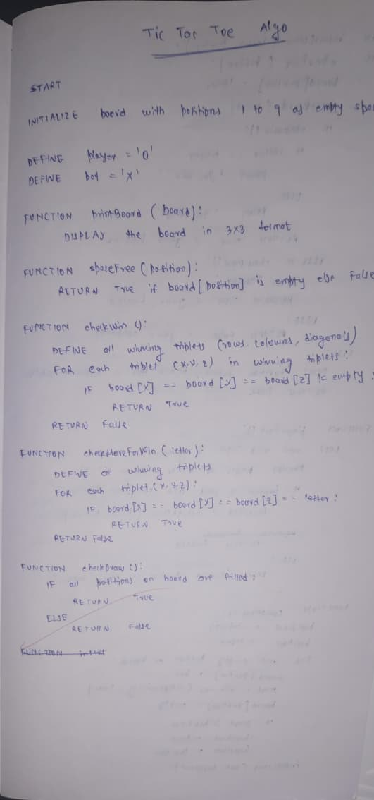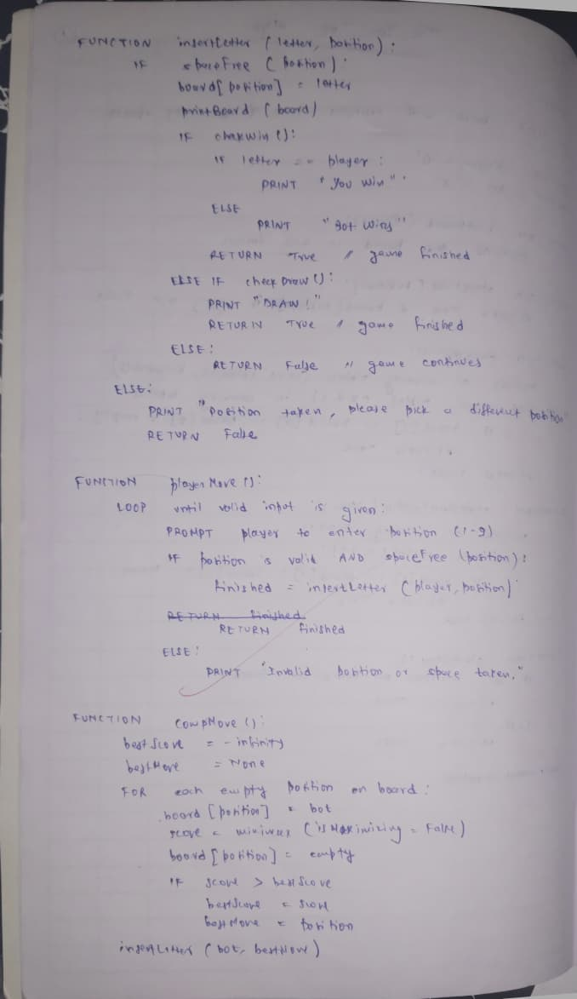

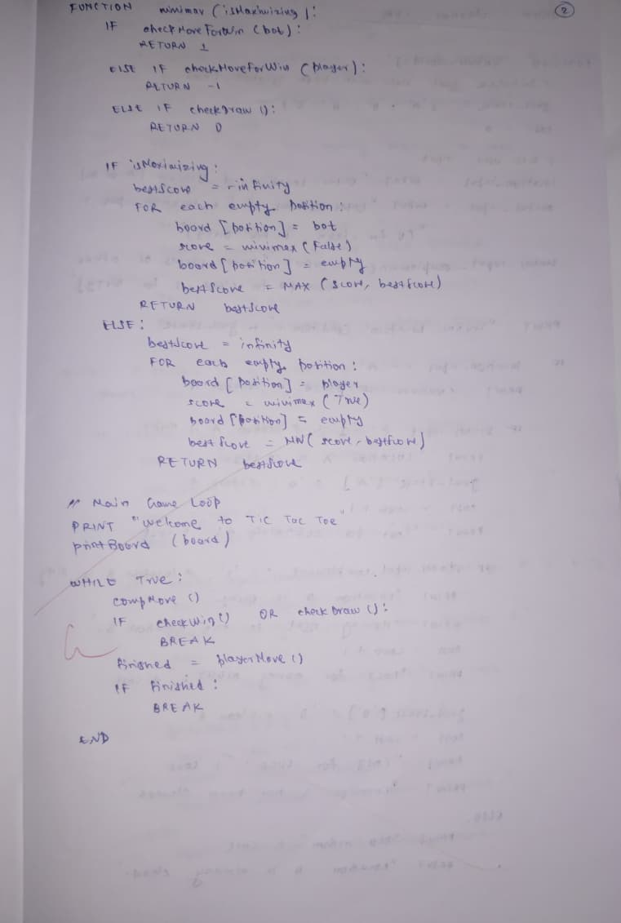
Algorithm (Vacuum Cleaner Agent):
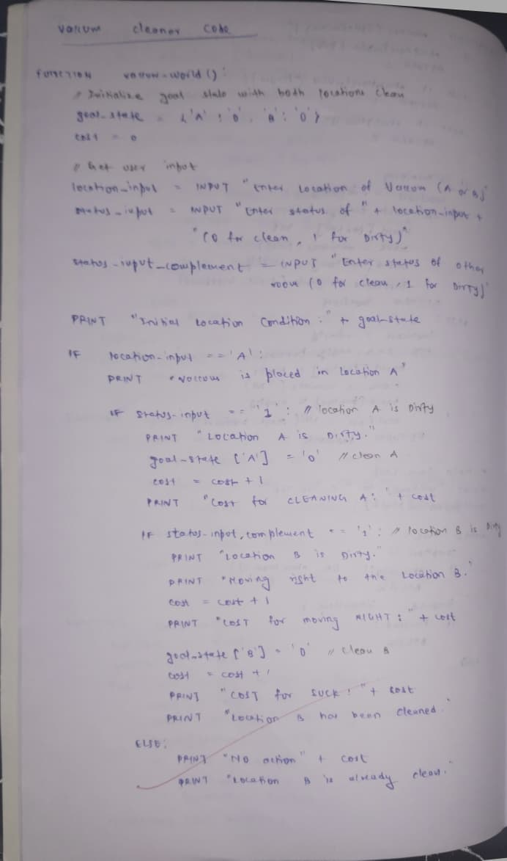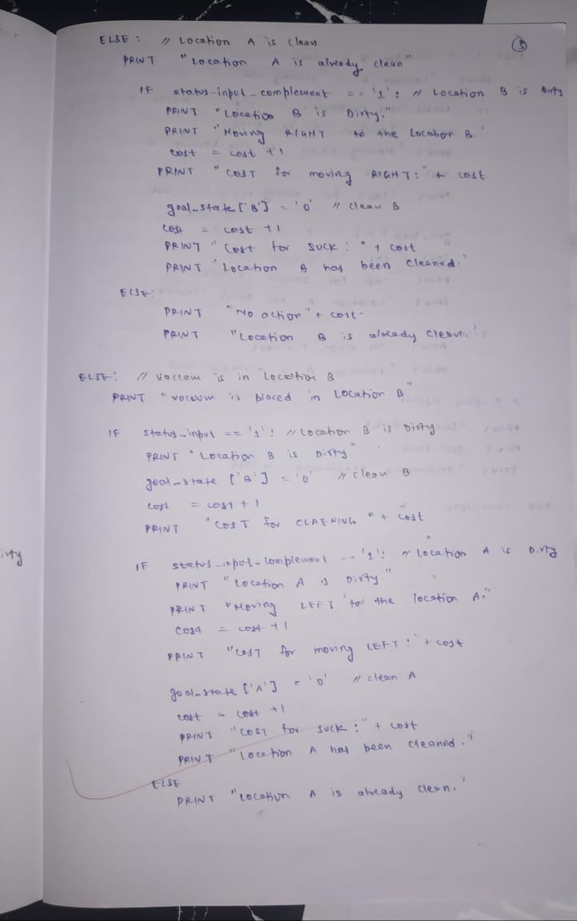

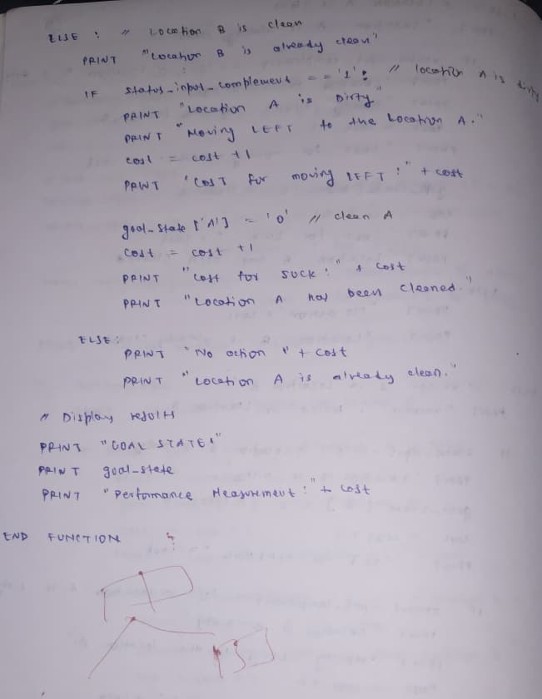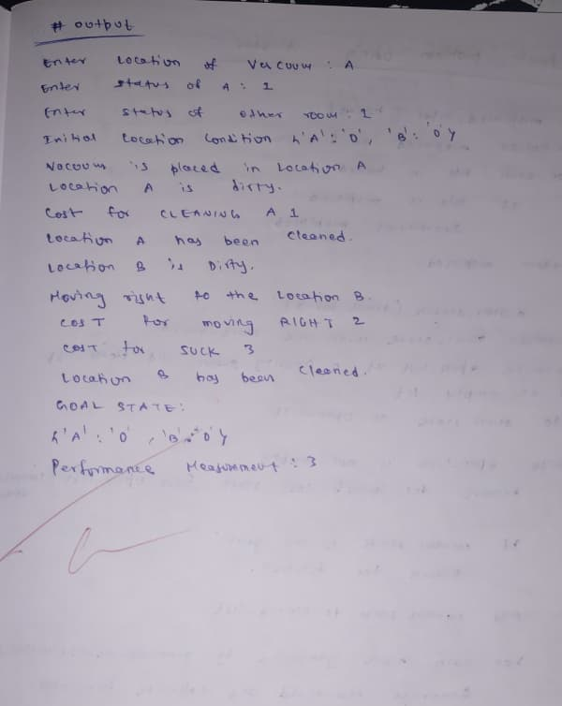

Code (Tic-Tac-Toe):

import math

def print_board(board):
print("-------------")
for row in board:
print("| " + " | ".join(row) + " |")
print("-------------")

def is_moves_left(board):
return any(cell == ' ' for row in board for cell in row)

def evaluate(board):
# Check rows
for row in board:
if row.count(row[0]) == 3 and row[0] != ' ':
return 10 if row[0] == 'O' else -10

# Check columns
for col in range(3):
if (board[0][col] == board[1][col] == board[2][col]) and board[0][col] != ' ':
return 10 if board[0][col] == 'O' else -10

# Check diagonals
if (board[0][0] == board[1][1] == board[2][2]) and board[0][0] != ' ':
return 10 if board[0][0] == 'O' else -10

if (board[0][2] == board[1][1] == board[2][0]) and board[0][2] != ' ':
return 10 if board[0][2] == 'O' else -10

return 0

def minimax(board, depth, is_max):
score = evaluate(board)

if score != 0:
return score - depth if score > 0 else score + depth

if not is_moves_left(board):
return 0

if is_max:
best = -math.inf
for i in range(3):
for j in range(3):
if board[i][j] == ' ':
board[i][j] = 'O'
best = max(best, minimax(board, depth + 1, False))
board[i][j] = ' '
return best
else:
best = math.inf
for i in range(3):
for j in range(3):
if board[i][j] == ' ':
board[i][j] = 'X'
best = min(best, minimax(board, depth + 1, True))
board[i][j] = ' '
return best

def find_best_move(board):
best_val = -math.inf
best_move = (-1, -1)

for i in range(3):
for j in range(3):
if board[i][j] == ' ':
board[i][j] = 'O'
move_val = minimax(board, 0, False)
board[i][j] = ' '

if move_val > best_val:
best_val = move_val
best_move = (i, j)

return best_move

# Game Execution
board = [[' ' for _ in range(3)] for _ in range(3)]

print("Tic-Tac-Toe: You are X and AI is O")
print_board(board)

while True:
r = int(input("Enter row (0-2): "))
c = int(input("Enter col (0-2): "))

if board[r][c] != ' ':
print("Cell occupied! Try again.")
continue

board[r][c] = 'X'
print_board(board)

if evaluate(board) == -10:
print("You win!")
break
if not is_moves_left(board):
print("Draw!")
break

print("AI is thinking...")
move = find_best_move(board)
board[move[0]][move[1]] = 'O'
print_board(board)

if evaluate(board) == 10:
print("AI wins!")
break

Code (Vacuum Cleaner Agent):

def reflex_agent(location, state):
print(f"Current location: {location}")
print(f"Location {location} is: {'Dirty' if state == 1 else 'Clean'}")

if state == 1:
print("Action: Suck")
return "Suck"

if location == 'A':
print("Action: Move Right")
return "Right"
else:
print("Action: Move Left")
return "Left"

def run_vacuum():
loc = input("Enter start location (A/B): ").upper()
state_a = int(input("Enter state of A (1=Dirty, 0=Clean): "))
state_b = int(input("Enter state of B (1=Dirty, 0=Clean): "))

states = {'A': state_a, 'B': state_b}

while True:
current_state = states[loc]
action = reflex_agent(loc, current_state)

if action == "Suck":
states[loc] = 0
else:
loc = "B" if loc == "A" else "A"

if states['A'] == 0 and states['B'] == 0:
print("Both rooms clean. Task completed.")
break

run_vacuum()

Program 2
Implement 8-puzzle using Manhattan Distance.
Implement A* search algorithm.

Algorithm (Manhattan Distance):

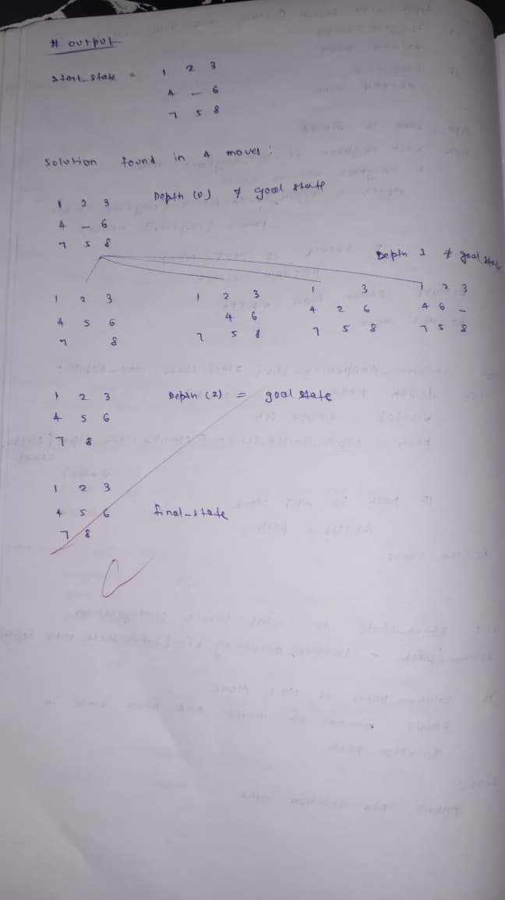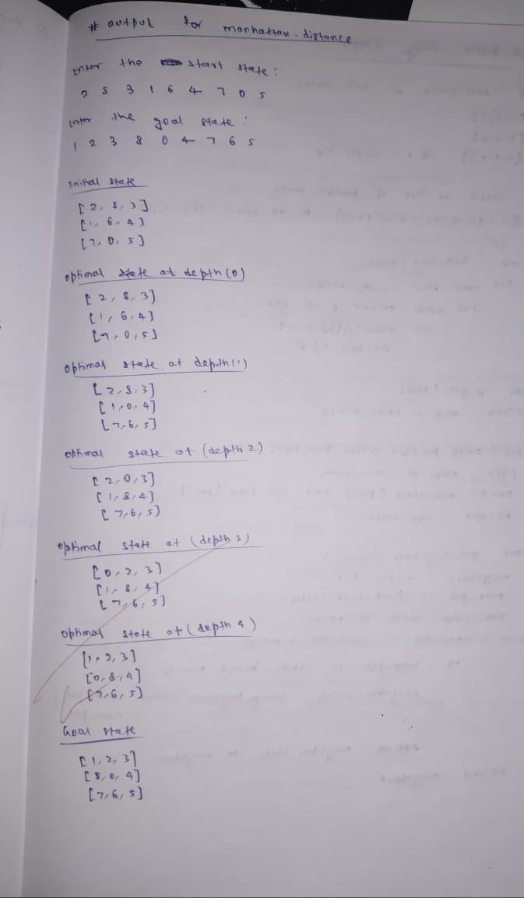
Algorithm (A*):
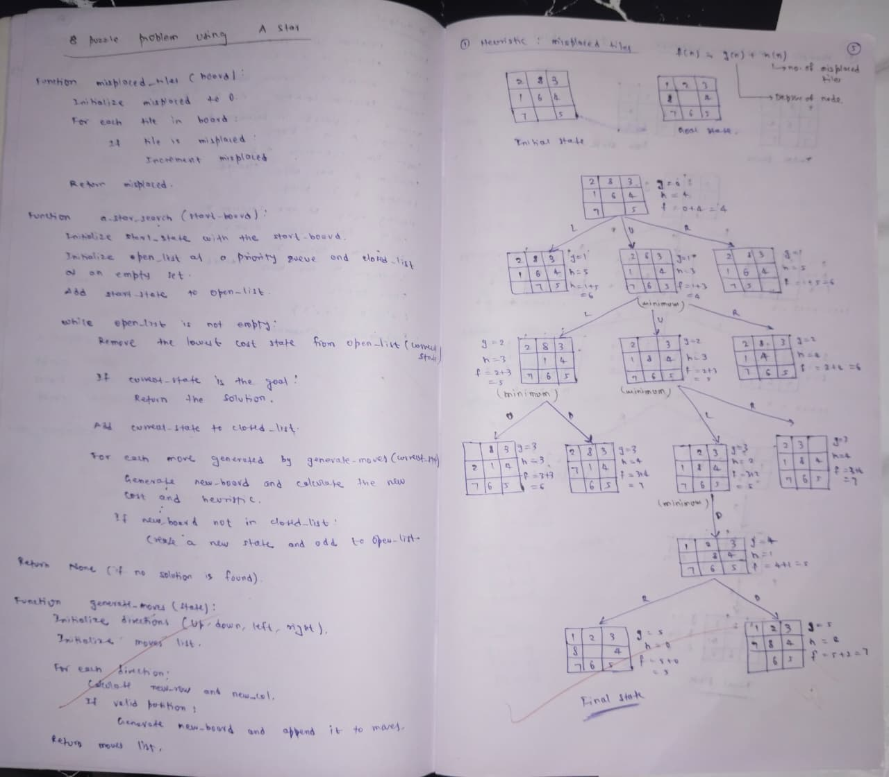

Code (Manhattan Distance):

import heapq

class PuzzleState:
def __init__(self, board, moves=0, previous=None):
self.board = board
self.moves = moves
self.previous = previous
self.zero_index = board.index(0)

def __lt__(self, other):
return (self.moves + self.heuristic()) < (other.moves + other.heuristic())

def heuristic(self):
"""Manhattan distance heuristic relative to spiral goal."""
goal = [1, 2, 3,
8, 0, 4,
7, 6, 5]

distance = 0
for index, value in enumerate(self.board):
if value != 0:
target_index = goal.index(value)
tx, ty = divmod(target_index, 3)
cx, cy = divmod(index, 3)
distance += abs(tx - cx) + abs(ty - cy)
return distance

def is_goal(self):
return self.board == [1, 2, 3,
8, 0, 4,
7, 6, 5]

def get_neighbors(self):
neighbors = []
x, y = divmod(self.zero_index, 3)
directions = [(-1, 0), (1, 0), (0, -1), (0, 1)]

for dx, dy in directions:
nx, ny = x + dx, y + dy
if 0 <= nx < 3 and 0 <= ny < 3:
new_index = nx * 3 + ny
new_board = self.board[:]
new_board[self.zero_index], new_board[new_index] = new_board[new_index], new_board[self.zero_index]
neighbors.append(PuzzleState(new_board, self.moves + 1, self))
return neighbors

def solve_puzzle(start_board):
start_state = PuzzleState(start_board)
frontier = []
heapq.heappush(frontier, start_state)
explored = set()

while frontier:
current = heapq.heappop(frontier)

if tuple(current.board) in explored:
continue
explored.add(tuple(current.board))

if current.is_goal():
return reconstruct_path(current)

for neighbor in current.get_neighbors():
if tuple(neighbor.board) not in explored:
heapq.heappush(frontier, neighbor)

return None

def reconstruct_path(state):
path = []
while state:
path.append(state.board)
state = state.previous
return path[::-1]

if __name__ == "__main__":
start = [2, 8, 3,
1, 6, 4,
0, 7, 5]

solution = solve_puzzle(start)

if solution:
print("Solution found in", len(solution) - 1, "moves")
for step in solution:
for i in range(0, 9, 3):
print(step[i:i+3])
print()
else:
print("No solution exists.")

Code (A*):

import heapq

class PuzzleState:
def __init__(self, board, moves=0, previous=None):
self.board = board
self.moves = moves
self.previous = previous
self.zero_index = board.index(0)

def __lt__(self, other):
return (self.moves + self.heuristic()) < (other.moves + other.heuristic())

def heuristic(self):
"""Misplaced tiles heuristic."""
goal = [1, 2, 3,
8, 0, 4,
7, 6, 5]

return sum(1 for i, val in enumerate(self.board) if val != 0 and val != goal[i])

def is_goal(self):
return self.board == [1, 2, 3,
8, 0, 4,
7, 6, 5]

def get_neighbors(self):
neighbors = []
x, y = divmod(self.zero_index, 3)
dirs = [(-1, 0), (1, 0), (0, -1), (0, 1)]

for dx, dy in dirs:
nx, ny = x + dx, y + dy
if 0 <= nx < 3 and 0 <= ny < 3:
ni = nx * 3 + ny
new_board = self.board[:]
new_board[self.zero_index], new_board[ni] = new_board[ni], new_board[self.zero_index]
neighbors.append(PuzzleState(new_board, self.moves + 1, self))

return neighbors

def solve_puzzle(start_board):
start = PuzzleState(start_board)
pq = []
heapq.heappush(pq, start)
visited = set()

while pq:
current = heapq.heappop(pq)

if tuple(current.board) in visited:
continue
visited.add(tuple(current.board))

if current.is_goal():
return reconstruct_path(current)

for nxt in current.get_neighbors():
if tuple(nxt.board) not in visited:
heapq.heappush(pq, nxt)

return None

def reconstruct_path(state):
path = []
while state:
path.append(state.board)
state = state.previous
return path[::-1]

if __name__ == "__main__":
start = [2, 8, 3,
1, 6, 4,
0, 7, 5]

sol = solve_puzzle(start)

if sol:
print("Solution found in", len(sol) - 1, "moves")
for step in sol:
for i in range(0, 9, 3):
print(step[i:i+3])
print()
else:
print("No solution exists.")
Program 3
Implement Hill Climbing search algorithm to solve N-Queens problem.

Algorithm:
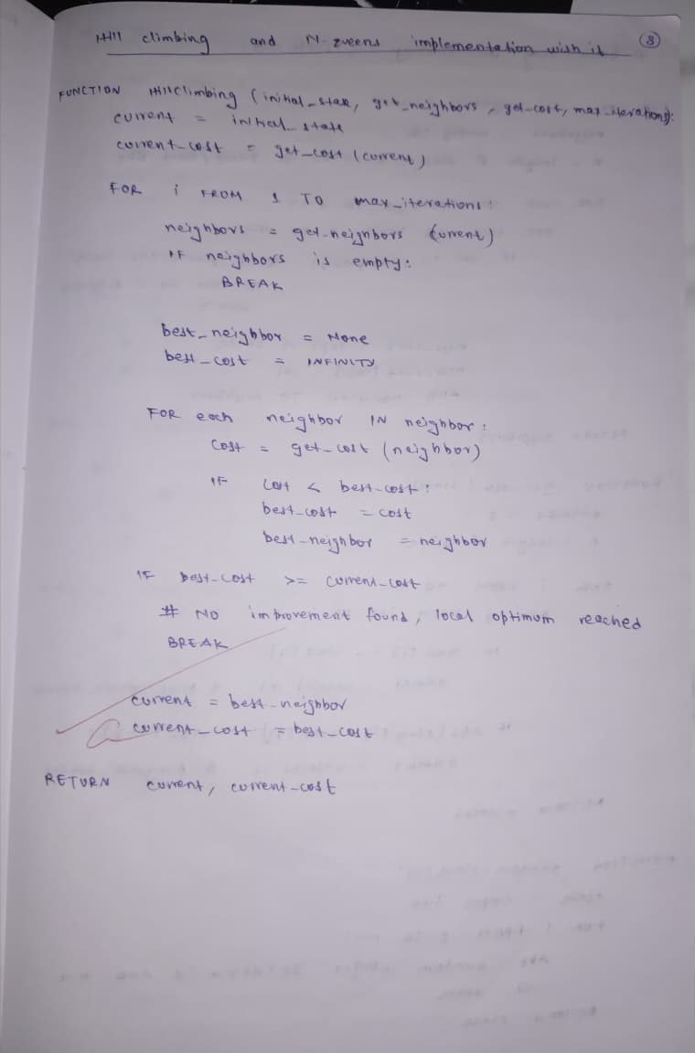

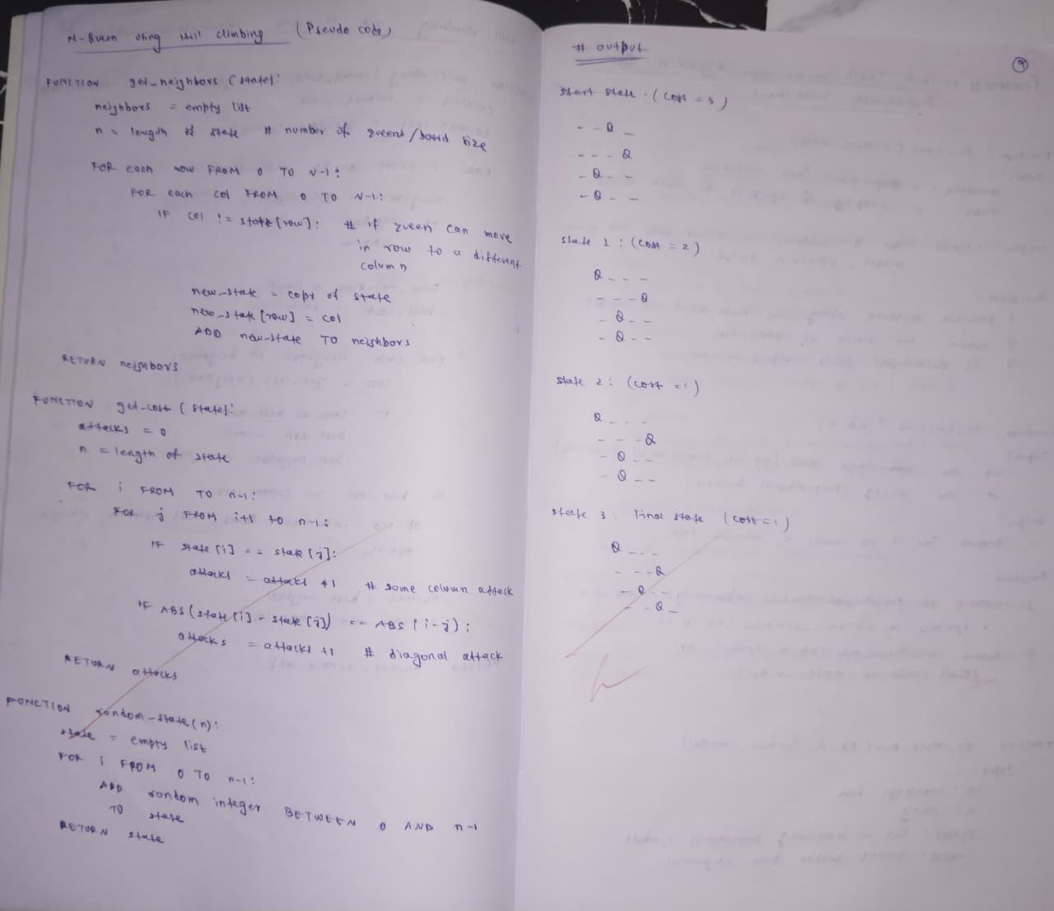
Code:

import random

def generate_initial_state(n):
return [random.randint(0, n - 1) for _ in range(n)]

def calculate_conflicts(state):
n = len(state)
conflicts = 0

for i in range(n):
for j in range(i + 1, n):
# Same row conflict
if state[i] == state[j]:
conflicts += 1
# Diagonal conflict
if abs(state[i] - state[j]) == abs(i - j):
conflicts += 1

return conflicts

def get_best_neighbor(state):
n = len(state)
best_state = state[:]
best_conflicts = calculate_conflicts(state)

for col in range(n):
original_row = state[col]
for row in range(n):
if row == original_row:
continue

new_state = state[:]
new_state[col] = row
current_conflicts = calculate_conflicts(new_state)

if current_conflicts < best_conflicts:
best_conflicts = current_conflicts
best_state = new_state

return best_state, best_conflicts

def hill_climbing(n, max_restarts=100):
for restart in range(max_restarts):
current_state = generate_initial_state(n)
current_conflicts = calculate_conflicts(current_state)

while True:
next_state, next_conflicts = get_best_neighbor(current_state)

# Local maximum reached (no improvement)
if next_conflicts >= current_conflicts:
break

current_state = next_state
current_conflicts = next_conflicts

if current_conflicts == 0:
print(f"Solution found after {restart + 1} restarts!")
return current_state

print("Failed to find a solution")
return None

def print_board(state):
if state is None:
print("No solution to print.")
return

n = len(state)
for row in range(n):
line = ""
for col in range(n):
line += " Q " if state[col] == row else " . "
print(line)

# Run the algorithm
n = 8
solution = hill_climbing(n)
print_board(solution)

Program 4
Implement Iterative Deepening Search Algorithm to solve 8-puzzle.

Algorithm:
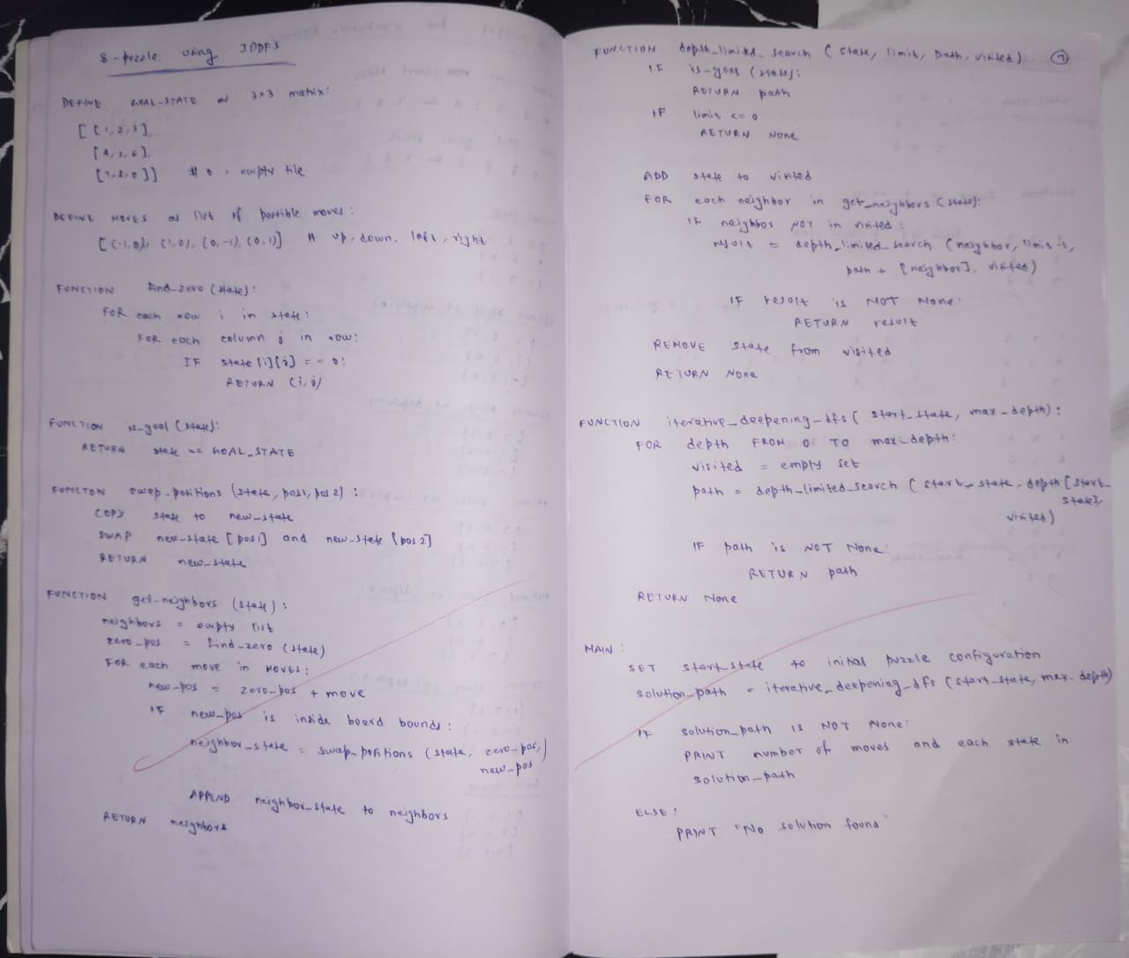
Code:

from collections import deque

# Goal configuration for the 8-puzzle
GOAL_STATE = (
1, 2, 3,
4, 5, 6,
7, 8, 0
)

# Possible movements for the blank tile (0)
MOVES = {
'UP': -3,
'DOWN': 3,
'LEFT': -1,
'RIGHT': 1
}

def is_valid_move(blank_idx, move):
if move == 'UP' and blank_idx < 3:
return False
if move == 'DOWN' and blank_idx > 5:
return False
if move == 'LEFT' and blank_idx % 3 == 0:
return False
if move == 'RIGHT' and blank_idx % 3 == 2:
return False
return True

def apply_move(state, move):
blank_idx = state.index(0)
if not is_valid_move(blank_idx, move):
return None

target_idx = blank_idx + MOVES[move]
new_state = list(state)
new_state[blank_idx], new_state[target_idx] = new_state[target_idx], new_state[blank_idx]

return tuple(new_state)

def dls(state, depth_limit, path, visited):
if state == GOAL_STATE:
return path

if depth_limit == 0:
return None

visited.add(state)

for move in MOVES:
next_state = apply_move(state, move)
if next_state and next_state not in visited:
result = dls(next_state, depth_limit - 1, path + [move], visited)
if result:
return result

return None

def iddfs(start_state, max_depth=30):
for depth in range(max_depth):
visited = set()
result = dls(start_state, depth, [], visited)
if result is not None:
return result
return None

def print_state(state):
for i in range(0, 9, 3):
print(state[i:i+3])
print()

# Start configuration
start_state = (
1, 2, 3,
4, 0, 6,
7, 5, 8
)

print("Initial State:")
print_state(start_state)

solution = iddfs(start_state)

if solution:
print(f"Solution found in {len(solution)} moves:")
print(solution)

current = start_state
for move in solution:
current = apply_move(current, move)
print(f"Move: {move}")
print_state(current)
else:
print("No solution found.")

Program 5
Create a knowledge base using propositional logic and show that the given query entails the knowledge base or not.

Algorithm:

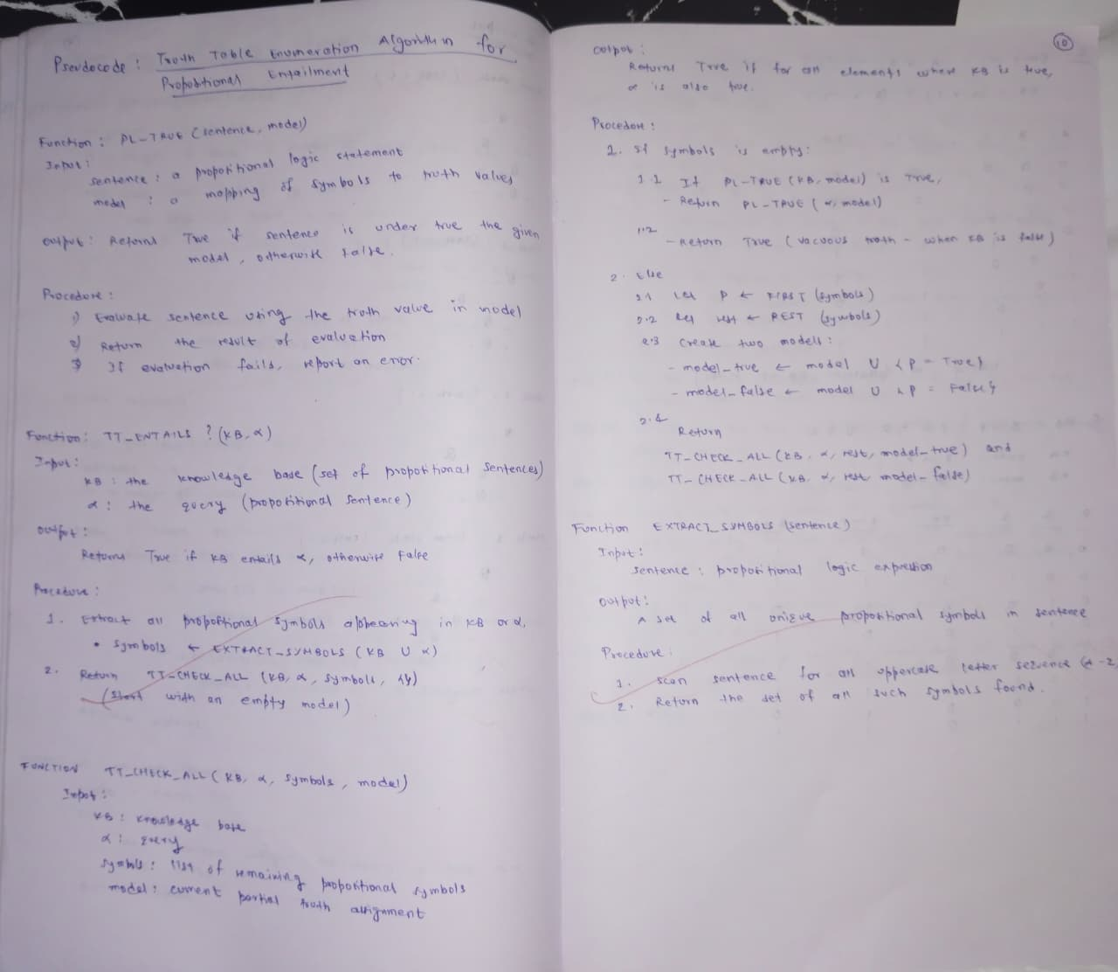
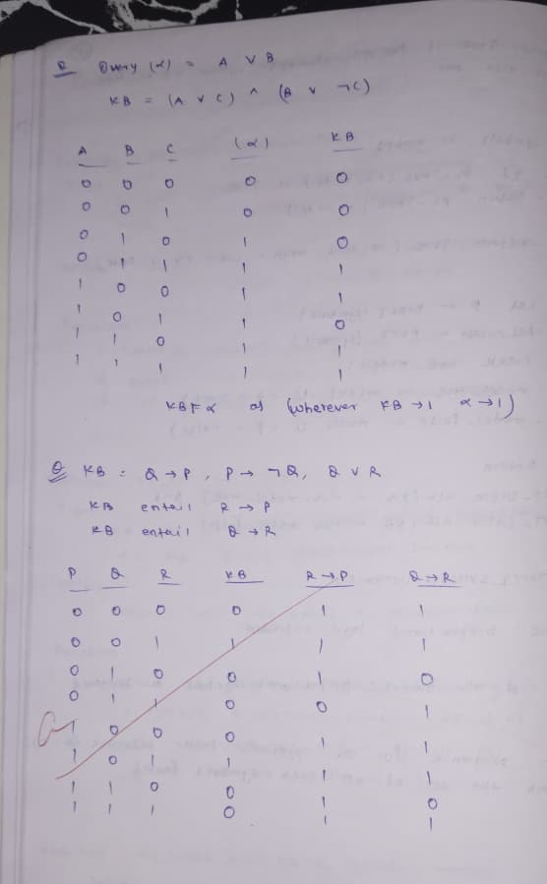

Code:

from itertools import product
import re

# ---------------------------------------------
# Main Entailment Function
# ---------------------------------------------
def TT_ENTAILS(KB, alpha):
"""
Check if knowledge base KB entails sentence alpha
using truth-table enumeration.
"""
symbols = get_symbols(KB) | get_symbols([alpha])
symbols = list(symbols)

return TT_CHECK_ALL(KB, alpha, symbols, {})

# ---------------------------------------------
# Recursive Truth Table Checker
# ---------------------------------------------
def TT_CHECK_ALL(KB, alpha, symbols, model):
"""
KB: list of propositional logic sentences
alpha: query sentence
symbols: remaining propositional symbols
model: current truth assignment dictionary
"""
# If all symbols assigned -> evaluate KB
if not symbols:
if PL_TRUE(KB, model):
return PL_TRUE([alpha], model)
else:
return True

# Otherwise, split symbol into True/False cases
P = symbols[0]
rest = symbols[1:]

return (
TT_CHECK_ALL(KB, alpha, rest, {**model, P: True}) and
TT_CHECK_ALL(KB, alpha, rest, {**model, P: False})
)

# ---------------------------------------------
# Evaluate KB under a model
# ---------------------------------------------
def PL_TRUE(sentences, model):
"""
Returns True if all sentences evaluate to True
in the given model.
"""
for sentence in sentences:
if not evaluate(sentence, model):
return False
return True

# ---------------------------------------------
# Extract symbols from sentences
# ---------------------------------------------
def get_symbols(sentences):
"""
Extract propositional symbols from list of sentences.
Assumes symbols are alphabetic words.
"""
symbols = set()

for sentence in sentences:
tokens = re.findall(r'\b[A-Za-z][A-Za-z0-9_]*\b', sentence)

for token in tokens:
if token.lower() not in ["and", "or", "not", "implies", "iff", "true", "false"]:
symbols.add(token)

return symbols

# ---------------------------------------------
# Evaluate propositional expression with model
# ---------------------------------------------
def evaluate(expr, model):
"""
Evaluate propositional logic expression under given model.
Supports symbols, AND/OR/NOT, parentheses, and logic symbols.
"""

# Replace variables with True/False
for symbol, value in model.items():
expr = replace_symbol(expr, symbol, str(value))

# Replace logic operators with Python equivalents
expr = expr.replace("∧", " and ")
expr = expr.replace("∨", " or ")
expr = expr.replace("¬", " not ")
expr = expr.replace("→", " <= ") # P → Q becomes (P <= Q)
expr = expr.replace("↔", " == ") # equivalence

# Safely evaluate
try:
return bool(eval(expr, {"__builtins__": None}, {}))
except Exception as e:
print(f"Error evaluating expression '{expr}': {e}")
return False

# ---------------------------------------------
# Replace symbol carefully (whole word match)
# ---------------------------------------------
def replace_symbol(expr, symbol, value):
pattern = r'\b' + re.escape(symbol) + r'\b'
return re.sub(pattern, value, expr)

# ---------------------------------------------
# Example Usage
# ---------------------------------------------
KB = [
"(P ∨ Q)",
"(¬P ∨ R)",
"(¬Q ∨ R)"
]

alpha = "R"

result = TT_ENTAILS(KB, alpha)
print(f"Does KB entail alpha? {result}")

Program 6
Implement unification in first order logic.

Algorithm:
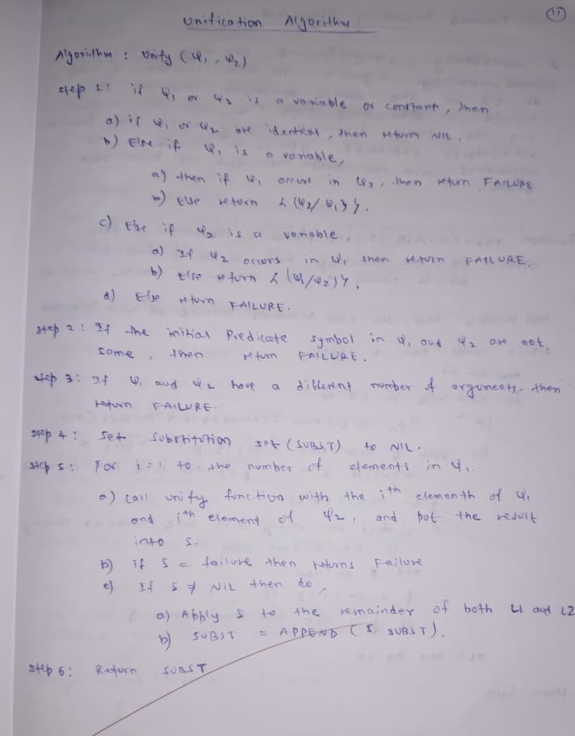

Code:

def is_variable(x):
"""Check if x is a variable (starts with lowercase letter)."""
return isinstance(x, str) and x[0].islower()

def occur_check(var, expr):
"""Check if variable 'var' occurs in expression 'expr'."""
if var == expr:
return True
elif isinstance(expr, list):
return any(occur_check(var, subexpr) for subexpr in expr)
return False

def substitute(expr, subst):
"""Apply a substitution set to an expression."""
if isinstance(expr, list):
return [substitute(e, subst) for e in expr]

for (var, val) in subst:
if expr == var:
return val
return expr

def unify(x, y, subst=None):
"""Unify two expressions x and y."""
if subst is None:
subst = []

# If already identical
if x == y:
return subst

# Case 1: x is a variable
if is_variable(x):
if occur_check(x, y):
return None
subst.append((x, y))
return subst

# Case 2: y is a variable
if is_variable(y):
if occur_check(y, x):
return None
subst.append((y, x))
return subst

# Case 3: both are compound expressions
if isinstance(x, list) and isinstance(y, list):
if x[0] != y[0]: # functors mismatch
return None
if len(x) != len(y): # arity mismatch
return None

for i in range(1, len(x)):
s = unify(substitute(x[i], subst), substitute(y[i], subst), subst)
if s is None:
return None
subst = s

return subst

# Otherwise cannot unify
return None

# Example expressions
expr1 = ['Knows', 'John', ['Father', 'x']]
expr2 = ['Knows', 'John', ['Father', 'Jack']]

result = unify(expr1, expr2)

print("Expression 1:", expr1)
print("Expression 2:", expr2)

if result:
print("Unification Successful. Substitution Set:", result)
else:
print("Unification Failed.")

Program 7
Create a knowledge base consisting of first order logic statements and prove the given query using forward reasoning.

Algorithm:
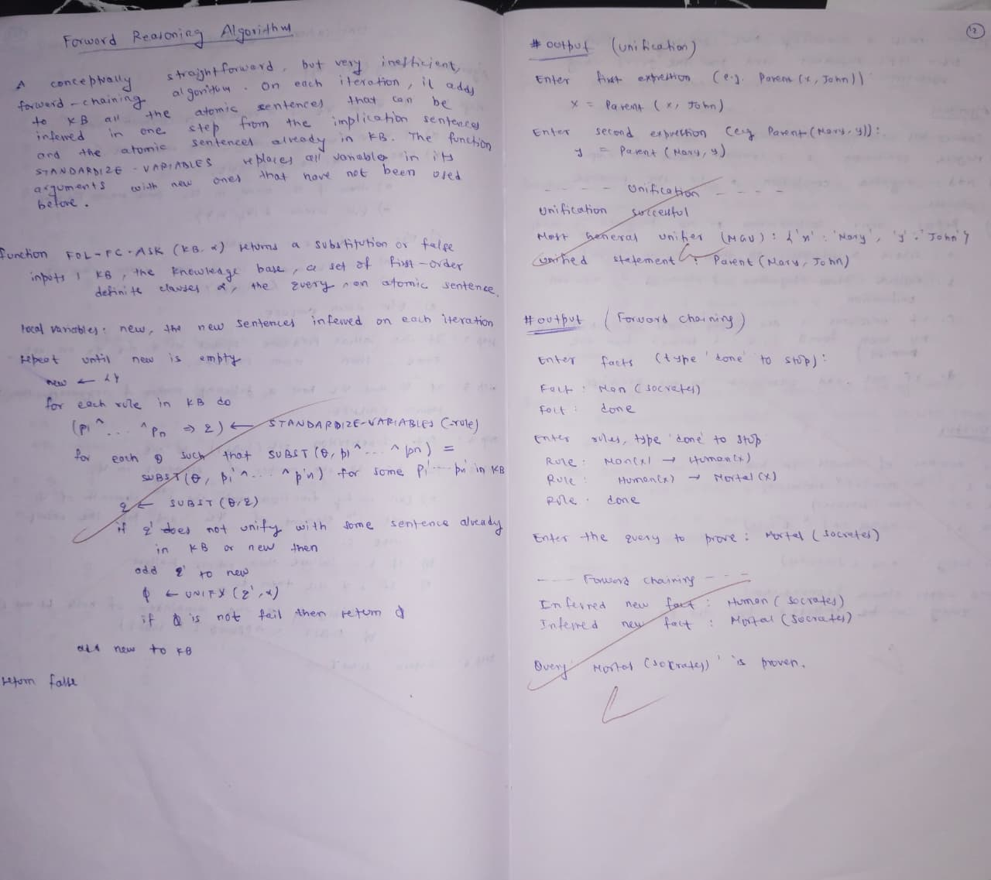

Code:

def is_variable(x):
return isinstance(x, str) and x[0].islower()

def occur_check(var, expr):
if var == expr:
return True
elif isinstance(expr, list):
return any(occur_check(var, subexpr) for subexpr in expr)
return False

def substitute(expr, subst):
if isinstance(expr, list):
return [substitute(e, subst) for e in expr]

for (var, val) in subst:
if expr == var:
return val
return expr

def unify(x, y, subst=None):
if subst is None:
subst = []

if x == y:
return subst

if is_variable(x):
if occur_check(x, y):
return None
subst.append((x, y))
return subst

if is_variable(y):
if occur_check(y, x):
return None
subst.append((y, x))
return subst

if isinstance(x, list) and isinstance(y, list):
if x[0] != y[0] or len(x) != len(y):
return None

for i in range(1, len(x)):
subst = unify(substitute(x[i], subst),
substitute(y[i], subst),
subst)
if subst is None:
return None
return subst

return None

def fol_fc_ask(KB, query):
inferred = set()
new = True

while new:
new = set()

for rule in KB:
if '=>' in rule:
idx = rule.index('=>')
premises = rule[:idx]
conclusion = rule[idx + 1]

matches = []
for premise in premises:
for fact in KB:
if '=>' not in fact:
s = unify(premise, fact)
if s is not None:
matches.append(s)

for s in matches:
new_fact = substitute(conclusion, s)

if new_fact not in KB and tuple(new_fact) not in new:
new.add(tuple(new_fact))

# Check if matches query
if unify(new_fact, query) is not None:
return True

KB.extend([list(n) for n in new])

return False

# Knowledge Base
KB = [
['Parent', 'John', 'Mary'],
['Parent', 'Mary', 'Anne'],
[['Parent', 'x', 'y'], ['Parent', 'y', 'z'], '=>', ['Grandparent', 'x', 'z']]
]

query = ['Grandparent', 'John', 'Anne']
result = fol_fc_ask(KB, query)

print("Query:", query)
print("Entailed?", result)

Program 8
Create a knowledge base consisting of first order logic statements and prove the given query using Resolution.

Algorithm:
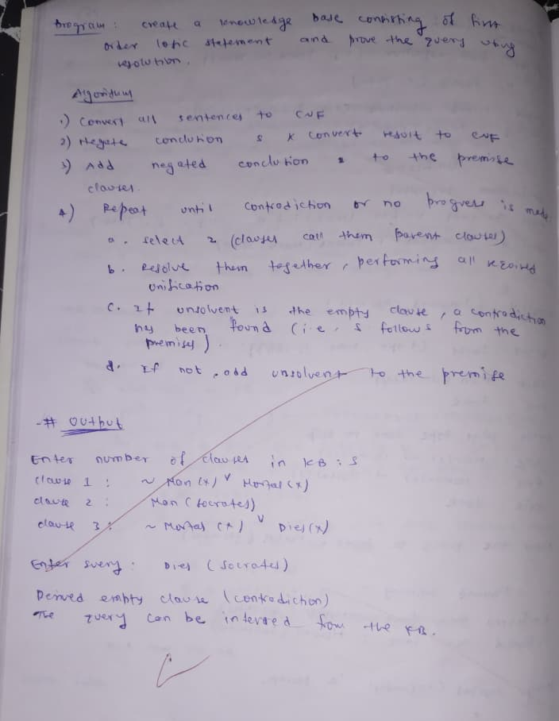

Code:

def is_variable(x):
return isinstance(x, str) and x[0].islower()

def substitute(expr, subst):
"""Apply a substitution mapping to an expression."""
if isinstance(expr, list):
return [substitute(e, subst) for e in expr]

for (var, val) in subst.items():
if expr == var:
return val
return expr

def unify(x, y, subst=None):
"""Unification algorithm."""
if subst is None:
subst = {}

if x == y:
return subst

if is_variable(x):
return unify_var(x, y, subst)

if is_variable(y):
return unify_var(y, x, subst)

if isinstance(x, list) and isinstance(y, list):
if len(x) != len(y) or x[0] != y[0]:
return None

for i in range(1, len(x)):
subst = unify(
substitute(x[i], subst),
substitute(y[i], subst),
subst
)
if subst is None:
return None

return subst

return None

def unify_var(var, x, subst):
if var in subst:
return unify(subst[var], x, subst)

elif isinstance(x, str) and x in subst:
return unify(var, subst[x], subst)

elif occur_check(var, x, subst):
return None

else:
subst[var] = x
return subst

def occur_check(var, x, subst):
"""Check if variable occurs in expression (to prevent infinite loops)."""
if var == x:
return True

elif isinstance(x, list):
return any(occur_check(var, xi, subst) for xi in x)

elif x in subst:
return occur_check(var, subst[x], subst)

return False

def negate(literal):
"""Return negation of a literal."""
if literal[0] == '¬':
return literal[1:] # remove negation
return '¬' + literal

def resolve(ci, cj):
"""Resolve two clauses."""
resolvents = []

for di in ci:
for dj in cj:
if di == negate(dj):
new_clause = list(set(ci + cj))
new_clause.remove(di)
new_clause.remove(dj)
resolvents.append(new_clause)

return resolvents

def pl_resolution(KB, query):
"""Resolution algorithm: returns True if KB ⊨ query."""
clauses = KB + [[negate(query)]]
new = set()

while True:
pairs = [
(clauses[i], clauses[j])
for i in range(len(clauses))
for j in range(i + 1, len(clauses))
]

for (ci, cj) in pairs:
resolvents = resolve(ci, cj)

if [] in resolvents:
return True # Empty clause found -> contradiction

for r in resolvents:
new.add(tuple(sorted(r)))

# If no new clauses generated → stop
if new.issubset(set(tuple(sorted(c)) for c in clauses)):
return False

# Add new clauses
for c in new:
if list(c) not in clauses:
clauses.append(list(c))

# ---------------------------------------------------------------
# Example Knowledge Base
# ---------------------------------------------------------------

# KB:
# 1. P ⇒ Q → [¬P, Q]
# 2. L ∧ M ⇒ P → [¬L, ¬M, P]
# 3. L → [L]
# 4. M → [M]
#
# Query: Q

KB = [
['¬P', 'Q'],
['¬L', '¬M', 'P'],
['L'],
['M']
]

query = 'Q'
result = pl_resolution(KB, query)

print("Query:", query)
print("Entailed?", result)

Program 9
Convert First Order Logic to Conjunctive Normal Form.

Algorithm:

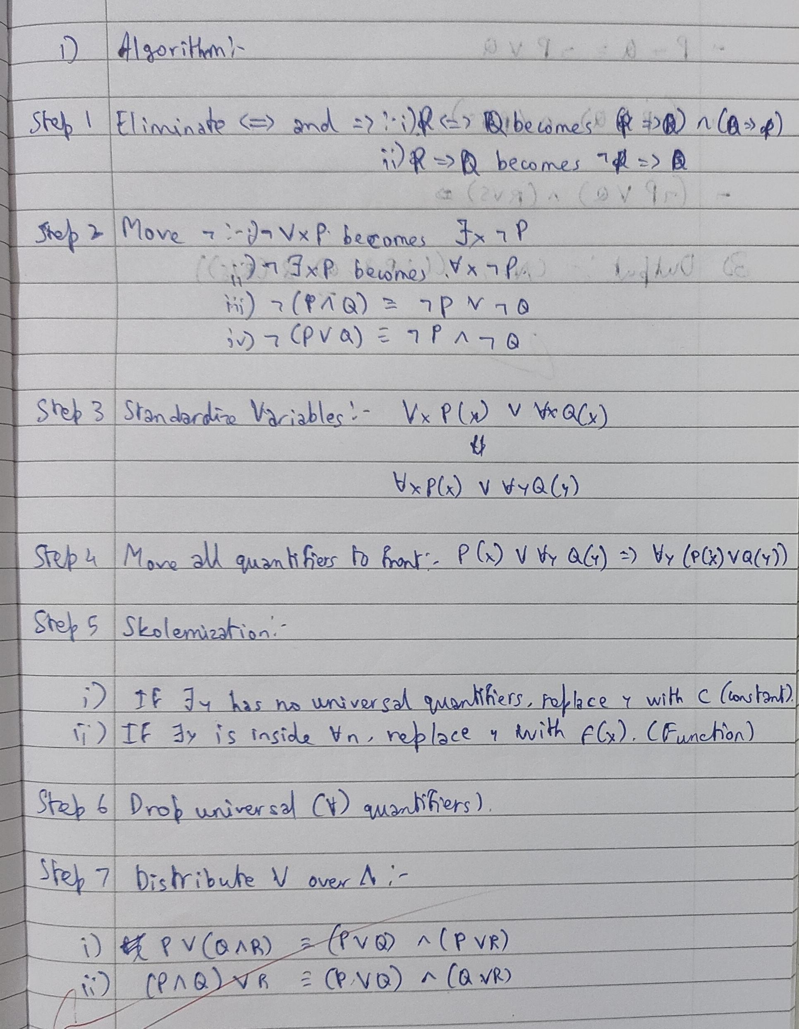

Code:

import itertools

# ---------------------------------------------------------
# Term, Predicate, and Logical Operator Classes
# ---------------------------------------------------------

class Var:
def __init__(self, name):
self.name = name

def __repr__(self):
return self.name

class Func:
def __init__(self, name, args=None):
if args is None:
args = []
self.name = name
self.args = args

def __repr__(self):
return f"{self.name}({', '.join(map(str, self.args))})"

class Pred:
def __init__(self, name, args=None):
if args is None:
args = []
self.name = name
self.args = args

def __repr__(self):
return f"{self.name}({', '.join(map(str, self.args))})"

class Not:
def __init__(self, f):
self.f = f

def __repr__(self):
return f"¬{self.f}"

class And:
def __init__(self, left, right):
self.left = left
self.right = right

def __repr__(self):
return f"({self.left} ∧ {self.right})"

class Or:
def __init__(self, left, right):
self.left = left
self.right = right

def __repr__(self):
return f"({self.left} ∨ {self.right})"

class Forall:
def __init__(self, var, f):
self.var = var
self.f = f

def __repr__(self):
return f"∀{self.var}.{self.f}"

class Exists:
def __init__(self, var, f):
self.var = var
self.f = f

def __repr__(self):
return f"∃{self.var}.{self.f}"

# ---------------------------------------------------------
# Implication Elimination
# ---------------------------------------------------------

def eliminate_implications(f):
if isinstance(f, Pred):
return f

if isinstance(f, Not):
return Not(eliminate_implications(f.f))

if isinstance(f, And):
return And(
eliminate_implications(f.left),
eliminate_implications(f.right)
)

if isinstance(f, Or):
return Or(
eliminate_implications(f.left),
eliminate_implications(f.right)
)

if isinstance(f, Forall):
return Forall(f.var, eliminate_implications(f.f))

if isinstance(f, Exists):
return Exists(f.var, eliminate_implications(f.f))

if isinstance(f, tuple) and f[0] == "IMP":
a = eliminate_implications(f[1])
b = eliminate_implications(f[2])
return Or(Not(a), b)

raise ValueError("Unknown formula type")

# ---------------------------------------------------------
# Negation Normal Form (NNF)
# ---------------------------------------------------------

def nnf(f):
if isinstance(f, Pred):
return f

if isinstance(f, And):
return And(nnf(f.left), nnf(f.right))

if isinstance(f, Or):
return Or(nnf(f.left), nnf(f.right))

if isinstance(f, Forall):
return Forall(f.var, nnf(f.f))

if isinstance(f, Exists):
return Exists(f.var, nnf(f.f))

if isinstance(f, Not):
g = f.f

# Base case: ¬Predicate
if isinstance(g, Pred):
return f

# Double negation
if isinstance(g, Not):
return nnf(g.f)

# ¬(A ∧ B)
if isinstance(g, And):
return Or(
nnf(Not(g.left)),
nnf(Not(g.right))
)

# ¬(A ∨ B)
if isinstance(g, Or):
return And(
nnf(Not(g.left)),
nnf(Not(g.right))
)

# ¬∀x P → ∃x ¬P
if isinstance(g, Forall):
return Exists(g.var, nnf(Not(g.f)))

# ¬∃x P → ∀x ¬P
if isinstance(g, Exists):
return Forall(g.var, nnf(Not(g.f)))

return f

# ---------------------------------------------------------
# Standardize Variables Apart
# ---------------------------------------------------------

counter = itertools.count()

def standardize(f, env=None):
if env is None:
env = {}

if isinstance(f, Var):
return env.get(f.name, f)

if isinstance(f, Pred):
return Pred(f.name, [standardize(a, env) for a in f.args])

if isinstance(f, And):
return And(standardize(f.left, env), standardize(f.right, env))

if isinstance(f, Or):
return Or(standardize(f.left, env), standardize(f.right, env))

if isinstance(f, Not):
return Not(standardize(f.f, env))

if isinstance(f, Forall) or isinstance(f, Exists):
new_var = Var(f"{f.var.name}_{next(counter)}")
new_env = env.copy()
new_env[f.var.name] = new_var
return type(f)(new_var, standardize(f.f, new_env))

# ---------------------------------------------------------
# Skolemization
# ---------------------------------------------------------

def skolemize(f, scope_vars=None):
if scope_vars is None:
scope_vars = []

if isinstance(f, Pred):
return f

if isinstance(f, Not):
return Not(skolemize(f.f, scope_vars))

if isinstance(f, And):
return And(
skolemize(f.left, scope_vars),
skolemize(f.right, scope_vars)
)

if isinstance(f, Or):
return Or(
skolemize(f.left, scope_vars),
skolemize(f.right, scope_vars)
)

if isinstance(f, Forall):
return Forall(f.var, skolemize(f.f, scope_vars + [f.var]))

if isinstance(f, Exists):
sk_name = f"Sk{next(counter)}"
sk_term = Func(sk_name, scope_vars)
return skolemize(
substitute(f.f, {f.var.name: sk_term}),
scope_vars
)

# ---------------------------------------------------------
# Substitution
# ---------------------------------------------------------

def substitute(f, sub):
if isinstance(f, Var):
return sub.get(f.name, f)

if isinstance(f, Pred):
return Pred(f.name, [substitute(a, sub) for a in f.args])

if isinstance(f, Func):
return Func(f.name, [substitute(a, sub) for a in f.args])

if isinstance(f, Not):
return Not(substitute(f.f, sub))

if isinstance(f, And):
return And(substitute(f.left, sub), substitute(f.right, sub))

if isinstance(f, Or):
return Or(substitute(f.left, sub), substitute(f.right, sub))

if isinstance(f, Forall) or isinstance(f, Exists):
return type(f)(f.var, substitute(f.f, sub))

# ---------------------------------------------------------
# Drop Universal Quantifiers
# ---------------------------------------------------------

def drop_universal(f):
if isinstance(f, Forall):
return drop_universal(f.f)

if isinstance(f, And):
return And(drop_universal(f.left), drop_universal(f.right))

if isinstance(f, Or):
return Or(drop_universal(f.left), drop_universal(f.right))

if isinstance(f, Not):
return f

return f

# ---------------------------------------------------------
# Distribute OR over AND (CNF conversion)
# ---------------------------------------------------------

def distribute(f):
if isinstance(f, Or):
A = distribute(f.left)
B = distribute(f.right)

if isinstance(A, And):
return And(
distribute(Or(A.left, B)),
distribute(Or(A.right, B))
)

if isinstance(B, And):
return And(
distribute(Or(A, B.left)),
distribute(Or(A, B.right))
)

return Or(A, B)

if isinstance(f, And):
return And(distribute(f.left), distribute(f.right))

return f

# ---------------------------------------------------------
# Full CNF Conversion Pipeline
# ---------------------------------------------------------

def to_cnf(f):
print("Original:", f)

f = eliminate_implications(f)
print("No → :", f)

f = nnf(f)
print("NNF:", f)

f = standardize(f)
print("Standardized:", f)

f = skolemize(f)
print("Skolemized:", f)

f = drop_universal(f)
print("Dropped ∀:", f)

f = distribute(f)
print("CNF:", f)

return f

# ---------------------------------------------------------
# Test Formula
# ---------------------------------------------------------

formula = Forall(
Var("x"),
Exists(
Var("y"),
("IMP", Pred("P", [Var("x")]), Pred("Q", [Var("y")]))
)
)

cnf_formula = to_cnf(formula)

Program 10
Implement Alpha-Beta Pruning.

Algorithm:
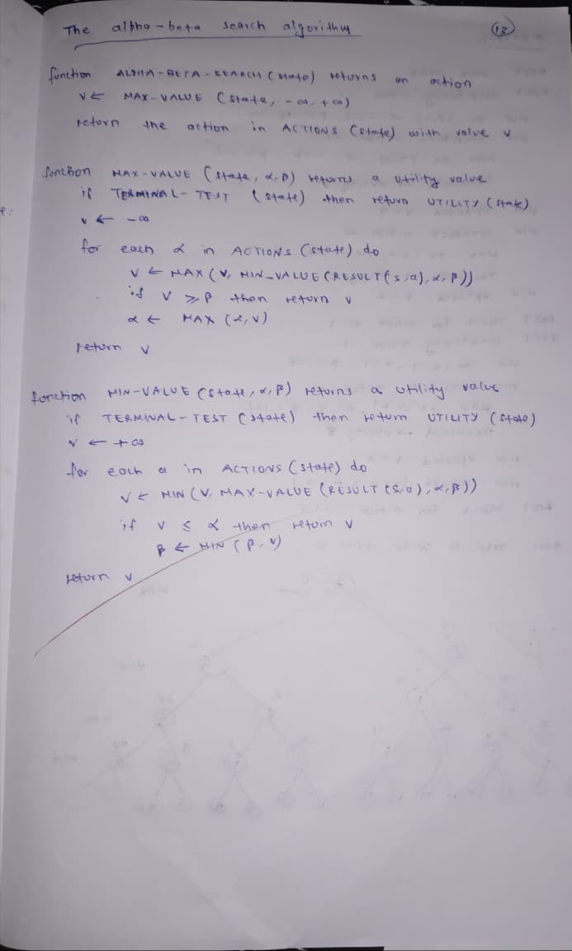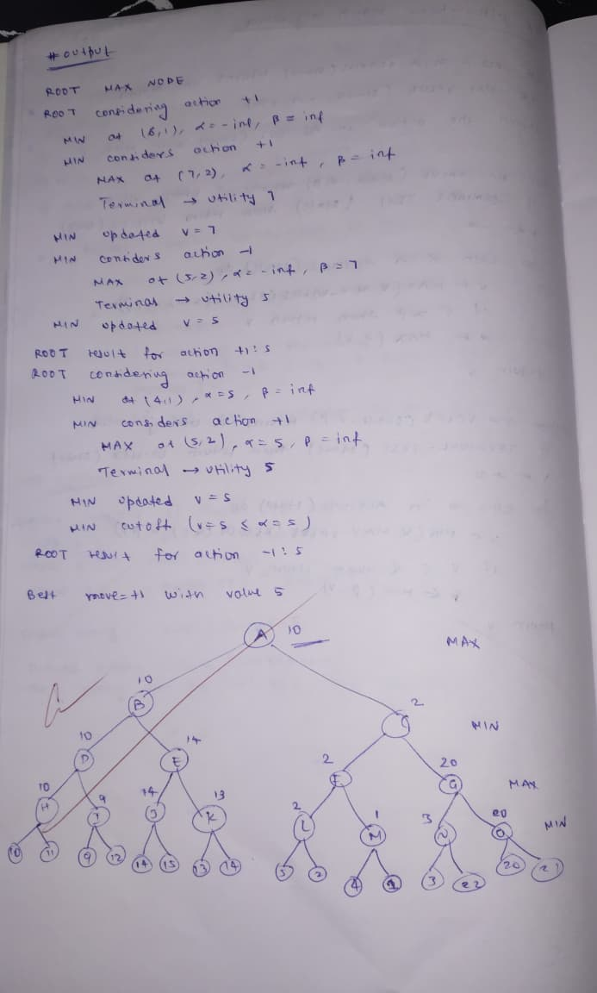

Code:

TREE = {
"A": ["B", "C"],
"B": ["D", "E"],
"C": ["F", "G"],
"D": ["H", "I"],
"E": ["J", "K"],
"F": ["L", "M"],
"G": ["N", "O"],

"H": [41, 5],
"I": [12, 90],
"J": [101, 80],
"K": [20, 30],
"L": [34, 80],
"M": [36, 35],
"N": [50, 36],
"O": [25, 3],
}

def is_terminal(node):
"""Check if the node is a leaf node."""
return isinstance(TREE[node][0], int)

def max_value(node, alpha, beta):
"""Maximizing player's turn."""
if is_terminal(node):
return max(TREE[node])

v = float("-inf")
for child in TREE[node]:
v = max(v, min_value(child, alpha, beta))
if v >= beta: # beta cut-off
return v
alpha = max(alpha, v)

return v

def min_value(node, alpha, beta):
"""Minimizing player's turn."""
if is_terminal(node):
return min(TREE[node])

v = float("inf")
for child in TREE[node]:
v = min(v, max_value(child, alpha, beta))
if v <= alpha: # alpha cut-off
return v
beta = min(beta, v)

return v

def alpha_beta_search(root):
"""Perform alpha-beta pruning starting from root."""
best_value = float("-inf")
best_action = None
alpha, beta = float("-inf"), float("inf")

print("Evaluating moves from A...\n")

for child in TREE[root]:
value = min_value(child, alpha, beta)
print(f"Move {root} → {child} gives value {value}")

if value > best_value:
best_value = value
best_action = child

alpha = max(alpha, best_value)

return best_action, best_value

if __name__ == "__main__":
move, value = alpha_beta_search("A")
print(f"\nBest move from A: {move}")
print(f"Root node (A) value: {value}")

