Getting the Tools to Talk to Each Other
A reflective write-up of BDA400 Assignment 2 by Navneet Kaur
The assignment looks like a shopping list: an account, two programs, two packages, a text file, a few functions. What I noticed while working through it is that every item only makes sense because of the one before it. This write-up follows that chain.

Why does a data course start with GitHub?
I expected GitHub to come later, once there was something worth saving. The assignment does the opposite, and the more I thought about it the more sense it made. Analysis code gets edited constantly, and the version that produced last week's result is exactly the one you want back when something breaks. So I made the account, then a repository named TechnicalAnalysis, which has to match the assignment spelling.
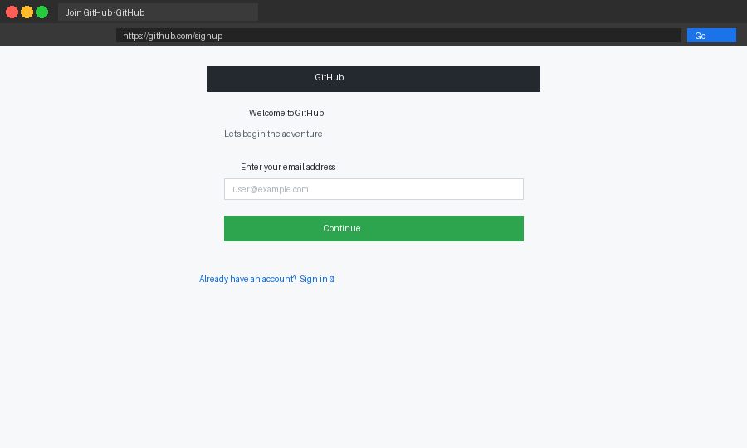
Creating the account (Placeholder image: replace with your own screenshot.)
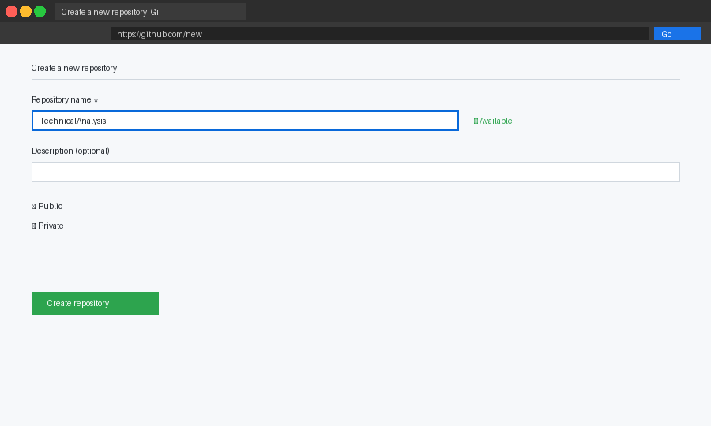
Naming the repository (Placeholder image: replace with your own screenshot.)
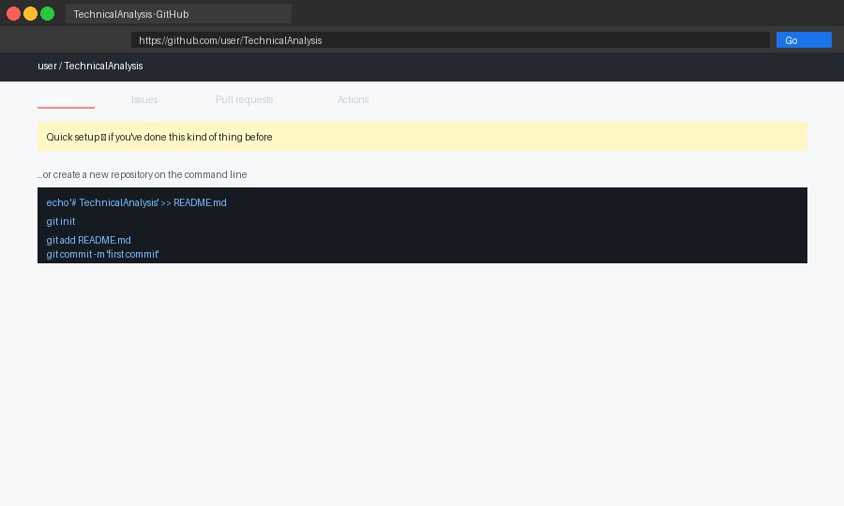
The repository, still empty (Placeholder image: replace with your own screenshot.)

What is the difference between R and RStudio?
I kept using the two names as if they were one thing. R is the language and engine. RStudio is the workbench around it, with an editor, a console, a list of objects and a plot area. Installing them in that order, R and then RStudio, was the only part of the setup that had a fixed sequence.
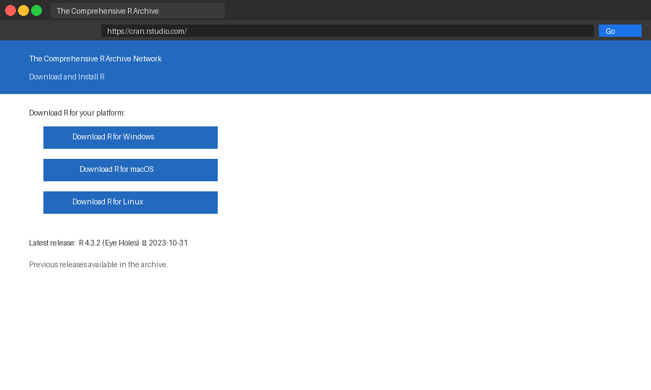
Where R comes from (Placeholder image: replace with your own screenshot.)
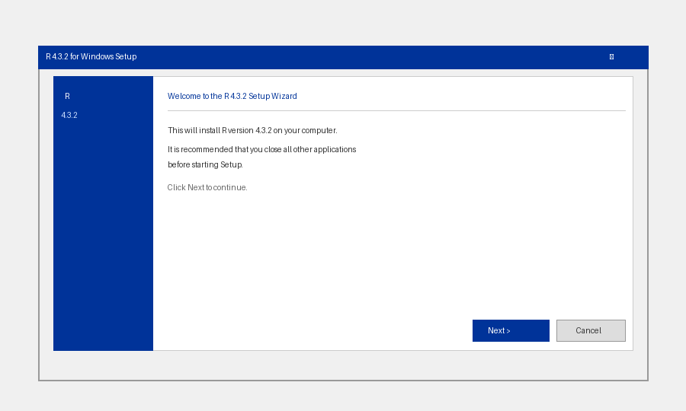
Running the R installer (Placeholder image: replace with your own screenshot.)
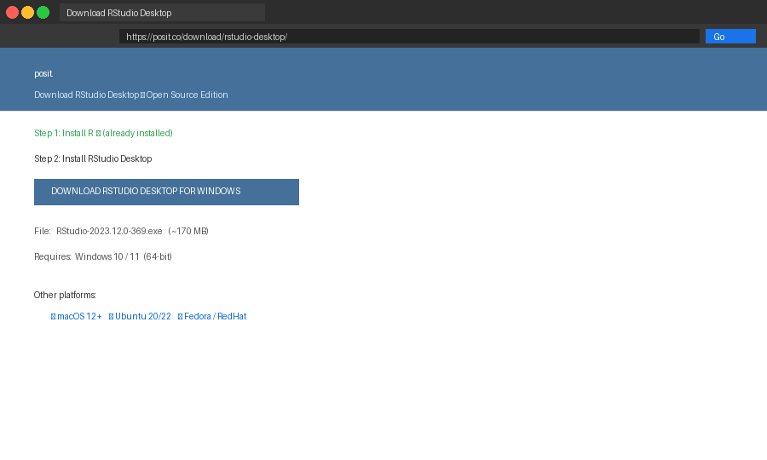
Where RStudio comes from (Placeholder image: replace with your own screenshot.)
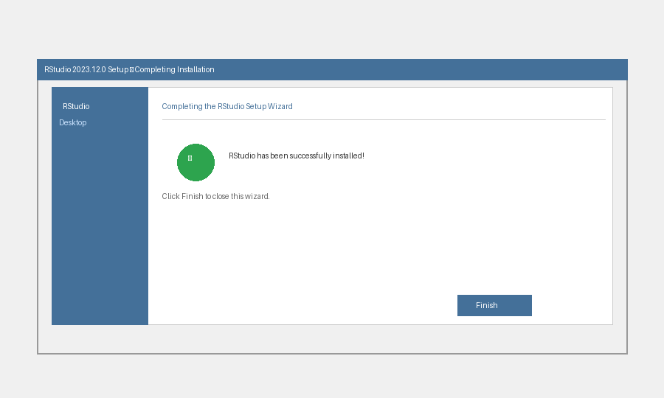
RStudio installed (Placeholder image: replace with your own screenshot.)

Where do stock prices come from?
This was the part that surprised me. Two packages are enough to go from a ticker symbol to a table of daily prices: quantmod fetches the quotes and TTR calculates indicators from them. Installing them takes one line each.
install.packages("quantmod")
install.packages("TTR")
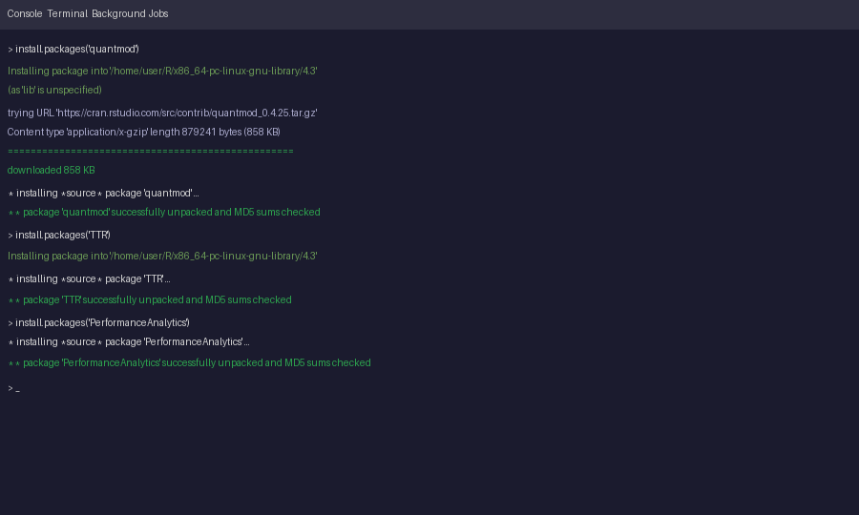
Installing the packages (Placeholder image: replace with your own screenshot.)

Which companies, and why?
I went with software companies: MSFT, ADBE, CRM and ORCL. They sell similar kinds of products, so if their prices move differently later on, there is something to explain. They go in portfolio.txt, one per line, and that file is the only thing the loading function needs to be told.
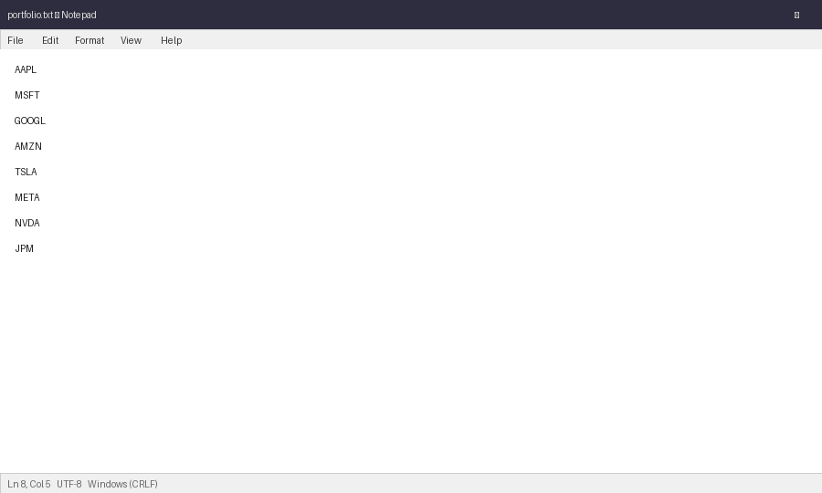
The portfolio file (Placeholder image: replace with your own screenshot.)

What does the code actually do?
load_stock_data() reads the symbols with read.table(), then asks Yahoo Finance for a year of prices for each. I wrapped every download so one bad symbol cannot stop the rest. Each stock comes back as its own data frame, which is what the assignment asks for.
calculate_statistics() raised a question I had not considered: what is the mode of a price? Prices almost never repeat exactly, so I group them into 25-cent buckets and report the busiest bucket. It is an approximation, and I would rather say so than hide it. The function also returns a 30-day moving average, and a separate helper arranges all stocks into one table.
The display script then writes a short text report for each stock, prints the table, and draws each price chart with its daily high-to-low range shaded behind the closing line.
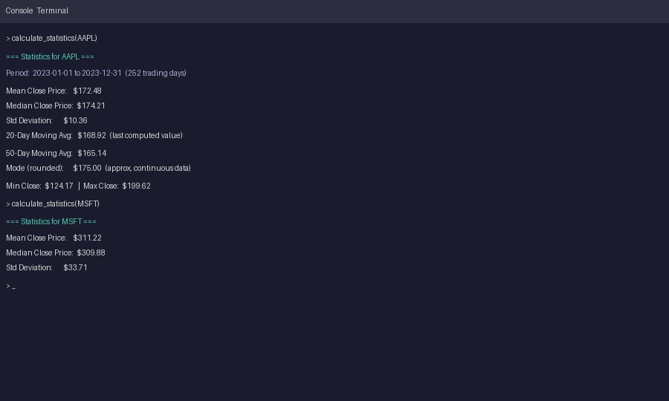
Statistics in the console (Placeholder image: replace with your own screenshot.)
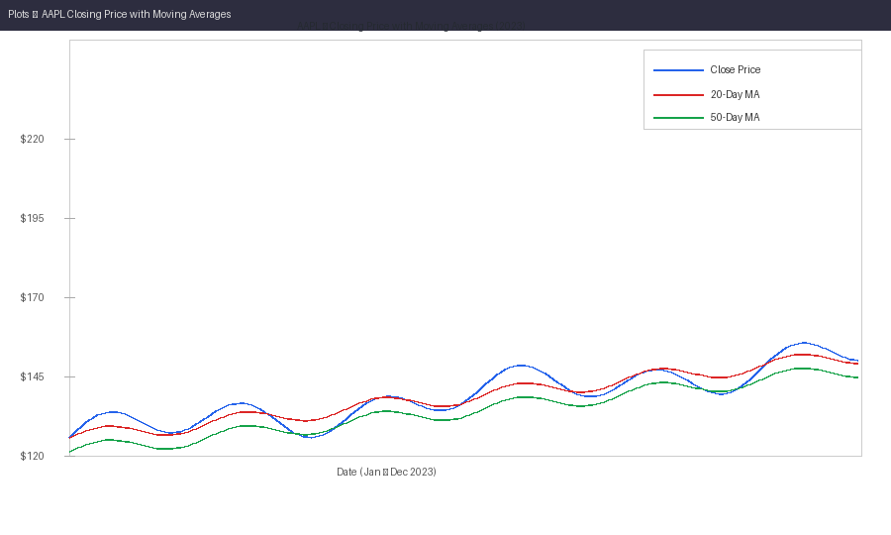
A chart from the display script (Placeholder image: replace with your own screenshot.)
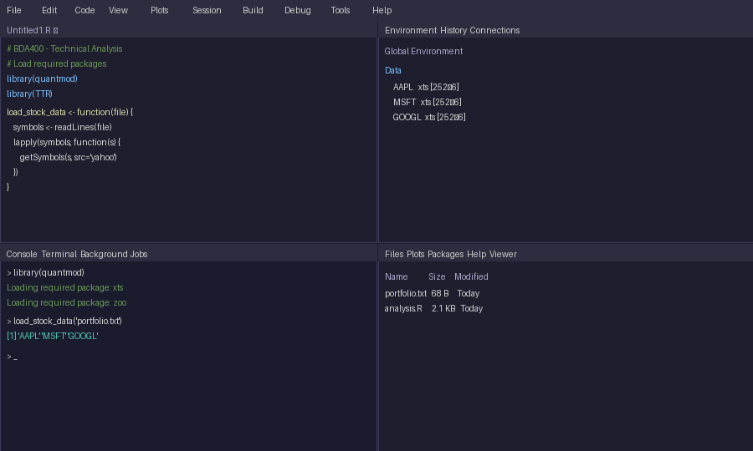
The finished workspace (Placeholder image: replace with your own screenshot.)

What would I do differently?
Next time I would commit to GitHub after each step instead of at the end, so the history shows how the work grew. And I want to see whether the moving average is any use for deciding anything, which is what the next stages are about. Does a line drawn from the past tell us anything about tomorrow?

Appendix: the code

stock_functions.R
# BDA400 Assignment 2 -- Navneet Kaur
library(quantmod)
library(TTR)

load_stock_data <- function(portfolio_file = "portfolio.txt", years_back = 1) {
symbols <- read.table(portfolio_file, stringsAsFactors = FALSE)[[1]]
start <- Sys.Date() - 365 * years_back

pull <- function(sym) {
quotes <- getSymbols(sym, src = "yahoo", from = start, auto.assign = FALSE)
data.frame(Date = as.Date(index(quotes)),
Open = as.numeric(quotes[, 1]),
High = as.numeric(quotes[, 2]),
Low = as.numeric(quotes[, 3]),
Close = as.numeric(quotes[, 4]),
Volume = as.numeric(quotes[, 5]),
Adjusted = as.numeric(quotes[, 6]))
}

out <- list()
for (s in symbols) {
res <- tryCatch(pull(s), error = function(e) NULL)
if (!is.null(res)) out[[s]] <- res
}
out
}

# Mode of a numeric vector: bucket to the nearest 25 cents, return the busiest bucket
bucket_mode <- function(v) {
buckets <- round(v * 4) / 4
tab <- table(buckets)
as.numeric(names(tab)[tab == max(tab)][1])
}

calculate_statistics <- function(price_df, avg_days = 30) {
v <- price_df$Close
list(
n_days = length(v),
mean = mean(v),
median = median(v),
mode = bucket_mode(v),
sd = sd(v),
moving_av = SMA(v, n = avg_days)
)
}

# Tidy table: one row per stock, easy to print or export
stats_table <- function(stats_by_stock) {
data.frame(
Stock = names(stats_by_stock),
Days = sapply(stats_by_stock, `[[`, "n_days"),
Mean = sapply(stats_by_stock, `[[`, "mean"),
Median = sapply(stats_by_stock, `[[`, "median"),
Mode = sapply(stats_by_stock, `[[`, "mode"),
SD = sapply(stats_by_stock, `[[`, "sd"),
row.names = NULL
)
}

display_stock_data.R
# BDA400 Assignment 2 -- Navneet Kaur -- displaying the results
source("stock_functions.R")

stocks <- load_stock_data("portfolio.txt")
stats <- lapply(stocks, calculate_statistics)

write_report <- function(stocks, stats) {
cat("PORTFOLIO REPORT\n", rep("-", 40), "\n", sep = "")
for (s in names(stocks)) {
d <- stocks[[s]]
cat(sprintf("\n%s (%s -> %s)\n", s, format(min(d$Date)), format(max(d$Date))))
cat(sprintf(" Highest close: %.2f on %s\n", max(d$Close), format(d$Date[which.max(d$Close)])))
cat(sprintf(" Lowest close : %.2f on %s\n", min(d$Close), format(d$Date[which.min(d$Close)])))
cat(sprintf(" Mean / median: %.2f / %.2f\n", stats[[s]]$mean, stats[[s]]$median))
}
}

write_report(stocks, stats)
print(stats_table(stats), digits = 4)

# Price chart with a shaded high-low range and the moving average on top
for (s in names(stocks)) {
d <- stocks[[s]]
plot(d$Date, d$Close, type = "n", ylim = range(d$Low, d$High),
main = paste(s, "- daily range and 30-day average"), xlab = "", ylab = "Price")
polygon(c(d$Date, rev(d$Date)), c(d$High, rev(d$Low)),
col = adjustcolor("grey70", 0.5), border = NA)
lines(d$Date, d$Close, col = "navy")
lines(d$Date, stats[[s]]$moving_av, col = "red", lwd = 2)
}

