**Navneet Taneja**

Contact No.: (91) 9717095398

E-Mail: navneettaneja.ds@gmail.com

Address: B-46, Shushant Lok Phase-3,Sector 57 , Near By Hong Kong Bazar

**Profile Summary**

Hi I am looking for Data Analysis / Tableau Developer job or internship. I know how to data collection , data cleaning , data visualization , getting prediction through sklearn(ML) , I am fresher in Data analysis.

**Data Anaysis Skills**

GIT, Bitbucket, Python , Python Tools :- (Matplotlib , Seaborn , Pandas , Numpy) , SQL , Machine Learning , Tableau , Data Cleaning , Data Visualzation.

**Experience Detail**

1=> I have past Experience in Frontend Development arrownd 5 Years above

**Data Analysis projects:-**

* **Movie Recommender system :-** This is a recommender system in this we can get list of similar movies names. According to tags based / content based and through user rating base / collabrative filter.Here you can type your movie name that will provide you recommend movies list.

<https://github.com/navneeet94/recommender-system.git>

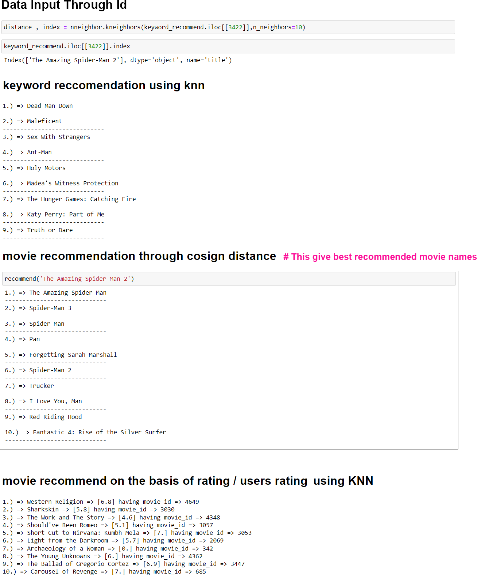

Currently working on covid analysis project :-

**Qualification Detail**

=> 10th from C.B.S.E

=> 12th from C.B.S.E

=> BCA from Makhnlal Chaturvedi National University of Journalism and communication

=> 8-month training in web designer from Tech Altum, Noida Sec. 15

=> Data Scientist Training from Ducat , Gurgao , currently training is little bit remaing

**Personal Detail**

Date of Birth: 9th-December-1994

Languages Known: English, Hindi

Address: 36/1196 Madangir D.D.A Flats New Delhi:- 110062.