**VISVESVARAYA TECHNOLOGICAL UNIVERSITY**

**“JnanaSangama”, Belgaum -590014, Karnataka.**



**LAB REPORT**

**on**

Artificial Intelligence (23CS5PCAIN)

***Submitted by***

**NAVNEETH K S (1BM22CS174)**

***in partial fulfillment for the award of the degree of***

**BACHELOR OF ENGINEERING**

***in***

**COMPUTER SCIENCE AND ENGINEERING**

**Swathi Sridharan**

**Professor**

**Department of Computer Science and Engineering**



**B.M.S. COLLEGE OF ENGINEERING**

**(Autonomous Institution under VTU)**

**BENGALURU-560019**

**Sep-2024 to Jan-2025**

**B.M.S. College of Engineering,**

**Bull Temple Road, Bangalore 560019**

(Affiliated To Visvesvaraya Technological University, Belgaum)

**Department of Computer Science and Engineering**



# CERTIFICATE

This is to certify that the Lab work entitled “Artificial Intelligence (23CS5PCAIN)” was carried out by NAVNEETH K S **(1BM22CS174),** who is Bonafide student of **B.M.S. College of Engineering.** It is in partial fulfillment for the award of **Bachelor of Engineering in Computer Science and Engineering** of the Visvesvaraya Technological University, Belgaum. The Lab report has been approved as it satisfies the academic requirements in respect of an Artificial Intelligence (23CS5PCAIN) work prescribed for the said degree.

Dr. Kavitha Sooda Professor & HOD

Department of CSE, BMSCE

Swathi Sridharan

Assistant Professor

Department of CSE, BMSCE

**Index**

|  |  |  |  |
| --- | --- | --- | --- |
| **Sl.**  **No.** | **Date** | **Experiment Title** | **Page No.** |
| 1 | 30-9-2024 | Implement Tic –Tac –Toe Game Implement vacuum cleaner agent | 4-12 |
| 2 | 7-10-2024 | Implement 8 puzzle problems using Depth First Search (DFS)  Implement Iterative deepening search algorithm | 13-16 |
| 3 | 14-10-2024 | Implement A* search algorithm | 17-21 |
| 4 | 21-10-2024 | Implement Hill Climbing search algorithm to solve N-Queens problem | 22-34 |
| 5 | 28-10-2024 | Simulated Annealing to Solve 8-Queens problem | 35-40 |
| 6 | 11-11-2024 | Create a knowledge base using propositional logic and show that the given query entails the knowledge base or not. | 41-47 |
| 7 | 2-12-2024 | Implement unification in first order logic | 48-54 |
| 8 | 2-12-2024 | Create a knowledge base consisting of first order logic statements and prove the given query using forward reasoning. | 55-58 |
| 9 | 16-12-2024 | Create a knowledge base consisting of first order logic statements and prove the given query using Resolution | 59-62 |
| 10 | 16-12-2024 | Implement Alpha-Beta Pruning. | 63-66 |

Github Link: https://github.com/navneeth-dev/AI

# Program 1

Implement Tic –Tac –Toe Game Implement vacuum cleaner agent Tic-Tac-Toe

Algorithm:

Code:

def check_win(board, r, c):

if board[r - 1][c - 1] == 'X': ch = "O"

else:

ch = "X"

if ch not in board[r - 1] and '-' not in board[r - 1]: return True

elif ch not in (board[0][c - 1], board[1][c - 1], board[2][c - 1]) and '-' not in (board[0][c - 1], board[1][c - 1], board[2][c - 1]):

return True

elif ch not in (board[0][0], board[1][1], board[2][2]) and '-' not in (board[0][0], board[1][1], board[2][2]):

return True

elif ch not in (board[0][2], board[1][1], board[2][0]) and '-' not in (board[0][2], board[1][1], board[2][0]):

return True return False

def displayb(board):

print(board[0]) print(board[1]) print(board[2])

board=[['-','-','-'],['-','-','-'],['-','-','-']]

displayb(board) xo=1

flag=0

while '-' in board[0] or '-' in board[1] or '-' in board[2]:

if xo==1:

print("enter position to place X:") x=int(input())

y=int(input()) if(x>3 or y>3):

print("invalid position") continue

if(board[x-1][y-1]=='-'): board[x-1][y-1]='X' xo=0

displayb(board) else:

print("invalid position") continue if(check_win(board,x,y)):

print("X wins") flag=1

break else :

print("enter position to place O:") x=int(input())

y=int(input()) if(x>3 or y>3):

print("invalid position") continue

if(board[x-1][y-1]=='-'): board[x-1][y-1]='O' xo=1

displayb(board) else:

print("invalid position") continue if(check_win(board,x,y)):

print("0 wins") flag=1

break if flag==0:

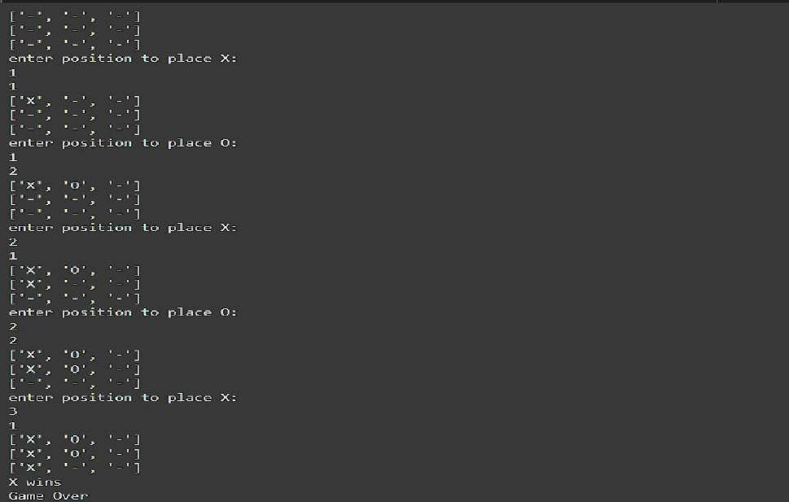print("Draw") print("Game Over")

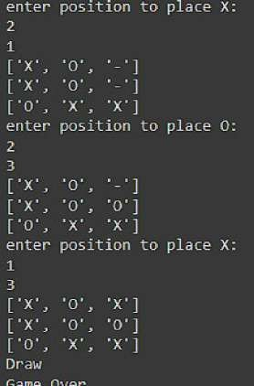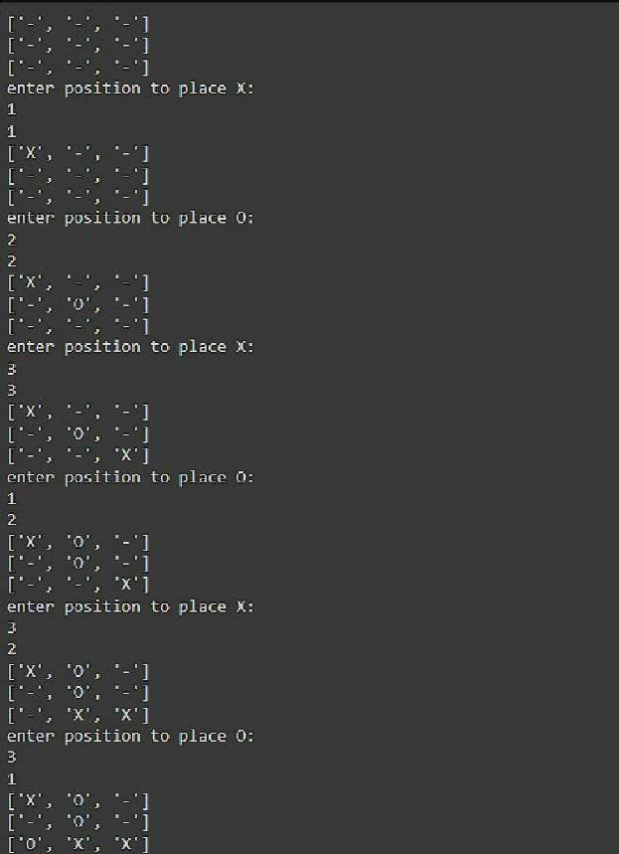

Vacuum Cleaner

Algorithm:

Code:

count = 0

def rec(state, loc): global count

if state['A'] == 0 and state['B'] == 0: print("Turning vacuum off") return

if state[loc] == 1: state[loc] = 0

count += 1 print(f"Cleaned {loc}.")

next_loc = 'B' if loc == 'A' else 'A'

state[loc] = int(input(f"Is {loc} clean now? (0 if clean, 1 if dirty): ")) if(state[next_loc]!=1):

state[next_loc]=int(input(f"Is {next_loc} dirty? (0 if clean, 1 if dirty): ")) if(state[loc]==1):

rec(state,loc) else:

next_loc = 'B' if loc == 'A' else 'A' dire="left" if loc=="B" else "right" print(loc,"is clean") print(f"Moving vacuum {dire}")

if state[next_loc] == 1: rec(state, next_loc)

state = {}

state['A'] = int(input("Enter state of A (0 for clean, 1 for dirty): ")) state['B'] = int(input("Enter state of B (0 for clean, 1 for dirty): ")) loc = input("Enter location (A or B): ")

rec(state, loc) print("Cost:",count) print(state

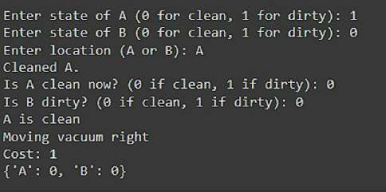

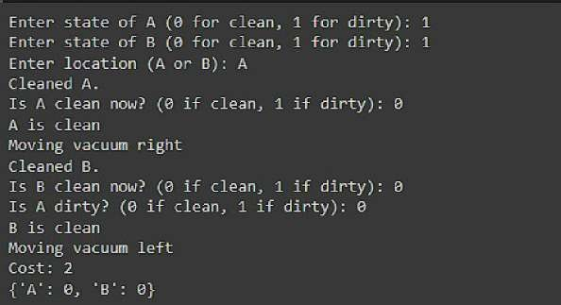

# Program 2

Implement 8 puzzle problems using Depth First Search (DFS) Implement Iterative deepening search algorithm

8 puzzles using DFS

Algorithm:

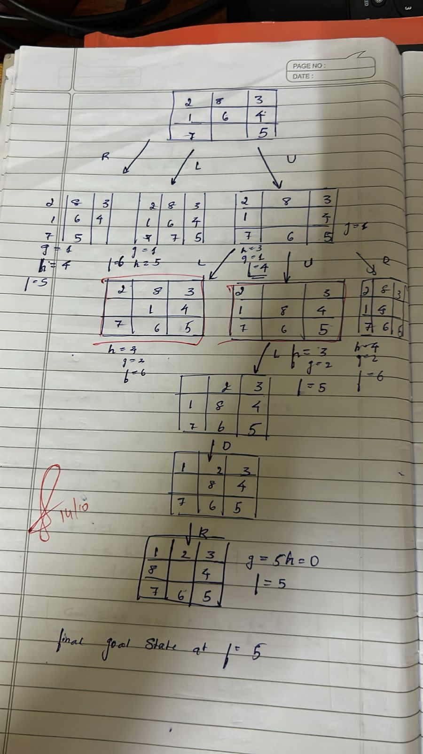

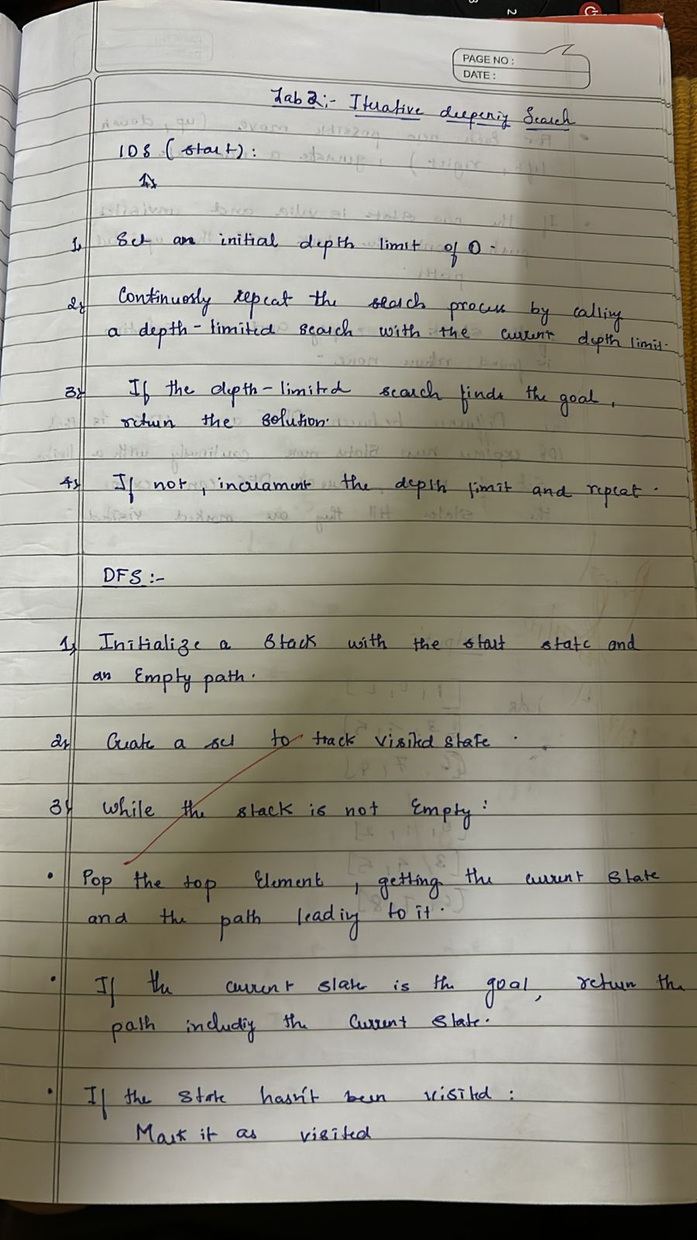

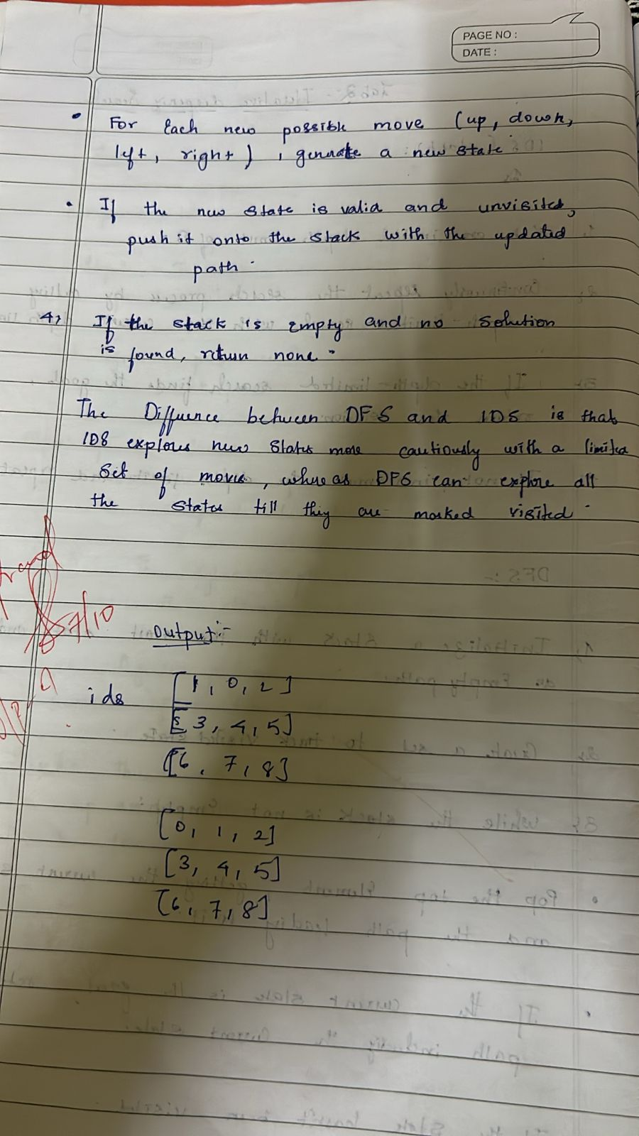

Code:

def dfs(initial_board, zero_pos):

stack = [(initial_board, zero_pos, [])] visited = set()

while stack:

current_board, zero_pos, moves = stack.pop()

if is_goal(current_board):

return moves, len(moves) # Return moves and their count visited.add(tuple(current_board))

for neighbor_board, neighbor_pos in get_neighbors(current_board, zero_pos): if tuple(neighbor_board) not in visited:

stack.append((neighbor_board, neighbor_pos, moves + [neighbor_board]))

return None, 0 # No solution found, return count as 0

# Initial state of the puzzle initial_board = [1, 2, 3, 0, 4, 6, 7, 5, 8]

zero_position = (1, 0) # Position of the empty tile (0)

# Solve the puzzle using DFS

solution, move_count = dfs(initial_board, zero_position)

if solution:

print("Solution found with moves ({} moves):".format(move_count)) for move in solution:

print_board(move)

print() # Print an empty line between moves

else:

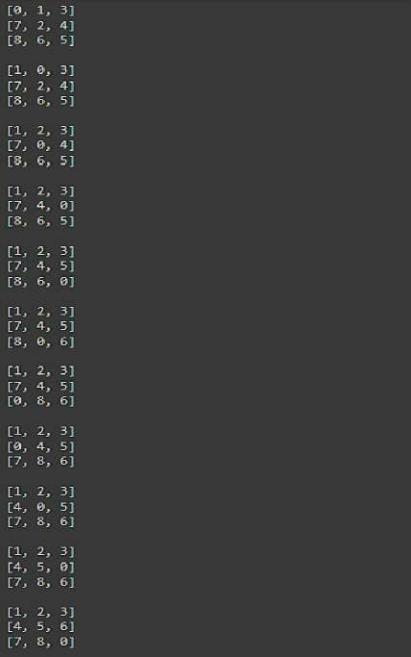print("No solution found.")

Implement Iterative deepening search algorithm

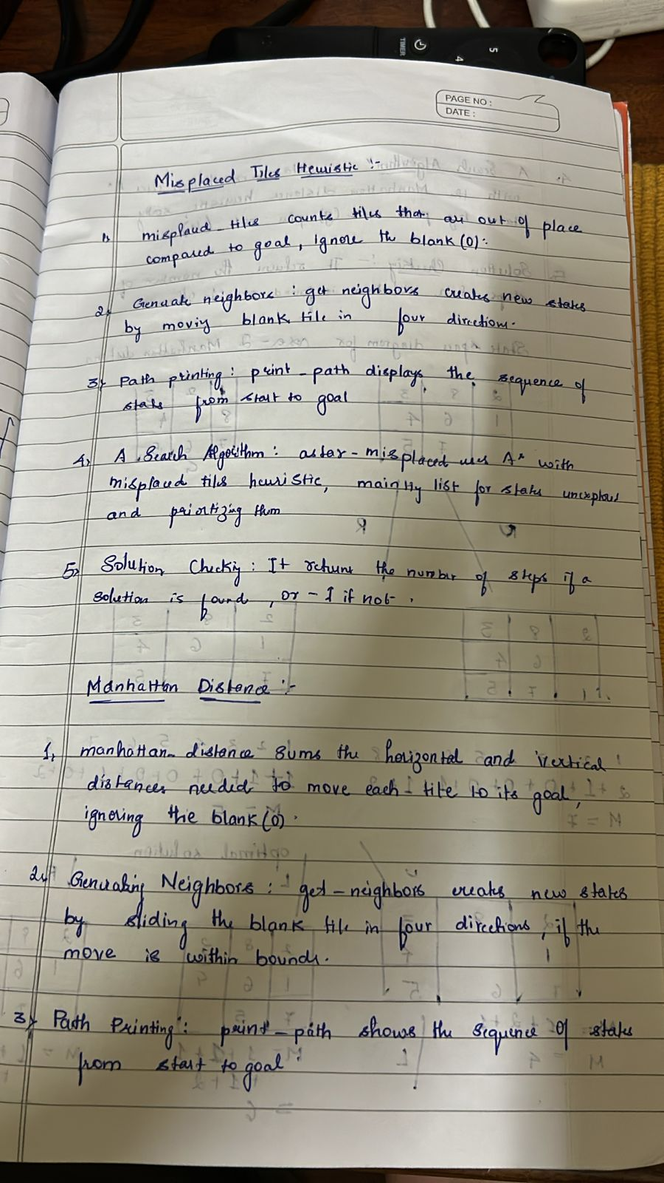

Algorithm:

Code:

from collections import deque

class PuzzleState:

def init (self, board, zero_pos, moves=0, previous=None): self.board = board

self.zero_pos = zero_pos # Position of the zero tile

self.moves = moves # Number of moves taken to reach this state self.previous = previous # For tracking the path

def is_goal(self, goal_state): return self.board == goal_state

def get_possible_moves(self): moves = []

x, y = self.zero_pos

directions = [(-1, 0), (1, 0), (0, -1), (0, 1)] # Up, Down, Left, Right for dx, dy in directions:

new_x, new_y = x + dx, y + dy

if 0 <= new_x < 3 and 0 <= new_y < 3: new_board = [row[:] for row in self.board]

# Swap the zero tile with the adjacent tile

new_board[x][y], new_board[new_x][new_y] = new_board[new_x][new_y], new_board[x][y]

moves.append((new_board, (new_x, new_y))) return moves

def ids(initial_state, goal_state, max_depth): for depth in range(max_depth):

visited = set()

result = dls(initial_state, goal_state, depth, visited) if result:

return result return None

def dls(state, goal_state, depth, visited): if state.is_goal(goal_state):

return state if depth == 0:

return None

visited.add(tuple(map(tuple, state.board))) # Mark this state as visited for new_board, new_zero_pos in state.get_possible_moves():

new_state = PuzzleState(new_board, new_zero_pos, state.moves + 1, state) if tuple(map(tuple, new_board)) not in visited:

result = dls(new_state, goal_state, depth - 1, visited) if result:

return result

visited.remove(tuple(map(tuple, state.board))) # Unmark this state return None

def print_solution(solution): path = []

while solution: path.append(solution.board) solution = solution.previous

for board in reversed(path): for row in board:

print(row) print()

# Define the initial state and goal state initial_state = PuzzleState(

board=[[1, 2, 3],

[4, 0, 5],

[7, 8, 6]],

zero_pos=(1, 1)

)

goal_state = [ [1, 2, 3],

[4, 5, 6],

[7, 8, 0]

]

# Perform Iterative Deepening Search max_depth = 20 # You can adjust this value

solution = ids(initial_state, goal_state, max_depth)

if solution: print("Solution found:") print_solution(solution)

else:

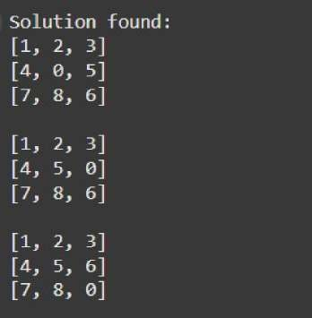print("No solution found.")

# Program 3

Implement A* search algorithm

Algorithm:

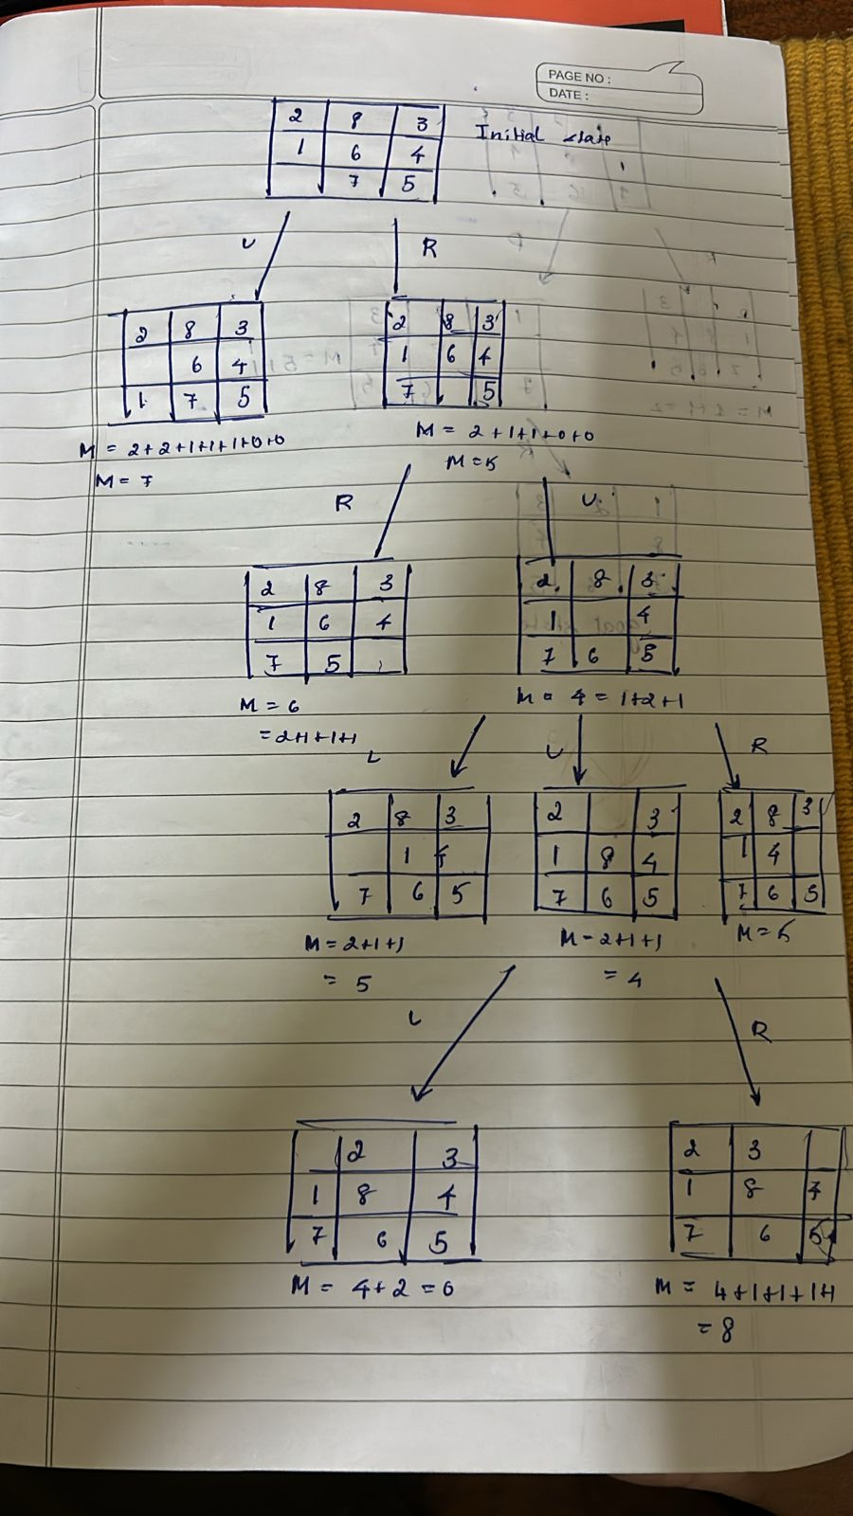

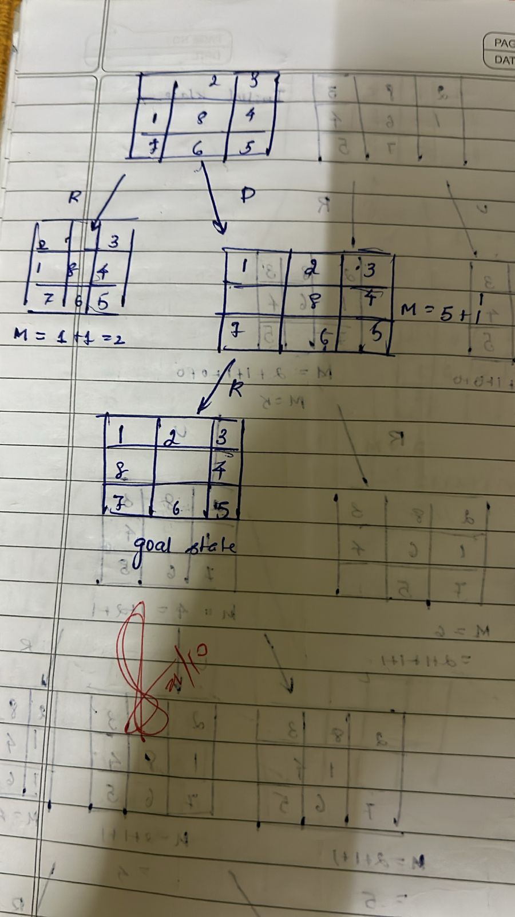

Code:

Misplaced Tiles

def mistil(state, goal): count = 0

for i in range(3): for j in range(3):

if state[i][j] != goal[i][j]: count += 1

return count

def findmin(open_list, goal): minv = float('inf') best_state = None

for state in open_list:

h = mistil(state['state'], goal) f = state['g'] + h

if f < minv: minv = f

best_state = state open_list.remove(best_state) return best_state

def operation(state): next_states = []

blank_pos = find_blank_position(state['state']) for move in ['up', 'down', 'left', 'right']:

new_state = apply_move(state['state'], blank_pos, move) if new_state:

next_states.append({ 'state': new_state, 'parent': state, 'move': move,

'g': state['g'] + 1

})

return next_states

def find_blank_position(state): for i in range(3):

for j in range(3):

if state[i][j] == 0: return i, j

return None

def apply_move(state, blank_pos, move): i, j = blank_pos

new_state = [row[:] for row in state] if move == 'up' and i > 0:

new_state[i][j], new_state[i - 1][j] = new_state[i - 1][j], new_state[i][j] elif move == 'down' and i < 2:

new_state[i][j], new_state[i + 1][j] = new_state[i + 1][j], new_state[i][j] elif move == 'left' and j > 0:

new_state[i][j], new_state[i][j - 1] = new_state[i][j - 1], new_state[i][j] elif move == 'right' and j < 2:

new_state[i][j], new_state[i][j + 1] = new_state[i][j + 1], new_state[i][j] else:

return None return new_state

def print_state(state): for row in state:

print(' '.join(map(str, row)))

initial_state = [[2,8,3], [1,6,4], [7,0,5]]

goal_state = [[1,2,3], [8,0,4], [7,6,5]]

open_list = [{'state': initial_state, 'parent': None, 'move': None, 'g': 0}] visited_states = []

while open_list:

best_state = findmin(open_list, goal_state) print("Current state:") print_state(best_state['state'])

h = mistil(best_state['state'], goal_state) f = best_state['g'] + h

print(f"g(n): {best_state['g']}, h(n): {h}, f(n): {f}") if best_state['move'] is not None:

print(f"Move: {best_state['move']}") print()

if mistil(best_state['state'], goal_state) == 0: goal_state_reached = best_state

break visited_states.append(best_state['state']) next_states = operation(best_state)

for state in next_states:

if state['state'] not in visited_states: open_list.append(state)

moves = []

while goal_state_reached['move'] is not None: moves.append(goal_state_reached['move']) goal_state_reached = goal_state_reached['parent']

moves.reverse()

print("\nMoves to reach the goal state:", moves) print("\nGoal state reached:")

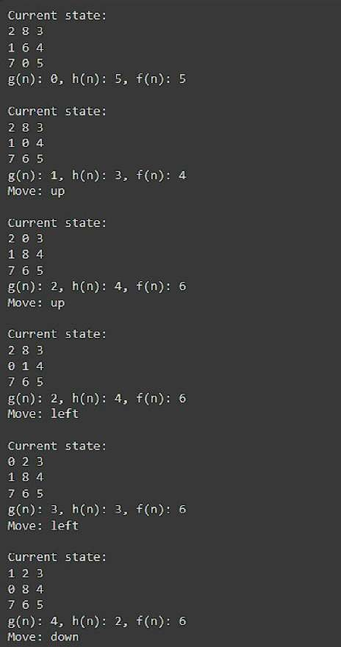print_state(goal_state)

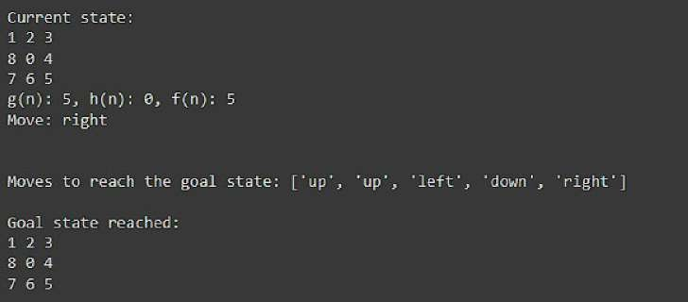

Manhattan Distance

def manhattan_distance(state, goal): distance = 0

for i in range(3): for j in range(3):

tile = state[i][j]

if tile != 0: # Ignore the blank space (0)

# Find the position of the tile in the goal state for r in range(3):

for c in range(3):

if goal[r][c] == tile: target_row, target_col = r, c break

# Add the Manhattan distance (absolute difference in rows and columns) distance += abs(target_row - i) + abs(target_col - j)

return distance

def findmin(open_list, goal): minv = float('inf') best_state = None

for state in open_list:

h = manhattan_distance(state['state'], goal) # Use Manhattan distance here f = state['g'] + h

if f < minv: minv = f

best_state = state open_list.remove(best_state) return best_state

def operation(state): next_states = []

blank_pos = find_blank_position(state['state']) for move in ['up', 'down', 'left', 'right']:

new_state = apply_move(state['state'], blank_pos, move) if new_state:

next_states.append({ 'state': new_state, 'parent': state, 'move': move,

'g': state['g'] + 1

})

return next_states

def find_blank_position(state): for i in range(3):

for j in range(3):

if state[i][j] == 0:

return i, j return None

def apply_move(state, blank_pos, move): i, j = blank_pos

new_state = [row[:] for row in state] if move == 'up' and i > 0:

new_state[i][j], new_state[i - 1][j] = new_state[i - 1][j], new_state[i][j] elif move == 'down' and i < 2:

new_state[i][j], new_state[i + 1][j] = new_state[i + 1][j], new_state[i][j] elif move == 'left' and j > 0:

new_state[i][j], new_state[i][j - 1] = new_state[i][j - 1], new_state[i][j] elif move == 'right' and j < 2:

new_state[i][j], new_state[i][j + 1] = new_state[i][j + 1], new_state[i][j] else:

return None return new_state

def print_state(state): for row in state:

print(' '.join(map(str, row)))

# Initial state and goal state initial_state = [[2,8,3], [1,6,4], [7,0,5]]

goal_state = [[1,2,3], [8,0,4], [7,6,5]]

# Open list and visited states

open_list = [{'state': initial_state, 'parent': None, 'move': None, 'g': 0}] visited_states = []

while open_list:

best_state = findmin(open_list, goal_state)

print("Current state:") print_state(best_state['state'])

h = manhattan_distance(best_state['state'], goal_state) # Using Manhattan distance here f = best_state['g'] + h

print(f"g(n): {best_state['g']}, h(n): {h}, f(n): {f}")

if best_state['move'] is not None: print(f"Move: {best_state['move']}")

print()

if h == 0: # Goal is reached if h == 0 goal_state_reached = best_state break

visited_states.append(best_state['state']) next_states = operation(best_state)

for state in next_states:

if state['state'] not in visited_states: open_list.append(state)

# Reconstruct the path of moves moves = []

while goal_state_reached['move'] is not None: moves.append(goal_state_reached['move']) goal_state_reached = goal_state_reached['parent']

moves.reverse()

print("\nMoves to reach the goal state:", moves) print("\nGoal state reached:") print_state(goal_state)

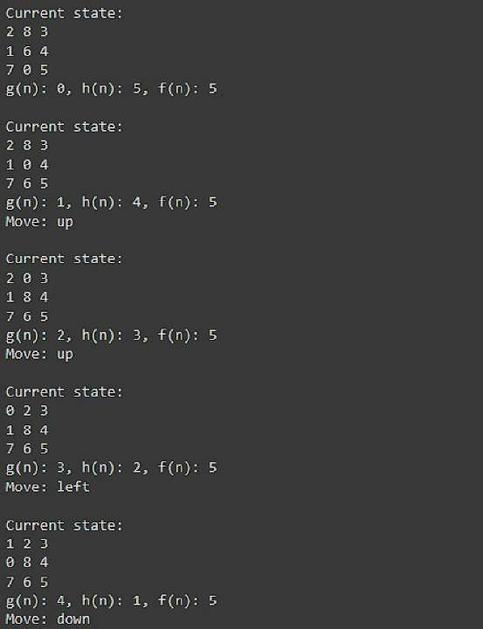



# Program 4

Implement Hill Climbing search algorithm to solve N-Queens problem

Algorithm:

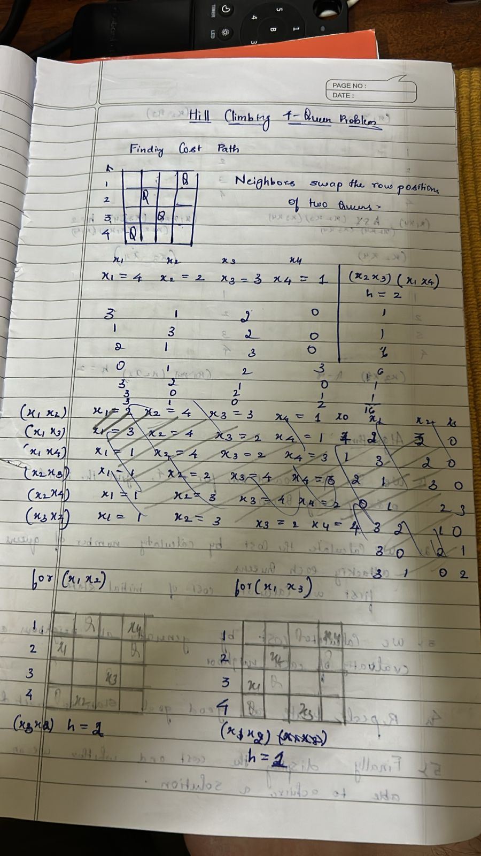

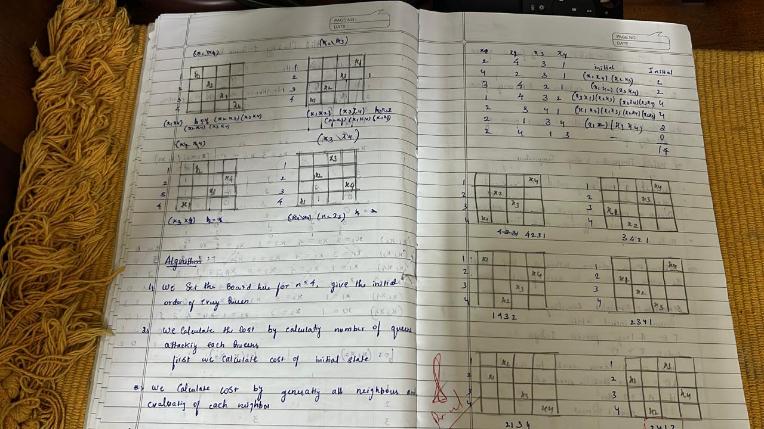

Code:

import random

def calculate_conflicts(board): conflicts = 0

n = len(board) for i in range(n):

for j in range(i + 1, n):

if board[i] == board[j] or abs(board[i] - board[j]) == abs(i - j): conflicts += 1

return conflicts

def hill_climbing(n): cost=0

while True:

# Initialize a random board current_board = list(range(n)) random.shuffle(current_board)

current_conflicts = calculate_conflicts(current_board)

while True:

# Generate neighbors by moving each queen to a different position found_better = False

for i in range(n): for j in range(n):

if j != current_board[i]: # Only consider different positions neighbor_board = list(current_board)

neighbor_board[i] = j

neighbor_conflicts = calculate_conflicts(neighbor_board) if neighbor_conflicts < current_conflicts:

print_board(current_board) print(current_conflicts) print_board(neighbor_board) print(neighbor_conflicts) current_board = neighbor_board current_conflicts = neighbor_conflicts cost+=1

found_better = True break

if found_better: break

# If no better neighbor found, stop searching if not found_better:

break

# If a solution is found (zero conflicts), return the board if current_conflicts == 0:

return current_board, current_conflicts, cost

def print_board(board): n = len(board)

for i in range(n): row = ['.'] * n

row[board[i]] = 'Q' # Place a queen print(' '.join(row))

print()

print("===============")

# Example Usage n = 4

solution, conflicts, cost = hill_climbing(n) print("Final Board Configuration:") print_board(solution)

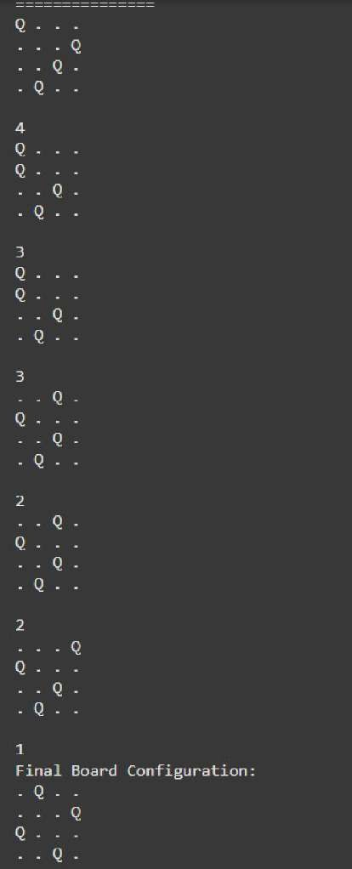print("Number of Cost:", cost)

# Program 5

Simulated Annealing to Solve 8-Queens problem

Algorithm:

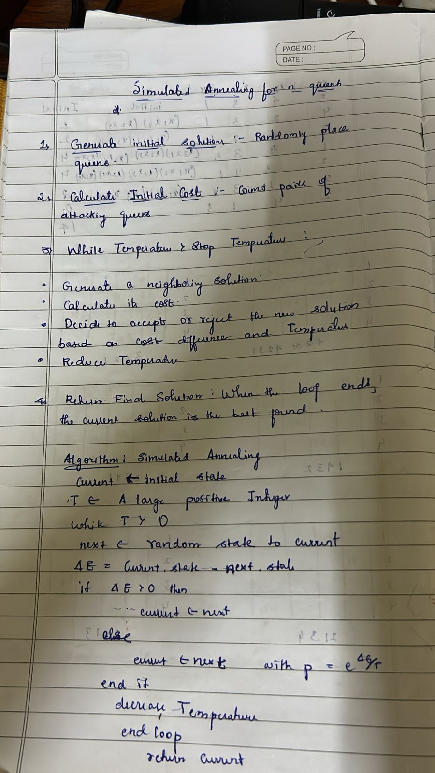

Code:

import numpy as np

from scipy.optimize import dual_annealing

def queens_max(position):

# This function calculates the number of pairs of queens that are not attacking each other position = np.round(position).astype(int) # Round and convert to integers for queen positions n = len(position)

queen_not_attacking = 0

for i in range(n - 1): no_attack_on_j = 0 for j in range(i + 1, n):

# Check if queens are on the same row or on the same diagonal

if position[i] != position[j] and abs(position[i] - position[j]) != (j - i): no_attack_on_j += 1

if no_attack_on_j == n - 1 - i: queen_not_attacking += 1

if queen_not_attacking == n - 1: queen_not_attacking += 1

return -queen_not_attacking # Negative because we want to maximize this value

# Bounds for each queen's position (0 to 7 for an 8x8 chessboard) bounds = [(0, 8) for _ in range(8)]

# Use dual_annealing for simulated annealing optimization result = dual_annealing(queens_max, bounds)

# Display the results

best_position = np.round(result.x).astype(int)

best_objective = -result.fun # Flip sign to get the number of non-attacking queens

print('The best position found is:', best_position)

print('The number of queens that are not attacking each other is:', best_objective)

# Program 6

Create a knowledge base using propositional logic and show that the given query entails the knowledge base or not.

Algorithm:

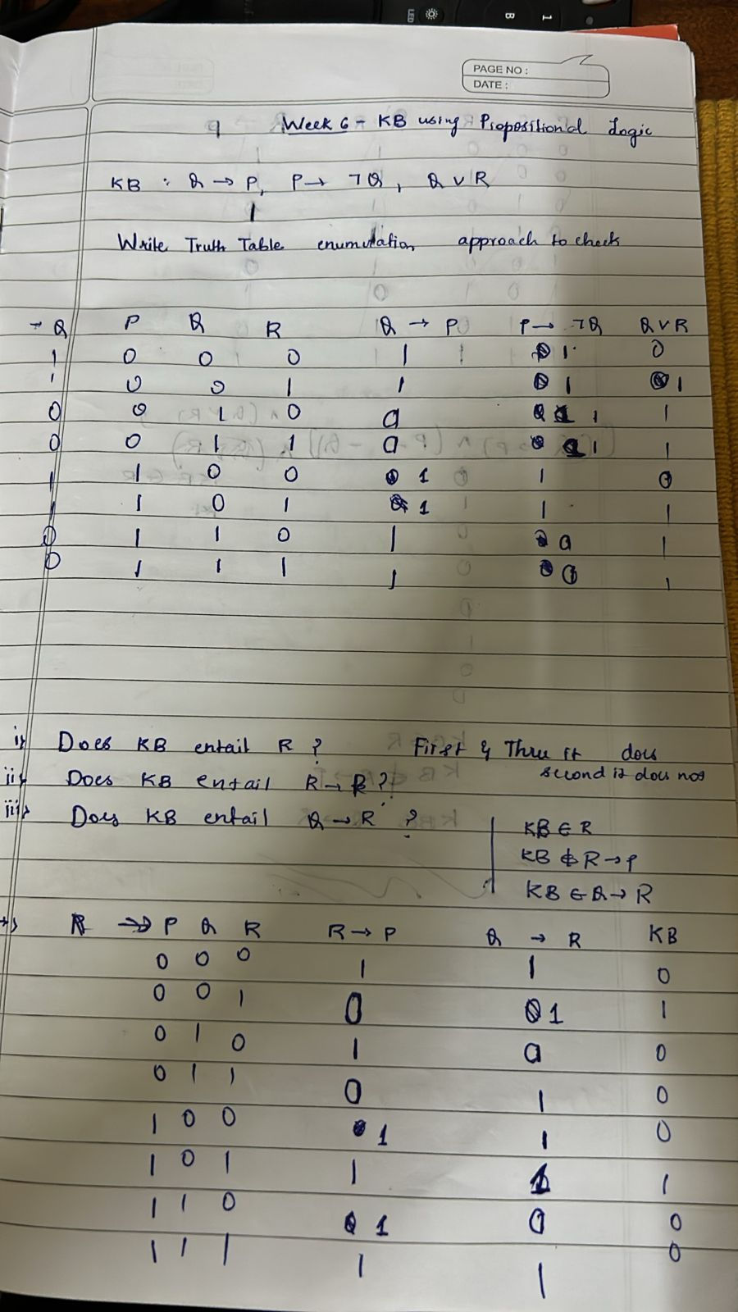

Code:

#Create a knowledge base using propositional logic and show that the given query entails the knowledge base or not.

import itertools

# Function to evaluate an expression

def evaluate_expression(a, b, c, expression):

# Use eval() to evaluate the logical expression return eval(expression)

# Function to generate the truth table and evaluate a logical expression def truth_table_and_evaluation(kb, query):

# All possible combinations of truth values for a, b, and c truth_values = [True, False]

combinations = list(itertools.product(truth_values, repeat=3))

# Reverse the combinations to start from the bottom (False -> True) combinations.reverse()

# Header for the full truth table

print(f"{'a':<5} {'b':<5} {'c':<5} {'KB':<20}{'Query':<20}")

# Evaluate the expressions for each combination

for combination in combinations: a, b, c = combination

# Evaluate the knowledge base (KB) and query expressions kb_result = evaluate_expression(a, b, c, kb)

query_result = evaluate_expression(a, b, c, query)

# Replace True/False with string "True"/"False" kb_result_str = "True" if kb_result else "False" query_result_str = "True" if query_result else "False"

# Convert boolean values of a, b, c to "True"/"False" a_str = "True" if a else "False"

b_str = "True" if b else "False" c_str = "True" if c else "False"

# Print the results for the knowledge base and the query

print(f"{a_str:<5} {b_str:<5} {c_str:<5} {kb_result_str:<20} {query_result_str:<20}")

# Additional output for combinations where both KB and query are true print("\nCombinations where both KB and Query are True:") print(f"{'a':<5} {'b':<5} {'c':<5} {'KB':<20}{'Query':<20}")

# Print only the rows where both KB and Query are True for combination in combinations:

a, b, c = combination

# Evaluate the knowledge base (KB) and query expressions kb_result = evaluate_expression(a, b, c, kb)

query_result = evaluate_expression(a, b, c, query)

# If both KB and query are True, print the combination if kb_result and query_result:

a_str = "True" if a else "False" b_str = "True" if b else "False" c_str = "True" if c else "False"

kb_result_str = "True" if kb_result else "False" query_result_str = "True" if query_result else "False"

print(f"{a_str:<5} {b_str:<5} {c_str:<5} {kb_result_str:<20} {query_result_str:<20}")

# Define the logical expressions as strings

kb = "(a or c) and (b or not c)" # Knowledge Base query = "a or b" # Query to evaluate

# Generate the truth table and evaluate the knowledge base and query truth_table_and_evaluation(kb, query)

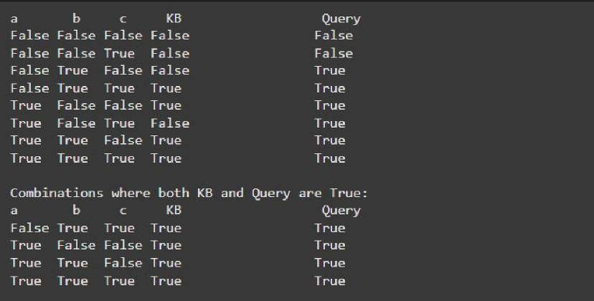

# Program 7

Implement unification in first order logic

Algorithm:

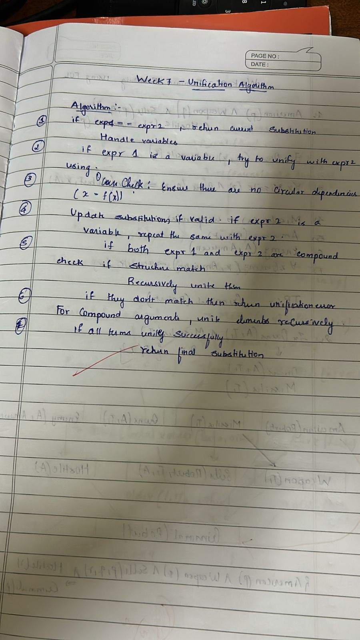

Code:

import re

def occurs_check(var, x):

"""Checks if var occurs in x (to prevent circular substitutions).""" if var == x:

return True

elif isinstance(x, list): # If x is a compound expression (like a function or predicate) return any(occurs_check(var, xi) for xi in x)

return False

def unify_var(var, x, subst):

"""Handles unification of a variable with another term."""

if var in subst: # If var is already substituted return unify(subst[var], x, subst)

elif isinstance(x, (list, tuple)) and tuple(x) in subst: # Handle compound expressions return unify(var, subst[tuple(x)], subst)

elif occurs_check(var, x): # Check for circular references return "FAILURE"

else:

# Add the substitution to the set (convert list to tuple for hashability) subst[var] = tuple(x) if isinstance(x, list) else x

return subst

def unify(x, y, subst=None): """

Unifies two expressions x and y and returns the substitution set if they can be unified. Returns 'FAILURE' if unification is not possible.

"""

if subst is None:

subst = {} # Initialize an empty substitution set

# Step 1: Handle cases where x or y is a variable or constant if x == y: # If x and y are identical

return subst

elif isinstance(x, str) and x.islower(): # If x is a variable return unify_var(x, y, subst)

elif isinstance(y, str) and y.islower(): # If y is a variable return unify_var(y, x, subst)

elif isinstance(x, list) and isinstance(y, list): # If x and y are compound expressions (lists) if len(x) != len(y): # Step 3: Different number of arguments

return "FAILURE"

# Step 2: Check if the predicate symbols (the first element) match if x[0] != y[0]: # If the predicates/functions are different

return "FAILURE"

# Step 5: Recursively unify each argument

for xi, yi in zip(x[1:], y[1:]): # Skip the predicate (first element) subst = unify(xi, yi, subst)

if subst == "FAILURE": return "FAILURE"

return subst

else: # If x and y are different constants or non-unifiable structures return "FAILURE"

def unify_and_check(expr1, expr2): """

Attempts to unify two expressions and returns a tuple: (is_unified: bool, substitutions: dict or None)

"""

result = unify(expr1, expr2) if result == "FAILURE":

return False, None return True, result

def display_result(expr1, expr2, is_unified, subst): print("Expression 1:", expr1)

print("Expression 2:", expr2) if not is_unified:

print("Result: Unification Failed") else:

print("Result: Unification Successful")

print("Substitutions:", {k: list(v) if isinstance(v, tuple) else v for k, v in subst.items()})

def parse_input(input_str):

"""Parses a string input into a structure that can be processed by the unification algorithm.""" # Remove spaces and handle parentheses

input_str = input_str.replace(" ", "")

# Handle compound terms (like p(x, f(y)) -> ['p', 'x', ['f', 'y']]) def parse_term(term):

# Handle the compound term if '(' in term:

match = re.match(r'([a-zA-Z0-9_]+)(.*)', term) if match:

predicate = match.group(1) arguments_str = match.group(2)

arguments = [parse_term(arg.strip()) for arg in arguments_str.split(',')] return [predicate] + arguments

return term

return parse_term(input_str)

# Main function to interact with the user def main():

while True:

# Get the first and second terms from the user

expr1_input = input("Enter the first expression (e.g., p(x, f(y))): ") expr2_input = input("Enter the second expression (e.g., p(a, f(z))): ")

# Parse the input strings into the appropriate structures expr1 = parse_input(expr1_input)

expr2 = parse_input(expr2_input)

# Perform unification

is_unified, result = unify_and_check(expr1, expr2)

# Display the results

display_result(expr1, expr2, is_unified, result)

# Ask the user if they want to run another test

another_test = input("Do you want to test another pair of expressions? (yes/no): ").strip().lower() if another_test != 'yes':

break

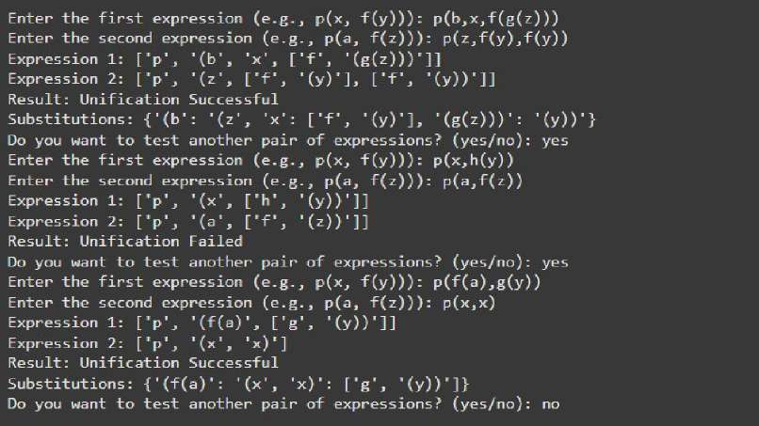if name == " main ": main()

# Program 8

Create a knowledge base consisting of first order logic statements and prove the given query using forward reasoning.

Algorithm:

: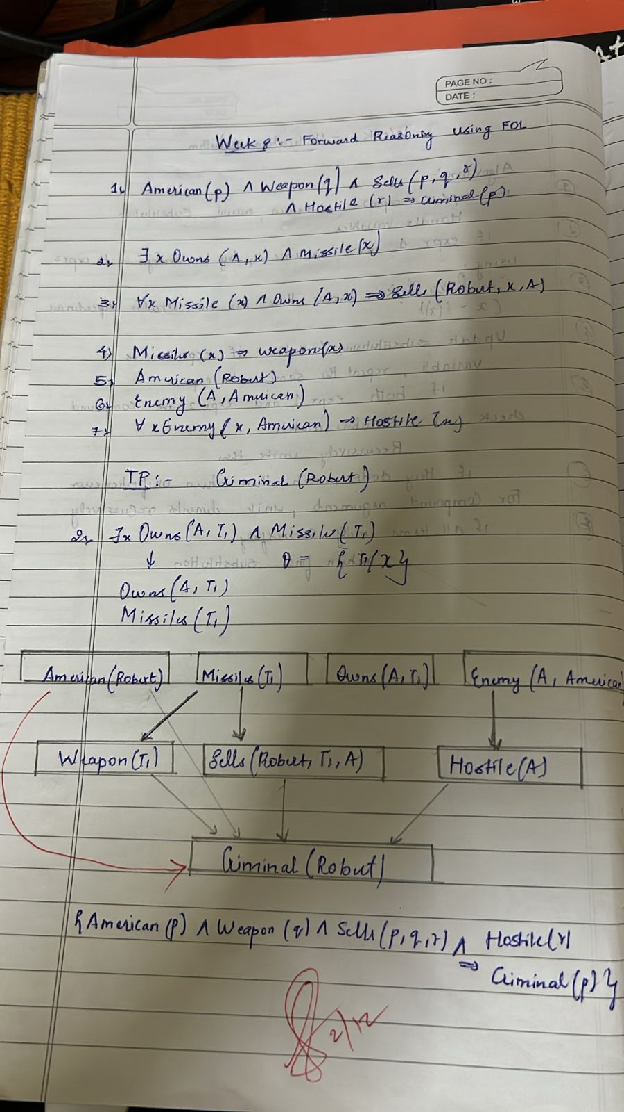

Code:

# Define the knowledge base (KB) as a set of facts KB = set()

# Premises based on the provided FOL problem KB.add('American(Robert)') KB.add('Enemy(America, A)')

KB.add('Missile(T1)')

KB.add('Owns(A, T1)')

# Define inference rules

def modus_ponens(fact1, fact2, conclusion):

""" Apply modus ponens inference rule: if fact1 and fact2 are true, then conclude conclusion """ if fact1 in KB and fact2 in KB:

KB.add(conclusion) print(f"Inferred: {conclusion}")

def forward_chaining():

""" Perform forward chaining to infer new facts until no more inferences can be made """ # 1. Apply: Missile(x) → Weapon(x)

if 'Missile(T1)' in KB: KB.add('Weapon(T1)') print(f"Inferred: Weapon(T1)")

# 2. Apply: Sells(Robert, T1, A) from Owns(A, T1) and Weapon(T1) if 'Owns(A, T1)' in KB and 'Weapon(T1)' in KB:

KB.add('Sells(Robert, T1, A)') print(f"Inferred: Sells(Robert, T1, A)")

# 3. Apply: Hostile(A) from Enemy(A, America) if 'Enemy(America, A)' in KB:

KB.add('Hostile(A)') print(f"Inferred: Hostile(A)")

# 4. Now, check if the goal is reached (i.e., if 'Criminal(Robert)' can be inferred)

if 'American(Robert)' in KB and 'Weapon(T1)' in KB and 'Sells(Robert, T1, A)' in KB and 'Hostile(A)' in KB:

KB.add('Criminal(Robert)') print("Inferred: Criminal(Robert)")

# Check if we've reached our goal if 'Criminal(Robert)' in KB:

print("Robert is a criminal!") else:

print("No more inferences can be made.")

# Run forward chaining to attempt to derive the conclusion forward_chaining()

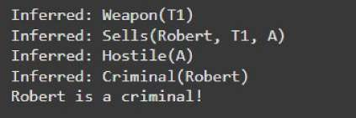

# Program 9

Create a knowledge base consisting of first order logic statements and prove the given query using Resolution

Algorithm:

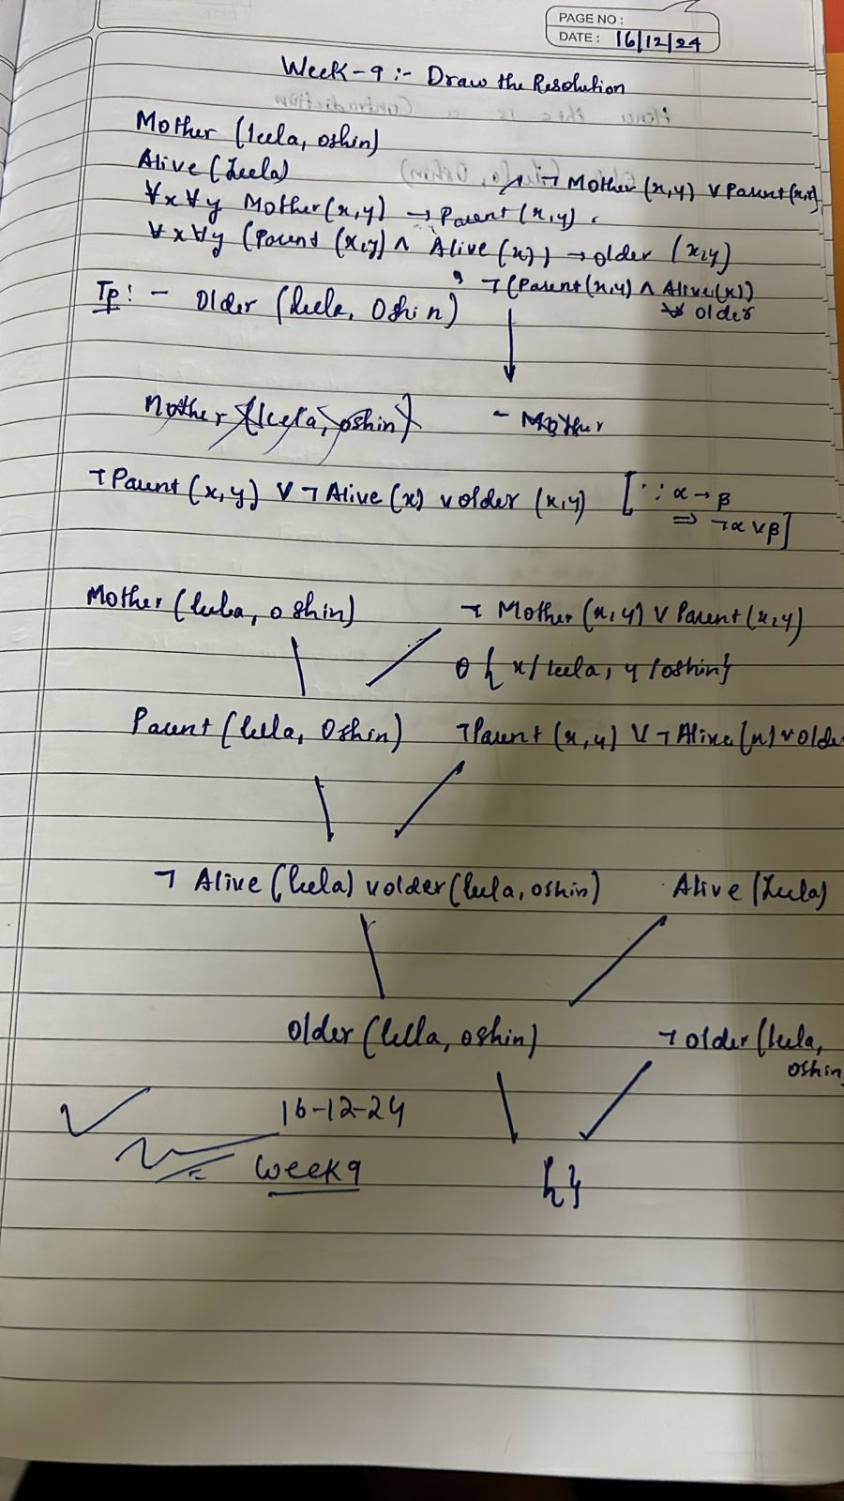

Code:

# Define the knowledge base (KB) KB = {

"food(Apple)": True, "food(vegetables)": True, "eats(Anil, Peanuts)": True, "alive(Anil)": True,

"likes(John, X)": "food(X)", # Rule: John likes all food

"food(X)": "eats(Y, X) and not killed(Y)", # Rule: Anything eaten and not killed is food "eats(Harry, X)": "eats(Anil, X)", # Rule: Harry eats what Anil eats

"alive(X)": "not killed(X)", # Rule: Alive implies not killed "not killed(X)": "alive(X)", # Rule: Not killed implies alive

}

# Function to evaluate if a predicate is true based on the KB def resolve(predicate):

# If it's a direct fact in KB

if predicate in KB and isinstance(KB[predicate], bool): return KB[predicate]

# If it's a derived rule if predicate in KB:

rule = KB[predicate]

if " and " in rule: # Handle conjunction sub_preds = rule.split(" and ")

return all(resolve(sub.strip()) for sub in sub_preds) elif " or " in rule: # Handle disjunction

sub_preds = rule.split(" or ")

return any(resolve(sub.strip()) for sub in sub_preds) elif "not " in rule: # Handle negation

sub_pred = rule[4:] # Remove "not " return not resolve(sub_pred.strip())

else: # Handle single predicate return resolve(rule.strip())

# If the predicate is a specific query (e.g., likes(John, Peanuts)) if "(" in predicate:

func, args = predicate.split("(") args = args.strip(")").split(", ")

if func == "food" and args[0] == "Peanuts":

return resolve("eats(Anil, Peanuts)") and not resolve("killed(Anil)") if func == "likes" and args[0] == "John" and args[1] == "Peanuts":

return resolve("food(Peanuts)")

# Default to False if no rule or fact applies return False

# Query to prove: John likes Peanuts query = "likes(John, Peanuts)"

result = resolve(query)

# Print the result

print(f"Does John like peanuts? {'Yes' if result else 'No'}")

# Program 10

Implement Alpha-Beta Pruning.

Algorithm:

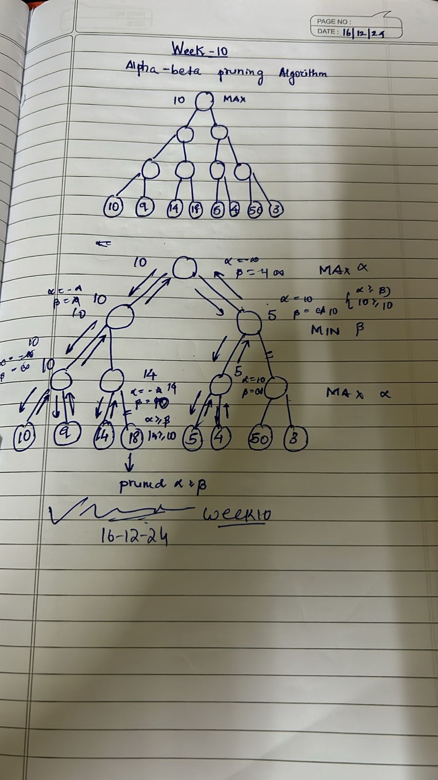

Code:

# Alpha-Beta Pruning Implementation

def alpha_beta_pruning(node, alpha, beta, maximizing_player):

# Base case: If it's a leaf node, return its value (simulating evaluation of the node) if type(node) is int:

return node

# If not a leaf node, explore the children if maximizing_player:

max_eval = -float('inf')

for child in node: # Iterate over children of the maximizer node eval = alpha_beta_pruning(child, alpha, beta, False) max_eval = max(max_eval, eval)

alpha = max(alpha, eval) # Maximize alpha if beta <= alpha: # Prune the branch

break return max_eval

else:

min_eval = float('inf')

for child in node: # Iterate over children of the minimizer node

eval = alpha_beta_pruning(child, alpha, beta, True) min_eval = min(min_eval, eval)

beta = min(beta, eval) # Minimize beta if beta <= alpha: # Prune the branch

break return min_eval

# Function to build the tree from a list of numbers def build_tree(numbers):

# We need to build a tree with alternating levels of maximizers and minimizers # Start from the leaf nodes and work up

current_level = [[n] for n in numbers]

while len(current_level) > 1: next_level = []

for i in range(0, len(current_level), 2): if i + 1 < len(current_level):

next_level.append(current_level[i] + current_level[i + 1]) # Combine two nodes else:

next_level.append(current_level[i]) # Odd number of elements, just carry forward current_level = next_level

return current_level[0] # Return the root node, which is a maximizer # Main function to run alpha-beta pruning

def main():

# Input: User provides a list of numbers

numbers = list(map(int, input("Enter numbers for the game tree (space-separated): ").split()))

# Build the tree with the given numbers tree = build_tree(numbers)

# Parameters: Tree, initial alpha, beta, and the root node is a maximizing player alpha = -float('inf')

beta = float('inf')

maximizing_player = True # The root node is a maximizing player

# Perform alpha-beta pruning and get the final result

result = alpha_beta_pruning(tree, alpha, beta, maximizing_player) print("Final Result of Alpha-Beta Pruning:", result)

if name == " main ": main()

