StudySphere
System Design Document

Project: | StudySphere – Collaborative Study GroupPlatform
Sprint: | Sprint 1
Course: | EECS 3311 M - Software Design
Date: | 9 March 2026

Team Members
Arshya Baweja | Authentication & Login
Gabriel Ottini | Group Creation
Navneet Kaur | Search Groups
Nimrat Kaur Randhawa | Join Group// Frontend UI Flow
Benjamin Bradley-Vokey | Version Control & Branch Integration  (Merge Conflict Resolution)

Table of Contents
Table of Contents 2
1. Project Overview 3
Sprint 1 Deliverables 3
2. System Environment & Dependencies 3
3. CRC Cards (Class-Responsibility-Collaborator) 4
3.1 User 4
3.2 Group 4
3.3 Chat (Implemented in Future Sprint) 5
3.4 Calendar (Implemented in Future Sprint) 5
4. Software Architecture Diagram 6
Backend Folder Structure (Sprint 1) 6
5. System Decomposition 7
5.1 Authentication Module 7
5.2 Group Management Module 7
5.3 REST API Layer (Express.js Routes) 7
5.4 Database Layer (MongoDB + Mongoose) 7
5.5 Version Control & Collaboration (GitHub) 7
6. Error Handling & Exceptional Cases 8

1. Project Overview
StudySphere is a web-based platform that enables university students to form and join study groups tied to their enrolled courses. Students can create an account, log in, update their profile, search for existing study groups relevant to their courses, and join or create virtual or in-person study sessions.

Sprint 1 Deliverables
- User authentication: registration and login
- Group creation: users can create new study groups
- Group search: users can search for groups by course
- Join group: users can join an existing study group

2. System Environment & Dependencies
StudySphere is a full-stack JavaScript web application using the MERN stack (Node.js backend, browser based frontend). The following describes the operating environment and key dependencies:

Component | Technology / Assumption
Stack | MERN Stack - MongoDB, Express.js, React, Node.js
Runtime | Node.js - server-side JavaScript runtime
Backend Framework | Express.js
Frontend | React (with HTML & CSS) - component-based UI, communicates with backend via REST API
Database | MongoDB Atlas - cloud-hosted NoSQL document store for users and groups
Database Library | Mongoose - defines schemas for Users and Groups, and handles all MongoDB Atlas queries
Authentication | bcrypt for password hashing
API Testing | Postman - used to test and validate all REST API endpoints during development
Version Control | Git & GitHub - feature branches per team member, merged via pull requests after conflict resolution
OS | Any OS supporting Node.js; MongoDB hosted on Atlas (cloud)
Development env. | Visual Studio Code

3. CRC Cards (Class-Responsibility-Collaborator)
The following CRC cards describe the primary classes in the StudySphere system, their responsibilities, and how they collaborate with other classes. Classes marked "Implemented in Future Sprint" are planned for upcoming sprints.

3.1 User
User
Parent Class: N/A Subclasses: N/A
Responsibilities:  - Registers an account with username and password  - Logs in to access personal user data  - Searches for study groups by course code  - Joins an existing study group  - Creates a new study group  - Maintains a list of groups the user belongs to | Collaborators:  - Group - User joins and creates Groups  - Chat - User sends/receives messages in a Group (future sprint)  - Calendar - User has a personal Calendar  (future sprint)

3.2 Group
Group
Parent Class: N/A Subclasses: Chat
Responsibilities:  - Stores group name, description, and meeting type (virtual or in-person)  - Stores a course code field to associate the group with a course (e.g. EECS3311)  - Maintains a list of member Users  - Allows a User to be designated as group creator/leader  - Allows Users to join the group | Collaborators:  - User - Group contains member User  - Chat - Group contains a Chat (future sprint)  - Calendar - Group provides session info to Calendar (future sprint)

3.3 Chat (Implemented in Future Sprint)
Chat
Parent Class: Group Subclasses: N/A
Responsibilities:  - Stores messages sent by Users within a Group  - Notifies Users when a new message is received  - Maintains full message history for the Group | Collaborators:  - Group - Chat belongs to a Group  - User - Chat has multiple Users as participants

3.4 Calendar (Implemented in Future Sprint)
Calendar
Parent Class: N/A Subclasses: N/A
Responsibilities:  - Displays upcoming study session times and locations for a User  - Allows Users to set notification alerts for upcoming sessions  - Aggregates session data from all Groups a User belongs to | Collaborators:  - User - each User has their own Calendar  - Group - Calendar retrieves session info from Groups

4. Software Architecture Diagram
StudySphere follows the MVC (Model-View-Controller) architecture pattern, which separates the application into three interconnected components. This is a well-established architecture for web applications (ref: https://developer.mozilla.org/en-US/docs/Glossary/MVC).

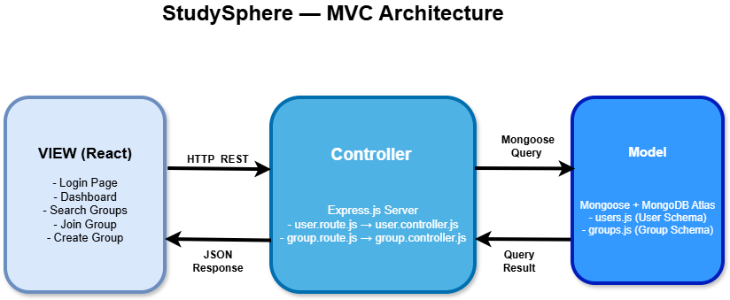

Backend Folder Structure (Sprint 1)

backend/

controllers/
user.controller.js - handles user auth logic (register, login )
group.controller.js - handles group CRUD (create, search, join)

models/
users.js - Mongoose schema for User
groups.js -Mongoose schema for Group

routes/
user.route.js - API endpoints: /api/users/*
group.route.js - API endpoints: /api/groups/*

config/
db.js - MongoDB connection configuration

5. System Decomposition
The following describes each major component of StudySphere, its role in the high-level architecture, and how it connects to the detailed design.

5.1 Authentication Module
Files: user.controller.js + user.route.js + users.js
- Handles user registration: validates inputs, hashes password with bcrypt, stores User document in MongoDB.
- Handles user login: verifies credentials
- The users.js Mongoose model enforces schema constraints (required fieldsl).

5.2 Group Management Module
Files: group.controller.js + group.route.js + groups.js
- Create Group: authenticated users can create a new Group document with name, course, meeting type (virtual/in-person)
- Search Groups: queries the groups collection by course code,department or mode (virtual ot in person) and returns matching results to the client.
- Join Group: adds the authenticated user's ID to the Group's members array; adds the group to the User's groups array.
- The groups.js model stores group metadata and an array of member User references.

5.3 REST API Layer (Express.js Routes)
- All client-server communication is via JSON REST API.
- Routes are prefixed: /api/users/* and /api/groups/*..

5.4 Database Layer (MongoDB + Mongoose)
- Two primary collections: users and groups.
- Mongoose schemas define field types, required constraints, and references between collections.
- MongoDB Atlas (cloud) or a local MongoDB instance can be used based on team configuration.

5.5 Version Control & Collaboration (GitHub)
- Each feature developed in an isolated branch (e.g., feature/auth, feature/create-group, feature/search-group, feature/join-group).
- Branches merged via pull requests after peer review and merge conflict resolution.
- Main branch maintained as stable, deployable code.

6. Error Handling & Exceptional Cases
The following table summarizes anticipated errors and how StudySphere handles them:

Error / Exception | Scenario | System Response
Missing required fields | Signup, login, or group creation submitted with empty fields | HTTP 400 - "Please provide all fields"
Username already in use | Signup attempted with a username that already exists | HTTP 409 - "Username already in use". Duplicate key error .
User not found (login) | Login attempted with an unregistered username | HTTP 404 -"User not found"
Invalid credentials | Login attempted with wrong password | HTTP 401 - "Invalid credentials". Hashed password comparison fails via bcrypt.
Group not found | User tries to join a group that does not exist | HTTP 404 - "Group not found"
User already in group | User attempts to join a group they already belong to | HTTP 400 - "User already in group". Checked using members.some() before update.
Leader not found | Group created with a username that does not exist as leader | HTTP 404 - "Leader not found". Looked up by username before group is created.
Empty search query | Search submitted with no filters provided | HTTP 400 - "Please provide at least one search filter"
Database failure | MongoDB Atlas is unreachable during any request | HTTP 500 - "Server Error" or "Internal Server Error". Error logged to console.

