**POLYTRONICS**

*B.Tech. 7th Semester Technical Seminar Report*

*Submitted for fulfilment of the requirements for the*

*Degree of Bachelor of Technology*

*Under Biju Pattnaik University of Technology*

*BY*

**Navneet Nipu Roll No. ECE#201710518**

**

**2020 – 2021**

*Under the guidance of*

**Prof. Santosh Kumar Patnaik**

**NATIONAL INSTITUTE OF SCIENCE & TECHNOLOGY**

**Institute Park, Palur Hills, Berhampur, Odisha – 761008, India**

**NATIONAL INSTITUTE OF SCIENCE & TECHNOLOGY**

**PALUR HILLS, BERHAMPUR, ODISHA– 761008, INDIA**

BONAFIDE CERTIFICATE

*This is to certify that the Seminar entitled “POLYTRONICS” is a bonafide record by* ***Navneet Nipu*** *(Roll No. 201710518 ) under my supervision and guidance, in partial fulfilment of the requirements for the Degree of Bachelor of technology from National Institute of Science and Technology under Biju Pattnaik University of Technology for the year 2020-21.*

**Prof. Santosh Kumar Patnaik**

(Guide)

Dept. of Electronics and Communication Engineering

**Prof. Durga Prasad Das** , **Dr . Sudhakar Das**

**Prof. Arttatran Sahu ,** HOD, ECE

Seminar Coordinator, ECE



**ABSTRACT**

For many years plastics were well known merely as INSULATORS and were used predominantly for shielding copper wires. Now the emerging new technology Polytronics,

changes our viewpoint in visualizing the conducting polymers as a material of MICROELECTRONICS.

Microelectronics technology in conjunction with silicon is flexible enough to easy rolling up of circuits that consume less power and above all they can be manufactured at a fraction of cost involved in making semiconductor chips. This technology has number of upcoming areas of interest where lot of research is going on to manufacture microelectronic components on plastic substrates which would allow manufacturing of gadgets through just printing process.

In this paper I would like to impart my ideas on INKJET PRINTING TECHNOLOGY which plays main role in printing polymer circuits, ELECTRONIC PAPER, construction and manufacturing of Plastic batteries, medicinal applications of Polytronics using RUBBER CIRCUITS and ELECTRO ACTIVE POLYMER and ORGANIC LED (OLED). If this technology emerges practically, the world of electronics will take a new leap.

In today’s world of ever-expanding technology, Polyt ronics is going to change the whole world of consumer electronics and form the principal root for the major advancement in the design of electronic circuits and manufacture of printed circuit boards (PCB).The era of polymer electronics has taken a great start and all the technological companies have turned their entire research towards Polytronics . We hope that, in the forthcoming years Polytronics will accelerate the pace of the technological advancements and describe a new dimension in the near future.

Current trends in the development of electronics systems show, that the provision of thin flexible components and semiconductors plays a decisive role in the steadily progressing development of highly integrated systems. A new generation of thin flexible electronic systems arises. At present, this world is very much dominated by inorganic active materials, in particular thin flexible silicon integrated circuits, but new functionality based on conductive and semi-conductive plastic materials is developing fast. Freedom of design, compact portable products, cost-effective production and assembly, environment friendly materials, software based printed ICs, flexible polymer transistors and thin flexible silicon ICs - there are unquestionable advantages of flexible electronics. Microsystems incorporating fluidic, mechanical, optical and electrical components are under research and development at present. A new word, "polytronics" (polymer+electronics) has appeared in electronic vocabulary as a short name of this quickly developed technology. This paper aims to present an overview of these technologies.

**ACKNOWLEDGEMENT**

I would like to take this opportunity to thank all those individuals whose invaluable contribution in a direct or indirect manner has gone into the making of this project a tremendous learning experience for me.

It is my proud privilege to epitomize my deepest sense of gratitude and indebtedness to my faculty guide, **Prof. Santosh Kumar Patnaik**, ECE for his valuable guidance, keen and sustained interest, intuitive ideas and persistent endeavour. His guidance and inspirations enabled me to complete my report work successfully.

I give my sincere thanks to **Prof. Durga Prasad Dash** & **Prof. Arttatran Sahu** , Seminar Coordinator, ECE, for giving me the opportunity and motivating me to complete the project within a stipulated period of time and providing a helping environment.

I acknowledge with immense pleasure the sustained interest, encouraging attitude and constant inspiration rendered by **Dr. Sukant K. Mohapatra**  (Chairman), **Prof. (Dr.) Sudhakar Das** (Principal, HoD of ECE) N.I.S.T. Their continued drive for better quality in everything that happens at N.I.S.T. and selfless inspiration has always helped us to move .

**NAVNEET NIPU**

**Roll No: 201710518**

TABLE OF CONTENT

1. INTRODUCTION 1

1.1. Definition 1

2. DEVELOPMENT OF POLYTRONICS 2

2.1. Inkjet Printing Technology 2

2.1.1. Principle 2

2.2. Screen printing 3

2.3. Evaporation printing 3

2.4. Plastic Batteries 4

2.4.1. Construction: 4

2.4.2. Uses: 4

3. MATERIALS FOR POLYTRONICS 5

3.1. Materials 5

3.2. Organic materials 6

3.3. Inorganic materials 7

3.4. Substrates 7

4. ADVANTAGES OF POLYTRONICS 9

5. APPLICATIONS 10

6. FUTURE OF POLYTRONICS 11

7. POLYTRONICS VS CONVENTIONAL ELECTRONICS 12

7.1. POLYTRONICS 12

7.2. CONVENTIONAL ELECTRONICS 12

8. LIMITATIONS 13

9. CONCLUSIONS 14

10. REFERENCES 15

LIST OF FIGURES

Figure 1: plastic electronics 1

Figure 2: construction of topgate transistor 2

Figure 3:plastic batteries 4

Figure 4:OFET structure 8

# INTRODUCTION

Silicon has largely influenced the Electronics industry and would continue to do so over a period of time. However, technologists are now looking at other alternatives, mainly “PLASTIC CIRCUITS”, to meet our future needs. Here is a look into how plastics would influence the world of electronics.

The study of usage of polymeric materials in electronics is termed as “POLYTRONICS” .This polytronics has some advantages over silicon technology. They are

1. Easy Manufacturability (mass production).

2. Low cost.

3. They can be recycled and reused

(decreases environmental stress).

4. Consumes less power.

5. They are mobile, small, and light in weight.

6. They are used to make display devices that have extraordinary picture quality.

#### Definition

Polymer electronics, or Polytronics , as the short name, is a promising technology for low-cost and large-area electronic systems, based on novel organic materials with conducting and semiconducting properties, not addressable by conventional silicon technology.

Polymers are long-chain molecules consisting of many repeat units to make a solid material Polymers are normally electrical insulators, but to enable their use in electronics, conductive filler such as silver have been added to chemical formulation to increase their electrical conductivity.

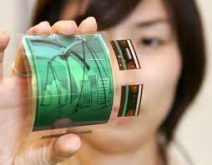

Figure 1: plastic electronics

# DEVELOPMENT OF POLYTRONICS

The feasibility of developing entire electronic components on basis of polymers is met by “INKJET PRINTING TECHNOLOGY” and is illustrated by several applications such as electronic paper, plastic batteries, etc.

#### Inkjet Printing Technology

The huge cost of manufacturing Silicon microchip is due to the large complex processes involved. Photolithographic techniques are used to pattern wafers with microcircuit, which is grown in powerful vacuum, while the wafers are baked at temperatures of several hundred centigrade. The INKJET PRINTING TECHNOLOGY provides continuous production line of plastic circuits on plastic substrates and then cut into individual units. The substrates are made of acetate material that is as transparent as vu graph sheets. This printing technology plays a major role in the development of “flat screen” displays.

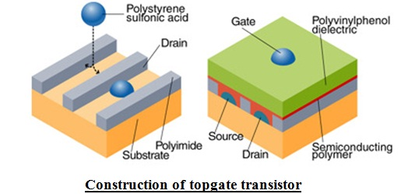

Figure 2: construction of topgate transistor

##### Principle

A piezoelectric material expands when a voltage is passed across it, pressing on a reservoir fluid and sending droplets flying out on to the substrates. Here, the construction of “TOPGATE TRANSISTOR” is explained below.

The water based droplets contain an organic conductor-POLY (3,4- ethylenedioxythiophene) doped with a solution of polystyrene sulphonic acid otherwise known as PEDOT/PSS.As the droplets dry they become a conducting layer and form source and drain of a transistor. They are then coated with a layer of semiconducting polymer (9, 9-dioctyl flourene-co-bithiophene) followed by a dielectric layer of polyvinylphenol.Finally gate is printed, creating a so called top gate transistor. How the semiconductor polymer dries is very crucial.

The molecular chains must line up in a way that makes it easy for an electron to hop from one chain to another, but the polymers tend to form into disordered microstructure that reduces electron charge.

Resolution of the screen can be improved by coating glass substrate with a hydrophobic film of polyimide pattern. When the water based droplets fall on the surface they are forced away from the hydrophobic regions in the required pattern.

#### Screen printing

Screen printing is appropriate for fabricating electrics and electronics due to its ability to produce patterned, thick layers from paste-like materials. This method can produce conducting lines from inorganic materials (e.g. for circuit boards and antennas), but also insulating and passivating layers, whereby layer thickness is more important than high resolution. Its 50 m²/h throughput and 100 µm resolution are similar to inkjets .This versatile and comparatively simple method is used mainly for conductive and dielectric layers ,but also organic semiconductors, e.g. for OPVCs, and even complete OFETs can be printed.

#### Evaporation printing

Evaporation printing uses a combination of high precision screen printing with material vaporization to print features to 5 µm. This method uses techniques such as thermal, e-beam, sputter and other traditional production technologies to deposit materials through a high precision shadow mask (or stencil) that is registered to the substrate to better than 1 micrometer. By layering different mask designs and/or adjusting materials, reliable, cost-effective circuits can be built additively, without the use of photo-lithography.

#### Plastic Batteries

Plastic batteries are new type of low power batteries that do not require a case and are thin enough to be printed on a paper. They are of low cost and can be mass produced as the battery material is roughly 0.5 millimeters thick.

##### Construction:

* The new battery consists of 3 different layers.
* It has conventional zinc manganese dioxide components as anode and cathode which are thin foil-like plastic sheets.
* Electrolyte is a polymer gel placed between electrodes.

##### Uses:

* They can be used for incorporating power source in integrated circuits.
* The polymer battery system can be used to power space satellites, giving them uninterrupted power supply by harnessing solar energy.

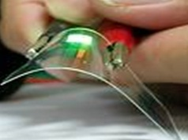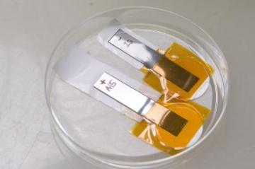

Figure 3:plastic batteries

# MATERIALS FOR POLYTRONICS

#### Materials

* Both organic and inorganic materials are used for printed electronics. Ink materials must be available in liquid form, for solution, dispersion or suspension. They must function as conductors, semiconductors, dielectrics, or insulators. Material costs must be fit for the application.
* Electronic functionality and printability can interfere with each other, mandating careful optimization.For example, a higher molecular weight in polymers enhances conductivity, but diminishes solubility. For printing, viscosity, surface tension and solid content must be tightly controlled. Cross-layer interactions such as wetting, adhesion, and solubility as well as post-deposition drying procedures affect the outcome. Additives often used in conventional printing inks are unavailable, because they often defeat electronic functionality.
* Material properties largely determine the differences between printed and conventional electronics. Printable materials provide decisive advantages beside printability, such as mechanical flexibility and functional adjustment by chemical modification (e.g. light colour in OLEDs).
* Printed conductors offer lower conductivity and charge carrier mobility.
* With a few exceptions, inorganic ink materials are dispersions of metallic or semiconducting micro- and nano-particles. Semiconducting nanoparticles used include silicon and oxide semiconductors. Silicon is also printed as an organic precursor which is then converted by pyrolisis and annealing into crystalline silicon.
* PMOS but not CMOS is possible in printed electronics.

#### Organic materials

* Organic printed electronics integrates knowledge and developments from printing, electronics, chemistry, and materials science, especially from organic and polymer chemistry. Organic materials in part differ from conventional electronics in terms of structure, operation and functionality, which influences device and circuit design and optimization as well as fabrication method.
* The discovery of conjugated polymers and their development into soluble materials provided the first organic ink materials. Materials from this class of polymers variously possess conducting, semiconducting, electroluminescent, photovoltaic and other properties. Other polymers are used mostly as insulators and dielectrics.
* In most organic materials, hole transport is favored over electron transport.Recent studies indicate that this is a specific feature of organic semiconductor/dielectric-interfaces, which play a major role in OFETs.Therefore, p-type devices should dominate over n-type devices. Durability (resistance to dispersion) and lifetime is less than conventional materials.
* Organic semiconductors include the conductive polymers poly(3,4-ethylene dioxitiophene), doped with poly(styrene sulfonate), (PEDOT:PSS) and poly(aniline) (PANI). Both polymers are commercially available in different formulations and have been printed using inkjet, screen and offset printing or screen, flexo and gravure printing, respectively.
* Polymer semiconductors are processed using inkjet printing, such as poly(thiopene)s like poly(3-hexylthiophene) (P3HT) and poly(9,9-dioctylfluorene co-bithiophen) (F8T2).The latter material has also been gravure printed. Different electroluminescent polymers are used with inkjet printing, as well as active materials for photovoltaics (e.g. blends of P3HT with fullerene derivatives),which in part also can be deposited using screen printing (e.g. blends of poly(phenylene vinylene) with fullerene derivatives).
* Printable organic and inorganic insulators and dielectrics exist, which can be processed with different printing methods.

#### Inorganic materials

* Inorganic electronics provides highly ordered layers and interfaces that organic and polymer materials cannot provide.
* Silver nanoparticles are used with flexo , offset and inkjet. Gold particles are used with inkjet.
* A.C. electroluminescent (EL) multi-colour displays can cover many tens of square meters, or be incorporated in watch faces and instrument displays. They involve six to eight printed in organic layers, including a copper doped phosphor, on a plastic film substrate.
* CIGS cells can be printed directly onto molybdenum coated glass sheets.
* A printed gallium arsenide germanium solar cell demonstrated 40.7% conversion efficiency, eight times that of the best organic cells, approaching the best performance of crystalline silicon.

#### Substrates

* Printed electronics allows the use of flexible substrates, which lowers production costs and allows fabrication of mechanically flexible circuits. While inkjet and screen printing typically imprint rigid substrates like glass and silicon, mass-printing methods nearly exclusively use flexible foil and paper. Poly(ethylene terephthalate)-foil (PET) is a common choice, due to its low cost and moderately high temperature stability. Poly(ethylene naphthalate)- (PEN) and poly(imide)-foil (PI) are higher performance, higher cost alternatives. Paper's low costs and manifold applications make it an attractive substrate , however, its high roughness and high wettability have traditionally made it problematic for electronics. This is an active research area, however, and print-compatible metal deposition techniques have been demonstrated that adapt to the rough 3D surface geometry of paper.
* Other important substrate criteria are low roughness and suitable wet-ability, which can be tuned pre-treatment by use of coating or Corona discharge. In contrast to conventional printing, high absorbency is usually disadvantages.

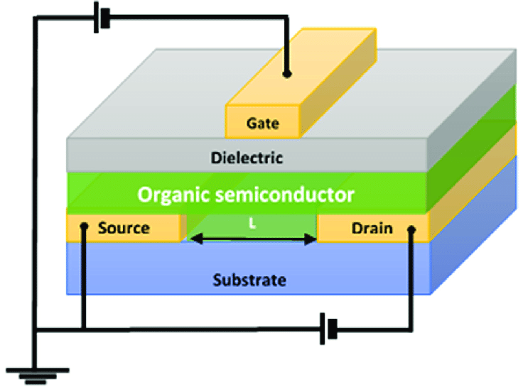

Figure 4:OFET structure

# ADVANTAGES OF POLYTRONICS

* Environment-friendly and bio-friendly
* Manufacture is relatively simple
* Light weighted and flexible
* Freedom of choice of their chemical composition
* Adaptable in various ways
* Flat discharge curve

# APPLICATIONS

1. Fabrication of organic thin film transistors
2. Non-volatile memory devices based on organic transistors
3. Development of novel conjugated polymers for photovoltaic
4. device applications
5. Fabrication of organic photovoltaic cells
6. Fabrication of organic light-emitting devices (OLED)
7. Ferroelectric polymers for thin film devices
8. Gene Sensors
9. Printed Electronics
10. Conducting Polymer Actuators and Micropumps.
11. Responsive Membranes/Hybrid Plastics.
12. focused upon polymer membranes that incorporated
13. electronically conducting polymers and piezoelectric polymers

# FUTURE OF POLYTRONICS

In today’s world of ever-expanding technology, Polytronics is going to change the whole world of consumer electronics and form the principal root for the major advancement in the design of electronic circuits and manufacture of printed circuit boards (PCB) .The era of polymer electronics has taken a great start and all the technological companies have turned their entire research towards Polytronics So I conclude that, in the forthcoming years Polytronics will accelerate the pace of the technological advancements and describe a new dimension in the near future.

# POLYTRONICS VS CONVENTIONAL ELECTRONICS

#### POLYTRONICS

* Long switching times.
* Low integration density.
* Large areas.
* Flexible substrate.
* Extremely low fabrication costs.

#### CONVENTIONAL ELECTRONICS

* Extremely short switching times.
* Extremely high integration density.
* Small areas.
* Rigid substrate.
* Sophisticated fabrication.
* High fabrication costs.

# LIMITATIONS

1. Due to their intrinsic physical properties (i.e. limited mobility of charge carriers), the performance of polymer electronic products lacks the speed of its silicon counterpart.
2. Research is still on going to increase performance for more complex functionality.
3. To be able to improve performance one should be able to distinguish between problems introduced during preparation, intrinsic material properties, and device characteristics.

# CONCLUSIONS

ICPs are Electrically-conductive polymers in which the Conductivity arises from the presence of conjugated car-bon-carbon bonds. These conjugated polymers possess interesting and useful properties due to their delocalised electron systems. Polymer electronics are light, flexible, and less expensive to produce on a mass quantity scale than conventional electronics Polymer electronics are not a competing product but are considered to be more complementary to its silicon counterparts.

# REFERENCES

1. Balde J. W. (Ed.), "Foldable Flex and Thinned Silicon Multichip Packaging Technology", Kluwer Academic-Publishers for IMAPS (Norwell, 2002) pp. 106-114.
2. Landesberger C. et al., "New Dicing and Thinning Concept Improves Mechanical Reliability of Ultra Thin silicon," Proc IEEE 01TH8562, ISBN 0-930815-64-5, March 2001, pp. 92-97.