Design and Development of LiKerBOT

**MINOR PROJECT REPORT**

Submitted in partial fulfillment of the requirements

For the degree of

**BACHELOR OF ENGINEERING**

In

**COMPUTER SCIENCE & ENGINEERING**

By

**GROUP NO. 41**

SHYAM MAURYA (0187CS171153)

NAVNEET PUROHIT (0187CS171089)

Under the guidance of

**Dr. Rajeev Gupta**

Associate Professor Department of CSE/IT



**Oct-2019**

**Department of COMPUTER SCIENCE & ENGINEERING**

**Sagar Institute of Science & Technology (SISTec)**

**Bhopal (M.P.)**

**An ISO 9001:2008 Certified Institution**

**Approved by AICTE, New Delhi & Govt. of M.P.**

**Affiliated to Rajiv Gandhi Proudyogiki Vishwavidyalaya, Bhopal (M.P.)**

***Sagar Institute of Science & Technology (SISTec), Bhopal***

***Department of COMPUTER SCIENCE & ENGINEERING***

***Bhopal (M.P.)***



***CERTIFICATE***

I hereby certify that the work which is being presented in the B.E. Minor Project Report entitled **Design and Development LiKerBOT,** in partial fulfilment of the requirements for the award of the degree of ***Bachelor of Engineering*** in ***Computer Science & Engineering*** and submitted to the Department of Computer Science &Engineering, *Sagar Institute of Science & Technology (SISTec)****,*** Bhopal (M.P.) is an authentic record of my own work carried out during the period from July-2019 to October-2019 under the supervision of **Dr. Rajeev Kumar Gupta, Associate Professor.**

The content presented in this project has not been submitted by me for the award of any other degree elsewhere.

**Name Enrolment no. Signature**

Shyam Maurya 0187cs171153

Navneet Purohit 0187cs171089

This is to certify that the above statement made by the candidate is correct to the best of my knowledge.

***Date:***

## *Project Supervisor HOD Principal*

## *Dr. Rajeev Gupta Dr Nikhlesh Pathak Dr Keshavendra Chaudhary*

## ABSTRACT

The project titled LiKerBoT is python based web application for automatically like the post, according to the hash-tag given by user. The LiKerBoT is developed in python using selenium and driver software (here gecko-driver software for Firefox).

It mainly focuses on reducing our precious time and which takes your email, password and a hash-tag and like the posts according to the given hash-tag.

“LikerBot” is a web application written for 64-bit windows operating system designed to help users to grow their community or business. Our software is easy to use for both beginners and advance user, it features a familiar and well through-out, an attractive user interface, combined with strong selenium automation.

The report generation facility of LiKerBOT helps to get a good idea of which are the software and hardware required and their installations, makes users possible to generate reports hard copy. The application LiKerBOT has one main python file which has 3 similar main classes for different social sites as Instagram-BOT for Instagram automation access, Twitterbot for twitter automation access and LinkedIn for LinkedIn automation access.

LikerBot has 3 main advantages:

* Manual human effort and time saving
* Automation (Handsfree)
* Helps to grow user`s community

## ACKNOWLEDGEMENT

We express our deepest gratitude to our **Principal Dr. Keshvendra Choudhary** for providing us with an environment to complete our project successfully.

We are deeply indebted to our **H.O.D Dr. Niklesh Pathak** who modelled us both technically and mentally for achieving greater success in life. He showed us different way to approach a research problem and the need to be persistent to accomplish any goal. We thank him heartily.

We are very grateful to our **Project Guide Dr. Rajeev Gupta** for being instrumental in the completion of our project with his complete guidance.

We also thank all the staff members of our college and technicians for their help in making this project a successful one.

Finally, we take this opportunity to extend our deep appreciation to our family and friends, for all that they meant to us during the crucial times of the competition of our project.

**Name Enrollment No. Signature**

**Shyam Maurya 0187cs171153**

**Navneet Purohit 0187cs171089**

## LIST OF FIGURES

|  |  |  |
| --- | --- | --- |
| **FIG. NO.** | **TITLE** | **PAGE NO.** |
| 5.1 | E-R Diagram | 11 |
| 5.2 | Use case diagram | 12 |
| 6.1 | LiKerBOT Homepage | 14 |
| 6.2 | LiKerBOT LinkedIn page | 14 |
| 6.3 | LiKerBOT Instagram page | 15 |
| 6.4 | LiKerBOT Twitter page | 15 |
| 6.5.1 | LinkedIn Login Page | 16 |
| 6.5.2 | LinkedIn Likes Activity | 16 |
| 6.6.1 | Instagram Login Page | 17 |
| 6.6.2 | Instagram Likes Activity | 17 |
| 6.7.1 | Twitter Login Page | 18 |
| 6.7.2 | Twitter Likes Activity | 18 |
| 7.1.1 | Python 3.7.4 downloading | 20 |
| 7.1.2 | Python Installation | 21 |
| 7.2 | Visual Studio Download | 22 |
| 7.3 | Mozilla firefox Download | 23 |
| 7.4 | Installation of Selenium | 24 |
| 7.5 | Geckodriver Download | 25 |

## LIST OF ABBREVIATIONS

|  |  |  |
| --- | --- | --- |
| **ACRONYM** | **FULL FORM** | |
| SDLC | | Software Development Life Cycle |
| CSS | | Cascading Style Sheet |
| HTML | | Hyper Text Markup Language |
| UML | | Unified Modeling Language |
| ER | | Entity Relationship Diagram |

**Table Of Contents**

Abstract i

Acknowledgement ii

List Of Figures iii

List Of Abbreviations iv

Chapter 1 1

Introduction 2

1.1 Purpose: 2

1.2 Intended Audience And Reading Suggestions 2

1.3 Project Scope 2

1.4 Characteristics Of Likerbot 2

1.5 Overview Of Document 3

Chapter 2 5

Software And Hardware Requirements 5

2.1 Hardware Requirement 5

2.1.1 Website 5

2.2 Software Requirements 5

2.2.1 Frontend(Website) 5

2.2.2 Backend(Website) 5

Chapter 3 7

Problem Description 7

3.1 Overview: 7

Chapter-4 9

Software Requirement Specification 9

4.1 Functional Requirements: 9

4.2 Non-Functional Requirements 9

Chapter 5 11

Software Design 11

5.1 Er Diagram 11

Chapter 6 14

Output Screen 14

6.1 Output Screens: 14

Chapter-7 Deployment 20

7.1 Python 20

7.2 Visual Studio Code 22

7.3 Mozilla Firefox 23

7.4 Selenium 24

7.5 Geckodriver 25

Appendix-1 Glossary Of Terms 28

E 28

G 28

H 29

P 29

**CHAPTER 1**

**INTRODUCTION**

## CHAPTER 1

## INTRODUCTION

**1.INTRODUCTION**

## 1.**1 PURPO­SE**:

The purpose of this project is to build the web application used to get attention of the other users to our LiKerBoT user profile. This help the user to promote or get attention on his or her profile of social media like Twitter, Instagram, LinkedIn.

## 1.2 INTENDED AUDIENCE AND READING SUGGESTIONS

This project is a prototype for like the post of twitter, Instagram and LinkedIn. This has been implemented under the guidance of college professor Prof. Rajeev Gupta. This project is useful for user of our web application for getting attention on user profile from other users.

## 1.3 PROJECT SCOPE

The scope of the project is building an web application which can be used for business purpose, shopping purposes as well as for education purposes and to create a convenient and easy-to-use web application for the users for all social sites.

## 1.4 CHARACTERISTICS OF LIKERBOT

* LikerBot saves the time of the user.
* LikerBot helps to find same type of persons.
* LikerBot is used to getting and throwing attention on the user’s profile.
* LikerBot provide facility to choose our required hashtag.

## 1.5 OVERVIEW OF DOCUMENT

The next chapter, the Software Requirement Specification section, of this document gives an overview of the Hardware and software requirement of the product. It describes all the software and the hardware requirements in the next chapter.

The third chapter, Problem description section, of this document is written primarily for the developers and describes in technical terms the details of the usage of the product

The fourth chapter, Literature Survey

The Fifth chapter describe all the functional and the non-functional requirements of our projects.

The sixth chapter describe all the functionalities and non-functionalities by using ER(Entity relationship diagram ) and UML(Unified Modeling Language) .

**CHAPTER 2**

**SOFTWARE AND HARDWARE REQUIREMENT**

## CHAPTER 2

## SOFTWARE AND HARDWARE REQUIREMENTS

## 

## **2**.**1 HARDWARE REQUIREMENT**

## 2.1.1 WEBSITE

* Processor : Minimum p4
* Windows : Minimum windows 64 -bit
* RAM : Minimum 1024MB
* Browser : Mozilla Firefox

## 2.2 SOFTWARE REQUIREMENTS

## 2.2.1 FRONTEND(WEBSITE)

* HTML
* CSS
* Visual Studio Code
* Mozilla Firefox

## 2.2.2 BACKEND(WEBSITE)

* Django
* Python
* Selenium
* Geckodriver

**CHAPTER 3**

**PROBLEM DESCRIPTION**

## CHAPTER 3

## PROBLEM DESCRIPTION

## 3.1 OVERVIEW:

The web application can be used for Business purpose, for Shopping purposes, for Learning purposes, for any Educational purposes, for Advertisement purposes and many more on the social sites. It is used to gathering and throwing attention to the user profile.

Basically, let us take an example of the user it is new on the social site and he or she is having some content to share with the peoples and basically user just need followers to increase its business or any purpose so he or she just like the post according to his or her business. Our web application needs the Email or username, password and hashtag and it likes the random post according to the hashtag given by the user and that photo like of other user’s and if other user’s is interested and exited then he or she will visit to the user profile and if the user profile content is good then other user’s like and share the content and also follow the user and it is used for business purpose and for getting attention to our profile by other peoples.

That helps in

* Finding same type of peoples
* Business purposes
* Shopping purposes
* Educational purposes
* Learning purposes
* Advertisement purposes
* Finding some new types of person

**CHAPTER 4**

**SOFTWARE REQUIREMENT SPECIFICATION**

## CHAPTER-4

## SOFTWARE REQUIREMENT SPECIFICATION

## 

## 4.1 FUNCTIONAL REQUIREMENTS:

* User must be logged in with correct email and password.
* User must have to type the hashtag.
* User must have internet connection.

## 4.2 NON-FUNCTIONAL REQUIREMENTS

* Performance
* Maintainability
* Availability
* Usability
* Interoperability
* Data Integrity
* Serviceability.
* Security

**CHAPTER 5**

**SOFTWARE DESIGN**

## CHAPTER 5

## SOFTWARE DESIGN

## 

## 5.1 ER DIAGRAM

An entity relationship diagram (ERD) shows the relationship of entity sets stored in a database. An entity in this context is a component of data. In other words, ER diagrams illustrate the logical structure of databases.

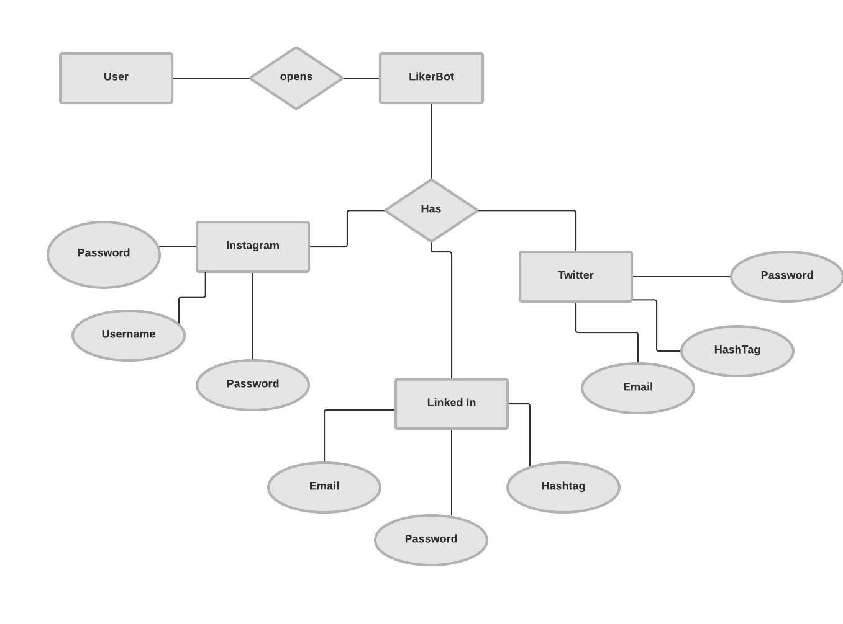

**Figure 5.1: Entity Relationship Diagram for LiKerBoT**

**5.2 USE CASE DIAGRAM**

A use case diagram at its simplest is a representation of a user's interaction with the system that shows the relationship between the user and the different use cases in which the user is involved. A use case diagram can identify the different types of users of a system and the different use cases and will often be accompanied by other types of diagrams as well. The use cases are represented by either circles or ellipses.

**5.2.2 USE CASE DIAGRAM FOR USER**

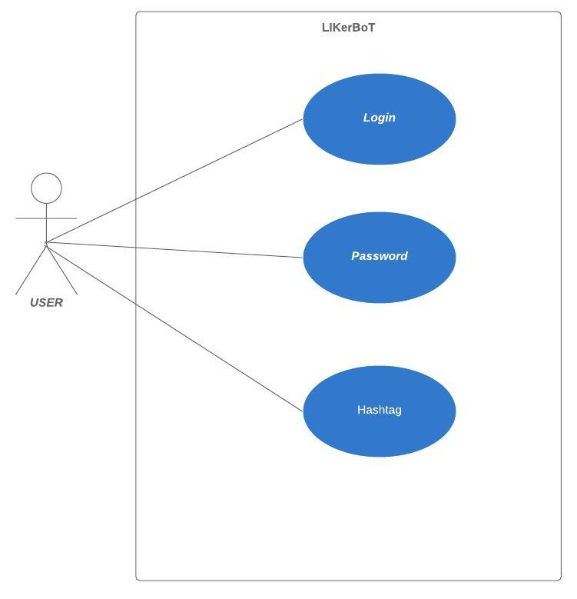

**Figure 5.2: Use Case Diagram For LiKerBOT**

**CHAPTER 6**

**OUTPUT SCREEN**

## CHAPTER 6

## OUTPUT SCREEN

## 6.1 OUTPUT SCREENS:

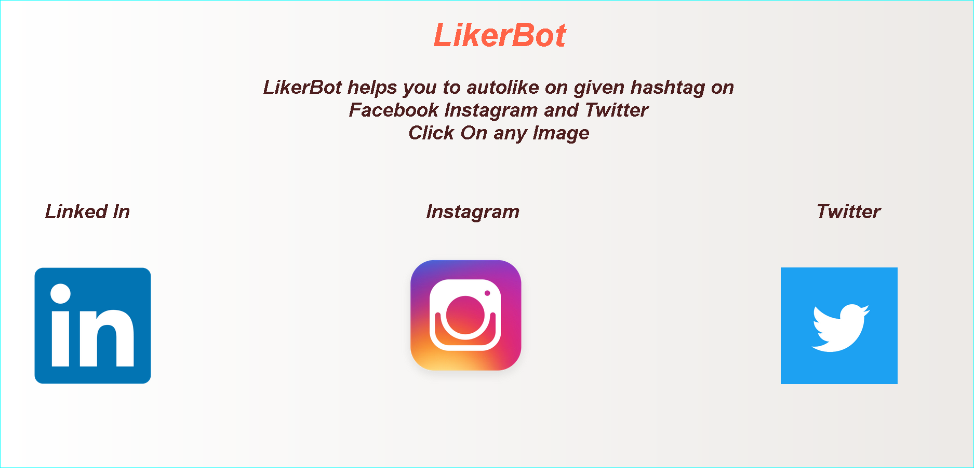

**Fig 6.1 LiKerBOT Homepage**

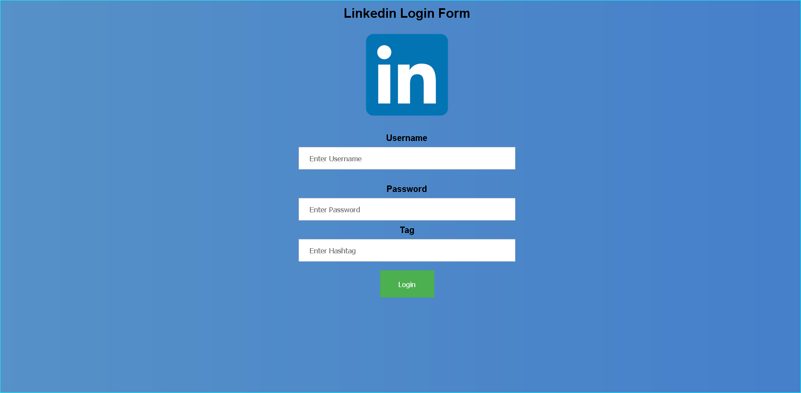

**Fig 6.2 LiKerBOT LinkedIn page**

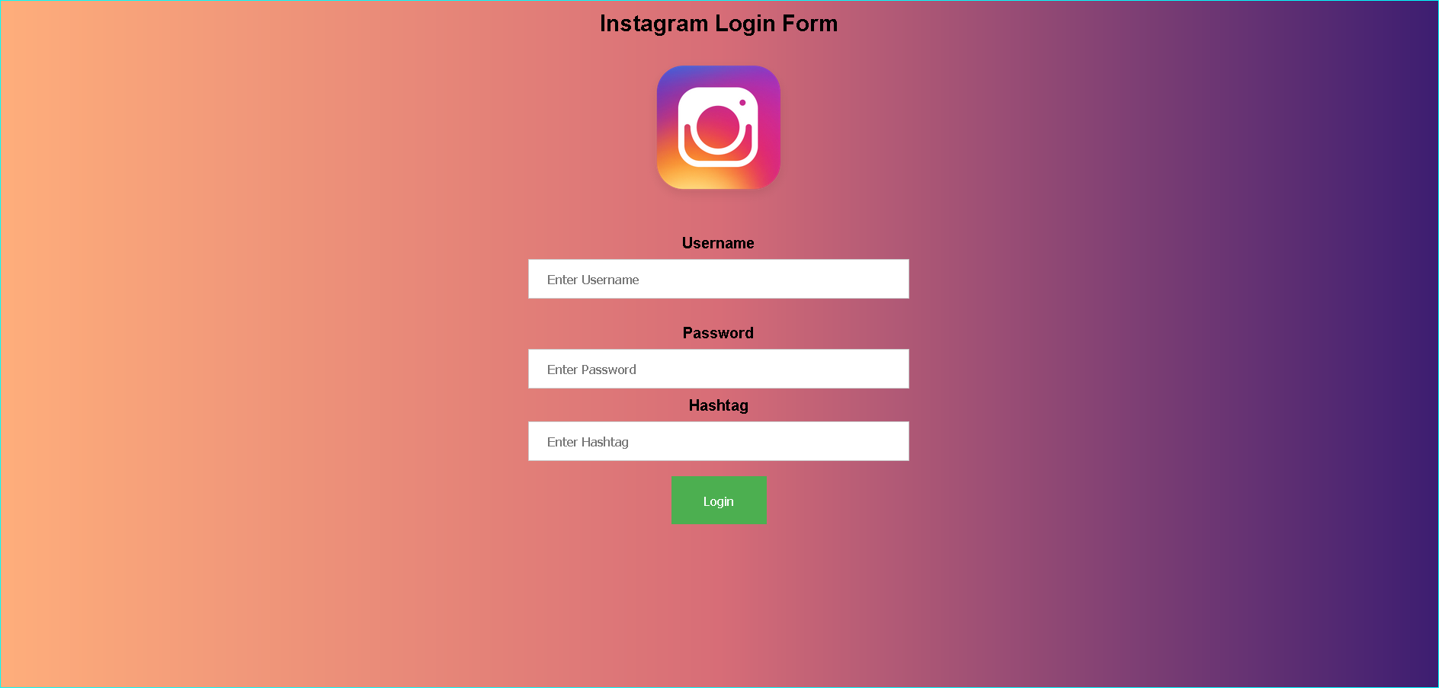

**Fig 6.3 LiKerBOT Instagram page**

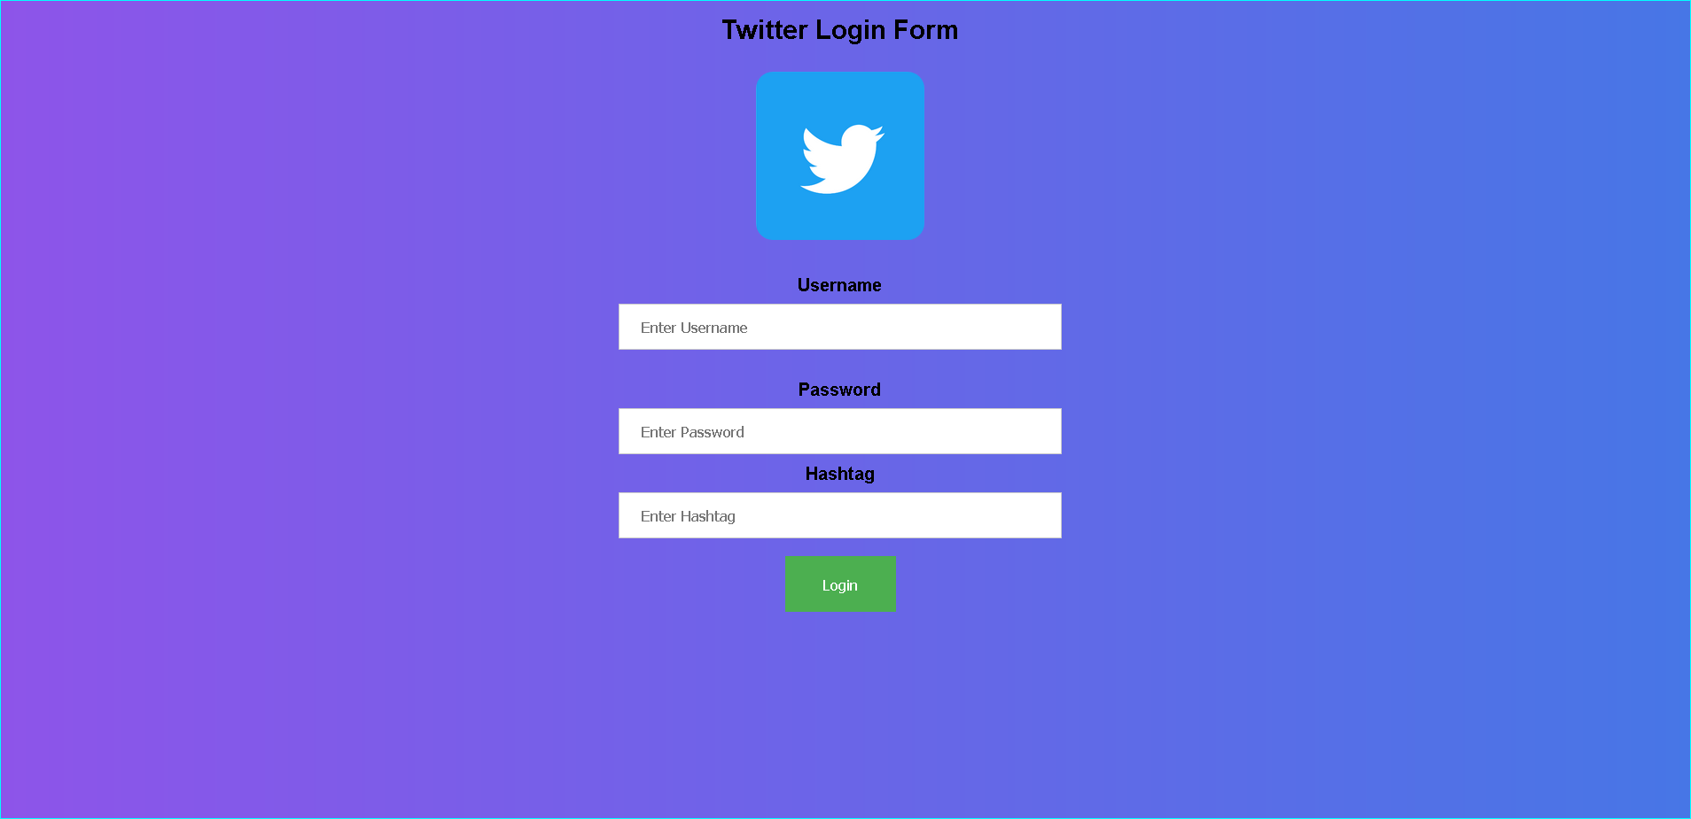

**Fig 6.4 LiKerBOT Twitter Page**

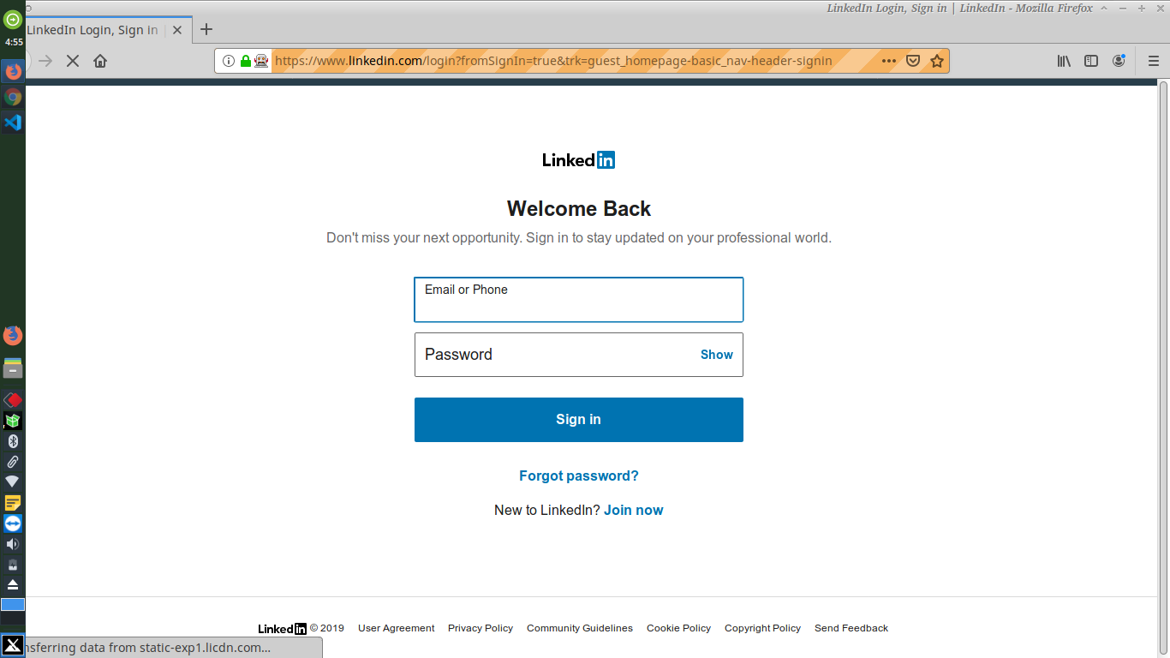

**Fig 6.5.1 LinkedIn Login page**

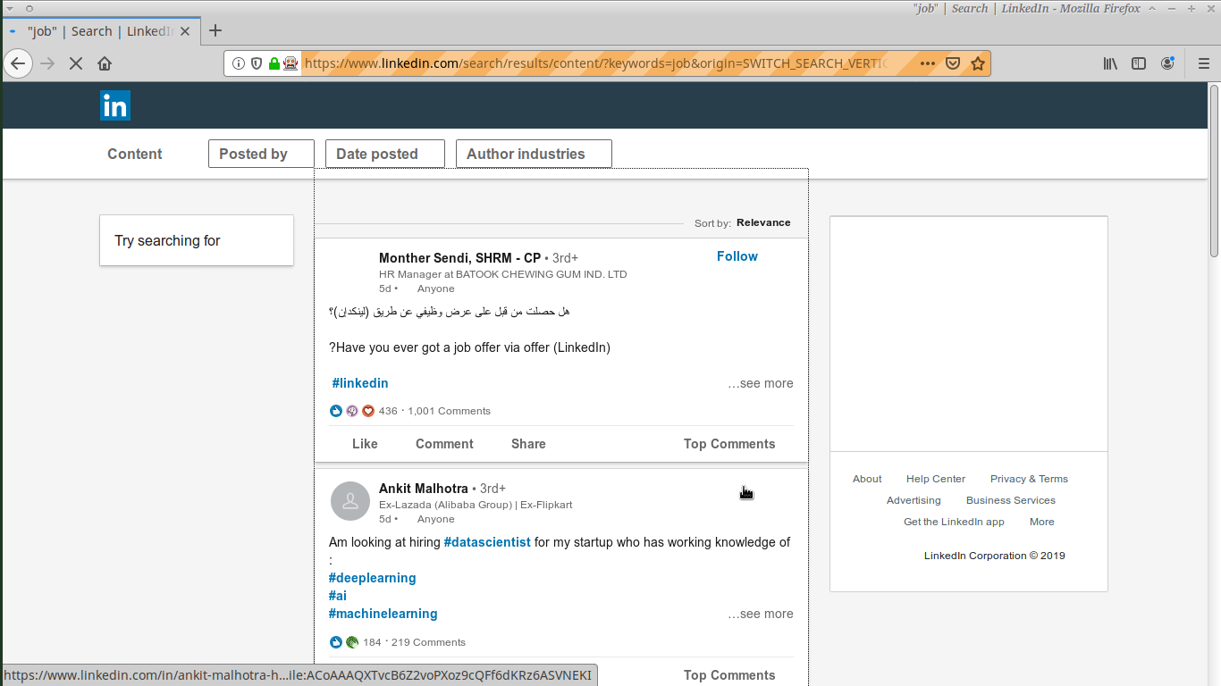

**Fig 6.5.2 LinkedIn Likes Activity**

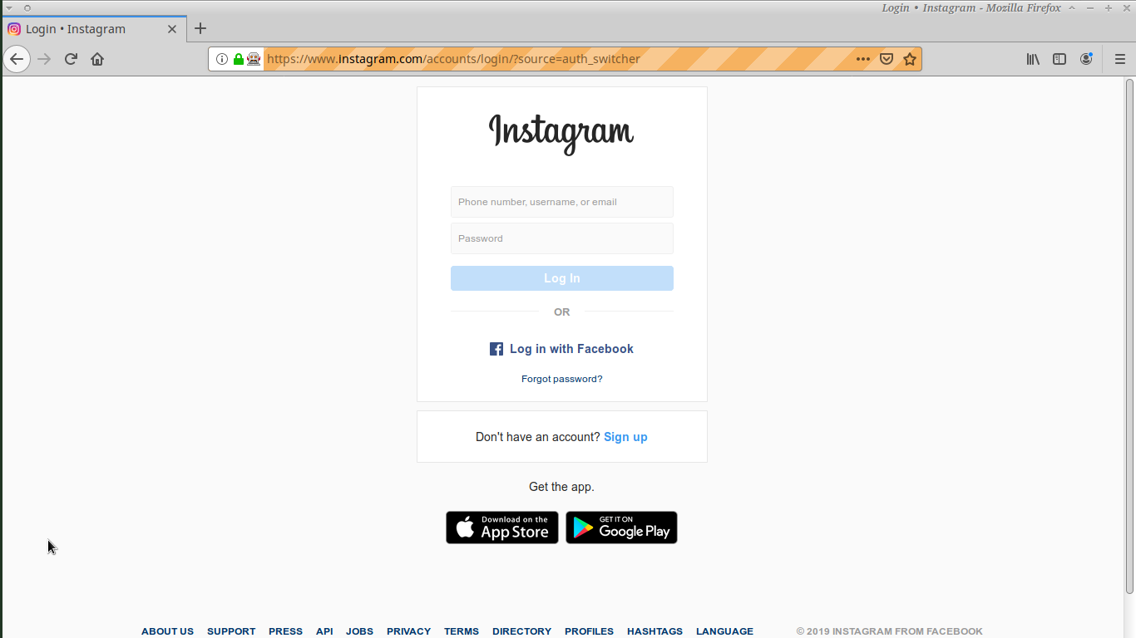

**Fig 6.6.1 Instagram Login page**

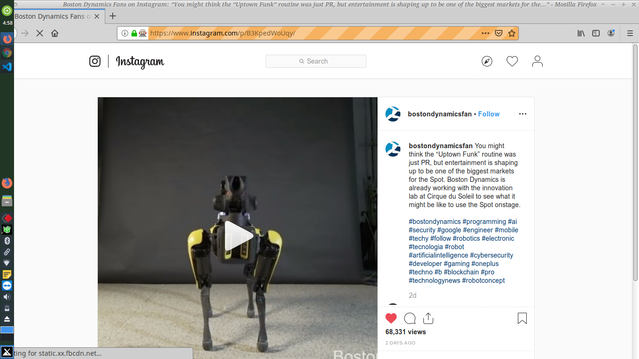

**Fig 6.6.2 Instagram Likes Activity**

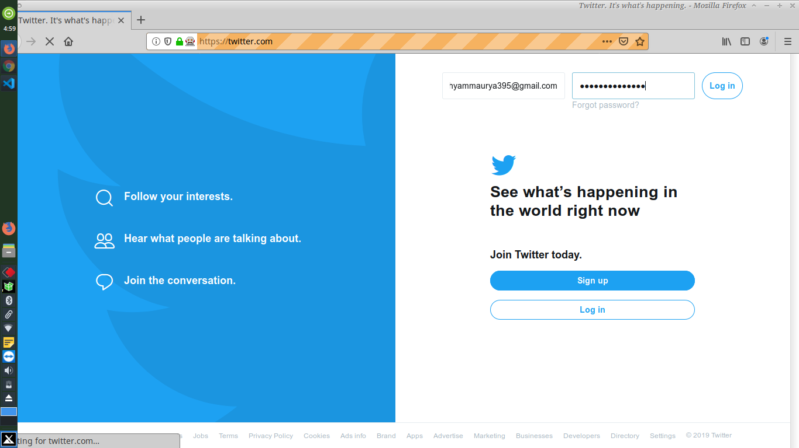

**Fig 6.7.1 Twitter Login page**

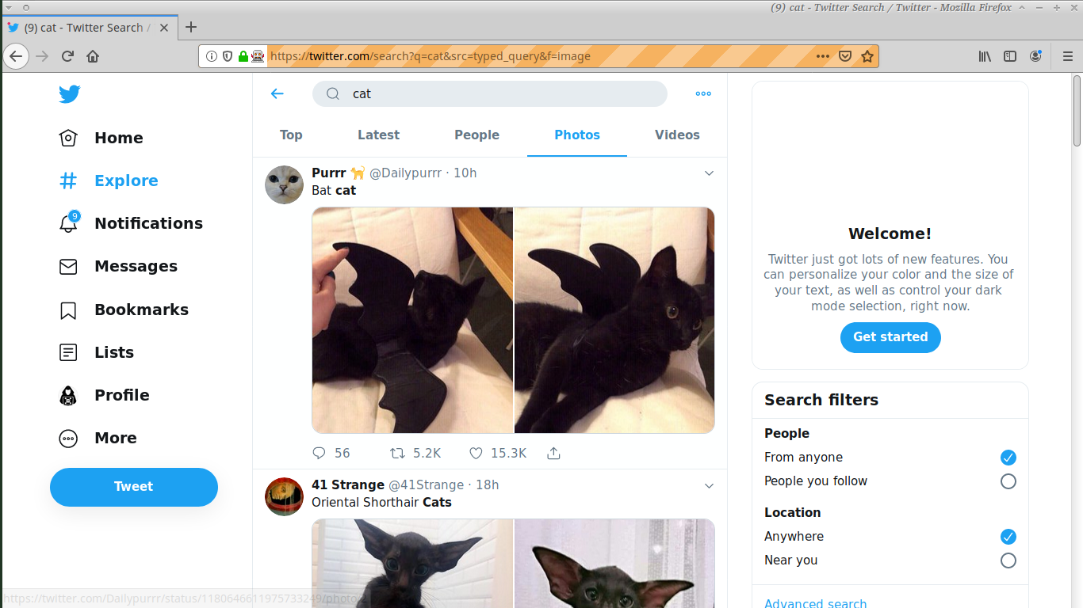

**Fig 6.5.2 Twitter Likes Activity**

**CHAPTER 7**

**DEPLOYMENT**

## CHAPTER-7 DEPLOYMENT

## 7.1 PYTHON

To install Python 3 on Linux

See if Python is already installed.

$ python --version

or

$ python3 --version

Note

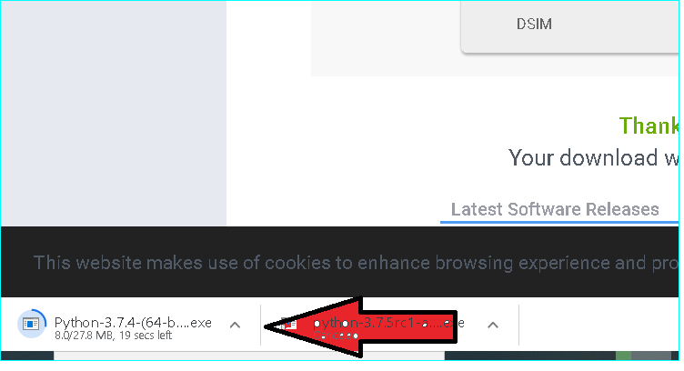

**Fig 7.1.1 Python 3.7.4 downloading**

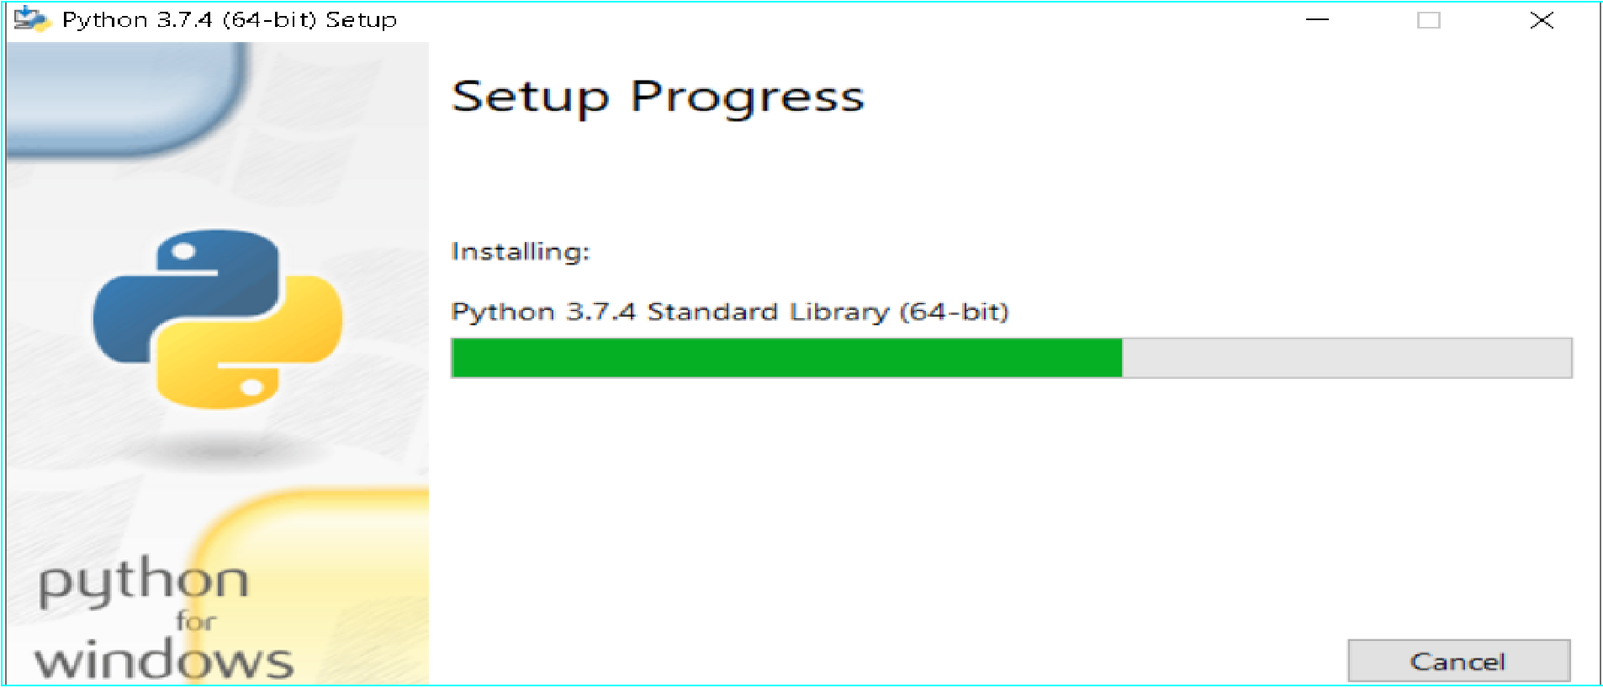

**Fig 7.1.2 Python Installation**

If your Linux distribution came with Python, you might need to install the Python developer package to get the headers and libraries required to compile extensions, and install the AWS CLI. Use your package manager to install the developer package (typically named python-dev or python-devel).

If Python 2.6 or later is not installed, install Python with your distribution's package manager. The command and package name varies.

On Debian derivatives such as Ubuntu, use apt. Check the apt repository for the versions of Python available to you. Then, run a command similar to the following, substituting the correct package name:

**$ sudo apt-get install python3**

On Red Hat and derivatives, use yum. Check the yum repository for the versions of Python available to you. Then, run a command similar to the following, substituting the correct package name:

**$ sudo yum install python35**

On SUSE and derivatives, use zypper. Check the repository for the versions of Python available to you. Then. run a command similar to the following, substituting the correct package name:

**$ sudo zypper install python3**

## 7.2 VISUAL STUDIO CODE

Installing vs Code in linux

Visual Studio Code is officially distributed as a Snap package in the Snap Store:

You can install it simply by running:

**sudo snap install --classic code**

The easiest way to install Visual Studio Code for Debian/Ubuntu based distributions is to download and install the .deb package (54-bit), either through the graphical software center if it's available, or through the command line with:

**sudo apt install ./<file>.deb**

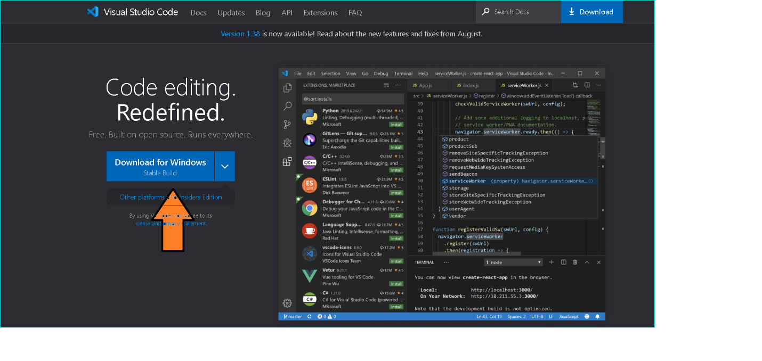

**Fig 7.2 Visual Studio download**

## 7.3 MOZILLA FIREFOX

Installing firefox on linux or windows:

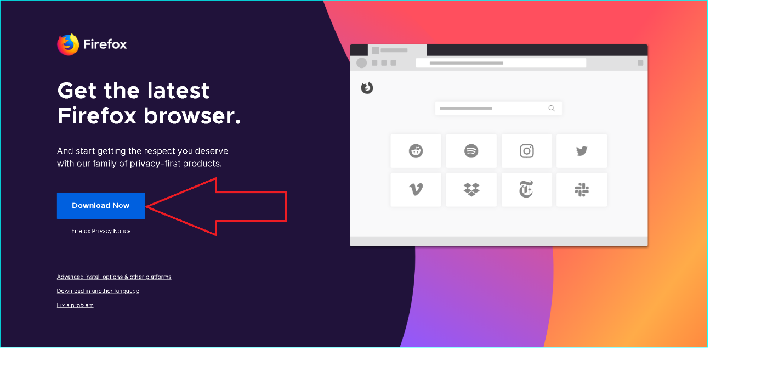

**Fig 7.3 Mozilla Firefox download**

Download the .deb file from this link

“https://packages.debian.org/sid/i375/firefox/download”

Run this cmd in terminal

**Sudo apt install ./<file>.deb**

## 7.4 SELENIUM

In terminal, run this cmd:

Pip install selenium

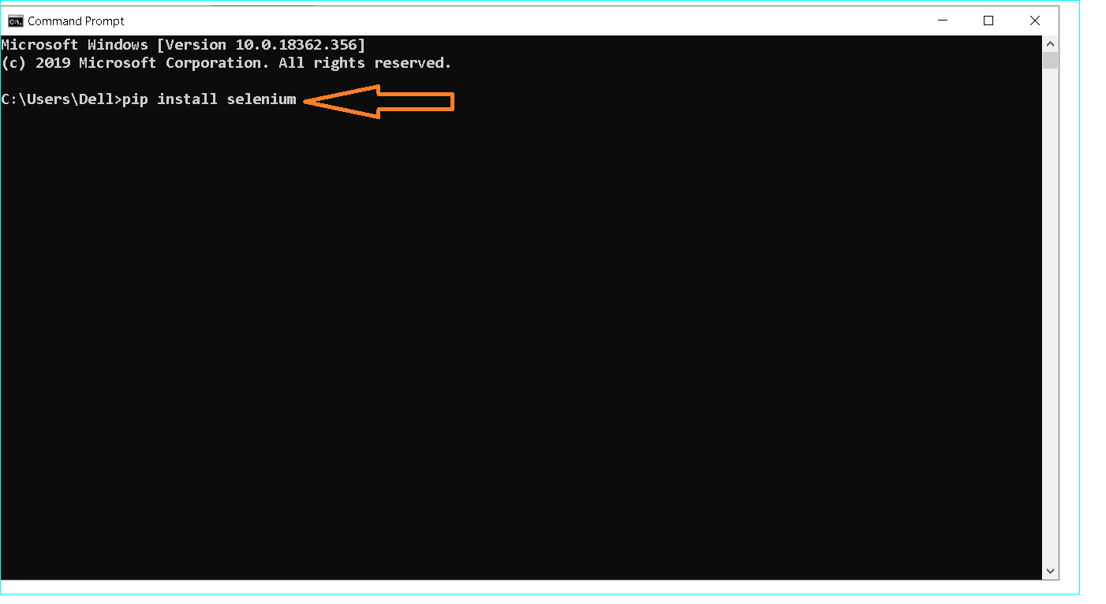

**Fig 7.4 Installation of selenium**

## 7.5 GECKODRIVER

Download it from this github link:

**https://github.com/mozilla/geckodriver/releases**

Setting path of geckodriver:

Paste the downloaded file in **/./././python/python36-32**

or

Run this cmd to set path from terminal:

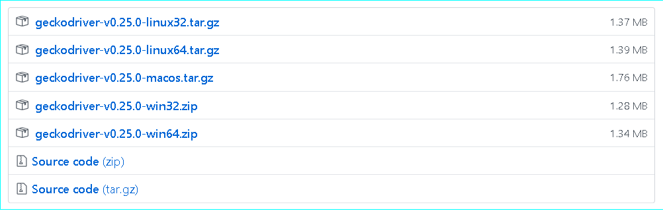

**Fig 7.5 Geckodriver download**

https://github.com/mozilla/geckodriver/releases/download/v0.23.0/geckodriver-v0.23.0-linux54.tar.gz

sudo sh -c 'tar -x geckodriver -zf geckodriver-v0.23.0-linux54.tar.gz -O > /usr/bin/geckodriver'

sudo chmod +x /usr/bin/geckodriver

rm geckodriver-v0.23.0-linux54.tar.gz

**REFRENCES**

**REFERENCES**

**WEBSITES**

1. <http://www.w3school.com/html/>
2. <http://www.w3school.com/css/>
3. <https://github.com/mozilla/geckodriver/releases>
4. <https://uigradients.com/>

# **APPENDIX-1 GLOSSARY OF TERMS**

## C

**CSS** Cascading Style Sheets (CSS) is a style sheet language used for describing the presentation of a document written in a markup language. Although most often used to set the visual style of web pages and user interfaces written in HTML and XHTML, the language can be applied to any XML document, including plain XML, SVG and XUL, and is applicable to rendering in speech, or on other media. Along with HTML and JavaScript, CSS is a cornerstone technology used by most websites to create visually engaging web pages, user interfaces for web applications, and user interfaces for many mobile applications.

# E

**ERD** An entity relationship diagram (ERD) shows the relationships of entity sets stored in a database. An entity in this context is a component of data. In other words, ER diagrams illustrate the logical structure of databases.

At first glance an entity relationship diagram looks very much like a [flowchart](https://www.smartdraw.com/flowchart/). It is the specialized symbols, and the meanings of those symbols, that make it unique.

# G

**GUI** The graphical user interface, is a type of [user interface](https://en.wikipedia.org/wiki/User_interface) that allows [users](https://en.wikipedia.org/wiki/User_(computing)) to [interact](https://en.wikipedia.org/wiki/Human%E2%80%93computer_interaction) [with electronic devices](https://en.wikipedia.org/wiki/Human%E2%80%93computer_interaction) through graphical [icons](https://en.wikipedia.org/wiki/Computer_icon) and visual indicators such as [secondary](https://en.wikipedia.org/wiki/Secondary_notation) [notation,](https://en.wikipedia.org/wiki/Secondary_notation) instead of [text-based user interfaces,](https://en.wikipedia.org/wiki/Text-based_user_interface) typed command labels or text navigation. GUIs were introduced in reaction to the perceived steep [learning curve](https://en.wikipedia.org/wiki/Learning_curve) of [command-line](https://en.wikipedia.org/wiki/Command-line_interface) [interfaces](https://en.wikipedia.org/wiki/Command-line_interface) (CLIs), which require commands to be typed on a [computer keyboard](https://en.wikipedia.org/wiki/Computer_keyboard).

# H

**HTML** Hypertext Markup Language (HTML) is the standard [markup language](https://en.wikipedia.org/wiki/Markup_language) for creating [web pages](https://en.wikipedia.org/wiki/Web_page) and [web applications.](https://en.wikipedia.org/wiki/Web_application) With [Cascading Style Sheets](https://en.wikipedia.org/wiki/Cascading_Style_Sheets) (CSS) and [JavaScript](https://en.wikipedia.org/wiki/JavaScript) it forms a triad of cornerstone technologies for the [World Wide Web.](https://en.wikipedia.org/wiki/World_Wide_Web) [Web](https://en.wikipedia.org/wiki/Web_browser) [browsers](https://en.wikipedia.org/wiki/Web_browser) receive HTML documents from a [web server](https://en.wikipedia.org/wiki/Webserver) or from local storage and render them into multimedia web pages. HTML describes the structure of a web page [semantically](https://en.wikipedia.org/wiki/Semantic) and originally included cues for the appearance of the document.

# P

**PDF** The Portable Document Format (commonly referred to as PDF) is a [file format](https://en.wikipedia.org/wiki/File_format) used to present [documents](https://en.wikipedia.org/wiki/Document) in a manner independent of [application software](https://en.wikipedia.org/wiki/Application_software), [hardware](https://en.wikipedia.org/wiki/Computer_hardware), and systems. Each PDF file encapsulates a complete description of a fixed-layout flat document, including the text, [fonts,](https://en.wikipedia.org/wiki/Font) graphics, and other information needed to display it.