**Supply Contracts at SkiRetail (Questions and Answers)**

**Navneet Vidyarthi (March 10, 2024)**

Q 1: Under vertical integration, the answers are as follows:

* Optimal production quantity = 15,000
* Expected profit for “the company” = $1,122,813

Refer to the excel sheet below:



Q 2: Consider the current scenario where the supplier “Skiekz” and the retailer “SkiRetail” are not vertically integrated.

Purchase (Wholesale) price for the retailer= $200 per unit (given)

* What is your estimate of the quantity for ski jackets that Bergard (SkiRetail) shall place an order for?
  + Optimal order quantity = 10,000
* Expected profit for SkiRetail based on your estimate of order quantity.
  + Using empirical method = $452,500
* Expected profit for Skiekz based on estimate of order quantity.
  + Using empirical method = $530,000
* Total supply chain profit
  + Using empirical method = $982,500
* How does this profit compare to the vertically integrated case (Q 1).
  + As expected, the profit is lower by $1,122,813 -$982,500 = 140,313. This is a decrease of 12.5% compared to the vertically integrated case.

Refer to the excel sheet below:



Q 3: Skiekz and SkiRetail would like to explore the option of buy-back contract, in which Skiekz would buy unsold goods from SkiRetail at an agreed upon price (referred as “buy-back price”).

* Analyze the impact of different buy-back prices on the optimal order quantity, retailer’s expected profit, supplier’s expected profit, as well as the total supply chain profit? Show your results using some plots.

Refer to the snapshot of excel sheet below:



* What is the “optimal” range of buy-back price that you would propose to the firms?

The optimal, range implies the “profit maximizing” buy-back price, which is $116.67 to

$ 143.33 as shown in the table below. The total profit is $1,023, 438

|  |  |  |  |  |  |
| --- | --- | --- | --- | --- | --- |
| **buy back**  **price** | **Service**  **Level** | ***Optimal***  ***Qty.*** | **Retailer's**  **Expected**  **Profit** | **Manuf.'s**  **Profit** | **Total**  **Profit** |
| $ 116.67 | 37.501% | 12000 | $479,170 | $544,268 | $1,023,438 |
| $ 143.33 | 46.874% | 12000 | $503,330 | $520,107 | $1,023,438 |

* Determine the expected profit for the “retailer” under the proposed buy-back contract.

The expected profit of the retailer ranges from $479,170 to $503,330.

* Determine the expected profit for the “supplier” under the proposed buy-back contract.

The expected profit of the supplier (or manufacturer) ranges from $544,268 to $520,107.

Q 4: Skiekz and SkiRetail would like to explore the option of revenue-sharing contract, in which SkiRetail is willing to share 15% of its revenues from regular sales for a reduced purchase /wholesale price.

* Analyze the impact of varying wholesale price on the optimal order quantity, retailer’s expected profit, supplier’s expected profit, as well as the total supply chain profit? Show your results using some plots.

Refer to the snapshot of excel sheet below:



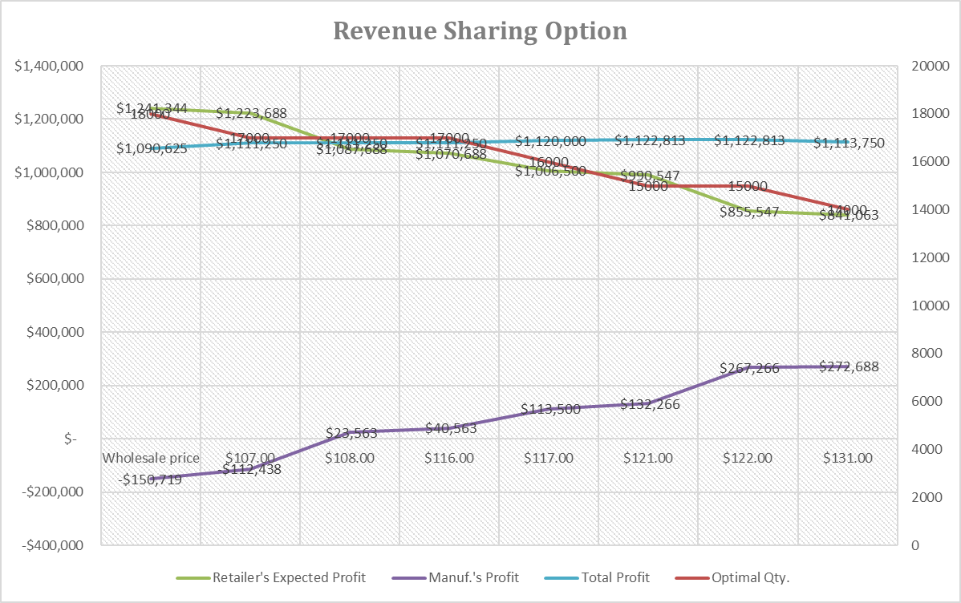

* What is the optimal purchase /wholesale price that Skiekz should propose?

The range of optimal purchase /wholesale price that Skiekz is [122,131]. The maximum profit is $1,122,813.

* Determine the expected profit for the “retailer” under the proposed revenue-sharing contract.

Refer to the table below:

* Determine the expected profit for the “supplier” under the proposed revenue-sharing contract.

Refer to the table below:

|  |  |  |  |  |  |
| --- | --- | --- | --- | --- | --- |
| **Wholesale price** | **Service Level** | ***Optimal Qty.*** | **Retailer's Expected Profit** | **Manuf.'s Profit** | **Total Profit** |
| $ 122.00 | 59.34% | 15000 | $ 990,547 | $ 132,266 | $ 1,122,813 |
| $ 131.00 | 53.44% | 15000 | $ 855,547 | $ 267,266 | $ 1,122,813 |

Q 5: Skiekz and SkiRetail would like to explore *optimal revenue-sharing contract(s)* that will maximize the total expected supply chain profit as opposed to their individual expected profits. The two decision variables of interests are the *wholesale price* and the *proportion of primary revenue shared.* Determine the optimal combination of wholesale price and the percentage of revenue sharing agreements that will maximize the total expected supply chain profit.

This is a very interesting question.

From the previous questions, we have already established that the order quantity that yields the highest total supply chain profit is 15,000 units, which gives a total supply chain profit of $1,122,813.

The next step is to find different combination of wholesale price and the proportion of primary revenue shared that yields an order quantity of 15,000 units. The desired service level for this is in the range [53.14%, 59.38%]. The several combinations of wholesale price and the proportion of primary revenue shared in the service level range [53.14%, 59.38%] can be found in the excel worksheet “Question 5”. Sample combinations are shown (and highlighted) as follows:



For example, with 10% of the revenue sharing, $128 as wholesale price (less than the variable cost), and a profit of $1,122,813, the calculations are as follows:



Another example, with 1% of the revenue sharing, $145 as wholesale price (more than the variable cost), and a profit of $1,122,813, the calculations are as follows:



Q 6: What is your recommendation to the companies: buy-back contract or revenue-sharing contract? Why? What are the potential benefits and risks associated with each?

Revenue sharing is what I would recommend, as the total supply chain profit can be as high as the vertically integrated supply chain. See all the calculations above.

I will let you think about the rest.