**Virtual Phone Application**

**BACHELOR OF COMPUTER APPLICATION**

***A Synopsis to be submitted by***

**Suman Kanrar**

**(Roll No: 10401215113 , Registration No: 151041010113 OF 2015-2016)**

**Sanwaya Dutta**

**(Roll No: 10401215085 , Registration No: 151041010085 OF 2015-2016)**

**Sanjana Mondal**

**(Roll No: 10401215083 , Registration No: 151041010083 OF 2015-2016)**

**Priyanka Saha**

**(Roll No: 10401215065 , Registration No: 151041010065 OF 2015-2016)**

**Guided By**

**Prof. Soumi Dutta**



**DEPARTMENT OF COMPUTER APPLICATION**

**INSTITUTE OF ENGINEERING AND MANAGEMENT**

**2017**

**DECLARATION CERTIFICATE**

This is to certify that the work presented in the project entitled **“Virtual Phone”** in partial fulfillment of the requirement for the award of degree of **Bachelor of Computer Application** of **INSTITUTE OF ENGINEERING & MANAGEMENT** is an authentic work carried out under my supervision and guidance.

To the best of my knowledge the content of this project does not form a basis for the award of any previous Degree to anyone else.

Date: 25/11/2017

_______________________

**Prof. Soumi Dutta**

Dept. of Computer Application

Institute of Engineering & Management

___________________________

**Prof. Abhishek Bhattacharya**

Head of the Department

Dept. of Computer Application

Institute of Engineering & Management

**CERTIFICATE OF APPROVAL**

The foregoing project entitled **“Virtual Phone”** is hereby approved as Minor Project and has been presented in satisfactory manner to warrant its acceptance as prerequisite to the degree for which it has been submitted.

It is understood that by this approval, the undersigned do not necessarily endorse any conclusion drawn or opinion expressed therein, but approve the project for the purpose for which it is submitted.

**(Internal Examiner) (External Examiner)**

**ACKNOWLEDGEMENT**

We take this opportunity in expressing our gratitude and sincerity to all who have directly and indirectly helped in compiling this project report.

It would be our pleasure in appreciating the excellent infrastructure

provided by Institute of Engineering and Management.

**Prof. Soumi Dutta**, our project supervisor & mentor gets our extreme applause for her guidance and assistance. We are grateful to her for her continuous encouragement and support. This project would not have succeeded without her help and mentoring.

Sanwaya Datta

Roll: **10401215085**

Suman Kanrar

Roll: **10401215113**

Sanjana Mondal

Roll: **10401215083**

Priyanka Saha

Roll: **10401215065**

**CONTENTS**

**Chapter 1**

1.1 Introduction*……………………………………………………………………………………*1

**Chapter 2**

2.1 Scope of the project……………………………………………………………………….2

2.2 Module wise Functionalities……..…………………………………………………3-5

**Chapter 3**

3.1 Block Diagrams……………………………………………………………………………….6

**Chapter 4**

4.1 Software requirement………………………………………………………….…….....7

4.2 Hardware Requirement………………………………………………………………….7

**Chapter 5**

5.1 Results and discussion*……………………………………………………………….*8-14

5.2 Future Scope….…………………………………………………………………………….15

**Chapter 6**

6.1 Conclusions ………………………………………………………………………………...16

**Chapter 1**

* 1. **Introduction**

This project ‘**VIRTUAL PHONE**’ helps us to perform few of the basic functionalities of a mobile phone. It can mainly be used as a substitute of a mobile phone for specific modules.

Over the internet, if we analyze, we will not get an application like this which performs the basic tasks of a phone in desktop environment. Keeping this in mind, we are trying to implement an application which can do few of the basic tasks very easily.

It is a simple desktop application without any ads and uses very trial API’s for the successful working of the modules. The designing of the UI’s have been done with the Qt Designer and the coding part with Python3 and the PyQt5 framework for Python.

**Chapter 2**

**2.1 Scope of the Project**

In our application we can do the following tasks:

* Send free SMS.
* Send free voice messages
* Send emails
* Store and Backup contacts
* Browse the internet using the Browser
* Write and save notes
* Make basic calculations using the Calculator
* Have access to the Calendar
* Get to know the present weather conditions using the Weather app.
  1. **Module wise Functionalities**

In Virtual phone app, there is a main module called **Homescreen**. In the homescreen module, there are different applications.

**1. Phonebook**

**2. Browser**

**3. Calendar**

**4. Calculator**

**5. Notepad**

**6. Weather Widget**

1. **Phonebook**: In the Phonebook Module, there are the following

Functionalities in the form of Tabs.

* Add contacts
* Backup Contacts
* Voice call or audio message.
* SMS
* Email

1. **Add contacts**: We can add anyone’s name, phone number, contact icon, address, email id and date of birth. Add contacts adds a contact and its details to the Contacts Tab reading from a CSV file.
2. **Voice call or Audio message**: Audio message functionality is limited/restricted due to the trial account API of twilio. We can select the audio from predefined list of audios and audio message can be sent only to verified contacts list. It is a type of simplex communication.
3. **SMS**: We can send personalized message to only the verified contacts list. Since, it uses the internet as carrier, so it takes a little time to get delivered. It also uses the twilio API for programmable SMS.
4. **Email**: We can send email to our contacts. Here the sender’s mail id is predefined. Receiver’s mail id is also predefined but can be changed or customized. The SMTP package has been used for this functionality.

2.**Browser**: It is a single tabbed browser with navigation buttons and home button. Icons for valid SSL certificates are also present. There is also reload and cancel buttons.

**3.Calender:** It displays the present day, current date and time as well the calendar for the month of the current year.

**4.Calculator:** It is a simple calculator where addition, subtraction, multiplication and division can be done. Values can be whole numbers, integers and decimal numbers. There are also two buttons for backspace and all clear functionality of the display screen.

**5.Notepad:** It is a simple text editor with some special features. We can **save** the written text to a **.txt** file and can even **open** a .txt file into the text area. We have also the function to write a new file. There is also a quit option to close the notepad. Another special feature to change the font type, size and style is also present in the Edit section.

**6.Weatherwidget:** It displays the weather data of the current location based on the location ID of openweathermap.org . Weather data includes temperature, sky condition, humidity and wind speed. All the data are fetched using the python openweathermap API. Weather icons also are showed on the side of the widget depending on the sky conditions.

**Chapter 3**

**3.1 Block Diagrams**

**Email**

**SMS**

**Audio Message**

**Contacts**

Browser

Calendar

Phone Book

Notepad

Calculator

Weather

**Chapter 4**

**4.1 Software requirements**

**Platform (OS) used:** Windows 10 Pro 64-bit.

**IDE used:** JetBrains PyCharm Community Edition or Python IDLE3

**Core Technologies Used:** Python3 and PyQt5

**Supporting Technologies Used:** Git and GitHub

**4.2 Hardware Requirements**

**Processor:** 1 Gigahertz(GHz) or faster.

**RAM:** Minimum 2 GB

**Hard Disk:** Minimum 20 GB

**Graphics Card:** DirectX 9 or later with WDDM 1.0 driver.

**Display Resolution:** 1920 x 1080

**Chapter 5**

**5.1 Results and Discussions**

1. 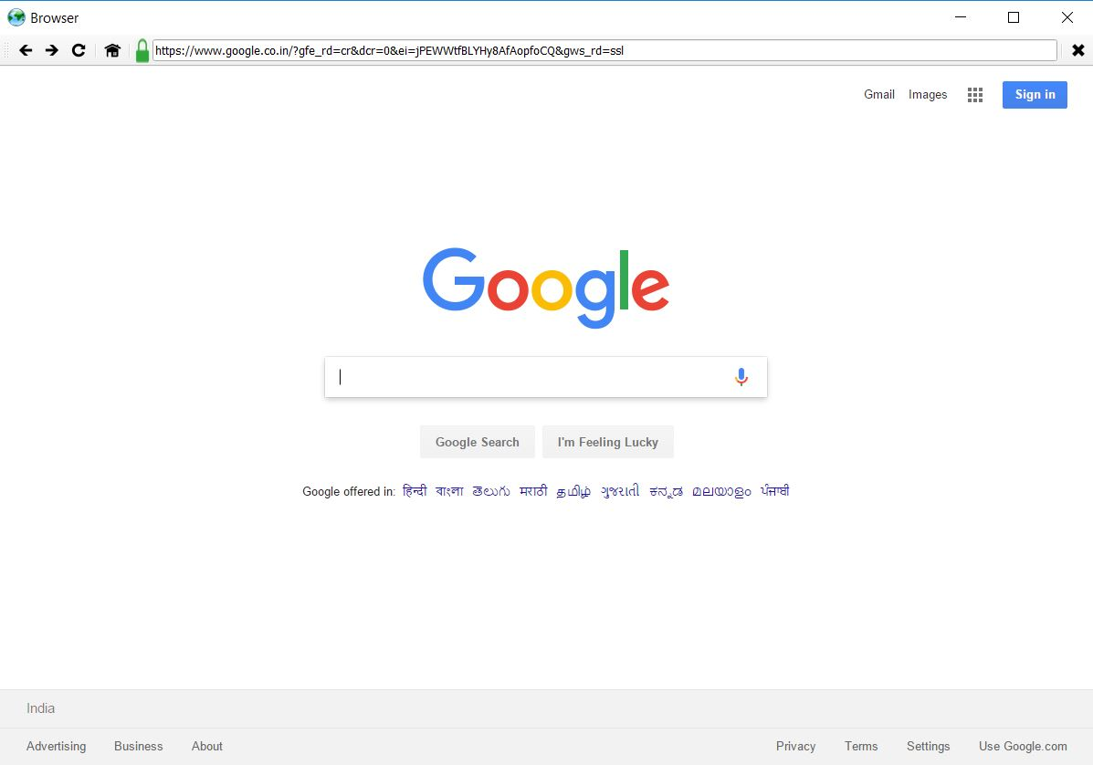**One-Tabbed Browser**

One Tabbed browser having navigation buttons, reload, home and cancel button. It is also having an icon for “**https**” and “**http**” SSL certifications depending on the website. It is also having a URL bar where we can search a particular website manually.

1. **Add Contacts** (name, phone number, email id, address, DOB)

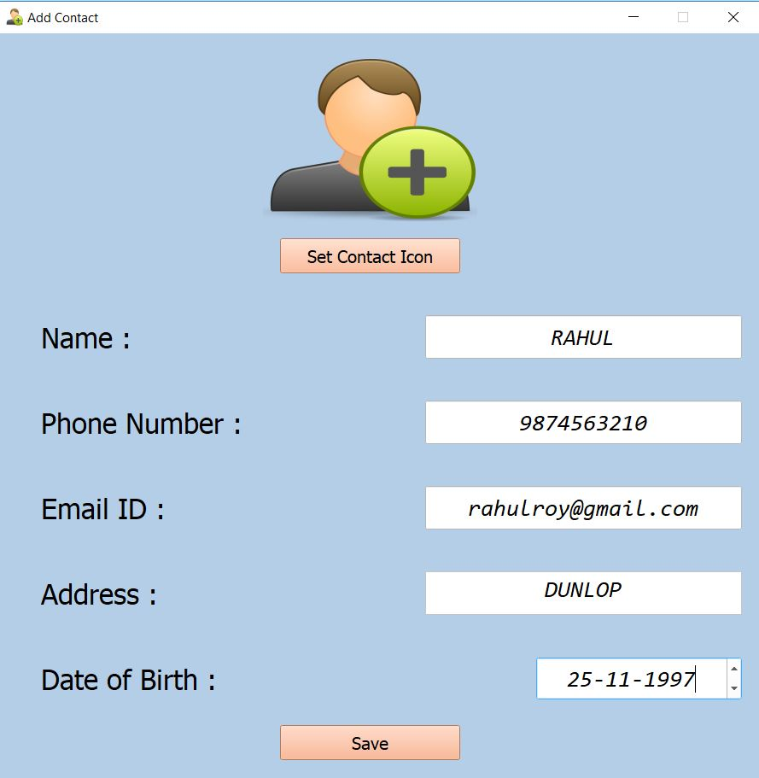

The “add contact” functionality allows us to add a new contact to the contacts table. Contact details include name, phone number, email id, address and date of birth. We can even set a contact icon to the contact.

1. **Backup Contacts** (write contacts data in .csv file)

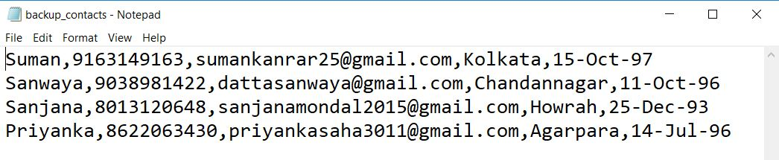

We can take backup of the contacts in csv format.

1. 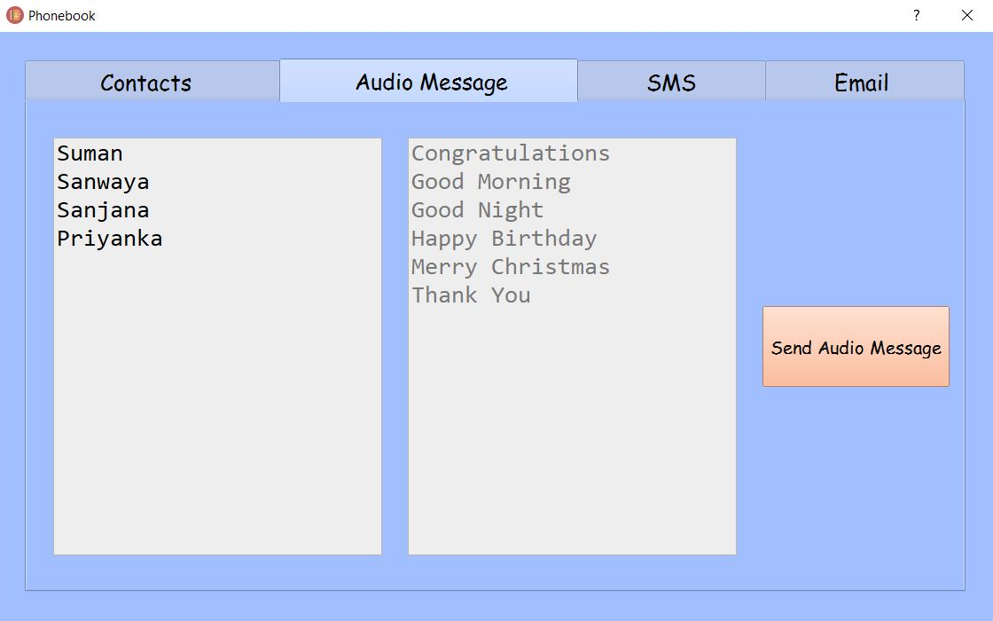**Audio Message** from Predefined list of audios and recipients (Trial Account restrictions)

In the audio message section, we have to select the contact and the audio message from the contact and audio lists respectively. On clicking the “send audio message” button, audio message in the form of a call will be sent to the recipient. Trial account of the API allows limited recipients.

1. 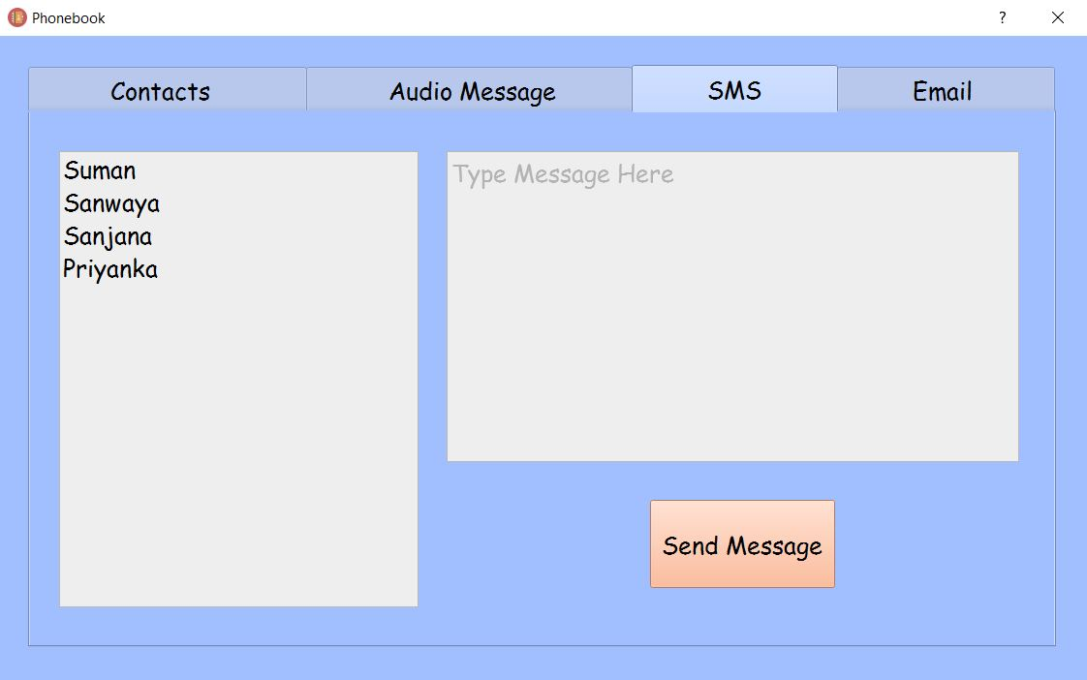**Personalized SMS** to verified recipients (Trial Account Restrictions)

In the SMS section, we can send personalized sms to contacts in the list. On clicking the “send message” button after selecting the recipient and writing the message, the sms will be sent. Trial Account API allows limited recipients.

1. **Email**

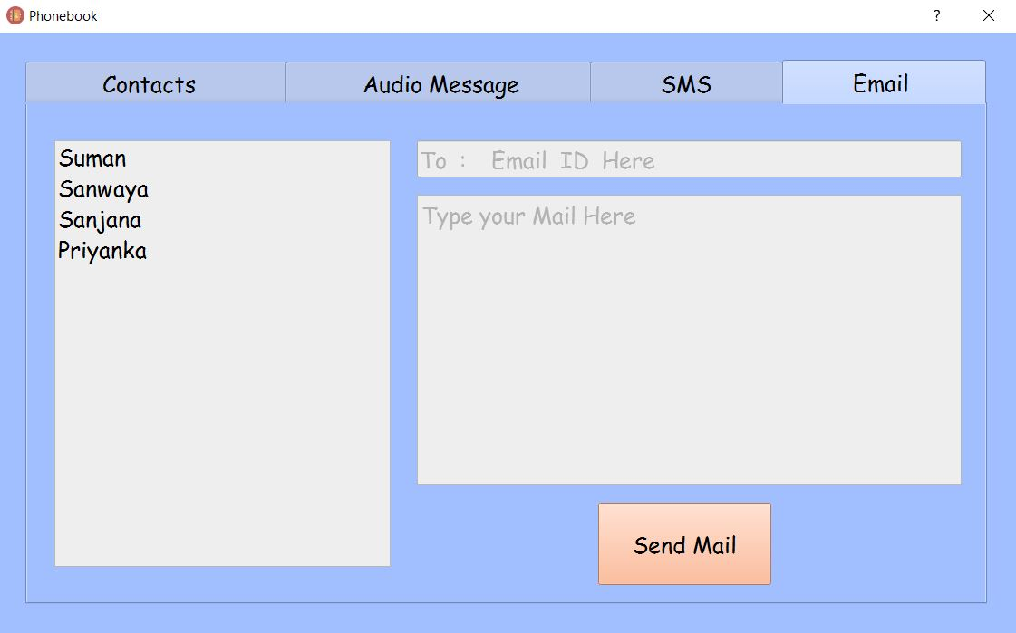

In the Email section, we can send email to any recipients we want. By default, we can send email to the contact we have selected and his/her default mail id will be put on the email id textbox but we can edit it. The sender remains fixed but the recipient may vary according to the user’s choice. On clicking the send email button, the mail written on the mail area will be sent to the recipient. Here, we have used the smtplib library/package.

1. **Simple Calculator**

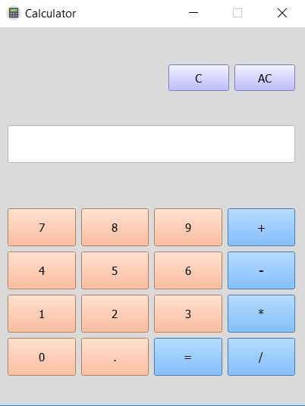

The simple calculator allows us to make basic arithmetic calculations like addition, subtraction, multiplication and division operations of whole number and decimal numbers. There are also two buttons for full clear and backspace clear of the display screen. The display screen is set to read only so that nobody can alter the values displayed there.

1. 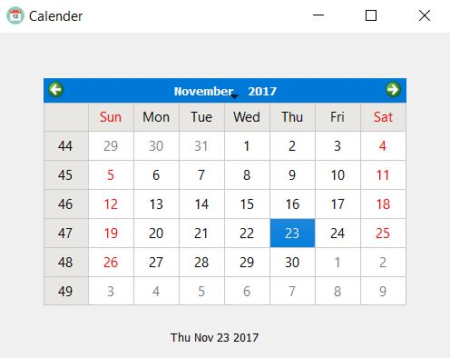**Simple Calendar**

The simple calendar displays the calendar for the current month of the year and also shows the present day and date. The present day is highlighted in the calendar.

1. **Notepad / Text Editor**

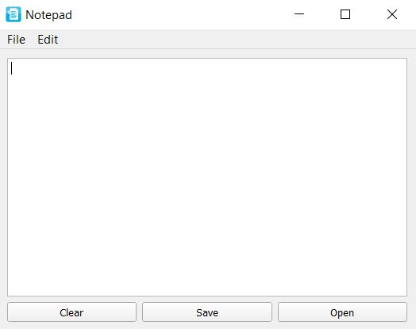

The notepad/text editor allows writing text files in “.txt” format and reading “.txt” files. There is also a clear button for clearing the text screen. It also has a menu bar with functionalities like **creating new file**, **quit** operation and the most important **changing the font style and size** functionality.

10. **Weather Widget** showing weather data

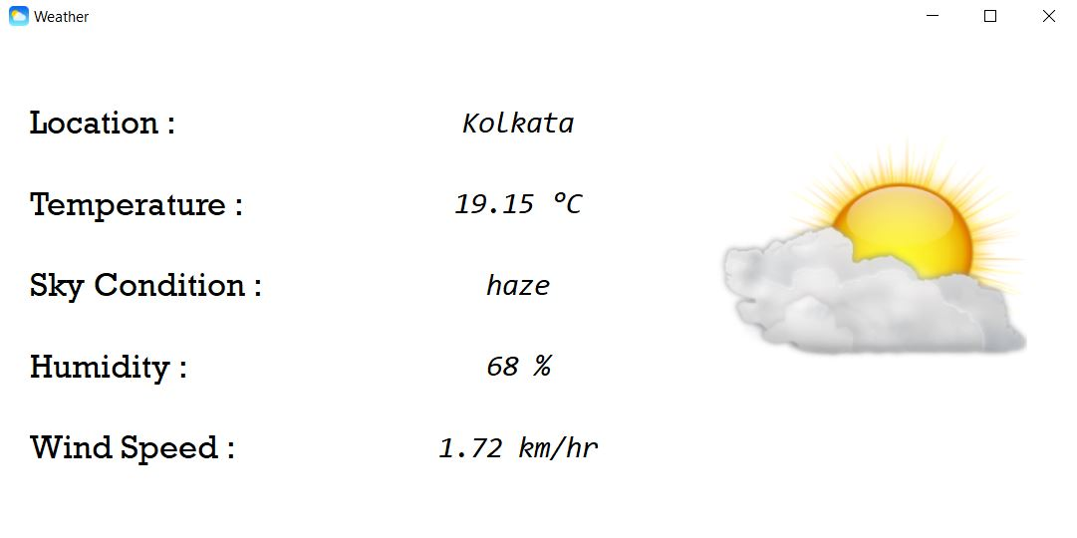

The weather widget shows us the current weather data of the present location based on a API call. The weather data set includes present location, current temperature (in °C), sky condition, humidity (in %) and wind speed (in km/hr.). There’s also an icon beside depending on the sky condition. It uses the python openweathermap API.

**5.2 Future Scope**

1. Browser to be made multi-tabbed with additional features like downloading files, viewing page source and saving and opening html files.
2. Contact icons to be added in the contacts table section beside the contacts in each row.
3. Contacts to be taken backup in **.vcf** format instead of **.csv** format.
4. Trial Account Restrictions of Twilio to be removed and professional account to be activated for audio message and personalized message to anybody (even non-verified existing phone numbers).
5. Recorder functionality to be added in audio message section for sending of own customized audio after recording them.
6. Adding subject to the email to be implemented.
7. Scientific Calculator to be implemented.
8. Birthday reminder alarm functionality to be added of the contacts using the calendar widget.
9. ***Find & Replace*** option, ***Spell Checker*** and ***help*** option to be added to the text editor module.
10. Converting the whole application into a **“.exe**” file and implementing the same project in **Android platform** in the form of a app or ROM (adding additional modules to it).

**Chapter 6**

**6.1 Conclusion**

In this project, **Python3**, which is one the popular programming language of recent times was used as a core technology along with **PyQt5** which is also a very popular framework of python. The **Virtual Phone App** have been presented and all the modules have been discussed in details. It was a wonderful learning experience for us while working on this project. This project took us through the various phases of **software development** and gave us a real insight of the world of concept of SDLC. The effort of working together as a team and tackling the various problems and challenges in the due course gave us a feel of a development teams of the corporate world. Working on this project we came to know about various new concepts related to programming. However, this project is further extendable and has a vast list of future scope. Overall, we enjoyed each and every bit of work done for the successful completion of this project.