5. Evaluation

5.1 Functional testing
Table 4 — Automated test suites and what each guards against
Suite | Tests | Guards against
API — Laravel | 460 | Contract, authorisation and invariant regressions
Mobile — Jest | 371 | Service and model-port regressions; state and cache errors
ML — provenance, split | 21 | Simulated rows in training; participant and temporal leakage
ML — label, baseline, feature | 71 | Baseline-free reporting; target drift; feature errors
Total | 923

All 923 pass in CI on every push (Appendix C). Golden-vector tests pin the TypeScript port to figures computed in Python, and check:model fails the build if the bundled coefficients drift. The suite is load-bearing: a test expecting a +10 bpm deviation returned 8.57, exposing a resting-heart-rate baseline that included the current day. Correcting it raised held-out recall from 0.449 to 0.536 and cut the largest coefficient from 0.839 to 0.376 — an artefact, not a finding.

5.2 Performance and security testing
Table 5 — Measured non-functional performance
Metric | Requirement | Measured
On-device readiness inference | < 50 ms | 【TBC】
API p95 latency, authenticated read | < 300 ms | 【TBC】
Application cold start | < 3 s | 【TBC】
JavaScript bundle size | — | 【TBC】

⟦ Fill Table 5 from REPORT-PLAN §6 P3; interpret in two sentences. ⟧
Security was tested rather than asserted: 19 tests assert cross-account isolation, 17 that unauthenticated routes are refused, 5 the login throttles; scanning all 46 commits for keys returned nothing. The design was reviewed against the OWASP Mobile Top 10 (OWASP, 2024)【VERIFY】 (Appendix C). Two residual risks are stated rather than hidden: a public MQTT broker (ADR-0003) and foreground-only location (ADR-0004).

5.3 Usability evaluation
⟦ Complete after REPORT-PLAN §6 P2. ⟧ The System Usability Scale (Brooke, 1996) was administered to n = 5 after four scripted tasks. Mean SUS was 【TBC】 (SD 【TBC】) against the acceptability anchor of 68 (Bangor et al., 2009)【VERIFY】; a Nielsen (1994) walkthrough found 【TBC】 issues, 【TBC】 major. ⟦ Name the two most severe. ⟧ Five participants detect severe problems but estimate the mean coarsely, so this is formative evidence.

5.4 Model performance and effectiveness
Target selection. The focus self-report is seven mutually exclusive categories covering 3.15% of hourly rows, so the task is classification, not regression. Of four binary targets the activation axis scored ROC-AUC 0.654 and valence 0.568 — as Russell’s (1980) circumplex predicts (§2.3).
Table 6 — Baselines, participant-wise five-fold CV
Model | ROC-AUC | F1 | Recall
Logistic regression | 0.656 ± 0.027 | 0.543 | 0.503
MLP (16, 8) | 0.626 ± 0.038 | 0.526 | 0.490
Hour-of-day lookup (baseline) | 0.599 ± 0.039 | 0.443 | 0.374
Base and personal rate (baselines) | 0.500 | 0.000 | 0.000

The linear model beats the strongest baseline by 0.057 AUC; the neural network lost, reported rather than dropped: ~2,400 rows are too few. The personal-rate baseline scoring exactly 0.500 is a leakage check that passed: under a participant-wise split a per-person lookup must collapse to the base rate. Decoding the cyclical hour coefficients recovers a learned circadian peak at 09:26 — unprompted agreement with chronobiology.
Figure 3 — Confusion matrix and strongest coefficients
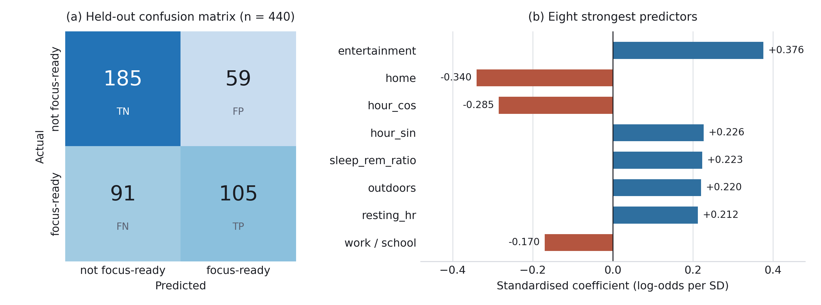
Effectiveness. AUC says the model can rank hours, not that acting helps: each held-out participant’s hours were ranked and the top k checked.
Table 7 — Policy evaluation (base rate 0.447)
Policy | P@1 | P@3 | P@5
AuraFlow (observed context) | 0.667 | 0.652 | 0.653
AuraFlow (time and biometrics) | 0.600 | 0.593 | 0.578
Fixed 09:00 (“work in the morning”) | 0.578 | 0.556 | 0.542
Population hour lookup | 0.533 | 0.519 | 0.493

The defensible figure is 0.600, not 0.667, because its strongest features record where a person was, which a deployed system must predict. The model gains +0.153 on a person’s own base rate, but only +0.022 on “work in the morning” — within noise, so it must not claim to beat generic advice.
The central finding. The Recovery Score, validated per participant against self-reported readiness, reaches only ρ = 0.123, tying Fitbit’s own sleep score (0.119). Biometrics add +0.002 AUC over time alone against location’s +0.043. Three independent analyses therefore agree: wearable signals are weak predictors of subjective cognitive state; time and location carry the model. The disclosure interface of §4.4 exists because of it.

5.5 Limitations and threats to validity
- Agreement, not causation. The hours were lived and labelled before being ranked, so only a prospective trial could support a causal claim.
- Recall 0.536. The model misses 91 of 196 focus-ready hours; a missed good hour is cheaper than a bad recommendation, so the threshold is defensible but stated.
- A counter-intuitive coefficient. Resting heart rate predicts readiness positively — likely confounded with time of day, and not interpreted causally.
- Scope. ROC-AUC 0.656 sits just above the conventional 0.60 floor; both cohorts are Fitbit-based and self-selected; and cross-cohort transfer and end-to-end UI behaviour are untested.

Appendix C — Test evidence
Captured verbatim from the runs; the summary lines are each suite’s own output rather than retyped text.
Figure C.1 — Console output of the three suites: 460 + 371 + 92 = 923 tests passing, with the model-sync build gate confirming the bundled coefficients match the artifact
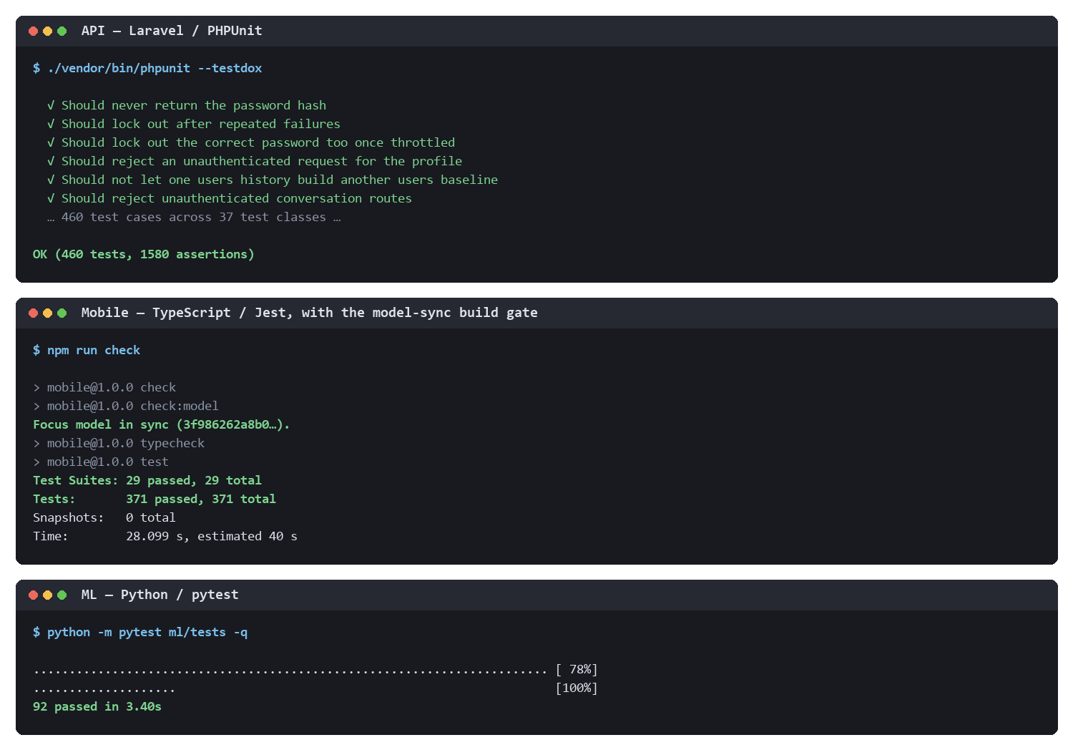
Table C.1 — Security assertions counted in §5.2
Property asserted | Tests | Representative case
Cross-account isolation | 19 | should_not_leak_another_users_nights
Unauthenticated access refused | 17 | should_reject_an_unauthenticated_request_for_the_profile
Login / one-time-code throttling | 5 | should_lock_out_the_correct_password_too_once_throttled
No committed secrets | 46 commits | git log --all -p grepped for key and token patterns — no match

