REAL TIME WEATHER FORECASTING

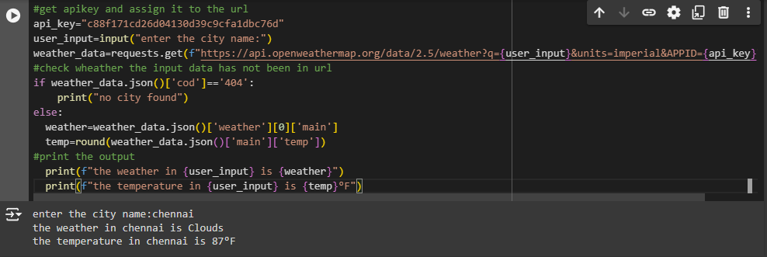

STOCK ANALYSING INVENTORY SYSTEM

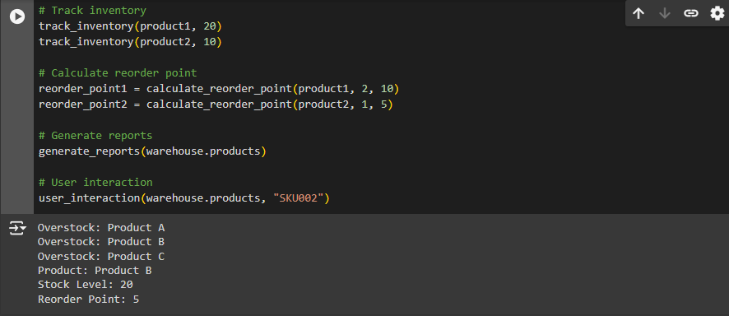

REAL TIME COVID 19 TRACKER

