**Mutation Method Selection**

***

( Methods and materials)

To find the balance between exploration and exploitation 4 methods were checked:

1. Exploration first method - Select random neighbor from the first neighbors for the first 100 generations and select random neighbor from second neighbors after 100 generations
2. Exploitation first method - Select random neighbor from the second neighbors for the first 100 generations and select random neighbor first neighbors after 100 generations
3. Combined method - Select random neighbor from the second neighbors for the first 100 generations, then select random neighbor first neighbors for more 150 generations, and after 250 generations select random neighbor from the second neighbors again.
4. Random Method – Select a random configuration from the non-simulated configurations

Those methods were tested in 4 different stop conditions:

1. Regular - global 1240 generations and local if the concepts in the DWOI.
2. Aggressive - global 1240 generations and local if the concepts in the DWOI or the concept $C_{r}=0$ for 30 generations in a row.
3. medium - global 1240 generations and local if the concepts in the DWOI or the concept $C_{r}=0$ for 50 generations in a row.
4. Ease - global 1240 generations and local if the concepts in the DWOI or the concept $C_{r}=0$ for 100 generations in a row.

(Results)

To find the best mutation method 6 large concepts were chosen randomly (can be seen in Table 7).

Table 7- Checked Concepts

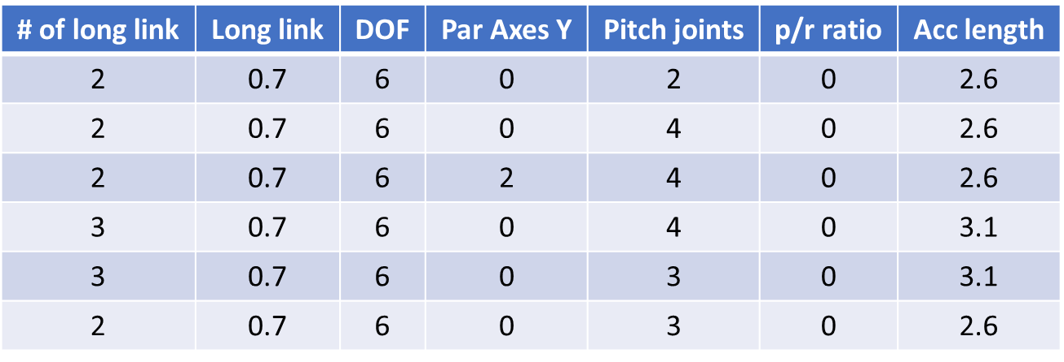

The selected concepts were fully sorted, all the configurations in those concepts were simulated and their results are known. In order to compare the methods, each method runs 30 times, for a maximum of 1240 generations. For each method, two indices were calculated: Hyper–Volume(HV) which bigger value means better result and minimum value of the manipulability. In figure 1 it can be seen HV at each generation for each method.

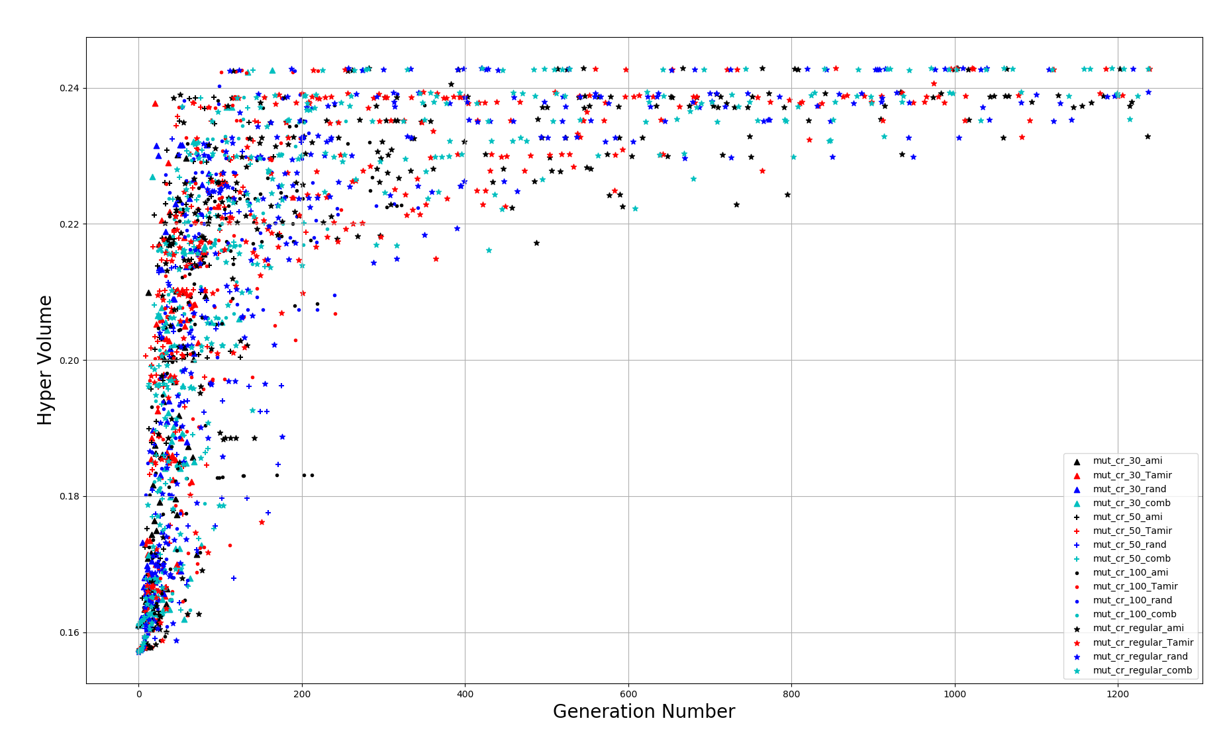

Figure 1 - HyperVolume Vs Generation

In figure 2 it can be seen minimum manipulability at each generation for each method.

From those figures, it can be seen that the most significant changes have occurred in the first 300 generations. Another thing that can be seen that except for the regular stop condition, all the stop conditions get their final position until generation number 200.

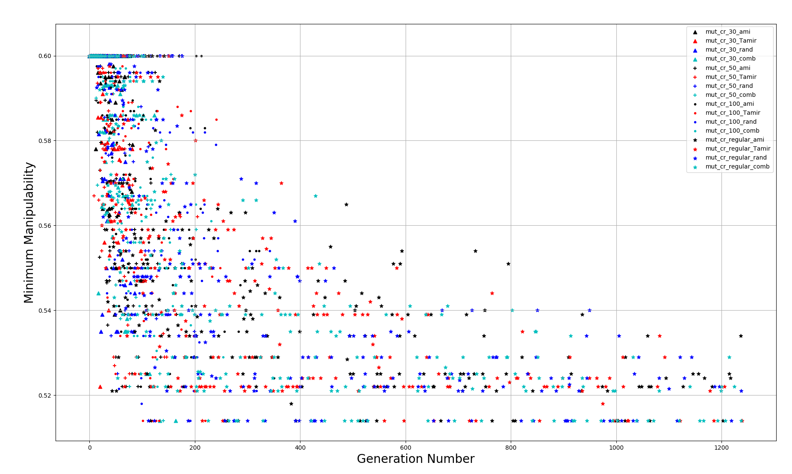

Figure 2 - Minimum Manipulability Vs Generation

To compare the algorithms Wilcoxon test was applied over the results of each method of the 30 runs. Wilcoxon test return P-Value, which P-Value lower than 0.05 means there is a statistical significance that one method its better than another. For HV index - from figure 3 it can be seen that methods with the same stop conditions are in the same population, therefore one method from each stop condition selected. The selected methods are with the highest median (figure 4). The best 4 methods are Combine_Aggressive, Combine_medium, Combine_ease, and Combine_Regular.

From figure 4 it can be seen, Combine_Aggressive is giving better results than all the other, and its Wilcoxon test indicates that Combine_Aggressive is statistically better than Combine_ease and Combine_Regular but not from Combine_medium.

From the Min-Manipulability index, the results look the same as the results of the HV, except that Combine_Aggressive is not statistically better than Combine_ease.

From those results the selected methods to continue with Combine_Aggressive and Combine_medium.

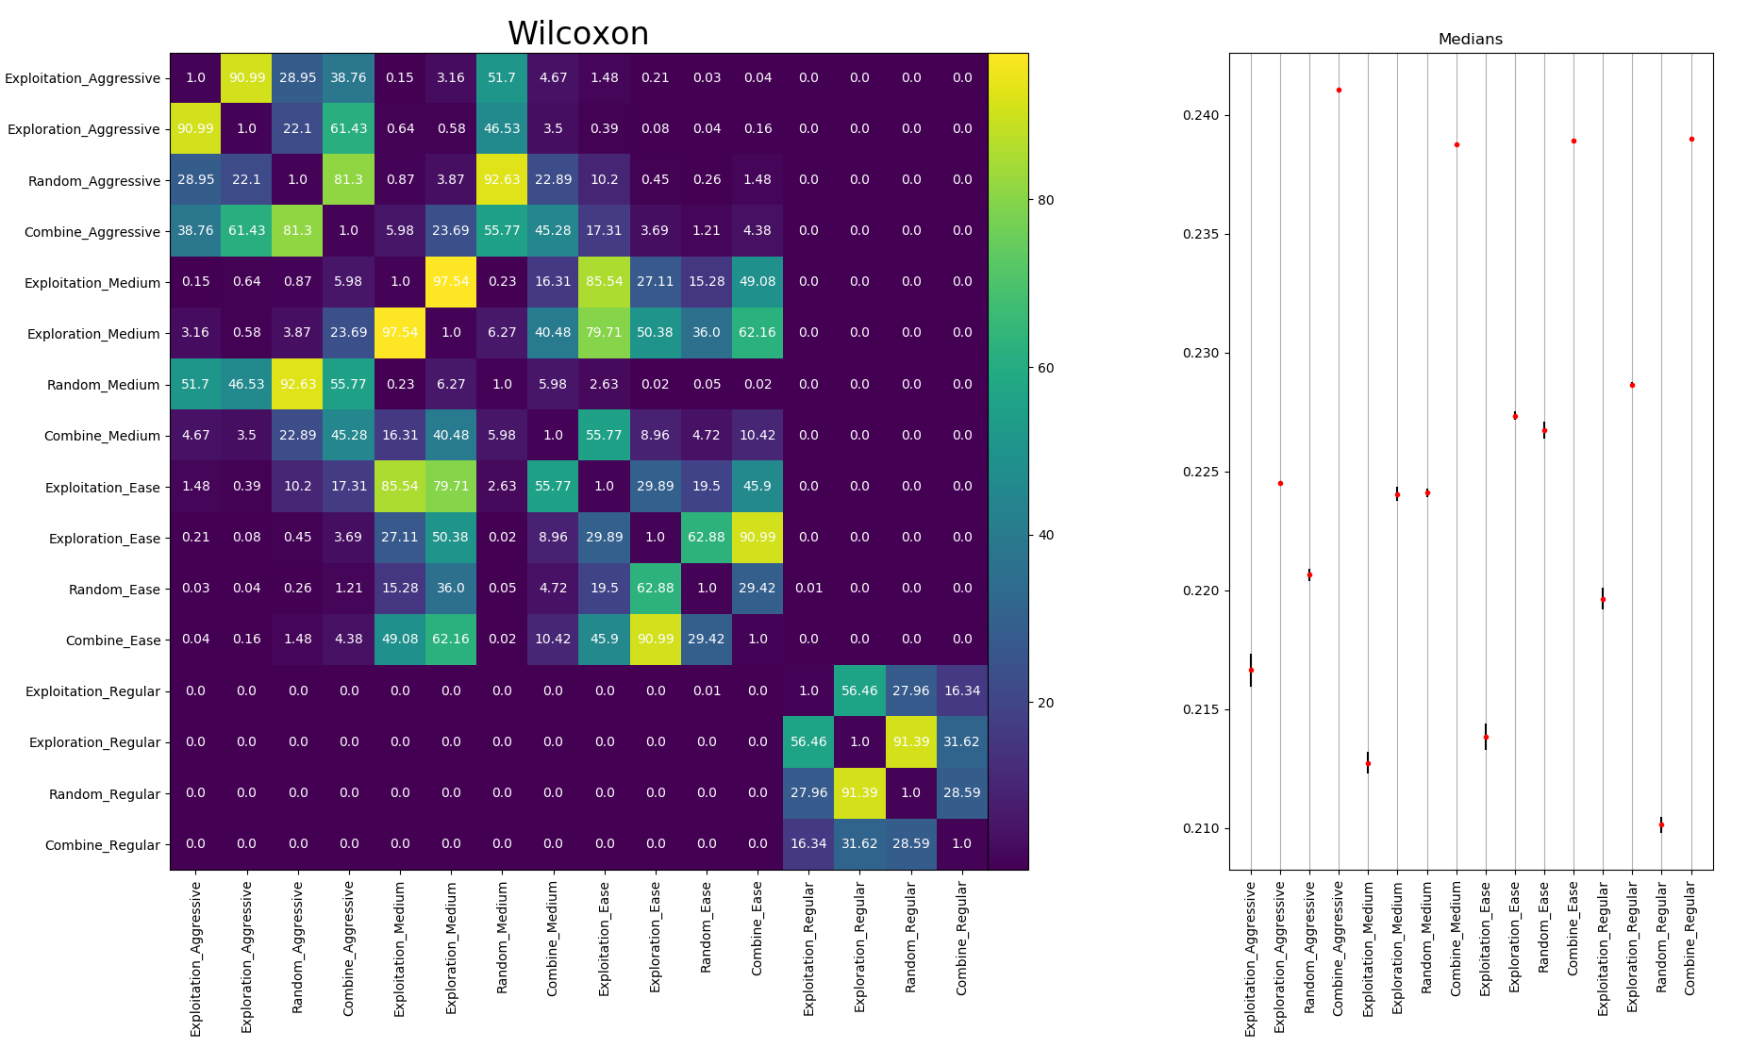

Figure 3- Wilcoxon: HV



Figure 4 – Median: HV

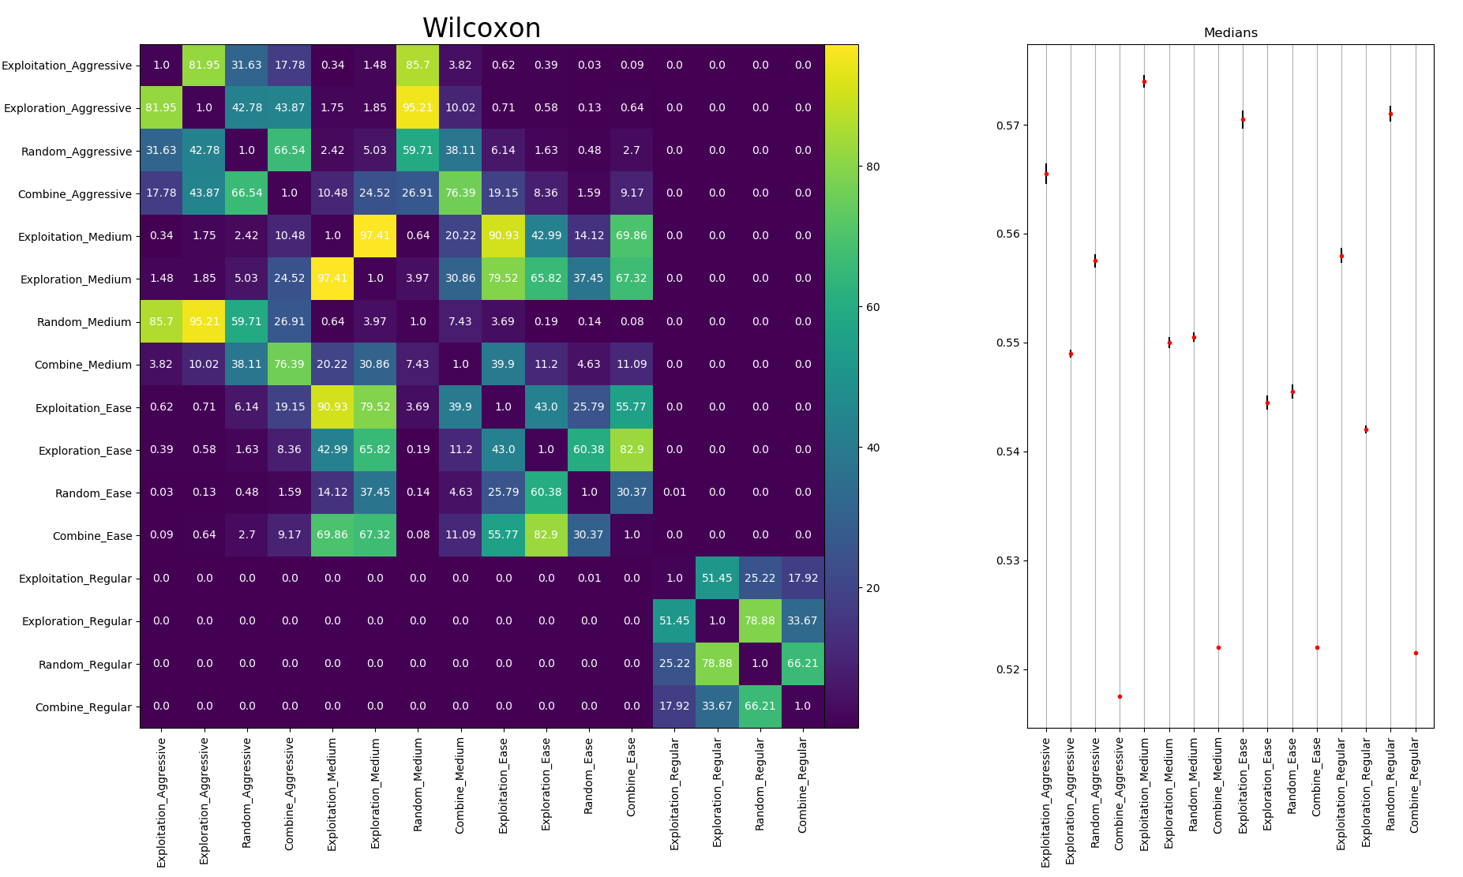

Figure 5 - Wilcoxon: Min Manipulability



Figure 6 - Median: Min Manipulability