# Results

## Manipulator arms

### Assumptions

After the assumption has been made a configuration generator was created. The configuration generator calculated all the possible joints & axes combinations due to the assumptions. In figure 1 it can be seen all the possible combinations of 3 DOF (24 combinations) and example of a branch that continues to 4,5,6 DOF, respectively.

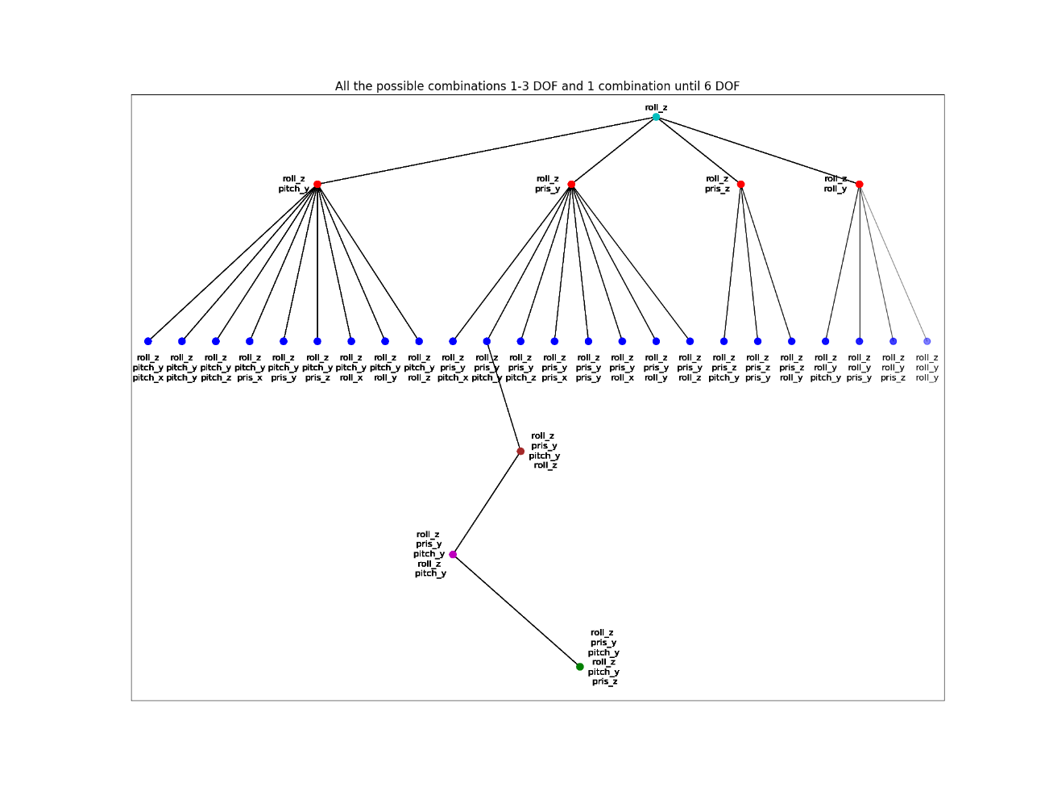

Figure 1- All Joints & Axes possibilities (3 DOF)

In figure 2 it can be seen an example to all the branches which go from one combination of 3DOF configuration. Every color represents different sub-branch and any joint-axis combination is what added to the branch. In the figure the 3DOf configuration of for Roll_Z🡪 Prismatic _Z 🡪 Roll_Y. from this combination, there are 4 combinations for 4 DOF: Pitch_Y (red), Pris_Y (blue), Pris_Z(green), Roll_y (purple). Form there it can be seen all the combinations of 5 & 6 DOF.

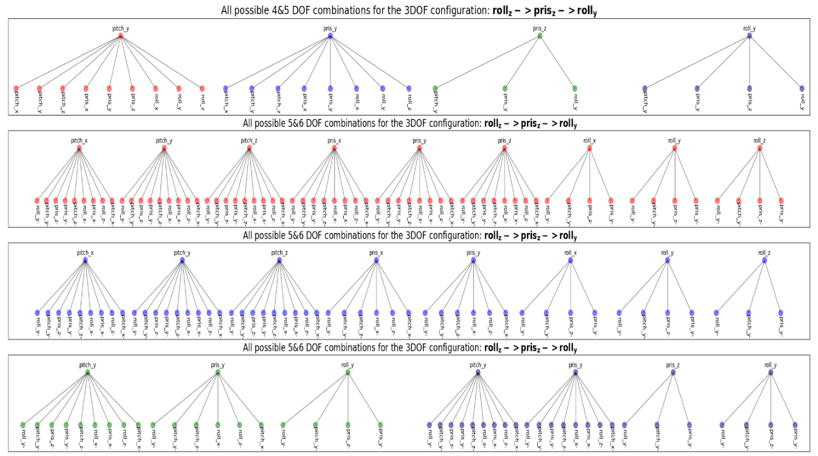

Figure 2-All Joints & Axes possibilities one branch

### Indices of manipulator performance

For choosing the indices to be used a preliminary simulation conducted over random 127000 configurations, all 3&4 DOF and part of 5&6 DOF.

From the preliminary simulation, none of the 3 DOF configurations succeeded to reach to desired points, therefore 3 DOF will not check further.

The tested indices of manipulator performance were :

* Manipulability Index
* Local Condition Number (LCI)
* Degrees of freedom (DOF)
* Time
* Mid-Proximity Joint Index

In figure 3 it can be seen that there is a linear relationship between LCI and Manipulability, which makes sense because both of them are checking how close the manipulator to singularity.

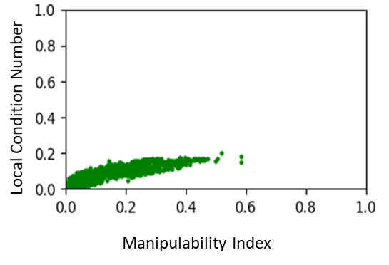

Figure 3 - LCI Vs Manipulability Index

In figure 4 it can be seen that no connection can be found between the Manipulability Index and the Mid-Proximity Joint Index.

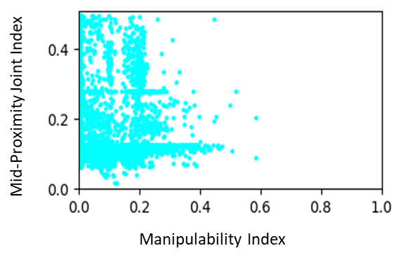

Figure 4- Mid-Proximity Joint Index Vs Manipulability Index

In figure 5 it can be seen that manipulators with lower DOF have lower Manipulability Index which makes sense because more DOF gives more movement options to the manipulator.

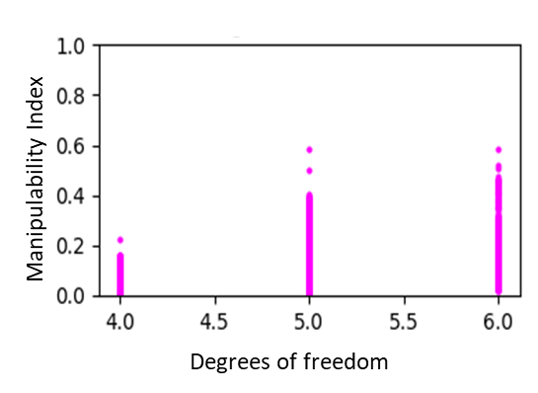

Figure 5- Manipulability Index Vs DOF

To find If the simulation time is a reliable index to compare between manipulators, 500 configurations were simulated in 2 different computers. In figure 6 it can be seen that sometimes simulation time can be one time high and one time low for the same configuration.

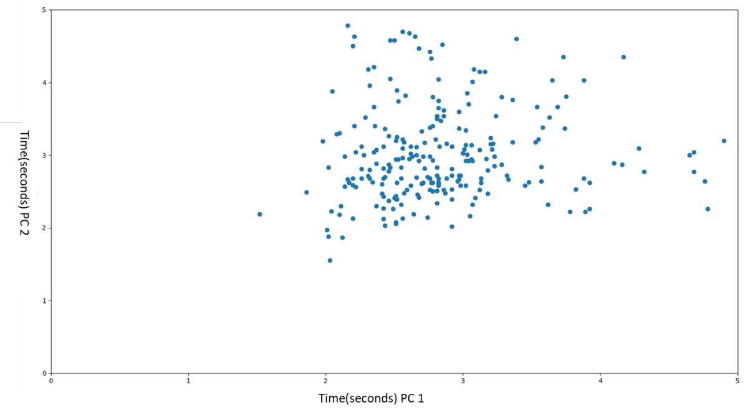

Figure 6 - Time Compassion

## Simulation

### Simulator

To find the weight of each link the ration between the accumulated weight and length of 2 different industrial manipulators. The ratio presented in figure 7. By averaging each component from the two linear equations, the ratio between the accumulated weight and length equation is :

$$Weight[i] = acc_length[i] * 8.79 + 4.29 –acc_weight[i-1]$$

Where i is ith link number and i = [2,3,4,5,6].

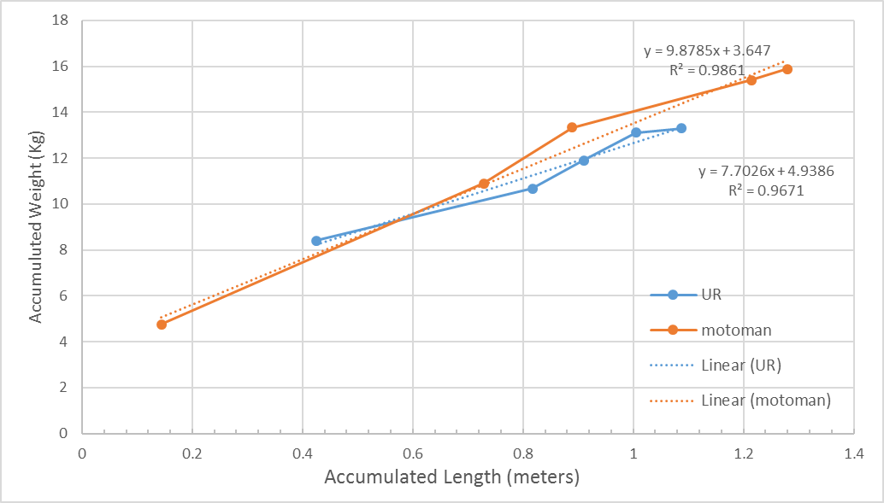

Figure 7- Accumulated Weight Vs Accumulated Length

## Preliminary Window of Interest

After simulating all the configurations that selected in the configuration selection (section 1.5.1 in methods), simulating all the 4 & 5 DOF configurations, all the concepts with up to 1000 configurations and all the other configurations that were simulated during the build of the algorithms, a Pareto front calculated. In the calculation of the Pareto front were used about 270,000 configurations, and 216 concepts left to the next step.

The front is the preliminary WOI of evolutionary optimization. In figure 8 it can be seen the preliminary WOI (the yellow surface), the points in the WOI ( numbered red dots) and all the other results (blue dots). In table 1 for each point in the WOI its results and the concept it belongs to. In table 2 for each point assigned the configuration name.

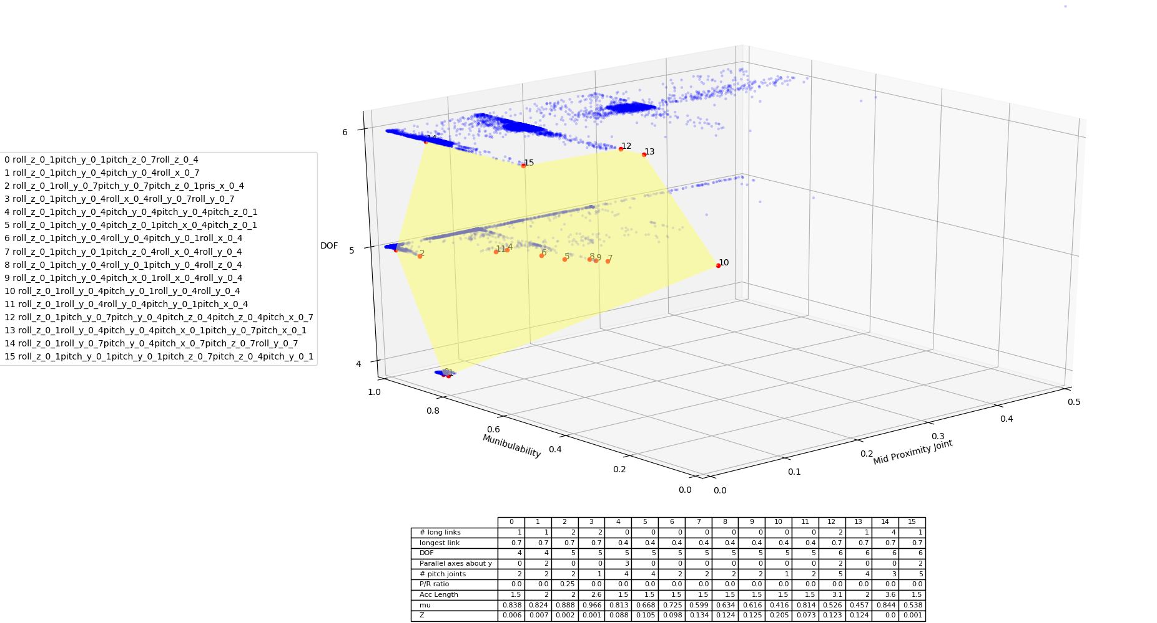

Figure 8- Preliminary WOI

Table 1 - Concepts in WOI



Table 2 - Configurations in WOI



## Evolutionary optimization with Dynamic-Window of interest

### Resource Allocation – Greedy Method

To find $T_{high}$ and $T_{low}$ 6 large concepts were chosen randomly (to add the concepts and their size) and their behavior was studied. The selected values are: $T_{high}=?$ and $T_{low}=?$.

### Resource Allocation – Fair Method