

**EXAMPLE OF PROPOGANDA COMMUNICATION**

**COMMUNICATION USING THE TWO STEP FLOW STRATEGY**

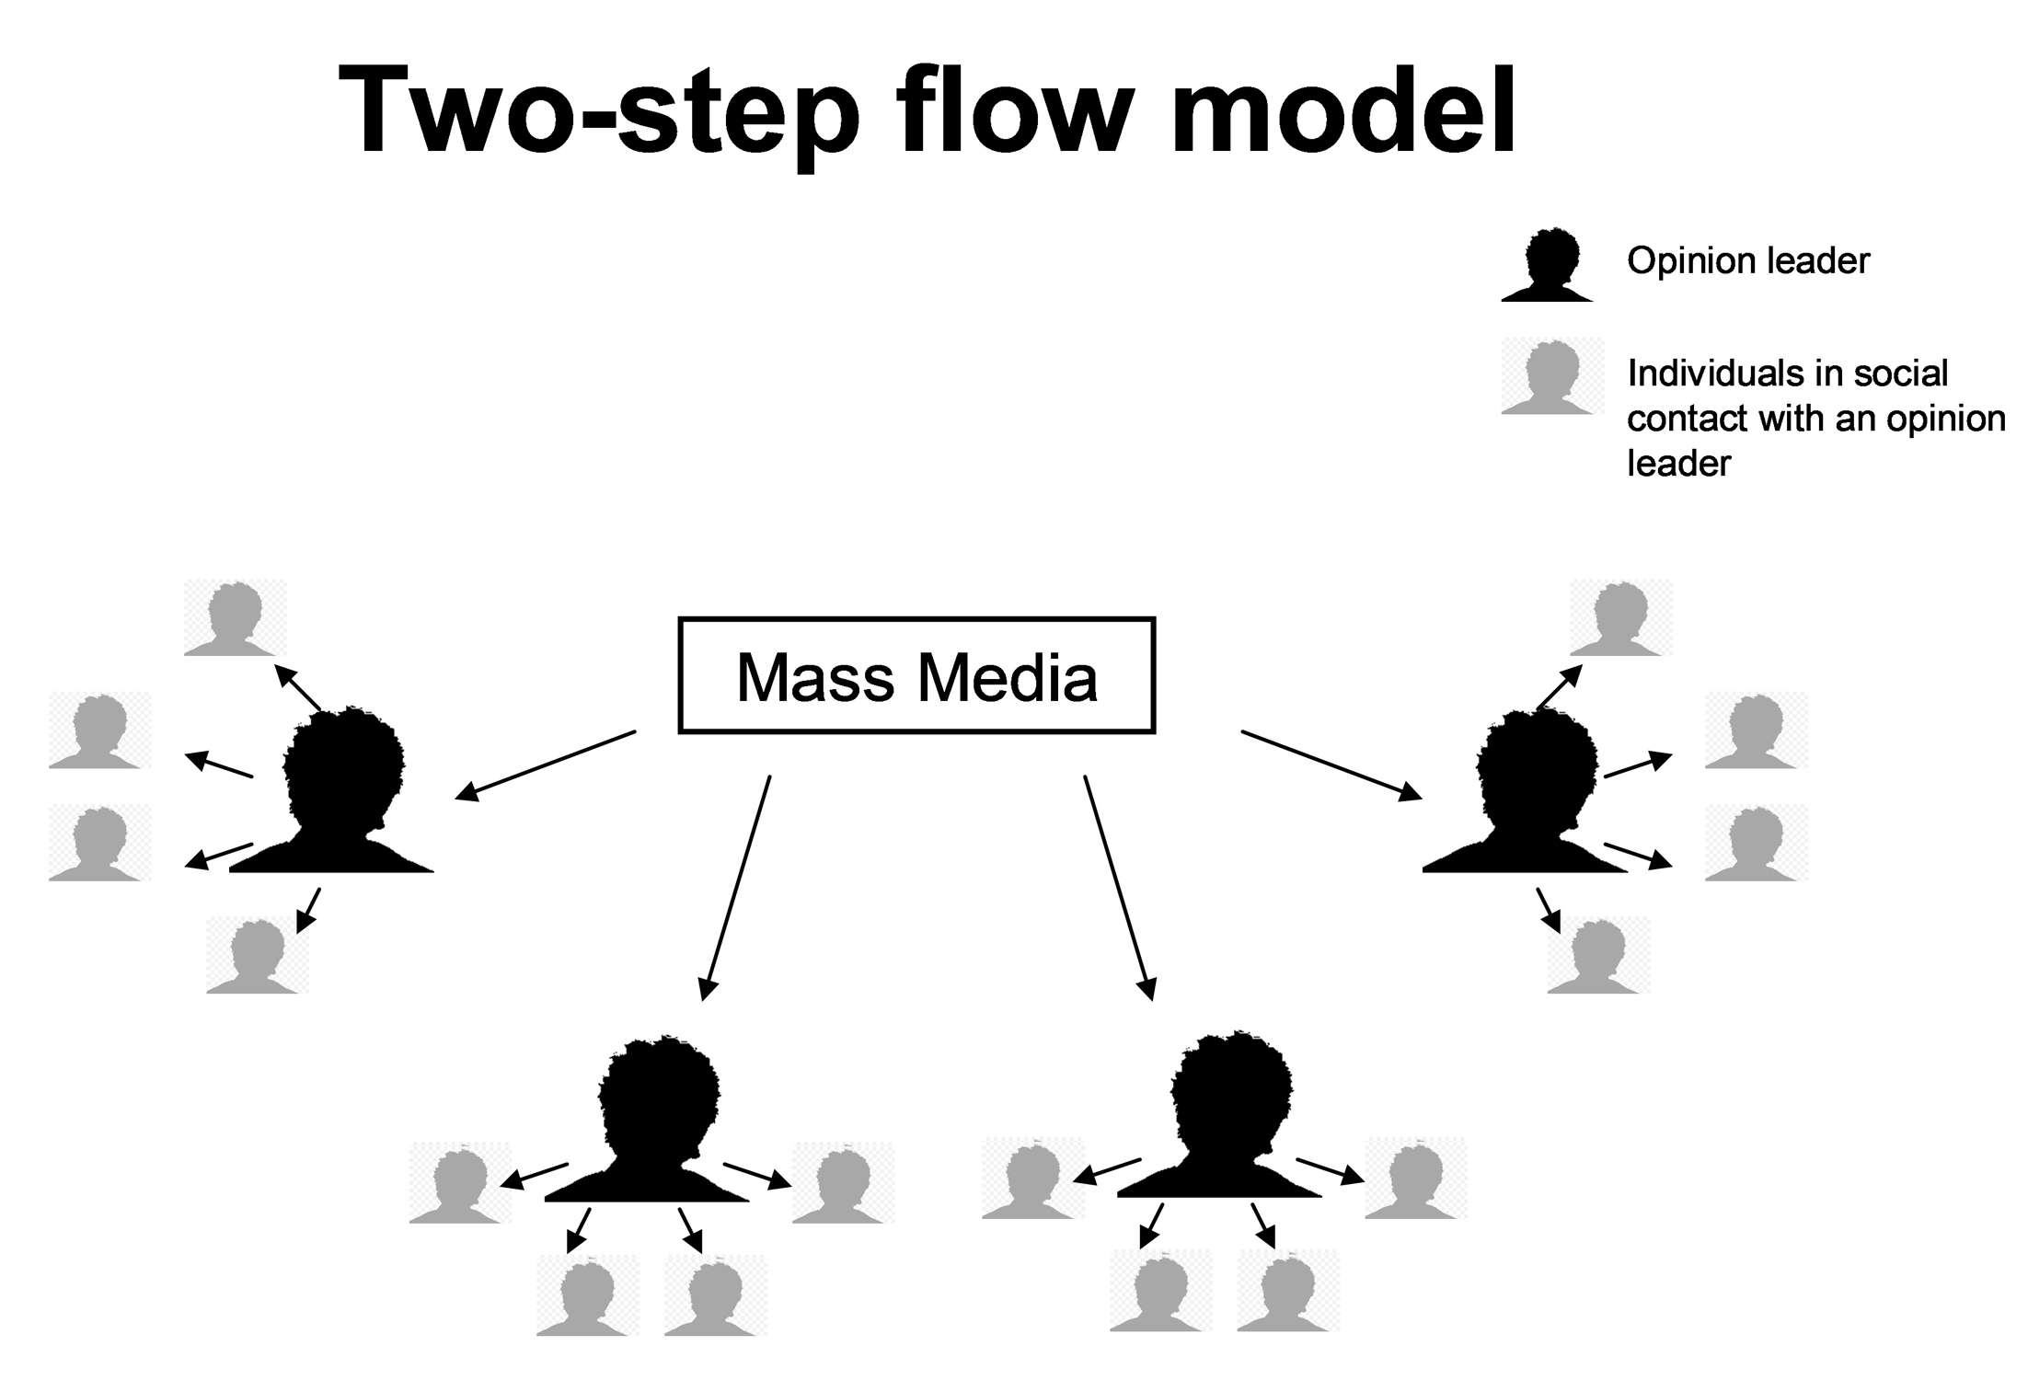

**EXAMPLE OF COMMUNICATION TARGETING YOUNG MEN**



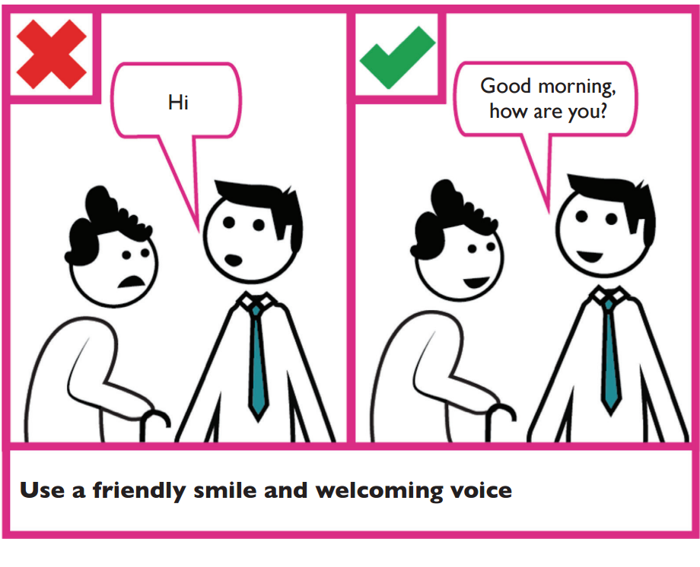

**EXAMPLE OF PUBLIC SERVICE COMMUNICATION**

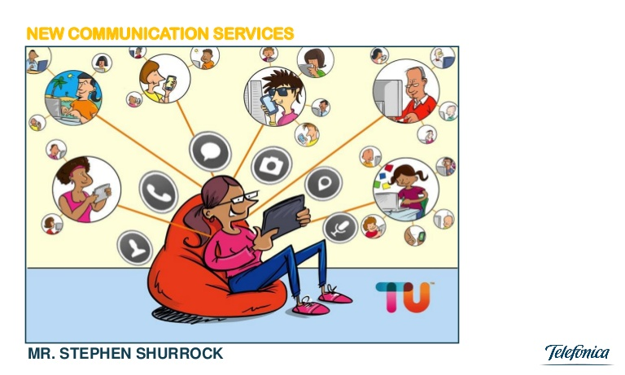

**EXAMPLE OF COMMUNICATION TARGETING YOUNG WOMEN**