

Machine Learning and Neural Networks

(CS401)

**Project Topic**

Disease Detection using Image Recognition

**Project Team**

|  |  |
| --- | --- |
| **Student Name** | **Student Number** |
| NAVEEN RAMPRASAD | 20253139 |
| SUBBALAKSHMI NARAYAN PRASAD | 21250754 |
| SREEVATHSA DEVANAHALLIBOKKSAM | 21250214 |

**Abstract**

COVID-19 is a global pandemic that has an impact on health care and lifestyle, and early discovery is crucial for limiting infection transmission and lowering mortality rates. The reverse transcription polymerase chain reaction (RT-PCR) is the most often used diagnosis test; nevertheless, the time and cost of these tests are prohibitive, forcing the development of new speedy and cost-effective diagnostic techniques. The approach utilized in this study is based on current research that links COVID-19 presence to chest X-ray findings. It classifies these pictures as "Covid," "Viral Pneumonia," or "Normal" using current deep learning models (VGG19, Resnet, Densenet). The proposed project contains a stage in which all X-Ray images are normalized to the same size, all images are labelled according to the classes, the dataset is separated into train and validation datasets, and pre-processed Xray images are shown. After that, the model is trained using three deep-learning models, and the results are analysed and interpreted. With 74 percent accuracy, the top model was able to recognize and label the images.

**Introduction**

The emerging coronavirus disease 2019 (COVID-19) pandemic triggered by SARS-CoV-2 continues to pose a major and imminent threat to global health. The outbreak originated in the Hubei province of the People's Republic of China in early December 2019 and has since spread throughout the world. There were more than 313,446,898 confirmed instances of the sickness in more than 180 countries as of December 2021, with the real number of people infected likely far higher. COVID-191 took the lives of about 5,519,424 people.

Underlying medical conditions including diabetes, cancer, cardiovascular disease, and lung disease might exacerbate the illness. The major approaches for COVID-19 detection are polymerase chain reaction (RT-PCR) and gene sequencing for respiratory and blood samples. COVID-19 exhibits identical pathologies to those seen in pneumonic disease, with chest pathologies obvious in medical pictures. Researchers have found a correlation between RT-PCR and chest CT scans. Even though skilled radiologists can recognize the visual patterns detected in these scans, this diagnosis technique is impracticable given the limited resources available at low-level medical centers and the growing number of patients.

Recent research in Artificial Intelligence (AI), notably in Deep Learning methods, demonstrates how well these techniques performed when applied to radiological images. We use the likes of neural network and deep learning to build self-learning models that predicts underlying conditions in never-seen before radiological images, also known as test dataset.

**Objective:**

**To diagnose Covid-19 and Viral Pneumonia in patients using chest X-Ray images**

**Tools and Libraries**

The project consists of many libraries that utilize a variety of tools and datasets.

Some of the libraries, tools, and datasets that may be utilized with it are as follows:

* Torch : Torch is an open-source machine learning library, a scientific computing framework, and a script language based on the Lua programming language. It provides a wide range of algorithms for deep learning
* Torchvision : Computer Vision library that works in tandem with PyTorch. It includes tools for doing efficient image and video transformations, as well as pre-trained models and datasets.
* Matplotlib : Is a graphing library for Python and its NumPy numerical mathematics extension.
* Random : Python Random module is an in-built module of Python which is used to generate random numbers.
* Pandas : Pandas is a software library written for the Python programming language for data manipulation and analysis.
* NumPy : NumPy is a library for the Python programming language, adding support for large, multi-dimensional arrays and matrices, along with a large collection of high-level mathematical functions to operate on these arrays.

**Dataset:**

* Contains separate folders of training and testing data
* The train data consists of X-Ray images of Covid-19 and Viral Pneumonia diagnosed patients along with images of healthy patients
* The test data is also distinguished similar to the train dataset

**Technology** **used:**

**Convolutional Neural Networks:**

CNNs (Convolutional Neural Networks) are a form of neural network that is frequently used to solve image processing difficulties. The convolutional layer, which connects neurons to pixels only in their receptive areas rather than every single pixel, distinguishes them from standard neural networks. As a consequence, features may be extracted while dimensionality is drastically reduced. David Hubel and Torsten Wiesel, two neurophysiologists, presented ground-breaking research on the response of a cat's visual cortical neurons to stimuli, which gave birth to CNN. Researchers took some of the findings as motivation to add a convolution layer to neural networks shortly after.

**Algorithms Implemented:**

**VGG16:**

VGG stands for Visual Geometry Group, and it is a multilayer deep Convolutional Neural Network (CNN) architecture. The term "deep" refers to the number of layers in VGG-16 or VGG-19, which have 16 or 19 convolutional layers respectively.

The VGG architecture serves as the foundation for cutting-edge object recognition models. The VGGNet, which was created as a deep neural network, outperforms baselines on a variety of tasks and datasets in addition to ImageNet. Furthermore, it is still one of the most widely used image recognition architectures today. Groundbreaking object recognition models are built on the VGG architecture. The VGGNet, which was created as a deep neural network, outperforms the ImageNet baseline on a variety of tasks and datasets. It's also one of the most widely used image recognition frameworks today.

**ResNet:**

ResNet-18 is a convolutional neural network that is 18 layers deep. Intuition behind residual blocks is that the identity mapping is optimal, we can easily push the residuals to zero (F(x) = 0) than to fit an identity mapping (x, input=output) by a stack of non-linear layers. In simple language it is very easy to come up with a solution like F(x) =0 rather than F(x)=x using stack of non-linear cnn layers as function. So, this function F(x) is what the authors called Residual function.

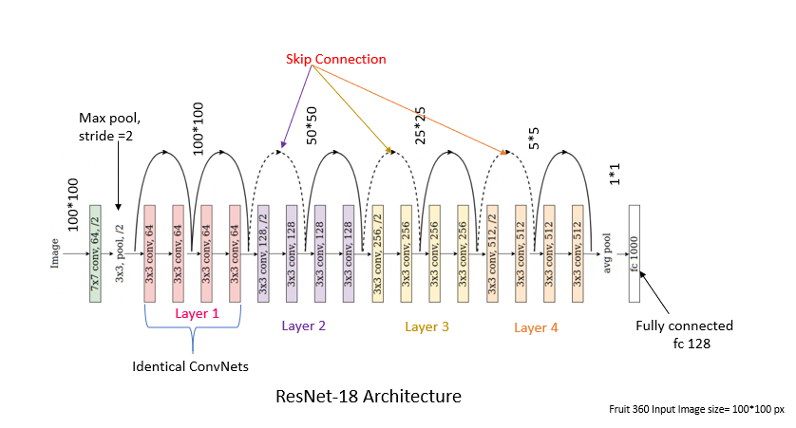

**DenseNet:**

DenseNets are divided into DenseBlocks, where the dimensions of the feature maps remain constant within a block, but the number of filters changes between them. These layers between them are called Transition Layers and take care of the downsampling applying a batch normalization, a 1x1 convolution and a 2x2 pooling layers.

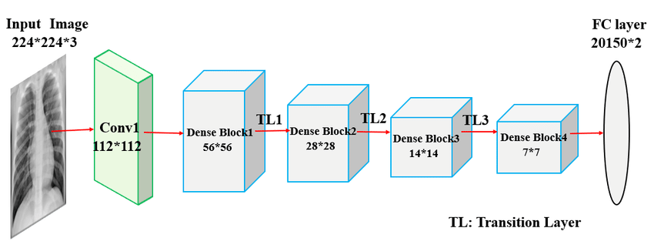

**Developed Methodology**

**Data Pre-processing:**

1. **Normalising the Xray Images and labelling :**

All of the train and validation datasets have been normalised to the same size and labelled according to their classes ("Covid," "Viral Pneumonia," or "Normal").

Covid's lung markings are partially covered by the enhanced whiteness, resulting in a ground glass pattern, whereas typical lung markings outline the chest cavity on either side by white bony structures that indicate the black ribs of the chest wall.

1. **Splitting the datasets using random split (Train, Validation, Test):**

**Code :**

**Count:**

**

1. **Batch processing:**

This is especially crucial if your machine's RAM can't hold the entire dataset. The total training technique takes less memory since the network is trained using fewer samples.

**Code:**

Sample Image set after Batch processing:

**Model Development:**

**VGG16:**

* VGG model was developed using 6 convolutional layers using a kernel size(window) of 3x3 matrix. This was moved by a stride of 1 with a padding of 1. This was added with a Relu activation function
* Convolution layer was followed by a max pooling layer of 2x2.
* Finally, there are 3 fully connected layers.
* The loss function used is Cross Entropy loss with Adam optimizer

**ResNet18:**

* In ResNet model, we have first used a convolution layer with a Relu activation function.
* We have used a Resnet18 model as this had the best results among ResNet18, ResNet34, ResNet50, ResNet101, ResNet152.
* For ResNet18 model, we have used a two-layer block, containing 2 convolution layers and 2 Relu activation layers.

**DenseNet121:**

* In DenseNet121 model, we have first used a convolution layer with a Relu activation function and a filter size of 7x7 and stride of 2x2.
* We follow it with Relu and maxpooling layer of filter size 3x3.
* We have used 4 dense layers with 3x3 filter size and stride of 1.
* We finally have Adaptive average pool layer along with a cross entropy loss function with Adam optimizer.

**Summary and Model results**

Amongst the three models chosen, we see the accuracies of respective models as below:

**Accuracy:**

**VGG-16 model**: 51%

**ResNet model**: 74.24%

**DenseNet model**: 59.5%

Hence, we can conclude that our champion model is ResNet model with a model accuracy of 74.2%

**Responsibilities**

I, **Naveen Ramprasad** had primary responsibility for data transformations, analysing and implementing **ResNet18** model.

I, **Subbalakshmi Narayana Prasad** had primary responsibility for data transformations and collections, analysing and implementing **DenseNet121** model.

I, **Sreevathsa Devanahallibokksam** had primary responsibility for data transformations, analysing and implementing **VGG-16** model.