IE 620 Spring 2016
Assignment #6 due Friday, May 22th
(10 points)
General Situation:
Suppose a manufacturer operates in the system plotted below:

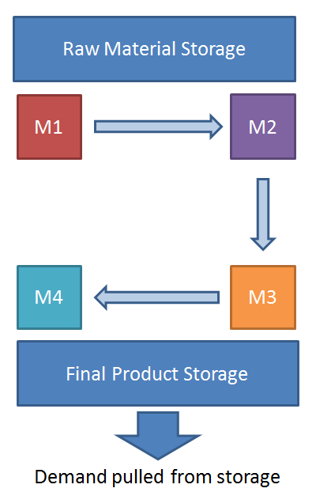
As far as the manufacturer concerns, a good markets represents that the all finished good produces can be sold. Therefore, the production site is operated in a made-to-stock manner.

Assumptions about the facility:
- The raw material is always abundant
- M1 produces with a processing time of Uni(20,120) seconds, each piece of raw material can be converted into 10 semi-products at M1.
- The processing time of M2, M3, and M4 are Uni(2,5) min, Normal (300,30) seconds, and Normal (6,1) minutes, respectively.
- There is a Uni(10,60) seconds transfer time between every two machines
- All finished goods generated after M4 is stored in the final product storage, assuming infinite storage space.
- Raw materials are routed to M1 using an AGV with a fixed travel time of 1 min. Also, finished goods are routed from M4 to Final product storage with a batch of 10 using an AGV with a fixed travel time of 1 min. There is only one AGV available in the shop.
- Whenever M1 finishes consuming a raw material (produce 10 semi-products), it will pull another raw material from RM storage and start processing.
- Finished goods will be pulled from the warehouse whenever an order arrives. Orders arrive with interarrival time of Uniform (10,500) min; each order contains Normal (80,5) quantity order. If inventory is smaller than demand, all remaining inventory will be pulled and the shortage amount will be recorded. No back-order will be made in such case

Requirement:

Build a simulation model using Arena for one month (24 hr per day) continuous operation and 30 replications. Monitor the finished goods inventory and collect the statistics on the percentage of out-of-stock order and the number of out-of-stock quantities.

- Is the current production setting appropriate with the Normal (80,5) demand? Is there any bottleneck within production? How does the inventory change within the one month simulated?
- Suppose the market is performing better than anticipated and the demand for each order increase to Normal (90,5). Can the current system still satisfy the demand? Which part (select one from machines or AGVs) in the system would you improve to meet the new demand.
- Suppose the market is performing better than anticipated and the demand for each order increase to Normal (70,5). In such case we would have too many finished goods storage on hand. Therefore we would like to propose a (s,S) inventory model where you stop starting new production once the final inventory reaches S while resumes production when it drops below s. Propose a (s,S) parameter to be used and find out the utilization rate of each machine in such scenario.

