## **Scenario**

### **Summary**

**We want to create a recipe creating/sharing and grocery list app.** You’ll be planning out what tables we’ll need, what information they’ll store, and how the data will relate to each other.

### **Features**

* users can sign into the app with their email and password -
* users can create recipes with ingredients and instructions -
* recipes can be marked as public or private -
* users can view other people’s recipes - (friend list or just set recipe public/private?)
* ingredients from recipes can be added to **user’s grocery lists** -
* users can create their own occasions and assign recipes to occasions

## 

## **Part 1: Conceptual Planning - Word/Google/Pages Doc**

### **Features**

### **Brainstorming things to keep track:**

* User_id
* User_name
* User_email
* User_password
* User_profile (text)
* User_profile_photo (imageURL)
* Recipe_id
* Recipe_title (heading?)
* Recipe_visibility (public/private)
* Recipe_instructions (text)
* Recipe_image_URL
* Recipe_ingredients (ingredient_ID?)
* Ingredient_amount
* Grocery_list
* List_id
* Ingredients
* Ingredient_amount (quantity?)
* User_friend_list
* Occasion_ID
* Occasion_description
* Recipe_ID for occasion

### **Table Ideas:**

* **User Table: This table will hold the key user info for identification**
  + User_id
  + Username
  + User_email
  + User_password
  + User_firstname
  + User_lastname
* **Recipe Table: This table holds unique info for each recipe**
  + Recipe_id
  + Recipe_title
  + Recipe_privacy (public/private)
  + Recipe_instructions (text)
  + Recipe_image_URL
  + Recipe_comments
  + Ingredients_ID
  + Ingredient_amount (per recipe)
  + User_id
* **Ingredient Table: This table holds unique info on each ingredient**
  + Ingredients_ID
  + Ingredient_name
  + Ingredient_description
* **Groceries List Table: This is a middle table that contains the user info and ingredients because the user creates the groceries list based on their recipes**
  + Groceries_list_ID
  + User_id
  + Ingredients_ID
  + Ingredient_count (this is different than the ingredient_amount which is portion per each recipe)
* **Occasions Table: This stores info on each unique occasion**
  + Occasion_ID
  + User_ID
  + Occasion_name
  + Occasion_date
  + Occasion_description
* **Recipe_ingredient Table: This is an association table that link the recipe to the ingredient**
  + Recipe_ingredient_id
  + recipe_id
  + ingredient_id
* **Recipes_Occasions Table: This is an association table that link the recipe_id to occasion_id**
  + Recipe_Occasion_ID (Serial Primary Key)
  + Recipe_ID (tie to Recipe Table) (foreign key)
  + Occasion_Id (tie to Occasion Table) (foreign key)

### 

### **Relationships**

* One-to-One
  + **None**
* One-to-Many
  + **User Table to Recipe Table:** one user can have multiple recipes, but a recipe can only belong to one user and multiple recipes can also belong to one user.
  + **User Table to Occasions Table:**one user can have multiple occasions because the user has to create the occasion
  + **User Table to Groceries Table:**  One user can create/edit multiple groceries list, but each grocery list only has one “owner user”.
* Many-to-Many
  + **Ingredient Table to Groceries Table:** one ingredient can belong to multiple groceries list, and one groceries list can contain multiple ingredients.
  + **User Table to Ingredients Table**: One user can consider many ingredients for a recipe or even a groceries list, and one ingredient can be considered by many users for a recipe or groceries list
  + **Recipes Table to Groceries Table:** one recipe can belong to many groceries list, and one groceries list can contain ingredients to make many recipes.
  + **Recipe Table to Ingredient Table:** the ingredient table contains the exact ingredient for the recipe.

## **Part 2: Table Planning - DB Designer & Word/Google/Pages Doc**

**Data Model Design using DB-DESIGNER.NET**

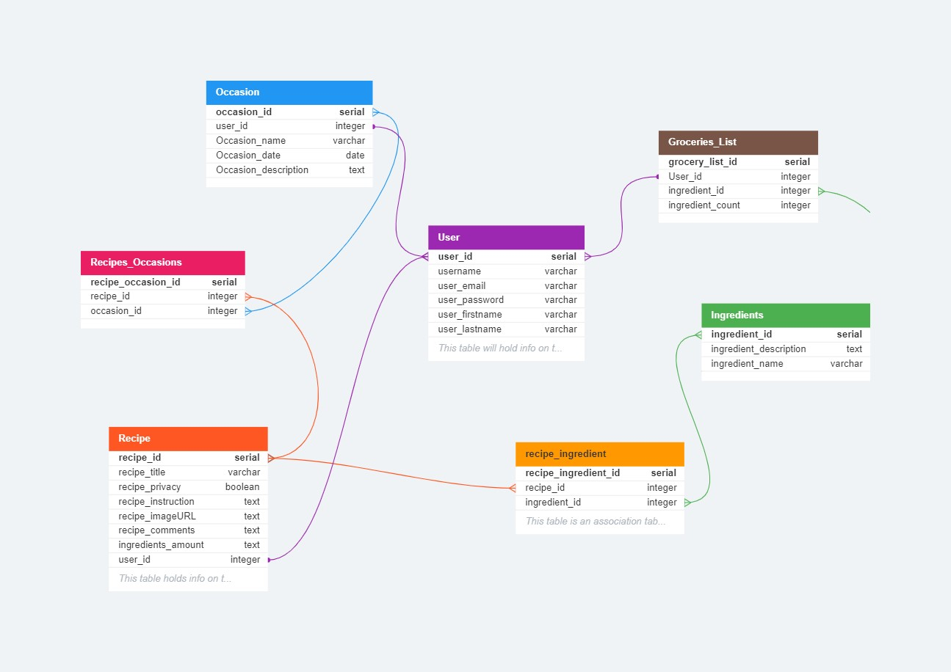

### **Columns**

* **User Signin Table: This table will hold info on the user**

User {

user_id serial pk increments unique unique serial primary key for unique user_id

username varchar(32) unique characters type with max 32 chars for unique username

user_email varchar(32) unique characters type with max 32 chars for unique email

user_password varchar(32) characters type with max 32 chars

user_firstname varchar(32) characters type with max 32 chars

user_lastname varchar(32) characters type with max 32 chars

}

* **Recipe Table: This table holds info on the recipe, instruction, ingredients, photos,**

Recipe {

recipe_id serial pk increments unique unique serial primary key for unique recipe_id

recipe_title varchar(100) chars type with max 100 chars

recipe_privacy boolean boolean type (True/False) for Public/Private, with False as default case for Public

recipe_instruction text chars type with max 500 chars for user to add instructions

recipe_imageURL text null text type for user to add image URLs with as many chars as needed

recipe_comments text null text type for user to comments with as many chars as needed

ingredients_amount text text type for the amount/portion of ingredient for each recipe, this is text type because it is part of the instruction

user_id integer unique >* User.user_id this is the creator of recipe, with id will always be integers or numbers in this example.

}

* **Ingredient Table: This table holds info on each ingredient type, the amount, user_id**

Ingredients {

ingredient_id serial pk increments unique unique serial primary key for unique ingredient_id

ingredient_description text text type for user to add description to each ingredient

ingredient_name varchar(100) chars type for each ingredient name

}

* **Groceries Table: Only the user has access to this groceries list**

Groceries_List {

grocery_list_id serial pk increments unique serial primary key for unique grocery_list_id

User_id integer unique >* User.user_id unique id for the creator of each grocery list, id should be numbers or integers

ingredient_id integer *>* Ingredients.ingredient_id unique id for each ingredient, id should be numbers of integers

ingredient_count integer *>* Ingredients.ingredient_amount integer type for each ingredient amount, portion

}

* **Occasions Table: This stores info on the occasion for the user to make a recipe, user can create their own occasion and assign the recipe**

Occasion {

occasion_id serial pk increments unique unique serial primary key for unique occasion_id

user_id integer >* User.user_id unique id for the creator of each grocery list, id should be numbers or integers

Occasion_name varchar(100) chars type with max 100 chars for each occasion name

Occasion_date date unique unique date type for each occasion date

Occasion_description text null text type for user to add description of occasion

}

* **Recipes_Occasion Bridge Table**

Recipes_Occasions {

recipe_occasion_id serial pk increments unique unique serial primary key for unique occasion_id

recipe_id integer unique *>* Recipe.recipe_id integer type for the recipe_id (tie back to recipe table)

occasion_id integer unique *>* Occasion.occasion_id integer type for the occasion_id (tie back to occasion table)

}

* **Recipe_Ingredient Bridge Table**

recipe_ingredient {

recipe_ingredient_id serial pk increments unique serial primary key for unique recipe_ingredient_id

recipe_id integer *>* Recipe.recipe_id integer type for the recipe_id (tie back to recipe table)

ingredient_id integer *>* Ingredients.ingredient_id integer type for ingredient_id (tie back to ingredient table)

}

## **Part 3: Create Tables in SQL - Postgres Sandbox & Word/Google/Pages Doc**

**SQL code examples using DB-FIDDLE.COM:**

**SCHEMA SQL:**

-- Ingredients table -

CREATE TABLE Ingredients (

ingredient_id SERIAL PRIMARY KEY,

ingredient_name VARCHAR,

ingredient_description TEXT

);

-- User table-

CREATE TABLE Users (

user_id SERIAL PRIMARY KEY,

username VARCHAR(32) UNIQUE,

user_email VARCHAR(32) UNIQUE,

user_password VARCHAR(32),

user_firstname VARCHAR(32),

user_lastname VARCHAR(32)

);

-- Occasion table -

CREATE TABLE Occasion (

occasion_id SERIAL PRIMARY KEY,

user_id INTEGER REFERENCES Users(user_id),

Occasion_name VARCHAR(100),

Occasion_date DATE UNIQUE,

Occasion_description TEXT

);

-- Recipe table-

CREATE TABLE Recipe (

recipe_id SERIAL PRIMARY KEY,

recipe_title VARCHAR(100),

recipe_privacy BOOLEAN,

recipe_instruction TEXT,

recipe_imageURL TEXT NULL,

recipe_comments TEXT NULL,

ingredients_amount TEXT,

user_id INTEGER REFERENCES Users(user_id)

);

-- Groceries_List table-

CREATE TABLE Groceries_List (

grocery_list_id SERIAL PRIMARY KEY,

user_id INTEGER REFERENCES Users(user_id),

ingredient_id INTEGER REFERENCES Ingredients(ingredient_id),

ingredient_count INTEGER

);

-- Recipes_Occasions table

CREATE TABLE Recipes_Occasions (

recipe_occasion_id SERIAL PRIMARY KEY,

recipe_id INTEGER REFERENCES Recipe(recipe_id),

occasion_id INTEGER REFERENCES Occasion(occasion_id)

);

-- recipe_ingredient table

CREATE TABLE recipe_ingredient (

recipe_ingredient_id SERIAL PRIMARY KEY,

recipe_id INTEGER REFERENCES Recipe(recipe_id),

ingredient_id INTEGER REFERENCES Ingredients(ingredient_id)

);

**QUERY SQL to insert data:**

-- Insert a new user

INSERT INTO Users (username, user_email, user_password, user_firstname, user_lastname)

VALUES ('annabanana', 'ann@email.com', 'pass123', 'Ann', 'Banana');

-- Insert a new recipe

INSERT INTO Recipe (recipe_title, recipe_privacy, recipe_instruction, recipe_imageURL, recipe_comments, ingredients_amount, user_id)

VALUES ('Shrimp Spring Rolls', true, 'Boil shrimp, Wash Veggies, Roll in Rice Paper, Make Dipping Sauce', 'yummyspringroll.jpg', 'Delicious recipe!', 'Yummy', 1);

-- Insert ingredients for the recipe

INSERT INTO Ingredients (ingredient_name, ingredient_description)

VALUES ('Shrimp', 'Shrimp for protein'),

('Veggies & Herbs', 'Veggies for daily greens that you like'),

('rice paper', 'soft but chewy rice paper to wrap'),

('fish sauce', '3 crabs fish sauce brand');

-- Get the ingredient IDs for the recipe

SELECT ingredient_id FROM Ingredients WHERE ingredient_name IN ('Shrimp', 'Veggies & Herbs', 'rice paper', 'fish sauce');

-- -- -- Insert the recipe's ingredients into the recipe_ingredient table

INSERT INTO recipe_ingredient (recipe_id, ingredient_id)

VALUES (1, 1), (1, 2), (1, 3), (1, 4);

-- -- -- Insert a new occasion

INSERT INTO Occasion (user_id, Occasion_name, Occasion_date, Occasion_description)

VALUES (1, 'Weekend_lunch', '2023-07-22', 'Lunch during the weekend when I want something healthy and have time to make fresh spring rolls');

-- -- display all the tables to check

SELECT * FROM users;

SELECT * FROM Recipe;

SELECT * FROM Groceries_List;

SELECT * FROM Ingredients;

SELECT * FROM Occasion;

**Schema (PostgreSQL v15)**

-- Ingredients table -

CREATE TABLE Ingredients (

ingredient_id SERIAL PRIMARY KEY,

ingredient_name VARCHAR,

ingredient_description TEXT

);

-- User table-

CREATE TABLE Users (

user_id SERIAL PRIMARY KEY,

username VARCHAR(32) UNIQUE,

user_email VARCHAR(32) UNIQUE,

user_password VARCHAR(32),

user_firstname VARCHAR(32),

user_lastname VARCHAR(32)

);

-- Occasion table -

CREATE TABLE Occasion (

occasion_id SERIAL PRIMARY KEY,

user_id INTEGER REFERENCES Users(user_id),

Occasion_name VARCHAR(100),

Occasion_date DATE UNIQUE,

Occasion_description TEXT

);

-- Recipe table-

CREATE TABLE Recipe (

recipe_id SERIAL PRIMARY KEY,

recipe_title VARCHAR(100),

recipe_privacy BOOLEAN,

recipe_instruction TEXT,

recipe_imageURL TEXT NULL,

recipe_comments TEXT NULL,

ingredients_amount TEXT,

user_id INTEGER REFERENCES Users(user_id)

);

-- Groceries_List table-

CREATE TABLE Groceries_List (

grocery_list_id SERIAL PRIMARY KEY,

user_id INTEGER REFERENCES Users(user_id),

ingredient_id INTEGER REFERENCES Ingredients(ingredient_id),

ingredient_count INTEGER

);

-- Recipes_Occasions table

CREATE TABLE Recipes_Occasions (

recipe_occasion_id SERIAL PRIMARY KEY,

recipe_id INTEGER REFERENCES Recipe(recipe_id),

occasion_id INTEGER REFERENCES Occasion(occasion_id)

);

-- recipe_ingredient table

CREATE TABLE recipe_ingredient (

recipe_ingredient_id SERIAL PRIMARY KEY,

recipe_id INTEGER REFERENCES Recipe(recipe_id),

ingredient_id INTEGER REFERENCES Ingredients(ingredient_id)

);

### **Results: (Markdown)**

### 

**Schema (PostgreSQL v15)**

-- Ingredients table -

CREATE TABLE Ingredients (

ingredient_id SERIAL PRIMARY KEY,

ingredient_name VARCHAR,

ingredient_description TEXT

);

-- User table-

CREATE TABLE Users (

user_id SERIAL PRIMARY KEY,

username VARCHAR(32) UNIQUE,

user_email VARCHAR(32) UNIQUE,

user_password VARCHAR(32),

user_firstname VARCHAR(32),

user_lastname VARCHAR(32)

);

-- Occasion table -

CREATE TABLE Occasion (

occasion_id SERIAL PRIMARY KEY,

user_id INTEGER REFERENCES Users(user_id),

Occasion_name VARCHAR(100),

Occasion_date DATE UNIQUE,

Occasion_description TEXT

);

-- Recipe table-

CREATE TABLE Recipe (

recipe_id SERIAL PRIMARY KEY,

recipe_title VARCHAR(100),

recipe_privacy BOOLEAN,

recipe_instruction TEXT,

recipe_imageURL TEXT NULL,

recipe_comments TEXT NULL,

ingredients_amount TEXT,

user_id INTEGER REFERENCES Users(user_id)

);

-- Groceries_List table-

CREATE TABLE Groceries_List (

grocery_list_id SERIAL PRIMARY KEY,

user_id INTEGER REFERENCES Users(user_id),

ingredient_id INTEGER REFERENCES Ingredients(ingredient_id),

ingredient_count INTEGER

);

-- Recipes_Occasions table

CREATE TABLE Recipes_Occasions (

recipe_occasion_id SERIAL PRIMARY KEY,

recipe_id INTEGER REFERENCES Recipe(recipe_id),

occasion_id INTEGER REFERENCES Occasion(occasion_id)

);

-- recipe_ingredient table

CREATE TABLE recipe_ingredient (

recipe_ingredient_id SERIAL PRIMARY KEY,

recipe_id INTEGER REFERENCES Recipe(recipe_id),

ingredient_id INTEGER REFERENCES Ingredients(ingredient_id)

);

---

**Query #1**

INSERT INTO Users (username, user_email, user_password, user_firstname, user_lastname)

VALUES ('annabanana', 'ann@email.com', 'pass123', 'Ann', 'Banana');

There are no results to be displayed.

---

**Query #2**

INSERT INTO Recipe (recipe_title, recipe_privacy, recipe_instruction, recipe_imageURL, recipe_comments, ingredients_amount, user_id)

VALUES ('Shrimp Spring Rolls', true, 'Boil shrimp, Wash Veggies, Roll in Rice Paper, Make Dipping Sauce', 'yummyspringroll.jpg', 'Delicious recipe!', 'Yummy', 1);

There are no results to be displayed.

---

**Query #3**

INSERT INTO Ingredients (ingredient_name, ingredient_description)

VALUES ('Shrimp', 'Shrimp for protein'),

('Veggies & Herbs', 'Veggies for daily greens that you like'),

('rice paper', 'soft but chewy rice paper to wrap'),

('fish sauce', '3 crabs fish sauce brand');

There are no results to be displayed.

---

**Query #4**

SELECT ingredient_id FROM Ingredients WHERE ingredient_name IN ('Shrimp', 'Veggies & Herbs', 'rice paper', 'fish sauce');

| ingredient_id |

| ------------- |

| 1 |

| 2 |

| 3 |

| 4 |

---

**Query #5**

INSERT INTO recipe_ingredient (recipe_id, ingredient_id)

VALUES (1, 1), (1, 2), (1, 3), (1, 4);

There are no results to be displayed.

---

**Query #6**

INSERT INTO Occasion (user_id, Occasion_name, Occasion_date, Occasion_description)

VALUES (1, 'Weekend_lunch', '2023-07-22', 'Lunch during the weekend when I want something healthy and have time to make fresh spring rolls');

There are no results to be displayed.

---

**Query #7**

SELECT * FROM users;

| user_id | username | user_email | user_password | user_firstname | user_lastname |

| ------- | ---------- | ------------- | ------------- | -------------- | ------------- |

| 1 | annabanana | ann@email.com | pass123 | Ann | Banana |

---

**Query #8**

SELECT * FROM Recipe;

| recipe_id | recipe_title | recipe_privacy | recipe_instruction | recipe_imageurl | recipe_comments | ingredients_amount | user_id |

| --------- | ------------------- | -------------- | ----------------------------------------------------------------- | ------------------- | ----------------- | ------------------ | ------- |

| 1 | Shrimp Spring Rolls | true | Boil shrimp, Wash Veggies, Roll in Rice Paper, Make Dipping Sauce | yummyspringroll.jpg | Delicious recipe! | Yummy | 1 |

---

**Query #9**

SELECT * FROM Groceries_List;

There are no results to be displayed.

---

**Query #10**

SELECT * FROM Ingredients;

| ingredient_id | ingredient_name | ingredient_description |

| ------------- | --------------- | -------------------------------------- |

| 1 | Shrimp | Shrimp for protein |

| 2 | Veggies & Herbs | Veggies for daily greens that you like |

| 3 | rice paper | soft but chewy rice paper to wrap |

| 4 | fish sauce | 3 crabs fish sauce brand |

---

**Query #11**

SELECT * FROM Occasion;

| occasion_id | user_id | occasion_name | occasion_date | occasion_description |

| ----------- | ------- | ------------- | ------------------------ | ----------------------------------------------------------------------------------------------- |

| 1 | 1 | Weekend_lunch | 2023-07-22T00:00:00.000Z | Lunch during the weekend when I want something healthy and have time to make fresh spring rolls |

---

[View on DB Fiddle](https://www.db-fiddle.com/f/tw2ZC8DrDX36BDZd7ZXhd4/0)