POWER USER PERSONA

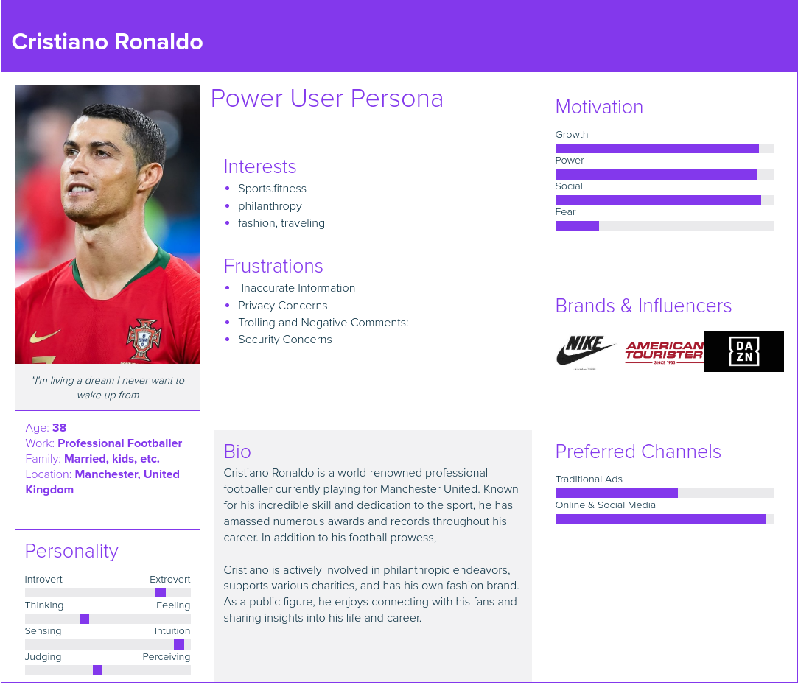

USER STORIES:

* ***As a Super User, I want to create an account so that I can share updates, photos, and videos of my life and career with my fans.***
* ***As a Super User, I want to log in and log out securely to protect my personal information.***
* ***As a Super User, I want to upload and share content related to my football matches, training sessions, personal life.***
* ***As a Super User, I want to edit or delete my posts if I need to make changes or remove content.***
* ***As a Super User, I want to like and comment on posts from other users.***
* ***As a Super User, I want to follow other users such as teamates, celebrities, fitness and fans.***
* ***As a Super User, I want to view and manage my list of followers and those i am following.***
* ***As a Super User, I want to have a verified account batch to ensure fans that this the real account.***

USER PERSONA

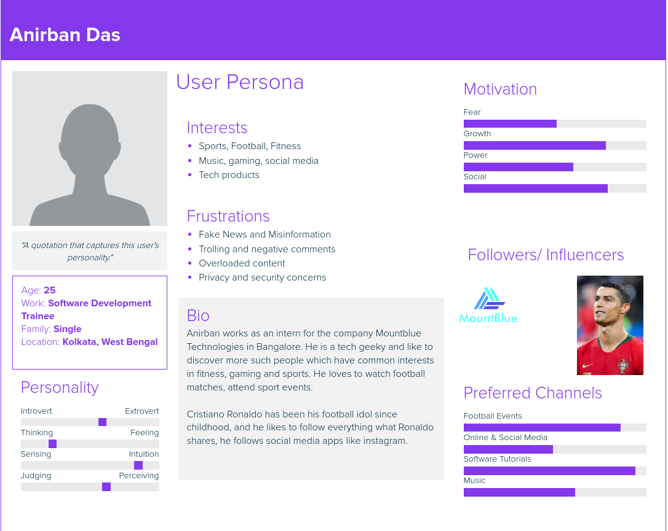

USER STORIES:

* ***As a User , I want to create an account so that i can follow my favourite influencers.***
* ***As a User, I want to securely login and logout of my account to protect my personal information.***
* ***As a User, I want to follow my favorite influencers so that i can get information of their posts.***
* ***As a User, I want to seach for anyone who have an account inside instagram.***
* ***As a User, I want to like and comment on posts others have shared on the application***
* ***As a User, I want to upload and share my own photos and videos to engage with others and express myself.***
* ***As a User, I want to share influencers post with my friends on the application.***

Database Schema

Database Schema for Instagram Clone

1. User

* user_id (Primary Key)
* username (Unique)
* email (Unique)
* password
* first_name
* last_name
* bio
* profile_picture
* is_verified
* date_joined

2. Post

* post_id (Primary Key)
* user_id (Foreign Key – references User.user_id)
* image
* caption
* created_at

3. Comment

* comment_id (Primary Key)
* user_id (Foreign Key – references User.user_id)
* post_id (Foreign Key – references Post.post_id)
* text
* created_at

4. Like

* like_id (Primary Key)
* user_id (Foreign Key – references User.user_id)
* post_id (Foreign Key – references Post.post_id)
* created_at

5. Follow

* follow_id (Primary Key)
* follower_id (Foreign Key – references User.user_id)
* following_id (Foreign Key – references User.user_id)