🏢 Mangoi · MANGOI
Branch User Guide
Sub-agencies, settlement & performance in one book

For · Regional branch operators
🌐 www.mangoi.co.kr 📞 1644-0561 ✉ support@mangoi.co.kr

📘 What is the Branch Admin Page?
The branch page is where you manage your branch and its sub-agencies with authority delegated by HQ. When you log in, only 'my branch' data (revenue, enrollment, attendance, settlement) is shown automatically. You see your sub-agencies' performance at a glance and process the settlement that flows HQ ↔ branch ↔ agency. The layout is the same as the admin page — only the scope differs.
🏢 My-branch scope, automatic — Just log in and see only your branch's data.
🏬 Manage sub-agencies — Agency list, performance and recruiting in one place.
🌳 HQ→branch→agency settlement — Receipt/distribution auto-calculated by the tree.
📊 Performance reports — Branch/agency performance in a monthly report.

🧭 How to Use the Main Features
01. 🔐 Branch Login & Permissions
Only my branch's data shows
📖 Logging in with a branch account shows only 'my branch' menus and data. HQ-wide or other branches' data isn't visible, so you can focus on your branch with peace of mind.

How to use
1. Log in with ID and password (Kakao, Naver, Google also work).
2. On login, menus/data for your role (branch) are applied automatically.
3. Forgot your password? Reset via 'Find password'.
4. You can split permission scope among staff.
✅ Key Points
• Only your branch and sub-agency data shows.
• Turn on 'Save ID' only on your own trusted PC.
💡 Tip On shared PCs, turn off auto-login and always log out when done.

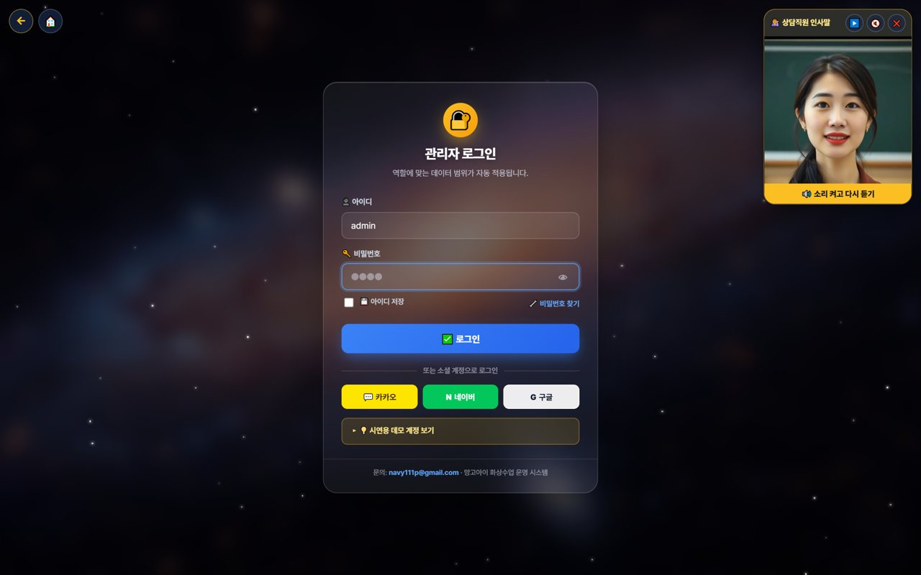
02. 👤 My Page & Admin Dashboard
Open the management screen from My Page
📖 Branch operations start from 'My Page.' After logging in, press the 📊 'Admin' button in the My Page menu to enter the branch-scope admin (operations) dashboard, where you manage revenue, enrollment, agencies and settlement.

How to use
1. After logging in, open '👤 My Page'.
2. Press the 📊 'Admin' button in the My Page menu. (goes to the admin dashboard)
3. On the admin dashboard, check your branch revenue, enrollment, attendance and sub-agencies.
4. My Page also has postpone/change, new inquiry, all-menu, pre-check and more.
5. If text looks English, use the EN button to switch language.
✅ Key Points
• One 'Admin' button takes you straight to the operations dashboard.
• All dashboard data is auto-totaled to 'your branch scope'.
• Menus and data are set automatically by your role (branch).
Good to know My Page and the admin dashboard open only within the logged-in branch account's permission scope.

💡 Tip Each day, spend 5 minutes: My Page → Admin dashboard → check branch metrics.


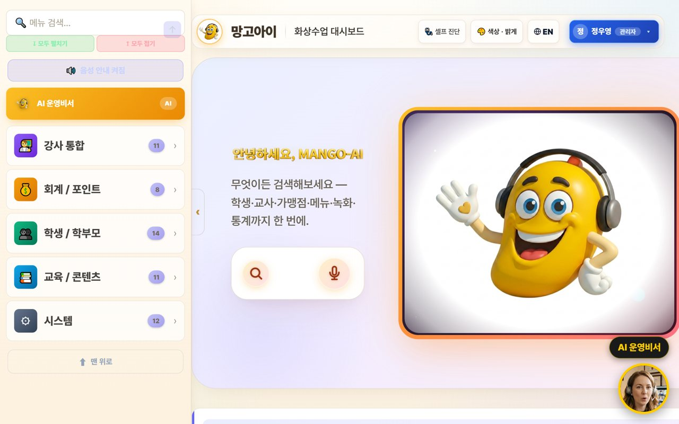
03. 🏠 Branch Dashboard
Your branch status at a glance
📖 On login, your branch's revenue, enrollment and attendance plus sub-agency status are organized as cards. Type a word in the top search box to jump right to a feature.

How to use
1. Check today's revenue, enrollment and attendance (your branch total) at the top.
2. Tap features from the category cards (agencies, teachers, accounting, students, content).
3. Type a word in the feature search box to jump right there.
4. The AI insight summarizes your branch status.
✅ Key Points
• All numbers are auto-totaled to 'your branch scope'.
• If a feature is hard to find, search is fastest.
💡 Tip A 5-minute morning check of branch metrics catches warning signs early.

04. 🤖 Using the AI Assistant
Look up/act by voice or text
📖 Speak or type into the search/mic and the AI looks up numbers or opens screens within your branch scope. Important actions are confirmed first, and it only does what you're permitted.

How to use
1. Speak or type into the center search/mic. e.g. 'How's the branch revenue this month?'
2. The AI looks up numbers or opens a screen. e.g. 'Open the agency list.'
3. Important actions are confirmed with 'Shall I?' first.
4. The assistant only executes what you're permitted.
✅ Key Points
• When busy, voice is much faster.
• Results are limited to your branch scope.
💡 Tip Just say 'show me/open ○○' to jump to the screen you want.

05. 🏬 Manage Sub-agencies
List, performance, recruiting
📖 Manage the agencies under your branch as a list and compare each agency's enrollment, revenue and performance. Recruiting and onboarding new agencies is handled here too.

How to use
1. Check each agency's enrollment, revenue and activity in the agency list.
2. Compare strong/weak agencies to set support priorities.
3. Manage new-agency recruiting/onboarding progress.
4. Set goals/incentives per agency if needed.
✅ Key Points
• Link agencies with big performance gaps to coaching/support.
• Share top agencies' methods with the others.
Good to know Agency data is also managed by each agency's own login; the branch sees the whole picture.

💡 Tip Sharing a monthly performance report at month-start boosts partner motivation.

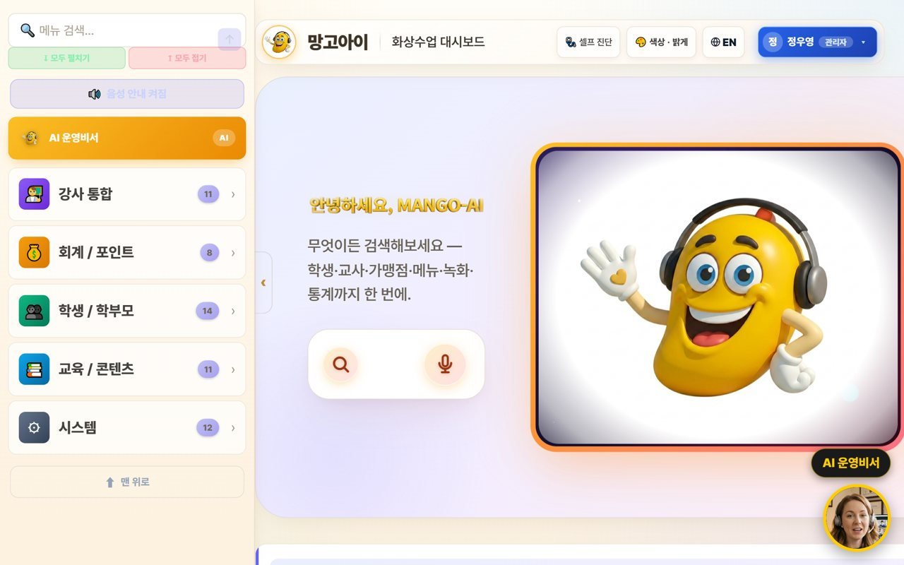
06. 🌳 Branch Settlement (receive & distribute)
HQ→branch→agency
📖 Receive the settlement coming from HQ to your branch and check the amount distributed from the branch to sub-agencies. Revenue and commissions are auto-calculated down the org tree.

How to use
1. Check HQ→branch settlement (received) by month.
2. Branch→agency distribution is auto-calculated by the tree.
3. Review/save the settlement in a monthly report (PDF).
4. If an item looks off, look up the details to confirm.
✅ Key Points
• Settlement is auto-calculated down the org tree (HQ·branch·agency).
• Distributing the settlement report early builds agency trust.
💡 Tip Announcing settlement terms (rate·timing) to agencies in advance reduces disputes.

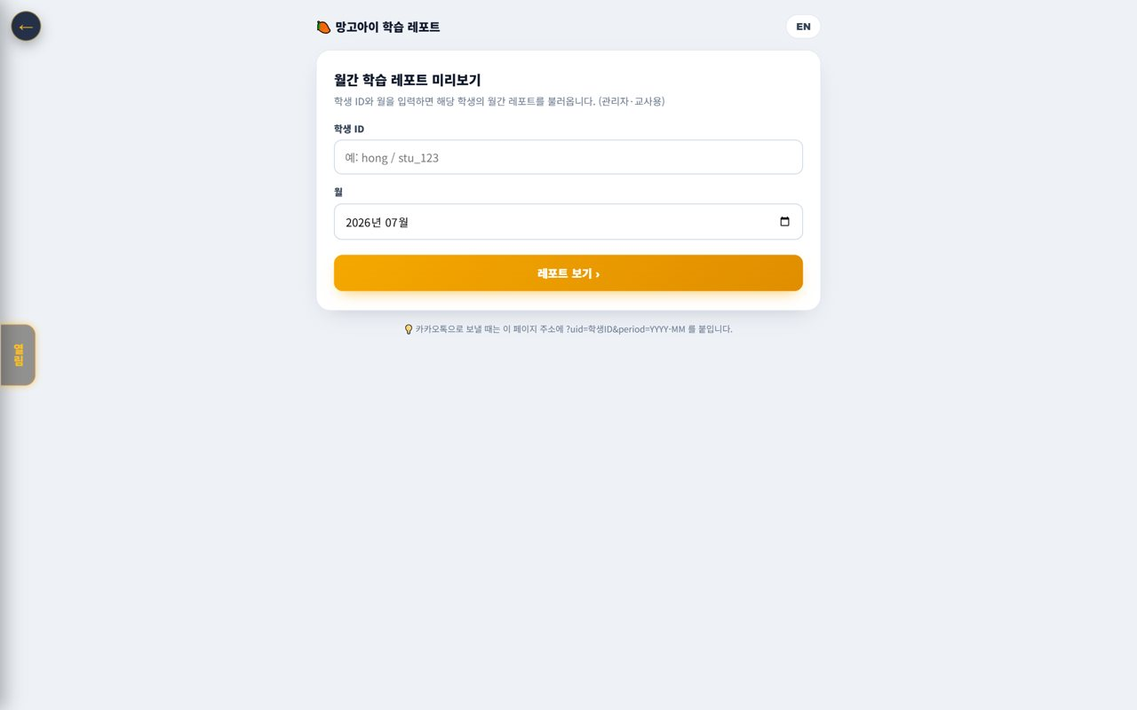
07. 🧑‍🎓 Student · Parent Status
Branch-scope enrollment·attendance·grades
📖 Check the status of students in your branch (enrollment, attendance, grades). View by agency or as a branch total.

How to use
1. Check branch-scope enrolled students in Students/Parents.
2. Compare attendance/grades by agency and overall.
3. Flag students/agencies that need attention.
✅ Key Points
• The student list is linked to real member data.
• At-risk students link to the Retention Center.
💡 Tip Find agencies whose attendance/enrollment is dipping and support them quickly.

08. 💳 Payments·Overdue·Refunds (branch)
Branch-scope accounting
📖 Check payments, overdue and refunds in your branch scope and review amounts auto-calculated by policy. Also see collection status by agency.

How to use
1. Check branch-scope payments/overdue/refunds in Accounting/Points.
2. Compare collection rate by agency.
3. Amounts are auto-calculated per the refund table.
✅ Key Points
• Strengthen alerts/support for agencies with high overdue.
• Discounted-payment refunds recalc at list price.
💡 Tip Advise agencies with low collection to automate reminders.

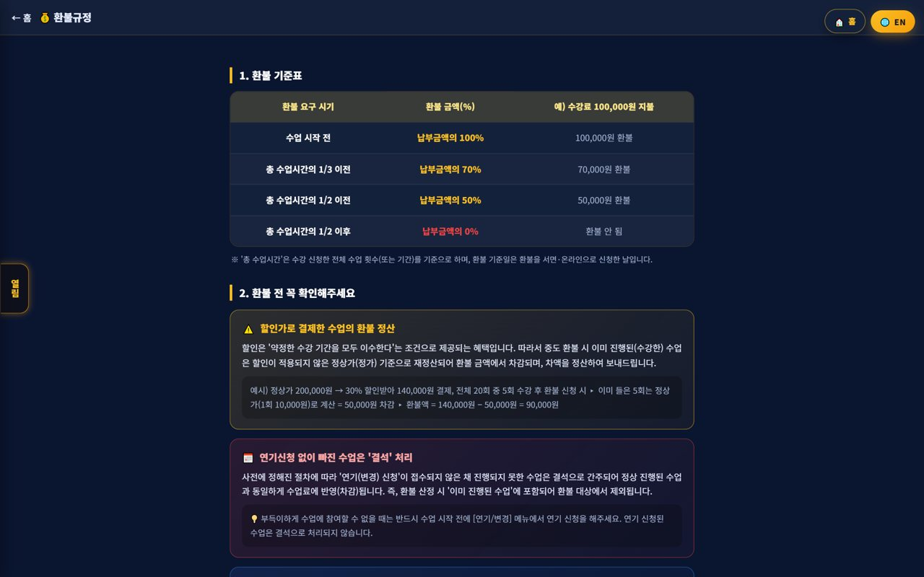
09. 🧲 Branch Retention
Churn risk·contagion·coaching
📖 Find at-risk students across your branch/agencies early and prevent chain churn through family/referral. It ties into agency and teacher coaching.

How to use
1. Find at-risk students/agencies with the churn-risk graph.
2. Prevent chain churn with the contagion network.
3. Link high-risk spots to alert-talk/counseling/coaching.
✅ Key Points
• Intervening early raises retention.
• Compare churn patterns by agency to support them.
💡 Tip Just caring weekly for the top at-risk agencies/students noticeably cuts churn.

10. 📊 Monthly Report·Performance
Branch·agency performance
📖 Summarize your branch and sub-agencies' performance in a monthly report. See revenue, enrollment, attendance and settlement at a glance and save/print to share.

How to use
1. Check branch/agency performance with the monthly report.
2. Compare metrics (revenue·enrollment·attendance·settlement) vs prior month/year.
3. Save the report as print/PDF to share.
✅ Key Points
• The AI insight helps summarize performance.
• The report also works as agency motivation material.
💡 Tip Making monthly report sharing routine keeps branch operations transparent.

11. 🎓 Agency Support·Training
Onboarding·ops coaching
📖 Support sub-agencies to operate well with onboarding and ops coaching. Guide the user guide/FAQ/support channels and share best practices.

How to use
1. Guide new agencies to the user guide·ops guide.
2. Organize frequent questions into an FAQ and distribute.
3. Share top-agency cases to level everyone up.
✅ Key Points
• Early onboarding largely decides an agency's success.
• Turn repeat questions into FAQ to cut support load.
💡 Tip Quarterly agency meetings help review performance and pain points together.

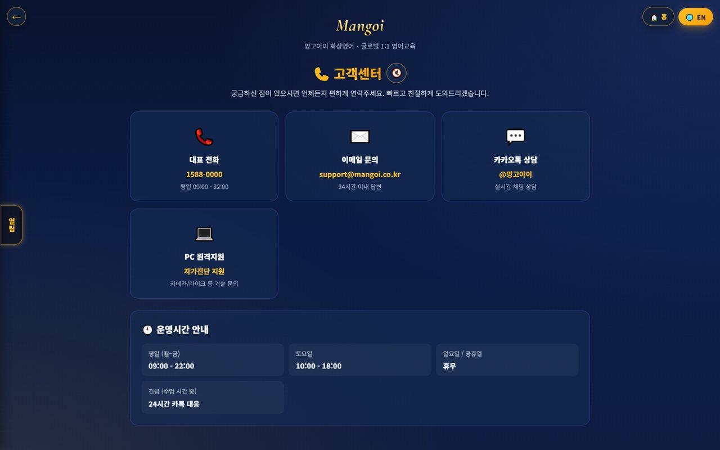
12. 🎧 Support·Inquiries
Get HQ support
📖 If a problem comes up in operations, contact HQ support channels. System/settlement/policy questions get resolved quickly.

How to use
1. Use phone, email, Kakao and remote support in Support.
2. Route settlement/policy questions to the HQ contact.
3. Note the fix for repeat issues.
✅ Key Points
• System issues resolve fast with remote support.
• Inquiries within business hours are faster.
💡 Tip Compile common inquiries and fixes and share them with agencies too.

13. 🕐 Korea·Philippines Dual Clock
Two countries' time on screen
📖 A clock on screen shows 🇰🇷 Korea and 🇵🇭 Philippines time together. It lets you check the time difference instantly when coordinating lessons between Philippine teachers and Korean students.

How to use
1. On the on-screen dual clock, see 🇰🇷 Korea and 🇵🇭 Philippines time at once.
2. Drag the clock to move it anywhere you like.
3. Tap (click) the clock to go to the home screen.
✅ Key Points
• The Philippines is 1 hour behind Korea (−1 hour).
• You can check booking/entry times in both countries' time.
💡 Tip When a lesson time is confusing due to the time difference, this clock clears it up instantly.

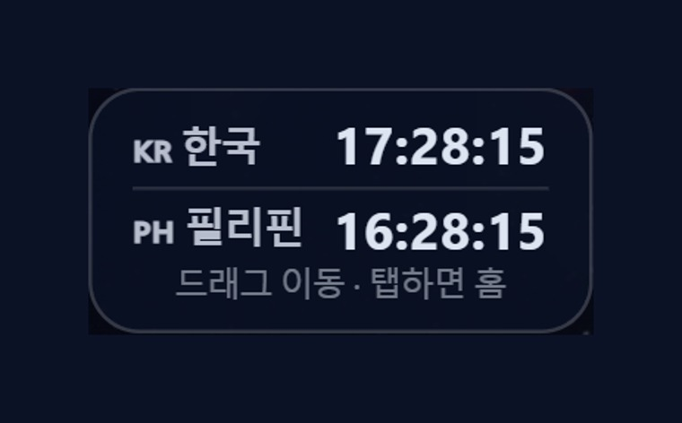
14. 🇨🇳 Chinese Pronunciation Coach
Darakwon Chinese Master Lv1–20
📖 Mangoi offers not only English but also a Chinese course. With a Darakwon Chinese Master (Lv 1–20) pronunciation coach (characters+pinyin, AI voice recognition, native comparison), you can attract and manage students who want Chinese.

How to use
1. In the AI voice coach, pick the CN Chinese level (or go to the Chinese pronunciation coach).
2. Choose a Master series (1–6, HSK 1–6) and a unit.
3. Read the sentence (characters + pinyin) and compare with 'Play native audio'.
4. Practice hard sounds/tones with repeat and slow (0.85x).
✅ Key Points
• Characters and pinyin appear together, so it's easy to read.
• The AI recognizes your voice and compares it to a native speaker.
• The learning games hub supports Chinese too.
💡 Tip Listen slowly and repeat clearly to nail the four tones.

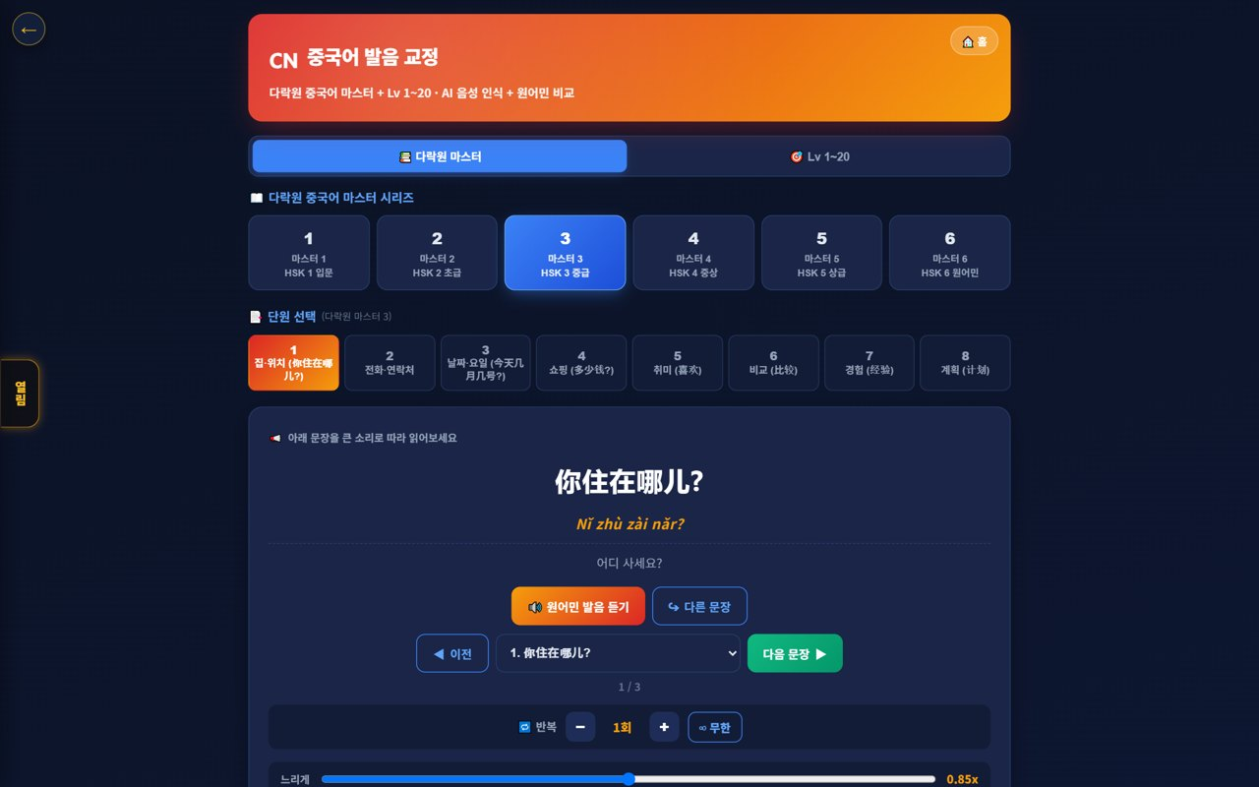
15. 🌟 In-class Praise Points (understand & use)
Linked to motivation·re-enrollment
📖 During class the teacher gives 🌟 praise points (+1P) to students on the spot, and an end-of-class rating (+10P) adds up into the student's total points. Points lead to shop/gift rewards, helping motivation and re-enrollment. Your branch understands and uses this flow for performance.

How to use
1. The teacher gives +1P via the 🌟 praise button on a student's video during class.
2. It accrues live in the student's 🧺 point basket and sums into their total.
3. A post-class star rating gives the student an extra +10P.
4. Points connect to shop/roulette/gift rewards.
✅ Key Points
• Instant rewards boost participation and re-enrollment.
• Use your branch students' points/reward response as a performance signal.
Good to know Teachers give praise points; HQ (admin) configures the shop/reward/gift policy.

💡 Tip Classes (teachers) where praise points flow well tend to have higher re-enrollment.


16. 📢 Notice Studio (Poster + Popup)
Design notice/event posters and push them as app popups
📖 This merges the old ‘Poster Maker’ and ‘Popup Notice’ tools into one place. In the ①Create tab you design a notice/event poster, then hand it straight to the ②Publish·Popup tab to show it as a popup in your branch's student app.

How to use
1. Go to the admin menu Notification Center → 📢 Notice Studio.
2. In the ①Create tab, design a poster with text, images, and video (resize · save on server · reuse).
3. Press ‘📢 Publish as popup’ on the finished poster to auto-switch to the ②Publish·Popup tab.
4. In the publish tab, set the display period / stop and publish it as a student-app popup.
✅ Key Points
• Poster creation and popup publishing flow through one screen, two tabs — no more confusion.
• Posters you make can be saved and reused.
• Whichever route you enter from — AI assistant or sidebar search — the correct tab opens.
Good to know Existing posters/popups are preserved (it was only merged, nothing was deleted).

💡 Tip Promoting an event takes just one flow: ‘Create → Publish as popup’ right away.

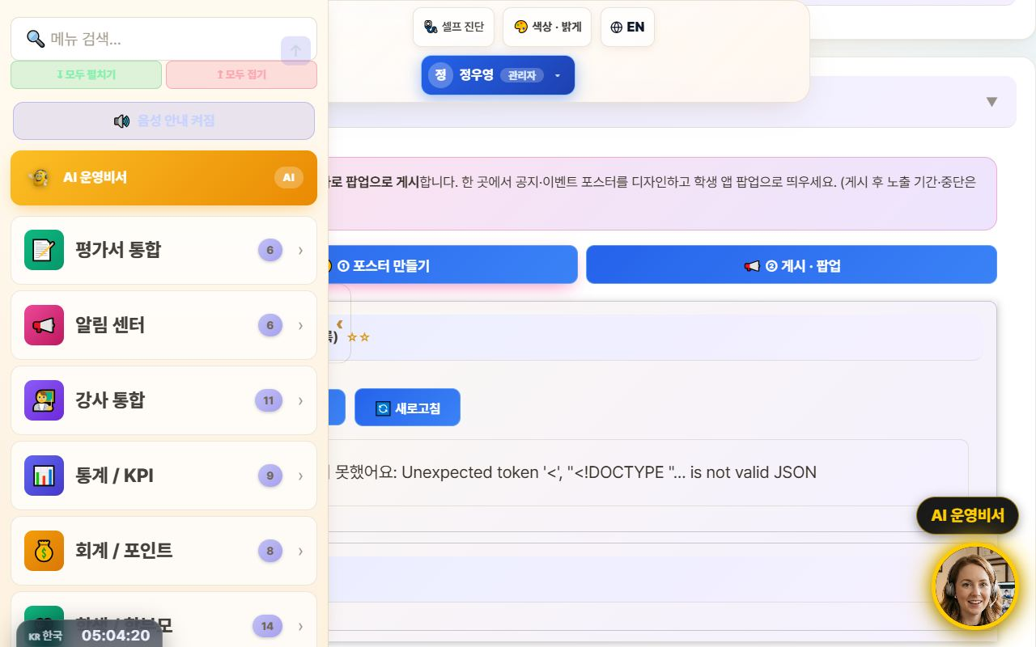
17. 🤖 Command the AI Operations Assistant
Navigate with one phrase: “Take me to ○○”
📖 Type what you want to do into the top search bar (or the bottom-right AI assistant) in plain language, and the AI understands and jumps straight to that screen. It now reliably follows navigation commands like ‘Take me to teacher ○○'s schedule’ or ‘Open auto-scheduling’.

How to use
1. Type a command in the top search bar or speak with the 🎤 mic.
2. e.g. “Take me to teacher Kim Minji's schedule” → auto-finds that teacher in the weekly schedule and opens it.
3. e.g. “Open auto-scheduling,” “Go to settlement” to navigate menus.
4. Press ‘Go now →’ on the AI response card to move to that screen.
✅ Key Points
• Navigation commands actually navigate — far fewer ‘explain only, do nothing’ replies.
• Searching a schedule by teacher name auto-fills the search box + filters + scrolls.
• For data/statistics questions it also helps with card-style answers.
Good to know Commands that actually change things — ‘register · send · modify’ — ask for one more confirmation (a safety guard).

💡 Tip When you can't recall a menu name, just say what you want to do — it finds its way there.

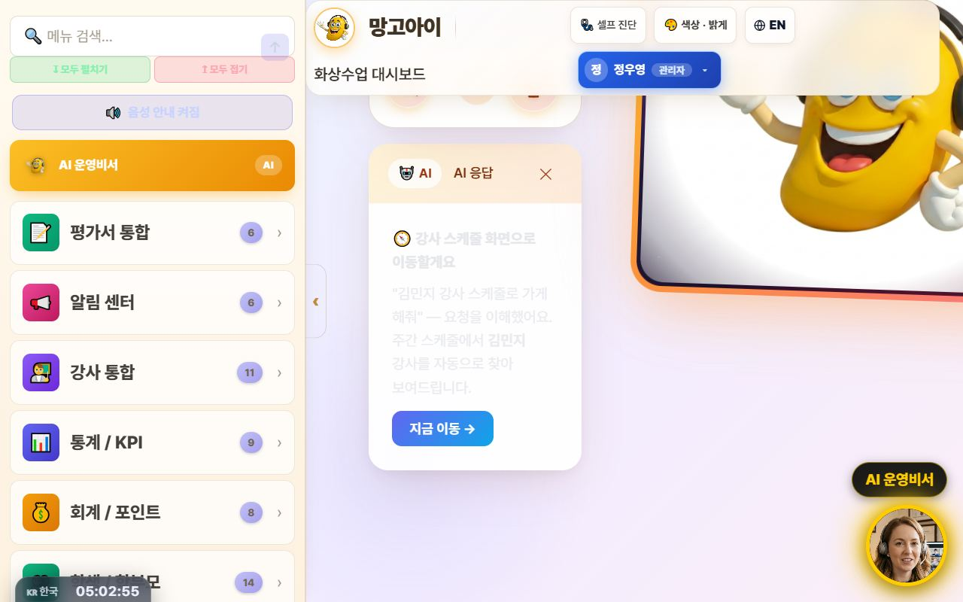
18. 💬 Share Library Links via KakaoTalk
Send videos & docs in original quality
📖 Every guide and video in the library now has a '💬 Copy KakaoTalk link' button. Attaching a file to KakaoTalk crushes the quality, but sending a link plays the original as-is. One tap copies the link — guiding parents and teachers gets much easier.

How to use
1. In the admin Library, press 💬 Copy KakaoTalk link next to the file.
2. Paste it into the KakaoTalk chat room.
3. Recipients tap the link to watch or download in original quality.
✅ Key Points
• For videos, link sharing = original quality; file attachments degrade it.
• Works the same for PDFs, PPTs, and videos anywhere in the library.
Good to know Anyone with the link can open it. For internal-only material, check who you share with.

💡 Tip In a parents' group chat, one video-guide link does all the explaining.

19. 🧭 A refreshed admin screen
Collapsible sidebar · lighter background · line icons
📖 The admin screen is now easier on the eyes and wider. The left menu collapses to a narrow icon rail via the ‹ Collapse button, and the background is now a consistent light tone. Menu icons were redrawn as line icons so labels read clearly.

How to use
1. Press ‹ Collapse at the top of the left menu — it shrinks to an icon rail and the content gets wider.
2. Press the › button in the same place to expand it again.
3. The collapsed state is remembered for your next visit.
4. Too many menus to find one? Type its name into menu search at the top.
✅ Key Points
• Screens full of tables and lists gain a lot of horizontal space.
• 15 sub-pages were moved onto the same light theme, so the colour jump between screens is gone.
• The collapse animation was removed so low-spec PCs don't stutter.
💡 Tip Wide-table screens like settlement and payroll are far easier to read with the menu collapsed.

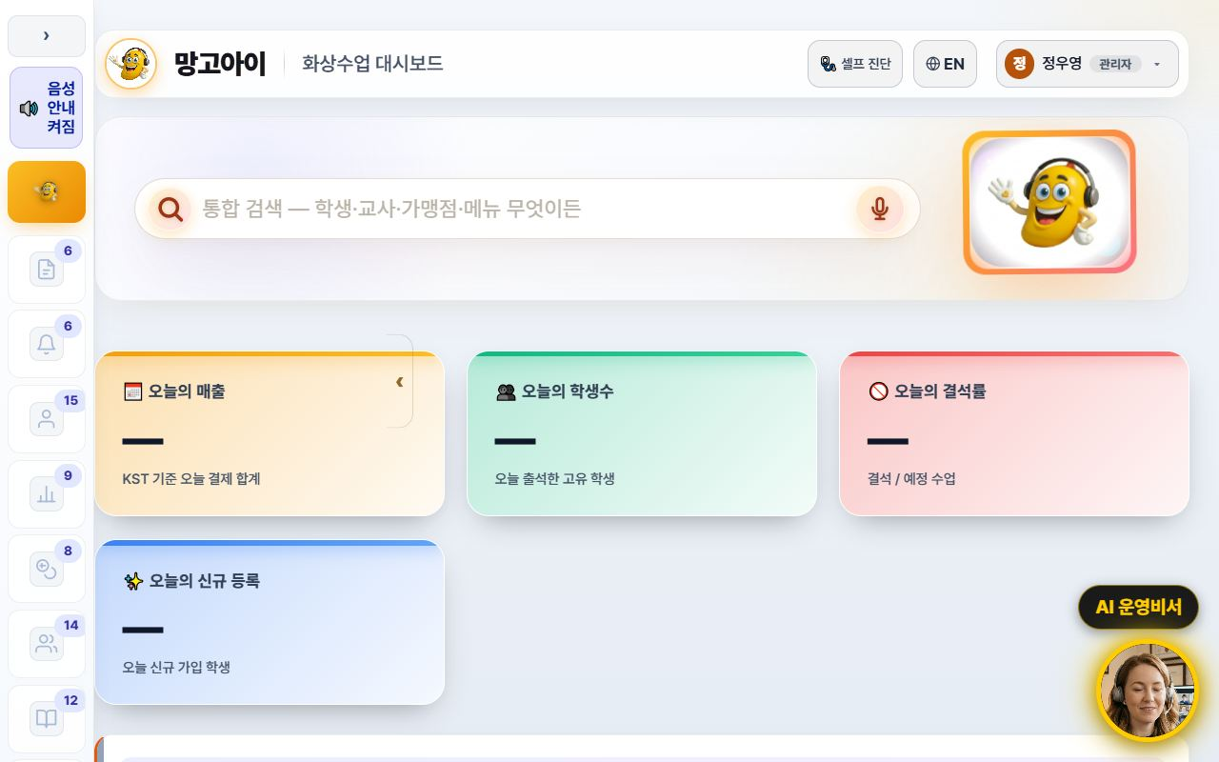
20. 🌐 The interface language sets itself
Overseas staff and teachers start in English
📖 Filipino teachers and overseas staff now start in English from the first screen. The interface language is decided from the account's nationality, and teacher accounts are always English regardless of name or previous choice. You can still switch any time with the 🌐 EN / KR button at the top.

How to use
1. If the account has a nationality on file, the right language appears automatically at login.
2. To change it manually, press the 🌐 EN / KR button at the top.
3. A manual choice is stored per account — several people can share one PC without interference.
4. Teacher guide slides and manuals switch to the English editions with it.
✅ Key Points
• Teacher accounts are always English — no more getting lost in a Korean screen.
• Accounts with an English name no longer flip to Korean because of a Korean job title.
• Language choice is isolated per account, so an overseas account isn't overwritten by someone else's pick.
Good to know Accounts with no nationality fall back to the old name/ID heuristic. Please fill in nationality when registering teachers.

💡 Tip Enter nationality when registering a new teacher and their very first login is in English — fewer support requests.

21. 💳 Enrolment & payment → automatic lesson creation
Once payment is confirmed, every session is scheduled
📖 On the Enrolment screen a student picks teacher, days and time and pays — and all lesson sessions are created automatically the moment payment is confirmed. The old manual timetable entry after payment is gone. If the slot clashes with an existing lesson, the conflict is detected before payment.

How to use
1. Send students and parents the enrolment link.
2. They choose teacher → lesson options (weekly count, term, length) → days & time.
3. The slot check must pass before the pay button unlocks (payment is blocked on a clash).
4. On confirmed payment, all sessions are created at once — verify in the admin lesson list.
5. Head-office prices and discount rates are managed on the pricing screen.
✅ Key Points
• Idempotent — a duplicated payment callback will not create the sessions twice.
• Clashes with holidays or existing lessons are pushed back so the session count is still met.
• Term discounts (6 months −5%, 12 months −10%) are applied to the amount automatically.
Good to know Stage 1 (enrol → pay → auto-create sessions) is live today. Later stages will follow.

💡 Tip Consultation → level test → send the enrolment link is the smoothest conversion path.

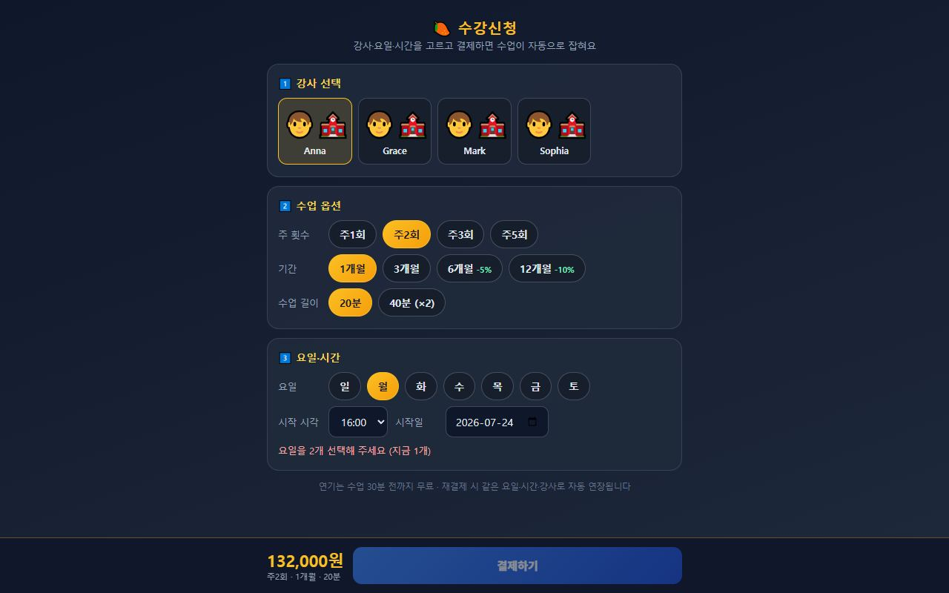
22. 🗂️ Teacher Management, redesigned (roster filters · groups · detail tabs)
Easy-to-search roster · detail at a glance
📖 The teacher-management screen is now easier to search and read. Scattered menus are grouped into four bundles in the sidebar, and above the roster there are status/group dropdown filters with applied-filter chips. Tapping a teacher opens a detail view split into Profile / Payroll / Evaluation tabs, with a manager badge and employment status (active / on-leave / left) shown at a glance.

How to use
1. Open Teachers in the admin menu (menus are tidied into four bundles).
2. Filter to just the teachers you want with the status/group dropdowns above the roster.
3. Applied filters show as chips; remove a chip to clear it.
4. Tap a teacher to open the Profile / Payroll / Evaluation detail tabs.
5. The summary numbers on the payroll/evaluation tabs load only as needed when opened.
✅ Key Points
• Managers are marked with a badge, and status shows as active / on-leave / left (3 states).
• A blank name falls back to the ID, so there are no empty cells.
• Detail tabs reuse existing APIs for speed, and the screen is bilingual (KO/EN).
• The duplicate payroll entry was tidied and bug reports moved to a separate system.
Good to know This is a filtering/detail cleanup. Registering, editing and deleting teachers works exactly as before.

💡 Tip The more teachers you have, the more the status/group filters help. Keep your usual conditions filtered.

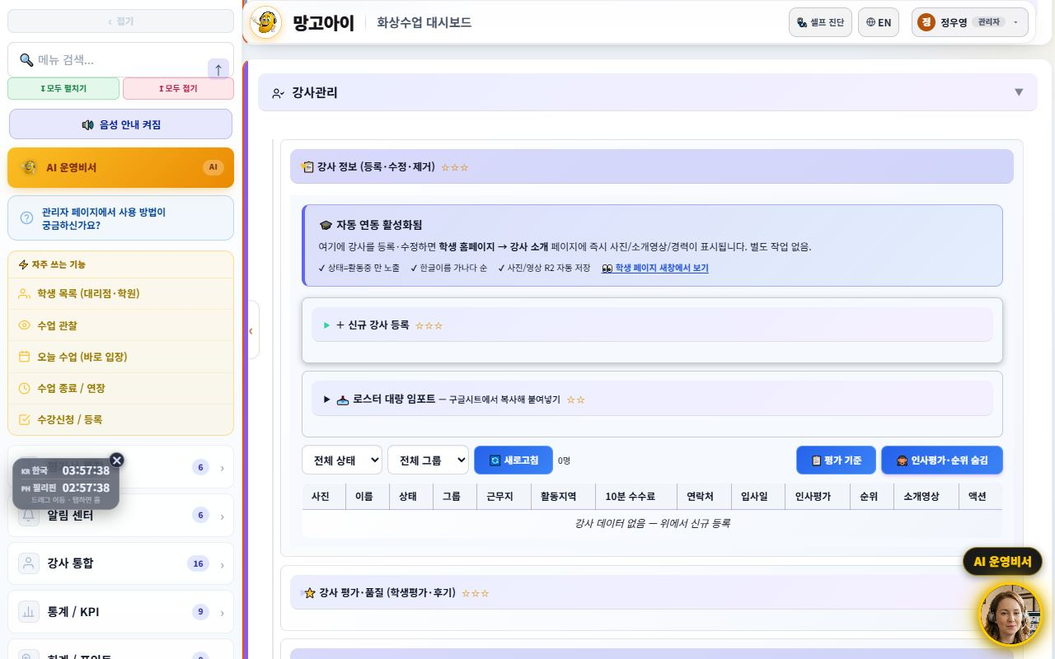
23. 🌟 Sending the Parent Monthly Report (pentagon)
Preview the 5-axis report, then share the link
📖 The monthly report sent to parents is renewed as a pentagon 5-axis graph — Pronunciation & Fluency / Vocabulary / Sentence Building / Class Attitude / Participation — at a glance, with attendance, judgment and a teacher's note. Admins and teachers enter a student ID and month to preview, then send the KakaoTalk link.

How to use
1. Open the Monthly Report screen.
2. Enter a student ID and month, press View Report to preview.
3. Check the pentagon and teacher's note; top up evaluations if needed.
4. Append ?uid=ID&period=YYYY-MM to the URL and send the KakaoTalk link.
✅ Key Points
• Only axes with real records are filled, so it's trustworthy.
• Compiled on a two-month cycle — conveys change without tiring parents.
• The Print/PDF button makes a paper report for consultations instantly.
Good to know Report access passes an approval gate — admins via their login session, parents only via the issued link (token).

💡 Tip Sending the report link ahead of a booked consultation makes the meeting much smoother.

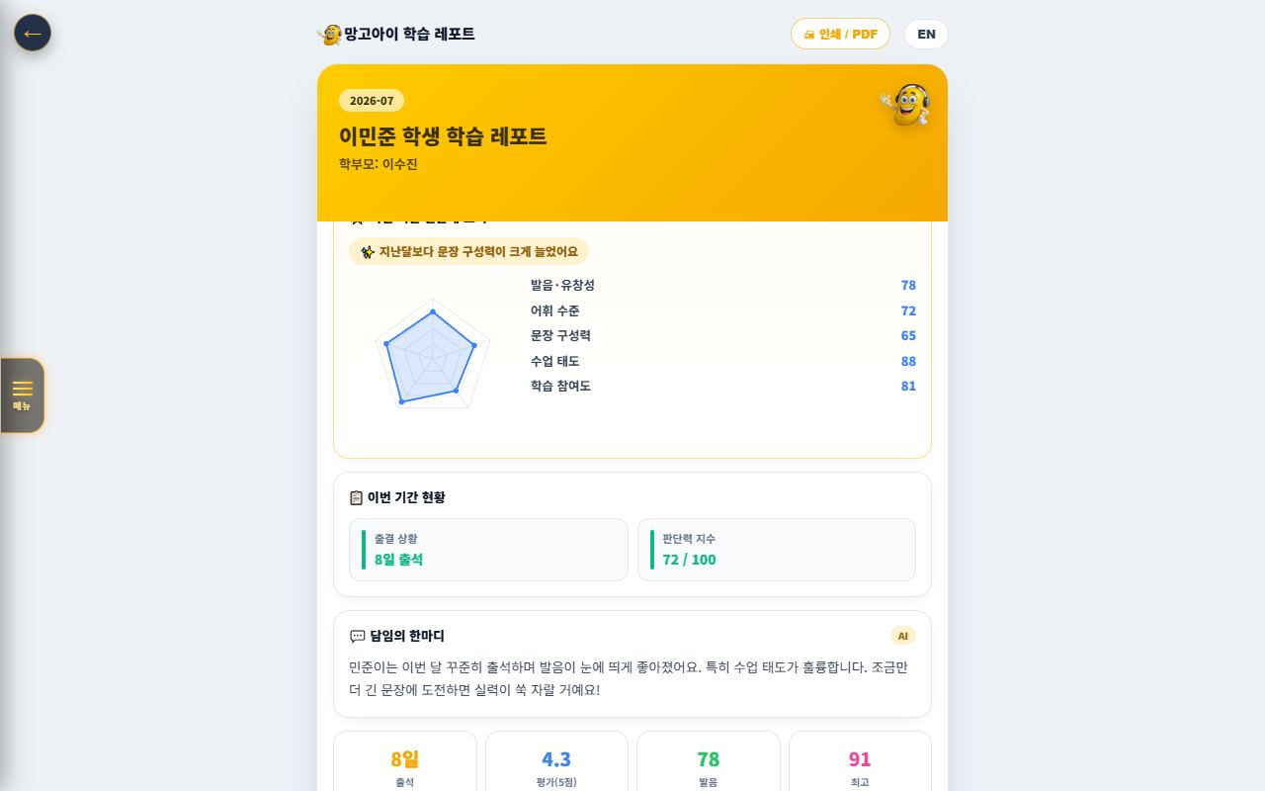
24. 📅 Parent Weekly Report (the re-enrolment lever)
Deliver the proof of growth competitors cannot show
📖 A report sent to parents containing the child's week of activity (attendance, AI friend chats, judgment training, words conquered, pronunciation). The purpose is explicit — deliver the proof of growth competitors cannot show, every week, and convert it into re-enrolment. The admin screen covers preview → test send → recipient count → send log.

How to use
1. Open 📅 Parent Weekly Report in the admin menu.
2. Enter a student ID and press Preview to check the content.
3. If needed, use Send to this parent to test with a single recipient.
4. Use Count recipients to see how many students can receive it (those with a registered phone number).
5. Check Recent send log for what actually went out.
✅ Key Points
• What the report contains: 📅 attendance days · 🔥 streak · 🤖 AI chats · 📚 words conquered · 🧠 judgment · 🎤 pronunciation.
• Only students with a registered phone number can receive it — the count screen also reports how many are missing one.
• A Friday-evening automatic send (cron) is prepared and ready.
Good to know 🔴 The full automatic send is OFF by default. Real messages only go out after an admin turns on the KV switch — a safeguard against accidentally messaging 29,000 people. Turn it on only after the alert-talk template is approved and management has decided.

💡 Tip Start with preview → a single test send only. Once the wording is settled, then turn on the full switch.

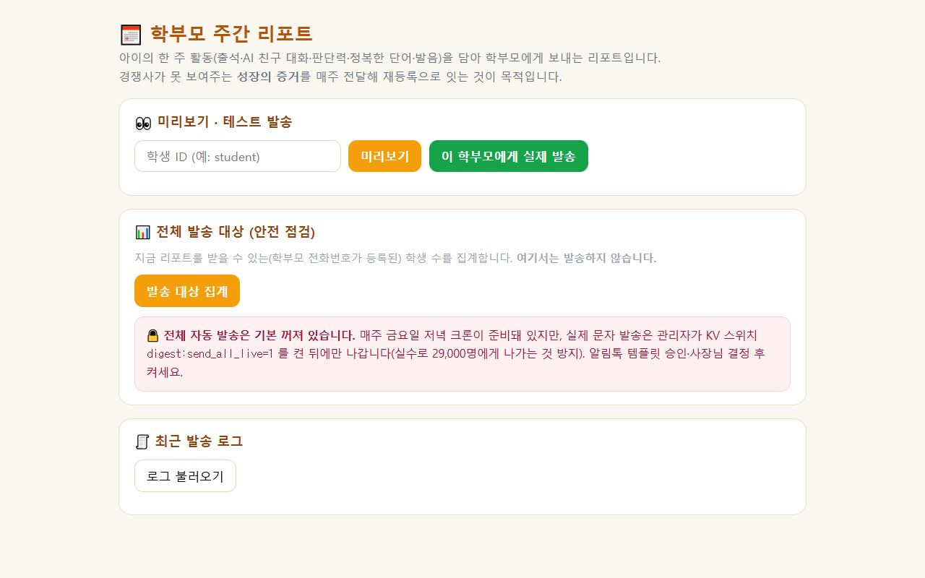
25. 🏠 Home Screen Split (first-time parent vs. existing member)
Fewer 'how do I start?' calls, more trial sign-ups
📖 The first screen of the site (the hero) now shows one of two versions depending on who is looking. A first-time parent sees <b>Book a Free Trial</b> as the biggest button; a logged-in member sees <b>Enter Class</b>. We checked four competitors directly (Cambly Kids, Min Byung-chul UPhone, Engoo, Ringle) and all four lead with a new-customer call to action — this change follows that evidence.

How to use
1. Open the home URL in a private/incognito window to see the guest screen.
2. Confirm the two large buttons: Book a Free Trial · Browse Teachers.
3. Log in and open the same page — it becomes Enter Class · Chat with AI.
4. Use the plain home URL in flyers and text messages — no separate landing page is needed.
✅ Key Points
• No new page was created. The same URL decides for itself based on login state.
• The guest screen still keeps a small 'Enter Class' link — this prevents an existing student who changed devices or was logged out from being locked out of class.
• If the check fails for any reason, it always falls back to the guest screen — the page is never blank.
• No flicker. The decision is made before the page paints.
Good to know Never remove the small 'Enter Class' link on the guest screen. Existing members also land there when their login expires (30 days) or they switch devices.

💡 Tip To see what a parent sees, open the home page in an incognito window — that is the exact first impression.

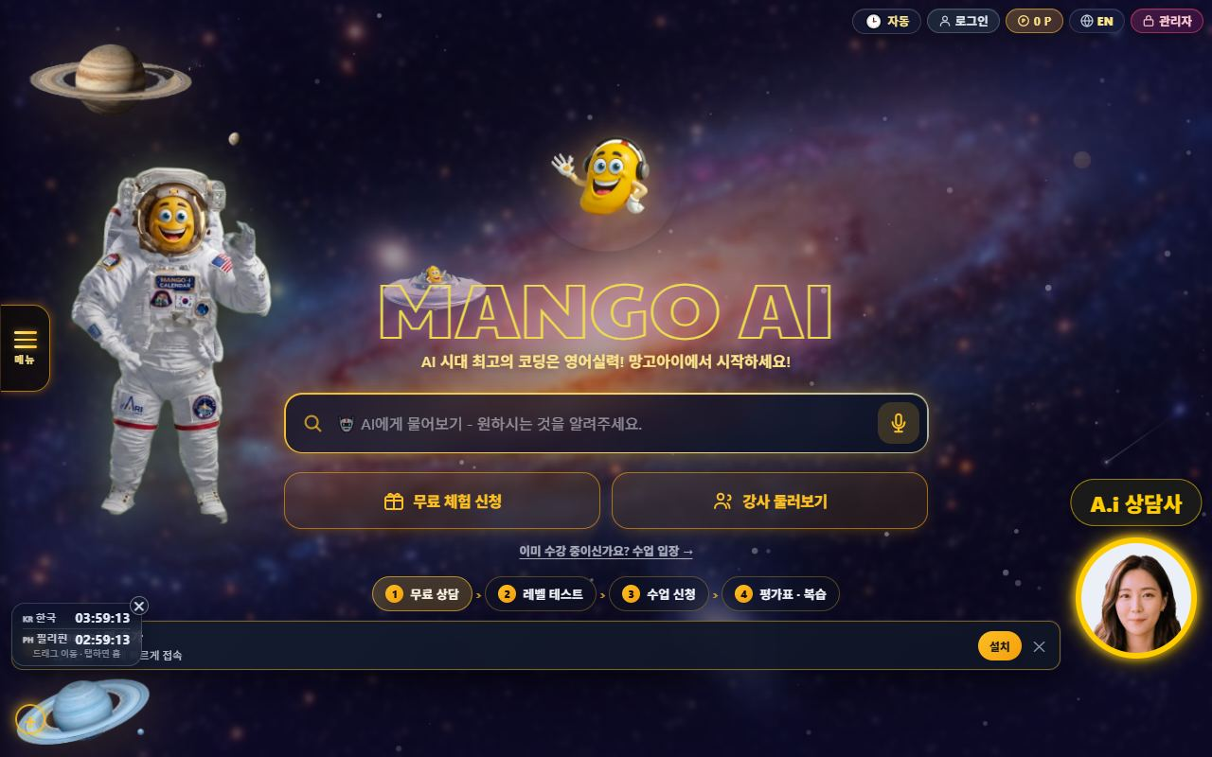
26. ⚡ The Admin Screen Is Much Faster Now
The freeze after clicking is gone
📖 We removed the brief freeze that happened whenever you clicked something in the admin screen. The cause was not the feature you clicked — a readability-enhancement routine was recalculating every collapsed card each time. It now skips collapsed cards and never re-touches what it has already processed.

How to use
1. Use the admin screen as usual.
2. Check that menus and cards open immediately, with no freeze.
3. If it still feels slow, do a hard refresh (Ctrl+F5) in the browser.
✅ Key Points
• Freeze on click dropped 396ms → 57ms; idle load dropped 366ms → 0ms.
• Nothing about the look or colours changed — only the speed.
• The difference is largest on card-heavy screens (teacher and student lists).
Good to know If your browser still holds an old copy of the page you may not feel the improvement. Do one hard refresh (Ctrl+F5).

💡 Tip If it is still slow, check whether too many browser tabs are open.

27. 🔎 Academy Search Box (find it by name)
No more scrolling the whole list
📖 The academy (branch/agency) list now has a search box so you can find one by typing its name. No more scrolling up and down a long list.

How to use
1. Open the academy list screen in the admin menu.
2. Type part of an academy name into the search box above the list.
3. The list filters to matching academies as you type.
4. Clear the box to return to the full list.
✅ Key Points
• A partial name is enough to find it.
• The existing list and its features are unchanged — only the way you find things was added.
💡 Tip For academies you check often, remember two or three letters of the name — that is enough to filter instantly.

28. 💳 New-Payment Screen, Now Step-by-Step
It no longer shows 12 products at once
📖 The new-payment screen now starts with 'who is this for?'. Previously all 12 products appeared at once and parents had no idea where to start. Now they pick from Kids · 1:1 · Group · Business · Test Prep · Corporate and only the matching products remain.

How to use
1. Point the parent to the New Payment screen.
2. Have them pick the audience first (Kids, 1:1, Group, Business, Test Prep, Corporate).
3. Only the products for that audience stay on screen.
4. If they want to compare everything, press See Full Price List.
✅ Key Points
• No product card or payment logic was changed — only what is displayed, so it is safe.
• Verified counts: 3 initially (free trial, other, policy) → 4 when Kids is selected → 12 in full view.
• See Full Price List was deliberately kept — hiding prices backfires.
💡 Tip When a caller says 'I don't know which one to pick', just have them choose the audience first.

29. 📋 Sample Report Card for Parents Without an Account
Something to show in front of the login wall
📖 Until now there was nothing to show a prospective parent who had no account. The report-card screen now offers 'No account — view a sample report first', so you can show what the 5-axis scores + teacher comment + AI analysis look like without logging in.

How to use
1. During a consultation, open the report-card screen for the parent.
2. Press No account — view a sample report first.
3. Walk through the 5-axis scores, teacher comment and AI analysis together.
4. Close with 'this is what you'll receive for your child' and offer the trial.
✅ Key Points
• ⚠️ All values are examples. The title and top banner are marked 'Sample'.
• Never remove that marking — if it is mistaken for a real record it becomes a trust problem.
Good to know The sample uses no real student data. Use it for consultations only.

💡 Tip Showing the sample report in the first three minutes of a consultation makes 'what do I actually get?' concrete and lifts trial conversion.

30. 📞 Unified Support Hours & Channel Order (KakaoTalk first)
One value across every screen
📖 Support hours previously appeared as 09-22 / 10-20 / 7 p.m. on different screens. They are now unified to 10:00–23:00 (closed weekends and public holidays). The KakaoTalk channel was also moved to first place, and the phone card now notes that KakaoTalk is faster.

How to use
1. On the Contact screen, confirm the card order is KakaoTalk → phone.
2. When advising parents, point them to the KakaoTalk channel first.
3. Quote support hours as 10:00–23:00 (closed weekends and holidays).
✅ Key Points
• Places corrected: contact screen, home menu, FAQ (both languages), AI consultant fact block, student FAQ — all the same value now.
• The unused fax number and placeholder phone numbers were deleted.
• The AI consultant quotes the same hours and the same channel order.
Good to know If real operating hours change, all of these must be updated together. Changing only one brings the inconsistency straight back.

💡 Tip If you need the Philippines call-centre numbers listed, provide the real ones — the previous placeholders were removed.

📋 Branch Features at a Glance
Feature | What it does | Scope | Core benefit
Branch dashboard | Revenue·enrollment·attendance | My branch | Quick read
Agency mgmt | List·performance·recruiting | Sub-agencies | Level up
Branch settlement | Receive·distribute auto-calc | HQ↔branch↔agency | Accurate settlement
Students·parents | Enrollment·attendance·grades | Branch scope | Churn prevention
Accounting | Payments·overdue·refunds | Branch scope | Healthy collection
Retention | Churn risk·contagion | Branch·agency | Retention ↑
Monthly report | Performance analysis | Branch·agency | Transparent ops
📊 Data at a Glance
Your Branch Metrics (example)
Revenue (M KRW) | █ 64
Enrolled | ██████████████████ 980
Sub-agencies | █ 12
Enrollment by Agency (example)
Gangnam | ██████████████████ 210
Bundang | ███████████████ 180
Ilsan | █████████████ 150
Suwon | ██████████ 120
Incheon | ████████ 90
Settlement Split (example)
HQ fee | ███████ 20
Branch share | ███████████ 30
Agency distribution | ██████████████████ 50

❓ Frequently Asked Questions (FAQ)
Q. Where do I log in?
A. Log in at admin.mangoi.co.kr. By role (branch), only your branch's data shows automatically.
Q. Can I see other branches' data?
A. No. By permission scope, only your branch and sub-agency data is visible.
Q. How is settlement calculated?
A. Revenue/commissions are auto-calculated down the org tree (HQ→branch→agency). Check the monthly report.
Q. An agency is underperforming.
A. Find causes via retention/accounting/reports and support with onboarding/coaching/incentives; sharing best cases helps.
Q. A system problem occurred.
A. Contact HQ support (phone·email·Kakao·remote) for a quick fix.
✅ Branch Operations Checklist
☐ Did you check today's branch revenue/enrollment/attendance?
☐ Did you spot and support underperforming agencies?
☐ Did you review this month's settlement (receive·distribute)?
☐ Did you check overdue/refund items?
☐ Did you care for at-risk students/agencies?
☐ Did you onboard new agencies?
☐ Did you share the monthly report?

🏁 Conclusion · A Practical Guide to Branch Growth
A branch is the bridge between HQ and agencies. Watch your branch metrics, support your agencies to grow, and process settlement transparently — and the whole branch grows together. Keep this rhythm and operations get far more stable.
🔄 The Flow at a Glance
Morning (5 min) | Check revenue/enrollment/attendance on the branch dashboard; read the AI insight
Late morning | Review performance/collection by agency; check overdue/refunds
Afternoon | Support/coach underperforming agencies; care for at-risk students (retention)
Weekly | Onboard new agencies; share best practices
Monthly | Check/distribute HQ→branch→agency settlement; share the monthly report
⭐ Key Principles
1. Metrics, 5 minutes each morning — catch branch/agency signals early.
2. Agencies as partners — close performance gaps with coaching/support.
3. Transparent settlement — announcing terms upfront builds trust.
4. Intervene on churn early — care for at-risk agencies/students first.
5. Spread best practices — share top agencies' methods branch-wide.
📌 Remember
• Log in at admin.mangoi.co.kr; data is auto-limited to your branch scope
• Settlement is auto-calculated by the HQ→branch→agency tree
• Most field inquiries like 'can't enter' are browser/permission issues
• Ops rhythm: 'Check → Support → Settle → Report'!
🍊 A good branch is one that helps its agencies thrive. Read the situation with metrics, support your partners, and keep settlement transparent — and branch and agencies grow together. Questions? Contact HQ support anytime — cheering on your solid branch operations! 🍊

