🎓 Mangoi · MANGOI
Teacher Training Manual
Getting kids to speak — from principle to practice

For · Mangoi video-English teachers · new-teacher onboarding
🌐 www.mangoi.co.kr 📞 1644-0561 ✉ support@mangoi.co.kr

📘 What is this manual for?
The Mangoi Teacher Training Manual is about getting children to speak. It is not a guide to the website — it is a guide to the skills that make a lesson work. Nothing here is theory; every item is something that repeatedly worked in real video lessons.
There is one central idea — the more a child speaks, the faster they improve. Every technique in this manual exists to serve that one thing.
🔥 Energy — The first 60 seconds set the temperature of the whole lesson.
🗣 Talk time — Aim for 70% student, 30% teacher.
⭐ Visible progress — They keep going when they can see it.
🎯 Personalisation — Remember one thing about this child.
🎵 Rhythm — Never run one activity past 7 minutes.
📝 Records — One line in the evaluation becomes parent trust.

🧭 Skills That Make a Lesson Work
01. 🔥 Energy — the first 60 seconds set the whole lesson
Your energy becomes their energy
📖 Children read the mood before the content. If you are bright and quick to react in the first minute, the lesson stays alive to the end; if that first minute is quiet, you will spend the remaining 25 minutes pulling it uphill. Energy is not a personality trait — it is a skill you switch on deliberately.

How to do it
1. The moment the camera is on, greet them by name — “Hi, Minjun! I missed you!”
2. Make your expressions 20% bigger than normal. A screen eats about half of them.
3. Make the first question impossible to fail — “Did you eat lunch?”
4. React instantly to anything they say — “Wow, really?”
5. Vary your pitch. A flat tone is even duller through a screen.
✅ Key Points
• If the child laughs even once in the first 60 seconds, the lesson is already half won.
• Energy is speed of reaction, not volume. React fast.
• If you look tired, children often assume it is their fault.
⚠️ Good to know Big reactions and forced cheerfulness are not the same thing. With teenagers, too much energy creates distance — the older the student, the more you want calm but fast reactions.

💡 Pro tip Stand up for 30 seconds before class, breathe deeply and loosen your face. Energy is something you warm up for.

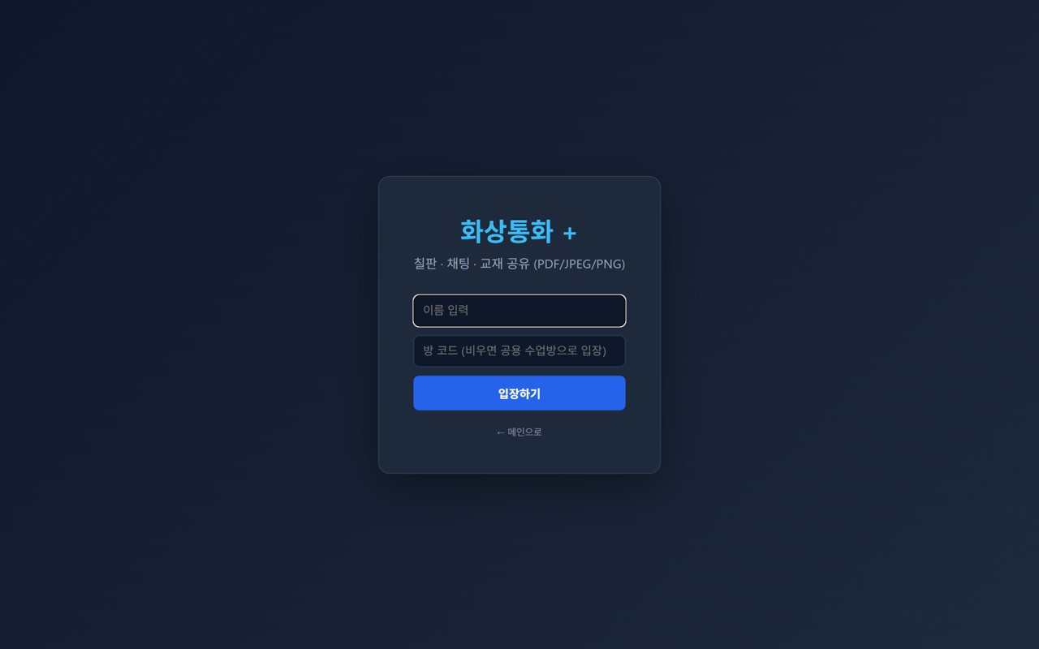
02. 🗣 Talk time — the more you talk, the less they learn
Aim for 70% student · 30% teacher
📖 English grows from how much they say, not how much they hear. Yet in most video lessons the teacher does 70% of the talking. Deliberately saying less and waiting is the single most important skill in this manual.

How to do it
1. After asking, count to five in your head. Do not break the silence first.
2. If they answer with one word, echo it back as a sentence — “Pizza? You like pizza?”
3. Turn statements into questions — instead of “This is a cat”, ask “What is this?”
4. When they make a mistake, do not correct immediately — recast it naturally.
5. Ask yourself mid-lesson: “How long have I been talking?”
✅ Key Points
• Five seconds of silence is what produces their first sentence. Do not give up at three.
• One minute of your explanation is one minute taken from their speaking.
• For quiet students, go closed questions (Yes/No) → open questions, in that order.
⚠️ Good to know Do not push so hard that waiting feels like pressure. Silence should read as patience, not demand.

💡 Pro tip Watch one recording of your own lesson. Seeing how much you talk changes your very next class.

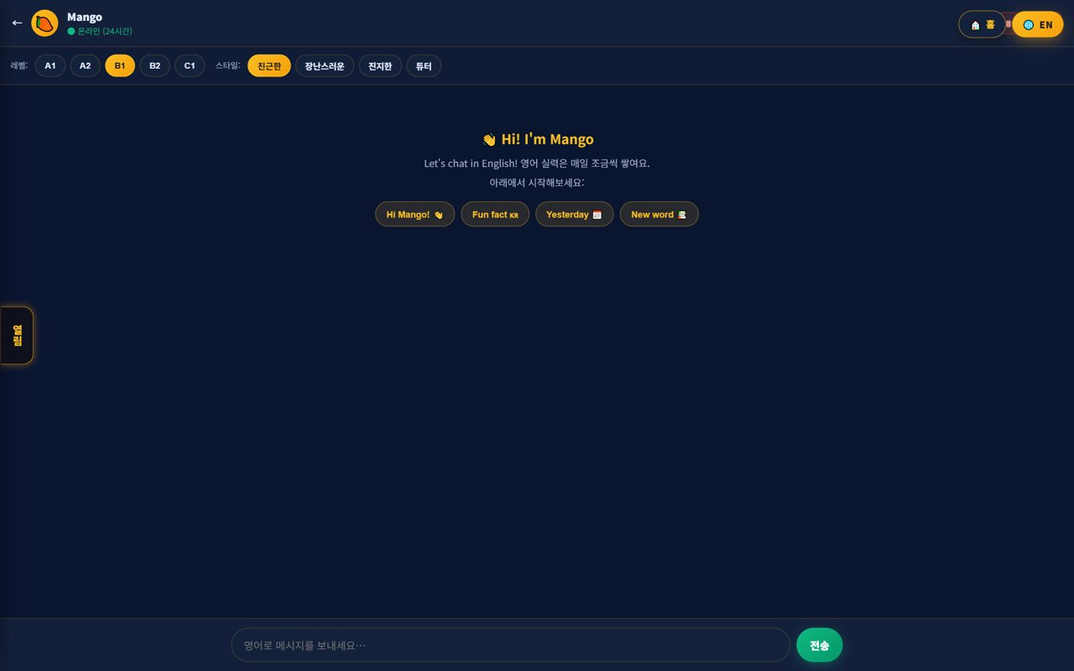
03. ⭐ Make progress visible — praise they can see
Praise that stays, not praise that vanishes
📖 Children keep going when they can see evidence that they are improving. “Good job” disappears in three seconds; stars, points and badges stay on the screen. The praise basket and points in Mangoi exist for exactly this.

How to do it
1. Drop praise into the praise basket (🧺) the moment they do something well.
2. Be specific — not “Good”, but “Your ‘th’ sound was perfect!”
3. At the end of the lesson, look at the points they earned together.
4. Always name one thing that improved since last lesson.
5. Remember: what you write in the evaluation becomes the parent's report.
✅ Key Points
• Praise the attempt, not just the result — praising “you said it even though it was wrong” is what makes them try again.
• Points and badges are what keep them going between lessons.
• Aim for at least three specific compliments per lesson.
⚠️ Good to know Praise loses value if you scatter it. Children notice a reflexive “Good job” every time.

💡 Pro tip Prepare five specific praise sentences in advance. They save you when nothing specific comes to mind in the moment.


04. 🎯 Personalisation — remember one thing about this child
Name, interest, last lesson
📖 The moment a child feels “this teacher knows me”, their attitude changes. It does not take much — remembering one thing they said last week is enough.

How to do it
1. Skim the last evaluation for 30 seconds before class.
2. Note one interest (football, K-pop, games).
3. Bring it up in your greeting — “Did your team win last week?”
4. Rebuild your examples and games around that interest.
5. Write down what to ask next time in the evaluation notes.
✅ Key Points
• Personalisation is record-keeping, not memory. Write it down.
• Putting their interests into example sentences makes the same grammar far stickier.
• Simply using their name often raises attention.
💡 Pro tip Ask “What do you love?” in the first week. That one answer becomes six months of lesson material.

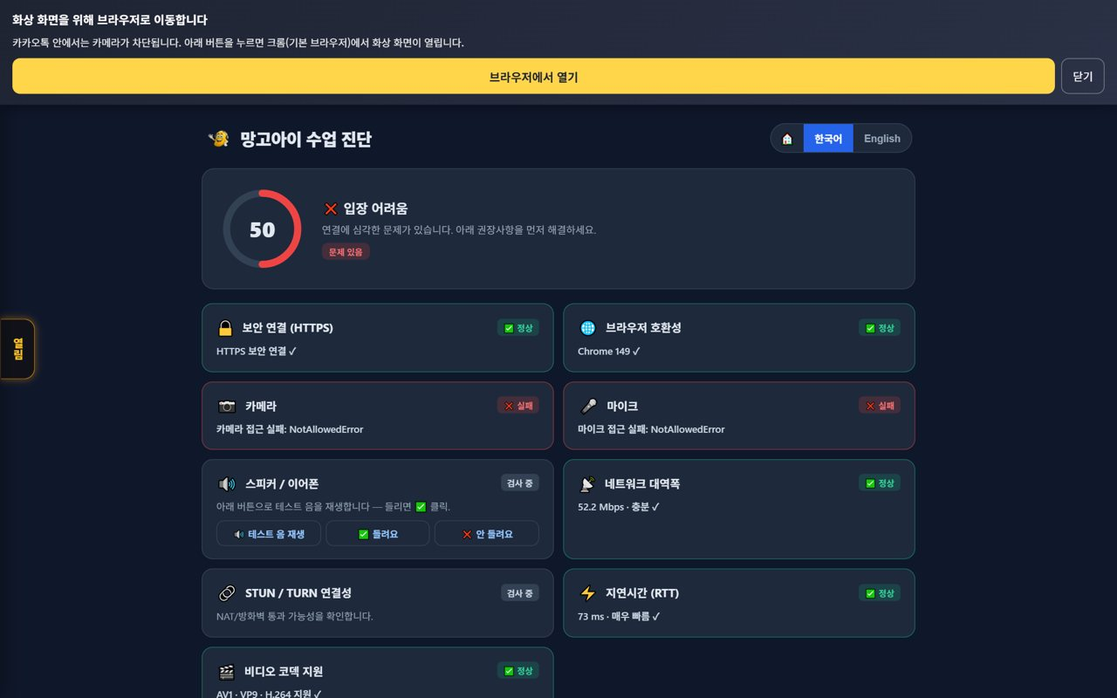
05. 🎵 Rhythm — cut 25 minutes into four pieces
Never run one activity past 7 minutes
📖 A child's attention on a single activity lasts 5–7 minutes. Run 25 minutes as one continuous block and the last 10 are effectively wasted. Simply switching activity brings attention back.

How to do it
1. Warm-up, 3 min — AI warm-up or light questions to get their mouth moving.
2. Core, 7 min — today's target expression or textbook.
3. Speaking, 7 min — real conversation using what they just learned.
4. Game & reward, 5 min — review through a learning game, earn points.
5. Close, 3 min — praise plus a preview of next time.
✅ Key Points
• Attention resets every time the activity changes.
• If they look bored, change the activity — do not add explanation.
• That final 3-minute preview measurably improves next-lesson attendance.
⚠️ Good to know Rhythm is a tool, not a rule. If a child is deeply engaged, do not interrupt it.

💡 Pro tip Keep the on-screen timer running. The child starts to anticipate “game time is coming”, which itself helps.

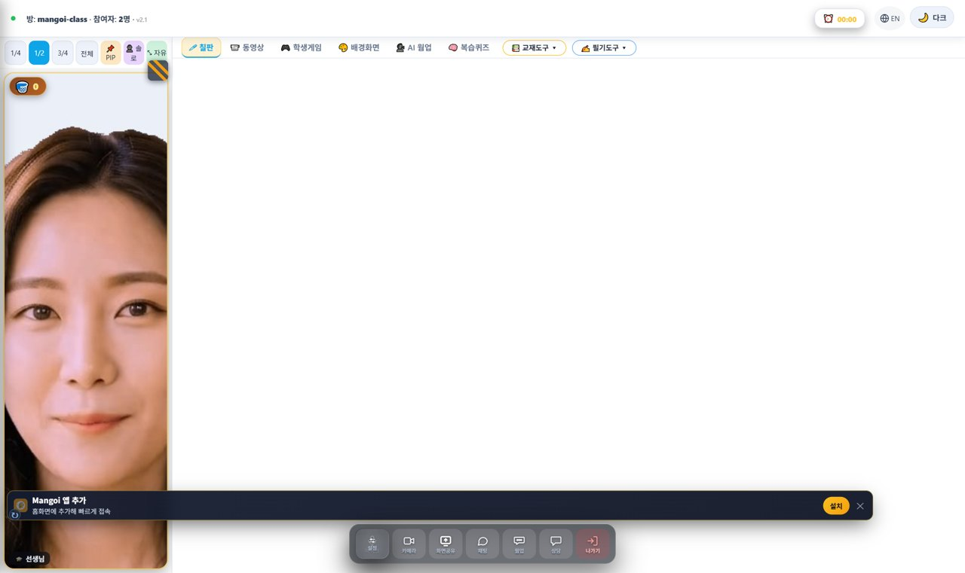
06. 🌡 Warm-up — loosen the mouth before you expect words
3 minutes that change 25
📖 Go straight into the material from cold and the child will spend the first 10 minutes in silence. The AI warm-up is the stretching that gets sound out of them with no pressure.

How to do it
1. Open the AI Warm-up tab in the classroom.
2. Choose the speed and level that fits the child.
3. Model it yourself first.
4. Have them say it aloud, and praise even a quiet attempt.
5. Carry the warm-up phrases straight into the main lesson.
✅ Key Points
• The goal of a warm-up is making sound, not being accurate.
• Going first yourself removes most of their hesitation.
• Reusing warm-up phrases later doubles the sense of achievement.
💡 Pro tip For very quiet students, stretch the warm-up to five minutes. Once the mouth is moving everything else gets easier.

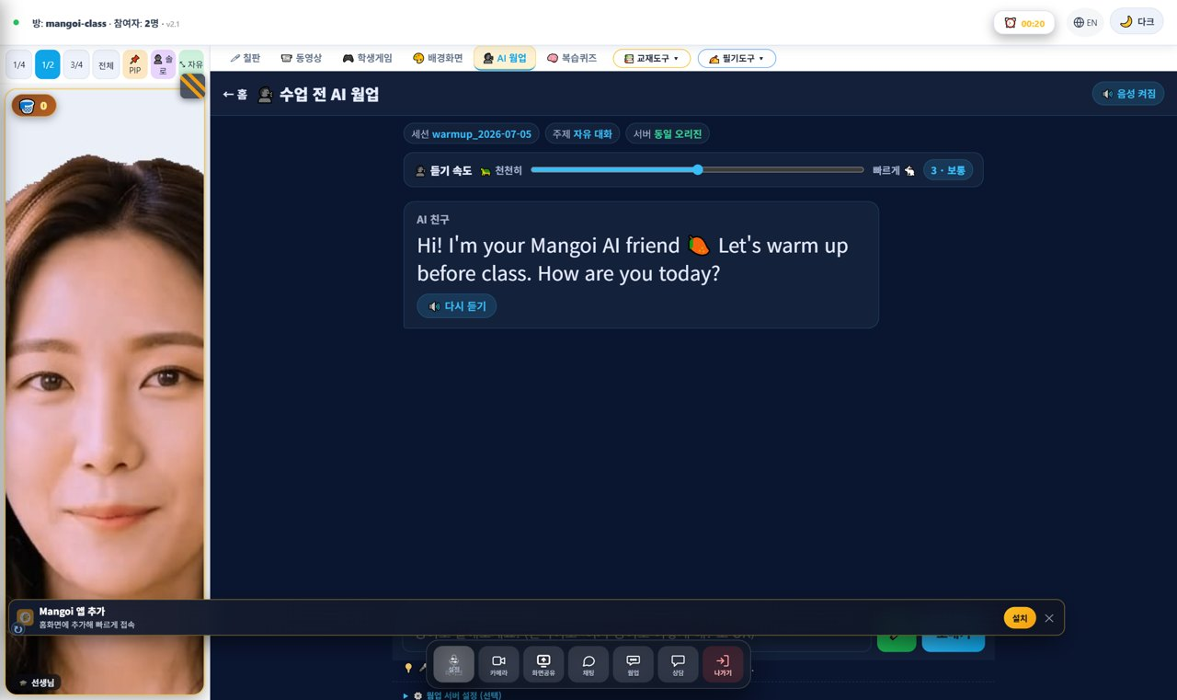
07. 🎮 Games — turning review into play
Not a reward — the review itself
📖 A game is not a prize after the lesson; it is the review. Inside a game a child will meet the same word five times without getting bored. Used with a stated purpose, it is the strongest learning tool you have.

How to do it
1. Pick a game that contains today's expressions.
2. State the goal first — “Let's get 10 points with today's words!”
3. While they play, note the words they get wrong.
4. After the game, revisit only the wrong ones.
5. Tie the result back to the praise basket and points.
✅ Key Points
• A game with no stated purpose is just playtime. Say the goal first.
• The wrong answers are the real harvest — they are next lesson's material.
• Rotating game types keeps the novelty alive.
⚠️ Good to know On slower devices or weak connections games can stutter. Switch to a lighter quiz-style activity when that happens.

💡 Pro tip Cheer out loud while they play. A game played alone and a game played together are completely different experiences.

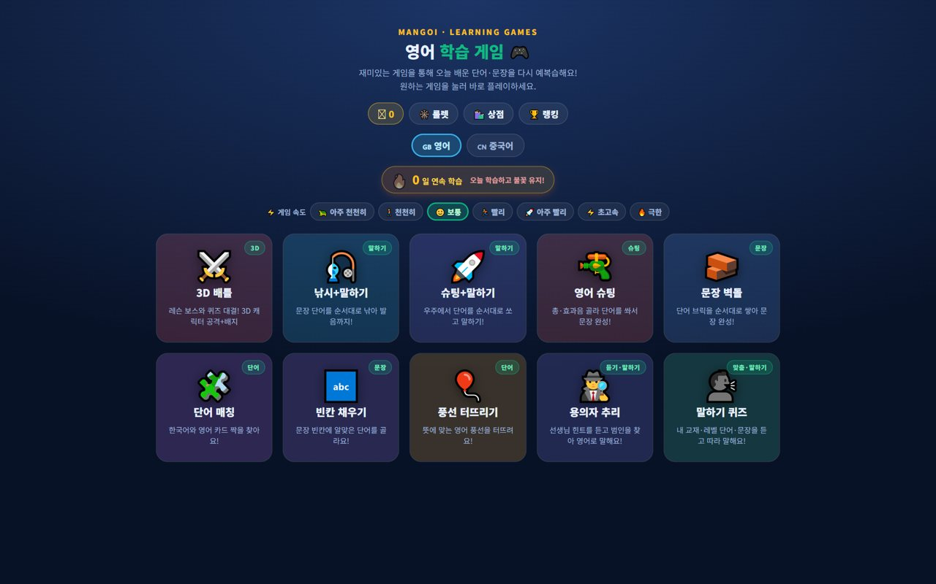
08. 🚪 The room that only opens when they speak
A game where clicking does nothing
📖 Escape by Voice is a game that only advances when the child says something in English out loud. There are no buttons, so “I don't want to speak” simply does not work. Treat it as a specialist tool for reluctant speakers.

How to do it
1. Open 🚪 Escape for a student who rarely speaks.
2. Demonstrate one room yourself first.
3. Have them press the mic and speak — accept a quiet attempt.
4. If they are stuck, let them use the Hint button — there is no penalty.
5. At the end, look at how many times they spoke and praise it.
✅ Key Points
• The experience of “speaking really does open the door” changes their attitude.
• Even a failed escape shows how far they got, so there is little discouragement.
• The spoken-attempt count is good evidence for the evaluation.
⚠️ Good to know Microphone permission is required. If nothing registers, check the browser's mic permission first.

💡 Pro tip Do just one room in the first session. A single success changes how much they speak in every lesson after.

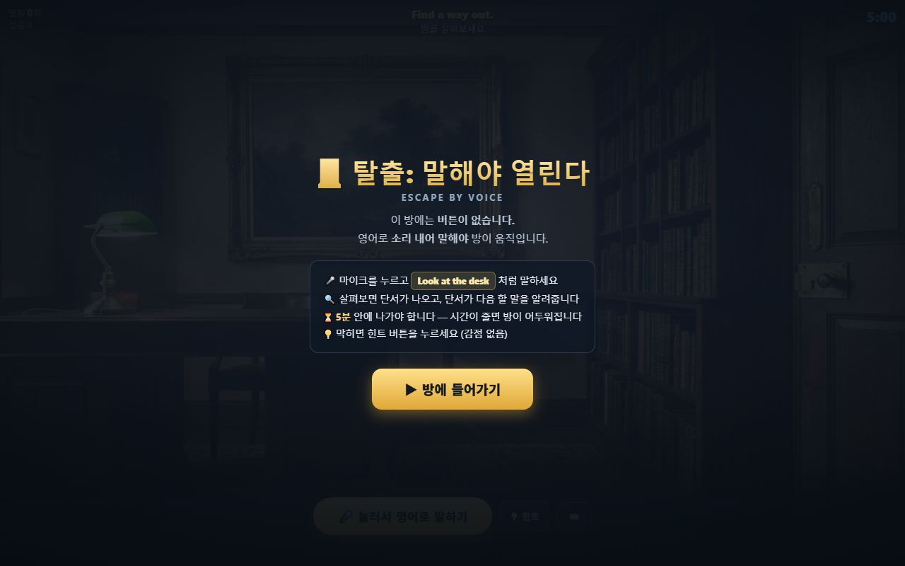
09. 📖 Vocabulary — don't make them memorise, make them meet it again
Automatic review · Preview tab
📖 Words are not memorised — they are met repeatedly. The Mangoi word list brings a word back just as the child is about to forget it. Your job is simply to get today's words into it.

How to do it
1. In the last minute of class, have them save three words from today.
2. They can leave the meaning blank — AI fills in the meaning and an example.
3. Ask them to check the 🔮 Preview tab before the next lesson.
4. When that word appears in class, point it out — “You saved this yesterday!”
5. Let it flow into the review game — points for every correct answer.
✅ Key Points
• Three is enough. Ask for ten and you will get none.
• A student who previewed follows the lesson far better that day.
• As the collection fills, their baby mango grows — that is what keeps them coming back.
💡 Pro tip Make “three words today” a fixed end-of-class ritual. That is 60 words a month — enough for the child to feel it.

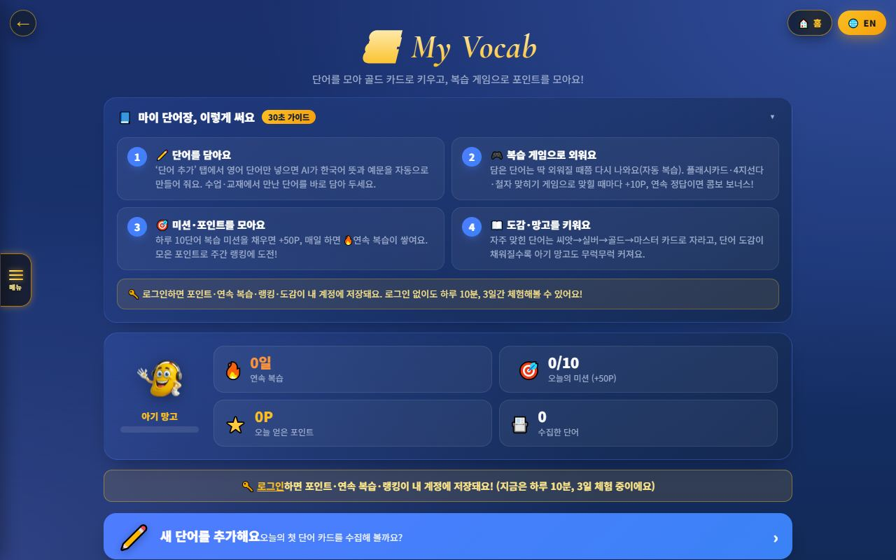
10. 📝 Evaluations — 3 minutes that build parent trust
One line from you becomes the report
📖 The evaluation is not paperwork. What you write here fills the five axes of the monthly report and the weekly report parents receive. In other words, if you do not write it, the parent receives no evidence at all.

How to do it
1. Write it immediately after the lesson, while it is fresh.
2. Always include one thing done well and one next goal.
3. Score pronunciation, vocabulary, sentences, attitude and participation honestly.
4. Note in the memo field what to ask next lesson.
5. Read and refine the AI draft comment before it goes out.
✅ Key Points
• A consistent one-liner beats an occasional essay for report quality.
• Axes with no evaluation appear empty on the parent's report.
• Writing the next goal also finishes your prep for the next lesson.
⚠️ Good to know Scoring more generously than reality feels kind, but parents eventually notice the gap and trust collapses. Be accurate, and warm about it.

💡 Pro tip Build a two-sentence template (“did well: … / next goal: …”) and evaluations take one minute.

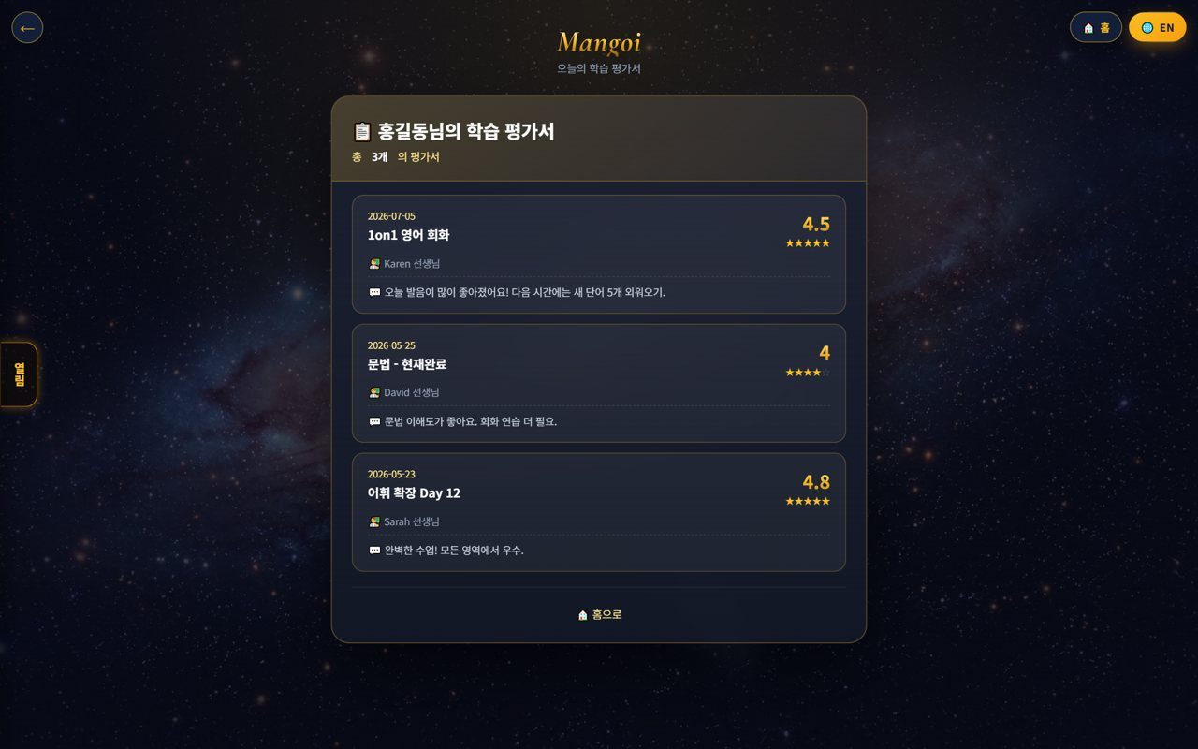
11. 👪 Parents — send proof of growth every week
Weekly report · monthly report card
📖 Parents re-enrol based on a feeling of progress, not a score. Mangoi sends a weekly report covering attendance, AI chats, judgment training, words conquered and pronunciation, and a pentagon report card every two months. You are the person who fills them.

How to do it
1. Encourage the student to use AI Friend chat, judgment training and the word list.
2. Attendance and activity are what make the report fill up.
3. Keep writing evaluations to fill the five axes of the report card.
4. On an especially good day, leave one specific line.
✅ Key Points
• The report contains no invented numbers — only what actually happened.
• Students who play games and use the word list get much richer reports.
• Parents read your one line before they read any number.
💡 Pro tip When a consultation is booked, ask for the report link to be sent beforehand. A prepared parent makes a completely different conversation.

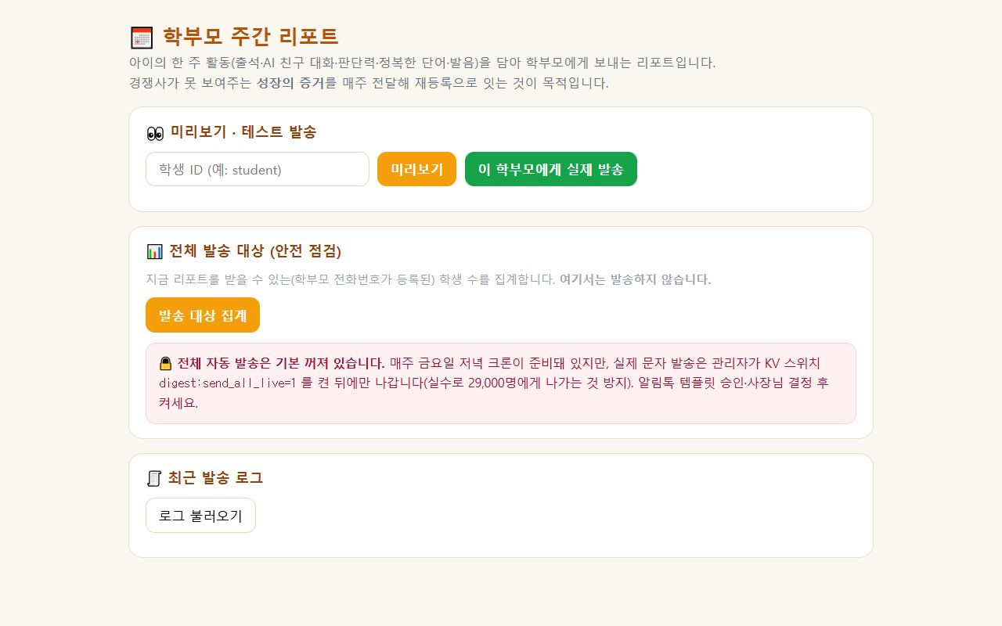
12. 🧒 Age tactics — one approach does not fit all
Preschool · primary · teens
📖 Teach a 7-year-old and a 15-year-old the same way and you will fail both. Attention span, motivation and how they respond differ completely by age.

How to do it
1. Preschool (5–7): change activity every 3–4 min; songs, movement, colours; praise participation over correctness.
2. Lower primary (8–10): games and points are strongest; favour collecting over competing.
3. Upper primary (11–13): they follow you if you explain why; use peer topics (games, idols).
4. Teens (14+): no forced cheerfulness; connect to usefulness, exams, future; correct privately.
5. All ages — give the chance to speak first.
✅ Key Points
• Younger means shorter activity cycles; older means explain the reason.
• For teens, embarrassment is the biggest barrier. Make it feel safe.
• Temperament often matters more than age.
💡 Pro tip Watch what they respond to over the first three lessons and write it in the evaluation. That becomes their personal manual.


13. 🧩 The student who won't speak — the order that unlocks it
Start with closed questions
📖 A silent student is not unwilling — they are afraid. Afraid of being wrong, of sounding strange. Follow the order and most of them open up.

How to do it
1. Start with questions they can answer with a nod — “Do you like pizza?”
2. Move up to choosing between two — “Pizza or chicken?”
3. Accept a one-word answer and echo it back as a sentence.
4. Build success with repeat-after-me.
5. Only then ask an open question — “What did you do?”
✅ Key Points
• Skip a step and they close again. Go one step at a time.
• Do not correct pronunciation on the spot — recasting it is enough.
• The Escape game and voice coach work especially well with these students.
⚠️ Good to know This can take weeks. Do not write “this child is just like that” in the evaluation after one or two attempts.

💡 Pro tip Record the day they first spoke freely. For a parent, that story is the most moving thing you can give them.

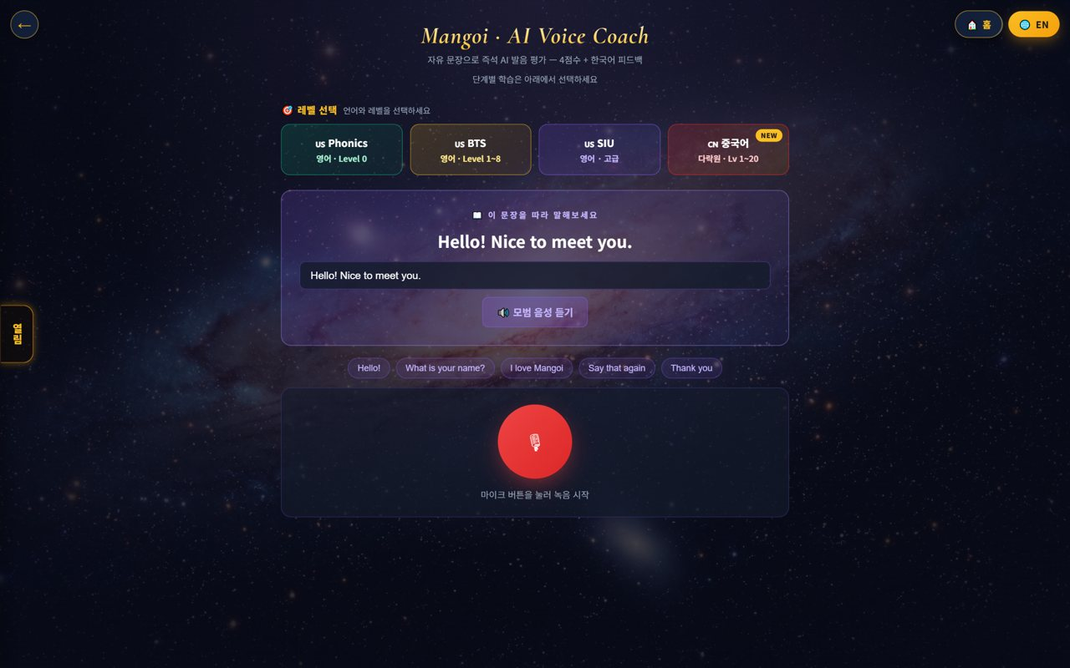
14. ⚡ Distraction & mixed levels — handling it live
Redirect, don't suppress
📖 Distraction is surplus energy; a level gap is a difference in pace. Suppress either and it grows; redirect it and it becomes a resource.

How to do it
1. When they lose focus, change the activity instead of scolding — game or whiteboard, immediately.
2. Get them moving — gestures, hands up, drawing on screen.
3. Give them a role — “You be the teacher. Ask me!”
4. Give the advanced student one harder task on the side.
5. For a slower student, reduce the amount and increase the wins.
✅ Key Points
• Forcing a static activity on a restless child collapses the whole lesson.
• A bored advanced student turns into a behaviour problem — prepare an extra task.
• A slower student needs small successes, not more time.
⚠️ Good to know In group lessons, managing the level gap matters even more. Do not spend too long on one child.

💡 Pro tip Restless children love the whiteboard. Let them draw and engagement jumps.

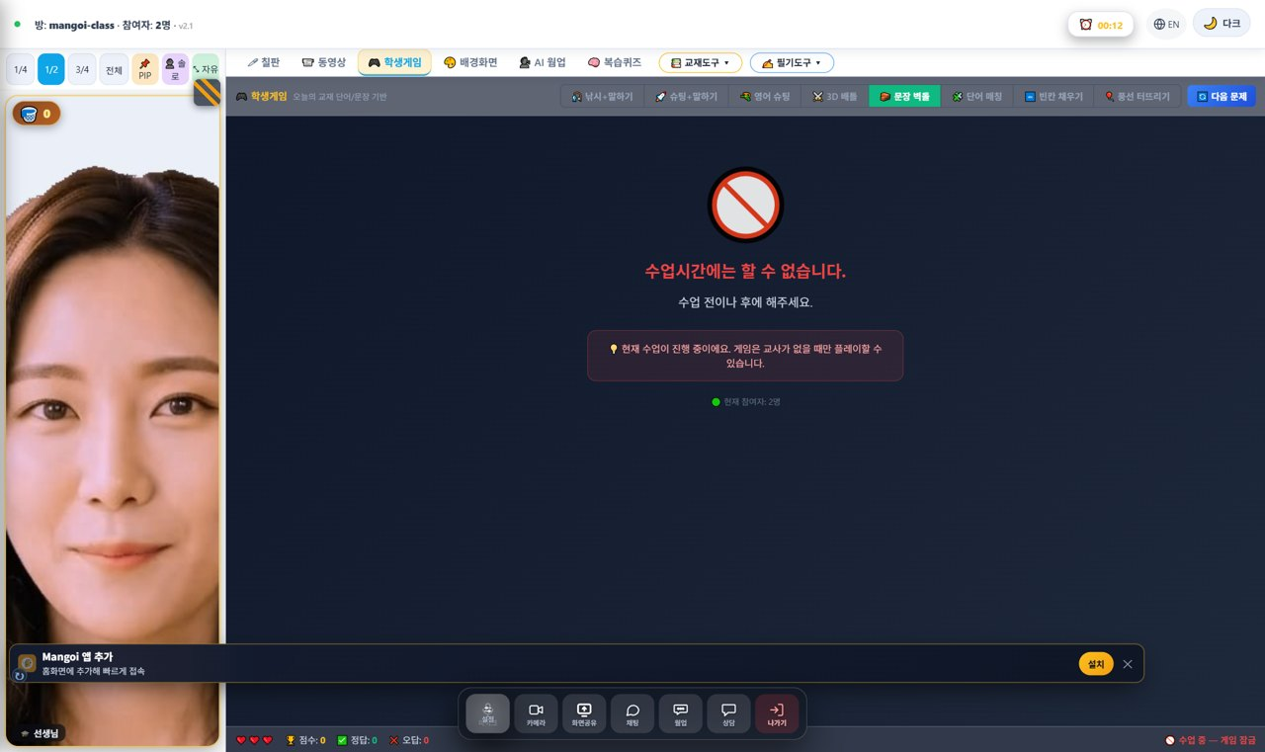
15. 🌐 When the connection wobbles — protect the lesson
Never dropping is the first priority
📖 Mangoi's first principle is that a lesson must not drop. Even if quality falls or the picture freezes, the lesson continues. Staying calm is itself a skill.

How to do it
1. If quality drops, the system lowers the video quality automatically — carry on.
2. If it gets much worse, it switches to audio-only mode. The voice survives.
3. If the other side freezes, wait a moment — automatic recovery runs.
4. If it still fails, refresh once and re-enter.
5. If the lesson genuinely stops, tell an admin straight away.
✅ Key Points
• Even with no picture, a speaking lesson can continue.
• Say what is happening so the child does not get anxious.
• Lost time is made up as a replacement lesson once reported.
⚠️ Good to know Never end a lesson yourself because of a connection problem. The system distinguishes a brief drop from someone leaving.

💡 Pro tip Make a pre-class camera and mic check a habit and half of these incidents disappear.

16. 📈 Your own growth — turning feedback into an asset
AI coaching · star ratings
📖 After each lesson AI drafts a coaching note, and star ratings and one-line feedback from students and parents accumulate. This is not an assessment — it is material for your next lesson.

How to do it
1. Read the AI coaching comment after class.
2. Look for what repeats in the ratings and feedback tags.
3. Change exactly one thing in the next lesson.
4. Record the result in the evaluation.
5. Share what worked with other teachers.
✅ Key Points
• Do not try to fix everything — one change per lesson is enough.
• Repeated feedback is the real signal; one-offs can be let go.
• Your growth record also supports pay reviews and renewals.
⚠️ Good to know The AI coaching draft is a reference. Read it and adjust it yourself before acting on it.

💡 Pro tip Set one goal a month. “This month: wait five seconds” is a complete goal.

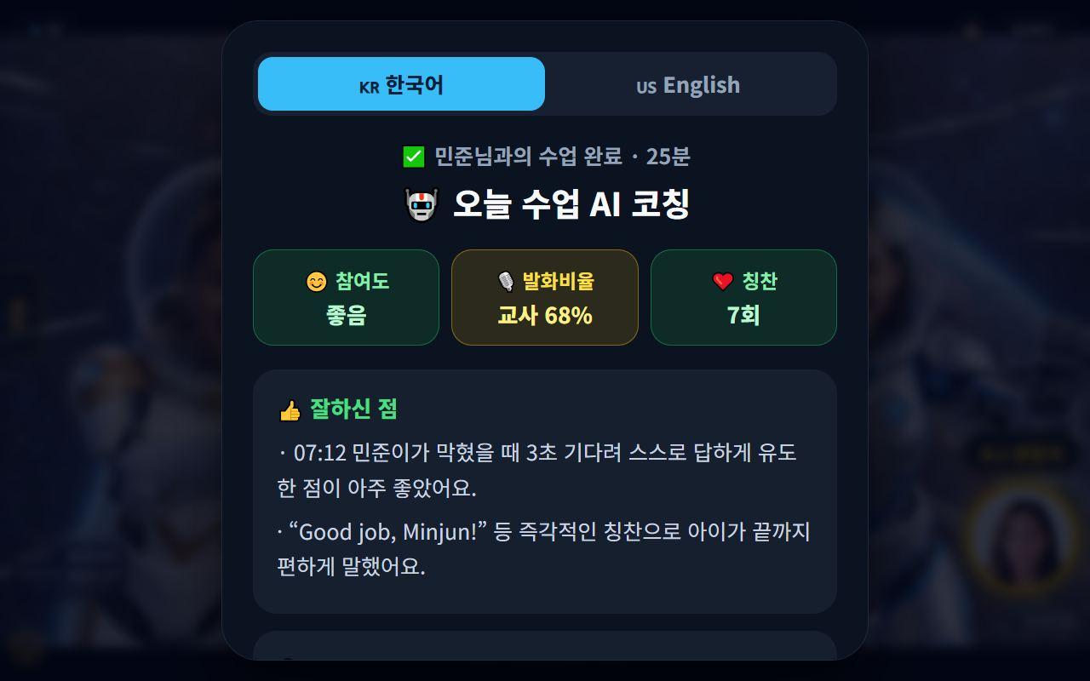

📋 🧰 Teaching Skills Summary
Skill | What it does | When to use it | Expected effect
Building energy | Greeting, expression, reaction in the first 60s | Every lesson start | Sets the mood for the whole lesson
Waiting 5 seconds | Holding the silence after a question | Every question | More student talk time
Praise basket | Making good moments visible | 3+ times per lesson | Sustained motivation
AI warm-up | Loosening the mouth first | First 3 minutes | Removes early silence
Learning games | Review through play | Last 5 minutes | Repetition plus points
Escape game | A room that needs speech | Reluctant speakers | Forced output, success experience
Three words | Saving today's words | Last minute of class | Feeds automatic review
Two-line evaluation | One win, one next goal | Right after class | Evidence for reports
Age tactics | Matching delivery to age | At assignment | Prevents drop-off
Reviewing AI coaching | One change from feedback | Weekly | Teacher growth
📊 Data at a Glance
Talk time in a lesson — target
Student talk | ██████████████████ 70
Teacher talk | ████████ 30
Attention per activity by age (minutes)
Age 5–7 | ███████ 4
Age 8–10 | ███████████ 6
Age 11–13 | ██████████████ 8
Age 14+ | ██████████████████ 10
Structure of a 25-minute lesson (minutes)
Warm-up | ████████ 3
Core | ██████████████████ 7
Speaking | ██████████████████ 7
Game | █████████████ 5
Close | ████████ 3

❓ Frequently Asked Questions
Q. My student keeps speaking Korean.
A. Do not scold — **lower the question until they can answer in English.** Start with a two-way choice (“Pizza or chicken?”), then one word, then a sentence. Making English easy works far faster than banning Korean.
Q. They keep mispronouncing. Should I correct every time?
A. Correct **one thing per lesson**. For the rest, recasting the sentence correctly is enough. Constant correction makes them stop speaking.
Q. How much game time is appropriate?
A. About **5 minutes** in a 25-minute lesson. But a game with no stated purpose is just playtime — always tie it to today's expressions and say the goal first.
Q. Do I really have to write an evaluation every time?
A. Yes. Without it, **the axes of the parent's report card look empty.** It does not need to be long — “one win + one next goal” is enough.
Q. The student is too distracted to continue.
A. Instead of scolding, **change the activity immediately.** Drawing on the whiteboard or giving them a role usually brings them back. Distraction is surplus energy; it only needs redirecting.
Q. The connection dropped and we lost the lesson.
A. Do not end it yourself — **tell an admin right away.** Lost time is verified and made up as a replacement lesson. The system distinguishes a brief drop from leaving.
Q. Where do I register work hours, breaks and leave?
A. Use the **shortcut on the Teachers screen**. The earlier you register leave, the more reliably it is reflected in assignments.
Q. I have no lesson today, so I cannot see the screens.
A. Ask an admin to **create a sample lesson**. It is created on the demo student account, so no real student data is affected.
✅ Every-Lesson Checklist
☐ Did you skim the last evaluation for 30 seconds?
☐ Did you check your camera and microphone beforehand?
☐ Did you greet them by name in the first 60 seconds?
☐ Did you wait five seconds after asking a question?
☐ Did you give at least three specific compliments?
☐ Did you avoid running one activity past 7 minutes?
☐ Did they save three of today's words to their list?
☐ Did you close with a preview of next time?
☐ Did you write the evaluation right after class?
☐ Have you read this week's AI coaching feedback?

🏁 You are the curriculum
Good materials and a good system still do not make a child speak — you do. Do not try to apply every technique in this manual at once. One thing per lesson is enough.
🔄 One Lesson, End to End
Before class | Check the last evaluation · test camera & mic · prepare one personal topic
First 3 minutes | Greet by name · AI warm-up to get the mouth moving
Main lesson | Wait five seconds after questions · change activity every 7 minutes
Last 5 minutes | Review game · praise basket · save three words
Right after | Two-line evaluation · note what to ask next time
⭐ Core Principles
1. Let them speak more — the less you talk, the faster they improve.
2. Make praise visible — spoken praise vanishes; praise that stacks up stays.
3. Remember one thing — “this teacher knows me” changes their attitude.
4. Keep the rhythm — if they look bored, change the activity, not the explanation.
5. Leave a record — one line in the evaluation becomes parent trust.
📌 Remember
• Wait five seconds after a question. That is where their first sentence comes from.
• Three specific compliments beat thirty “Good job”s.
• For silent students, start with the Escape game and closed questions.
• Never end a lesson yourself over a connection problem — tell an admin.
• Choose one thing to change each month.
🍊 If one child said their first full sentence today, that lesson was a success. Those sentences add up to fluency, and those records add up to parent trust. One lesson of yours changes one child's English. Thank you for today! 🥭

