For students & academy directors

AI Speaking Guide
Practice speaking English with AI. With this guide, you can start on your own, even on day one.

Before you start
- Get a mic
- Earphones with a mic work best.
- Find a quiet place
- The AI hears you better when it's quiet.
- Allow the mic
- When a pop-up asks to use the mic, tap [Allow].
- Check the volume
- Make sure you can hear the AI clearly.

The screen at a glance
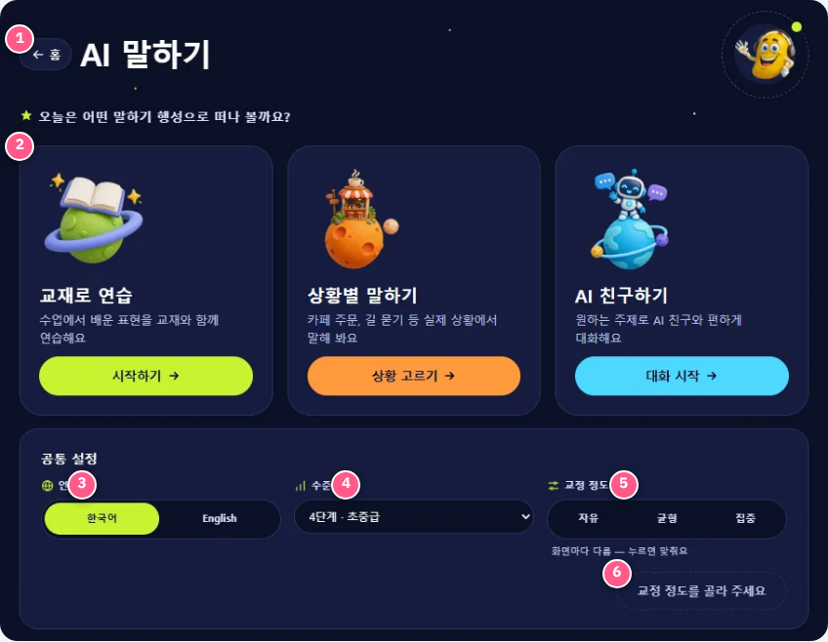
- ← Home : Go back to the main screen.
- 3 speaking planets : Choose today's practice.
- Language : See screen text in Korean or English.
- Level : Pick the level that fits you.
- Correction : Decide how much the AI corrects your mistakes.
- [Confirm] : Tap it to save your level and corrections.

3 ways to talk
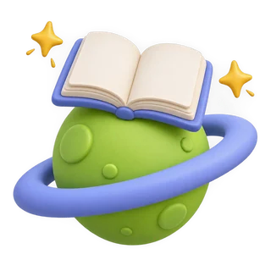

Textbook practice
Best for reviewing what you learned in class.
- Tap Start →
- Choose your age, level and book
- Listen and repeat
“How was your weekend?”


Real-life situations
Best for real-life English, like ordering at a café or asking for directions.
- Tap Choose a situation →
- Pick the situation you want
- The AI plays the clerk or friend and speaks first
“Can I get a hot chocolate, please?”


AI friend
Best for chatting freely about topics you like.
- Tap Start chatting →
- Choose a topic to talk about
- Ask and answer freely
“I like soccer. What about you?”
Tip : Short answers are fine. Finishing your sentence matters most!

More handy features
- Change the voice : Change the AI's voice on the practice screen.
- Speaking speed : Too fast? Slow it down on the practice screen.
- Set once, use everywhere : They apply to all 3 practices. “Differs by screen”? Pick one, tap [Confirm].
- ← Home : Tap “← Home” (top left) to go back.

Common settings
Level and corrections apply to all three practices. Choose both and tap [Confirm] to save; language saves right away. Change voice and speed on each practice screen.
Language
한국어 / English
Choose Korean or English for the screen text. You always talk with the AI in English.
Level
e.g. Level 4 · Low-intermediate
The right level is when you understand about 80% of what the AI says. Too easy? Go up one. Too hard? Go down one.
Correction
Option | What the AI does | Good for
Free | No repeat-after-me. Just keep talking. | Beginners and shy speakers
Balanced | Mostly key mistakes. Repeat sometimes. | Most students (recommended)
Focused | Fixes all, says it 3 times, you repeat. | Students preparing for tests or presentations
See “Differs by screen”? The three practices have different settings. Pick one and tap [Confirm] to match them all.

For directors & teachers

Recommended settings by student
Student | Level | Correction | Language
New starters · Lower elementary | One level below their skill | Free | Korean
Upper elementary · Middle school | Current level | Balanced | Korean or English
Advanced · Test or speech prep | Current or one level up | Focused | English

15-minute routine
- 5 min · Textbook practice · Review today's expressions
- 5 min · Real-life situations · Use them in a real situation
- 5 min · AI friend · Free talk to build confidence

First-day checklist
- Test the mic and earphones on every device.
- Set the level and correction for each student.
- Read the “Safety promises” below with students.
- For the first 2 weeks, use Free or Balanced to build confidence first.

Safety promises
- Never tell the AI your full name, address, phone number, school, or passwords.
- AI can make mistakes. If something feels strange or uncomfortable, stop and tell your teacher.
- Practice only for the time you're given.

Q&A

Q. My mic doesn't work.
A. Tap the lock icon (site settings) next to the address bar, set the mic to “Allow,” and refresh. If another app like Zoom is using the mic, close it first.

Q. The AI doesn't understand me.
A. Keep the mic close, find a quiet place, and speak slowly and clearly. Say long ideas one sentence at a time.

Q. The AI talks too fast.
A. You can slow down the speed on each practice screen.

Q. It's too hard or too easy.
A. Change the Level on the main screen one step at a time and tap [Confirm]. If you understand about 80% of what the AI says, it's the right level.

Q. I'm afraid of making mistakes.
A. Try setting Correction to Free. The AI never laughs at mistakes. Finishing your sentence comes first!

Q. What does “Differs by screen” mean?
A. The three practices have different settings. Pick one and tap [Confirm] to make them all the same.

Q. Where do my settings apply?
A. After you tap [Confirm], level and corrections apply to all three practices. Voice and speed are changed on each practice screen.

Q. (Directors) Which devices and browsers work best?
A. Any PC, tablet, or phone with a mic works. We recommend the latest Chrome, Edge, or Safari, and earphones with a mic to cut classroom noise.

Q. (Directors) How long should students practice each day?
A. About 10–15 minutes for elementary and 15–20 minutes for middle school. Short daily practice works better than one long session.

Q. How do I go back to the main screen?
A. Tap the “← Home” button at the top left.

As of November 2026 · Screens may change slightly with updates.

