🤝 Mangoi · MANGOI
Agency User Guide
From enrollment to lessons and settlement, in one book

For · Agency (franchise) operators
🌐 test.mangoi.co.kr 📞 1588-0000 ✉ support@mangoi.co.kr

📘 What is the Agency Admin Page?
The agency page is where you directly manage your agency's students, lessons, payments and settlement. From recruiting and counseling to enrollment, lesson assignment, collection, parent communication and receiving settlement — everything you need to run an agency is here. On login, only 'my agency' data shows, so you can focus on your students.
🤝 My-agency scope, automatic — Just log in and see only your students/revenue.
🧑‍🎓 Recruit·enroll·manage students — From counseling to enrollment and lesson assignment.
💳 Collection·settlement — Payments/overdue and receiving branch→agency settlement.
📈 Learning status·reports — Your students' learning at a glance.

🧭 How to Use the Main Features
01. 🔐 Agency Login & Permissions
Only my agency's data
📖 Logging in with an agency account shows only 'my agency' menus and data. Other agencies or branch-wide data isn't visible, so you can focus on managing your students.

How to use
1. Log in with ID and password (social login also works).
2. On login, menus/data for your role (agency) are applied automatically.
3. Forgot your password? Reset via 'Find password'.
✅ Key Points
• Only your agency's student/revenue data shows.
• Turn on 'Save ID' only on your own trusted PC.
💡 Tip On shared PCs, turn off auto-login and log out when done.

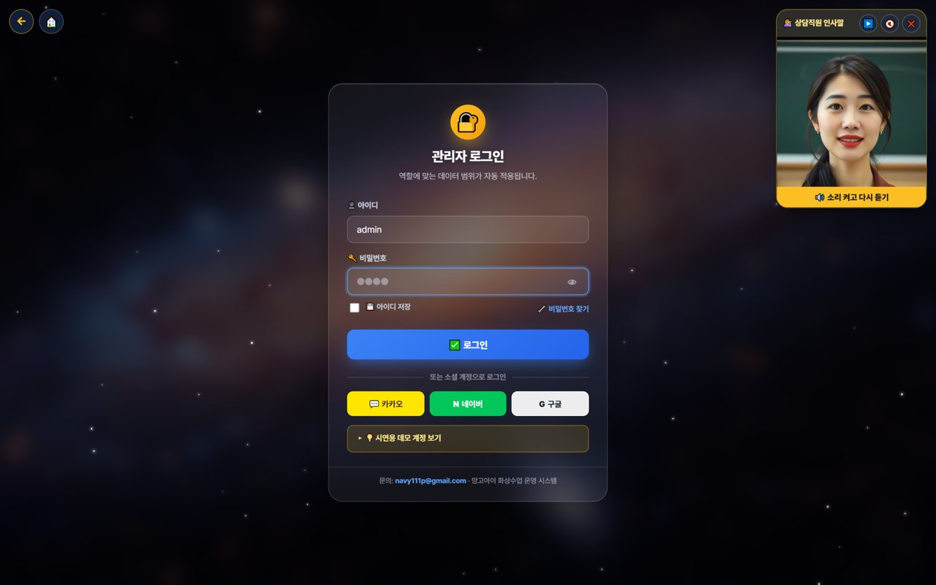
02. 👤 My Page & Admin Dashboard
Open the management screen from My Page
📖 Agency operations also start from 'My Page.' After logging in, press the 📊 'Admin' button in the My Page menu to enter the agency-scope admin (operations) dashboard, where you manage students, revenue, lessons and settlement.

How to use
1. After logging in, open '👤 My Page'.
2. Press the 📊 'Admin' button in the My Page menu. (goes to the admin dashboard)
3. On the admin dashboard, check your agency revenue, enrollment and today's lessons.
4. My Page also has postpone/change, new inquiry, all-menu, pre-check and more.
5. If text looks English, use the EN button to switch language.
✅ Key Points
• One 'Admin' button takes you straight to the operations dashboard.
• All dashboard data is auto-totaled to 'your agency scope'.
• Menus and data are set automatically by your role (agency).
⚠️ Good to know My Page and the admin dashboard open only within the logged-in agency account's permission scope.

💡 Tip Each day, go My Page → Admin dashboard to check your agency metrics.


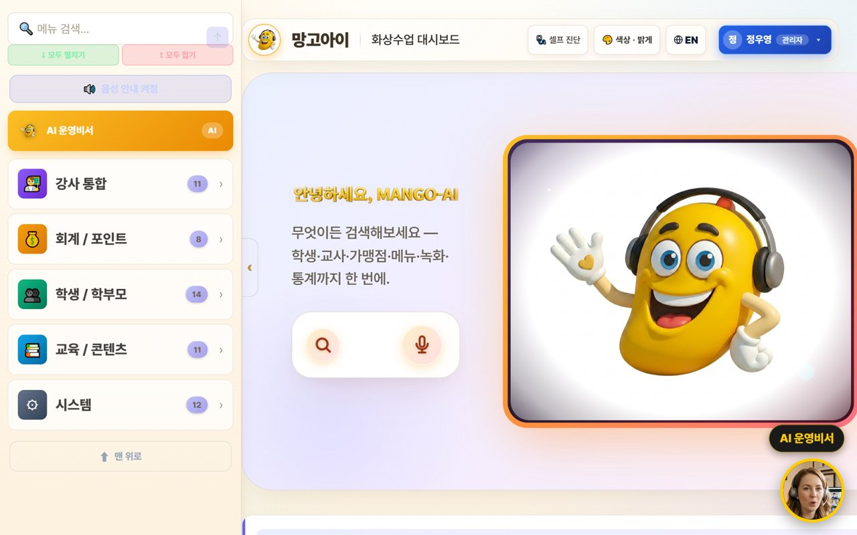
03. 🏠 Agency Dashboard
Your students·revenue·today's lessons
📖 On login, your agency's enrollment, revenue and today's lessons are organized as cards. Find features fast with the search box.

How to use
1. Check today's revenue, enrollment and attendance (your agency) at the top.
2. Tap features from the category cards (students, accounting, content, etc.).
3. Type a word in the feature search box to jump right there.
4. Check the live (LIVE) lesson status.
✅ Key Points
• Numbers are auto-totaled to 'your agency scope'.
• If a feature is hard to find, search is fastest.
💡 Tip A morning metrics check quickly tells you your academy's status.


04. 🤖 Using the AI Assistant
Look up/act by voice or text
📖 Speak or type into the search/mic and the AI helps you look up and handle things within your agency scope. Especially handy during busy counseling hours.

How to use
1. Speak or type into the center search/mic. e.g. 'How's today's revenue?'
2. The AI looks up or opens a screen. e.g. 'Open student management.'
3. Important actions are confirmed with 'Shall I?' first.
✅ Key Points
• Voice is much faster than clicking.
• Only permitted actions are handled, safely.
💡 Tip Can't find a button? Just say 'open ○○'.


05. 🧑‍🎓 Recruit·Enroll·Manage Students
From counseling to enrollment
📖 Take new counseling, enroll students, and manage enrolled students' attendance, grades and history. This is your agency's core work.

How to use
1. Take new counseling and convert to enrollment.
2. Manage the roster/history in Students/Parents.
3. Check attendance/reviews/points/chat history by student.
4. Flag and care for students who need attention.
✅ Key Points
• The student list is linked to real member data.
• Raising the counsel→enroll conversion is key to growth.
💡 Tip Keeping thorough counseling notes greatly helps re-counseling and conversion.

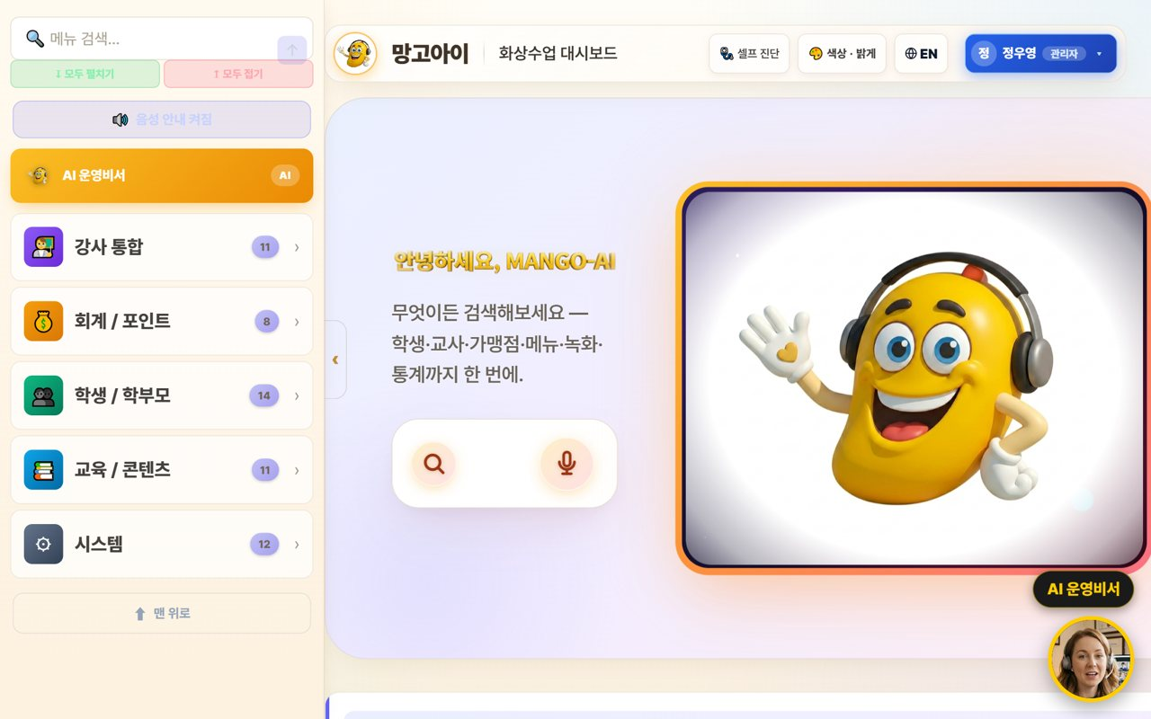
06. 👨‍👩‍👧 Parent Communication
Guide My Page
📖 Guide parents to My Page so they can check their child's learning themselves. It reduces inquiries and raises satisfaction and re-enrollment.

How to use
1. Share the My Page link with parents.
2. Parents check attendance/reviews/payments/reports with the child's student ID.
3. Share growth with the monthly report (print/PDF).
✅ Key Points
• Parent satisfaction leads to re-enrollment.
• Advise managing the student ID like a password.
💡 Tip Reading the review together periodically builds parent trust.

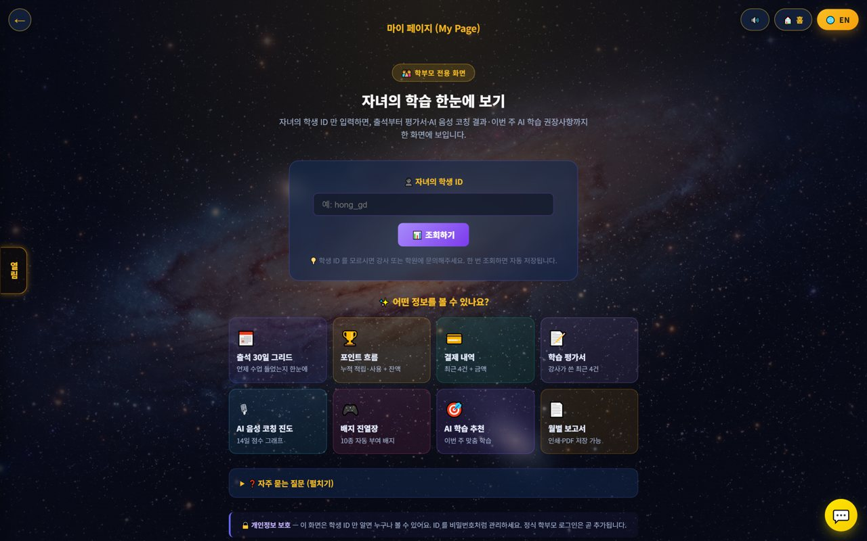
07. 📅 Booking·Assignment
Schedule and teacher
📖 Assign a student's lesson type, time and teacher, and manage booking status. Handle postpone/change requests too.

How to use
1. Assign lesson type, teacher and time in Booking.
2. Check empty slots/overlaps and adjust.
3. Handle students' postpone/change requests per policy.
✅ Key Points
• Assign popular slots in advance.
• Announcing the postpone cutoff reduces no-shows.
💡 Tip Pre-registering each teacher's available times speeds up assignment.

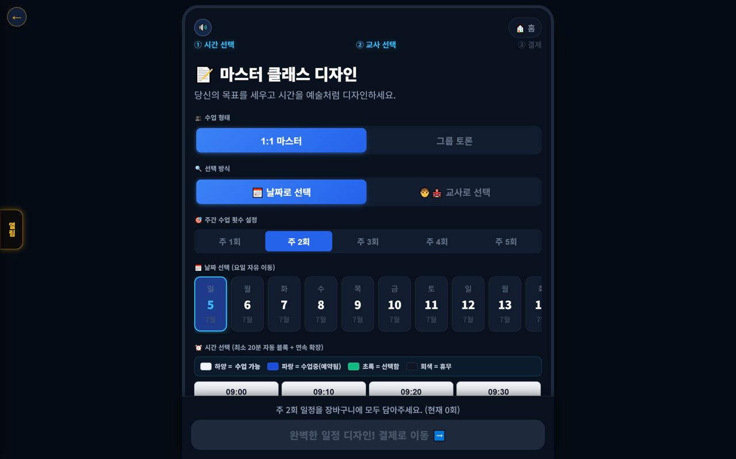
08. 💳 Payments·Collection
Payments·overdue·refunds
📖 Process your agency's payments, overdue and refunds. Amounts auto-calculate by policy, and overdue is managed with alerts.

How to use
1. Process payments/overdue/refunds in Accounting/Points.
2. Notify overdue via alert-talk/SMS.
3. Amounts are auto-calculated per the refund table.
✅ Key Points
• Automate overdue alerts to raise collection.
• Discounted-payment refunds recalc at list price.
💡 Tip Reviewing collection status regularly stabilizes revenue.

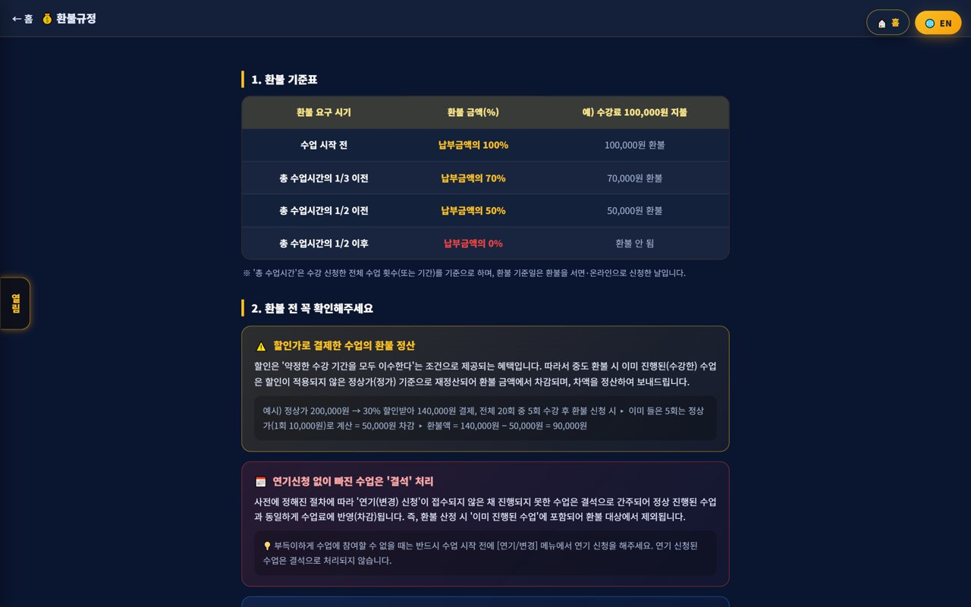
09. 📈 Student Learning·Reports
Progress·performance
📖 Check your students' attendance, reviews and learning progress, and review performance with reports. Use it for parent counseling and re-enrollment persuasion.

How to use
1. Check each student's attendance·reviews·progress.
2. Summarize performance with the monthly report.
3. Use reports in parent counseling.
✅ Key Points
• Showing data builds parent trust.
• Link high-performing students to reviews/referrals.
💡 Tip Showing performance with a report before re-enrollment makes persuasion easier.


10. 🌳 Agency Settlement
Receive branch→agency
📖 Check the settlement coming from the branch to your agency. Revenue and commissions are auto-calculated down the org tree, so you can see your share transparently.

How to use
1. Check branch→agency settlement (received) by month.
2. Review the revenue/commission calculation details.
3. Save (PDF) the settlement report to keep.
✅ Key Points
• Settlement is auto-calculated by the org tree.
• Ask the branch/HQ to confirm any off items.
💡 Tip Viewing revenue and settlement together clarifies your agency's profit structure.

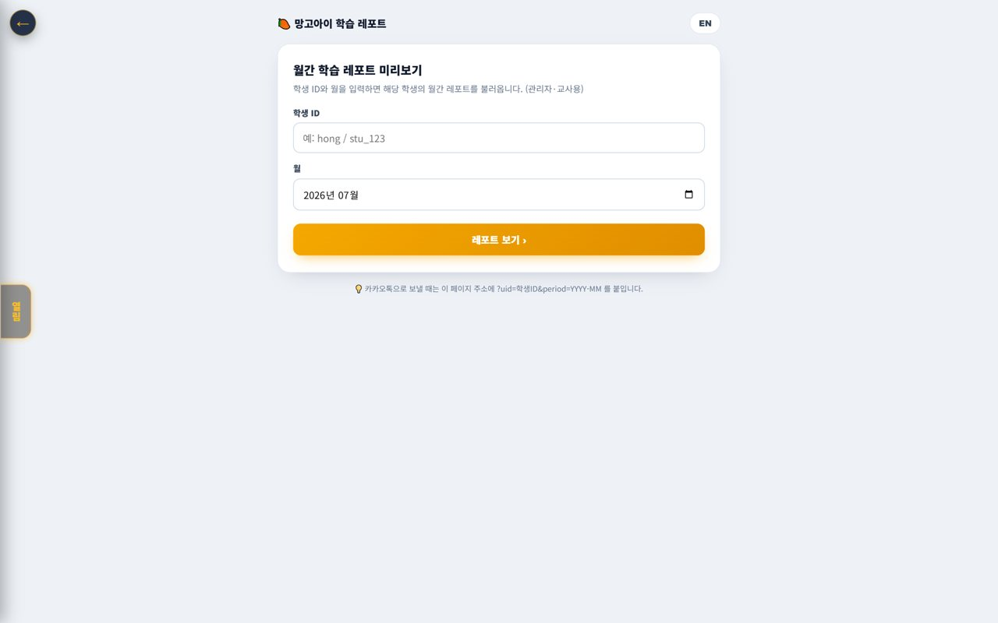
11. 🧲 Prevent Churn (care for students)
Spot at-risk early
📖 Find students likely to quit early and care for them. Quickly caring for students with frequent absences or dropping performance raises re-enrollment.

How to use
1. Check churn-risk signals (absences·performance drop).
2. Intervene on at-risk students with counseling/alert-talk.
3. Manage family/referral relationships too.
✅ Key Points
• Intervening early raises retention.
• Care before re-enrollment season is especially important.
💡 Tip Caring first for frequently-absent students noticeably cuts churn.


12. 💬 New Counseling·Recruiting
Intake·conversion
📖 Take new counseling/inquiries and convert to enrollment. Recruiting is the starting point of agency growth.

How to use
1. Take new counseling/inquiries.
2. Record the counseling and convert to enrollment.
3. Drive enrollment with trial lessons·level tests.
✅ Key Points
• Fast response raises conversion.
• Make the trial→enroll flow smooth.
💡 Tip Following up after counseling raises conversion.

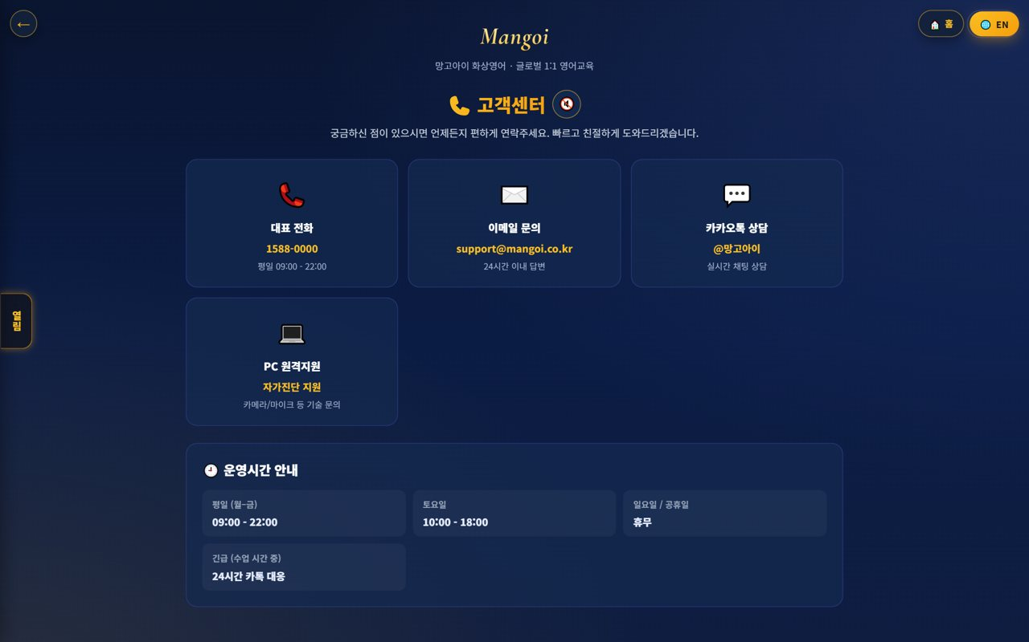
13. 🎧 Support·Help
Get branch·HQ support
📖 If a problem comes up in operations, contact branch/HQ support. System/settlement/policy questions get resolved quickly.

How to use
1. Use phone, email, Kakao and remote support in Support.
2. Route settlement/policy questions to the branch/HQ.
3. Note the fix for repeat issues.
✅ Key Points
• System issues resolve fast with remote support.
• For 'can't enter' tickets, check browser/permission first.
💡 Tip Compiling common inquiries and fixes speeds up counseling.


14. 🕐 Korea·Philippines Dual Clock
Two countries' time on screen
📖 A clock on screen shows 🇰🇷 Korea and 🇵🇭 Philippines time together. It lets you check the time difference instantly when coordinating lessons between Philippine teachers and Korean students.

How to use
1. On the on-screen dual clock, see 🇰🇷 Korea and 🇵🇭 Philippines time at once.
2. Drag the clock to move it anywhere you like.
3. Tap (click) the clock to go to the home screen.
✅ Key Points
• The Philippines is 1 hour behind Korea (−1 hour).
• You can check booking/entry times in both countries' time.
💡 Tip When a lesson time is confusing due to the time difference, this clock clears it up instantly.

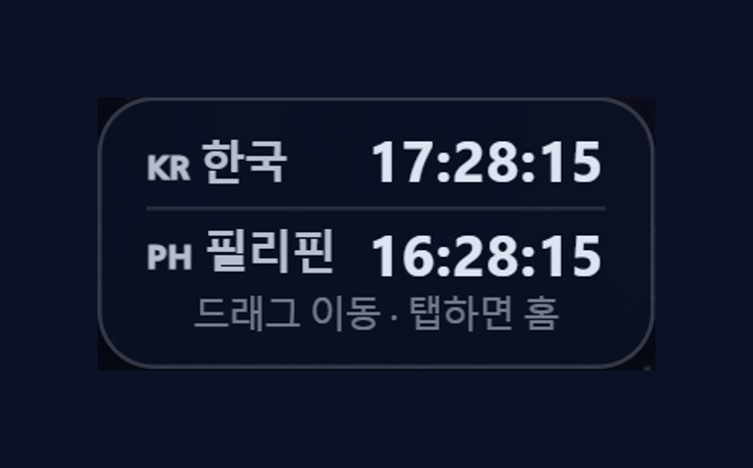
15. 🇨🇳 Chinese Pronunciation Coach
Darakwon Chinese Master Lv1–20
📖 Mangoi offers not only English but also a Chinese course. With a Darakwon Chinese Master (Lv 1–20) pronunciation coach (characters+pinyin, AI voice recognition, native comparison), you can attract and manage students who want Chinese.

How to use
1. In the AI voice coach, pick the CN Chinese level (or go to the Chinese pronunciation coach).
2. Choose a Master series (1–6, HSK 1–6) and a unit.
3. Read the sentence (characters + pinyin) and compare with 'Play native audio'.
4. Practice hard sounds/tones with repeat and slow (0.85x).
✅ Key Points
• Characters and pinyin appear together, so it's easy to read.
• The AI recognizes your voice and compares it to a native speaker.
• The learning games hub supports Chinese too.
💡 Tip Listen slowly and repeat clearly to nail the four tones.

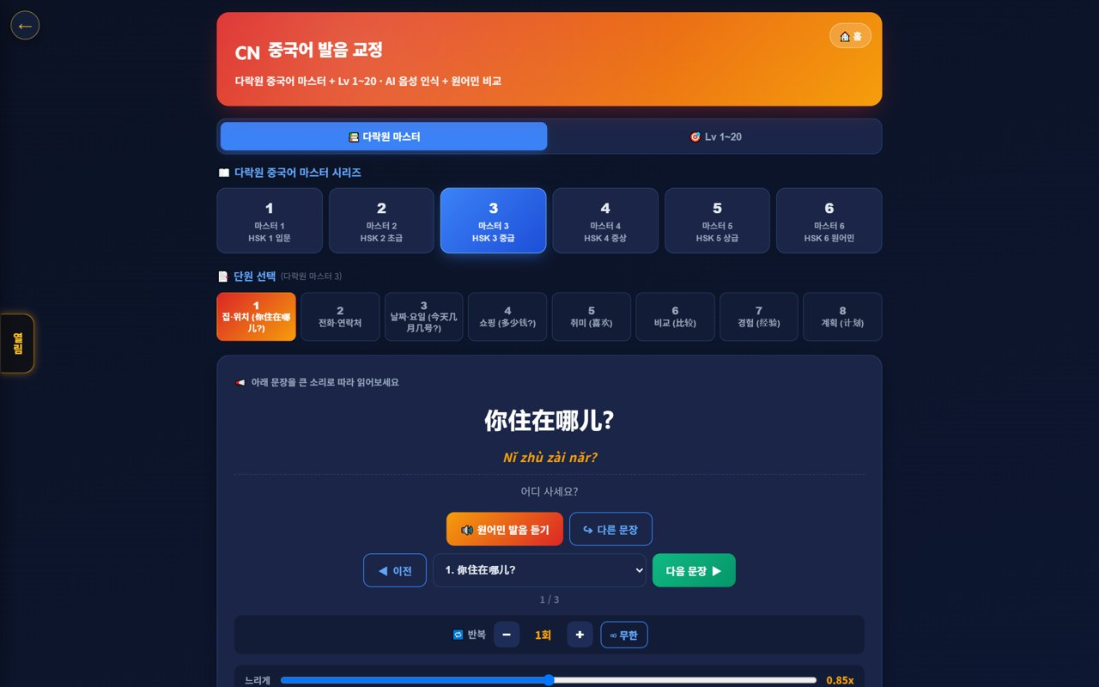
16. 🌟 In-class Praise Points (understand & use)
Linked to motivation·re-enrollment
📖 During class the teacher gives 🌟 praise points (+1P) to students on the spot, and an end-of-class rating (+10P) adds up into the student's total points. Points lead to shop/gift rewards, helping motivation and re-enrollment. Your agency understands and uses this flow for performance.

How to use
1. The teacher gives +1P via the 🌟 praise button on a student's video during class.
2. It accrues live in the student's 🧺 point basket and sums into their total.
3. A post-class star rating gives the student an extra +10P.
4. Points connect to shop/roulette/gift rewards.
✅ Key Points
• Instant rewards boost participation and re-enrollment.
• Use your agency students' points/reward response as a performance signal.
⚠️ Good to know Teachers give praise points; HQ (admin) configures the shop/reward/gift policy.

💡 Tip Classes (teachers) where praise points flow well tend to have higher re-enrollment.



📋 Agency Features at a Glance
Feature | What it does | When | Core benefit
Dashboard | Revenue·enrollment·today | Every morning | Quick read
Student mgmt | Recruit·enroll·history | Always | Grow enrollment
Parent comm | Guide My Page | Enroll·re-enroll | Satisfaction ↑
Booking | Schedule·teacher | Assigning lessons | Smooth flow
Payments | Payments·overdue·refunds | Collection | Stable revenue
Reports | Learning performance | Counsel·re-enroll | Persuasion ↑
Settlement | Receive branch→agency | Monthly | Transparent profit
Retention | Care for at-risk | Always | Retention ↑
📊 Data at a Glance
Your Agency Metrics (example)
Revenue (10k KRW) | █████ 46
Enrolled | ██████████████████ 180
Attendance (%) | █████████ 93
Enrollment Trend (example)
Jan | ████████████ 120
Feb | ██████████████ 135
Mar | ███████████████ 150
Apr | ████████████████ 162
May | █████████████████ 171
Jun | ██████████████████ 180
Churn-risk Distribution (example)
Safe | ██████████████████ 72
Watch | █████ 20
At risk | ██ 8

❓ Frequently Asked Questions (FAQ)
Q. Where do I log in?
A. Log in at admin.mangoi.co.kr. By role (agency), only your agency's data shows automatically.
Q. Can I see other agencies' data?
A. No. By permission scope, only your agency's data is visible.
Q. How do I grow enrollment?
A. Fast counseling response, a smooth trial→enroll flow, and persuading parents with learning reports are key.
Q. How do I check settlement?
A. Branch→agency settlement (received) is auto-calculated by the org tree; check it in the monthly report.
Q. A student seems about to quit.
A. Watch churn-risk signals (absences·performance drop) and intervene quickly with counseling/alert-talk.
✅ Agency Operations Checklist
☐ Did you check today's revenue/enrollment/attendance?
☐ Did you take and respond to new counseling/inquiries?
☐ Did you check and notify overdue items?
☐ Did you care for at-risk students?
☐ Did you guide parents to the report/My Page?
☐ Did you check this month's settlement (received)?
☐ Did you follow up on trial→enroll?

🏁 Conclusion · A Practical Guide to Agency Growth
The core of agency operations is the virtuous cycle of 'recruit → enroll → satisfy → re-enroll.' Respond to counseling fast, show learning results with data, and prevent churn early — and your agency grows steadily. Keep this rhythm and operations feel solid.
🔄 The Flow at a Glance
Morning (5 min) | Check revenue/enrollment/attendance on the dashboard; check live-lesson status
Late morning | Respond to new counseling·convert; notify overdue
Class hours | Check lesson assignment/progress; guide 'entry' tickets to browser/permission first
Afternoon | Care for at-risk students; parent reports·counseling
Monthly | Check branch→agency settlement; re-enroll·follow-up
⭐ Key Principles
1. Respond fast — the faster you handle counseling/inquiries, the higher conversion.
2. Persuade with data — showing results via learning reports makes re-enrollment easy.
3. Intervene on churn early — care first for frequently-absent students.
4. Communicate with parents — build trust with My Page and reports.
5. Follow up — following up after counseling completes enrollment.
📌 Remember
• Log in at admin.mangoi.co.kr; data is auto-limited to your agency scope
• Settlement is auto-calculated by the branch→agency tree
• Most 'can't enter class' tickets are browser/permission issues
• Growth rhythm: 'Recruit → Enroll → Satisfy → Re-enroll'!
🍊 An agency's strength comes from 'the care you give each student.' Respond quickly, show results, and prevent churn early. Your branch and HQ back you up solidly. Questions? Contact support anytime — cheering on your thriving agency! 🍊

