🏢 Mangoi · MANGOI
Branch User Guide
Sub-agencies, settlement & performance in one book

For · Regional branch operators
🌐 test.mangoi.co.kr 📞 1588-0000 ✉ support@mangoi.co.kr

📘 What is the Branch Admin Page?
The branch page is where you manage your branch and its sub-agencies with authority delegated by HQ. When you log in, only 'my branch' data (revenue, enrollment, attendance, settlement) is shown automatically. You see your sub-agencies' performance at a glance and process the settlement that flows HQ ↔ branch ↔ agency. The layout is the same as the admin page — only the scope differs.
🏢 My-branch scope, automatic — Just log in and see only your branch's data.
🏬 Manage sub-agencies — Agency list, performance and recruiting in one place.
🌳 HQ→branch→agency settlement — Receipt/distribution auto-calculated by the tree.
📊 Performance reports — Branch/agency performance in a monthly report.

🧭 How to Use the Main Features
01. 🔐 Branch Login & Permissions
Only my branch's data shows
📖 Logging in with a branch account shows only 'my branch' menus and data. HQ-wide or other branches' data isn't visible, so you can focus on your branch with peace of mind.

How to use
1. Log in with ID and password (Kakao, Naver, Google also work).
2. On login, menus/data for your role (branch) are applied automatically.
3. Forgot your password? Reset via 'Find password'.
4. You can split permission scope among staff.
✅ Key Points
• Only your branch and sub-agency data shows.
• Turn on 'Save ID' only on your own trusted PC.
💡 Tip On shared PCs, turn off auto-login and always log out when done.

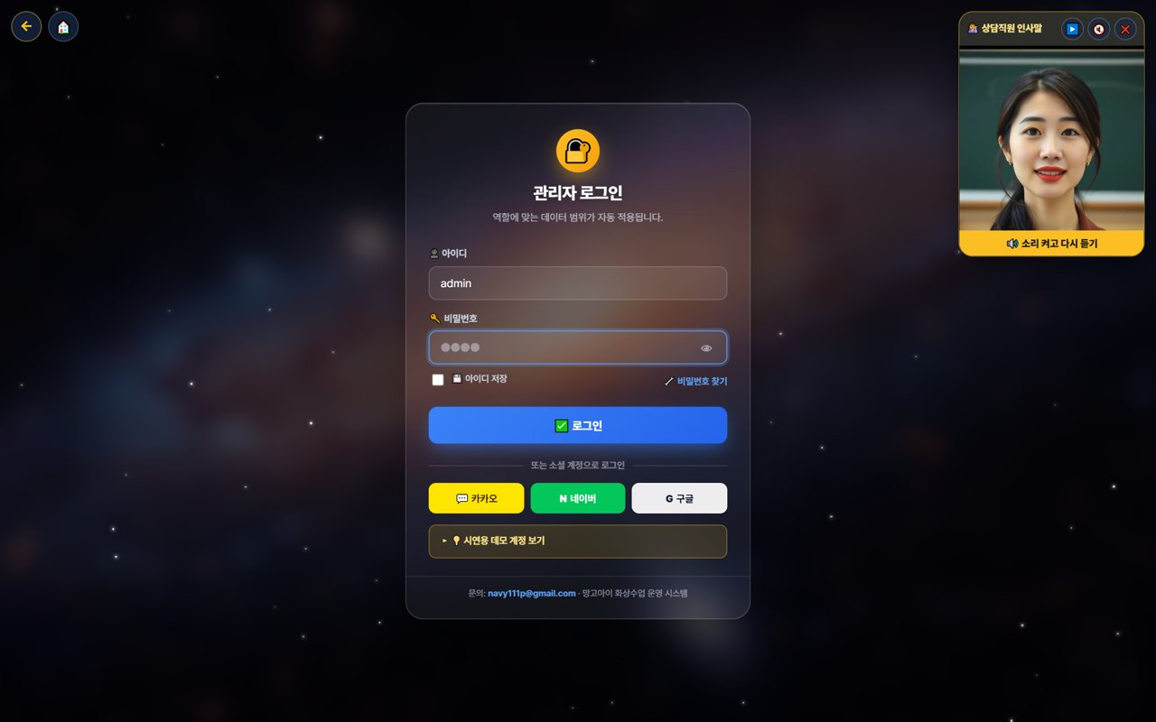
02. 👤 My Page & Admin Dashboard
Open the management screen from My Page
📖 Branch operations start from 'My Page.' After logging in, press the 📊 'Admin' button in the My Page menu to enter the branch-scope admin (operations) dashboard, where you manage revenue, enrollment, agencies and settlement.

How to use
1. After logging in, open '👤 My Page'.
2. Press the 📊 'Admin' button in the My Page menu. (goes to the admin dashboard)
3. On the admin dashboard, check your branch revenue, enrollment, attendance and sub-agencies.
4. My Page also has postpone/change, new inquiry, all-menu, pre-check and more.
5. If text looks English, use the EN button to switch language.
✅ Key Points
• One 'Admin' button takes you straight to the operations dashboard.
• All dashboard data is auto-totaled to 'your branch scope'.
• Menus and data are set automatically by your role (branch).
⚠️ Good to know My Page and the admin dashboard open only within the logged-in branch account's permission scope.

💡 Tip Each day, spend 5 minutes: My Page → Admin dashboard → check branch metrics.


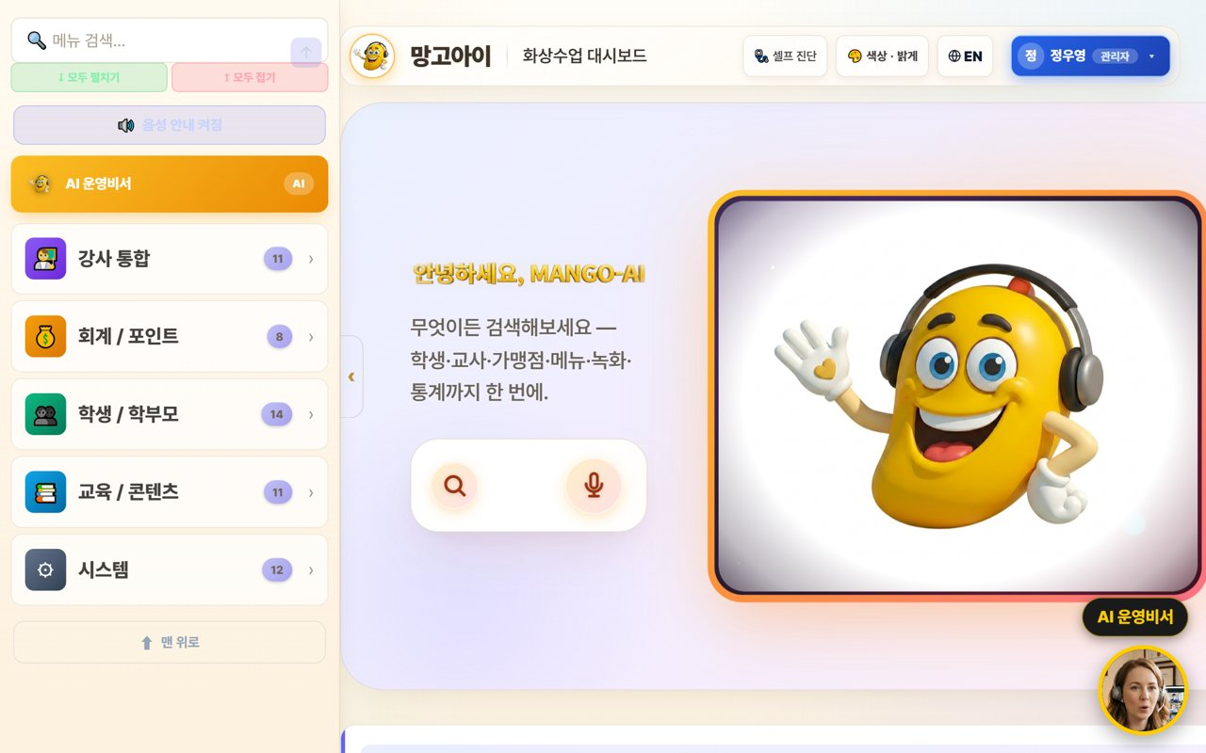
03. 🏠 Branch Dashboard
Your branch status at a glance
📖 On login, your branch's revenue, enrollment and attendance plus sub-agency status are organized as cards. Type a word in the top search box to jump right to a feature.

How to use
1. Check today's revenue, enrollment and attendance (your branch total) at the top.
2. Tap features from the category cards (agencies, teachers, accounting, students, content).
3. Type a word in the feature search box to jump right there.
4. The AI insight summarizes your branch status.
✅ Key Points
• All numbers are auto-totaled to 'your branch scope'.
• If a feature is hard to find, search is fastest.
💡 Tip A 5-minute morning check of branch metrics catches warning signs early.


04. 🤖 Using the AI Assistant
Look up/act by voice or text
📖 Speak or type into the search/mic and the AI looks up numbers or opens screens within your branch scope. Important actions are confirmed first, and it only does what you're permitted.

How to use
1. Speak or type into the center search/mic. e.g. 'How's the branch revenue this month?'
2. The AI looks up numbers or opens a screen. e.g. 'Open the agency list.'
3. Important actions are confirmed with 'Shall I?' first.
4. The assistant only executes what you're permitted.
✅ Key Points
• When busy, voice is much faster.
• Results are limited to your branch scope.
💡 Tip Just say 'show me/open ○○' to jump to the screen you want.


05. 🏬 Manage Sub-agencies
List, performance, recruiting
📖 Manage the agencies under your branch as a list and compare each agency's enrollment, revenue and performance. Recruiting and onboarding new agencies is handled here too.

How to use
1. Check each agency's enrollment, revenue and activity in the agency list.
2. Compare strong/weak agencies to set support priorities.
3. Manage new-agency recruiting/onboarding progress.
4. Set goals/incentives per agency if needed.
✅ Key Points
• Link agencies with big performance gaps to coaching/support.
• Share top agencies' methods with the others.
⚠️ Good to know Agency data is also managed by each agency's own login; the branch sees the whole picture.

💡 Tip Sharing a monthly performance report at month-start boosts partner motivation.

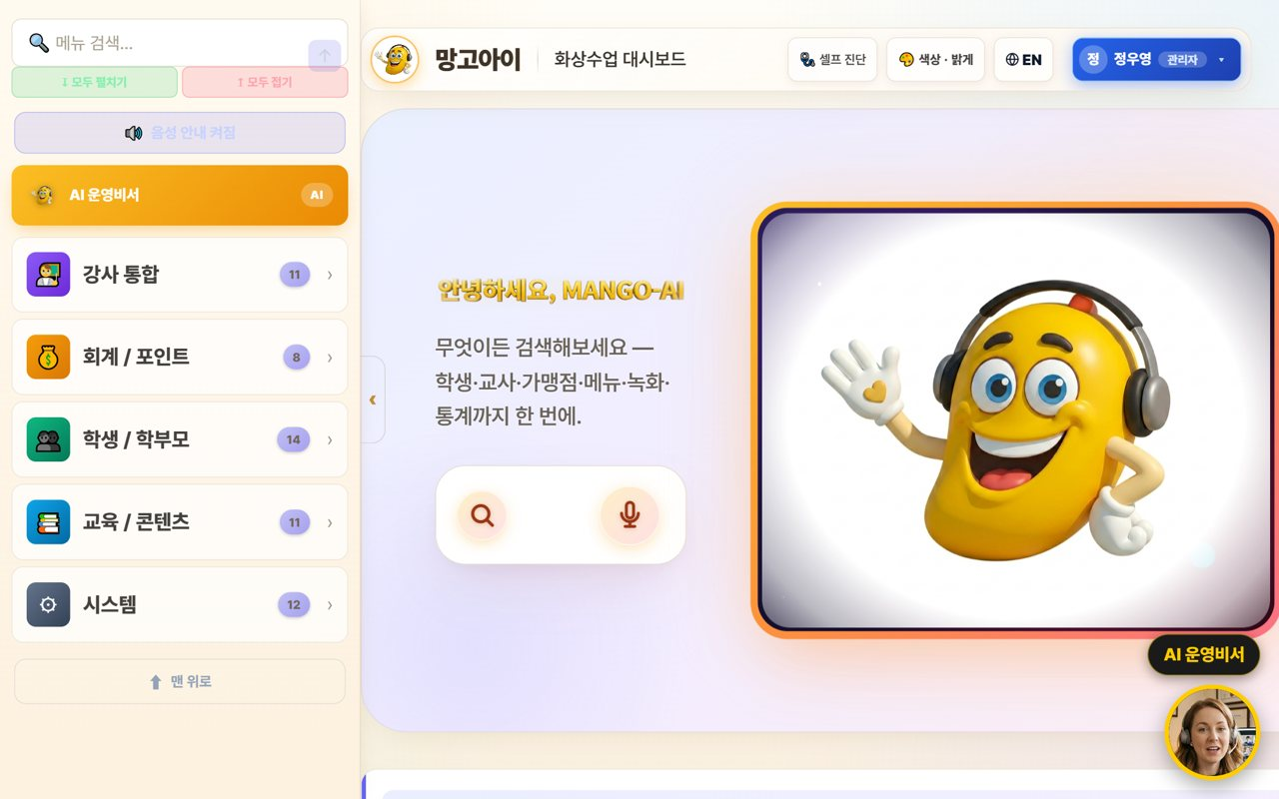
06. 🌳 Branch Settlement (receive & distribute)
HQ→branch→agency
📖 Receive the settlement coming from HQ to your branch and check the amount distributed from the branch to sub-agencies. Revenue and commissions are auto-calculated down the org tree.

How to use
1. Check HQ→branch settlement (received) by month.
2. Branch→agency distribution is auto-calculated by the tree.
3. Review/save the settlement in a monthly report (PDF).
4. If an item looks off, look up the details to confirm.
✅ Key Points
• Settlement is auto-calculated down the org tree (HQ·branch·agency).
• Distributing the settlement report early builds agency trust.
💡 Tip Announcing settlement terms (rate·timing) to agencies in advance reduces disputes.

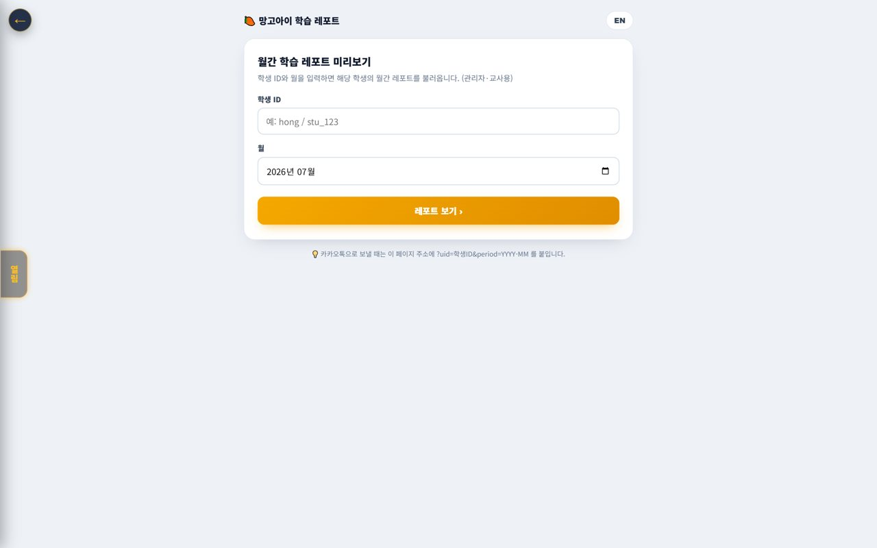
07. 🧑‍🎓 Student · Parent Status
Branch-scope enrollment·attendance·grades
📖 Check the status of students in your branch (enrollment, attendance, grades). View by agency or as a branch total.

How to use
1. Check branch-scope enrolled students in Students/Parents.
2. Compare attendance/grades by agency and overall.
3. Flag students/agencies that need attention.
✅ Key Points
• The student list is linked to real member data.
• At-risk students link to the Retention Center.
💡 Tip Find agencies whose attendance/enrollment is dipping and support them quickly.


08. 💳 Payments·Overdue·Refunds (branch)
Branch-scope accounting
📖 Check payments, overdue and refunds in your branch scope and review amounts auto-calculated by policy. Also see collection status by agency.

How to use
1. Check branch-scope payments/overdue/refunds in Accounting/Points.
2. Compare collection rate by agency.
3. Amounts are auto-calculated per the refund table.
✅ Key Points
• Strengthen alerts/support for agencies with high overdue.
• Discounted-payment refunds recalc at list price.
💡 Tip Advise agencies with low collection to automate reminders.

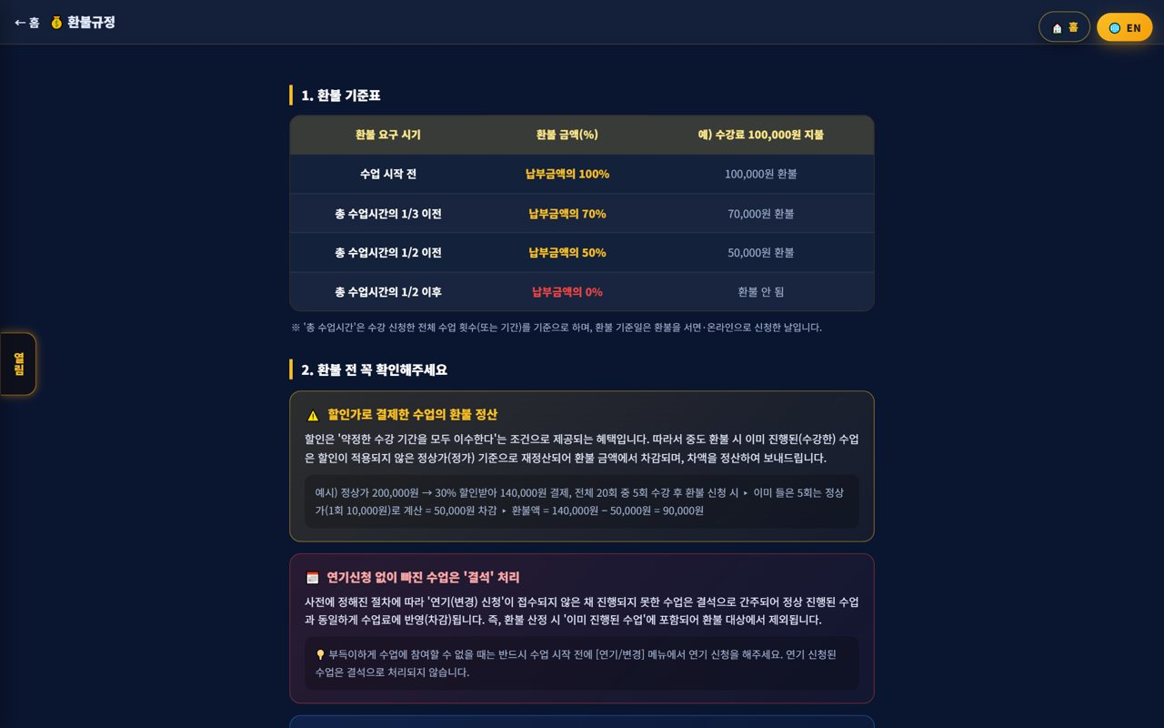
09. 🧲 Branch Retention
Churn risk·contagion·coaching
📖 Find at-risk students across your branch/agencies early and prevent chain churn through family/referral. It ties into agency and teacher coaching.

How to use
1. Find at-risk students/agencies with the churn-risk graph.
2. Prevent chain churn with the contagion network.
3. Link high-risk spots to alert-talk/counseling/coaching.
✅ Key Points
• Intervening early raises retention.
• Compare churn patterns by agency to support them.
💡 Tip Just caring weekly for the top at-risk agencies/students noticeably cuts churn.


10. 📊 Monthly Report·Performance
Branch·agency performance
📖 Summarize your branch and sub-agencies' performance in a monthly report. See revenue, enrollment, attendance and settlement at a glance and save/print to share.

How to use
1. Check branch/agency performance with the monthly report.
2. Compare metrics (revenue·enrollment·attendance·settlement) vs prior month/year.
3. Save the report as print/PDF to share.
✅ Key Points
• The AI insight helps summarize performance.
• The report also works as agency motivation material.
💡 Tip Making monthly report sharing routine keeps branch operations transparent.


11. 🎓 Agency Support·Training
Onboarding·ops coaching
📖 Support sub-agencies to operate well with onboarding and ops coaching. Guide the user guide/FAQ/support channels and share best practices.

How to use
1. Guide new agencies to the user guide·ops guide.
2. Organize frequent questions into an FAQ and distribute.
3. Share top-agency cases to level everyone up.
✅ Key Points
• Early onboarding largely decides an agency's success.
• Turn repeat questions into FAQ to cut support load.
💡 Tip Quarterly agency meetings help review performance and pain points together.

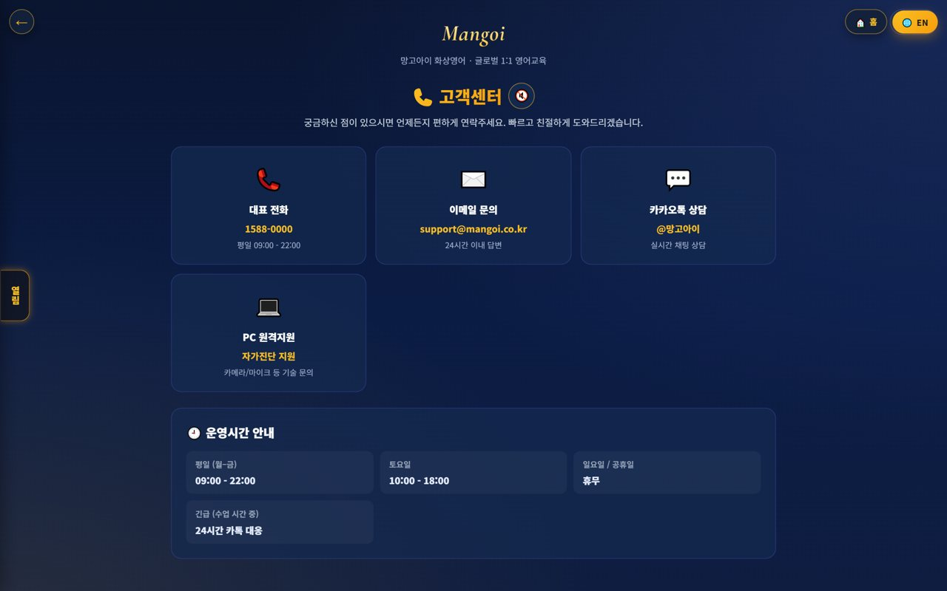
12. 🎧 Support·Inquiries
Get HQ support
📖 If a problem comes up in operations, contact HQ support channels. System/settlement/policy questions get resolved quickly.

How to use
1. Use phone, email, Kakao and remote support in Support.
2. Route settlement/policy questions to the HQ contact.
3. Note the fix for repeat issues.
✅ Key Points
• System issues resolve fast with remote support.
• Inquiries within business hours are faster.
💡 Tip Compile common inquiries and fixes and share them with agencies too.


13. 🕐 Korea·Philippines Dual Clock
Two countries' time on screen
📖 A clock on screen shows 🇰🇷 Korea and 🇵🇭 Philippines time together. It lets you check the time difference instantly when coordinating lessons between Philippine teachers and Korean students.

How to use
1. On the on-screen dual clock, see 🇰🇷 Korea and 🇵🇭 Philippines time at once.
2. Drag the clock to move it anywhere you like.
3. Tap (click) the clock to go to the home screen.
✅ Key Points
• The Philippines is 1 hour behind Korea (−1 hour).
• You can check booking/entry times in both countries' time.
💡 Tip When a lesson time is confusing due to the time difference, this clock clears it up instantly.

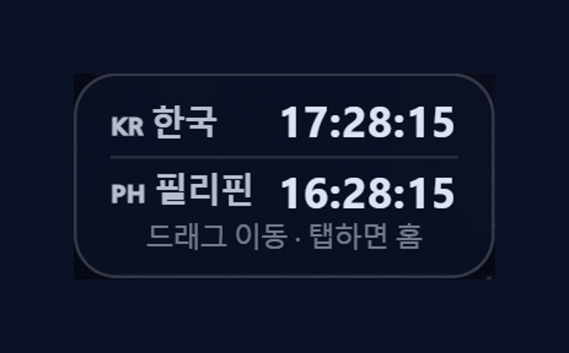
14. 🇨🇳 Chinese Pronunciation Coach
Darakwon Chinese Master Lv1–20
📖 Mangoi offers not only English but also a Chinese course. With a Darakwon Chinese Master (Lv 1–20) pronunciation coach (characters+pinyin, AI voice recognition, native comparison), you can attract and manage students who want Chinese.

How to use
1. In the AI voice coach, pick the CN Chinese level (or go to the Chinese pronunciation coach).
2. Choose a Master series (1–6, HSK 1–6) and a unit.
3. Read the sentence (characters + pinyin) and compare with 'Play native audio'.
4. Practice hard sounds/tones with repeat and slow (0.85x).
✅ Key Points
• Characters and pinyin appear together, so it's easy to read.
• The AI recognizes your voice and compares it to a native speaker.
• The learning games hub supports Chinese too.
💡 Tip Listen slowly and repeat clearly to nail the four tones.

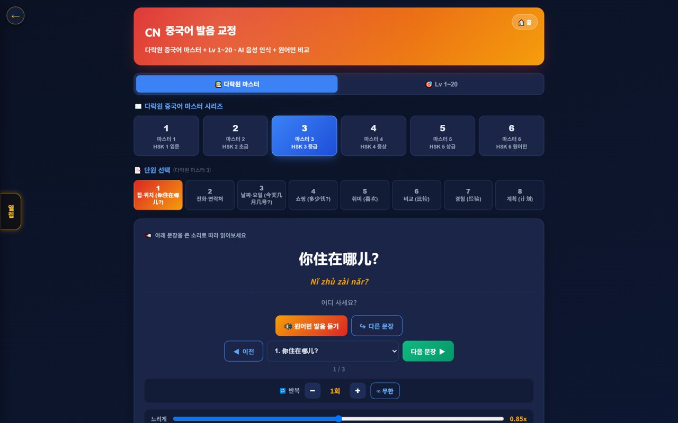
15. 🌟 In-class Praise Points (understand & use)
Linked to motivation·re-enrollment
📖 During class the teacher gives 🌟 praise points (+1P) to students on the spot, and an end-of-class rating (+10P) adds up into the student's total points. Points lead to shop/gift rewards, helping motivation and re-enrollment. Your branch understands and uses this flow for performance.

How to use
1. The teacher gives +1P via the 🌟 praise button on a student's video during class.
2. It accrues live in the student's 🧺 point basket and sums into their total.
3. A post-class star rating gives the student an extra +10P.
4. Points connect to shop/roulette/gift rewards.
✅ Key Points
• Instant rewards boost participation and re-enrollment.
• Use your branch students' points/reward response as a performance signal.
⚠️ Good to know Teachers give praise points; HQ (admin) configures the shop/reward/gift policy.

💡 Tip Classes (teachers) where praise points flow well tend to have higher re-enrollment.



📋 Branch Features at a Glance
Feature | What it does | Scope | Core benefit
Branch dashboard | Revenue·enrollment·attendance | My branch | Quick read
Agency mgmt | List·performance·recruiting | Sub-agencies | Level up
Branch settlement | Receive·distribute auto-calc | HQ↔branch↔agency | Accurate settlement
Students·parents | Enrollment·attendance·grades | Branch scope | Churn prevention
Accounting | Payments·overdue·refunds | Branch scope | Healthy collection
Retention | Churn risk·contagion | Branch·agency | Retention ↑
Monthly report | Performance analysis | Branch·agency | Transparent ops
📊 Data at a Glance
Your Branch Metrics (example)
Revenue (M KRW) | █ 64
Enrolled | ██████████████████ 980
Sub-agencies | █ 12
Enrollment by Agency (example)
Gangnam | ██████████████████ 210
Bundang | ███████████████ 180
Ilsan | █████████████ 150
Suwon | ██████████ 120
Incheon | ████████ 90
Settlement Split (example)
HQ fee | ███████ 20
Branch share | ███████████ 30
Agency distribution | ██████████████████ 50

❓ Frequently Asked Questions (FAQ)
Q. Where do I log in?
A. Log in at admin.mangoi.co.kr. By role (branch), only your branch's data shows automatically.
Q. Can I see other branches' data?
A. No. By permission scope, only your branch and sub-agency data is visible.
Q. How is settlement calculated?
A. Revenue/commissions are auto-calculated down the org tree (HQ→branch→agency). Check the monthly report.
Q. An agency is underperforming.
A. Find causes via retention/accounting/reports and support with onboarding/coaching/incentives; sharing best cases helps.
Q. A system problem occurred.
A. Contact HQ support (phone·email·Kakao·remote) for a quick fix.
✅ Branch Operations Checklist
☐ Did you check today's branch revenue/enrollment/attendance?
☐ Did you spot and support underperforming agencies?
☐ Did you review this month's settlement (receive·distribute)?
☐ Did you check overdue/refund items?
☐ Did you care for at-risk students/agencies?
☐ Did you onboard new agencies?
☐ Did you share the monthly report?

🏁 Conclusion · A Practical Guide to Branch Growth
A branch is the bridge between HQ and agencies. Watch your branch metrics, support your agencies to grow, and process settlement transparently — and the whole branch grows together. Keep this rhythm and operations get far more stable.
🔄 The Flow at a Glance
Morning (5 min) | Check revenue/enrollment/attendance on the branch dashboard; read the AI insight
Late morning | Review performance/collection by agency; check overdue/refunds
Afternoon | Support/coach underperforming agencies; care for at-risk students (retention)
Weekly | Onboard new agencies; share best practices
Monthly | Check/distribute HQ→branch→agency settlement; share the monthly report
⭐ Key Principles
1. Metrics, 5 minutes each morning — catch branch/agency signals early.
2. Agencies as partners — close performance gaps with coaching/support.
3. Transparent settlement — announcing terms upfront builds trust.
4. Intervene on churn early — care for at-risk agencies/students first.
5. Spread best practices — share top agencies' methods branch-wide.
📌 Remember
• Log in at admin.mangoi.co.kr; data is auto-limited to your branch scope
• Settlement is auto-calculated by the HQ→branch→agency tree
• Most field inquiries like 'can't enter' are browser/permission issues
• Ops rhythm: 'Check → Support → Settle → Report'!
🍊 A good branch is one that helps its agencies thrive. Read the situation with metrics, support your partners, and keep settlement transparent — and branch and agencies grow together. Questions? Contact HQ support anytime — cheering on your solid branch operations! 🍊

