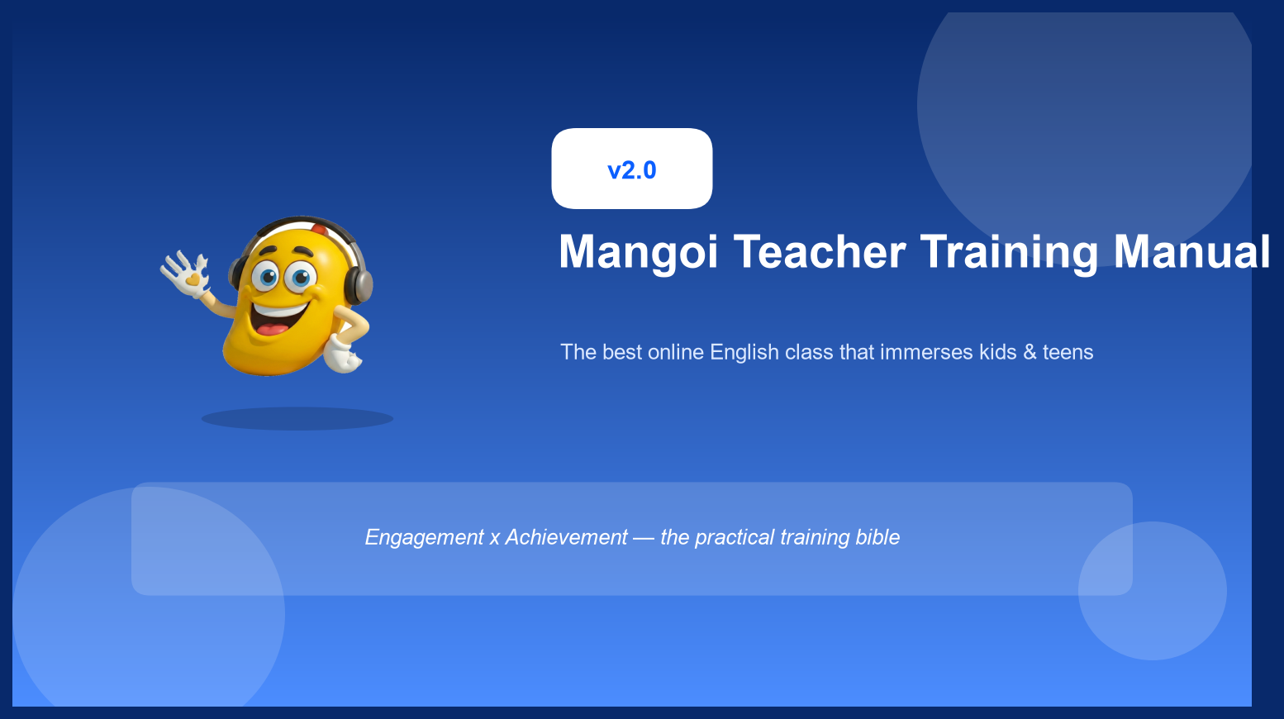
Issued by | Date | Classification
Teacher Success Team | July 4, 2026 | Confidential

Table of Contents

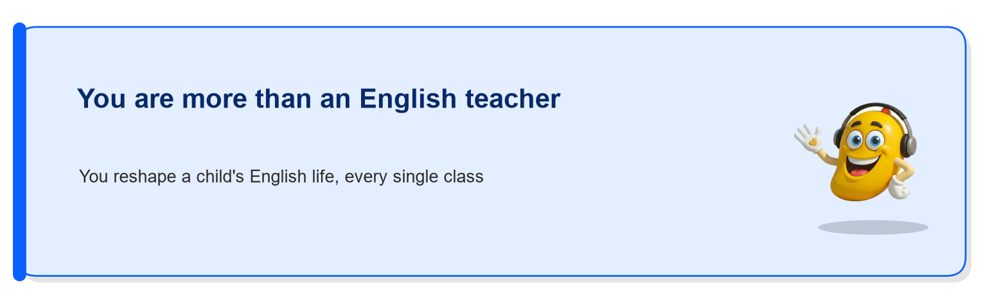
Whether a child grows up loving English for life, or dreading and fearing it, is decided not by how hard the textbook is, but by how much fun today's class actually was. Children simply do not learn when something is boring — and when something is fun, they keep learning on their own, without anyone telling them to.
This manual is not a rulebook you must obey — it is an armory you can pull tools from right in the middle of class. Master the 5 core behaviors, the engagement cycle, and the age-specific tactics below one at a time, and you will become the kind of teacher who can make even the most distracted, short-attention-span child light up with excitement.
If you are reading this all the way through and actually planning to try it in your next class, you are already in the top 10% of teachers. You don't need to memorize everything perfectly. Even trying just one new thing consciously in each class will noticeably change how the child responds to you.
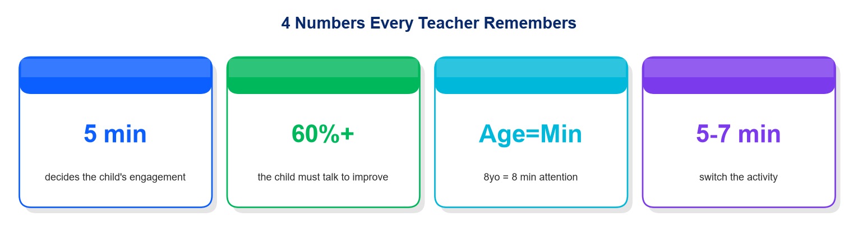
These 4 numbers summarize the entire manual. Repeat just these to yourself right before you start a class.

01. Why This Manual Exists
Most Mangoi students are curious, energetic children and teenagers whose attention spans are just as short as their curiosity is big. For this age group, it goes far beyond “I won't learn if it's boring.” The harsher truth is: “if I don't feel like this is fun within the first 5 minutes, my body may still be in front of the screen, but my mind has already logged out.” In other words, that first impression can decide the entire fate of the class.
On top of that, the online video format itself works against you. Compared to sitting face-to-face, a video class filters out roughly 30-40% of the non-verbal signals — tone of voice, facial expressions, body language — as they travel through the camera, the screen, and the internet connection. So if a teacher performs with the exact same “calm classroom energy” they'd use in person, it lands on the other side of the screen as flat and boring, and the child immediately reaches for a phone or opens another window.
“We are not teachers force-feeding dry grammar knowledge. We are pacesetters who build an exciting English playground and run alongside the child inside it — matching their pace so they don't stumble, and setting a rhythm so they never get tired. That is the true role of a Mangoi teacher.”
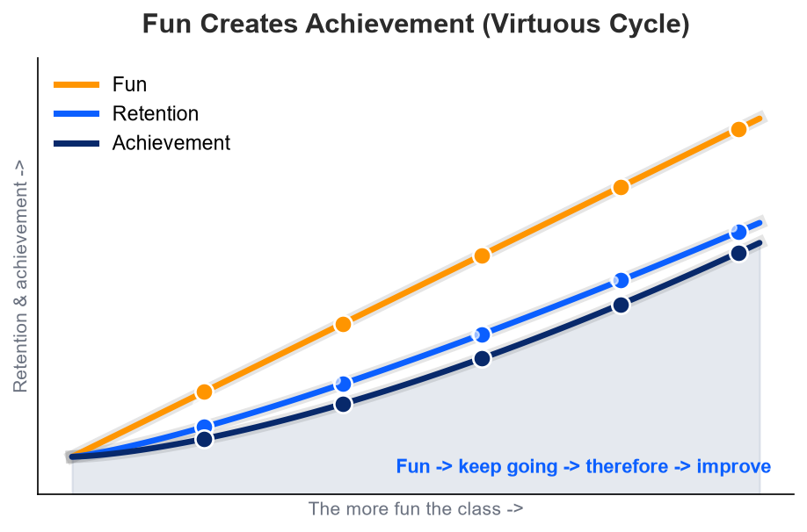
This chart tells a simple story. The more fun a class is (Fun), the less likely a child is to quit and the more likely they are to keep coming back (Retention) — and the longer a child stays, the greater their real improvement (Achievement) becomes. In other words, “engagement” is not a luxury that gets in the way of achievement — it is the single most reliable cause of it. Always remember the order: it's fun -> so they keep coming -> and because they keep coming -> they improve.

02. The 5 Core Areas to Drive Kid Engagement
The five items below are behaviors that every excellent Mangoi teacher applies consciously, in every single class, without exception. For each one, we've included why it matters, exactly how to do it, and a real example sentence you can say out loud. Don't try to master all five at once — just pick one to consciously practice today.
1 | 1. Energy & Expression — Warmth That Reaches Through the Screen  Why It Matters As explained above, facial expressions and vocal energy carry far weaker through a video call than in person. So if a teacher performs at their “normal, comfortable” level, it reads to the child as flat and boring. You need to react at roughly 1.5x your usual intensity for it to land, on the other side of the screen, as merely “warm and friendly.”  What To Do Don't hold back on non-verbal reactions — a thumbs-up, applause, wide eyes of surprise — the instant a child gets something right. Keep your vocal tone one notch higher and brighter than your everyday speaking voice — think of a slightly higher, more musical “Sol” tone. Look directly into the camera often to maintain eye contact.  Real Example Example: When a child answers a hard question correctly, react big — “Wow! Amazing! You are a genius!” — throw both hands up and clap.

2 | 2. Student Talk 60%+ — The One Who Talks Is the One Who Learns  Why It Matters Language only truly becomes yours once you've actually spoken it out loud. Yet the single easiest trap for a new teacher to fall into is simply talking too much. If the teacher keeps explaining grammar and vocabulary alone, the child becomes a passive audience, and both engagement and interest drop together. Always remember: the star of this class is the child, not the teacher.  What To Do Your target is for the child to be talking for 60% or more of the class time. After you ask a question, never rush — silently count “one, two, three” in your head and wait the full 3 seconds. During that pause, the child is actively assembling a sentence in their mind. If the teacher jumps in with the answer or interrupts, that valuable thinking process gets cut short.  Real Example Example: Ask “What did you do yesterday?” and if the child hesitates, don't rush to give the answer — smile and quietly wait the full 3 seconds. That alone will noticeably increase how much the child talks.

3 | 3. Make Achievement Visible, Instantly — the Power of Small Rewards  Why It Matters A child needs a clear, unmistakable signal that “I'm doing well right now” in order to want to come back for the next class. But a flat, soulless “good job” loses all impact after being repeated a few times. A sensory, almost physical-feeling reward — something that flashes, sounds, and bursts across the screen — builds confidence far more powerfully.  What To Do Make active use of Mangoi's star ratings, character badges, confetti effects that burst across the screen, and the dancing reactions of the Mango mascot. Building anticipation ahead of time also helps — try saying, “If you get this right, Mango is going to dance for you!” before a question.  Real Example Example: When the child answers correctly, shout “Yes! Look, Mango is dancing for you!” while showing the badge or star-rating effect at the same time.

4 | 4. Full Personalization — “This Class Was Made Just for Me”  Why It Matters A child opens up fully when they feel they are not just one of many students, but that this particular class was prepared specifically for them. Saying their name once or twice isn't enough — true personalization means weaving in their own stories, interests, and memories from past sessions naturally into the lesson.  What To Do Call the child's name often, and warmly. Slip in their favorite interests — soccer, K-pop, a specific video game — into example sentences or questions. Using Mangoi's textbook-linked AI warm-up and mistake-personalization features lets you walk into class already knowing exactly what that child tends to get wrong.  Real Example Example: For a child who loves soccer, ask something made just for them: “If you were Son Heung-min, what would you say right after scoring a goal?”

5 | 5. Rhythmic Transitions — Never Leaving Room for Boredom  Why It Matters A child's attention span is widely understood to roughly track their age in minutes (e.g., an 8-year-old ≈ 8 minutes). Push a single activity past that window and the child will start fidgeting, yawning, or drifting off — without exception. Boredom doesn't strike all at once; it builds up steadily from the moment an activity starts to drag.  What To Do Plan for no single activity to run longer than 5-7 minutes. Alternate rhythmically between different kinds of activities — “textbook -> mini-game -> free conversation -> another mini-game” — so the child keeps receiving fresh stimulation and never gets the chance to grow bored. The moment you spot a yawn or wandering eyes, switch to the next activity immediately.  Real Example Example: If a grammar explanation looks like it's about to run past 5 minutes, say “Okay, let's take a quick break and play a game!” and smoothly move into the game tab.

At a Glance — a Do vs Avoid Quick-Reference Table
The 5 core areas explained above are summarized here as a quick-reference table you can glance at mid-class. Feel free to print this out and keep it on your desk.
No | Engagement Area | Why It Matters | 🟢 Do This | 🔴 Avoid This
1 | Energy & Expression | Video calls filter out 30-40% of emotional expression, so only exaggerated energy actually registers as normal to the child. | Habitually use non-verbal reactions like thumbs-up, clapping, wide-eyed surprise, and raise your vocal tone one notch brighter. | A blank facial expression, a flat monotone voice reading like a script, and eyes that stay fixed on the keyboard or the textbook.
2 | Student Talk | The person doing the talking is the person doing the learning. The child must speak for both engagement and skill to rise together. | Aim for 60%+ student talk time, and always wait a full 3 seconds in silence after asking a question. | Answering your own question before the child has a chance to think, or monopolizing the conversation with long grammar explanations.
3 | Visible Achievement | A child needs concrete, physical-feeling feedback that says “I'm doing well” in order to want to keep coming to class. | Actively use stars, badges, confetti effects, and Mango mascot reactions to make achievement visible and audible. | Repeating a soulless “good job” over and over, or focusing only on pointing out wrong answers and weak points.
4 | Personalization | A child only fully opens up when they feel this particular class was prepared just for them, not a generic script. | Call the child's name often and warmly, and actively weave their interests — soccer, K-pop, games — into the conversation. | Repeating the exact same script for every single student, or completely forgetting last session's mistakes and feedback.
5 | Rhythm & Switching | A child's attention span roughly tracks their age in minutes (e.g., 8 years old ≈ 8 minutes). A dragging activity guarantees boredom. | Plan each activity in 5-7 minute blocks, and alternate rhythmically between textbook learning and fun game rewards. | Holding onto a single explanation for more than 15 minutes, or pushing forward with the lesson while the child is visibly yawning or distracted.

03. Age-Specific Teaching Tactics
The same idea of “fun” works in completely different ways depending on a child's age. Use the table below to prepare the right tactic in advance for whichever age group you're about to teach.
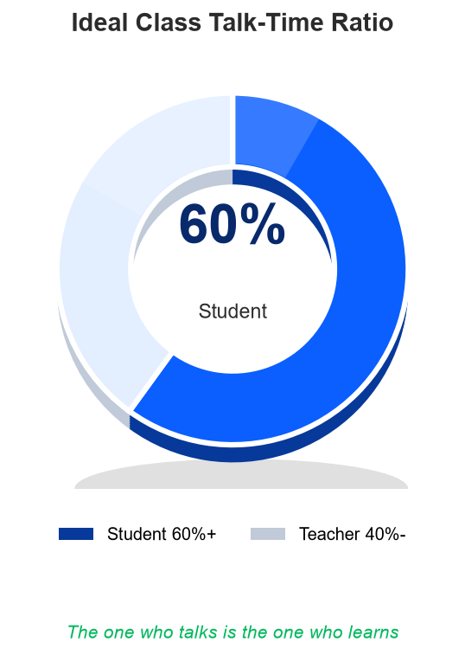  In an ideal class, it's the child — not the teacher — who talks 60% or more of the time. The more they talk, the faster they improve. | 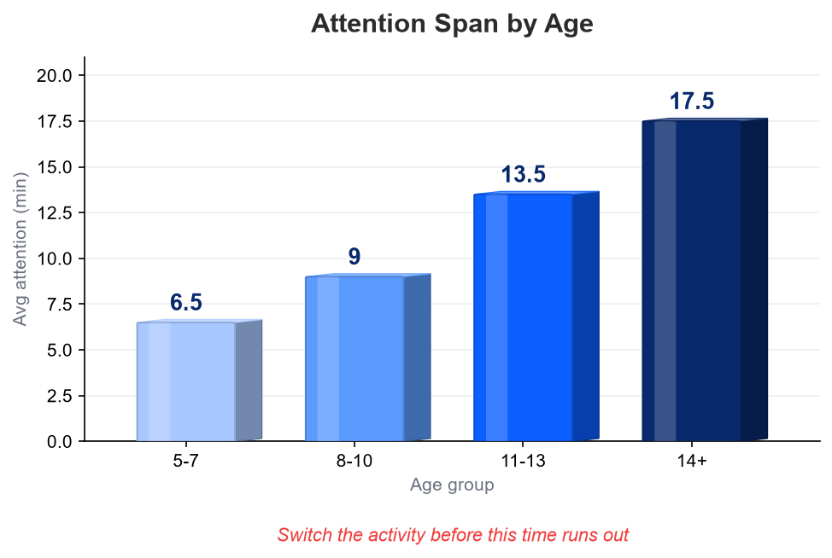  A child's age roughly equals their attention span in minutes. Switch to the next activity before this window runs out to keep boredom at bay.
Age Group | Avg. Attention Span | Field-Ready Tactics
5-7 (Early Childhood) | ~5-7 min | This age responds far more strongly to bouncy sounds and moving images than to text. Mix in puppets or hand-puppet gestures, upbeat action songs, and games with extremely simple rules (like color-matching or sound-repeating). It's more effective to build understanding through pictures and sound first, rather than through reading letters.
8-10 (Lower Elementary) | ~8-10 min | You need to precisely target their instinct to win and their drive to complete a mission. Make heavy use of short-round shooter games or 3D battle content, and emphasize the joy of collecting — badges, items, anything to gather.
11-13 (Upper Elementary) | ~12-15 min | This is the age where kids slowly start needing a reason — “why do I even need to learn this?” Showing them news about their favorite idols or YouTubers, or a ranking/competition graph comparing them to peers, noticeably boosts their focus.
14+ (Teenagers) | ~15-20 min | Overly childish vocal tones or exaggerated reactions can actually backfire, causing discomfort or resistance — be careful. Treat them with adult-to-adult respect, and win them over with practical payoffs like improved test scores or real conversational ability.

Appendix A. The Mangoi Engagement Cycle
The features Mangoi has already built are, on their own, just tools. Weave them together in the 6-step cycle below, run in order, and one single class transforms into a complete engagement structure. Practice this sequence until it becomes second nature, and repeat it naturally in every class.
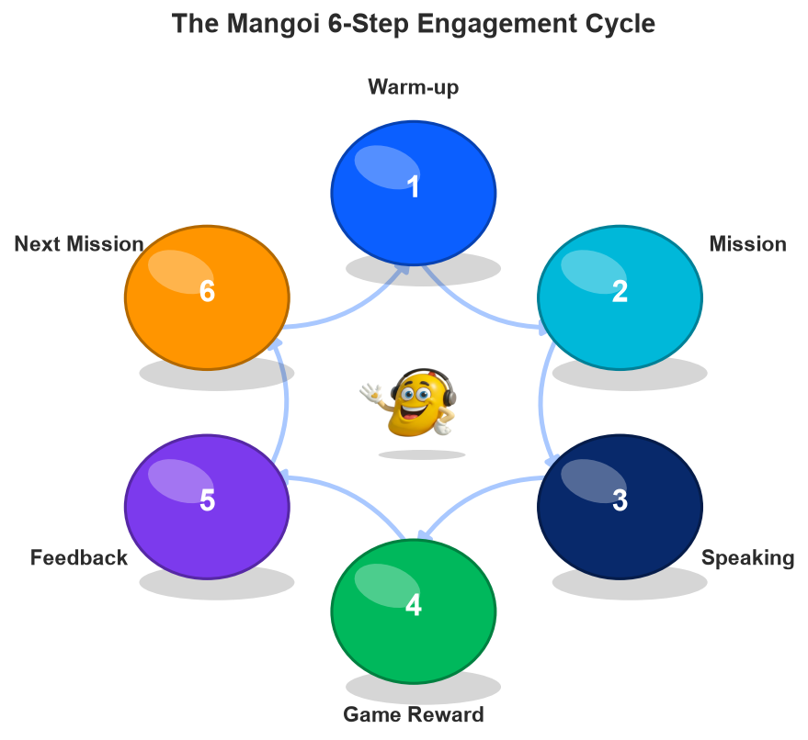
Warm-up -> Mission -> Speaking -> Game Reward -> Instant Feedback -> Next Mission. Complete one full loop of this cycle and you have a self-contained engagement structure.
Step | Session Phase | Mangoi Feature Used | Exactly What the Teacher Does | Goal of This Step
1 | Warm-up | AI Warm-up & Mistake Analytics | Slip in a light question that naturally touches on the grammar or vocabulary the child struggled with last time, folded casually into small talk. The key is that it should feel like a natural conversation, not a stern “you got this wrong last time, let's redo it.” | Lower the child's psychological guard with a low-pressure opening conversation and build a comfortable mood.
2 | Set a Mission | Goal-of-the-day Card | Declare one very easy, crystal-clear, visible target — like “If you master these 3 words today, you get a bonus game!” Always phrase the goal as a concrete number or action so it's instantly understandable to the child. | Instill the same tension and motivation a child feels right before starting a game.
3 | Speaking Focus | Textbook & Screen Sharing | Minimize explanations of sentence structure or grammar rules, and instead repeat a loop of “ask -> answer -> ask again” so the child thinks for themselves and produces their own speech. The teacher should act as a conversation partner, not a lecturer. | Create vibrant, student-led action learning.
4 | Game Reward | Game Hub (3D Battle / Shooter, etc.) | Activate a pre-prepared game right around the moment the child's energy starts to dip — typically around the 10-minute mark. The effect doubles when the game content connects back to what was just learned. | Give attention a crisp refresh and maximize the fun factor.
5 | Instant Reward | Stars, Badges, Mascot Feedback | Say something like “Look, Mango is dancing like crazy!” while showing celebratory effects across the whole screen. In this moment, the memory “I did well” gets stamped clearly into the child's mind. | Make achievement visibly quantifiable and build enthusiasm for the next challenge.
6 | Data Continuity | Learning Analytics & Teacher Report | Immediately jot down, in the report, any pronunciation or sentence pattern the child struggled with today. This note becomes the fuel that flows directly into next class's Step 1 warm-up. | Keep an unbroken, data-driven personalization loop going.

Appendix B. Teacher Self-Check Checklist
This checklist is organized around the before/during/after flow of a class so a teacher can self-monitor. You don't need to hit every single item perfectly every time — but printing it out and building the habit of checking off items one by one will noticeably improve the quality of your classes.
☐ | Phase | Item | Detailed Explanation & Execution Tip
☐ | Before Class | Confirmed the child's name, last week's feedback, and special hobbies | Remember the games or characters the child likes, along with last session's mistakes, and use them as material for the opening conversation.
☐ | Before Class | Set today's micro-goal (a small target) | Design one very light, low-pressure mission the child can easily achieve, like “get these 3 words exactly right.”
☐ | Before Class | Did a final check of camera angle and lighting | A teacher's face appearing dark is, on its own, a source of boredom. Check like a mirror that the lighting brightly illuminates your face from the front.
☐ | During Class | Made the child laugh brightly within the first 30 seconds | Bold gestures paired with a warm, excited call of the child's name can create a dramatic icebreaking effect all on their own.
☐ | During Class | Secured 60%+ of the class as student talk time | Compress your explanations as much as possible, and fully hand over the initiative of asking questions to the child — that's when true engagement begins.
☐ | During Class | Waited the full 3 seconds after asking a question | Don't feel awkward about the silence while the child translates and assembles a sentence in their head — trust it and wait it out.
☐ | During Class | Naturally switched activities every 5-7 minutes | Don't miss the signal — right before a child starts fidgeting or yawning, shift the rhythm into the next game or activity.
☐ | After Class | Logged today's star rating and report data immediately | Right after class, while memory is freshest, record specifically how many mistakes were made and which pronunciation was weak.

Appendix C. Teacher Evaluation Rubric
Score yourself, or have a trainer score you, from 1 (needs work) to 3 (excellent) on each of the 6 items below, then add them up. Whichever item scores lowest is exactly where the next coaching session should focus first. (The Excel workbook includes a feature that auto-calculates the total the moment you enter scores.)
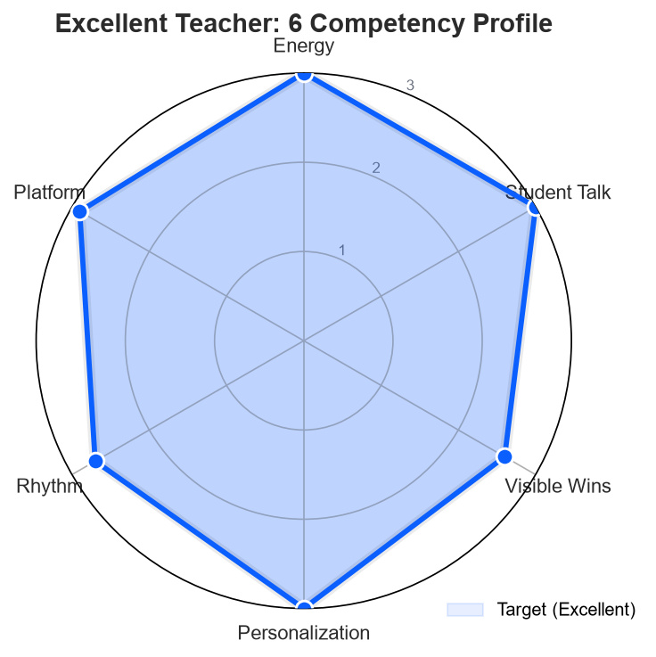
Excellent teachers show all 6 competencies evenly high, without any single area lagging behind. Compare your own profile and see where you can improve.
Criterion | What to Check for This Item | Score (1-3)
1. Energy & Expression | Do exaggerated smiles and rich reactions clearly reach through the screen, making the child naturally feel the fun? | ___
2. Driving Student Talk | Is teacher intervention and explanation minimized so the child gets 60% or more of the class as talk time? | ___
3. Visible Achievement | Are tools like stars, badges, and mascot reactions actively used so the child clearly feels their achievement, both visually and audibly? | ___
4. Personalization | Are the child's name, interests, and records from past sessions naturally woven into the lesson so it feels like “their own class”? | ___
5. Rhythm & Transitions | Are activities switched rhythmically every 5-7 minutes so the child's focus never has a chance to drift? | ___
6. Platform Mastery | Are the game tab, effect sounds, and integrated games handled smoothly, with no lag or fumbling? | ___
Total Score / 18 → |  | /18

Coaching Priority Guide by Total Score
15-18 pts (Excellent)
A teacher who is consistently excellent across every area. Worth recommending as a mentor for new teachers, or as a provider of best-practice clips for others to learn from.
10-14 pts (Reliable Quality)
Generally leading classes reliably in the field, but growth can accelerate a lot with focused coaching on the 1-2 items that scored lowest.
Under 9 pts (Needs Coaching)
Improvement is urgently needed across multiple areas. A 1-on-1 mock-class feedback session with the assigned trainer is strongly recommended as soon as possible.

04. Teacher Certification & Sign-off
The training lead and the certified teacher jointly confirm, with their signatures, that every teaching principle in this manual has been understood and committed to.
“I hereby pledge that I have fully understood and mastered every principle and piece of know-how in Mangoi's Engagement Growth Manual v2.0 — the 5 core behaviors, the engagement cycle, and the age-specific tactics alike. I commit to delivering a vibrant, boredom-free, tailored playground lesson to every student I meet going forward.”
Mangoi Training Lead  ________________________  Teacher Success Lead | Certified Teacher  ________________________  Professional Teacher
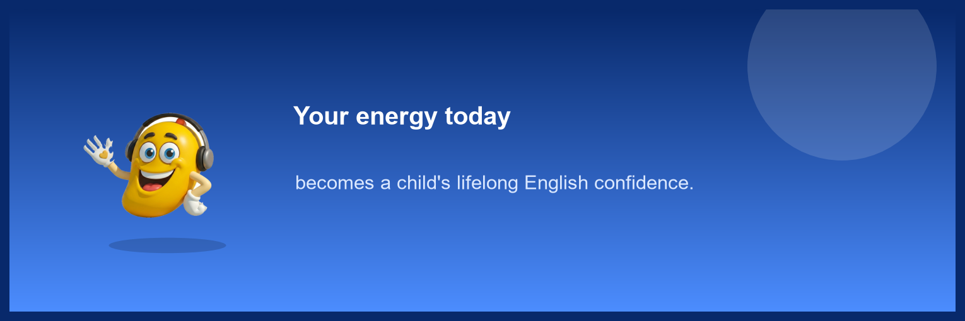
© Mangoi English | Teacher Success Team. All Rights Reserved.

