3GPP TS 36.321 V8.1.0 (2008-03)
Technical Specification
3rd Generation Partnership Project;
Technical Specification Group Radio Access Network;
Evolved Universal Terrestrial Radio Access (E-UTRA)
Medium Access Control (MAC) protocol specification
(Release 8)


The present document has been developed within the 3rd Generation Partnership Project (3GPP TM) and may be further elaborated for the purposes of 3GPP.
The present document has not been subject to any approval process by the 3GPP Organizational Partners and shall not be implemented.
This Specification is provided for future development work within 3GPP only. The Organizational Partners accept no liability for any use of this Specification.
Specifications and reports for implementation of the 3GPP TM system should be obtained via the 3GPP Organizational Partners' Publications Offices.

Keywords
UMTS, radio
3GPP
Postal address

3GPP support office address
650 Route des Lucioles - Sophia Antipolis
Valbonne - FRANCE
Tel.: +33 4 92 94 42 00 Fax: +33 4 93 65 47 16
Internet
http://www.3gpp.org
Copyright Notification
No part may be reproduced except as authorized by written permission.
The copyright and the foregoing restriction extend to reproduction in all media.

© 2008, 3GPP Organizational Partners (ARIB, ATIS, CCSA, ETSI, TTA, TTC).
All rights reserved.
Contents
Foreword 5
1 Scope 6
2 References 6
3 Definitions and abbreviations 6
3.1 Definitions 6
3.2 Abbreviations 7
4 General 7
4.1 Introduction 7
4.2 MAC architecture 7
4.2.1 MAC Entities 7
4.3 Services 8
4.3.1 Services provided to upper layers 8
4.3.2 Services expected from physical layer 8
4.4 Functions 8
4.5 Channel structure 9
4.5.1 Transport Channels 9
4.5.2 Logical Channels 9
4.5.3 Mapping of Transport Channels to Logical Channels 10
4.5.3.1 Uplink mapping 10
4.5.3.2 Downlink mapping 10
5 MAC procedures 11
5.1 Random Access procedure 11
5.1.1 Random Access Procedure initialization 11
5.1.2 Random Access Resource selection 11
5.1.3 Random Access Preamble transmission 12
5.1.4 Random Access Response reception 12
5.1.5 Contention Resolution 13
5.2 Maintenance of Uplink Time Alignment 14
5.3 DL-SCH data transfer 14
5.3.1 DL Assignment reception 14
5.3.2 HARQ operation 15
5.3.2.1 HARQ Entity 15
5.3.2.2 HARQ process 15
5.3.3 Disassembly and demultiplexing 16
5.4 UL-SCH data transfer 16
5.4.1 UL Grant reception 16
5.4.2 HARQ operation 16
5.4.2.1 HARQ entity 17
5.4.2.2 HARQ process 17
5.4.3 Multiplexing and assembly 18
5.4.3.1 Logical channel prioritization 18
5.4.3.2 Multiplexing of MAC SDUs 19
5.4.4 Scheduling Request 19
5.4.5 Buffer Status Reporting 19
5.5 PCH reception 20
5.6 BCH reception 20
5.7 Discontinuous Reception (DRX) 20
5.8 MAC reconfiguration 21
5.9 MAC Reset 21
5.X Handling of unknown, unforeseen and erroneous protocol data 22
6 Protocol Data Units, formats and parameters 22
6.1 Protocol Data Units 22
6.1.1 General 22
6.1.2 MAC PDU (DL-SCH and UL-SCH) 22
6.1.3 MAC Control Elements 23
6.1.3.1 Buffer Status Report MAC Control Elements 23
6.1.3.2 C-RNTI MAC Control Element 24
6.1.3.3 DRX Command MAC Control Element 24
6.1.3.4 UE Contention Resolution Identity MAC Control Element 24
6.1.4 MAC PDU (transparent MAC) 25
6.1.5 MAC PDU (Random Access Response) 25
6.2 Formats and parameters 26
6.2.1 MAC header for DL-SCH and UL-SCH 26
6.2.2 MAC header for Random Access Response 27
6.2.3 MAC payload for Random Access Response 28
7 Variables and constants 28
7.1 RNTI values 29
Annex A (informative): Change history 30

Foreword
This Technical Specification has been produced by the 3rd Generation Partnership Project (3GPP).
The contents of the present document are subject to continuing work within the TSG and may change following formal TSG approval. Should the TSG modify the contents of the present document, it will be re-released by the TSG with an identifying change of release date and an increase in version number as follows:
Version x.y.z
where:
x the first digit:
1 presented to TSG for information;
2 presented to TSG for approval;
3 or greater indicates TSG approved document under change control.
y the second digit is incremented for all changes of substance, i.e. technical enhancements, corrections, updates, etc.
z the third digit is incremented when editorial only changes have been incorporated in the document.

1 Scope
The present document specifies the E-UTRA MAC protocol.

2 References
The following documents contain provisions which, through reference in this text, constitute provisions of the present document.
- References are either specific (identified by date of publication, edition number, version number, etc.) or non-specific.
- For a specific reference, subsequent revisions do not apply.
- For a non-specific reference, the latest version applies. In the case of a reference to a 3GPP document (including a GSM document), a non-specific reference implicitly refers to the latest version of that document in the same Release as the present document.
[1] 3GPP TR 21.905: "Vocabulary for 3GPP Specifications".
[2] 3GPP TR 36.213: "E-UTRA; Physical Layer Procedures".

3 Definitions and abbreviations

3.1 Definitions
For the purposes of the present document, the terms and definitions given in TR 21.905 [1] and the following apply. A term defined in the present document takes precedence over the definition of the same term, if any, in TR 21.905 [1].
Active Time: time that the UE is awake. When DRX is configured by higher layer, this includes the On Duration, the time UE is continuously monitoring the PDCCH while the DRX Inactivity Timer has not expired and the time UE is continuously monitoring the PDCCH while any DRX Retransmission Timer is running.
Contention Resolution Timer: Specifies the number of consecutive [downlink subframe(s)] during which the UE shall monitor the PDCCH after the uplink message containing the C-RNTI MAC control element or the uplink message associated with UE Contention Resolution Identity submitted from higher layer is transmitted.
DRX Cycle: Specifies the periodic repetition of the On Duration followed by a possible period of inactivity (see figure 3.1-1 below).
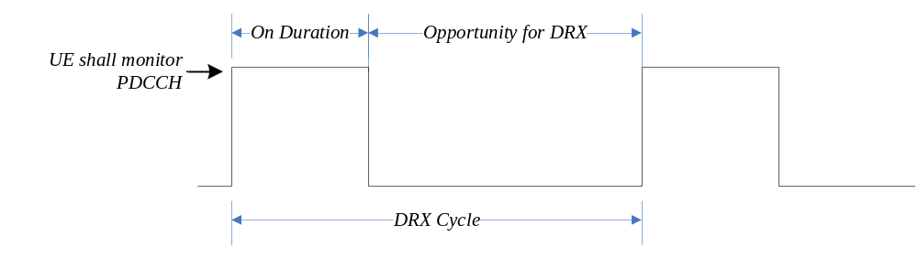
Figure 3.1-1: DRX Cycle
DRX Inactivity Timer: Specifies the number of consecutive downlink subframe(s) during which the UE shall monitor the PDCCH after successfully decoding a PDCCH indicating an initial UL or DL user data transmission for this UE.
DRX Retransmission Timer: Specifies the maximum number of consecutive downlink subframe(s) the UE shall monitor the PDCCH for as soon as a DL retransmission is expected by the UE.
DRX Short Cycle Timer: This parameter specifies the number of consecutive subframe(s)the UE shall follow the short DRX cycle after the DRX Inactivity Timer has expired.
HARQ RTT Timer: This parameter specifies the minimum amount of subframe(s) before a DL HARQ retransmission is expected by the UE.
On Duration Timer: Specifies the number of consecutive downlink subframe(s) during which the UE shall monitor the PDCCH for possible allocations. The On Duration Timer is a part of a DRX Cycle.
RA-RNTI: The Random Access RNTI is used on the [PDCCH] when Random Access Response messages are transmitted. It unambiguously identifies which time-frequency resource was utilized by the UE to transmit the Random Access preamble.

3.2 Abbreviations
For the purposes of the present document, the abbreviations given in TR 21.905 [1] and the following apply. An abbreviation defined in the present document takes precedence over the definition of the same abbreviation, if any, in TR 21.905 [1].
BSR Buffer Status Report
C-RNTI Cell RNTI
E-UTRA Evolved UMTS Terrestrial Radio Access
E-UTRAN Evolved UMTS Terrestrial Radio Access Network
MAC Medium Access Control
RA-RNTI Random Access RNTI
RNTI Radio Network Temporary Identifier
SR Scheduling Request
SRS Sounding Reference Symbols

Editor’s note: Check list of abbreviations for duplicates with TR 21.905.

4 General

4.1 Introduction
The objective is to describe the MAC architecture and the MAC entity from a functional point of view.

4.2 MAC architecture
The description in this sub clause is a model and does not specify or restrict implementations.
RRC is in control of configuration of MAC.

4.2.1 MAC Entities
E-UTRA defines two MAC entities; one in the UE and one in the E-UTRAN. These MAC entities handle the following transport channels:
- Broadcast Channel (BCH)
- Downlink Shared Channel (DL-SCH)
- Paging Channel (PCH)
- Multicast Channel (MCH)
- Uplink Shared Channel (UL-SCH)
- Random Access Channel(s) (RACH)
The exact functions performed by the MAC entities are different in the UE from those performed in the E-UTRAN.

4.3 Services

4.3.1 Services provided to upper layers
This clause describes the different services provided by MAC sub layer to upper layers.
- Data transfer
- Radio resource allocation

4.3.2 Services expected from physical layer
The physical layer provides the following services to MAC:
- data transfer services;
- signalling of HARQ feedback;
- signalling of Scheduling Request;
- measurements (e.g. Channel Quality Indication (CQI)).
The access to the data transfer services is through the use of transport channels. The characteristics of a transport channel are defined by its transport format (or format set), specifying the physical layer processing to be applied to the transport channel in question, such as channel coding and interleaving, and any service-specific rate matching as needed.

4.4 Functions
The following functions are supported by MAC sub layer:
- Mapping between logical channels and transport channels;
- Multiplexing of MAC SDUs from one or different logical channels onto transport blocks (TB) to be delivered to the physical layer on transport channels;
- Demultiplexing of MAC SDUs from one or different logical channels from transport blocks (TB) delivered from the physical layer on transport channels;
- Scheduling information reporting;
- Error correction through HARQ;
- Priority handling between UEs by means of dynamic scheduling;
- Priority handling between logical channels of one UE;
- Logical Channel prioritisation;
- Transport format selection;
NOTE: How the multiplexing relates to the QoS of the multiplexed logical channels is FFS.
The location of the different functions and their relevance for uplink and downlink respectively is illustrated in Table 4.4-1.
Table 4.4-1: MAC function location and link direction association.
MAC function | UE | eNB | Downlink | Uplink
Mapping between logical channels and transport channels | X |  | X | X
Mapping between logical channels and transport channels |  | X | X | X
Multiplexing | X |  |  | X
Multiplexing |  | X | X
Demultiplexing | X |  | X
Demultiplexing |  | X |  | X
Error correction through HARQ | X |  | X | X
Error correction through HARQ |  | X | X | X
Transport Format Selection |  | X | X | X
Priority handling between UEs |  | X | X | X
Priority handling between logical channels of one UE |  | X | X | X
Logical Channel prioritisation | X |  |  | X
Scheduling information reporting | X |  |  | X

4.5 Channel structure
The MAC sub layer operates on the channels defined below; transport channels are SAPs between MAC and Layer 1, logical channels are SAPs between MAC and RLC.

4.5.1 Transport Channels
The transport channels used by MAC are described in Table 4.5.1-1 below.
Table 4.5.1-1: Transport channels used by MAC
Transport channel name | Acronym | Downlink | Uplink
Broadcast Channel | BCH | X
Downlink Shared Channel | DL-SCH | X
Paging Channel | PCH | X
Multicast Channel | MCH | X
Uplink Shared Channel | UL-SCH |  | X
Random Access Channel | RACH |  | X

4.5.2 Logical Channels
The MAC layer provides data transfer services on logical channels. A set of logical channel types is defined for different kinds of data transfer services as offered by MAC.
Each logical channel type is defined by what type of information is transferred.
MAC provides the control and traffic channels listed in Table 4.5.2-1 below. When MAC uses the [L1/L2 control channel (name FFS)] to indicate radio resource allocation, the RNTI that is mapped on the [L1/L2 control channel (name FFS)] depends on the logical channel type.
Table 4.5.2-1: Logical channels provided by MAC.
Logical channel name | Acronym | Control channel | Traffic channel
Broadcast Control Channel | BCCH | X
Paging Control Channel | PCCH | X
Common Control Channel | CCCH | X
Multicast Control Channel | MCCH | X
Dedicated Control Channel | DCCH | X
Dedicated Traffic Channel | DTCH |  | X
Multicast Traffic Channel | MTCH |  | X

4.5.3 Mapping of Transport Channels to Logical Channels
The mapping of logical channels on transport channels depends on the multiplexing that is configured by RRC.

4.5.3.1 Uplink mapping
The MAC entity is responsible for mapping logical channels for the uplink onto uplink transport channels. The uplink logical channels can be mapped as described in Figure 4.5.3.1-1 and Table 4.5.3.1-1.
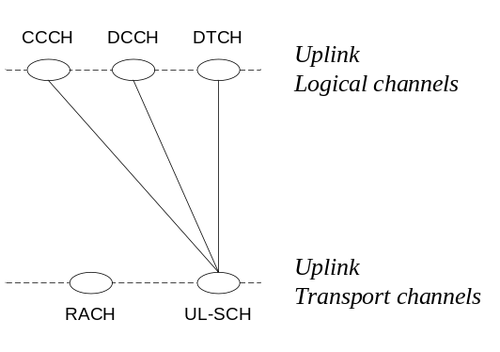
Figure 4.5.3.1-1
Table 4.5.3.1-1: Uplink channel mapping.
Transport channel  Logical channel | UL-SCH | RACH
CCCH | X
DCCH | X
DTCH | X

4.5.3.2 Downlink mapping
The MAC entity is responsible for mapping the downlink logical channels to downlink transport channels. The downlink logical channels can be mapped as described in Figure 4.5.3.2-1 and Table 4.5.3.2-1.
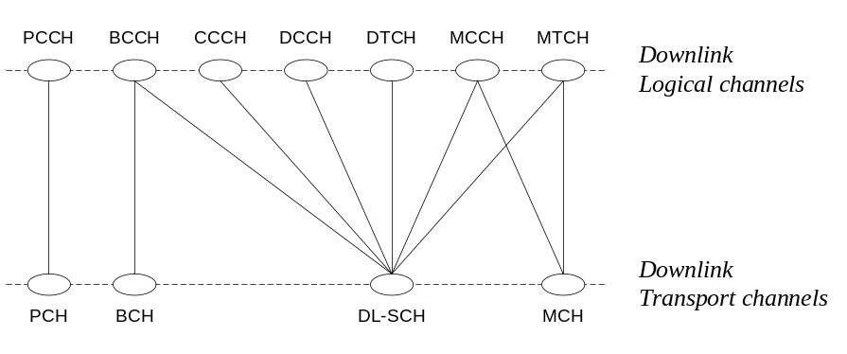
Figure 4.5.3.2-1
Table 4.5.3.2-1: Downlink channel mapping.
Transport channel  Logical channel | BCH | PCH | MCH | DL-SCH
BCCH | X |  |  | X
PCCH |  | X
CCCH |  |  |  | X
MCCH |  |  | X | X
DCCH |  |  |  | X
DTCH |  |  |  | X
MTCH |  |  | X | X

5 MAC procedures

5.1 Random Access procedure

5.1.1 Random Access Procedure initialization
The Random Access procedure described in this subclause is initiated upon request from higher layer, a PDCCH order or by the MAC sublayer itself.
Before the procedure can be initiated, the following information is assumed to be available:
- The available set of PRACH resources for the transmission of the Random Access Preamble and their corresponding RA-RNTIs.
- The groups of Random Access Preambles and the set of available Random Access Preambles in each group.
- The thresholds required for selecting one of the two groups of Random Access Preambles.
- The parameters required to derive the TTI window described in subclause 5.1.4.
- The power-ramping factor POWER_RAMP_STEP [integer ≥ 0].
- The parameter PREAMBLE_TRANS_MAX [integer > 0].
- The initial preamble power PREAMBLE_INITIAL_POWER.
[Note that the above parameters may be updated from higher layers before each Random Access procedure is initiated.]
The Random Access procedure shall be performed as follows:
- Set the PREAMBLE_TRANSMISSION_COUNTER to 1;
- proceed to the selection of the Random Access Resource (see subclause 5.1.2).

5.1.2 Random Access Resource selection
The Random Access Resource procedure shall be performed as follows:
If the Random Access Preamble and PRACH resource are explicitly signalled and its expiration time was configured and has not expired
- the UE can directly proceed to its transmission (see subclause 5.1.3).
- Else the Random Access Preamble shall be selected by the UE as follows:
- depending on the size of the message to be transmitted on the UL or the requested resource blocks [FFS] [the selection also depends on radio conditions], select one of the two groups of Random Access Preambles configured by RRC;
- randomly select a Random Access Preamble within the selected group. The random function shall be such that each of the allowed selections can be chosen with equal probability;
- if more than one PRACH resources are available in the same subframe (TDD), randomly select one. The random function shall be such that each of the allowed selections can be chosen with equal probability;
- proceed to the transmission of the Random Access Preamble (see subclause 5.1.3).

5.1.3 Random Access Preamble transmission
Editor’s note: The actual generation of the Random Access sequence is performed in 36.211.
The random-access procedure shall be performed as follows:
[- Set the parameter PREAMBLE_TRANSMISSION_POWER to PREAMBLE_INITIAL_POWER + (PREAMBLE_TRANSMISSION_COUNTER-1) * POWER_RAMP_STEP.]
[- If the PREAMBLE_TRANSMISSION_POWER is below the minimum power level, set the PREAMBLE_TRANSMISSION_POWER to the minimum power level.]
[- If the PREAMBLE_TRANSMISSION_POWER is above the maximum power level, set the PREAMBLE_TRANSMISSION_POWER to the maximum power level.]
- determine the next available Random Access occasion
- Instruct the physical layer to transmit a preamble using the selected PRACH resource, corresponding RA-RNTI, preamble index and PREAMBLE_TRANSMISSION_POWER.

5.1.4 Random Access Response reception
Once the Random Access Preamble is transmitted, the UE shall monitor the [PDCCH] in the TTI window [RA_WINDOW_BEGIN—RA_WINDOW_END] for Random Access Response(s). The UE may stop monitoring for Random Access Response(s) after successful reception of a Random Access Response corresponding to the Random Access Preamble transmission.
- If notification of a reception of the Random Access Response is received from lower layers, the UE shall:
- if the Random Access Response contains an Overload Indicator
- update the backoff parameter value in the UE
- else the UE shall update the backoff parameter to the value [0],
- if the Random Access Response contains a Random Access Preamble identifier corresponding to the transmitted Random Access Preamble (see subclause 5.1.3)
- the UE shall:
- consider this Random Access Response reception successful;
- process the received Timing Alignment value (see subclause 5.2);
- if an UL grant was received, process the UL grant value;
- if the UE does not have a C-RNTI, Temporary C-RNTI shall be set to the value received in the Random Access Response message no later than at the time of the first transmission corresponding to the UL grant provided in the Random Access Response message;
- If the UE is in RRC_CONNECTED state [except for RLF] and the Random Access Preamble was selected by MAC, a C-RNTI MAC control element shall be included in the subsequent uplink transmission;
- if the UE is in RRC_IDLE state [or RLF], provide an indication to the higher layers that the procedure was successful.
If no Random Access Response is received within the TTI window [RA_WINDOW_BEGIN—RA_WINDOW_END], or if all received Random Access Responses contain Random Access Preamble identifiers that do not match the transmitted Random Access Preamble, the Random Access Response reception is considered not successful and the UE shall:
- If the PREAMBLE_TRANSMISSION_COUNTER is less than PREAMBLE_TRANS_MAX
- increment PREAMBLE_TRANSMISSION_COUNTER by 1;
- if in this Random Access procedure:
- the Random Access Preamble was selected by MAC; or
- the Random Access Preamble and PRACH resource were explicitly signalled and will expire before the next available Random Access occasion:
- based on the backoff parameter stored in the UE since the Random Access procedure initialization (see subclause 5.1.1), compute and apply a backoff value indicating when a new Random Access transmission shall be attempted;
- proceed to the selection of a Random Access Resource (see subclause 5.1.2).
- Else if PREAMBLE_TRANSMISSION_COUNTER is equal to PREAMBLE_TRANS_MAX
- if the UE is in RRC_IDLE state [or RLF], indicate to the higher layer that the random access procedure failed.
Editor’s note: Whether error conditions are specified is FFS.

5.1.5 Contention Resolution
Contention Resolution is based on C-RNTI on [PDCCH] and UE Contention Resolution Identity on DL-SCH. The UE Contention Resolution Identity is informed by higher layer, when higher layer initiates Random Access procedure.
Once the uplink message containing the C-RNTI MAC control element or the uplink message including CCCH is transmitted, the UE shall:
- start the Contention Resolution Timer;
- monitor the [PDCCH] until the Contention Resolution Timer expires.
- If notification of a reception of a [PDCCH] transmission is received from lower layers, the UE shall:
- if the C-RNTI MAC control element was included in uplink message and the [PDCCH] transmission is addressed to its C-RNTI:
- consider this Contention Resolution successful and provide an indication to the higher layers;
- stop the Contention Resolution Timer.
- else if the uplink message includes CCCH and the [PDCCH] transmission is addressed to its Temporary C-RNTI:
- if the MAC PDU is successfully decoded:
- stop the Contention Resolution Timer.
- if the MAC PDU contains a UE Contention Resolution Identity MAC control element; and
- if the UE Contention Resolution Identity included in the MAC control element matches the UE Contention Resolution Identity provided by higher layer
- consider this Contention Resolution successful and finish the disassembly and demultiplexing of the MAC PDU.
- else
- consider this Contention Resolution not successful, discard the successfully decoded MAC PDU and provide an indication to the higher layers.
- If the Contention Resolution Timer expires
- if the C-RNTI MAC control element was used in uplink message and no [PDCCH] transmission addressed to its C-RNTI is received, the Contention Resolution is considered not successful and the UE shall:
- If the PREAMBLE_TRANSMISSION_COUNTER is less than PREAMBLE_TRANS_MAX
- increment PREAMBLE_TRANSMISSION_COUNTER by 1;
- based on the backoff parameter stored in the UE since the Random Access procedure initialization (see subclause 5.1.1), compute and apply a backoff value indicating when a new Random Access transmission shall be attempted;
- proceed to the selection of a Random Access Resource (see subclause 5.1.2).
- if the uplink message includes CCCH and no [PDCCH] transmission addressed to its Temporary C-RNTI is received:
- consider this Contention Resolution not successful and provide an indication to the higher layers.

5.2 Maintenance of Uplink Time Alignment
The UE has a configurable Time Alignment Timer. The Time Alignment Timer is valid only in the cell for which it was configured and started.
If the Time Alignment Timer has been configured, the UE shall:
- when a Time Alignment Command is received:
- apply the Time Alignment Command;
- start the Time Alignment Timer (if it is not running) or restart the Time Alignment Timer (if it was already running)
- when the Time Alignment Timer has expired or is not running:
- prior to any uplink transmission, use the Random Access procedure in order to obtain uplink Time Alignment
- when the Time Alignment Timer expires:
- release all PUCCH resources;
- release any assigned SRS resources.

5.3 DL-SCH data transfer
Editor’s note: Current text applies to, at least, FDD.

5.3.1 DL Assignment reception
Editor’s note: A downlink assignment can relate to one or two (MIMO) TBs. It is FFS how this information is presented to MAC.
Editor’s note: Mapping of downlink assignments received on [PDCCH] onto the TTIs for which they are valid is done by L1.
When the UE has a C-RNTI, Temporary C-RNTI or RA-RNTI, the UE shall for each TTI during Active Time, for each TTI when a Random Access Response or Contention Resolution is expected and for each TTI for which a DL assignment has been configured:
- If a downlink assignment for this TTI has been received on the [PDCCH] for the UE’s C-RNTI, Temporary C-RNTI or RA-RNTI:
- Indicate a downlink assignment and the associated HARQ information to the HARQ entity for this TTI;
- else, if a downlink assignment for this TTI has been configured and a downlink assignment for this TTI has not been received on the [PDCCH] for the UE’s C-RNTI, Temporary C-RNTI or RA-RNTI:
- Indicate a downlink assignment, for a new transmission, and the associated HARQ information to the HARQ entity for this TTI;
When the UE needs to read BCCH, the UE shall:
- If a downlink assignment for this TTI has been received on the [PDCCH] for the [broadcast identity];
- Indicate a downlink assignment for the dedicated broadcast HARQ process to the HARQ entity for this TTI;
NOTE: Downlink assignments for both C-RNTI and [broadcast identity] can be received in the same TTI.
Editor’s note: L1 is configured, as needed, by upper layers or MAC [FFS] to monitor [PDCCH] for C-RNTI, and by MAC to monitor [PDCCH] for Temporary C-RNTI and RA-RNTI.

5.3.2 HARQ operation
NOTE: Additional optimisations (e.g. less adaptive/synchronous) are FFS.

5.3.2.1 HARQ Entity
There is one HARQ entity at the UE which processes the HARQ process identifiers indicated by the HARQ information associated with TBs received on the DL-SCH.
A number of parallel HARQ processes are used in the UE to support the HARQ entity. [The number of HARQ processes is FFS].
If a downlink assignment has been indicated or configured for this TTI, the UE shall:
- allocate the received TB to the HARQ process indicated by the associated HARQ information.
NOTE: In case of BCCH a dedicated broadcast HARQ process will be used.

5.3.2.2 HARQ process
The HARQ process processes the New Data Indicator (name FFS) indicated from the HARQ entity for each received MAC PDU.
The UE shall:
- if a new transmission is indicated for this HARQ process:
- replace the data currently in the soft buffer for this HARQ process with the received data.
- if a retransmission is indicated for this HARQ process:
- if the data has not yet been successfully decoded:
- combine the received data with the data currently in the soft buffer for this HARQ process.
- if the transport block size is different from the last valid transport block size signalled for this HARQ process:
- the UE may replace the data currently in the soft buffer for this HARQ process with the received data.
- attempt to decode the data in the soft buffer
- if the data in the soft buffer was successfully decoded:
- deliver the decoded MAC PDU to the disassembly and demultiplexing entity;
- generate a positive acknowledgement (ACK) of the data in this HARQ process.
- else:
- generate a negative acknowledgement (NACK) of the data in this HARQ process;
- if the HARQ process is associated with a transmission indicated with an RA-RNTI; or
- if the HARQ process is associated with a transmission indicated with a Temorary C-RNTI and a Random Access Identity match is not indicated; or
- if the HARQ process is equal to the broadcast process:
- do not indicate the generated positive or negative acknowledgement to the physical layer
- else
- indicate the generated positive or negative acknowledgement to the physical layer.
Editor’s note: Multiplexing of multiple positive or negative acknowledgements and the time of transmission relative to the reception of data in a HARQ process is handled by L1.

5.3.3 Disassembly and demultiplexing
Editor’s note: This section describes the disassembly and demultiplexing of MAC PDUs into MAC SDUs.

5.4 UL-SCH data transfer
Editor’s note: Current text applies to, at least, FDD.

5.4.1 UL Grant reception
Editor’s note: For TDD, more than one uplink grant may need to be signalled in one TTI. Demultiplexing/decoding of such uplink grants is done by L1.
Editor’s note: Mapping of uplink grants received on [PDCCH] onto the TTIs for which they are valid is done by L1.
The UE shall for each TTI:
- If an uplink grant for this TTI has been received on the [PDCCH]; or
- if an uplink grant for this TTI has been received in a Random Access Response:
- Indicate a valid uplink grant and the associated HARQ information to the HARQ entity for this TTI;
- else, if an uplink grant for this TTI has been configured and an uplink grant for this TTI has not been received on the [PDCCH], nor in a Random Access Response:
- Indicate an uplink grant, valid for new transmission, and the associated HARQ information to the HARQ entity for this TTI.
NOTE: The period of configured uplink grants is expressed in TTIs.

5.4.2 HARQ operation
NOTE: Whether resource allocation and modulation and coding scheme can be adapted for retransmissions is FFS.

5.4.2.1 HARQ entity
There is one HARQ entity at the UE. A number of parallel HARQ processes are used in the UE to support the HARQ entity, allowing transmissions to take place continuously while waiting for the feedback on the successful or unsuccessful reception of previous transmissions.
At a given TTI, if an uplink grant is indicated for the TTI, the HARQ entity identifies the HARQ process for which a transmission should take place. It also routes the receiver feedback (ACK/NACK information), relayed by the physical layer, to the appropriate HARQ process.
The number of HARQ processes is equal to [X] [FFS]. Each process is associated with a number from 0 to [X-1].
At the given TTI, the HARQ entity shall:
- if an uplink grant, indicating a new transmission, is indicated for this TTI:
- notify the “uplink prioritisation” entity that the TTI is available for a new transmission;
- if the "uplink prioritisation" entity indicates the need for a new transmission:
- obtain the MAC PDU to transmit from the "Multiplexing and assembly" entity;
- instruct the HARQ process corresponding to this TTI to trigger the transmission of this new payload using the identified parameters.
- else:
- flush the HARQ buffer.
- else:
- if an uplink grant, indicating a re-transmission, is indicated for this TTI; or
- if the HARQ buffer of the HARQ process corresponding to this TTI is not empty:
- instruct the HARQ process to generate a re-transmission.
NOTE: Adaptive retransmissions are ‘sticky’; i.e., when parameters are modified for a retransmission, previous parameters no longer apply for subsequent retransmissions.

5.4.2.2 HARQ process
Each HARQ process is associated with a HARQ buffer.
Each HARQ process shall maintain a state variable CURRENT_TX_NB, which indicates the number of transmissions that have taken place for the MAC PDU currently in the buffer. When the HARQ process is established, CURRENT_TX_NB shall be initialized to 0.
The UE is configured with a maximum number of transmissions that is identical across all HARQ Processes and all Logical Channels.
If the HARQ entity provides a new PDU, the HARQ process shall:
- set CURRENT_TX_NB to 0;
- set CURRENT_IRV to 0;
- store the MAC PDU in the associated HARQ buffer;
- generate a transmission as described below.
If the HARQ entity requests a re-transmission, the HARQ process shall:
- if there is a measurement gap at the time of the re-transmission:
- increment CURRENT_TX_NB by 1;
- else:
- if an uplink grant for this was received on [PDCCH]:
- set CURRENT_IRV to the value indicated in the uplink grant;
- generate a transmission as described below;
- if no uplink grant for this was received on [PDCCH]:
- if a HARQ ACK was received for the last preceding transmission of the same data:
- increment CURRENT_TX_NB by 1.
- if no HARQ ACK was received for the last preceding transmission of the same data:
- generate a transmission as described below.
To generate a transmission, the HARQ process shall:
- instruct the physical layer to generate a transmission with the redundancy version corresponding to the CURRENT_IRV value and the transmission timing;
- if CURRENT_IRV < [Y] [FFS]:
- increment CURRENT_IRV by 1;
- increment CURRENT_TX_NB by 1;
The HARQ process shall:
- if CURRENT_TX_NB = maximum number of transmissions configured:
- flush the HARQ buffer;
- if the transmission corresponds to a transmission of CCCH and no HARQ ACK is received for this process:
- notify RRC that the transmission of the corresponding MAC SDU failed.
The HARQ process may:
- if CURRENT_TX_NB = maximum number of transmissions configured and no HARQ ACK is received for this process:
- notify the relevant ARQ entities in the upper layer that the transmission of the corresponding RLC PDUs failed.
Editor’s note: Demultiplexing of multiple positive or negative acknowledgements and the time of reception relative to the transmission of data in a HARQ process is handled by L1.

5.4.3 Multiplexing and assembly
Editor’s note: This subclause describes the procedure for creation of MAC SDUs including multiplexing of MAC SDUs and creating the MAC header.

5.4.3.1 Logical channel prioritization
The Logical Channel Prioritization procedure shall be applied when a new transmission is performed.
RRC can control the scheduling of uplink data by giving each logical channel a priority where increasing priority values indicate lower priority levels. In addition, each logical channel is given a Prioritized Bit Rate (PBR). The Logical Channel Prioritization procedure ensures that the UE serves the logical channels in the following sequence:
- All the logical channels are served in a decreasing priority order up to their configured PBR;
- if any resources remain, all the logical channels are served in a strict decreasing priority orderuntil either the data for that logical channel or the UL grant is exhausted, whichever comes first.
Logical channels configured with the same priority shall be served equally the by UE.
MAC control elements for BSR, with exception of Padding BSR, have higher priority than U-plane Logical Channels.
At serving cell change, the first UL-DCCH MAC SDU to be transmitted in the new cell has higher priority than MAC control elements for BSR.

5.4.3.2 Multiplexing of MAC SDUs
Editor’s note: This subclause describes the construction of MAC PDUs from MAC SDUs as prioritised and selected by the Logical channel prioritisation entity.

5.4.4 Scheduling Request
The Scheduling Request (SR) is for requesting UL-SCH resources.
If an SR has been triggered, the UE shall for each TTI, until UL-SCH resources are granted:
- If no UL-SCH resources are available in this TTI:
- If a PUCCH is configured for the UE to send an SR in this TTI, instruct the physical layer to signal the SR on PUCCH;
- If no PUCCH for SR is configured for the UE in any TTI, initiate a Random Access procedure (see subclause 5.1).
NOTE: A triggered SR is considered pending and is repeated until UL-SCH resources are granted.

5.4.5 Buffer Status Reporting
The Buffer Status reporting procedure is used to provide the serving eNB with information about the amount of data in the UL buffers of the UE.
A Buffer Status Report (BSR) shall be triggered if any of the following events occur:
- UL data arrives in the UE transmission buffer and the data belongs to a logical channel with higher priority than those for which data already existed in the UE transmission buffer, in which case the BSR is referred below to as “Regular BSR”;
- UL resources are allocated and number of padding bits is larger than the size of the Buffer Status Report MAC control element, in which case the BSR is referred below to as “Padding BSR”;
- a serving cell change occurs, in which case the BSR is referred below to as “Regular BSR”;
- the PERIODIC BSR TIMER expires, in which case the BSR is referred below to as “Periodic BSR”.
For Regular and Periodic BSR:
- if only one LCG has buffered data in the TTI where the BSR is transmitted: report short BSR;
- else if more than one LCG has buffered data in the TTI where the BSR is transmitted: report long BSR.
For padding BSR:
- if the number of padding bits is equal to or larger than the size of the Short BSR but smaller than the size of the Long BSR, report Short BSR of the LCG with the highest priority logical channel with buffered data;
- else if the number of padding bits is equal to or larger than the size of the Long BSR, report Long BSR.
If the Buffer Status reporting procedure determines that a BSR has been triggered since the last transmission of a BSR:
- if the UE has UL resources allocated for new transmission for this TTI:
- instruct the Multiplexing and Assembly procedure to generate a BSR MAC control element;
- restart the PERIODIC BSR TIMER;
- else if a Regular BSR has been triggered since the last transmission of a BSR:
- a Scheduling Request shall be triggered
NOTE: Even if multiple events occur by the time a BSR can be transmitted, only one BSR will be included in the MAC PDU.
A pending Buffer Status report is cancelled in case the UL grant can accommodate all pending data but is not sufficient to accommodate the BSR MAC control element in addition.

5.5 PCH reception
When in RRC_IDLE, the UE shall at its paging occasions:
- If a PCH assignment has been received on the [PDCCH] with the Paging RNTI:
- attempt to decode the TB on the PCH as indicated by the [PDCCH] information;
- If a TB on the PCH has been successfully decoded:
- deliver the decoded MAC PDU to higher layers.

5.6 BCH reception
When the UE needs to receive BCH, the UE shall:
- receive and attempt to decode the BCH;
- if a TB on the BCH has been successfully decoded:
- deliver the decoded MAC PDU to higher layers;

5.7 Discontinuous Reception (DRX)
The UE may be configured [by RRC/MAC] with a DRX functionality that allows it to stop monitoring PDCCH during some period of time.
The DRX functionality consists of a Long DRX cycle, a DRX Inactivity Timer, a DRX Retransmission Timer and optionally a Short DRX Cycle and a DRX Short Cycle Timer all defined in subclause 3.1.
When a DRX cycle has been configured, the UE shall for each downlink subframe:
- Whenever a new DRX Cycle begins (long or short) i.e. whenever [(SFN * 10) + subframe number] modulo (current DRX) = DRX Start Offset, the On Duration Timer is started.
- If a HARQ RTT Timer expires in this downlink subframe and the data in the soft buffer of the corresponding HARQ process was not successfully decoded:
- UE shall start the DRX Retransmission Timer for the corresponding HARQ process.
- If a DRX Command MAC control element is received:
- stop the On Duration Timer;
- stop the DRX Inactivity Timer.
NOTE: Once a timer is stopped, it cannot expire.
- If the Contention Resolution Timer or On Duration Timer or DRX Inactivity Timer or any DRX Retransmission Timer is running; or:
- an UL grant for a retransmission can occur; or
- a Scheduling Request is pending as described in subclause 5.4.4; or
- a PDCCH addressed to the C-RNTI or Temporary C-RNTI of the UE has not been received after successful reception of a Random Access Response is indicated (as described in subclause 5.1.4):
- UE shall monitor the PDCCH;
- if the PDCCH is successfully decoded:
- stop the DRX Short Cycle Timer if configured,
- if the PDCCH indicates a DL transmission:
- start the HARQ RTT Timer for the corresponding HARQ process;
- stop the DRX Retransmission Timer for the corresponding HARQ process.
- If the PDCCH indicates a new transmission (DL or UL); and
- this is the first received PDCCH addressed to the C-RNTI or Temporary C-RNTI of the UE since successful reception of a Random Access Response is indicated; or
- a Scheduling Request is pending; or
- the On Duration Timer is running; or
- the DRX Inactivity Timer is running:
- start or restart the DRX Inactivity Timer.
- If a DL assignment has been configured for this downlink subframe and no PDCCH indicating a DL transmission was successfully decoded:
- start the HARQ RTT Timer for the corresponding HARQ process.
- If the DRX Inactivity Timer expires in this downlink subframe:
- if the short DRX cycle is configured:
- start DRX Short Cycle Timer;
- use the short DRX cycle;
- else use the long DRX cycle.
- If DRX Short Cycle Timer expires in this downlink subframe:
- use the long DRX cycle.
Regardless of whether the UE is monitoring PDCCH or not the UE receives and transmits HARQ feedback when such is expected.

5.8 MAC reconfiguration
Editor’s note: This subclause describes the procedure for handling reconfiguration of MAC parameters during normal operation.

5.9 MAC Reset
Editor’s note: This subclause describes the procedure for resetting MAC [FFS]; e.g. at handover.

5.X Handling of unknown, unforeseen and erroneous protocol data
Editor’s note: This subclause describes how MAC treats and acts on unexpected data.
Editor’s note: The subclause on “Handling of unknown, unforeseen and erroneous protocol data” should be the last subsection of Section “MAC procedures”.

6 Protocol Data Units, formats and parameters

6.1 Protocol Data Units

6.1.1 General
A MAC PDU is a bit string that is byte aligned (i.e. multiple of 8 bits) in length. In the figures in subclause 6.1, bit strings are represented by tables in which the most significant bit is the leftmost bit of the first line of the table, the least significant bit is the rightmost bit on the last line of the table, and more generally the bit string is to be read from left to right and then in the reading order of the lines. The bit order of each parameter field within a MAC PDU is represented with the first and most significant bit in the leftmost bit and the last and least significant bit in the rightmost bit.
MAC SDUs are bit strings that are byte aligned (i.e. multiple of 8 bits) in length. An SDU is included into a MAC PDU from the first bit onward.

6.1.2 MAC PDU (DL-SCH and UL-SCH)
A MAC PDU consists of a MAC header, zero or more MAC Service Data Units (MAC SDU), zero, or more MAC control elements, and optionally padding; as described in Figure 6.1.2-3.
Both the MAC header and the MAC SDUs are of variable sizes.
A MAC PDU header consists of one or more MAC PDU sub-headers; each sub-header corresponding to either a MAC SDU, a MAC control element or padding.
A MAC PDU sub-header consists of the six header fields R/R/E/LCID/F/L but for the last sub-header in the MAC PDU and for fixed sized MAC control elements. The last sub-header in the MAC PDU and sub-headers for fixed sized MAC control elements consist solely of the four header fields R/R/E/LCID. It follows that a MAC PDU sub-header corresponding to padding consists of the four header fields R/R/E/LCID.
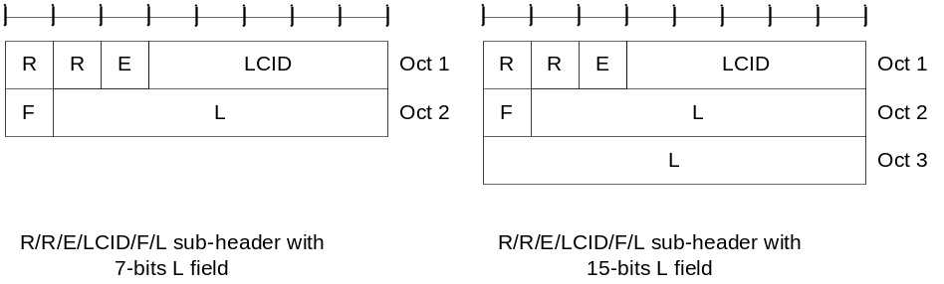
Figure 6.1.2-1: R/R/E/LCID/F/L MAC sub-header
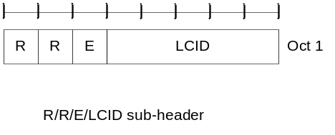
Figure 6.1.2-2: R/R/E/LCID MAC sub-header
MAC PDU sub-headers have the same order as the corresponding MAC SDUs, MAC control elements and padding.
MAC control elements, except Padding BSR, are always placed before any MAC SDU. Padding BSR occurs at the end of the MAC PDU.
Padding occurs at the end of the MAC PDU, except when single-byte or two-byte padding is required but cannot be achieved by padding at the end of the MAC PDU.
When single-byte or two-byte padding is required but cannot be achieved by padding at the end of the MAC PDU, one or two MAC PDU sub-headers corresponding to padding are inserted before the first MAC PDU sub-header corresponding to a MAC SDU; or if such sub-header is not present, before the last MAC PDU sub-header corresponding to a MAC control element.
A maximum of one MAC PDU can be transmitted per TB per UE. [Depending on the physical layer category], one or two TBs can be transmitted per TTI per UE.
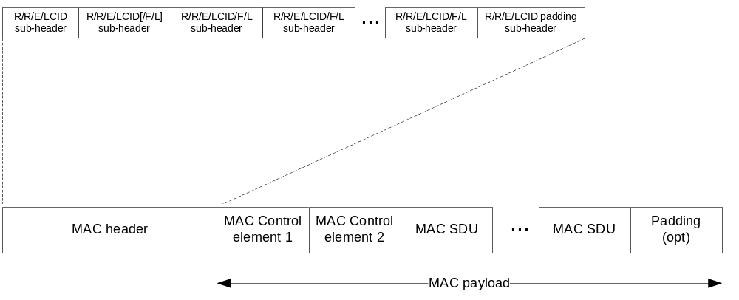
Figure 6.1.2-3: MAC PDU consisting of MAC header, MAC control elements, MAC SDUs and padding
Editor’s note: It is FFS whether this MAC PDU applies only to DL/UL SCH or also to other transport channels

6.1.3 MAC Control Elements

6.1.3.1 Buffer Status Report MAC Control Elements
Buffer Status Report (BSR) MAC control elements consist of either:
- Short BSR format: one LCG ID field and one corresponding BS field (figure 6.1.3.1-1); or
- Long BSR format: four Buffer Size fields, corresponding to LCG IDs #1 through #4 (figure 6.1.3.1-2).
The BSR formats are identified by MAC PDU subheaders with LCIDs as specified in table 6.2.1.-1.
The fields LCG ID and BS are defined as follow:
- LCG ID: The Logical Channel Group ID field identifies the group of logical channel(s) which buffer status is being reported. The length of the field is 2 bits.
- Buffer Size: The Buffer Size field identifies the total amount of data available across all logical channels of a logical channel group after the MAC PDU has been built. The amount of data is indicated in number of bytes. It shall include all data that is available for transmission in the RLC layer and in the PDCP layer. RLC control PDUs to be transmitted, RLC PDUs that have been transmitted and negatively acknowledged by the peer entity and PDCP control PDUs shall also be included in the buffer size computation. The RLC and MAC header sizes are not considered in the buffer size computation.The length of this field is 6 bits. The values taken by the Buffer Size field are shown in [Table 6.1.2.1-1].
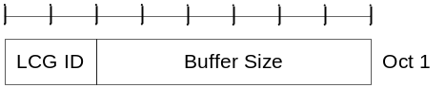
Figure 6.1.3.1-1: Short Buffer Status MAC control element
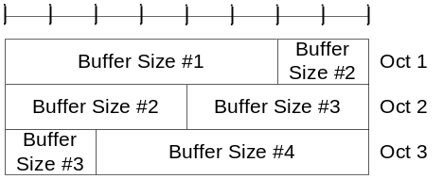
Figure 6.1.3.1-2: Long Buffer Status MAC control element

6.1.3.2 C-RNTI MAC Control Element
The C-RNTI MAC control element is identified by MAC PDU subheaders with LCIDs as specified in table 6.2.1-2.
It has a fixed size and consists of a single field defined as follows (figure 6.1.3.2-1):
- C-RNTI: This field contains the C-RNTI of the UE. The length of the field is 16 bits.
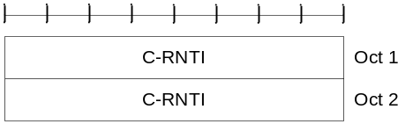
Figure 6.1.3.2-1: C-RNTI MAC control element

6.1.3.3 DRX Command MAC Control Element
The DRX Command MAC control element is identified by a MAC PDU subheader with and LCID as specified in table 6.2.1-1.
It has a fixed size of zero bits.

6.1.3.4 UE Contention Resolution Identity MAC Control Element
The UE Contention Resolution Identity MAC control element is identified by MAC PDU subheaders with LCIDs as specified in table 6.2.1-2.
It has a fixed size and consists of a single field defined as follows (figure 6.1.3.4-1)
- UE Contention Resolution Identity: This field contains the information used for contention resolution. The detailed structure and length of the field is 40 or 48 bits (FFS).
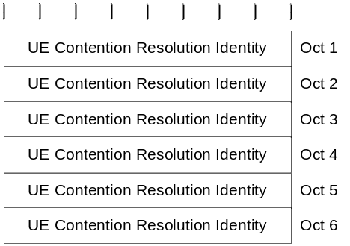
Figure 6.1.3.4-1: UE Contention Resolution Identity MAC control element

6.1.4 MAC PDU (transparent MAC)
A MAC PDU consists solely of a MAC Service Data Unit (MAC SDU) whose size is aligned to a transport block; as described in figure 6.1.4-1.
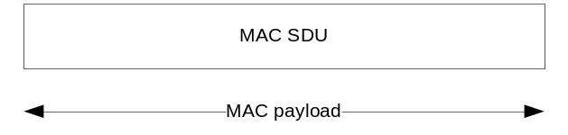
Figure 6.1.4-1: MAC PDU (transparent MAC)

6.1.5 MAC PDU (Random Access Response)
A MAC PDU consists of a MAC header and one or more MAC Random Access Responses (MAC RAR) as described in figure 6.1.5-4.
The MAC header is of variable size.
A MAC PDU header consists of one or more MAC PDU sub-headers; each sub-header corresponding to a MAC RAR except for the Overload Indicator sub-header.
A MAC PDU sub-header consists of the three header fields E/T/RAID (as described in figure 6.1.5-1) but for the Overload Indicator sub-header which consists of the five header field E/T/R/R/OI (as described in figure 6.1.5-2).
A MAC RAR consists of the three fields TA/UL Grant/T-CRNTI (as described in figure 6.1.5-3)
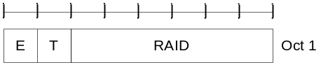
Figure 6.1.5-1: E/T/RAID MAC sub-header
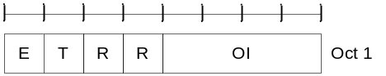
Figure 6.1.5-2: E/T/R/R/OI MAC sub-header
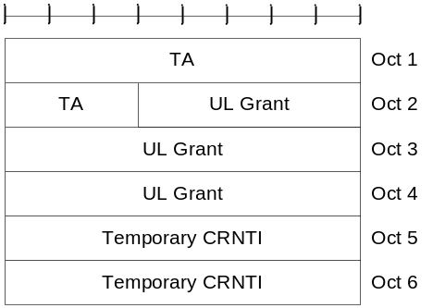
Figure 6.1.5-3: MAC RAR
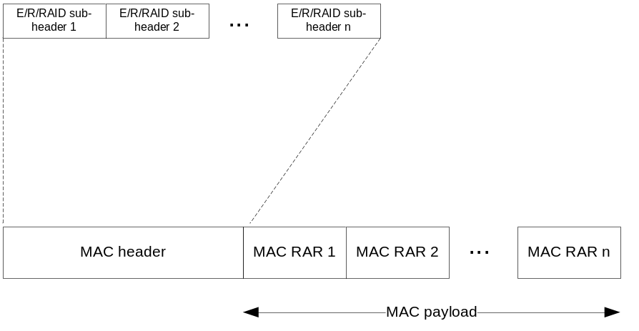
Figure 6.1.5-4: MAC PDU consisting of a MAC header and MAC RARs

6.2 Formats and parameters

6.2.1 MAC header for DL-SCH and UL-SCH
The MAC header is of variable size and consists of the following fields:
- LCID: The Logical Channel ID field identifies the logical channel instance of the corresponding MAC SDU or the type of the corresponding MAC control element or padding as described in tables 6.2.1-1 and 6.2.1-2 for the DL and UL-SCH respectively. There is one LCID field for each MAC SDU, MAC control element or padding included in the MAC PDU. The LCID field size is 5 bits.
- L: The Length field indicates the length of the corresponding MAC SDU or MAC control element in bytes. There is one L field per MAC PDU sub-header except for the last sub-header and sub-headers corresponding to fixed-sized MAC control elements. The size of the L field is indicated by the F field.
- F: The Format field indicates the size of the Length field as indicated in table 6.2.1-3. There is one F field per MAC PDU sub-header except for the last sub-header and sub-headers corresponding to fixed-sized MAC control elements. The size of the F field is 1 bit.
- E: The Extension field is a flag indicating if more fields are present in the MAC header or not. The E field is set to "1" to indicate another set of at least R/R/E/LCID fields. The E field is set to "0" to indicate that either a MAC SDU, a MAC control element or padding starts at the next byte
- R: Reserved bits.
The MAC header and sub-headers are octet aligned.
Table 6.2.1-1 Values of LCID for DL-SCH
Index | LCID values
00000 | CCCH
00001-xxxxx | Identity of the logical channel
xxxxx-11011 | Reserved
11100 | [UE Contention Resolution Identity]
11101 | [Timing Advance]
11110 | DRX Command
11111 | Padding

Table 6.2.1-2 Values of LCID for UL-SCH
Index | LCID values
00000 | CCCH
00001-yyyyy | Identity of the logical channel
yyyyy-11010 | Reserved
11011 | [Power Headroom Report]
11100 | C-RNTI
11101 | Short Buffer Status Report
11110 | Long Buffer Status Report
11111 | Padding

Table 6.2.1-3 Values of F field:
Index | Size of Length field (in bits)
0 | 7
1 | 15

Editor’s note: It is FFS whether this MAC header applies only to DL/UL SCH or also to other transport channels.
Editor’s note: xxxxx and yyyyy are FFS

6.2.2 MAC header for Random Access Response
The MAC header is of variable size and consists of the following fields:
- E: The Extension field is a flag indicating if more fields are present in the MAC header or not. The E field is set to "1" to indicate another set of at least E/T/RAID or E/T/R/R/OI fields. The E field is set to "0" to indicate that a MAC RAR starts at the next byte
- T: The Type field is a flag indicating whether the MAC sub-header contains a Random Access ID or an Overload Indicator. The T field is set to “0” to indicate the presence of an Overload Indicator field in the sub-header (OI). The T field is set to “1” to indicate the presence of a Random Access ID field in the sub-header (RAID).
- R: Reserved bit.
- OI: The Overload Indicator field identifies the overload condition in the cell. The size of the OI field is 4 bits.
- RAID: The Random Access IDentity field identifies the transmitted Random Access Preamble (see subclause 5.1.3). The size of the RAID field is 6 bits.
The MAC header and sub-headers are octet aligned.

6.2.3 MAC payload for Random Access Response
The MAC RAR is of [fixed] size and consists of the following fields:
- TA: The Timing Advance field indicates the required adjustment to the uplink transmission timing to be used for timing synchronisation (see subclause 4.2.4 of [2]). The size of the TA field is [11] bits.
- UL Grant: The UpLink Grant field indicates the resources to be used on the uplink. The size of the UL Grant field is [21] bits.
- T-CRNTI: The Temporary CRNTI field indicates the temporary identity that is used by the UE until contention resolution succeeds or another Random Access procedure is initiated. The size of the T-CRNTI field is 16 bits.
The MAC RAR is octet aligned.
Editor’s note: The size of the TA and UL Grant field is FFS

7 Variables and constants
Editor’s note: This subclause defines the variables and constants used by MAC.

7.1 RNTI values
RNTI values are presented in Table 7.1-1.
Table 7.1-1: RNTI values.
Value (hexa-decimal) | RNTI
0000-[tbd] | RA-RNTI
[tbd]-FFF2 | C-RNTI and T-CRNTI
FFF3-FFFC | Reserved for future use
FFFD | P-RNTI
FFFE | SI-RNTI
FFFF | SC-RNTI

Annex A (informative):
Change history

Change history
Date | TSG # | TSG Doc. | CR | Rev | Subject/Comment | Old | New
2007-06 | RAN2#58bis | R2-072710 |  |  | MAC Protocol Specification Baseline | -
2007-06 | RAN2#58bis | R2-072912 |  |  | Text Proposal for UL HARQ (Tdoc R2-072708)  Text Proposal for DL HARQ (Tdoc R2-072707)  Text Proposal for RACH procedure (Tdoc R2-072640)  Text Proposal for Logical Channel prioritization (Tdoc R2-072643) |  | 0.1.0
2007-06 | RAN2#58bis | R2-072994 |  |  | Basic MAC PDU structure (Tdoc R2-072983) with updates  Agreements on time-frequency resource configuration (Tdoc R2-072993)  Agreement on RA-RNTI association (Tdoc R2-072993)  Clarification on RA Response reception (Tdoc R2-072993) | 0.1.0 | 0.1.1
2007-08 | RAN2#59 | R2-073715 |  |  | Removed reference to non-existing table (Tdoc R2-073473)  Incorrect mapping of logical to transport channel (Tdoc R2-073473)  Un-necessary error checking in HARQ process procedure (Tdoc R2-073473)  Removal of reference to timing relation for HARQ feedback (Tdoc R2-073473)  Correction of Internal variable name (Tdoc R2-073473)  Correction of procedure in case of successful HARQ reception (Tdoc R2-073473) | 0.1.1 | 0.2.0
2007-09 | RAN2#59 | R2-073885 |  |  | Text proposal for Random Access procedure  Text proposal on HARQ clarification for TDD  Text proposal on HARQ for grants | 0.2.0 | 0.2.1
2007-09 | RAN#37 | RP-070688 |  |  | Clean version for information | 0.2.1 | 1.0.0
2007-10 | RAN2#59bis | R2-074530 |  |  | Editorial update with Editor’s notes (Tdoc R2-074211). | 1.0.0 | 1.1.0
2007-11 | RAN2#60 | R2-075093 |  |  | Agreements on MAC PDU format (R2-074536)  Corrections on Random Access Procedure (R2-074536) | 1.1.0 | 1.1.1
2007-11 | RAN2#60 | R2-075243 |  |  | Endorsement of v1.1.1  Removal of FFS on DL CCCH existence | 1.1.1 | 1.2.0
2007-11 | RAN2#60 | R2-075488 |  |  | Agreement on identity used Random Access Response (R2-075038)  Agreement on Local Nack1 (R2-074949)  PUCCH Resource handling (R2-075432)  UL HARQ agreements (R2-075432)  Agreements on semi-persistent scheduling (R2-075432, 36.300)  Agreements on BSR/SR triggers (R2-075432)  Agreements on BSR contents (R2-075432)  Agreements on Timing Advance principles (36.300)  Agreements on DRX control (36.300)  Handling of P-BCH, D-BCH, PCH (R2-075246) | 1.2.0 | 1.3.0
2007-11 | RAN #38 | RP-070917 |  |  | Clean version, presented at TSG RAN-38 for approval | 1.3.0 | 2.0.0
2007-12 | RAN #38 | - |  |  | Approved at TSG RAN-38 and placed under change control | 2.0.0 | 8.0.0
2008-03 | RAN #39 | RP-080162 | 0001 | 2 | CR to 36.321 with E-UTRA MAC protocol specification update | 8.0.0 | 8.1.0

