MMS IoT Monitor System
(Web Dashboard)
User Manual: Operator & Admin Guide
Classification: Internal Use Only
High-Throughput IoT Pipeline (1,000 msg/sec)
Web URL: http://xxx.xxx.x.x:1311/
Portainer URL: http://xxx.xxx.x.x:9000/

1. Web Dashboard Usage & Configurations
1.1 Signing In (Login)
When opening the web dashboard at http://xxx.xxx.x.x:1311/, you will be automatically redirected to the login page. Enter your credentials based on your assigned role:
• Admin Role: Username = admin / Password = admin (Allows managing system configurations and registers)
• User Role: Username = user / Password = user (Allows viewing real-time machine statuses only)
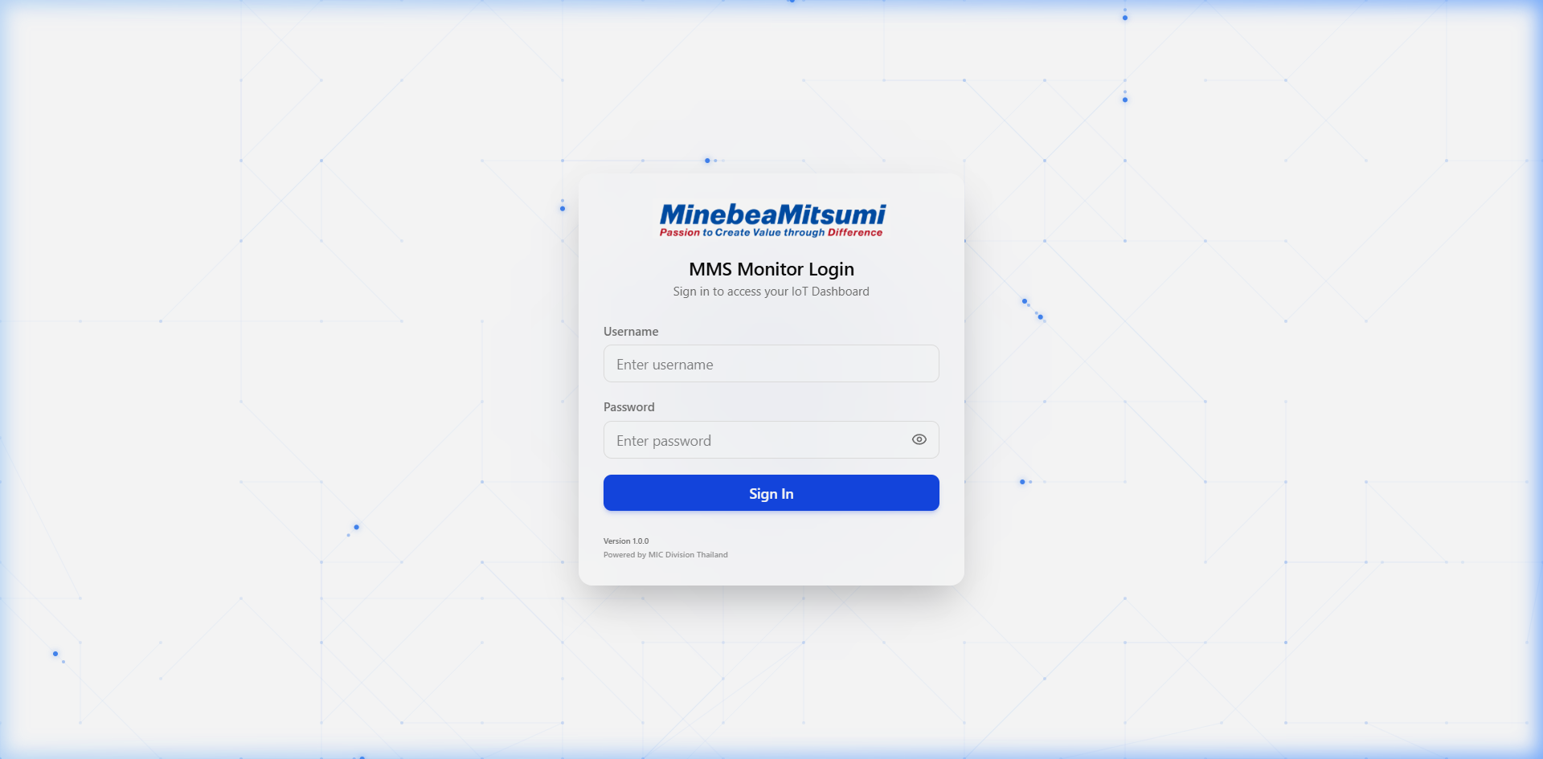
Figure 1.1: Web Dashboard Login Screen (Login Page)
1.2 System Configurations via Wizard Setup (Admin Only)
For Admin users, the "Setting" menu will be visible at the bottom-left of the sidebar. This opens a wizard configuration page to manage registrations in PostgreSQL and ClickHouse (CRUD operations):
1. Users Tab: Manage user accounts, passwords, and system roles (Admin / User).
2. Projects Tab: Configure global project settings, such as Division (default is 'mic'), Server IP, and record periods.
3. Devices Tab: Register new machine/device IDs and assign them to processes.
4. Columns Tab: Configure PLC payload fields to be stored in ClickHouse. Supports bulk registration (Batch Add).
5. Statuses Tab: Map machine status codes from the PLC (e.g. 1) to human-readable states (e.g. run) and display colors.
6. Alarms Tab: Map error/alarm codes to error descriptions and blinking red alert states.
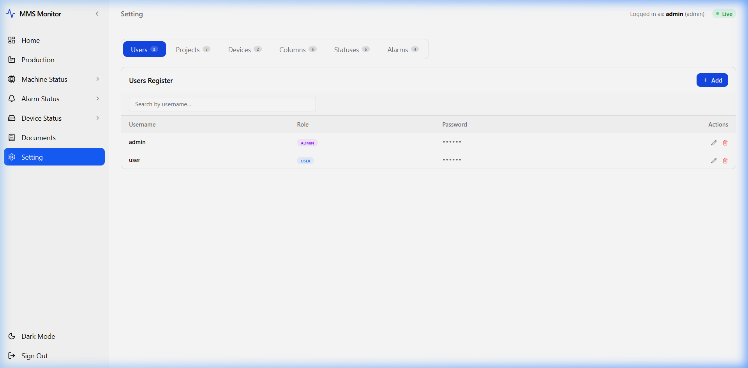
Figure 1.2: System Wizard Settings View (Setting Page)
⚠️ Critical Warning & Action Required:
Every time you modify columns or register new devices in the Settings page, you MUST restart the 'kafka-clickhouse' container via Portainer (Benthos pipeline middleman). This ensures Benthos reloads the database schema and matches incoming sensor data correctly. Otherwise, new sensor payloads will fail to save into ClickHouse.
1.2.1 Steps to Restart 'kafka-clickhouse' Container in Portainer
After modifying columns or registering new devices, proceed with the restart as follows:
1. Open your browser and navigate to the Portainer interface: http://xxx.xxx.x.x:9000/
2. Log in using your administrator account (Username = admin / Password = adminadminadmin).
3. Go to the "Containers" page (local environment -> Containers in the left sidebar).
4. Search for the container named "kafka-clickhouse".
5. Select the checkbox next to the container "kafka-clickhouse".
6. Click the "Restart" button at the top header of the containers list table.
7. Ensure that the container's status turns green showing "running" or "healthy".
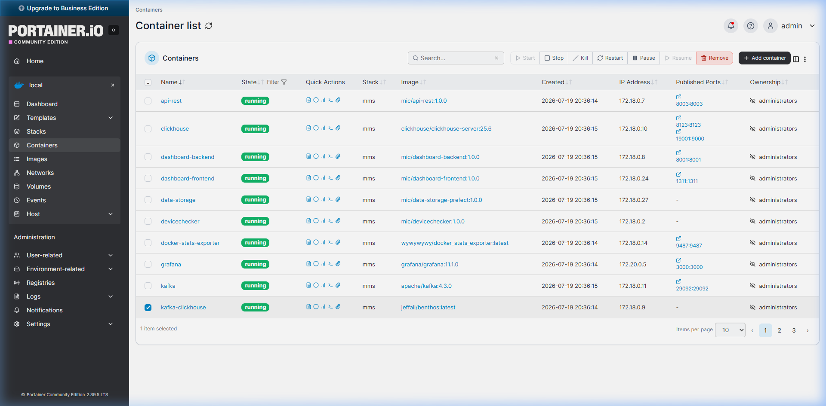
Figure 1.3: Selecting kafka-clickhouse container and clicking Restart in Portainer

2. Dashboard Menu Walkthrough
2.1 Home (Operations Overview)
This is the entry screen of the dashboard. It displays database health, real-time KPI metrics, and the status of docker containers in the pipeline:
• KPI Cards: Summary of network connectivity, online/offline counts, registered processes, and alarm rules.
• Device Availability: Progress bars representing the online percentage of devices sorted by process group.
• Latest Production Signals: Live table streaming raw sensor payload values from PLC controllers via Server-Sent Events (SSE).
• Data Pipeline Health Monitor: Visualizes status indicators of all Docker containers in the pipeline. If a container stops (Offline), its box turns red. Users can hover over any container box to inspect its CPU usage, memory, and network traffic (Rx/Tx) in real-time.
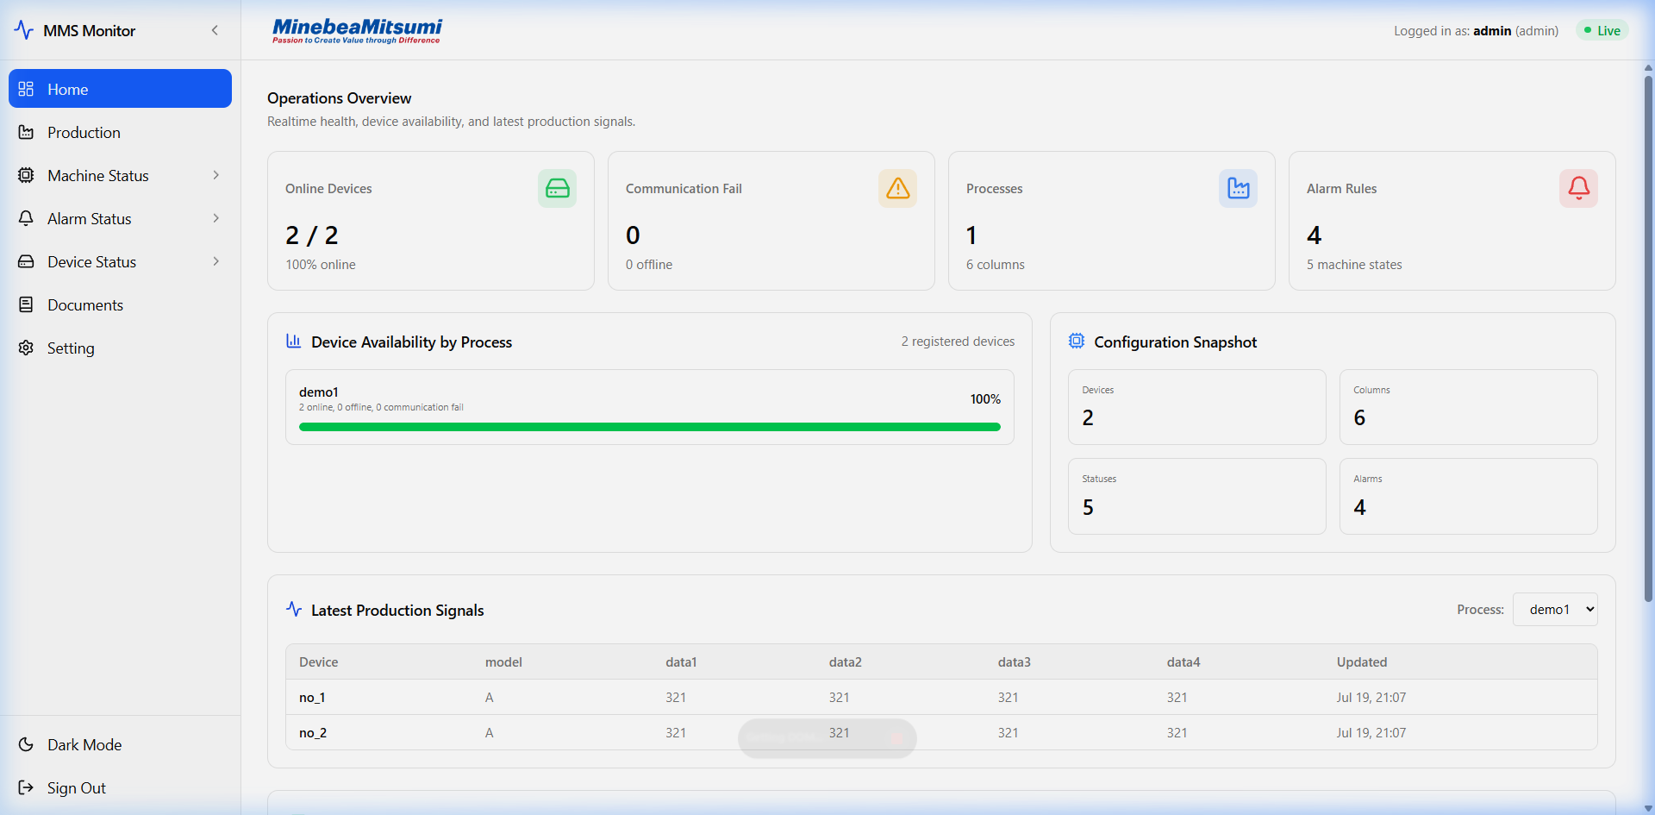
Figure 2.1: Overview page showing KPI cards and Container Pipeline Health Monitor
2.2 Production Realtime
Used for monitoring specific production telemetry signals from machine sensors:
• Display Filters: Users can select the process group, choose up to 2 specific payload columns to compare, and select up to 18 specific machines to monitor.
• Telemetry Cards: Each machine card features a pulsing green light when online and displays live values of the selected sensors, updating second-by-second.
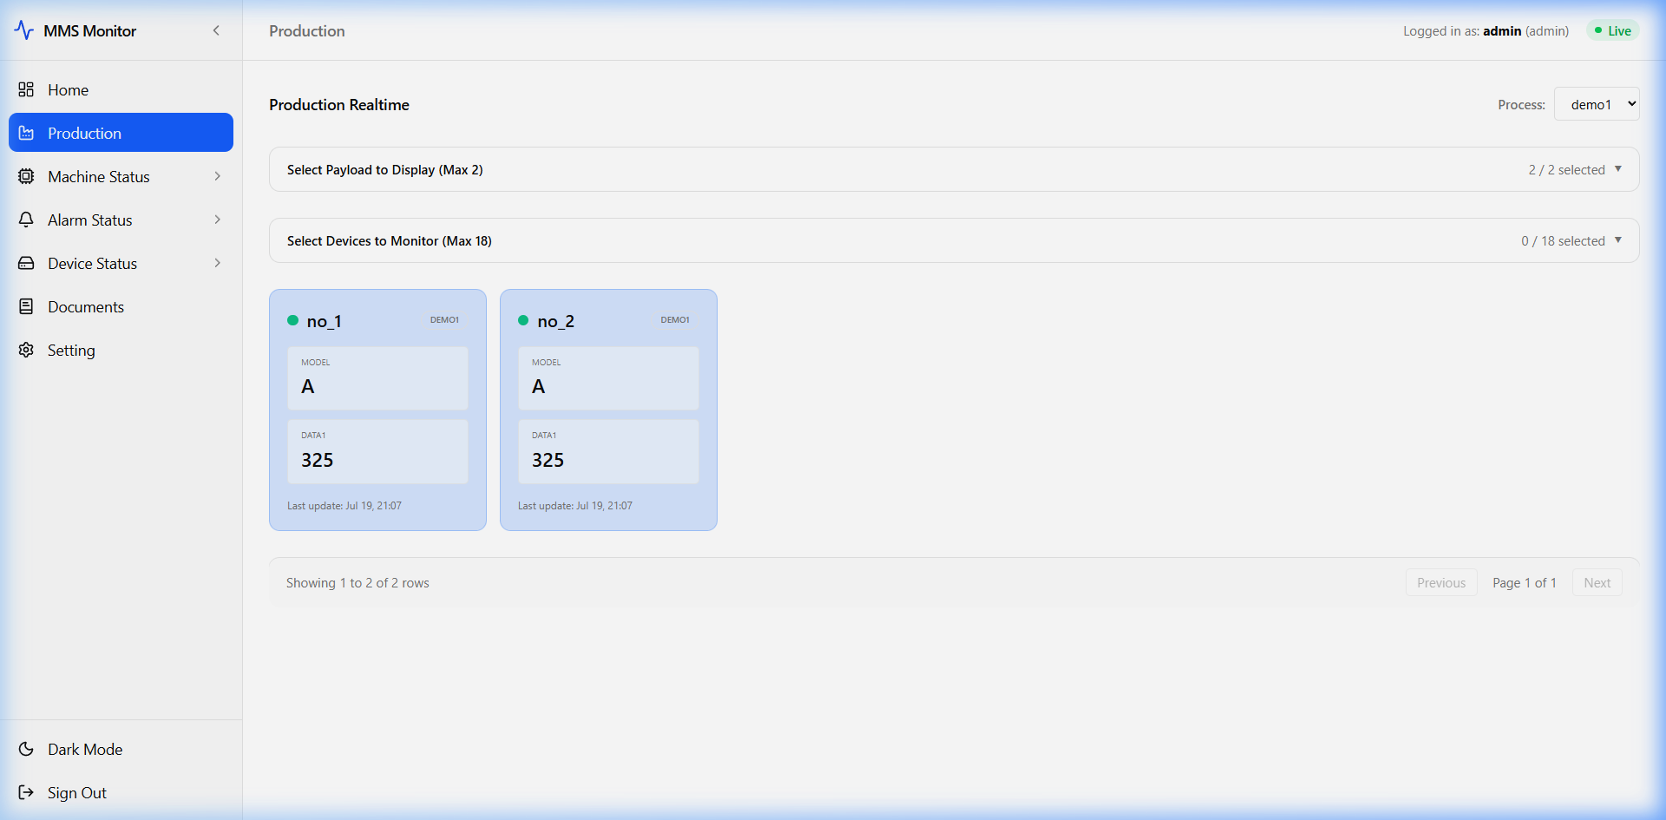
Figure 2.2: Live sensor payload grid for selected machines (Production Page)

2.3 Machine Status
This section is split into three sub-pages to facilitate detailed downtime and performance analysis:
1. Overview (Latest State): Displays counts of machines currently in Run, Alarm, Wait, Stop, or Offline states. The machine cards dynamically change background color based on their current status.
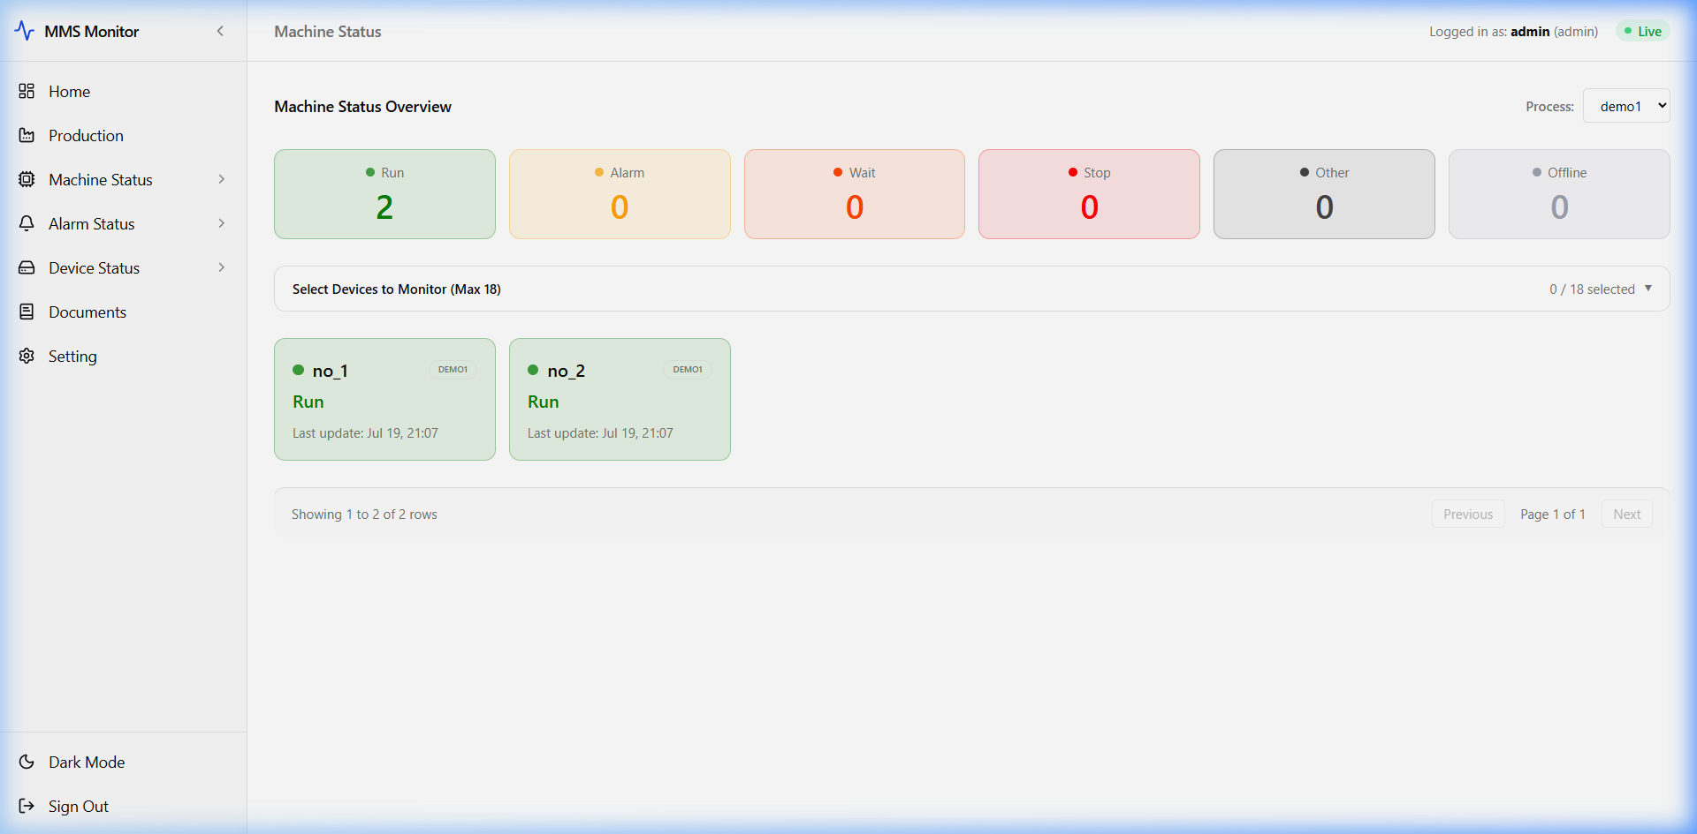
Figure 2.3.1: Machine state indicators grid (Machine Status Overview)
2. Timeline (Status Gantt Chart): Displays a horizontal status history timeline for up to 5 selected machines. Color segments trace status transitions (Run, Wait, Stop, Alarm, Offline) second-by-second, pulling from ClickHouse historical tables. Refreshes every 30 seconds.
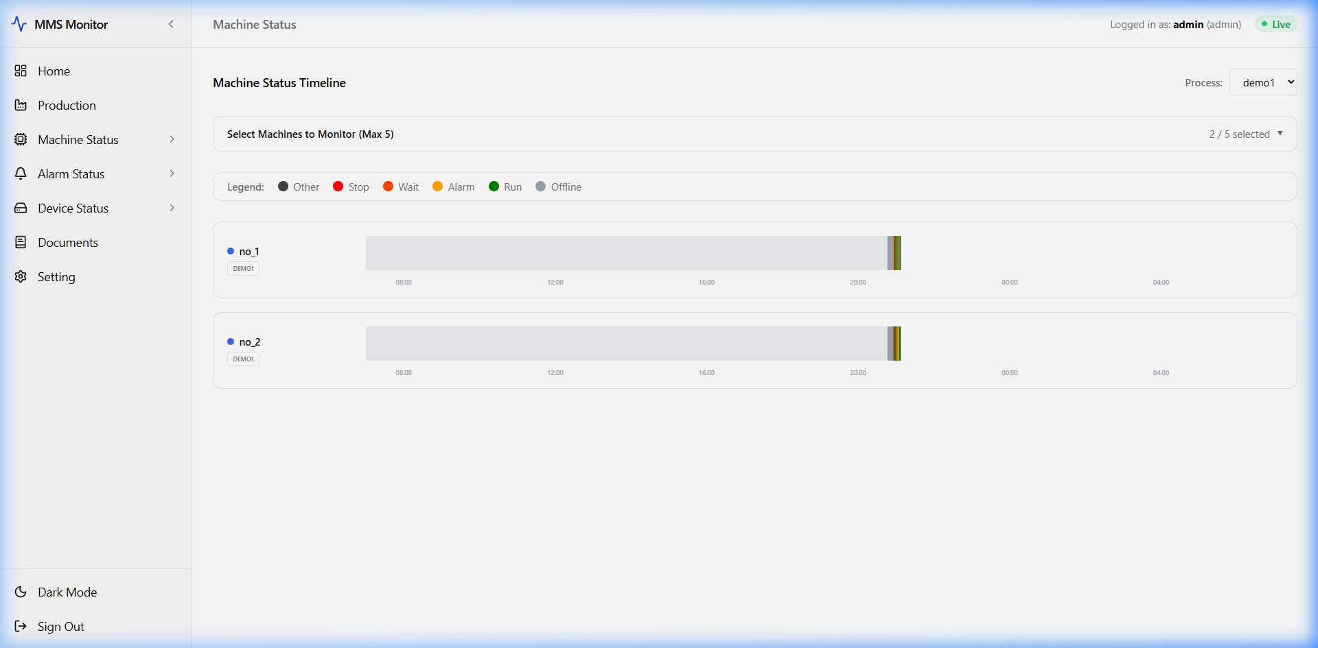
Figure 2.3.2: Status timeline Gantt chart for downtime tracking (Machine Timeline)
3. Daily Utilization: Displays utilization rate charts (up to 12 machines) showing operational performance ratios accumulated during the day.
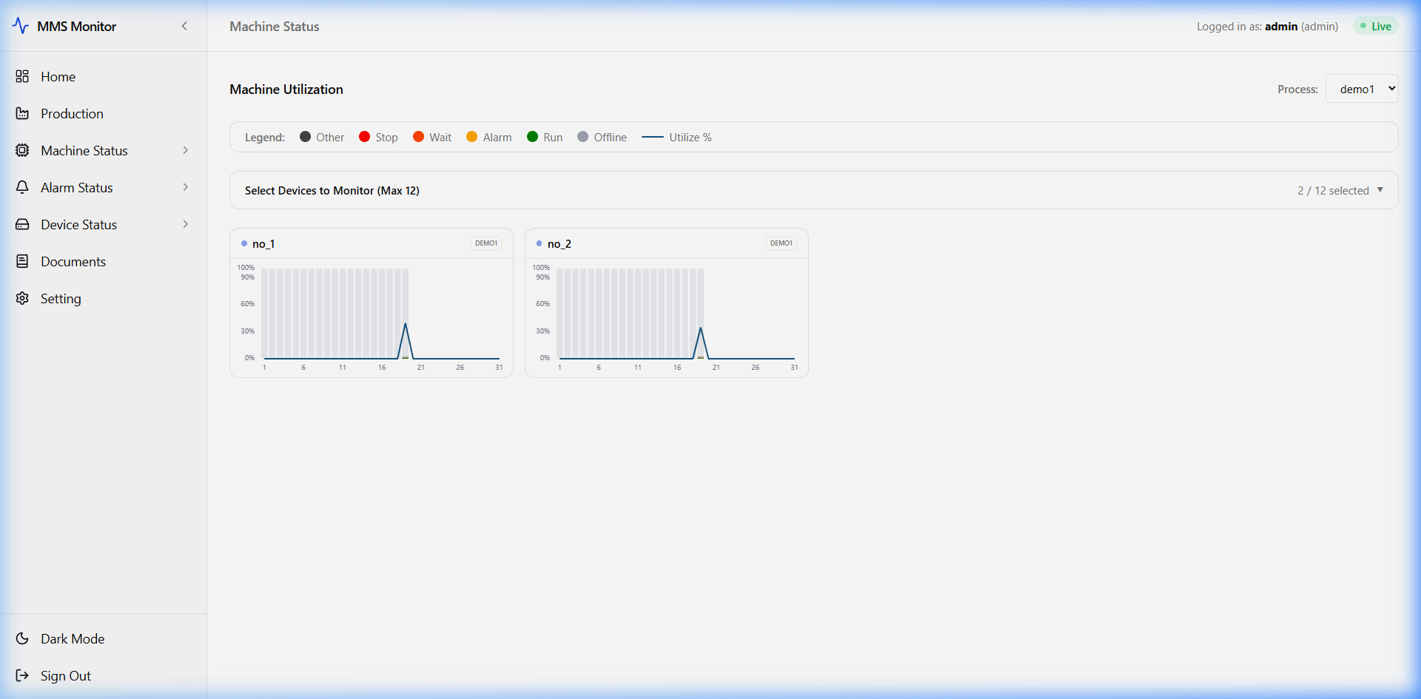
Figure 2.3.3: Daily machine efficiency and status ratios (Daily Utilization Page)

2.4 Alarm Status
Filters and highlights machines facing critical errors or malfunctions:
• Blinking Warning Cards: Any machine in an active alarm state flashes with a red border, pulling the latest alarm description or code from the PLC payload to facilitate immediate troubleshooting.
• Alarm Summary: Compare the count of normal machines against active alarms.
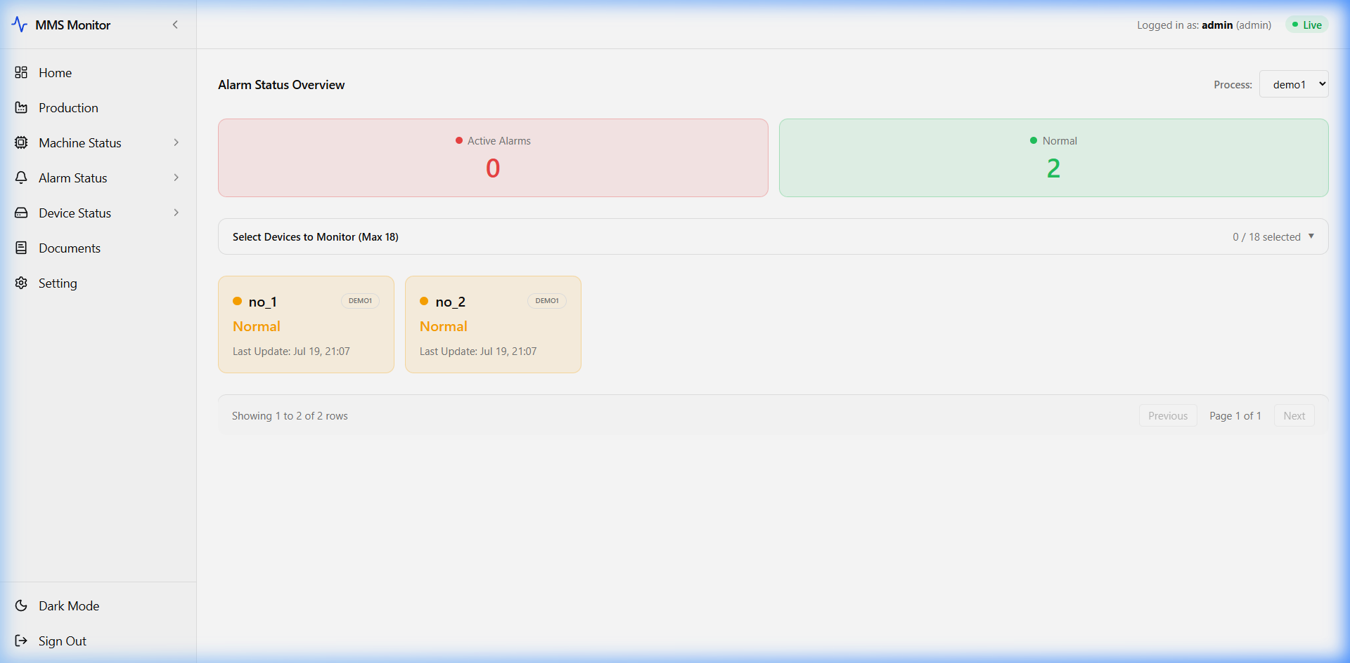
Figure 2.4: Active alarm monitoring and ratio summaries (Alarm Status Page)
2.5 Device Status
Used for monitoring hardware communication and WiFi network connectivity health of controllers/gateways:
• Network Diagnostics: Helps distinguish between intentional machine shut-downs (where gateways remain online) and actual hardware power losses or network outages (where device shows Offline for over 300 seconds).
• Benefits: Prevents data loss tracking issues from skewing overall equipment effectiveness (OEE) parameters.
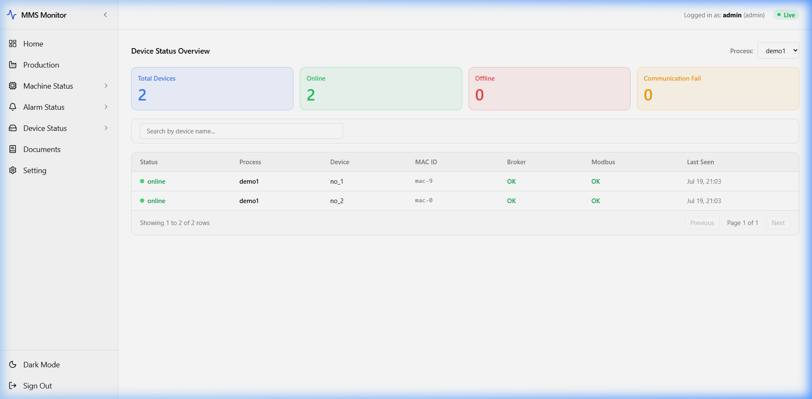
Figure 2.5: Gateway connection status tracking grid (Device Status Page)
2.6 Documents (API Reference)
The Documents menu hosts developer guidelines and API schemas for querying historical data from ClickHouse OLAP:
• Authentication: Standard Kong API Gateway Key-Auth requires client calls to include a header named "apikey" containing the secure key value (e.g. sawadeeja).
• API Endpoints: Developer references for data, status, alarm, and device endpoints.
• Copy cURL Button: Features a dedicated "Copy" button on the right side of each cURL code block, enabling developers to copy and run test commands on their local terminal instantly.
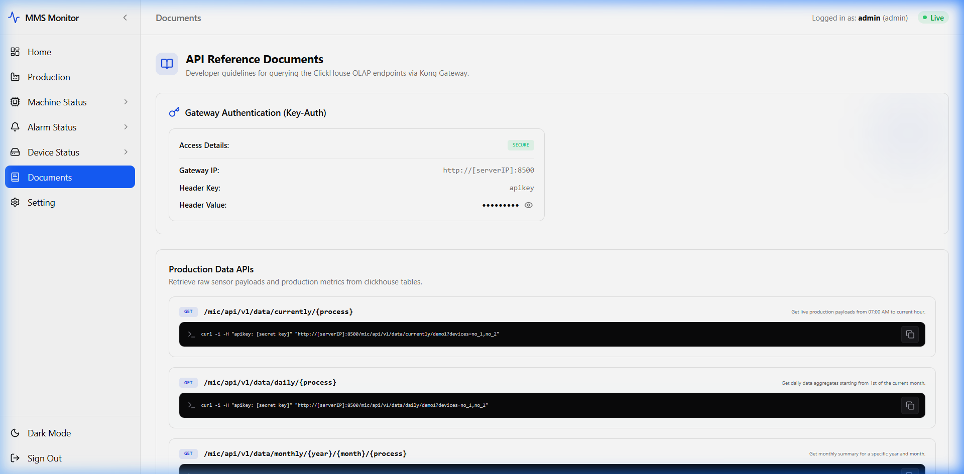
Figure 2.6: API reference definitions and cURL code snippets (Documents Page)

