**Experiment Procedure Documentation:**

**Instructions**

1. To run the experiment, simply run the Compression_Test_proj.html file by clicking on it and the experiment will open in the browser as shown below:

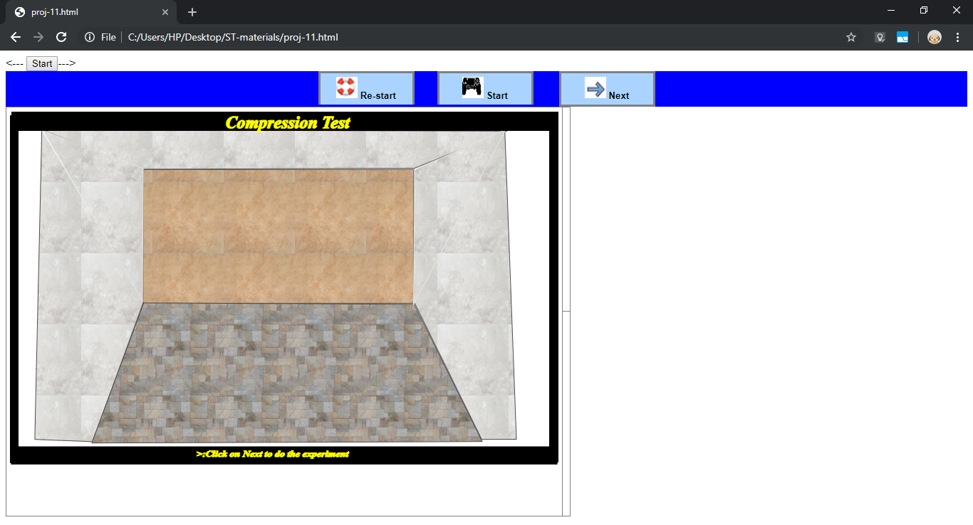

2. To run the experiment of Compression Test, click on the “Start” button. After clicking on the ‘Start” button, the animations commence. The results which is drawn as a graph based on data recorded in the table.The screen appears as under:

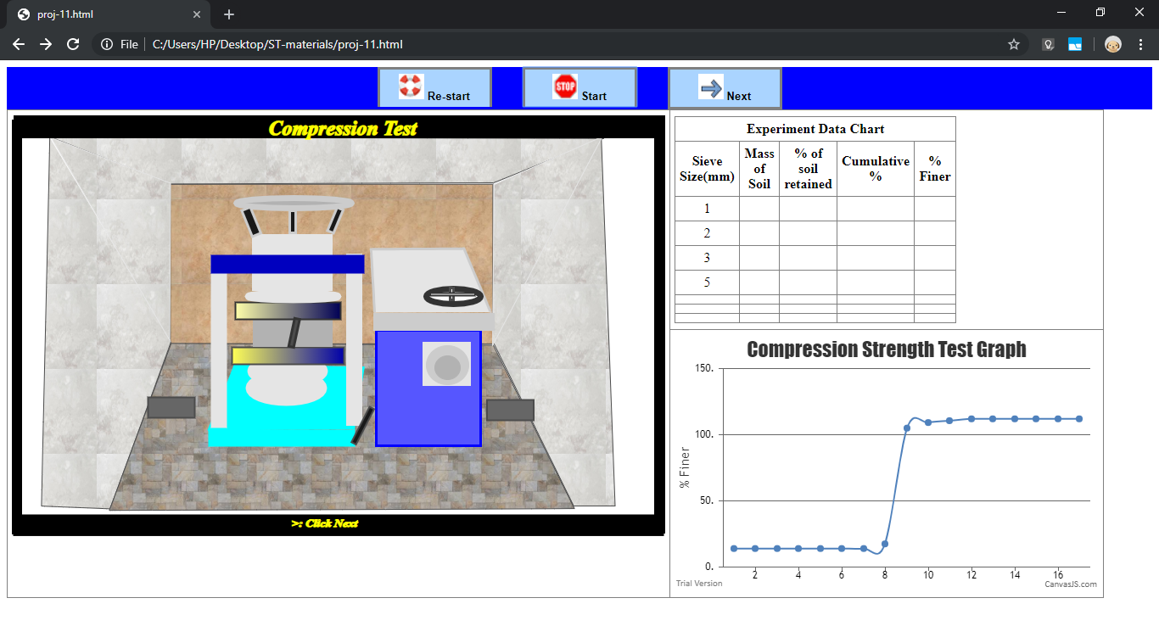

1. After completion of the various animation the next procedure is initiated by pressing the button marked ”Next”. After clicking on the “Next” button, the animations commence again. The result which is drawn as a graph based on data recorded in the table. The screen appears as under:

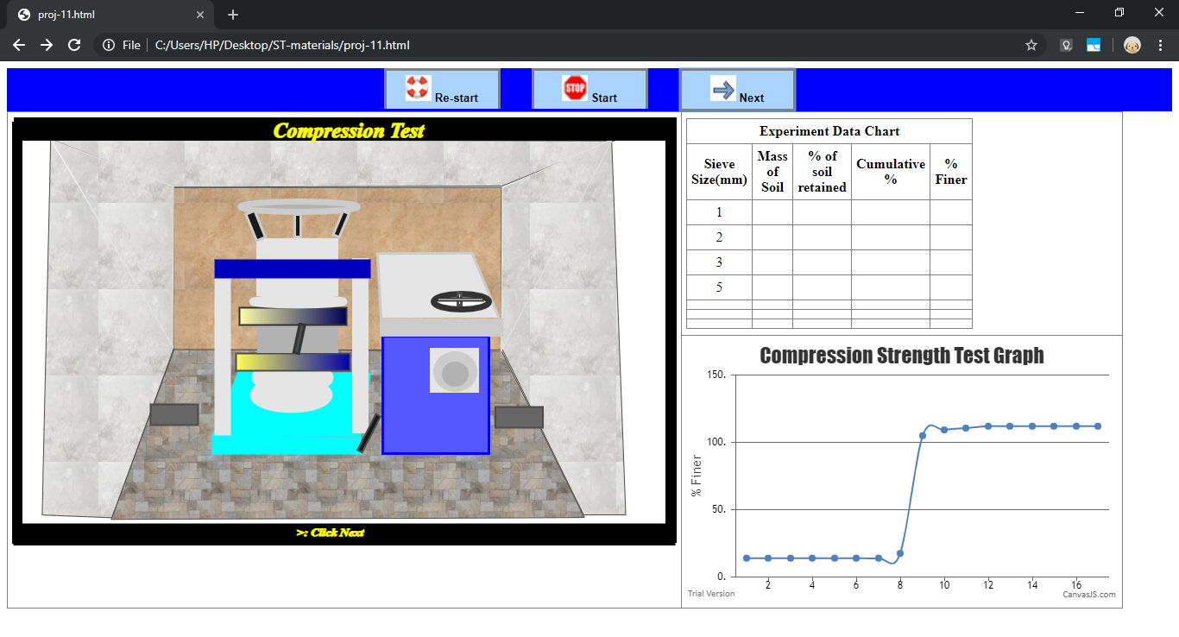

1. After completion of the various animations the next procedure is initiated by pressing the button marked ”Re-start” when the screen display returns to yhe initial stage where a fresh experiment can be done by pressing button ”Start”.

