Multimodal AI-Generated Content and Deepfake Detection System

Abstract
This project addresses AI-generated content and deepfake detection across four modalities: text, image, audio, and video. The system trains one detector per modality and then combines outputs using an accuracy-weighted fusion rule. Text is classified using BERT, images using a custom convolutional neural network, audio using MFCC features with a CNN classifier, and video using EfficientNet-B0 over face-centered frame crops with per-video probability aggregation. The best single model was the text detector at 99.06% accuracy, while the weighted fusion strategy achieved 99.31% in simulation, outperforming naive averaging at 92.85%. Robustness testing showed that seed changes, image learning-rate variation, and audio noise injection affected model behavior, confirming the need for stronger cross-dataset evaluation and calibrated fusion before deployment.

Introduction
Generative AI can now create realistic text, images, speech, and video. This creates risks in misinformation, identity fraud, academic integrity, journalism, and public trust. A single-modality detector is not enough because realistic attacks may combine generated text, manipulated faces, and cloned audio. The goal of this project was to build an end-to-end multimodal deepfake detection pipeline that can classify content as REAL or FAKE and study whether weighted fusion improves reliability over treating every modality equally.
The group goals were: (1) implement independent detectors for text, image, audio, and video; (2) evaluate each model using held-out data and classification metrics; (3) design a simple but explainable fusion strategy; and (4) complete Path B robustness analysis using seed, learning-rate, and noise experiments.

Methodology
Text detector. The text branch uses bert-base-uncased with a binary classification head. The AI_Human dataset was split using train_test_split with a 30% test set. Tokenization used a maximum length of 128, and training was performed with the HuggingFace Trainer.
Image detector. The image branch uses a custom three-layer CNN with Conv2D filters 32, 64, and 128, followed by Flatten, Dense(128), Dropout(0.3), and a sigmoid output neuron. Images were resized to 128 x 128 and normalized to [0, 1].
Audio detector. The audio branch converts each .wav file into a 20-coefficient MFCC feature matrix. Clips are loaded with librosa, padded or truncated to a fixed length, and passed to a CNN classifier. Gaussian noise injection was added during MFCC extraction.
Video detector. The video branch samples 10 frames per clip, applies face-centered preprocessing, and classifies frames using EfficientNet-B0. Video-level probability is computed by averaging frame probabilities across the clip.
Fusion rule. Let P_i(x) be the fake probability predicted by modality i and acc_i be its validation accuracy.
P(x) = Sum[ w_i * P_i(x) ], where w_i = acc_i / Sum[ acc_j ]
This rule is intentionally simple and interpretable: stronger validation performers receive higher weights, while weaker modalities receive lower influence.

Experiments and Results
All four modality models were evaluated on held-out data. The table summarizes the main notebook outputs and fusion experiment.

Component | Algorithm / Features | Held-out Evaluation | Key Result
Text | BERT-base-uncased, max length 128 | 30,000 samples | 99.06% accuracy; macro F1 about 0.99
Image | 3-layer CNN, 128 x 128 RGB | 20,000 images | 93.81% accuracy; FAKE/REAL F1 about 0.94
Audio | MFCC + CNN | 110 clips | 91.82% latest run; robustness runs varied under added noise
Video | EffNet-B0 + 10-frame aggregation | 20 videos | 80.00% video accuracy; ROC-AUC 0.9075
Naive Fusion | Equal modality weights | 50,000 simulated trials | 92.85% accuracy
Weighted Fusion | Accuracy-normalized weights | 50,000 simulated trials | 99.31% accuracy
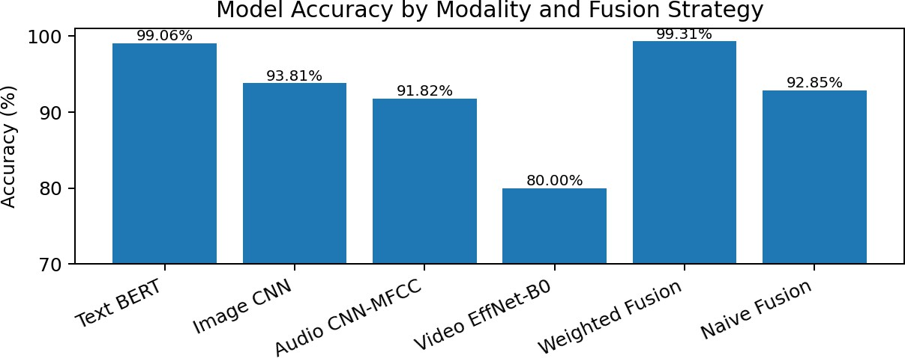

Interpretation. Weighted fusion improved over naive averaging because equal weighting allows a weaker modality to pull the final score down. Accuracy-normalized weighting gave more influence to text and image models while still preserving signal from audio and video. However, the fusion value is based on an independence-assumption simulation, so it should be interpreted as a prototype-level result, not final production evidence.

Robustness Testing
Path B required evidence that model behavior was tested under changes such as random seeds, hyperparameters, or noise. Three tests were completed:

Test | Change Made | Observed Result | Meaning
Text seed | Changed train/test split random_state from 42 to 21 | Accuracy changed from 99.06% to 99.37% | Text model remained highly stable on this dataset.
Image learning rate | Trained CNN with Adam learning_rate  = 0.001 and 0.0001 | Accuracy changed from about 93-94% to about 93% | CNN performance was stable, but learning rate affected convergence.
Audio noise | Added Gaussian noise during MFCC extraction: 0.005 and 0.01 | Accuracy varied from 74% to 92% across noise settings/runs | Audio branch is more sensitive because the dataset is small and features are noise-dependent.
These tests show that high accuracy alone is not enough. A model can perform well on one split but still vary under seed, hyperparameter, or noise changes. Future work should report mean +/- standard deviation across multiple seeds and evaluate on external datasets.

Discussion and Conclusion
Strengths. The project demonstrates a complete multimodal pipeline instead of a single isolated classifier. The BERT text branch and CNN image branch achieved strong held-out performance, while video aggregation improved reliability over frame-level predictions. The weighted fusion design is explainable because every modality weight is tied to validation performance rather than hidden learned parameters.
Limitations. The audio dataset is relatively small, leading to higher variability in performance metrics. Similarly, the video model was evaluated on a limited subset of data. These constraints arise primarily due to dataset size and runtime limitations.
Next improvements. The next phase should train video on the full Celeb-DF v2 dataset and evaluate on DFDC or FaceForensics++. The audio branch should be upgraded from MFCC-CNN to Wav2Vec2-style embeddings.. Explainability should be added using SHAP for text and Grad-CAM for image/video. Overall, the project shows that multimodal detection and accuracy-weighted fusion can improve deepfake screening, but stronger robustness and cross-dataset validation are required before real-world deployment.

