**3.Set Up and Configure GitHub Account**.

# cd

# ssh-keygen

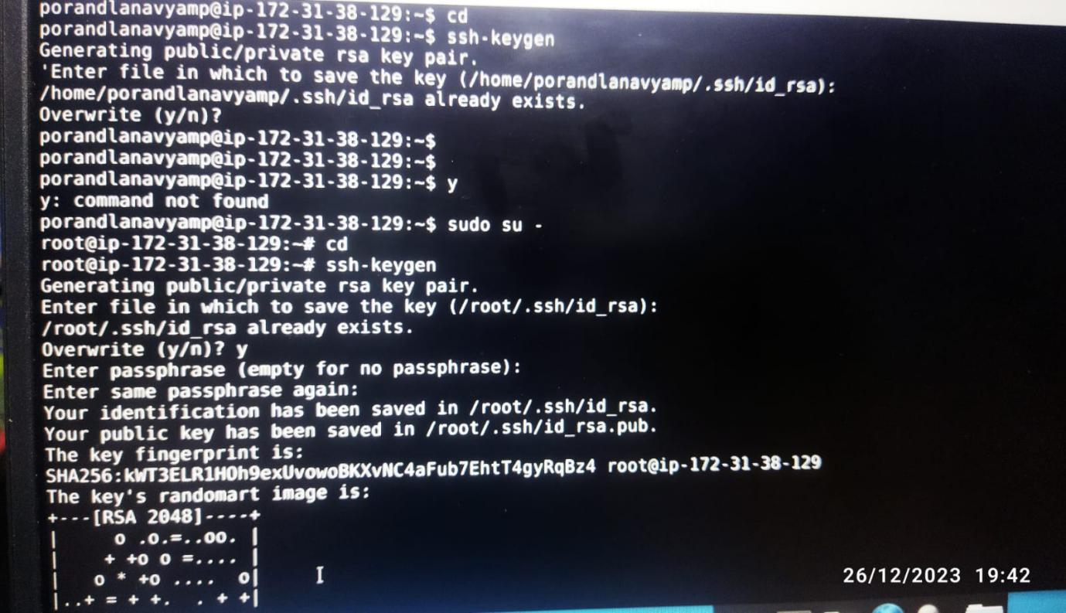

The public key can be seen by exeucting below commad:

# cat /root/.ssh/id_rsa.pub

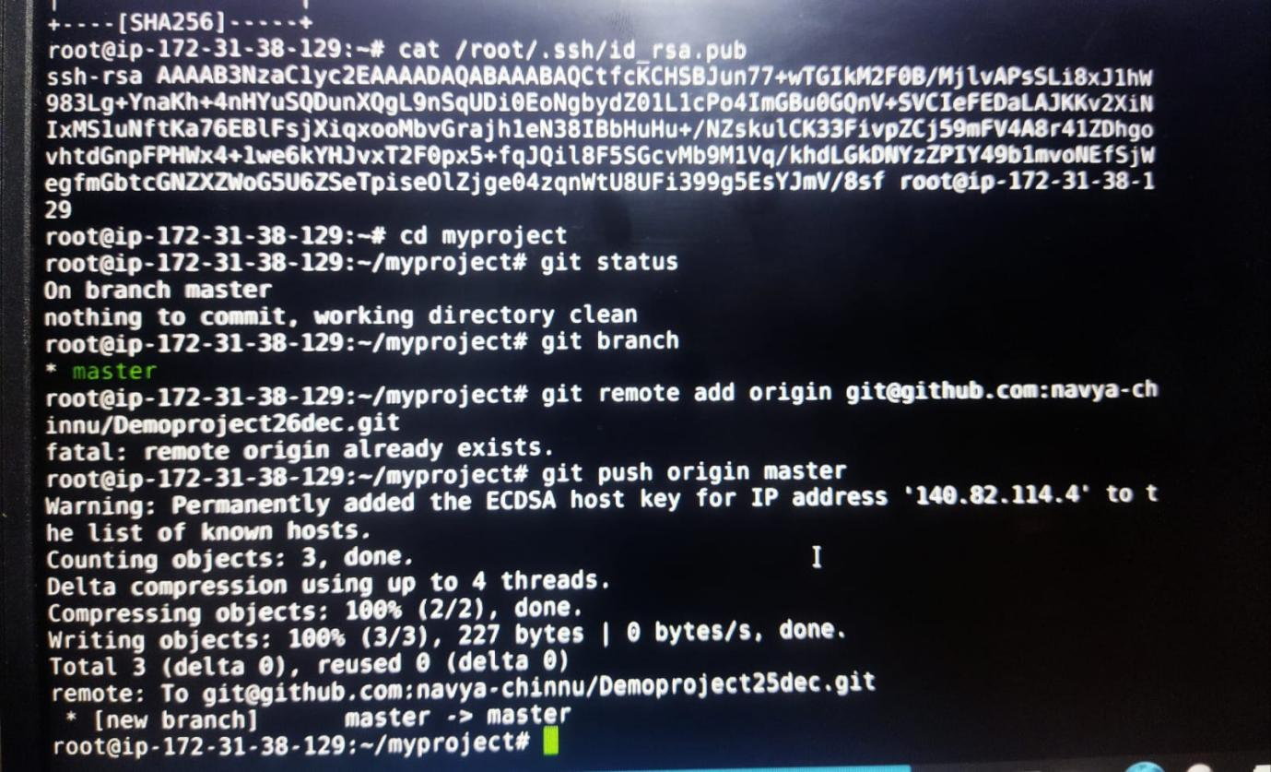

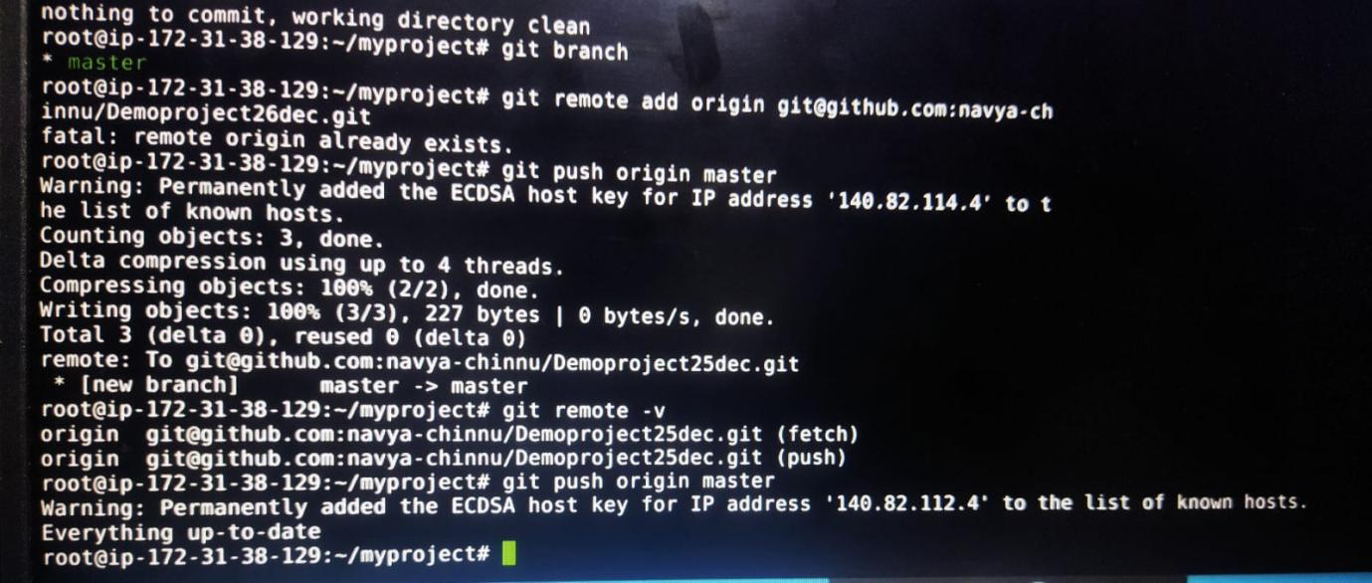

Copy the key carefully

 paste it on git hub

$ cd myproject

$ git checkout master

$ git status

Working tree to be clean

Check you are on master branch

$ git remote add origin [remote repo SSH URL]

Check if remote details on local

$ git remote -v

**Command to push files from local to remote:**

**$ git push origin master.**

