**1.Setup and create a git repository**

Switch from lab user to a root user

# sudo su –

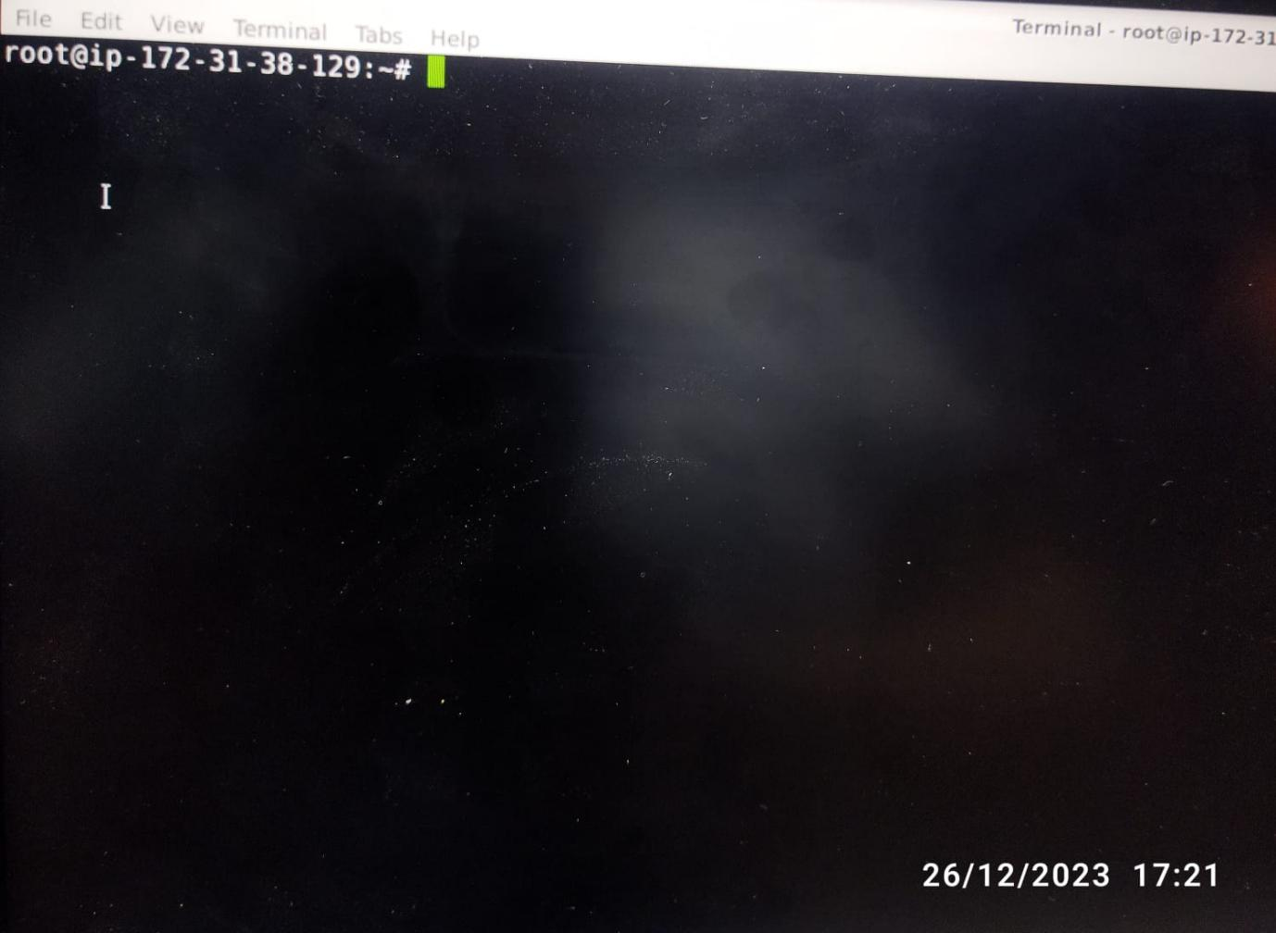

List the configurations:

# git config

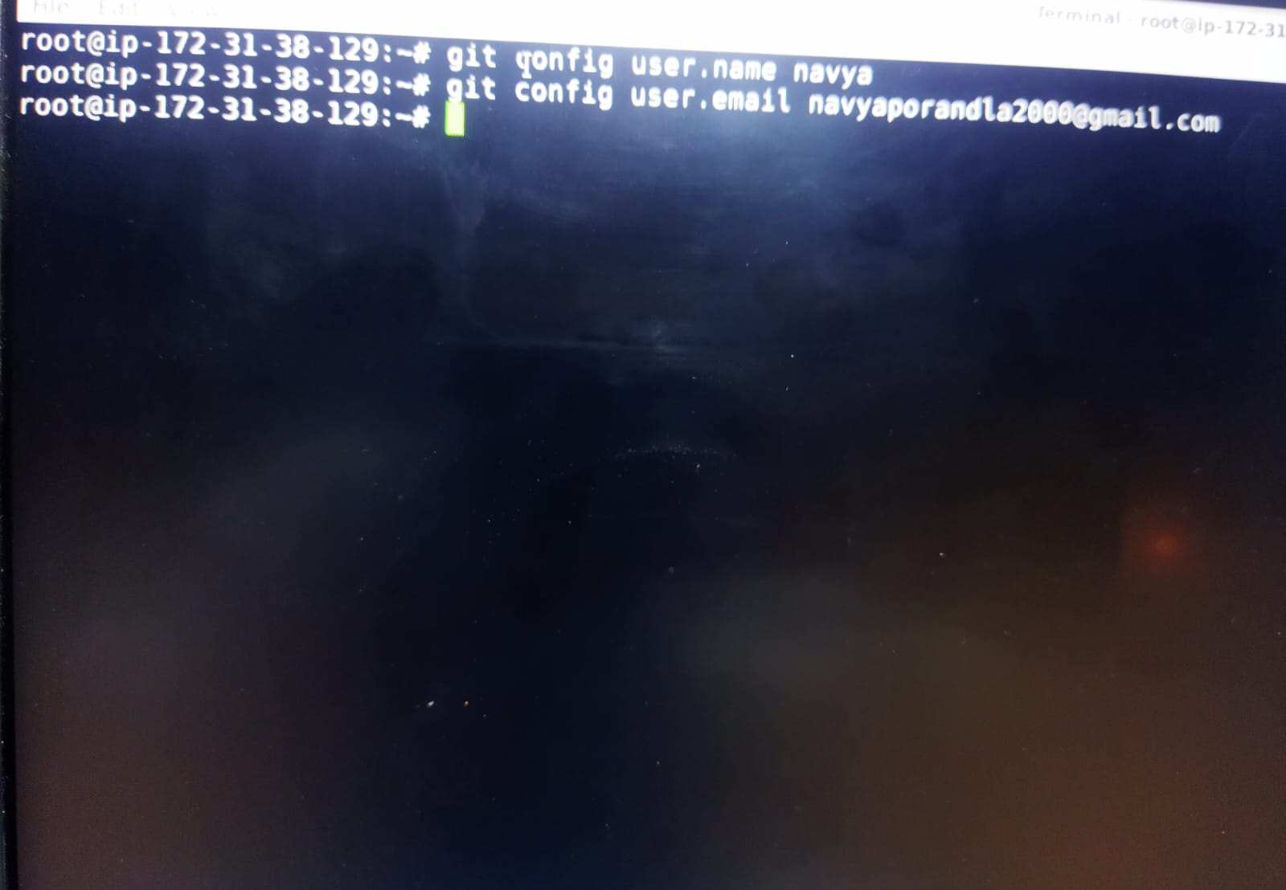

Create a working directory

$ sudo su -

$ mkdir myproject

$ cd myproject

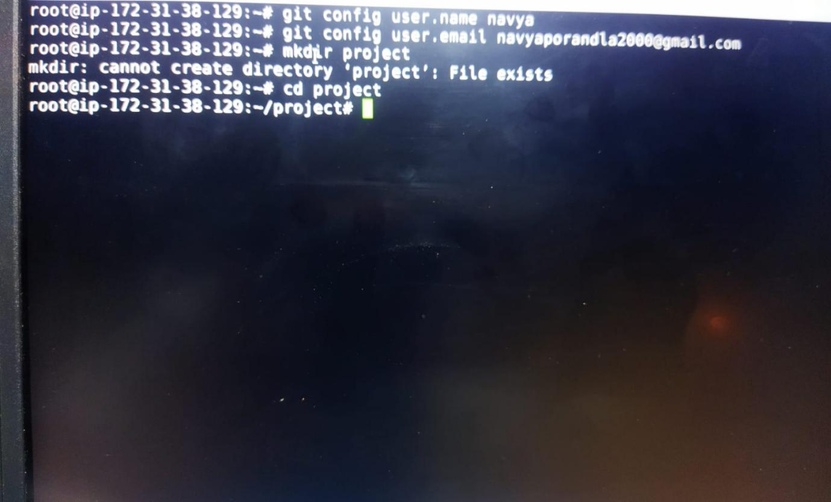

Initialize git on the working directory, there byc resting a Local repo

$ git init

