AN INTERNSHIP REPORT
ON
ETHICAL HACKING

Submitted To
School of Computer Science and Engineering
IILM University, Greater Noida, U.P.

In partial fulfillment of the requirements for the degree of
Bachelor of Technology
Computer Science and Engineering

Submitted By:
NAVYA MAHAJAN
Roll No.: 2410030563
Batch: 2024–28
Internship Duration: 8 Weeks

1. CANDIDATE'S DECLARATION
I, NAVYA MAHAJAN, do hereby declare that the internship report titled "Ethical Hacking Internship" has been completed by me to fulfill the requirement for the award of the degree of Bachelor of Technology in Computer Science and Engineering.
All the references have been quoted and I have not taken as such any material from any other source without proper acknowledgement. I affirm to you that this report represents my genuine learning during the 8-week internship program. This report is my own and has not been submitted to any other institute for any degree/diploma requirement, and further I shall be solely responsible for any kind of copyright violation in this regard.

Signature: ____________________
Student Name: NAVYA MAHAJAN
Roll No.: 2410030563
Date: ____________________

2. ACKNOWLEDGEMENT
I am using this opportunity to express my profound gratitude to everyone who supported me throughout this Internship Program. I am deeply thankful to IILM University, Greater Noida, and the School of Computer Science and Engineering for providing a robust academic foundation and the opportunity to undertake this crucial industrial training.
I extend my sincere appreciation to [ENTER ORGANIZATION NAME] for providing a structured learning environment, practical exposure, and comprehensive resources in the domain of Ethical Hacking. I am particularly thankful to my mentor(s), [ENTER MENTOR NAME], for their invaluable guidance, continuous support, and technical insights which have profoundly shaped my understanding of cybersecurity.
Lastly, I am forever grateful to my parents and family members for their endless encouragement, blessings, and continuous support throughout the duration of this internship and my academic journey. The practical skills and domain knowledge gained during these 8 weeks have vastly strengthened my technical competencies and prepared me for future professional endeavors.

Signature: ____________________
Student Name: NAVYA MAHAJAN
Roll No.: 2410030563

3. TABLE OF CONTENTS
1. Candidate's Declaration
2. Acknowledgement
3. Table of Contents
4. Internship Completion Certificate
5. Project Description
5.1 Introduction
5.2 Organization/Program Profile
5.3 Problem Statement
5.4 Project Objectives
5.5 Scope of the Internship
5.6 Technologies and Tools
5.7 Security Testing Architecture
5.8 Methodology
5.9 Week-wise Internship Learning
5.10 Learning Outcomes
5.11 Certificate and Supporting Evidence
6. Bibliography
[Note: Page numbers should be updated manually upon finalization of the document layout.]

4. INTERNSHIP COMPLETION CERTIFICATE
- Certificate Title: Internship Credential
- Domain: Ethical Hacking
- Duration: 8 Weeks
- Issued On: 12 June 2026
- Certificate ID: 2026-C0C67193F2

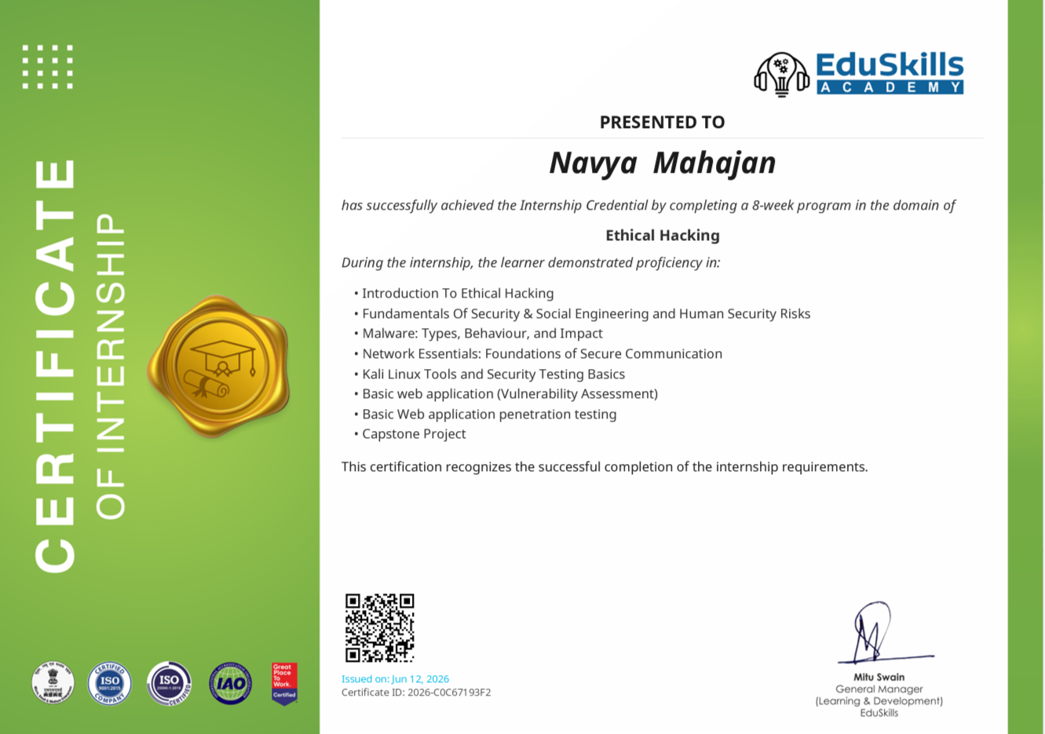

5. PROJECT DESCRIPTION

5.1 Introduction
In an increasingly interconnected digital world, the reliance on networked systems, web applications, and digital infrastructure has grown exponentially. While this technological advancement drives innovation, it simultaneously expands the attack surface for malicious actors. Cybersecurity is the practice of protecting systems, networks, and programs from digital attacks, which are typically aimed at accessing, changing, or destroying sensitive information, extorting money from users, or interrupting normal business processes. Within this broader domain, ethical hacking plays a vital, proactive role.
Ethical hacking involves an authorized attempt to gain unauthorized access to a computer system, application, or data. Carrying out an ethical hack involves duplicating strategies and actions of malicious attackers to identify security vulnerabilities that can be resolved before a malicious attacker has the opportunity to exploit them. Unlike malicious actors, ethical hackers operate strictly within authorized scopes, reporting their findings comprehensively so that organizations can fortify their defenses. This internship provides fundamental exposure to this critical discipline.
The significance of ethical hacking spans across multiple dimensions of computing. Web applications, often serving as the primary interface between an organization and its users, are frequent targets. A single unpatched vulnerability can lead to data breaches affecting millions. Therefore, understanding web application security is paramount. Similarly, network security focuses on protecting the foundational communication infrastructure, ensuring data confidentiality, integrity, and availability (the CIA Triad) as it travels across different segments.
This 8-week internship program is designed to bridge the gap between theoretical computer science concepts and practical security awareness. By exploring topics ranging from social engineering and malware analysis to vulnerability assessments and authorized penetration testing, the program equips engineering students with a security-first mindset. It underscores that robust software development and system administration must intrinsically incorporate security testing at every stage.

5.2 Organization/Program Profile
Internship Organization/Platform: [ENTER ORGANIZATION NAME]
The internship was facilitated by an organization dedicated to providing structured technical training and cybersecurity awareness. The program aims to cultivate practical skills in emerging technologies by offering an immersive learning environment. In the domain of Ethical Hacking, the platform provided a curated curriculum designed to transition students from basic security concepts to more advanced, practical security testing methodologies.
Through a combination of theoretical modules, conceptual deep-dives, and structured evaluations, the training structure emphasizes foundational strength. The learning environment was engineered to introduce the nuances of network security, human-related risks, and digital vulnerabilities securely and responsibly.
[Organization-specific information should be updated by the student based on the official internship documentation.]

5.3 Problem Statement

Bridging Cybersecurity Theory with Practical Security Testing
Modern digital ecosystems—spanning web applications, enterprise networks, and cloud infrastructures—face a relentless barrage of security threats. Traditional academic curricula successfully impart the theoretical and mathematical foundations of computer networks, cryptography, and operating systems. However, a significant gap exists when it comes to understanding how these technologies behave under duress and how vulnerabilities are actively identified, assessed, and exploited by malicious entities.
The implementation challenge lies in the multifaceted nature of cyber threats. It is not sufficient to merely configure a firewall or enforce password policies. Human security risks, often exploited via social engineering, remain a highly effective attack vector, bypassing traditional perimeter defenses entirely. Furthermore, the proliferation of sophisticated malware necessitates a deeper understanding of malicious behaviors and their potential impacts on system architecture.
At the infrastructure level, network vulnerabilities and web application flaws (such as those consistently highlighted by OWASP) require continuous and rigorous security assessment. Identifying these flaws demands a specialized skill set: the ability to think like an attacker while operating ethically and legally. There is an urgent industry need for professionals who not only understand how to build software but also how to test it through ethical and authorized penetration testing.
This internship addresses this critical problem by systematically introducing the methodologies of security assessment. By guiding the learning process from foundational security awareness to basic penetration testing concepts, it bridges the gap between passive understanding and active, practical security testing, fostering an engineering mindset focused on resilience and risk mitigation.

5.4 Project / Internship Objectives
- To understand the fundamental principles, ethics, and legalities of ethical hacking.
- To comprehend core cybersecurity and information-security principles.
- To study the CIA Triad (Confidentiality, Integrity, Availability) and common security risks.
- To understand social engineering methodologies and evaluate human-focused security risks.
- To study various malware types, analyze their behaviour, and understand their impact on systems.
- To develop foundational networking knowledge crucial for secure communication.
- To become familiar with Kali Linux as a premier security-testing and auditing environment.
- To understand the lifecycle and techniques of basic web application vulnerability assessment.
- To grasp the fundamentals of basic web application penetration testing in authorized scopes.

5.5 Scope of the Internship
The scope of this internship encapsulates a comprehensive, foundational overview of modern cybersecurity practices, specifically tailored toward ethical hacking. The covered domains include:
- Cybersecurity Fundamentals: Exploration of ethical hacking principles, information security policies, and foundational security risks.
- Human Security: Detailed study of social engineering techniques, understanding how psychological manipulation is used to compromise security, and establishing human-related vulnerability awareness.
- Malware: Analysis of malware classifications (viruses, worms, trojans, ransomware), their operational behaviors, their impact on host systems, and basic defensive strategies.
- Network Security: Study of network essentials, exploring fundamental protocols, port operations, and the foundations of establishing secure, encrypted communication channels.
- Security Testing: Introduction to Kali Linux, familiarization with a security-focused operating system, and understanding basic security-testing concepts and environments.
- Web Security: Understanding the landscape of web application vulnerabilities, exploring methodologies for systematic vulnerability assessment, and introducing the concepts of penetration testing.
IMPORTANT NOTE: The scope of all practical learning strictly emphasized that security testing, vulnerability assessment, and penetration testing must be performed exclusively within authorized, controlled, and heavily regulated environments. No real-world, unauthorized targets were assessed during this educational internship.

5.6 Technologies and Tools
The internship introduced a variety of concepts, environments, and technologies foundational to the cybersecurity industry.

Kali Linux
Kali Linux is a Debian-derived Linux distribution designed specifically for digital forensics and penetration testing. It was studied as the primary operating system environment for security testing. By providing a pre-configured suite of hundreds of security tools, it allows ethical hackers to perform varied assessments efficiently.

Networking Technologies
A deep understanding of networking is mandatory for security assessment. The internship covered core networking technologies, including the TCP/IP stack, fundamental protocols (HTTP/S, FTP, SSH, DNS), subnetting, and port operations. These technologies form the basis of understanding how data flows and how secure communication is established or intercepted.

Web Applications
The architecture of modern web applications was reviewed from a security standpoint. Concepts related to client-server communication, session management, and common vulnerability paradigms (such as those tracked by OWASP) were explored to understand how applications can be assessed for flaws.

Security Testing Concepts
Rather than solely focusing on automated software, the program emphasized security testing methodologies. This included reconnaissance (information gathering), systematic assessment, vulnerability identification, controlled validation (testing), reporting, and remediation planning.
Examples of commonly associated tools—not necessarily tools used directly during this internship—include Nmap for network scanning, Burp Suite for web vulnerability interception, and Metasploit for exploitation conceptualization. The focus remained heavily on the underlying technologies and the methodology of testing rather than isolated tool usage.

5.7 Security Testing Architecture
The process of evaluating the security posture of a target follows a highly structured, architectural workflow designed to maximize discovery while minimizing disruption. The internship emphasized the following standard security testing architecture:
1. Target Definition / Authorized Environment
↓
2. Information Gathering (Reconnaissance)
↓
3. Security Assessment (Scanning and Enumeration)
↓
4. Vulnerability Identification
↓
5. Controlled Validation / Authorized Testing
↓
6. Risk Analysis
↓
7. Reporting
↓
8. Remediation (Mitigation Strategies)
Target Definition: Establishing the exact scope and rules of engagement for the authorized environment.
Information Gathering: Collecting publicly available data and technical footprints without active probing.
Security Assessment: Actively probing the target to map open ports, services, and application pathways.
Vulnerability Identification: Analyzing the assessment data to locate known flaws, misconfigurations, or potential exploits.
Controlled Validation: Safely attempting to verify the existence and impact of the vulnerability without causing damage.
Risk Analysis: Evaluating the potential business and technical impact if a malicious actor exploited the flaw.
Reporting: Documenting the findings, reproduction steps, and severity levels clearly for stakeholders.
Remediation: Providing actionable, technical recommendations to fix the identified security gaps.
ETHICAL NOTE: All penetration-testing and assessment activities must be performed only with explicit authorization and strictly within the predefined scope.

5.8 Methodology
The internship was conducted using a progressive learning methodology, structuring complex cybersecurity concepts into digestible, logically sequenced phases.
Phase 1 — Ethical Hacking Fundamentals: The methodology began by establishing the baseline definition of ethical hacking, legal boundaries, and the general landscape of modern cybersecurity.
Phase 2 — Security Fundamentals: Focused on the core tenets of information security, primarily the CIA Triad. This phase explored authentication mechanisms, authorization controls, and common security risks inherent in digital systems.
Phase 3 — Social Engineering: Shifted focus to the human element. The methodology involved understanding the psychology of cyber-attacks, including phishing, pretexting, and physical manipulation techniques that bypass digital controls.
Phase 4 — Malware: Dedicated to understanding malicious software. This phase categorized malware types, analyzed their operational behavior, and studied their impact on host systems and networks.
Phase 5 — Network Essentials: Explored the backbone of digital communication. The methodology included studying IP addressing, ports, protocols, and the fundamental requirements for establishing secure communication channels.
Phase 6 — Kali Linux: Transitioned from theory to the testing environment. This phase familiarized the learner with the Kali Linux OS, its architecture, and the basic concepts of operating a security-testing environment.
Phase 7 — Web Application Security: Combined previous network and environment knowledge to focus on the web layer. The methodology covered identifying web vulnerabilities, understanding the assessment lifecycle, and the concepts of basic penetration testing.
Phase 8 — Final Assessment & Reporting: The culmination of the methodology, requiring the synthesis of the preceding phases into a structured reporting format to demonstrate conceptual understanding of ethical hacking principles.

5.9 Week-wise Internship Learning
The 8-week duration of the internship facilitated a steady, week-by-week immersion into the domain of Ethical Hacking. The structured learning journey progressed as follows:
WEEK 1 — Introduction to Ethical Hacking: Exploration of what constitutes ethical hacking versus malicious exploitation. The week focused on the necessity of security testing, the rules of engagement, and the primary legal and ethical frameworks that govern the cybersecurity profession.
WEEK 2 — Security Fundamentals: Deep dive into core security principles. The week covered the CIA Triad, the concepts of non-repudiation, identity management, and an overview of the threat landscape affecting modern digital infrastructures.
WEEK 3 — Social Engineering & Human Security: A specialized focus on human vulnerabilities. Learning centered on how attackers exploit human psychology through phishing, tailgating, and baiting, and the importance of security awareness training as a defensive measure.
WEEK 4 — Malware: Comprehensive study of malicious payloads. The week distinguished between viruses, worms, trojans, spyware, and ransomware. Learning outcomes included understanding how malware spreads, its behavioral signatures, and its ultimate impact on system integrity.
WEEK 5 — Network Essentials: Focus on the foundational mechanics of the internet. The week covered the OSI and TCP/IP models, port scanning concepts, the role of firewalls, and how secure communication (like SSL/TLS) protects data in transit.
WEEK 6 — Kali Linux: Practical introduction to the standard operating system for security professionals. The week covered Linux command-line basics, filesystem navigation, and the conceptual organization of security and auditing tools within the Kali environment.
WEEK 7 — Web Application Security: Exploration of application-layer threats. The week introduced the concepts of vulnerability assessment, identifying common flaws like misconfigurations or injection vulnerabilities, and understanding the theoretical frameworks of authorized web penetration testing.
WEEK 8 — Final Review & Reporting: The final week was dedicated to consolidating the 8 weeks of learning. The acquired knowledge across networks, malware, social engineering, and web security was applied in controlled assessments to validate the foundational understanding of ethical hacking.

5.10 Learning Outcomes
The internship resulted in significant technical and professional development, yielding the following key learning outcomes:
- Ethical Hacking Fundamentals: Gained a clear, professional understanding of the ethical hacker's role, the critical importance of scope, and the legal constraints of security testing.
- Cybersecurity Awareness: Developed a robust 'security mindset,' learning to look at systems not just for how they function, but how they might be broken or manipulated.
- Social Engineering Awareness: Learned to identify and analyze human-based attack vectors, understanding that technical defenses are insufficient without human security awareness.
- Malware Awareness: Acquired the ability to classify malicious software, understand basic infection vectors, and articulate the potential business impact of malware outbreaks.
- Networking Fundamentals: Strengthened core computer networking knowledge, essential for understanding how vulnerabilities are exploited over local and wide-area networks.
- Kali Linux Familiarity: Developed foundational comfort with the Kali Linux operating system, understanding its structure as a platform for security assessment.
- Web Application Security: Gained exposure to the methodologies required to secure web applications, including understanding the difference between automated scanning and manual assessment.
- Penetration Testing Concepts: Learned the end-to-end lifecycle of a penetration test, from reconnaissance through exploitation and into the vital reporting phase.
- Security Documentation: Understood the critical importance of documentation in cybersecurity, recognizing that a security test is only as valuable as the report generated for remediation.

5.11 Certificate and Supporting Evidence
The successful completion of the internship is supported by the following official documentation and learning evidence:
1. Official Internship Completion Certificate (ID: 2026-C0C67193F2, Issued: 12 June 2026).
2. Training program completion tracking and assessment records via the internship platform.
3. [INSERT ANY BADGES / CREDENTIALS IF AVAILABLE]
4. [INSERT SCREENSHOTS OF LEARNING ACTIVITIES OR LABS IF AVAILABLE]

6. BIBLIOGRAPHY
The following resources, documentations, and frameworks were referenced for foundational cybersecurity learning and understanding:
- OWASP (Open Worldwide Application Security Project). 'OWASP Top Ten Web Application Security Risks'. Available at: https://owasp.org/www-project-top-ten/
- Kali Linux Official Documentation. 'Introduction to Kali Linux'. Available at: https://www.kali.org/docs/
- NIST (National Institute of Standards and Technology). 'Cybersecurity Framework'. Available at: https://www.nist.gov/cyberframework
- CISA (Cybersecurity and Infrastructure Security Agency). 'Cybersecurity Training and Resources'. Available at: https://www.cisa.gov/
- MITRE ATT&CK Framework. 'Enterprise Tactics and Techniques'. Available at: https://attack.mitre.org/

