1)Tested with the db name and schema ..

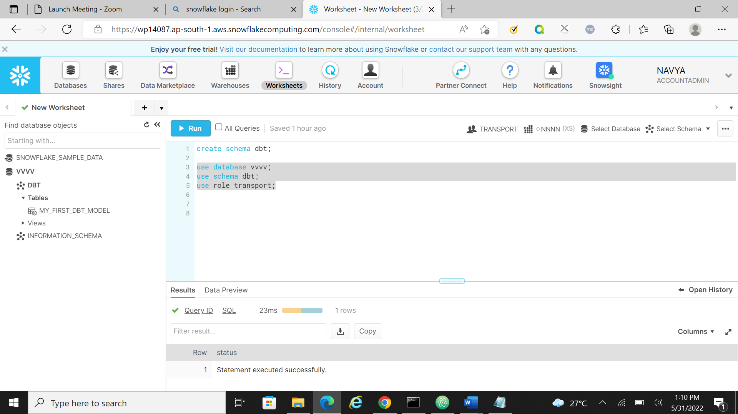

ERROR:

Tried with many video from the you tube , still I faced some errors … then I went with one more approach and I got this one While uploading the xml data to snowflex..

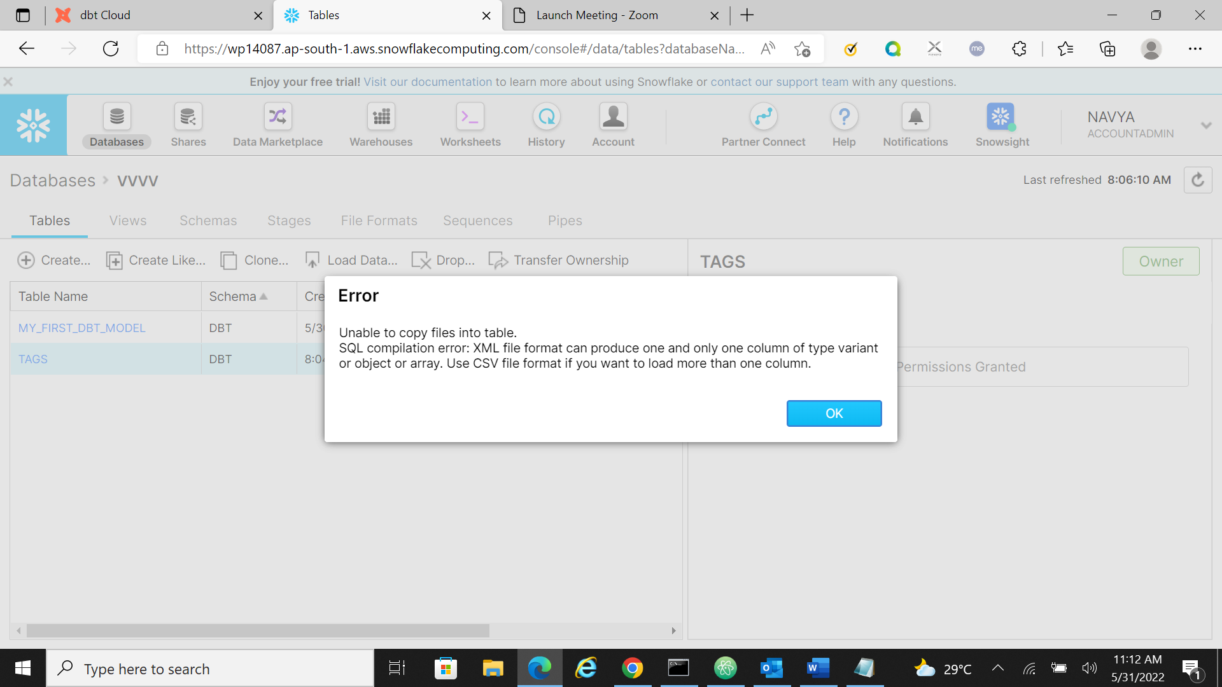

The creation of columns in the table:

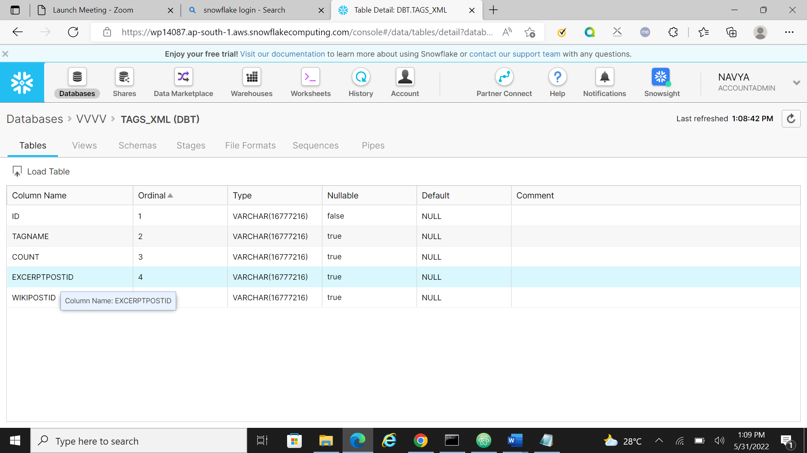

Loading 1 data record to snowflex

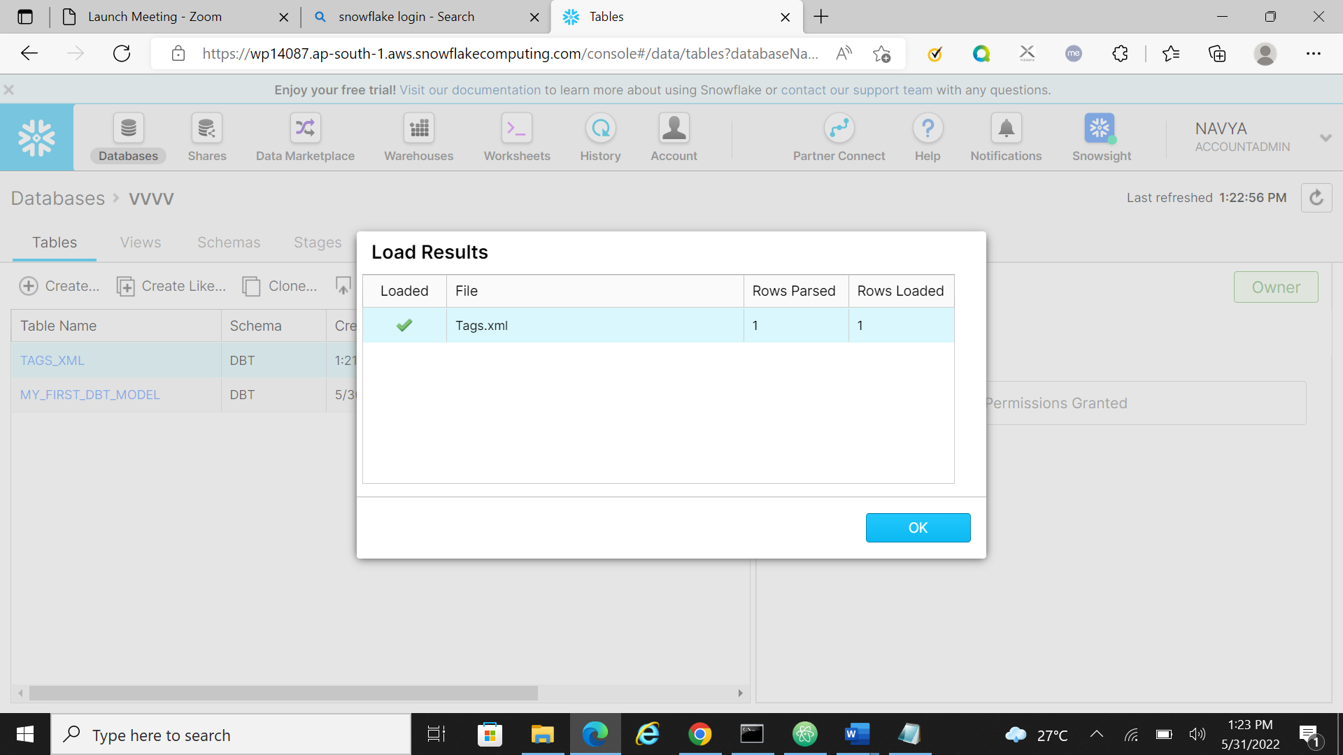

Done with uploading the users xml file

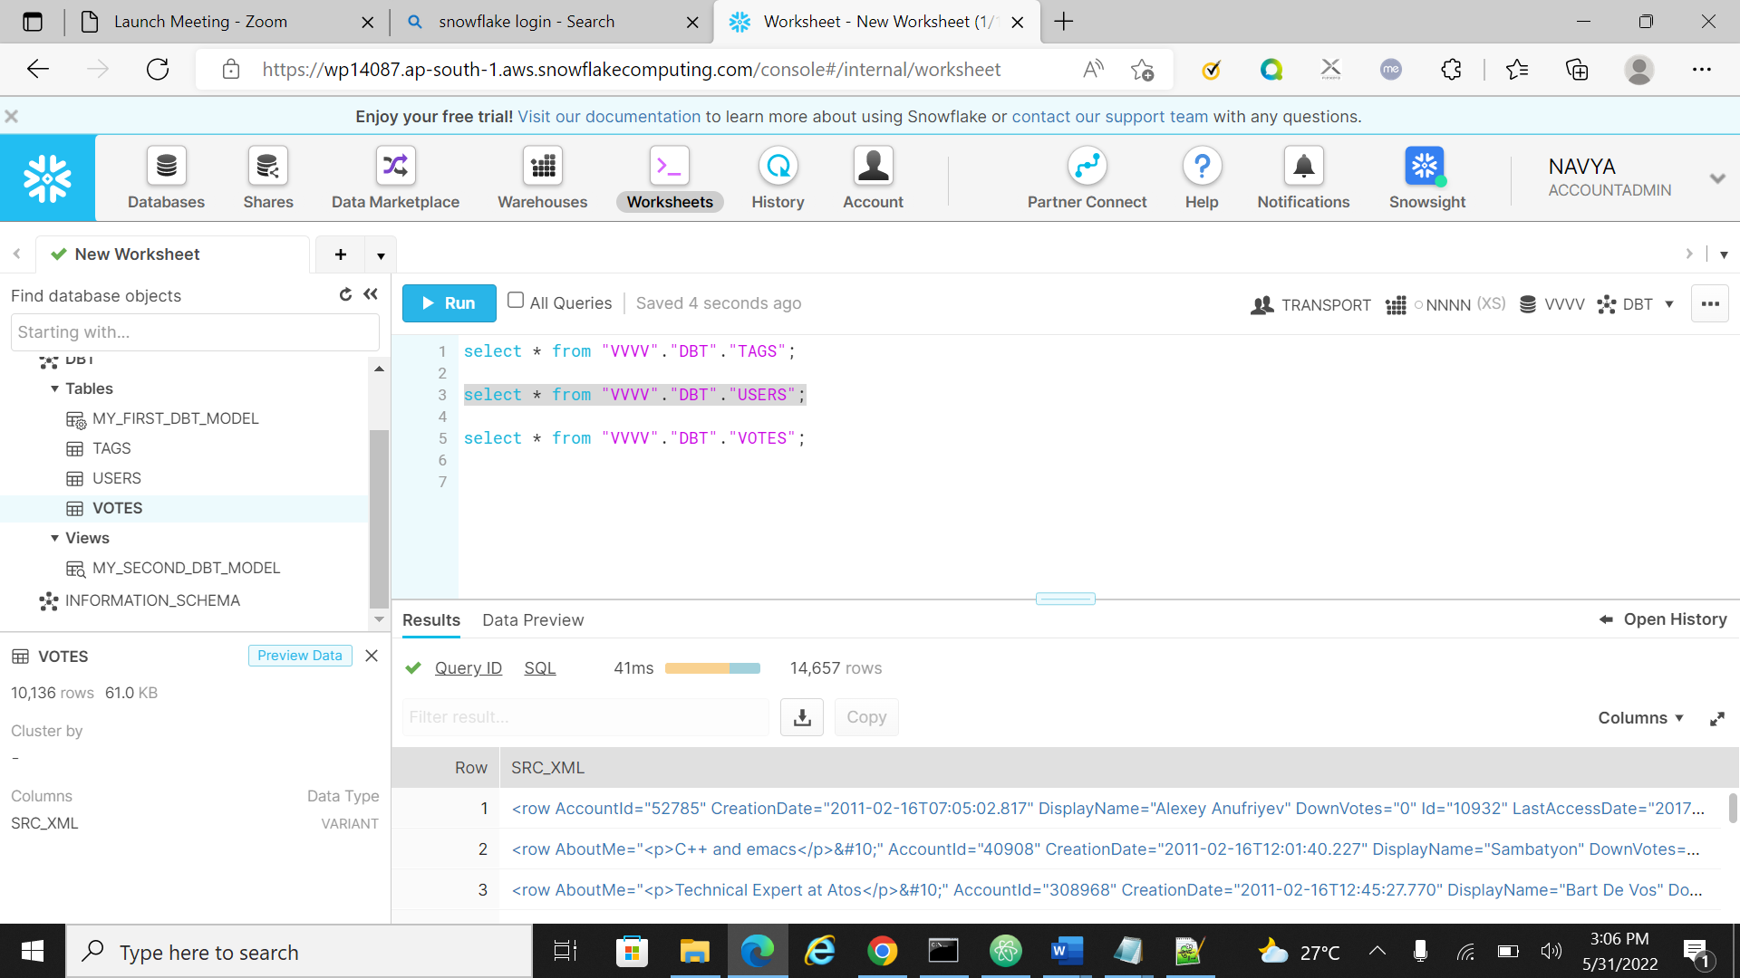

Got error while uploading large data records

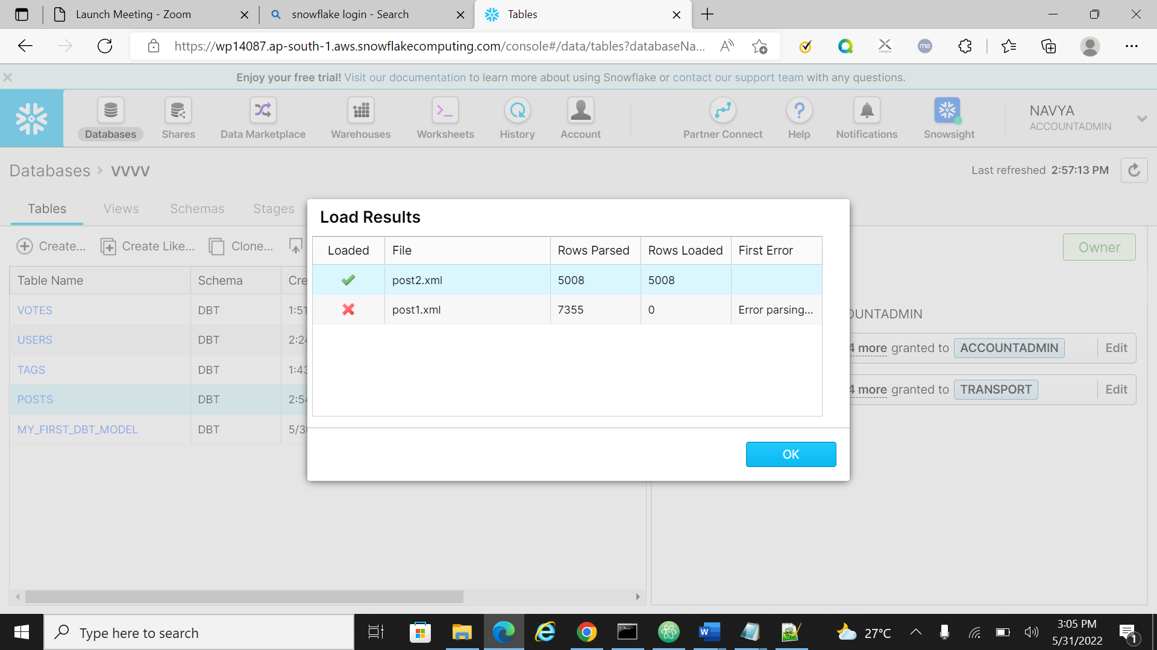

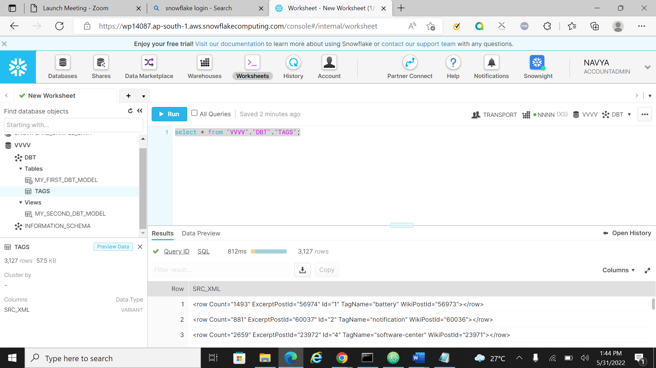

Tried with the 1st query , in this I got the value as null.

