Loading of all tables to the database:

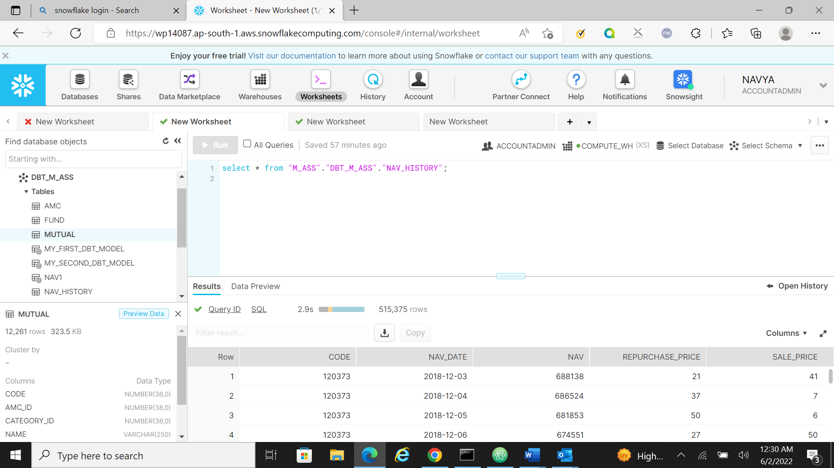

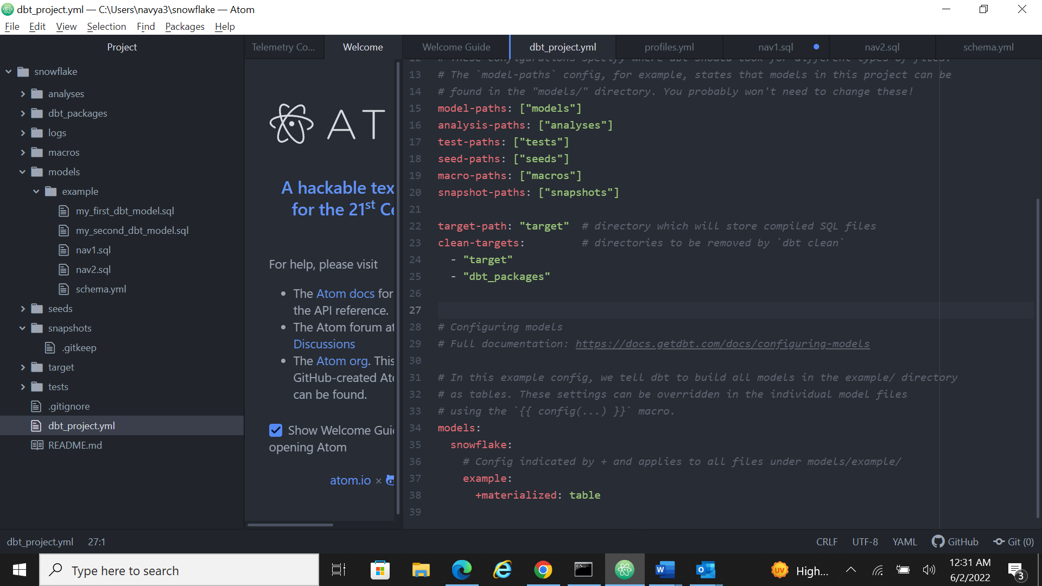

Milestone 1:

Calculate Monthly average NAV, Repurchase & Sale Price for each scheme.

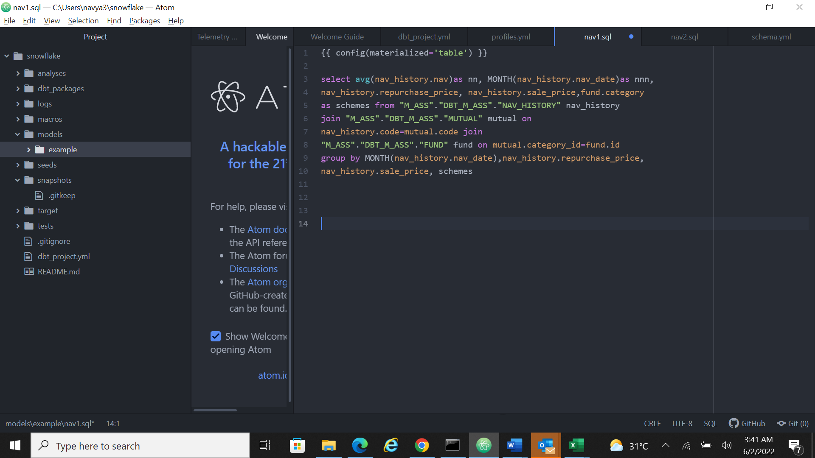

Tried without joining the tables

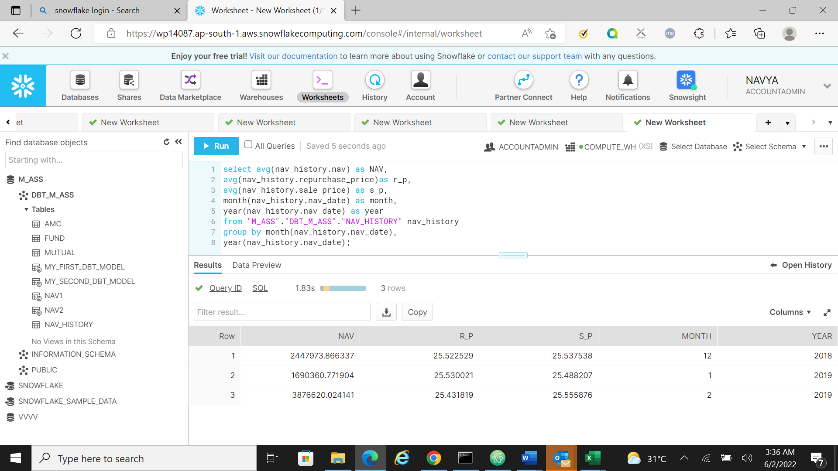

2)Find out each scheme’s Max and Min NAV value and Date it occurred

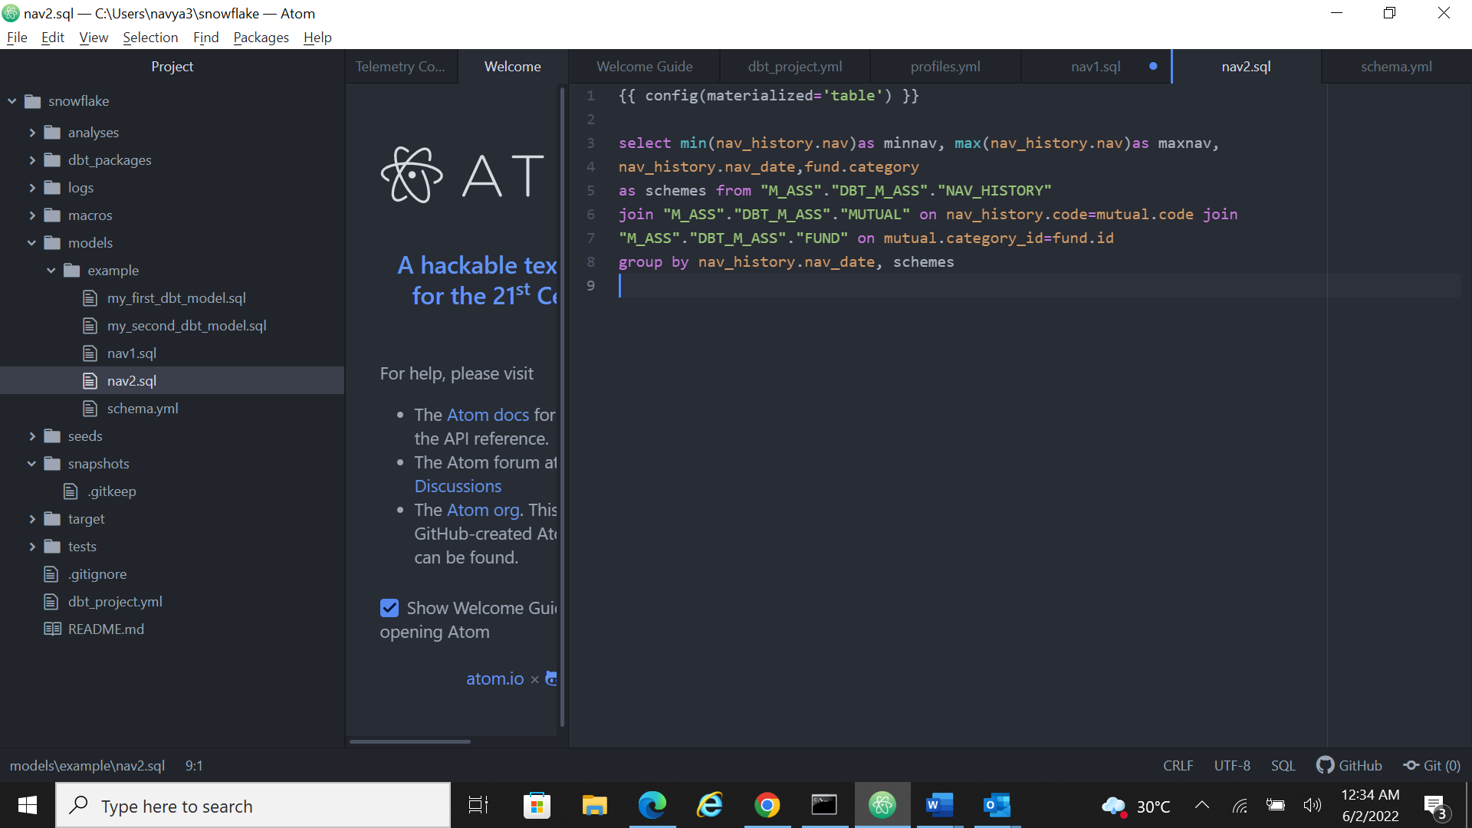

Tried without joining the tables:

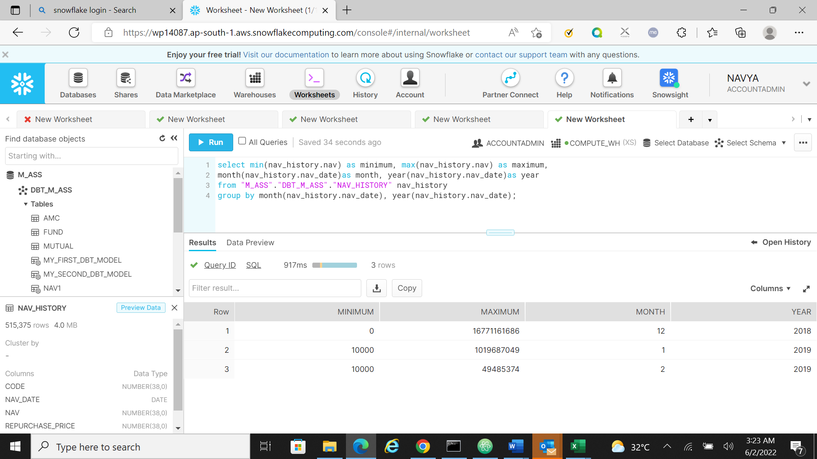

Status is successful:

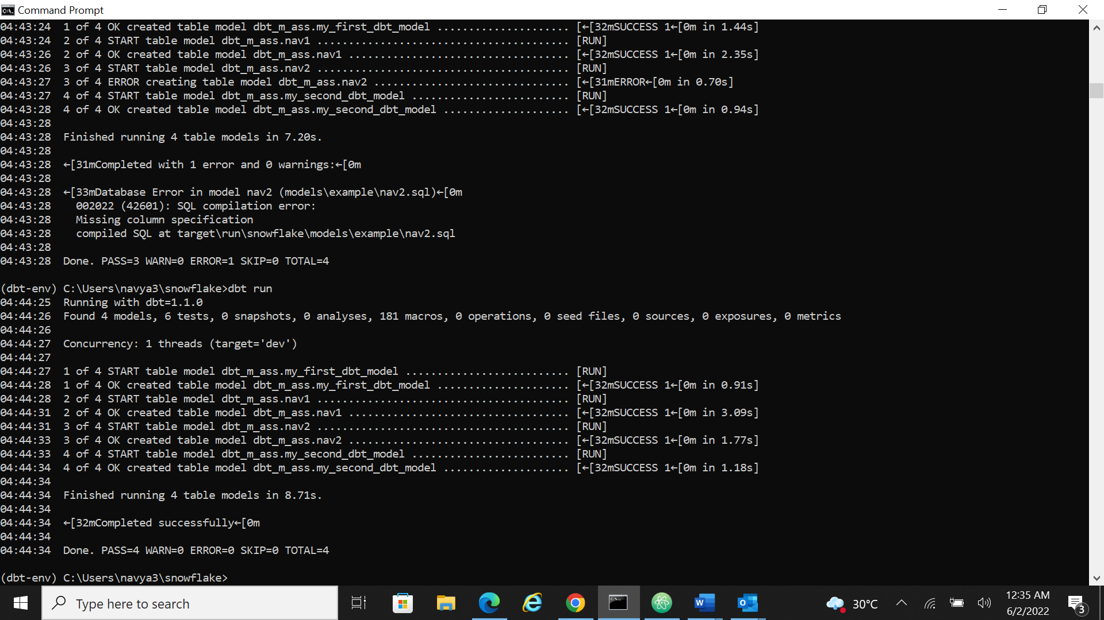

MILESTONE 3:  
Getting error while uploading all the files, but only one file is uploaded. So tried with different approach

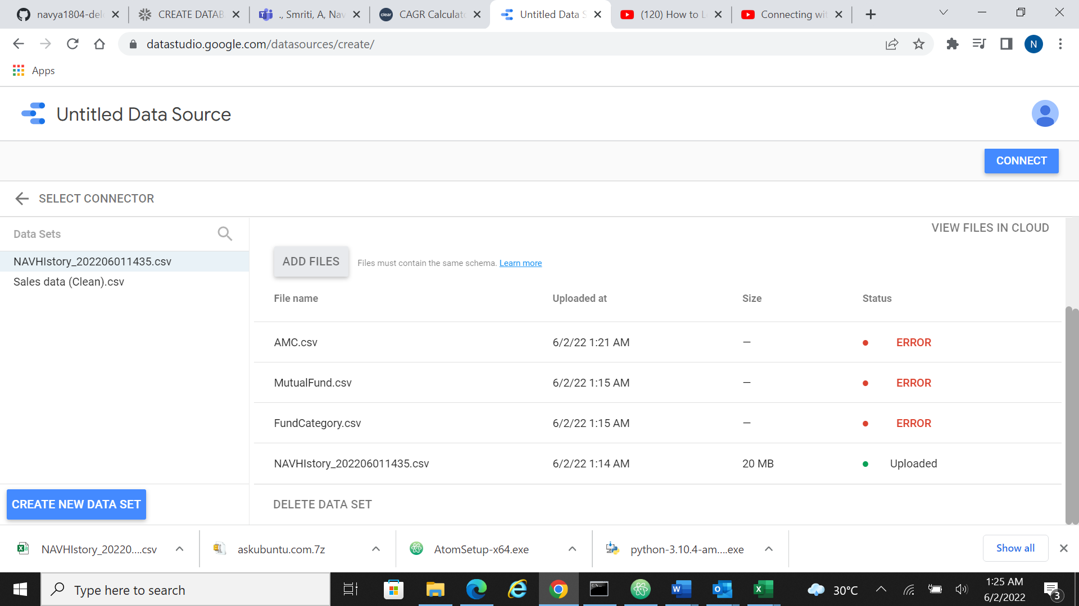

1. Distribution of latest mutual funds based on category. [pie]

